AUTOMATIC TRAFFIC OVERCROWDING USING DEEP LEARNING

|  |  |  |  |
| --- | --- | --- | --- |
| N.Akhila | N.Sri Ramya | K.Shivani | P.Tanuj Kumar |
| Senior Assistant Professor | Student | Student | Student |
| *Department of CSE* | *Department of CSE* | *Department of CSE* | *Department of CSE* |
| *AEC*, Surampalem | *AEC*, Surampalem | *AEC*, Surampalem | *AEC*, Surampalem |
| [akhila.nalla@aec.edu.in](mailto:akhila.nalla@aec.edu.in) | nsriramya7@gmail.com | shewahnihkovvuri@gmail.com | [tanujkumar19011@gmail.com](mailto:tanujkumar19011@gmail.com) |

***Abstract:* A prototype used to handle issues with traffic congestion is the traffic control management. One of the major variables affecting the traffic flow is the traffic lights. Traffic congestion causes accidents in which people may perish. The research involves autonomously calculating the green light period based on current traffic at the signal and identifying license plates of vehicles that violate traffic laws. The proposed system includes a feature that looks for the license plate of a car that is disobeying traffic signals. Additionally, the proposed system has autonomous traffic light switching based on vehicle density.Depending on how many vehicles are in the line, the signal will change automatically. As opposed to the way with less traffic, the direction with more traffic will receive a green signal for a longer period of time because of this. When cars disregard traffic signals, their license plates are photographed.In order to do this, we use camera footage as our input and identify the moving objects that are disobeying the law. We also offer an automatic traffic light adjustment.Depending on the density of the vehicles, we adjust the signals. By doing this, we can lessen the amount of times cars violate traffic signals. Additionally, we can lessen accidents brought on by high traffic.**

**Technologies Used: Python, Jupyter notebook, and other technologies You Only Look Once [YOLO] V3 model, Region of Interest [ROI], Convolution Neural Network [CNN], YOLOV3, signal switching algorithm, and Pygame for simulation model are some examples of deep learning techniques.**

***Keywords: Traffic, License plate,Vehicles, Accidents***

**I.INTRODUCTION**

Recently, there have been more accidents on the highways. The majority of these collisions take place at signal and highway crossings.The increased traffic in our quickly populating world is the cause of that issue. Traffic has increased as a result of the growing population. This generation is willing to purchase a single automobile, which is the primary cause of the rise in traffic in society. To reduce the risks and challenges that arise when the traffic regulations are not adhered to as stated, the traffic must be regulated at all costs. Manually enforcing traffic laws and regulations to ensure traffic flow is becoming more and more challenging as there are more vehicles on the road.Traffic management tools are used at traffic lights to spot automobiles and bicycles that are operating illegally. Automating these processes will improve their effectiveness and require a system that can instantly identify a vehicle.

Traffic violations are serious crimes that put both drivers and

pedestrians lives in danger. Real-world issues including longer travel times, excessive fuel use, weariness, and higher pollution can be seen as a result of the infractions. Drivers frequently have to pay fines, receive tickets for moving offenses, or even face arrest as a result of charges.

Minor and significant violations are the two categories into which traffic infractions fall. Parking in a prohibited location, a no parking zone, a handicapped zone, or trespassing areas are examples of minor infractions. More serious offenses including reckless driving and accident-related problems are considered major offenses. Each city and state has its own set of traffic laws. Before entering the city, it is the individual's responsibility to be aware of their legal rights.Most nations have harsh penalties for breaching traffic laws, which can result in license suspension. Documents you must have with you when riding a two-wheeler on Indian highways

1. **ARCHITECTURAL DESIGN FOR PROPOSED SYSTEM:**
2. ***Existing system:***

This traffic law was broken. System for detection:

The system consists of two primary parts: a graphical user interface (GUI) and a model for detecting vehicles. The developed algorithm successfully identified the types of violations stated for this project, including disobeying traffic signals, parking in no-parking zones, and going in the incorrect direction. Given that each has a different threshold condition, the convergence of detection for the three types of traffic offenses listed is varied.

Image processing is used in the smart traffic control system:

Instead of employing electronic sensors buried in the pavement, the system will detect automobiles using photographs. There will be a camera set up next to the traffic light. It will record video clips.The acquired photos are successively matched using image matching, utilizing an image of a deserted road as the reference image. Edge detection has been performed for this purpose using the Prewitt edge detection operator, and it can be regulated based on the percentage of matching traffic light durations.

1. ***Proposed system:***

The proposed system aims to reduce traffic violations and improve traffic flow through various tasks such as object detection, image segmentation, and traffic signal control. The system involves detecting license plates, traffic violations such as crossing red signals and not wearing helmets, and classifying different types of vehicles. To achieve these tasks, the system will use machine learning techniques such as YOLOv3 for object detection and CNNs for vehicle classification. YOLOv3 is a neural network architecture known for its speed and accuracy in detecting objects,

# 1

including small objects like license plates and helmets. CNNs, on the other hand, are commonly used for image classification and are good at identifying visual patterns and features in images. However, developing such a system will require a significant amount of data and expertise in designing, training, and evaluating machine learning models.

1. **BLOCK DIAGRAM**

The proposed system aims to reduce traffic violations and improve traffic flow through various tasks such as object detection, image segmentation, and traffic signal control. The system involves detecting license plates, traffic violations such as crossing red signals and not wearing helmets, and classifying different types of vehicles. To achieve these tasks, the system will use machine learning techniques such as YOLOv3 for object detection and CNNs for vehicle classification. YOLOv3 is a neural network architecture known for its speed and accuracy in detecting objects, including small objects like license plates and helmets. CNNs, on the other hand, are commonly used for image classification and are good at identifying visual patterns and features in images. However, developing such a system will require a significant amount of data and expertise in designing, training, and evaluating machine learning models.

In software engineering, a system architecture is a conceptual model that defines the structure and behavior of a system. It showcases the connections between the different components of the system and describes the functions that the system performs. In the context of traffic control management, the system architecture depicts how the traffic violation detection system and automatic signal switching work in tandem to manage traffic flow. Additionally, a workflow diagram is a visual representation of the steps involved in a project or process, providing a clear understanding of the sequence of tasks, who is responsible for performing them, and how they will be completed. It is a highly effective tool for simplifying complex business processes and improving their efficiency. Together, a well-designed system architecture and workflow diagram are essential for ensuring the successful implementation of a project and achieving its objectives.

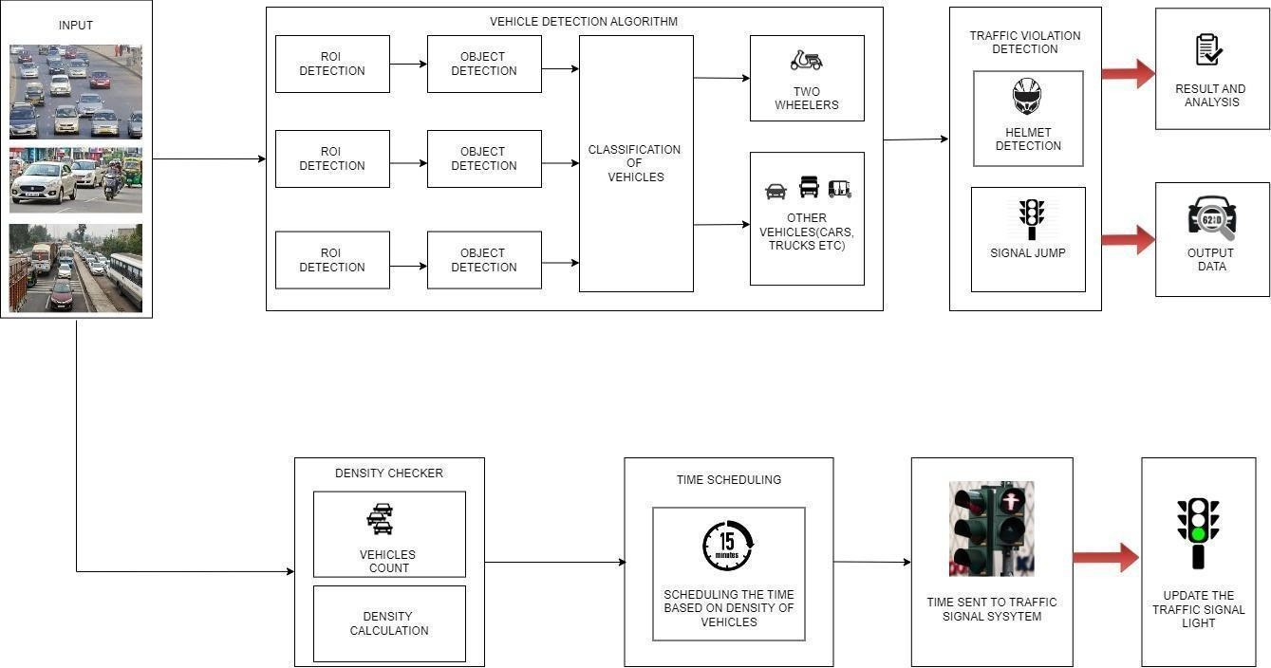

Fig 1.Block Diagram

1. **RESULTS**
   1. ***OUTPUT OF HELMET DETECTION***

Fig 2 represents to image as input containing two wheelers wearing helmet.It should detect the person who wears helmet and gives the confidence percentage of person and helmet.

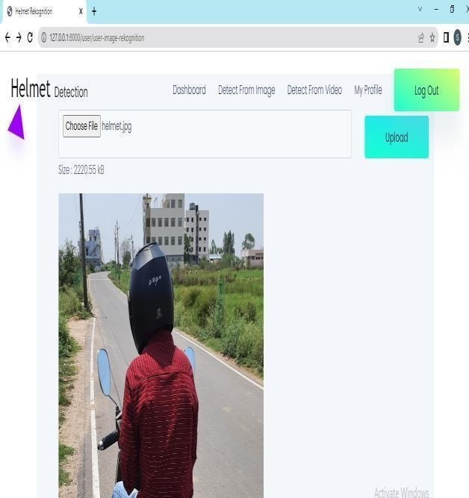

Fig 2. Detection of Helmet

* 1. ***OUTPUT OF AUTOMATIC TRAFFIC SIGNAL SWITCHING***

For the first cycle , the green signal timer for the four lanes are given defaultly as 10 sec. After the first cycle of signal switching is completed , then automatically vehicle detection and simulation algorithm comes into play

For the remaining cycles , the green signal timer for four lanes updates according to the density of vehicles on the particular lane.

Only one green signal timer of a lane switches at a time , while the remaining lane signals switch to red and yellow.

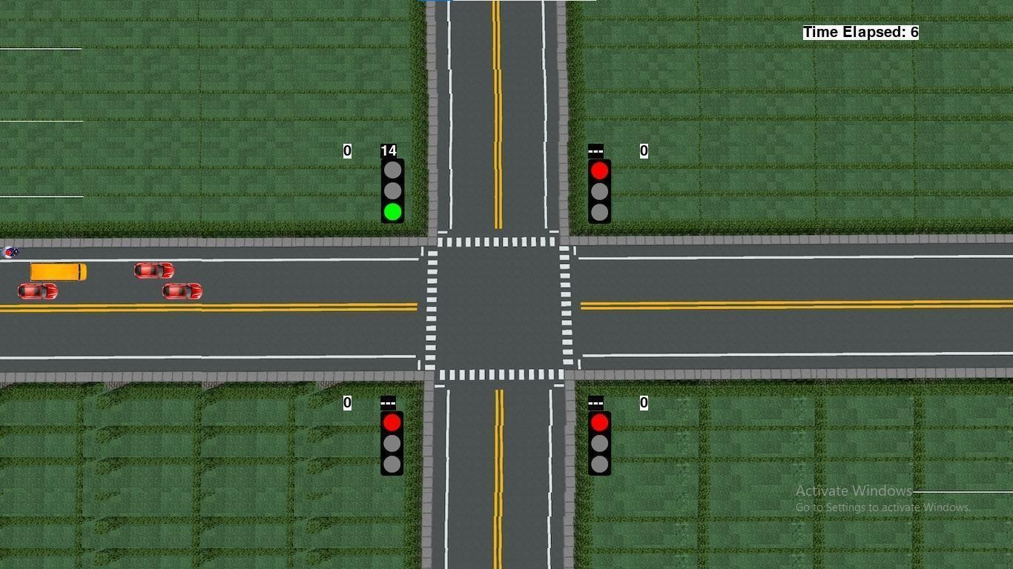

Fig 3. Way traffic signal stimulation

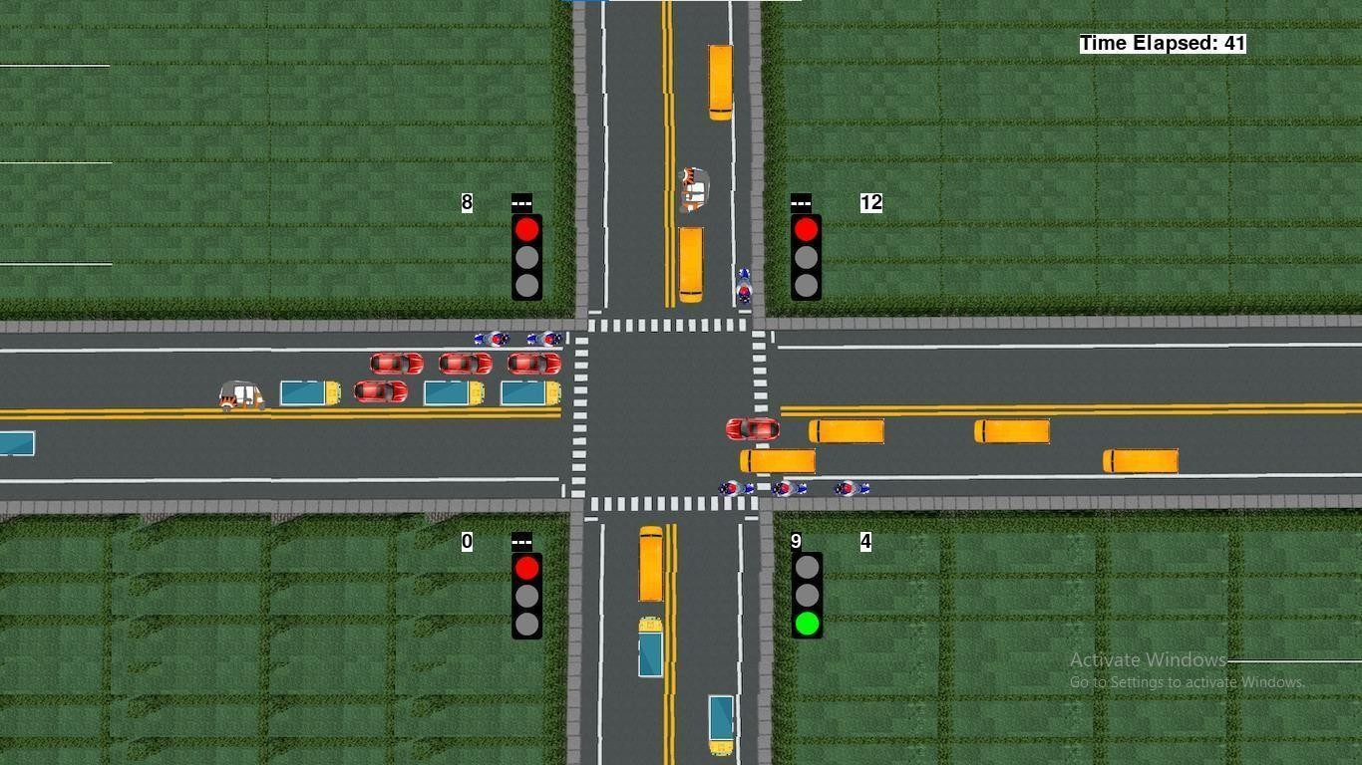 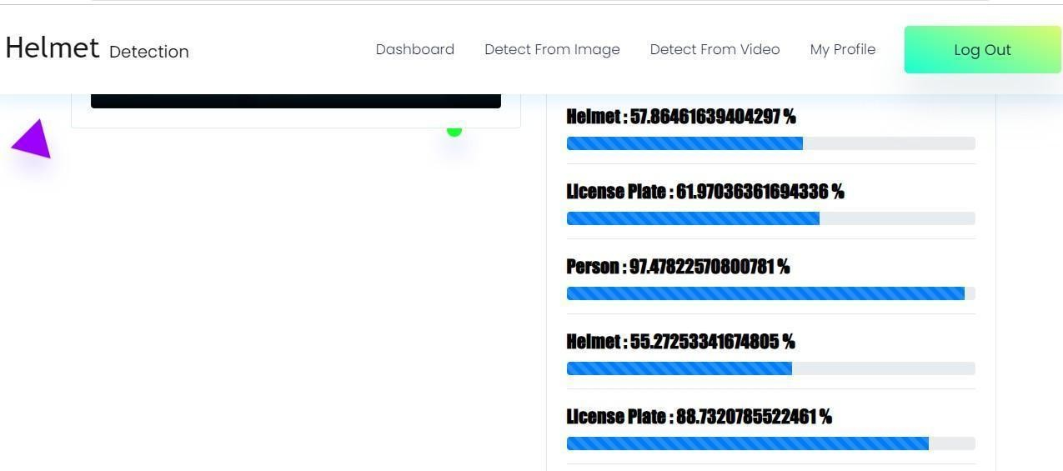

Fig 4. Green signal timer is 10 seconds for 3rd lane during first cycle

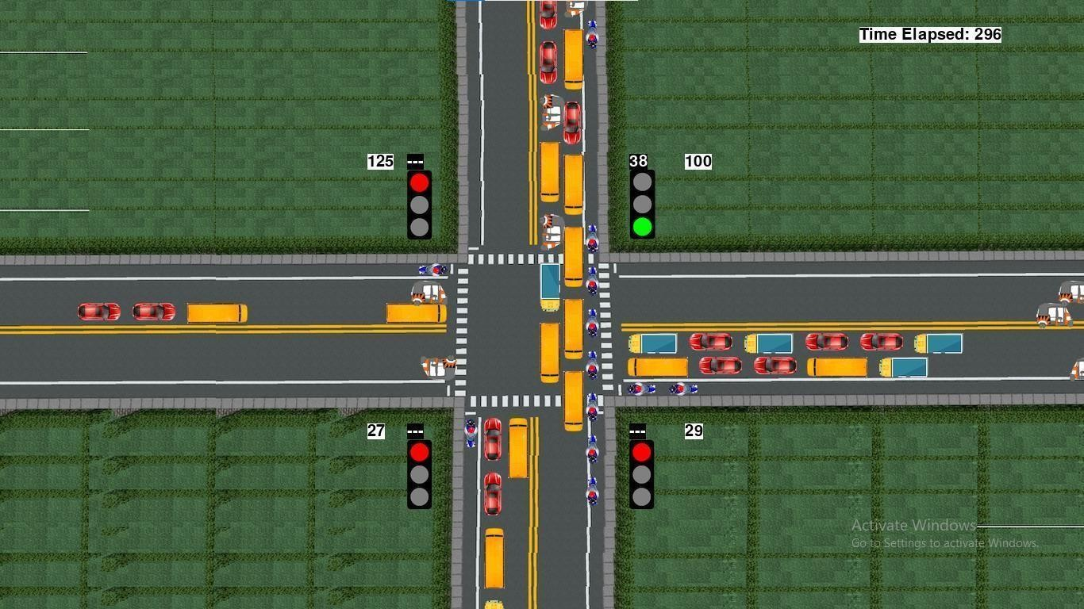

Fig 5.Green signal timer updates to 38 seconds based on its density on 2nd lane

* 1. ***OUTPUT OF LICENSE PLATE DETECTION***

Fig 6 represents the license plate detection if there is no helmet.

A video was uploaded as an input to detect the number plate and helmet.

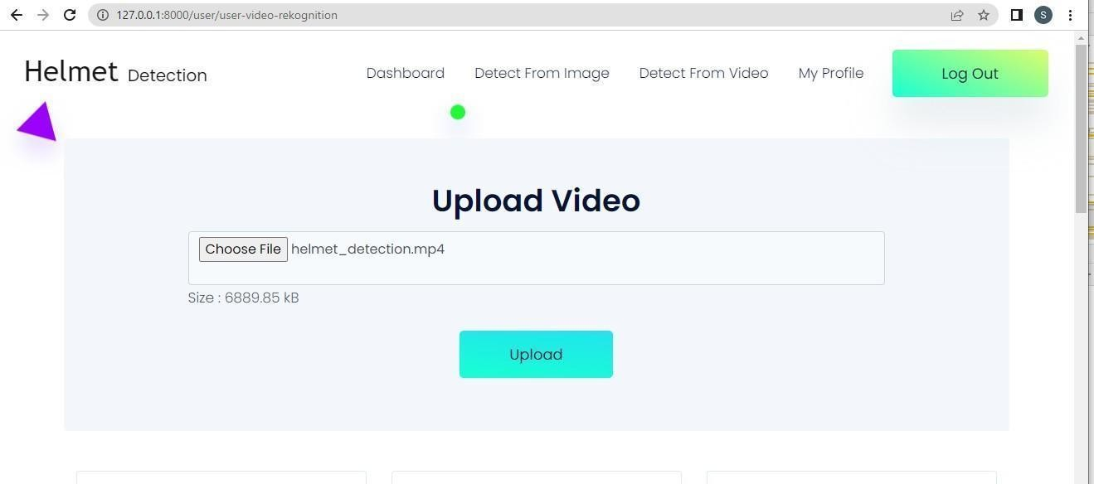

Fig 6. Video was given as input

Fig 7. Accuracy of helmet and license plate detection

1. **CONCLUSION AND FUTURE SCOPE**

*A.Conclusion:*

Traffic control management deals with managing the traffic lights by automatically switching the signal lights and detecting the vehicles which violates the traffic rules.

The main motive of our proposed work is to switch the signals where the greater mass of vehicles are identified in the lane and green light time is scheduled based on density of vehicles. The vehicles which are violating the traffic rules such as red signal violation and helmet detection are identified and their license plate is recognized .

By this work, we can reduce the traffic congestion and control the traffic system

*A. Future Scope:*

To improve accuracy, we will incorporate some ML algorithms. In the future, we would like to use machine learning technology to implement a project. We will be able to stop hacker attacks thanks to this project. To obtain accurate findings, we shall test after training the data set. People learned how to secure their information from this project.

The program runtime is somewhat slow, and can be improved by using a computer with high speed processor specifications or GPU.

Future research about the application of the designed algorithm for other advanced image processing techniques. Since, this may improve the program runtime of the system by neglecting other unnecessary steps done in a background difference method.

 A computer vision algorithm may be done instead to provide more intelligence.

1. **REFERENCE**
2. Ms. C. Sushmitha, J. Subhasree, Thushara. S.S, Mrs. V.Rajalakshmi, “Traffic Rules Violation Detection System”.
3. Vismay Pandit, Jinesh Doshi, Dhruv Mehta, Ashay Mhatre and Abhilash Janardhan, “Smart Traffic Control System Using Image Processing”.
4. Chinmayi Gurav, Vedika Kamble, Rupali Gurav and Prof. Neha S. Sakhalkar, “A Review Paper on Vehicle Number Plate Recognition”.
5. According to J. Sivaraj, R.S. Sudhan Adithya, Adhavan Alexander, M. Vishnudeep, S. Mohammed Farhanudin, P. Vishnu and T. Anusha, “Helmet Violation Detection Application for Road Safety”.
6. Xiaoling Wang, Li-Min Meng, Biaobiao Zhang, K.-L. Du,” A Video-based Traffic Violation Detection System”.