**Advanced AI based Cosmetic Suggestion System**

**SureshKumar.P1, Rishika.S2, Vyshakh.VS3,Udhaya.M⁴**

1Assistant Professor, Department Of CSE, Hindusthan Institute Of Technology, Coimbatore, TamilNadu, India

2,3,4Student, Department Of CSE, Hindusthan Institute Of Technology, Coimbatore, TamilNadu, India

**ABSTRACT**

Now a days,cosmetic products plays major role in personality appearance.With online Shopping and Ecommerce websites

customers are given number of products.Selecting best product for our skin is difficult for us.Therefore we propose a

predictive system which gives exact idea about which product is best for our skin type.The composition is based on

the skin types which can be oily, dry or neutral.The suggestion for the composition will better than the traditional system.

By using AI algorithms we will ease the challenging task of IT industry in cosmetic and beauty care.

**Keywords:** Cosmetic products, Skin type, Suggestion, AI algorithms, Cosmetic and beauty care

1. **INTRODUCTION**

Over the years beauty industry becomes more and more vast,and so the products offered by this industry and the customers

are also increased.So based on this expansion of products and consumers, the selection of appropriate cosmetic product

becomes very important. As cosmetic products plays important role in personal appearance there is need for selecting

best products according to their skin type. Finding perfect cosmetic for users skin type in notoriously tricky- as every

individual have unique skin texture.Even if we find product for customer it can lead to skin trouble,which is very complex

issue. For solving this problem we can use AI algorithms,as it works fine with unstructured and large amount of data with

promising result.

1. **METHODOLOGY**

In this system we will implement the best composition of cosmetic product using AI architectures(CNN)

**2.1 Finding the skin type**

The method first find the skin type of the customers using Conventional neural network algorithm

**2.2 Finding input features**

This method finds input features like product ingredients, product suitability for skin type which are passed to the input layer

and then to the hidden layers for automatic feature learning. Finally we get composition of cosmetic product on the output

layer. The suggestion for the composition will better than the traditional system.

1. **MODELING AND ANALYSIS**

Here we will implement the best composition of cosmetic product using AI architectures ( Convolution Neural Network). The proposed method takes input features like product ingredients, product suitability for skin type etc which are passed to the input layer and then to the hidden layers for automatic feature learning . Finally we get composition of cosmetic product on the output layer. The suggestion for the composition will better than the traditional system. Here we use python language.Python is an amazing programming language. It is simple to read but also powerful enough that it can do a lot of things. Compared to other languages, it allows fast iteration. If you want to tweak your code a bit, you only need to change a line or two, and you can run the modified code right away. No need to update many places for small changes. No need to wait for minutes and hours to re-compile your code to run it.Python is never meant to run fast. In fact, if execution speed is the concern, using a different language such as C++ or Java might be a better idea. In machine learning projects. We need many experiments and iterations to finalize our approach. Having a language that allows us to iterate fast means we can improve our solution faster. As a result, a lot of people are using Python. And a lot of libraries are written for Python. This virtuous cycle makes Python a mature language with a powerful ecosystem.

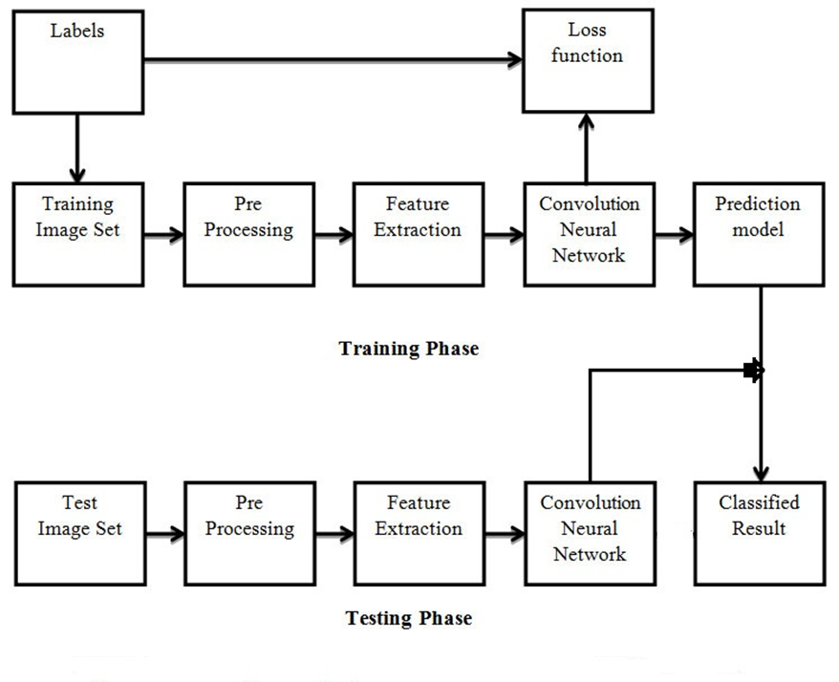

**Figure 1:** Block diagram

1. **RESULTS AND DISCUSSION**

Firstly the dataset is collected from several data science domains like kaggle and data is categorized into four classes

namely oily ,dry ,combinational ,normal.The data set is imported in AI algorithm and before performing the pre-processing

techniques are implemented to enhance the dataset some of the techniques are grayscale conversion and histogram

equalisation.The data set is imported in AI algorithm and before performing the pre-processing techniques are implemented

to enhance the dataset some of the techniques are grayscale conversion and histogram equalisation.From the trained model

file the input skin image is classified and the cosmetic suggestions are provided based on that..

| SN. | PRODUCT NAME | SKIN TYPE |
| --- | --- | --- |
| 1 | Ayur  Skin Toner | Combination |
| 2 | Lotus Herbal | Dry |
| 3 | Biotique Face pack | Normal |
| 4 | Blossom Face Wash | Dry |
| 5 | Mac Foundation | Combination |
| 6 | Lacto  Oil Balance | Oily |

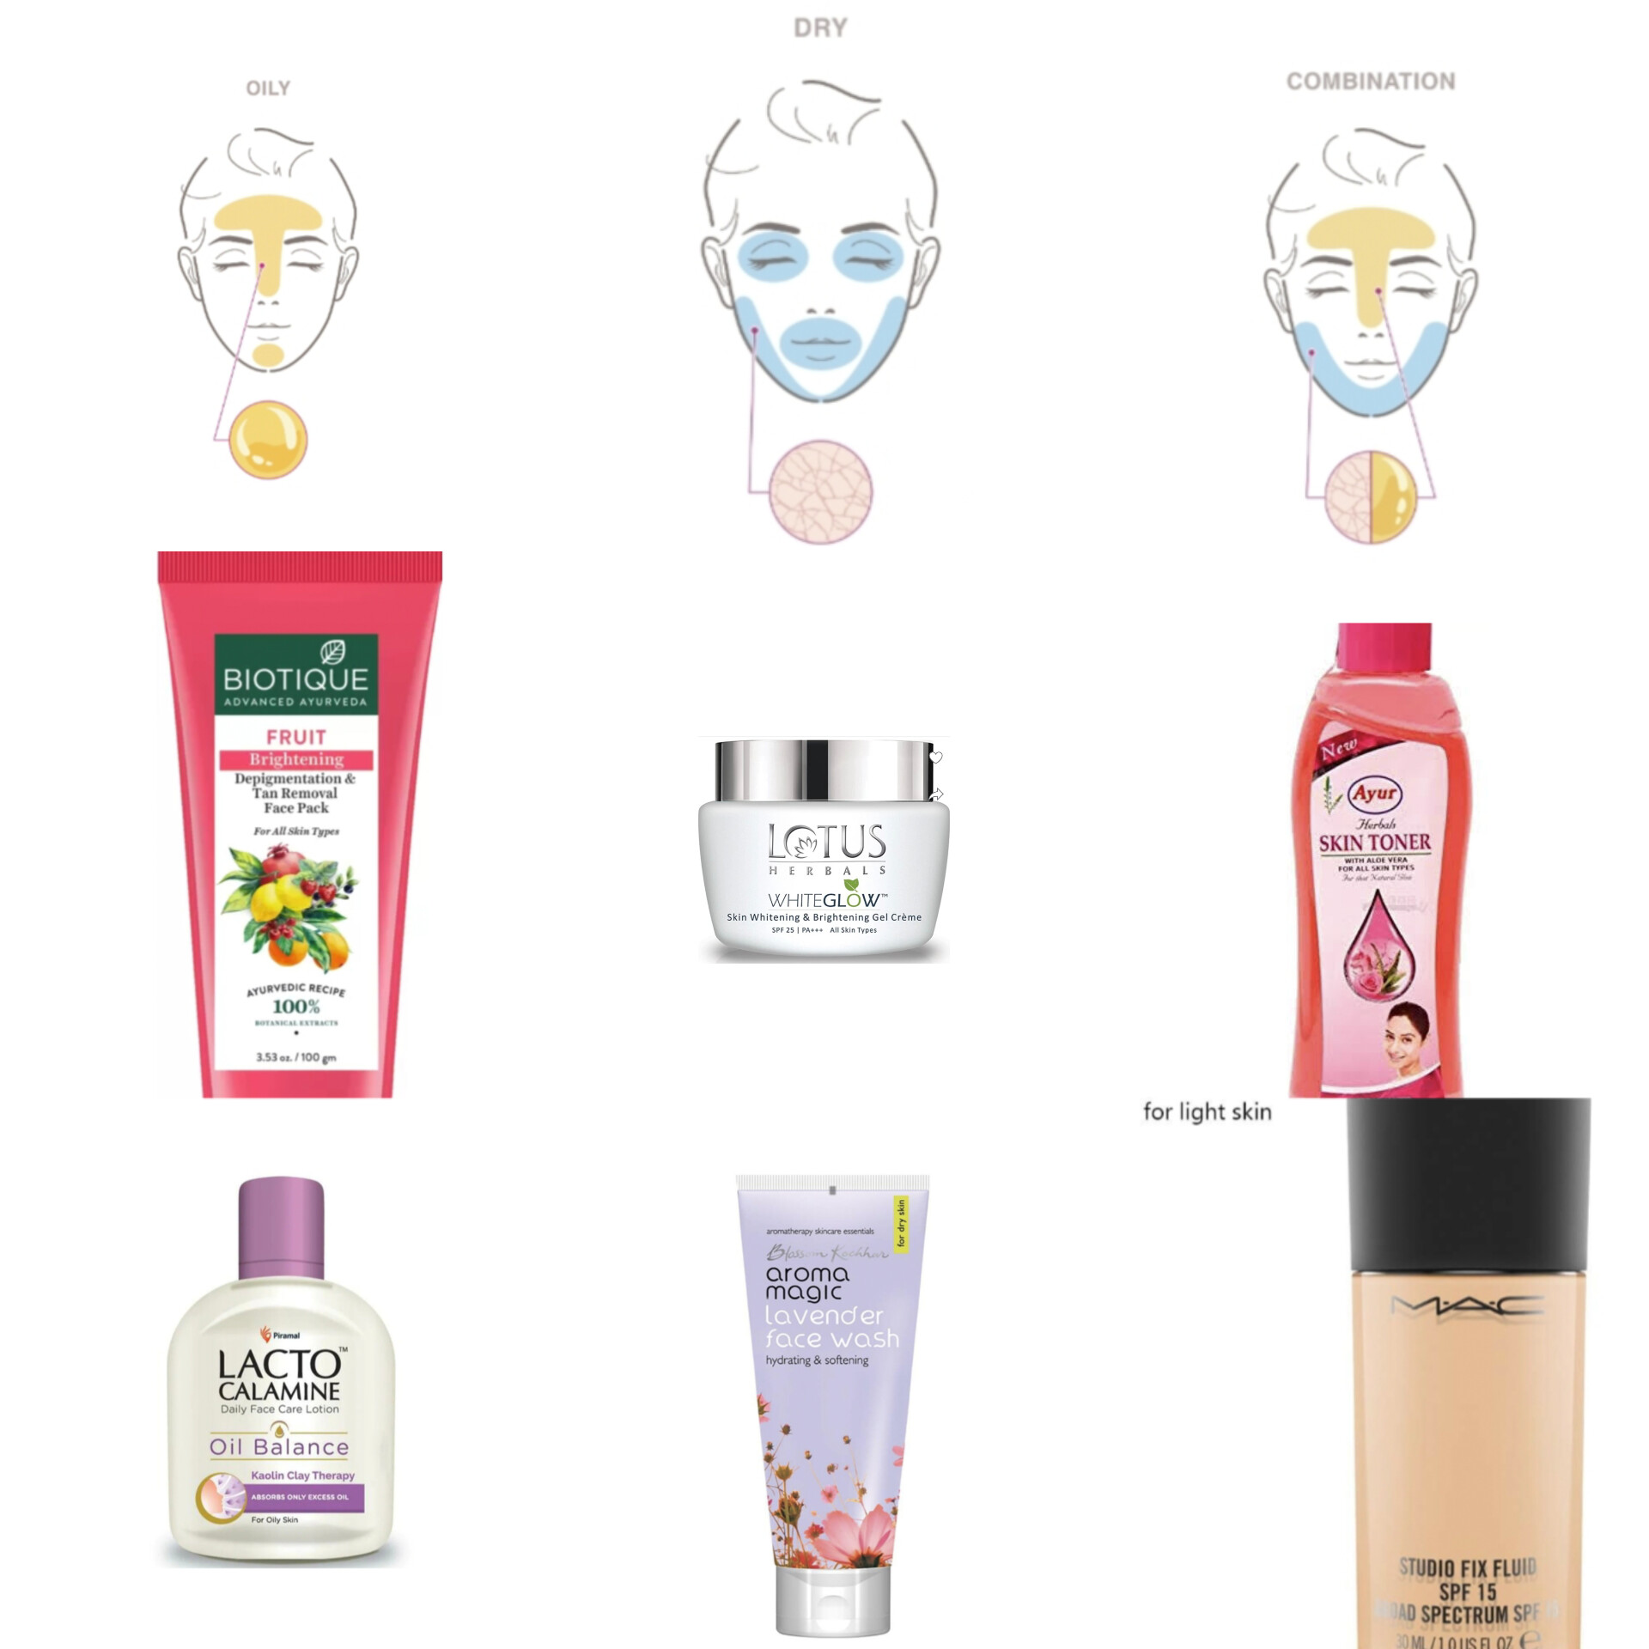

**Figure 2:** Suggestion of accurate cosmetic product based on their skin type

1. **CONCLUSION**

Decision making in today’s world is more complex than the past, as for consumers who are now confronted by various kind

of choice for each type of products and brands. This approach provides the composition based on skin types (i.e. dry, oily or

natural). Our main aim is to serve better composition of cosmetic products. By using AI algorithm technique the proposed

system will definitely help in better composition of cosmetic products.

**6.REFERENCES**

[1]Liying Yang,'A study on optimization design of cosmetics sustainable service system and case-based design on Xie fuchun',2020 International Conference on Innovation Design and Digital Technology (ICIDDT)

[2]Rianne Stam,Ken Karipidis,Jacques Abramowicz,Guglielmo D'Inzeo,Adèle Green,Sharon Miller,Tsutomu Okuno,Tim Toivo,'Progress report: ICNIRP Statement on non-ionizing radiation for cosmetic purposes',2018 EMF-Med 1st World Conference on Biomedical Applications of Electromagnetic Fields (EMF-Med)

[3]Vincent Gauthier,Davina Desplan,Stéphane Serfaty,Magalie Michiel,Emmanuel Caplain,Jean-Yves Le Huérou,'Multi-Frequency Ultrasonic Shear Waves Rheology for Soft Materials Monitoring in Cosmetics',2017 Cosmetic Measurements And Testing (COSMETIC)

[4]Min Wang,'Empirical Study on Cosmetics Purchasing Intention of Traditional Chinese Cosmetics Customers',2021 5th Annual International Conference on Data Science and Business Analytics (ICDSBA)

[5]Zhen Wu,Lin Wang,Ji-Hui Fang,Wen-Ge Chen,Ai-Lin Yu,Shu-Qing Liu,Wei-Qiang Lin,'Cosmetic safety risk assessment model and system implementation based on six-dimensional classification',2021 International Conference on Internet, Education and Information Technology (IEIT)