Project Bidding and Cost Estimation

Using Machine Learning

| G.Uma Mahesh1 | R.Venkata Sai Chaitanya2 | E .Tarun3 | A.Priyanka4 |
| --- | --- | --- | --- |
| Senior Associate Professor | Student | Student | Student |
| Department of CSE | Department of cse | Department of cse | Department of cse |
| Aditya Engineering College**,** Surampalem  [Mahesh.gandhikota@aec.edu.in](mailto:Mahesh.gandhikota@aec.edu.in)1 | Aditya Engineering College **,** Surampalem  [19A91A0546@aec.edu.in](mailto:19A91A0546@aec.edu.in)2 | Aditya Engineering College**,** Surampalem  [19A91A0508@aec.edu.in](mailto:19A91A0508@aec.edu.in)3 | Aditya Engineering College**,** Surampalem  [19A91A0504@aec.edu.in](mailto:19A91A0504@aec.edu.in)4 |

**Abstract**—**The major factor in the success of most projects is accurate cost estimation at an early stage of production. Cost forecasting relates to cost prediction and typically involves calculating costs for supplies, labor, sales, overhead, and extra expenses. The project manager drafts a bid including the specifications and anticipated cost of construction projects. The contractor evaluates the bid and calculates the project completion costs. Here, we propose a cost calculating strategy for the early stages that is based on machine learning methods like regression and linear modeling. The goal of the project is to create a machine learning-based system that can deliver precise cost estimates and efficient bidding techniques for engineering and construction projects. In order to anticipate expenses and offer advice on bidding methods, the system will specifically use a linear regression algorithm to examine historical data and other project characteristics. Prior projects' size, length, location, materials utilized, labor prices, and other pertinent information will be first gathered by the system.In order to anticipate the costs of upcoming projects, a linear regression model will be trained using this data. The technology will also take into account information about the bidding procedure, such as client preferences and competitive analyses. As a result, the algorithm will be able to offer competitive bidding tactics that are customized for particular projects. A variety of measures, such as the precision of cost projections, the effectiveness of bidder strategies, and ultimate project profitability, will be used to assess the system. The ultimate objective of this project is to create a potent tool that may assist engineering and construction companies in streamlining their cost estimation and bidding procedures, which will increase productivity and profitability.**

**Keywords— Machine Learning; linear regression**

1. INTRODUCTION

Cost estimating is an essential process for every business before creating pricing budgets and allocating resources over the course of a project. This could lead to inaccurate and misleading estimates because it is difficult to acquire data for the cost-estimating process and the nature of the task is rarely understood. Knowing the project's scope also gives you more chances to provide additional project details and get precise estimates. On the other hand, it should be taken into account that the cost management process becomes more difficult as a result of progressive expansion when the project is dependent on inaccurate cost forecasts.

Furthermore, the construction industry is a high-risk industry that necessitates careful supervision due to its characteristics and the significant amount of work needed to start and continue a construction process. Variations between the planned budget and the known price may result from overestimating or underestimating the cost of certain construction methods. Price predictors can identify and address their relevant gaps more easily when there are more reliable solutions available. Traditionally, the whole working of the price could be predicted by understanding office supplies, finances, and the way they distribute themselves throughout the course of a shift. It might be information for reducing operating expenses and afterwards checking money. Other pricing and straight prices exist for working prices. Costs incurred directly on work, additional project components, significant job-related costs, and personal expenses are all included in the working straight price.

The components described in various ways:

The straight price, which can be described as costs incurred directly in connection with a project & its manufacturing activity, can be correctly forecasted given enough information about the site's state, the method of construction used, and the resources used. Direct pricing are made up of a variety of costs, including the cost of the labor allotted to the project, the equipment, materials, and workers used, as well as subcontractors who complete work packages under the overall contract.

Types of other ways include:

There are several ways that building rates are determined, who is in charge of the money used for construction, how utilities are distributed, etc.

These frequently cited expenses, in contrast to project overhead, are not individually ascribed for all projects, which is essential because they are associated with work-related expenses like cash spent at the corporate office, employee expenses, and so forth. Projects based on the complete cost of the construction job.

1. RELATED WORK

**1. REASONING FOR CONSTRUCTION BASED ON A CASE ESTIMATION OF PRICES IN KOREA** Case-based reasoning applies previous solutions to current problems. No situation from the past can ever be compared to a current one, hence old solutions must be applied to new circumstances. Case adaptation is the procedure in question. The ability to change cases is therefore essential to the success of CBR. Case adaptation can be approached in one of two ways: by reducing the need for modification or by increasing effectiveness. 13 test projects were used to test the methodology after building a CBR cost framework with an adaptability feature employing 129 military barrack projects in Korea.

**2. NEURAL NETWORK FOR CONSTRUCTION COST ESTIMATION**

This essay illustrates a regularization neural network for estimating building project costs. A faulty function with a regularization term, a standard error term, or both is used to express the problem. The goal of the second term is to improve cost estimation and address the overfitting problem using data sources that are not currently available. It is feasible to expand the database of examples from earlier construction projects, which will aid in lowering the regularization networks' generalization error. Intrinsic noise is undetectable noise caused by uncontrollable, unpredictable, and non-quantifiable sources.

**3. SUSTAINABILITY FACTORS INCLUDED IN COST CALCULATION OF Building PROJECTS USING CASE BASED REASONING (CBR) METHOD**

Krzysztof Zima, Agnieszka Lesniak ID Sustainable development principles and the resulting environmentally conscious mindsets are being used in construction projects more frequently. When sustainable development principles are included in the design process, construction project costs are impacted. The authors of this study recommended using Case Based Reasoning to project the costs of constructing sports fields. They found 16 factors in their research that can be mentioned at the start of planning and that have an effect on the price of a construction project.

The work's distinctive features include the creation of a separate database with information on 143 construction projects related to sports fields and consideration of environmental aspects like the facility's impact on the surrounding area and the ecological impact of the materials used in construction.

The degree of similarity between the examples was calculated using a variety of mathematical formulas depending on the type of data. Quantitative, qualitative, unsure, and lacking in data. The findings suggested that the CBR method, which incorporates historical data and sustainable development criteria, may be useful for cost prediction during the planning stage of a construction project.

III. EXISTING SYSTEM

A.Case-Based-Reasoning:

Case-Based Justification for Cost Estimation of Korean Infrastructure Case-based reasoning (CBR) applies earlier methods to address current issues. Due to the fact that no circumstance from the past will ever be identical to a current one, the process of adapting old remedies to new situations is known as case adaptation. The ability to change cases is therefore essential to the success of CBR. Case adaptation can be approached in one of two ways: by reducing the need for modification or by increasing effectiveness. The method was validated using, for example, 129 military barrack constructions in Korea, and the method was then put to the test with 13 test cases using a CBR cost estimator with an adaptability feature. Since memory has the details of individual previous events, it serves as the primary information source in CBR. The most crucial approaches are retrieved and updated (not chained) in order to address new situations and develop solutions. How people learn new abilities and how they make judgements about a situation based on existing knowledge are two issues that CBR is interested in (Paul & Shui 2004). A related specific type of human thinking that people frequently employ to come up with solutions is the Critical Thinking (CBR) method. The adoption framework utilized to develop theoretical and strategic budgetary estimations served as the basis for the development of the CBR cost framework. The case adaptation of previously gathered candidate data is the main emphasis of the model. The CBR cost model specifically applies the data-mining idea of case adaptation to human-worked procedures.

Comparisons from above are used to test price forecasts based on searching methods:

(1) Pre-processing or estimates of having units pricing for many previously processed types

(2) Making the most accurate price predictions for key model components whose values are already known.

(3) Prediction with pricing in additional ways while maintaining pre-processing value.

(4)prediction with maximum ways of prices of value of pre-processed values.

**Disadvantages:**

* Facing difficulty in evaluation.
* Having local resource constraints.
* Older cases may be poor.
* Retrieval/compatibility knowledge is still required.

B. Neural Network For Construction Cost Estimation:

The system provides a regularized neural network for estimating construction project costs. The issue is caused by a flawed function that includes both a regularity term and a standard deviation term. By using data sources that are not currently available, the second term aims to enhance cost estimation and solve the overfitting issue. Only specific types of processes, such as polynomial equations, can be fitted to data using traditional regression analysis approaches. The information must have one of the characteristics mentioned above, which is yet another fundamental criterion. On the other hand, no presumptions are made regarding the shape of the approximation functions to be learned in the dependability neural networks technique discussed here. It is only natural to anticipate general harmony and consistency of performance. In comparison to earlier neural network methods, such as back-propagation (BP) neural networks, for instance, the neural approach proposed with a search for useful ways to employ. Important fundamental principles that are relevant to this are currently being utilized for preparation.

It can be difficult to explain practice in a meaningful way when it is difficult. To be computationally modeled, learning must be characterized practically as opposed to as an abstract concept. Own organization of work, verification of work, and the obtaining and producing of work. Based on the final definition, a list of examples, and an observation of the stimulus, one chooses how to react to the stimuli. Consider supervised learning, in which a system is initially trained using examples of inputs and outputs. After getting the fresh input, the learner chooses the output. This is a difficult puzzle since there are many different solutions that could work.The solution depends on the threshold or normalizing standards that are selected during the decision-making process. When the practicing activity is perceived as decision-making work, the generalization standards are evident. Regression analysis and other outdated workarounds for keeping solutions have not been proven to be accurate.

**Disadvantages:**

* Neural network require long training time.
* Financially and computationally expensive.
* Difficulty understanding the learned functions.
* Quality predictions require a large amount of data.

IV. METHODOLOGY USED

Proposed System and Benefits In order to reduce difficult tests, the management decision-making process primarily relies on constructing price forecasts. A sizable dataset is required for machine learning algorithms to model and estimate project expenses. This publication's end outcome is a thorough examination of machine learning techniques and a method for applying analysis to price prediction for building projects based on direct and indirect expenses. The application sectors of interest for project cost evaluation include buildings, on the mainroad, common areas, transport way, the way connected to water of building materials, transport underground, passenger railways, hydroelectricity, current station and current works. In other respects, statistical methods rely on certain unusual approaches to show a typical connection between ultimate prices and the qualities that are connected to them. Parametric cost estimate methods characterize costs like mass, volume, and cost without taking into account minute details. The genuine way the project cost is assessed is based on determining the typical relationship between different types, with the solution being a numerical method of connecting numbers. Any estimation of a building project's cost should be based on a number of factors, such as the type of project, material costs, changes to the design and scope, site conditions, timeline, scope, client type, and tendering procedure. The cost of construction projects is influenced by several different elements.

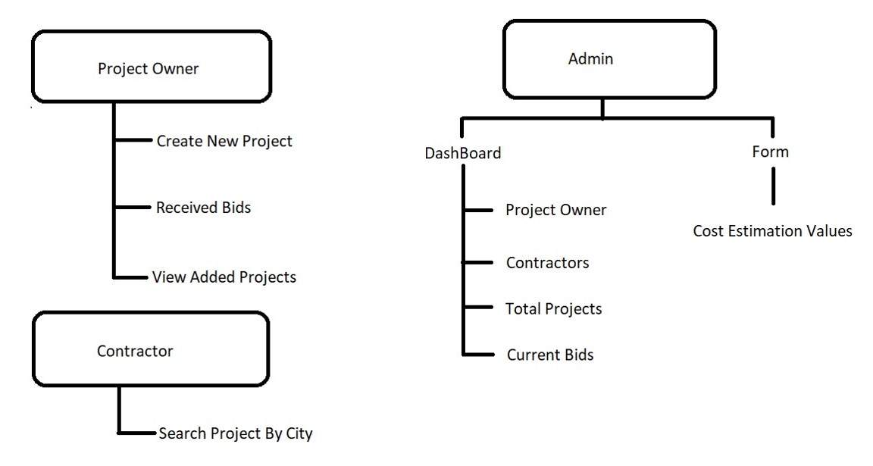

**Fig. 1. System design**

This types may divide in two different ways :

(i) Making crucial type predictions. The three probable cost estimators are contractor, consultant, or owner. Cost calculations could incorporate Cognitive As a result, predicting errors

(ii) Design and work are done in accordance with the predictors' experience and rank. Instead of considering the actual outcome, the cost estimator typically relies on his or her conclusions on the venture's projected profits or losses. It's also possible to change the personalized estimator.

As a result, the study focuses on design- and project-specific aspects. Plans and categories related to work. These sorts include information on the work, different types of construction, sand situations, guest ways, staff rates, plans and work changes, times, and other ways. This is described in the eagerness to provide information, kinds in job for work price prediction. the same labor type measured in meters, feet, or workers. As the number of employees rises, price prediction for some goods may become permissible and subject to laws. having further research on topics related to price prediction in construction.The proper method must be chosen for certain types of construction, including the proper construction methods. The restricted number of available materials and laborers will have an impact on the project's costs. Project types can be categorized into a number of groups.

There are generally six primary categories for building work:

1) developing

2) planning of building

3) large work

4) road work

5) sand work

,6) factory work.

Prior to submission, sand issues should be among the first considerations in every building project. Without knowing the ground condition, the construction worker must still estimate the cost; but, if the assumption is inaccurate, there may be additional costs associated with the ground condition.

The type of customer has the most influence on the terms of the contract of sale and how bids operate because each building project has a different set of client expectations, responsibilities, and goals.

Prices of things: The timing and sorts of things one chooses in regular marketplaces have known effects on the estimated cost of construction projects. The majority of the cost of building is in the staff. All methods used to obtain roughly predicted product prices include reducing waste, working with expensive building costs, and gaining time. Additionally, the number of items required should match the plan and should not depend on the crew's actions or working methods. The stats are prone to sudden fluctuation and are based primarily on the employees' work habits and environment.

The scope and conceptual framework may change. If they are in the building, based on their seniority, they have a lot of control over this design. In order to achieve the customer's anticipated steps, some project types necessitate that the client hire a design firm to plan and supervise building methods. On the other hand, the success of the construction plan depends on the right definition of the scope phase. The main causes of projects failing have been attributed to seniors' lack of knowledge of hope, despite the fact that thorough planning can cut costs by roughly 20%. Conceptual Framework and Scope are subject to change. If they are in a position of authority at the building site, people have significant control over this design. For certain project types, the client must hire a design company to organize and monitor the construction process in order to satisfy the client's anticipated steps. On the other hand, a proper specification of the scope step is essential to the success of the construction plan. Despite the fact that thorough planning can cut expenses by roughly 20%, inadequate knowledge of hope has been mentioned as one of the main reasons initiatives fail with seniors.

V. Objectives of the Project

Checking standards for price estimation for construction projects is one of the main components of the same information.Finding the building blocks for a project depends on practical locations, practical methods, previously used types, reporters, and published years.

VI. REQUIREMENTS ANALYSIS

Requirement analysis overview information acquired and technique of operation. For any work, information is just beginning. Other work execution phases include gathering information, selecting it, preparation, and transformation. These steps can all be broken down into multiple steps.

Data collection-

This is a period of information verification to compile the data and direct machine learning operations. Information checkers are responsible for identifying methods and data types that can be used to obtain relevant data, interpret it, and analyze problems numerically. information based on our preferences. Following the values of information, scientists use construction and methods of value prediction. The best approach is helpful in this. Less than one-third of the data gathered, according to information scientists, may be relevant. Before the model training begins, it is difficult to determine which portion of the data would produce the most accurate results. As a result, it's crucial to collect and retain both organized and unstructured information. Users that are interested in starting a personalization campaign can use web analytics tools like MixPanel, Hotjar, Crazy Egg, the well-known Google exam. The website's file contains some useful information. Obtain information about visitor behavior, such as how long they stayed or what they saw. Businesses may remark on their information using transparent information. Provide free datasets for AWS analysis, just like contributors.

Data pre-processing-

Pre-processing is done to make raw data acceptable and clean so that a data scientist may use it to apply machine learning and provide more accurate findings. Data formatting, cleaning, and sampling are examples of techniques.

**Outputs:**

A machine learning linear regression algorithm is used to analyze the data set that contains the prior project data.It provides the best accuracy when utilizing these algorithms.

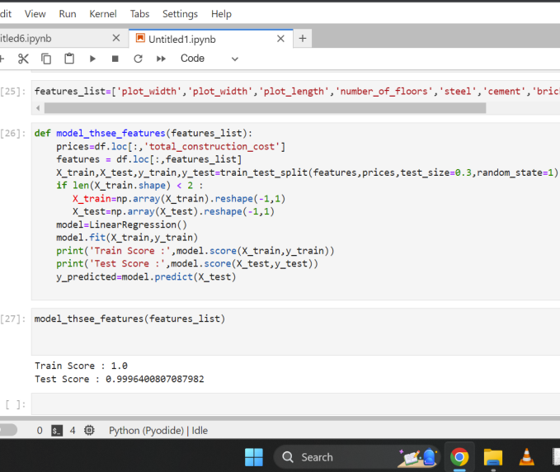

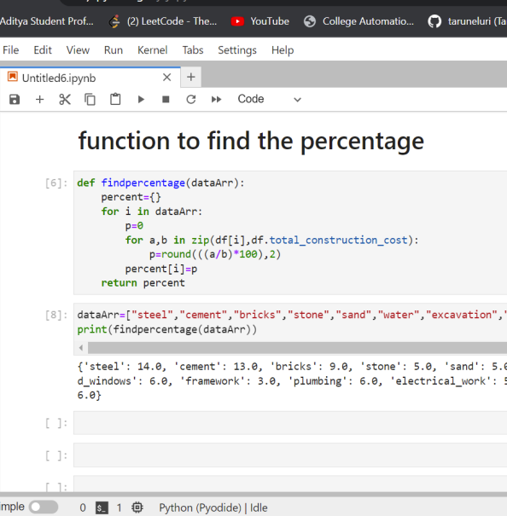

VII. RESULTS AND DISCUSSIONS

TABLE I. Various techniques in stress detection

| **S.No** | **Reference Paper Title** | **Advantages** | **Disadvantages** |
| --- | --- | --- | --- |
| 1 | Cost-Based Reasoning for Korean Construction. | Case-based reasoning (CBR) makes use of previous solutions to address current issues. The term "case adaptation" refers to the process of adapting existing solutions to new problems because no two situations from the past are ever precisely the same.  As a result, the capability of case adaptation is crucial to the success of CBR. | Encountering challenges with evaluation.  a lack of adequate local resources.  Poor old cases could exist.  Knowledge retrieval and adaptation are still required. |
| 2 | For estimating construction costs, use a neural network. | The latter term's goal is to address the overfitting issue and enhance cost estimation using data that is not currently available. Insufficient data examples can be blamed for the regularization networks' generalization mistake. This can be enhanced by expanding the library of samples from prior construction projects and to inherent noise originating from imperceptible, unquantifiable, and unavoidable variables. | The neural network requires extensive training.  Costly both economically and computationally.  Understanding the learnt functions is challenging.  A lot of data is required to make accurate predictions. |
| 3 | Construction project cost estimate and forecasting: a thorough evaluation of machine learning methods | This system's examination and research of articles that were suggested for cost estimation using machine learning approaches are shown. The various machine learning methods discussed in this proposed system are used to estimate project costs. | This system has no such flaws because it has theoretical information on all machine learning algorithms. |

VIII. CONCLUSION

By offering a formidable tool for enhancing bidding and cost estimate procedures, the project bidding and cost estimation utilizing machine learning linear regression algorithm has the potential to revolutionize the construction and engineering sectors. For project cost estimation and bidding, the application of machine learning algorithms, particularly linear regression, can offer more precise and effective techniques. The system may offer customized suggestions for bidding methods that maximize profitability and minimize risk by taking into account historical data, project characteristics, and competitor analysis. In the suggested system, we are employing linear regression to build a machine learning model. We can forecast the cost of the input factor in the future thanks to this specific model. The website also gives us the chance to take part in free bidding, which is something that not many websites provide. The created system can aid engineering and construction companies in making better judgements, which will ultimately boost productivity, profit, and project success. The evaluation criteria employed to gauge the system's effectiveness will guarantee that it is precise, dependable, and useful in cost prediction and offering advice on bidding methods.Overall, this project has the potential to significantly improve the engineering and construction sectors, allowing businesses to compete more successfully and complete projects more quickly, leading to increased profitability and success.

IX. FUTURE SCOPE

There is a sizable future potential for improvements and breakthroughs in the project of creating a machine learning-based system for project bidding and cost estimation utilizing

the linear regression technique. Future developments that could occur include: combining with more machine learning techniques While decision trees and neural networks are effective machine learning algorithms for improving the accuracy of cost estimation and bidding methods, linear regression is a good approach for forecasting cost estimations. Real-time data analysis: Including real-time data analysis in the system can give current details on project factors and market trends, which can be utilized to improve cost estimations and improve bidding strategies. 55 Environmental considerations: Taking into account environmental aspects like weather patterns and climate change might result in cost estimates that are more precise and thorough, which can boost project success. Integration with other project management tools: A comprehensive solution for managing engineering and construction projects may be obtained by integrating the machine learning-based system with other project management tools like budgeting and scheduling software. Expanding into different industries Other sectors, like manufacturing, shipping, and healthcare, where precise cost estimation and successful bidding tactics are crucial for success, can benefit from the application of machine learning algorithms for cost estimation and bidding.

X. REFERENCES

[1]. Ji S-H et al (2019) Cost estimation model using modified parameters for construction projects. Adv Civ Eng 2019:1–10

[2]. Aamodt A, Plaza E (1994) Case-based reasoning: foundational issues, methodological variations, and system approaches. AI Commun 7(1):39–59

[3]. Hegazy T (2002) Computer-based construction project management. Prentice Hall, Upper Saddle River

[4]. Alpaydin E (2014) Introduction to machine learning. MIT Press, Cambridge

[5]. Graupe D (2013) Principles of artificial neural networks, vol 7. World Scientific, Singapore

[6]. Anderson D, McNeill G (1992) Artificial neural networks technology. Kaman SciCorp 258:1–83

[7]. Hsu KL, Gupta HV, Sorooshian S (1995) Artificial neural network modeling of the rainfall-runoff process. Water Resour Res. 31(10):2517– 2530

[8]. Tu JV (1996) Advantages and disadvantages of using artificial neural networks versus logistic regression for predicting medical outcomes. J Clin Epidemiol 49(11):1225–1231

[9]. Bjornson C, Barney DK (1999) Identifying significant model inputs with neural networks: