A REVIEW PAPER ON INVESTIGATIONAL STUDY ON BEAMS WITH DIFFERENT CROSS SECTIONS

**Vishal Kumar1, Mr. Virender Singh2, Sonam Kumari3**

1 M.Tech Scholar, Ganga Institute Of Tech. & Management, Jhajjar, India

ervishalkumar07[@gmail.com](mailto:refazgitm@gmail.com)

2 Assistant Professor, Ganga Institute Of Tech. & Management, Jhajjar, India

[virender.rana9581@gmail.com](mailto:virender.rana9581@gmail.com)

3 Assistant Professor, Ganga Institute Of Tech. & Management, Jhajjar, India

sljakhar06@gmail.com

**ABSTRACT**

To improve the overall appearance of pre-cracked elevated might concrete beams, ferrocement laminates are introduced. Eight beams with dimensions of 150 mm wide, 200 mm deep, and 1500 mm overall were cast and tested for flexure. Out of eight beams, two were treated as being in charge of the beams, and the remaining two beams were strengthened by fastening ferrocement laminates at critical loads of 65 percent for two beams, 75 percent for another two beams, and 85 percent for the remaining two beams that were at risk of damage under overcapacity. Using epoxy resin adhesive, ferrocement laminates were bound to the stress surface of the pre-cracked beam. The ultimate load carrying capacity of the strengthened beams was once more tested using a flexural test. Between the control beams and the pre-cracked beams that were reinforced with ferrocement laminates, a proportionate research was conducted. According to the findings of the experiment, ferrocement can be utilised as another strengthening object for high strength concrete beams that have already fractured owing to overcrowding.

**Keywords*:*** Ferrocement, Overloading, Distress, Laminates, Flexural, Precracked.

1. **INTRODUCTION**

A huge quantity of Civil Engineering structures around Due to carbonation, chloride attack, environmental pollution, low-quality building materials, and a lack of corresponding capability outlook, a significant number of civil engineering structures worldwide are currently in a state of severe weakening. In addition, a lot of Civil Engineering constructions are no longer thought to be safe and sound because of increased load arrangements brought on by the review of new rules, overloading, and inadequate design of preexisting structures. Every structure ought to be built to be able to bear a certain level of loading. To be able to sustain the increased load requirement, many structures must frequently be rebuilt or strengthened. Therefore, compared to alternatives, an increase in accessible structures becomes necessary from an economic and environmental standpoint. Older structures need to be restored and strengthened in order to retain efficient serviceability so that they can satisfy the same standards as structures constructed today and in the future. Repairing or strengthening existing structures rather than replacing them is increasingly more advantageous economically and environmentally, especially when quick, simple, cost-effective techniques of strengthening are available. As time has gone on, the ferrocement strengthening technique has earned respect for its exceptional performance and adaptability, not only in the housing industry but also in the growth and retrofitting of damaged structural members. A thin structural component called ferrocement is made of sparsely spaced, relatively small-diameter wire mesh, such as weld mesh and woven mesh, that is entirely enmeshed in a rich cement mortar mixture. These meshes could be made of steel or any appropriate material. Stronger reinforced concrete members can be achieved by using ferrocement laminates with skeleton bars. For For flexural strengthening, ferrocement laminates with dimensions of 150 mm in width, 25 mm in thickness, and 1300 mm in length were cast and glued onto the tension face of the beams. The structural behaviour of reinforced concrete beam members strengthened with ferrocement laminates has to be thoroughly described as this technology develops. The strengthening strip is totally mechanically linked to the concrete surface using several small, distributed power activated fasteners, according to a method also developed by Lamina et al. (2004). This method demonstrated better ductility than the beam reinforced with a bonded strip. investigations into the Sivagurunathan's impact on damage, techniques for boosting the ultimate load of the original beams using ferrocement laminates, and techniques for anchoring ferrocement laminates in the strengthened beams. The original beams before restoration are studied by B et al (2012). This analysis revealed that the reinforced beams had higher performance in lowering deflection and increasing ultimate load carrying capacity.

1. **OBJECTIVE OF THE STUDY**

While there have been several studies on the impact force on various types of concrete slabs, there have been relatively few studies on rehabilitated slabs under impact loading, according to a review of the literature. Only selected fabric materials from those carried works were employed for the repair procedure. Therefore, all artificial fiber reinforced polymer fabrics that were accessible were employed in my research as wrapping materials for rehabilitation, and their performances were examined and compared with one another and with a control slab. The following were the key goals.

• To determine the number of blows at the time of first crack and at the time of failure

. • To determine energy absorption capacity of control and rehabilitated slabs.

• To determine the increase in the energy absorption capacity of rehabilitated slabs compared with control slabs.

• To know the effective wrapping using different FRP to enhance the impact strength.

• To suggest suitable recommendations to the practicing engineers.

1. **LITERATURE REVIEW**

**Ganapathy and Sakthieswaran (2015)** used fibrous cement laminate composites that were directly attached into the broken strain face of the beam using epoxy adhesives to study the behavior of strengthening reinforced concrete beams. Beams were cast and put through two-point load testing. Five beams were preserved as ideal beams, while the other beams fractured when they were overloaded with 70% of their maximum load. Fibrous ferrocement composites with polymer modifications and two different volume fractions (4.94% and 7.41%) were used to reinforce the fractured beams.

**Eldeen (2015)** The strengthening and retrofitting of reinforced concrete beams entirely destroyed by flexural failure was the subject of this paper's study. Steel wire mesh with and without extra longitudinal steel angles, cast, and tested under two point loads, make up the strengthening technology. All beams underwent testing and were loaded continuously until they broke, after which grout mortar was used to patch any fractures. Using two and three exterior plies of expanded galvanized steel wire mesh with square grids in the shape of a U-jacket, the beams were reinforced and refitted under the existing deformation. The dimensions of the longitudinal steel angles, which were added to the bottom corners of the beams within the steel wire mesh, were the variables under investigation. In order to prevent debonding, the jacket was fixed with a number of vertical steel clamps (2, 4 and 6). The repaired and reinforced beams underwent a second test with two points of loading. According to the findings, the beam carrying capacity increases from 26.59% to 49.55% as the number of steel wire mesh plies attached with 2, 4, and 6 vertical clamps increases without the use of external steel angles.

**Ragheed (2014**) An investigation of the behavior of reinforced concrete beams that have been ferrocement-retrofitted to boost their strength in both shear and flexure is provided. Ten reinforced concrete beams are cast in order to study various parameters, including shear reinforcement (stirrups), different diameters of wire mesh used in rehabilitation, two types of rehabilitation are used (first, strengthening, and second, repairing), the beams are initially stressed to a different predetermined percentage of the ultimate load, and finally mechanical method is used to fix the ferrocement wire mesh (using bolts) to prevent ferroceme debonding. The beams have undergone two-point loading testing. According to the findings of the research, utilizing ferrocement meshes for external strengthening or repair has a substantial impact on the crack pattern of reinforced concrete beams by delaying the formation of the fracture and lowering the crack's breadth, as well as by producing a considerable amount of deflection at the ultimate load.

**Shaheen et al. (2013)** ) examined the behavior of control beams that were reinforced with steel and compared it to conventional reinforced ferrocement beams reinforced with expanded metal mesh, welded metal mesh, and glass fiber mesh to determine the mechanical properties of the steel and wire meshes, ultimate load, flexural behavior, ductility ratio, energy absorption, and mode of failure at collapse. In comparison to all evaluated beams, using welded steel mesh produced the best results. The ductility ratio decreased, and there was reduced deflection at the corresponding load levels, according to the results.

1. **METHODOLOGY**

The current study specifies that additional investigation is being led on coatedcompound plates, shells and beams. Though, relatively few researches have included vibration assessments of compound laminates. The researchers favour using numerical approaches over analytical ones when it comes to methodology. High-speed computers have made it possible to conduct more research applying the FA-method. The current review of the literature points up areas where earlier study needs to be done.

**Used materials**

For the beam specimens, M30, the concrete was placed using locally available coarse aggregate with a maximum size of 20 mm, excellence modulus 6.97, and specific gravity 2.9. Additionally, the IS specifications were met by using fine aggregates that passed through a 4.75 mm IS sieve conforming to zone II, having a fineness modulus of 2.61 and specific gravity 2.65. Typical Portland cement with a specific gravity of 2.92 that complies with IS requirements was utilisedFe415 steel deformed bars with a high yield strength were utilised as reinforcement in beams. Weft and weld mesh linked together with a volume percentage of 2.192 percent was employed to cast the ferrocement laminates. These ferro-cement reinforcing rods were completely encased in a rich cement mortar mixture comprised of 1:2 (one part regular Portland cement, 1.5 parts locally accessible river sand, and 0.5 parts copper slag).

**Specifications of the specimen casting and testing**

The casting and testing of eight full-scale rectangular reinforced concrete beams with dimensions of 150 mm in width, 200 mm in depth, and 1500 mm in overall span with 1300 mm in effective span. The beams were strengthened with three rows of 12mm diameter bars at the tension face, two rows of 12mm diameter bars at the compression face, and stirrups made of 8mm diameter bars spaced 125mm apart. Steel and teak wood moulds that fit the beam measurements were created for casting the beams. Machine oil was applied to the mold's interior surface. In the laboratory concrete mixer, the measured amounts of cement, fine aggregate, and coarse aggregate were completely mixed to produce a consistent colour. The dry mix was adequately mixed once the water was supplied in the correct amount. The correct cover was used to insert the steel reinforcement within the mould. In stages, the concrete was poured into the mould. Each concrete layer was tightly packed. The top of the concrete was well-finished. After casting for 24 hours, the beam specimen was taken out of the mould and cured in wet gunny bags for 28 days. The beams CB1 and CB2 were subjected to two points of loading until they failed (at the ultimate load Pu), and Figure1 depicts the overall setup for evaluating the control beams and the precracked repaired beams. Ferrocement laminates were used to reinforce the precracked beams. The surface of the beam's soffit was made rough by sandblasting. After that, an air blower was used to thoroughly clean the surface of any particles. As indicated in Figure 2, wooden moulds measuring 150 mm wide by 1300 mm long by 25 mm thick were utilised for casting the ferrocement laminates. The bottom of the wooden mould was covered with a thin layer of rich cement mortar 1:2. Two layers of reinforced ferrocement were then applied on top, with the volume fraction confirmed to be 4.384 percent. The top surface was then effectively smoothed. Three layers of ferrocement reinforcement were cast in a similar way, with the volume fraction Vr = 6.576 percent confirmed. The cast ferrocement laminates had a good curing process. As shown in figure 2, the ferro-cement laminate was successfully bonded without any air gap between the two surfaces on the bottom of the beam by applying a thin coating of epoxy resin to both the surfaces of the cleaned beam surface and the laminates using a trowel The ultimate load carrying capacity of two of the eight beams (CB1 and CB2), which were designated as control beams, was evaluated (Pu). The remaining six beams were pre-damaged to an application of 65 percent of the ultimate load for two beams, 75 percent for two more beams, and 85 percent for the final two beams.

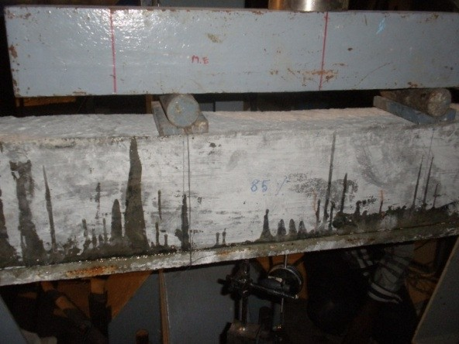

**Features of MESH reinforcement**

Table 1 lists the main types of wire meshes used in ferrocement laminates and their qualities. One layer of woven mesh and one layer of weld mesh are used in mesh reinforcement arrangements with a volume fraction of 2.192 percent. Two layers of woven mesh and two layers of weld mesh are produced by arrangements of mesh reinforcements with volume fraction (Vr = 4.384 percent) of mesh reinforcements. Three layers of woven mesh and three layers of weld mesh are contributed by arrangements of mesh reinforcements with volume percentage (Vr = 6.576 percent). In order to ensure the volume fraction Vr = 2.192 percent, one layer of woven layer and one layer of weld mesh were connected together to serve as one layer of ferrocement reinforcement. Table 2 provides information on the applied ultimate beam load as well as strengthening information.

Table1. Properties of reinforcing mesh

|  |  |  |  |  |
| --- | --- | --- | --- | --- |
| Type | Shape | Gauge | Wire spacing in mm | Wire diameter in mm |
| Steel mesh | Square weld | 20 | 6.52 | 0.92 |
| Hexagonal  weld | 24 | 11.24 | 0.75 |
|  |  |  |  |  |

Fig 1. Beam strengthened on loading frame

|  |  |  |
| --- | --- | --- |
| Beam | % of Pu | No. of layers |
| B1 | 65% Pu | 2 |
| B2 | 65% Pu | 3 |
| B3 | 75% Pu | 2 |
| B4 | 75% Pu | 3 |
| B5 | 85% Pu | 2 |
| B6 | 85% Pu | 3 |

Table2. Ultimate Load of Beams applied and strengthening details

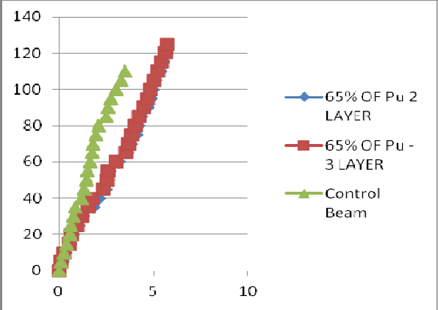

Graph 1 Comparsion of stregthened beam 2 layer & 3 layer (65%Pu)

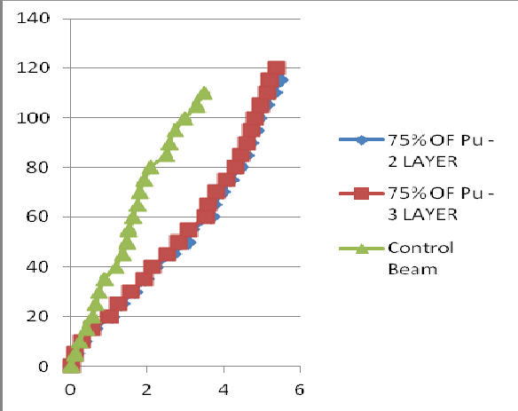

**Graph 2 Comparison of strengthened beam 2 layer & 3 layer (75%Pu)**

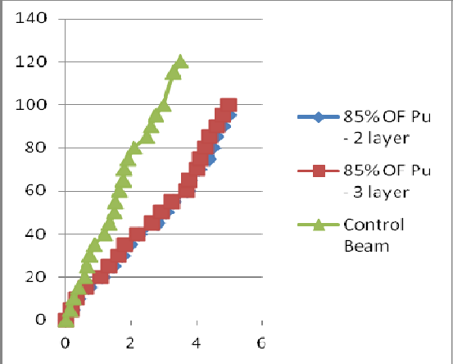

Graph 3 Comparison of strengthened beam 2 layer & 3 layer (85%Pu)

1. **Conclusion And Discussion**

The proportional demonstration of all eight beams, which are grouped in series and distressed to varying degrees (65, 75, and 85 percent pu), is shown graphically in Graphs 1, 2, and 3. These beams were then repaired using ferrocement laminates with two different volume fractions of ferrocement reinforcement. The ultimate load of control beams is 110 KN and the corresponding 65%, 75% and 85% of stress level are 71KN, 82KN, 93KN respectively. Then the rehabilitation of the beams is done with ferrocement laminate of two layers and three layers of meshes for each loading condition. Afterwards these rehabilitated beams were then loaded to failure and data was recorded in the form of load and deflection. The ultimate load of after strengthening of different stress of beams are 65%, 75%, 85% in two layer mesh of laminate are 124KN, 123KN,and 95KN, and three layer of laminate are 127KN,125KN and 102KN. The results indicate that the beams rehabilitated with three layer laminate at 65%Pu beam is best among all other specimen. Compared to control beams 65%Pu rehabilitated beams with two and three layer meshes carries 11.3% and 11.5% more , 75%Pu rehabilitated beams with two and three layer meshes carries 11.1% and 11.3% more 85%Pu rehabilitated beams with two and three layer meshes carries 10.4% and 10.7% high.

1. **Conclusion**

The submission of ferrocement deposit has specified enough captivity for the reinforced concrete beams. Hence for the duration of testing of beams, splitting of concrete did not occur for the beams transformed by plate bonding. The calculation of ferrocement laminate in predamaged beams increases the inflexibility of the beam and hence increases in load carrying capacity and drop in deflection. in addition the bonding of ferrocement laminate by plate bonding performance has less labour connection and is cheaper compared to other methods of increase the distressed beams accessible.

1. **Reference**
2. Almusalam, T.H., and Alsayed, S.H., “structural Behaviour of Reinforced concrete Beams strengthened by Bonded steel or GFRP laminates”, proceedings of the first international conference on composites in infrastructures, Tucson, Arizona, 786-799.Saadatmanesh,H. and Eshani, MR., “RC Beams strengthened with GFRP laminates: I experimental study”, Journal of structural engineering, Vol.117, No.11, 3417-3433
3. ACI., 2008. “Guide for the design and construction of externally bonded FRP systems for strengthening concrete structures.” American concrete institute, Farmington Hills, Mich. AIJ., 1997. Design guidelines for earthquake-resistant R.C buildings based on inelastic displacement concept, architectural institute of Japan, Tokyo.
4. Antonopoulos, C.P. and Triantafillou, T.C., 2002. Analysis of FRP-strengthened Beam-column joints.Journal of composites for construction, ASCE, 6(1), 41-51
5. Antonopoulos, C.P. and Triantafillou, T.C., 2003. “Experimental investigation of FRP-strengthened RC beam column joints.” Journal of composites for construction, ASCE,7(1): 39-49
6. Akguzel, U., Pampanin, S., 2007. Experimental behavior of exterior Beam-column joint subassemblies retrofitted using GFRP composites. NZSEE conference. Palmerston, New Zealand. Paper no:15
7. Achyutha.H,M.S.SrinivasaRao.P(1988)Assessment of Impact Resistance ofFerrocement Slabs,Proce of the Third International Symposium on Ferrocemnet,University of Roorkee,December, 359-361
8. ACI Committee 549R (1997) State of the Art report on Ferrocement, Manual ofconcrete practice, ACI, Farmingt on Hills, Michigan ACI 549R-97
9. Alwis.W.A.M,Paramasivam.P (2001) Impact Response of Ferrocement, Proc Seventh International Symposium on Ferrocement and Thin Reinforced Cement Composites, National University of Singapore, 113-120
10. ACI structural journal, 98(3):347-358. Grace N.F., Abdel- sayed G., Soliman A.K. and saleh K.R. (1999), strengthening RC Beams using FRP laminates, ACI structural Journal, 96(5): 865-874.
11. Alagusundaramoorthy, P., Harik, I.E., and choo, C.C., “flexural behavior of R/C Beams strengthened with carbon fiber-reinforced polymer laminates and steel”, Journal of composites for construction, Vol.7, No.4, pp.292-301.
12. Duthinh, D., and starnes, M., “strength and ductility of concrete Beams reinforced with carbon fiber reinforced polymer sheets or fabric”, journal of composites for construction, Vol.8, No.1, pp.59-69
13. IS 516:1959 Methods Of Test For Strength Of Concrete
14. IS383:1970 Specifications For Coarse And Fine Aggregates From Natural Sources For Concrete
15. IS2386:1963 Methods Of Test For Aggregates for Concrete
16. IS12269:1987 Specification For 53 Grade Ordinary Portland Cement.