**Wireless Service Station for Hotel Application**

**Apurva Sali1, Sakshi Udawant2, Nilesh Deore3**

1Student, Department of Electronics and Telecommunication Engineering, NDMVP College of Engineering, Nashik, Maharashtra, India

2 Student, Department of Electronics and Telecommunication Engineering, NDMVP College of Engineering, Nashik, Maharashtra, India

3Student, Department of Electronics and Telecommunication Engineering, NDMVP College of Engineering, Nashik, Maharashtra, India

**ABSTRACT**

The Hotel Industry is a great ever-growing industry. The Hotels provide different services and facilities to the customer, the customer satisfaction and review of hotel depends on this. This project work aims at solving the problems face by the customer in the hotels regarding the services. The system is a wireless system which works on 5V power supply. The communication between the guest room and the reception takes place through RF receiver and transmitter which operate at 433MHz frequency. Once the signal is been send from the transmitter side (by the guest), the led on the room door of the guest room will glow. Led will continue to grow till the reception doesn’t acknowledge about it. Further, when the required service is provided to the guest, the service provider will press the button and the respective led will be off.

**Keywords:** wireless, guest, RF, receiver, transmitter, reception.

**1. INTRODUCTION**

The Hotel industry is a big industry with vast economy. The hotels demand and review increases based on the customer satisfaction. One part of this, is providing quick and reliable service to the customer. Here, the normal method of communication between the reception and guest occurs via phone. To make it more flexible and time consuming, using wireless communication. The wireless device helps in fast communication and reducing the time required. Engaging the customer time happens in the phone method, but it reduces this problem via the wireless device. It also tracks the room number and what type of service they need. This is a user-friendly, fast and easy to use device.

**2.** **METHODOLOGY**

**2.1 Observation**

The Project “Wireless Service Station for Hotel Application” deals with the hotel industry management. The day-by-day increase in the hotel industry is making a great contribution to the Indian economy. For this project we used various forms to collect the data. The primary most purpose for the data collection is observation, we come to know about this problem when we personally visit the hotels for a stay. This was a sudden for the idea to pop-up. Many big hotels in fact today also, make the service via phone.

**2.2 Interviews**

After a keen observation, we started conducting interviews with the respective hotels. From this also we learned a lot. Like to name a few hotels which help us with our project, such as “Hotel Panchavati”, “Hotel City Pride”. Also, changing technology in the hotels will be well-known to the teachers of the Hotel Management College. Hence, by having face-to-face visit and meet with them hep us in knowing more about this. One more important part related to our project is, the hotel industry depends on the customer review, so we interviewed some of the customers who basically take a stay in hotels.

**2.3 Internet**

The project “Wireless Service Station for Hotel Application”, the name itself says, the hotel with a station. Here, station can be recognized as a specific area, which provides service making use of wireless technology. The information related to this was moreover taken from internet. As the internet is a vast source of information. The data collected from the local hotels of the city, which uses the specific technology needs is a real-time source of information. Whereas for more deep study into this, we collected the information form the internet, for the national hotels of other big cities.

**2.4 Literature Surveys**

As the data related to this topic was also collected from the various literature surveys. But to a limited extent, like the basic technology use and management of hotels.The names of the few literature surveys used by us for the information collection are mentioned in the reference section.

**3. MODELING AND ANALYSIS**

In this section we have represented the block diagram, according to which the procedure takes place.

Power Supply

Room 1

Room 3

Room 2

LED Display Room Array

8051

Microco-ntroller

Encoder

RF Receiver

Decoder

LCD Display

RF

Transmitter

Buzzer

**Figure 1:** Block Diagram

Also, with that we have shown the circuit diagram of the project.

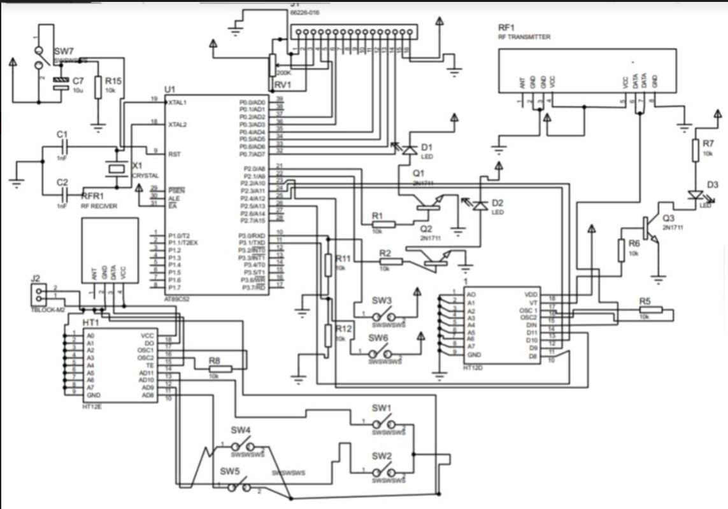

**Figure 2:** Circuit Diagram

**4. RESULTS AND DISCUSSION**

The results of the glowing of the led from an array of led’s at the receiving end is shown after pressing the button.

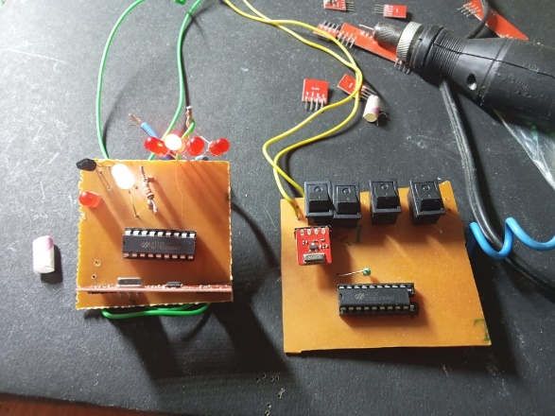

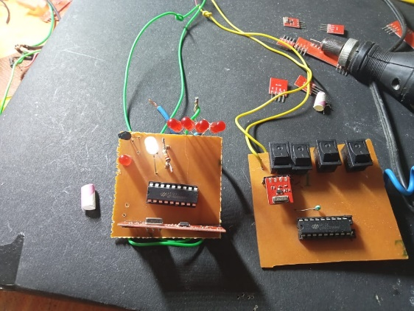

**Figure 3:** results of the work

**5. CONCLUSION**

This system is efficient, good, reliable in providing service to the customers. Increasing trends towards a smarter world, this system helps in meeting with real time customer feedback due to the wireless service station. This will help in increase of the reputation of the hotel and profit for the business.

**6. ACKNOWLEDGEMENTS**

The paper publishing and in the project work, a lot people help me. This paper would not have possible without the help of my guide. I want to give my sincere thanks to my guide Ms. D. V. Patil Ma’am for guiding and supporting us throughout the work.

And last thanks to my friends who help me with the paper.

**7. REFERENCES**

[1] Ogirima S.A.O., “Online Computerized Hotel Management System,” for “Journal of Computations in Biosciences and

Engineering”, Volume 1/Issue 2, April 2014, ISSN: 2348-7321.

[2] Mounika Nandiraju, Salluri Rachana Shaik Chandani, Sandhu Srilatha, G.Sabitha, Seema Nazneen, “Hotel Management

System”, for “International Research Journal of Modernization in Engineering Technology and Science”, Volume 2, Issue

3, March 2020, ISSN: 2582-5208.

[3] Yu Wang, “Research on the influence of the service quality of Hotel Intelligent System on Customer Satisfaction based on

Artificial Intelligence evaluation”, Volume 2022, Article ID: 3832935, 29 March 2022.

[4] Jingda Yang, “Research and Development of Hotel Management System Model”, for “International Conference on

Education Technology and Information System”, (ICETIS 2013).

[5] Joleen Bizi Muzbiri, “Customer Satisfaction In The Hotel Services”, for “School of Service and Business Management”,

Degree Program in Facility Management, May 2016.