**Image Fusion Watermarking schema based on Saliency Detection**

Karri Kusala  
*CSE,Aditya Engineering College,Surampalem*19A91A05F6 & 2023  
19A91A05F6@aec.edu.in

Parasa Sai Niharika  
*CSE,Aditya Engineering College,Surampalem*19A91A05H3 & 2023  
19A91A05H3@aec.edu.in

Dr. S PrasanthVaidya  
*CSE,Aditya Engineering College,Surampalem*Associate Professor  
 Vaddi Pushpa  
*CSE,Aditya Engineering College,Surampalem*19A91A05J2 & 2023  
19A91A05J2@aec.edu.in

*Abstract--- When extra or useful information from the source pictures is merged or incorporated into the fused image, this phenomenon* *is referred to as picture fusion. Many applications use image fusion, including machine vision, digital photos, medical imaging, navigation, and the military. Any one of the three levels—symbolic, objective, or pixel—can be used for the fusing procedure. The military, tracking, and hidden weapon detection all need a variety of imaging modes,* *using all available light, visible and infrared, to view a certain scene. These methods offer more information. Complementary information from these photos has to be combined into one image for improved situational awareness. Data from various sources are combined during the picture fusion procedure to produce a composite image. We propose a novel method for watermarking combined pictures using saliency recognition and two-scale image decomposition. It is advised to employ a novel visual saliency-based weight map building technique. Using this method, the aesthetically crucial data from the source photographs can be incorporated into the fused picture. The suggested method simply uses two-scale picture decomposition and a watermark for verification, in contrast to the majority of multi-scale image fusing techniques.*

*Key Words: Image fusing, security, two-scale image reconstruction, watermarking, two-scale image deconstruction, identification, watermark embedding, and visual saliency*

1. INTRODUCTION

When extra or useful information from the source pictures is combined with or merged into the merged picture, this occurrence is mentioned as "image fusion." Image fusion is used in various areas, including machine vision, digital photos, medical imaging, navigation, and the military. Any one of the three levels—symbolic, objective, or pixel—can be used for the fusing procedure.

i. At the pixel level, co-registered source images are combined pixel for pixel.

ii. The property descriptors, features, and object labels produced from each source image are used for the fusion in objective level image fusion.

iii) A high level of fusing is the fusion of symbolic-level images. Local decision-makers in this case are chosen based on the outcomes of the objective level fusion.

A capture of a single sensor picture might often not accurately catch the intended scene. For greater visual comprehension, we may require two or more photos of the same scenario. Depending on the application, these images may be taken with a sensor of the same modality or with a mix of sensors of other modalities .These screens grabs offer additional information or compelling visuals. It is impossible to dependably merge the numerous picture captures into a single composite image that a human viewer can trust to see. The information from these photos that is useful or complementary should be combined into one image to provide a representation of the scene that is more accurate than any of the source photos alone.

**2. RELATED WORK**

The original development of fusing methods based on pyramid decomposition occurred in the 1990s. Using techniques like down sampling and blurring, these methods' fundamental premise is to first split each original picture into a number of following sub images. Apply fusion criteria to these different sub images in the second step, and then use these merged sub images to recreate the fused picture. The margins of these techniques might exhibit fringe effects. Later, it was discovered that wavelets, as opposed to pyramids, offer a suitable depiction of time and frequency. Consequently, discrete wavelet transform (DWT)-based merging was effective. Due to the shift variation of DWT, the merged picture might contain artefacts. Transform with shift-invariant wavelet (SIDWT) based fusing approach was created to address the issue brought on by DWT.

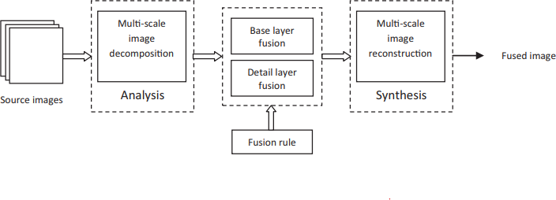This approach may result in artefacts in the fused image.

In order to achieve outstanding outcomes, the majority of multi-scale decomposition (MSD) fusion techniques call for more decomposition layers. These techniques necessitate laborious calculations. As a consequence, they require more memory and computing time. Techniques built on wavelets and pyramids may result in edge distortions. On the basis of saliency detection and two-scale picture decomposition, we propose a novel image fusion method, which incorporates an invisible watermark and embeds it to create an image fusion watermark, allowing us to easily identify the source of the image and even share it with others. The intricacy of multi-scale fusion methods is reduced while addressing the aforementioned issues.

Disadvantages

● Weak capacity for authentication

● decreased security

● high computational complexity

● high cost of calculation

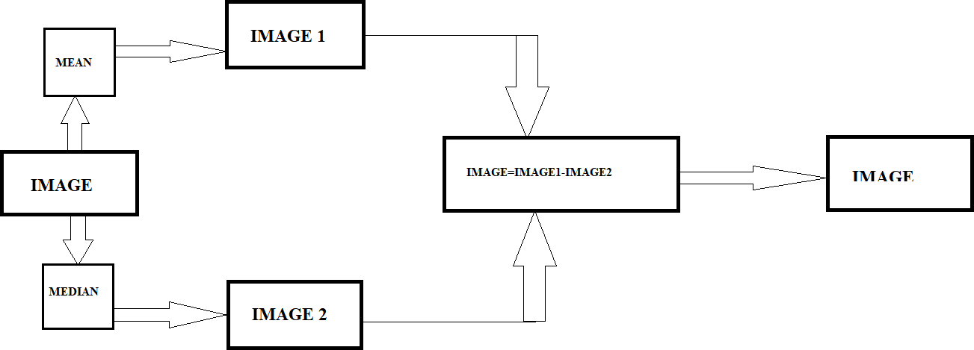● need for greater memory and processing time

**3. PROPOSED METHOD**

The novel method for image fusion, It is based on two-scale picture decomposition and saliency recognition, embeds the invisible stamp in the image fusion watermark. In this manner, even if the picture is shared with others, we can quickly locate the image's creator and find the perpetrator.

The four steps needed by the proposed method Image breakdown or picture analysis, watermark embedding, fusion, and image rebuilding or image synthesis are all ways to perform fusion. An average or mean filter is used during decomposition to produce basic and specific levels. These deconstructed base and detail levels are then combined utilizing a number of fusion factors. A label has been added to the picture. The rebuilt fusion picture's basis is made up of the final basic and detail layers.

**Image Fusion:**

When images are fused, additional or helpful information from the source images is combined or incorporated into the fused image .Reconstructing the combined image using the complimentary information provided by the numerous photographs using a fusion approach, it seeks to derive significant features from images of multi-modal sources. There are many uses for image merging, including defogging, security monitoring, and medical imaging.

**Two-Scale Image Decomposition:**

A picture can be divided into two layers using the two-scale decomposition technique: a rough approximation of the image and a detail layer that includes the high-frequency information. Two-scale decomposition refers to the method of decomposing in two stages. When creating a fused picture by merging the coarse estimate and detail layers from numerous photos, the two-scale decomposition can be used as a preprocessing phase.

**Visual Saliency Detection:**

Visual saliency detection is the process of identifying areas, such as people, objects, or pixels, that are more important than their surroundings .These salient regions in the scene draw more eye focus than other regions in comparison to other areas of the setting.

**Two-Scale picture Reconstruction:**

By combining the end basic and detail layers linearly, the fused picture is recreated.

**Watermark Embedding:**

The method of creating a watermark image utilizing a water marking algorithm and key. At every stage of dissemination, a digital signal incorporates a watermark. The watermark can be removed from a copy of the work if one is later found. revealing where it was distributed from.

Advantages

• Trustworthiness

• Copy right ownership

• High security

• Computationally efficient

• Intellectual protection

• Capability to successfully extract salient information from complimentary source photos.

**4. IMPLEMENTATION**

Think about two identical-sized original pictures. These source images are split up into detail layers with tiny variants and base layers with large scale variations. The proposed method calls for fusion is accomplished in four steps: image deconstruction or image evaluation, fusing, watermark embedding, and image reconstruction. An average filter is used for breakdown in order to produce basic and layers of detail. Several fusing criteria are used to combine these deconstructed base and detail layers. The finished basic and detail layers are used to recreate the fused image. The desired scene might not always be captured precisely by a single sensor picture capture. For greater visual comprehension, we may require two or more photos of the same scenario. Depending on the application, these images may be taken with a sensor of the same modality or a number of sensors of different models. These screenshots offer additional or replacement graphic information. A selected scene is monitored using various imagery systems like visible (VI) and infrared (IR) in applications like military, navigation, and hidden weapon detection. Due to the poor visual contrast in these apps, it is very difficult to discern target details from a VI picture alone. However, they are simple to locate in IR images. The VI picture can show background information like foliage, texture, area, and dirt. Image fusing is the process of combining information from different sources to produce an integrated image. Due to how well the image saliency extraction procedure described here can emphasize the saliency information of source images, this approach has some advantages. The visually important information from the original pictures can be integrated into the fused image using this method. Only two-scale picture segmentation is used in this method. This approach is examined on a number of image pairs, both subjectively and numerically, using objective fusion measures.

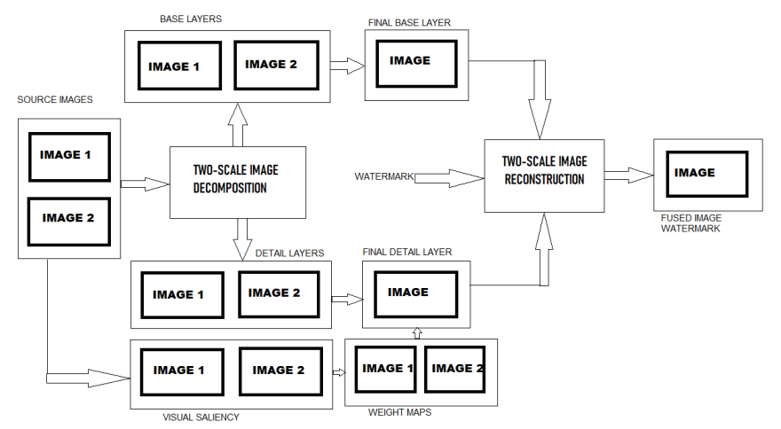

Fig. 1. Diagram of the suggested method's architecture

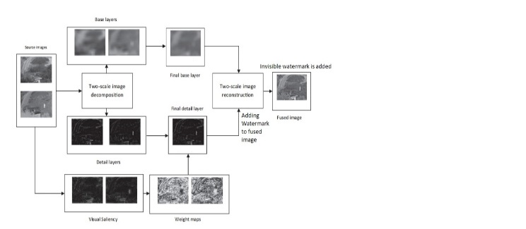

Fig. 2 . Flowchart of the suggested technique

**5. RESULTS AND DISCUSSIONS**

All the 5 examples of [a],[b] images undergo two scale image decomposition process.

The first image [a] of all the examples are known as visible images. These Visible images are consistent with the human eye’s visual characteristics and contain many edge features and detailed information. And the second image [b] of all examples are known as infrared images .infrared images are can’t be seen with naked eye.Here the most fundamental purpose of both visible and infrared images is to produce a new image which has higher reliability and understandability for human or computer vision

The 5 images are the final outcomes of all the considered examples .These images are embedded with an invisible watermark. The invisible watermark can be text and image .These invisible watermarks are embedded within the final fused image .The obtained fused images consists of the information that is present in the individual images .The result images has higher information when compared to the input images.

Text watermarks of the above five examples are

1.[d] report 1

2.[d] sky

3.[d] girl

4.[d] batch 14

5.[d] project

Image watermarks of above examples

Both text and image watermarks are invisible

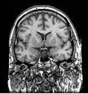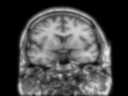

**1.[a] 1.[b] 1.[c] 1.[d] 1.[e]**



**2.[a] 2.[b] 2.[c] 2.[d] 2.[e]**



**3.[a] 3.[b] 3.[c] 3.[d] 3.[e]**



**4.[a] 4.[b] 4.[c] 4.[d] 4.[e]**

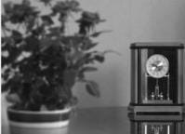

**5.[a] 5.[b] 5.[c] 5.[d] 5.[e]**

**    **

**1.[f] 2.[f] 3.[f] 4.[f] 5.[f]**

**PSNR :**

The PSNR block computes the peak signal-to-noise ratio, in decibels, between two images. This ratio is used as a quality measurement between the original and a compressed image. The higher the PSNR, the better the quality of the compressed, or reconstructed image.

The Formula for PSNR is :

PSNR=20 log10(MAX/(MSE)^(1/2))

|  |  |
| --- | --- |
| **IMAGES** | **PSNR** |
| Skull 1[c] | 27.82 dB |
| Skull 1[d] | 28.91 dB |
| Parachute 2[c] | 27.72 dB |
| Parachute 2[d] | 28.37dB |
| Lisa 3[c] | 27.89dB |
| Lisa 3[d] | 28.91dB |
| Bottle 4[c] | 27.32dB |
| Bottle 4[d] | 28.95dB |
| Plant 5[c] | 27.72 dB |
| Plant 5[d] | 28. 37 dB |

**6. CONCLUSION**

In conclusion, watermarking is a potent method that can be applied to preserve the ownership rights to digital content. It is suggested to use innovative picture fusion method based on two-scale image decomposition and visual saliency. Since the suggested method just employs a straightforward average filter for picture decomposition, it is simple to implement. At the first level of decomposition itself, our approach is yielding acceptable results, unlike the vast majority of multi-scale fusing methods. Therefore, it is efficient in terms of calculation. A simple and effective A method of extracting visual saliency is suggested, along with using a mean-and-median filter. The recommended weight diagram creation technique successfully locates the supplemental data of the original images. The suggested approach is compared to modern methods for multi-scale fusion using several fusion metrics. Results indicate that the efficacy of the suggested strategy outperforms or is on par with the existing methods. Additionally, the calculation period is very lengthy.

Since the suggested method just employs a straightforward average filter for picture decomposition, it is simple to implement. At the first level of decomposition itself, our method is producing good results, as opposed to the numerous methods for multi-scale fusion. It is therefore computationally effective. A mean and median filter is suggested as part of a straightforward and effective visual saliency extraction technique. The suggested weight map creation method efficiently recognizes the supplementary information of the source photos. Various fusion metrics are used to compare the proposed strategy to cutting-edge multi-scale fusion techniques. Findings indicate that the suggested strategy performs as well as or even better than the existing methods. For real-time implementation, it also takes much less time to compute. Recently, digital watermarking techniques have been used to safeguard the authenticity, ownership, and integrity of digital multimedia files like images, audio, and videos. However, watermarks are frequently incorporated into the focal points of the host photographs, distorting the quality of the watermarked images. The encoded watermark could be removed by the authorized user, who could then recreate a high-quality, unmarked image. Any fusion algorithm's effectiveness cannot be determined solely by its visual quality. Both qualitative and quantitative evaluations should be included. For real-time implementation, image fusion methods are recommended because they have shorter calculation times, greater visual quality, and higher fusion metric values. The project's findings show that watermarking can effectively safeguard digital assets from copyright infringement. By locating and tracking unauthorized copies of the original media, the installed system can assist in defending the owner's rights.

**7. FUTURE SCOPE**

Recently, digital watermarking techniques have been used to safeguard the authenticity, ownership, and integrity of digital multimedia files like images, audio, and videos. However, watermarks are frequently incorporated into the focal points of the host photographs, distorting the quality of the watermarked images. The encoded watermark could be removed by the authorized user, who could then recreate a high-quality, unmarked image. Any fusion algorithm's effectiveness cannot be determined solely by its visual quality. Both qualitative and quantitative evaluations should be included. For real-time implementation, image fusion methods are recommended because they have shorter calculation times, increased fusion metric values and improved picture quality.

##### **References**

[1] A. Ardeshir Goshtasby, Stavri Nikolov Image fusion: advances in the state of the art, Inform. Fusion 8 (2) (2007) 114–118.

[2] Zhong Zhang, Rick S. Blum A categorization of multiscale-decompositionbased image fusion schemes with a performance study for a digital camera application, Proc. IEEE 87 (8) (1999) 1315–1326.

[3] Shutao Li, Xudong Kang Fast multi-exposure image fusion with median filter and recursive filter, IEEE Trans. Consum. Electr. 58 (2) (2012) 626–632.

[4] Guihong Qu, Dali Zhang, Pingfan Yan Medical image fusion by wavelet transform modulus maxima, Opt. Exp. 9 (4) (2001) 184–190.

[5] Jufeng Zhao et al Fusion of visible and infrared images using saliency analysis and detail preserving based image decomposition, Infrared Phys. Technol. 56 (2013) 93–99.

[6] B.K. Shreyamsha Kumar Image fusion based on pixel significance using cross bilateral filter, Signal Image Video Process. (2013) 1–12.

[7] Tania StathakiImage Fusion: Algorithms and Applications, Academic Press, 2011. [8] Jagdishkumar Keshoram Aggarwal (Ed.), Multisensor Fusion for Computer