NAVIGATING OBJECTS AND FINDING DISTANCE FOR SELF DRIVING CARS

|  |  |  |
| --- | --- | --- |
| Gopu.Kathyayani, | *Chatla.Prasada Rao* | Chatla.Prasada Rao, |
| K.Priscilla Grace, | *Assistant Professor, Department of* | *Research Mentor,* |
| V.Sumanth. | *CSE, Aditya Engineering College* |  |
| U.G Student,Department of CSE | *Surampalem, A.P; India* |  |
| Aditya Engineering College |  |  |
| Surampalem, A.P; India |  |  |

[19a91a0514@aec.edu.in](mailto:19a91a0514@aec.edu.in) [19a91a0525@aec.edu.in](mailto:19a91a0525@aec.edu.in)[19a91a0563@aec.edu.in](mailto:19a91a0563@aec.edu.in)

***ABSTRACT***— The road lane markings serves as a continual reference for vehicle navigation, and during driving operations, humans employ their optical vision for vehicle maneuvering. The creation of an algorithm-based automatic lane detection system is among the requirements for a self-driving car. With the aid of computer vision technology, automobiles may be able to comprehend their environment. It is a subfield of AI that enables software to comprehend the information of images and videos. Thanks to developments in deep learning, modern computer vision has advanced significantly. Which enables it to recognize different objects in images by examining and comparing millions of examples and cleaning the visual patterns that define each object.

***Keywords***— Flask, Open-CV

1. **INTRODUCTION**

Thanks to developments in deep learning, modern computer vision has advanced significantly. and displaying distance between the object and camera. Self-driving cars reduce human error and can accomplish various missions to help people in different fields. They have become one of the main interests in automotive research and development, both in the industry and academia. However, many challenges are encountered in dealing with distance measurement and cost, both in equipment and technique. The use of depth information to measure the distance of an object is convenient and popular for obstacle avoidance and navigation of autonomous vehicles. The calculation of distance considers angular distance, distance between cameras, and the pixel of the image.

This study proposes a method that measures object distance based on depth information, that is, facing the self-driving car using image processing, low cost, and computational speed. It can be implemented in real time computing systems and can determine the safe driving distance between obstacles.

1. **PROPOSED SYSTEM**

This project focuses on object detection and inter-vehicle distance measuring, which are both crucial and difficult tasks in the field of image processing.

There are two possibilities when there are several things in an image.

Object detection and localization

Object segmentation

Combining the two tasks mentioned above into one network is another method of performing object detection and to lessen this laborious job. Here, the model is provided a collection of pre-defined boxes to seek for items rather than suggesting regions for each image. So some pre-defined rectangular rectangles that represent specific items are provided to the neural network before it enters the training phase. As a result, when the fully connected layer of the network has processed an image, the trained model attempts to tie together items on the image using specified boxes utilizing non-maxima suppression approach. The model tries to draw the bounding box across the object if the comparison exceeds a certain threshold. Single Shot Detection is the approach that YOLO employs. . The name "You Only Look Once" refers to the fact that it predicts classes and bounding boxes using a single activation map at a time.

It's not always a good idea to add extra hardware modules to your gadget to make it heavier. You can choose a more practical and convenient course of action to avoid such situations. You can use the depth information because you've already incorporated a camera for object detection

that camera employs to construct the bounding boxes for localizing things in order to figure out how far away that object is. Therefore, we suggest an Object detection and inter vehicle distance measuring system that identifies objects in real time and calculates their distance from the camera.

**Advantages**

* This system can use a camera to simultaneously detect objects and calculate distance without the need for any additional gear.
* It is more convenient and feasible approach.
* Combines two tasks into one network.

1. **ARCHITECTURE**

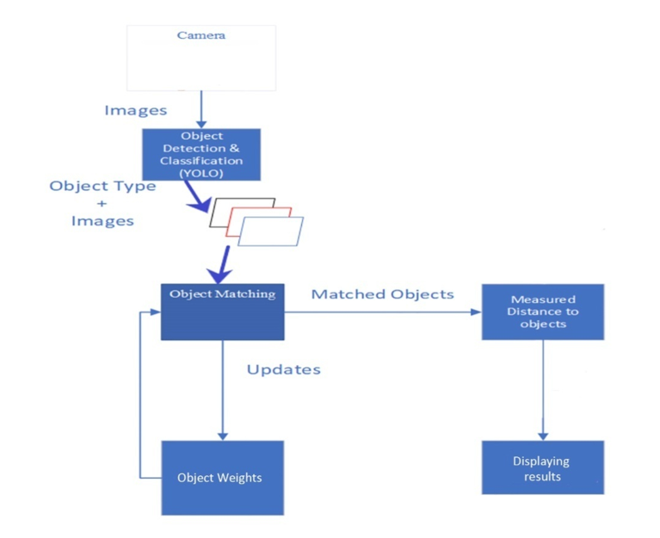 Fig.1 Architecture

**Hardware Requirements**

* Intel I5 Processor
* 64 bit Architecture System
* RAM: 8 GB
* Graphics Card: 2GB
* Disk: 512GB
* High Resolution Cameras

**Software Requirements**

* Operating system: - Windows 10
* Language: - Python
* Libraries:OpenCV,python,numpy,
* pandas,torch_nightly,matplotlib,
* Pillow,torch
* Flask
* HTML & CSS

1. **MODULES**

A module is a distinct piece of hardware or software. Portability-which enables them to be utilized in a range of systems and Interoperability-which enables them to work with the components of other systems are typical qualities of modular components. Architecture is where the phrase initially appeared. A module is a relatively small unit within a larger device or arrangement that is intended to be installed, repaired, or serviced individually in computer hardware and electronics. One type of random-access memory (RAM) that can be added to a personal computer is a single in-line memory module. A thorough foundation in the application and implementation of machine learning techniques will be provided by the programmer. The module will concentrate on classification, regression, and clustering methods, as well as supervised and unsupervised learning algorithms. Code and data are combined in modules in machine learning. A structure is the name for the fundamental module construct.

The modules are as follows:

* System
* User

**System Module:**

• Object counting

• Object detection

• Object verification

• Training

1. **Object counting:** In this module the user will connect camera to the computer and states the program to work then the code will open an web browser were the camera will be opened and starts the process.
2. **Object detection:** In this module the camera will capture the objects appearing on the frame and starts analyzing how much distance it is there between object and computer and gives boundary boxes to the object and starts the calculation.
3. **Object Verification:** In this module the system will identify the object after the object is detected. It will use YOLO algorithm the yolo algorithm provides the object's classification, confidence level, and bounding box, and Each object that is recognized has a bounding box that identifies it in the image. Finding the distance of the objects from the camera is made easier with the use of this information.
4. **Training :** In this module the system will train itself when a user gives data set for identification. First we need to create the folder with the name of the user and we should insert the pic of the user in that folder.

And each folder should have the names of the objects. After creating the folder we should close the system for training itself. When the system starts counting or detecting a object it will show the object name what we create the folder name.

**User Module:**

* **Capture image**
* **View Distance**

1. **Capture Image:** The user has to upload an image which needs to be classified.
2. **View Distance: The** classified image results are viewed by user.
3. **ALGORITHM**

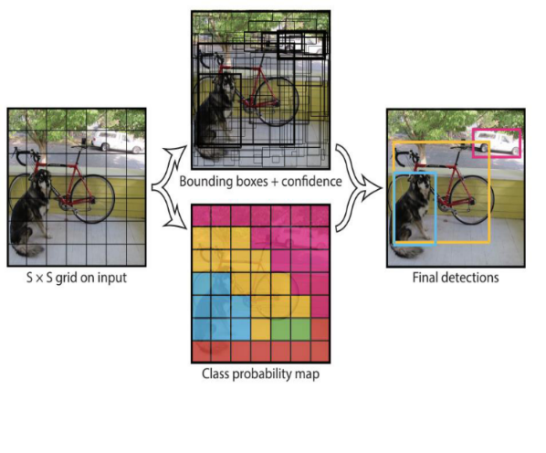**YOLO:** takes an image and divides it into a SxS grid. It forecasts bounding boxes, confidence in those boxes, and class likelihood for every grid cell. Where the bounding boxes have a class probability higher than a threshold value, objects are present in the image. Every object that is discovered is classified by YOLO, along with the object's bounding box and confidence level.

Fig2: Illustration of Yolo

The YOLO algorithm's basic operation is shown in the above figure. Each object that is recognized has a bounding box that identifies it in the image. Finding the distance of the objects from the camera is made easier with the use of this information.

1. **SYSTEM DESIGN**

**Data Flow Diagram:**

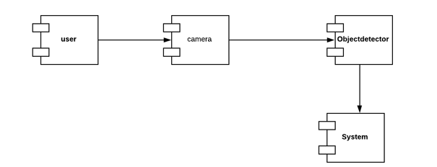

Fig.3 Data Flow Diagram

**System Design Module:**

* User
* Camera
* Object detector
* System

1. **User:** In this module the user will connect camera to the computer and states the program to work then the code will open an web browser were the camera will be opened and starts the process.
2. **Camera:** In this module the camera will capture the objects appearing on the frame and starts analyzing how much distance it is there between object and computer and gives boundary boxes to the object and starts the calculation.
3. **Object Detection:** After the object is recognized in this module, the system will identify the object. It will employ the YOLO algorithm, which categorizes the object and provides its bounding box and confidence level. Each object that is recognized has a bounding box that identifies it in the image. Finding the distance of the objects from the camera is made easier with the use of this information.
4. **System:** In this module the system will train itself when a user gives data set for identification. First we need to create the folder with the name of the user and we should insert the pic of the user in that folder. And each folder should have the names of the objects. After creating the folder we should close the system for training itself. When the system starts counting or detecting a object it will show the object name what we create the folder name.

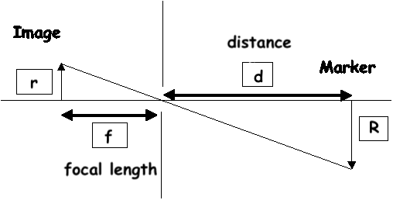 **How the distance measurement works?**

Fig.4 Principal of Method

The object and the picture produced by the pinhole (monocular) camera are identical. This idea allows us to infer a link between the unknown parameter, the distance from the camera to the object (d), and the known parameters, the focal length (f), the radius of the marker in the image plane (r), and the radios of the marker in the object plane (R).

Using the principle of Similar Triangles, we can obtain the formulas as follows:

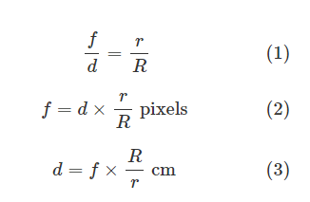

**Measurement to determine focal length:**

After shooting 10 to 20 photographs of a checkerboard pattern with your camera, as shown above, OpenCV may be used to estimate the focal length. The result will be intrinsic parameters, such as the focal length and optical center, as well as extrinsic factors, such as the camera's rotation and translation vectors.

However, we'll utilize the following example instead:

* Print a blue circle with a 1 cm radius on paper, and then adhere it to a stiff item, such as a cardboard box.
* We utilize a colour circle to simplify marker segmentation; when a black marker is used, there is a lot of noise.
* Set a specific distance between the cameras and object (d).
* The circle's radius (R) is known to be 1 cm.

After segmenting the circle and determining its radius, the radius of the marker in the picture plane (r) can be found.

* To obtain the focal length (f) in pixels, add these parameters to equation (2).

If we see there are three variable named:

* do (Distance of object from the lens)
* di (Distance of the refracted image from the convex lens)
* f (focal length or focal distance.

1. **OBJECT DETECTION**

Object Detection is the process of finding real-world object instances like car, bike, TV, flowers, and humans in still images or Videos. It allows for the recognition, localization, and detection of multiple objects within an image which provides us with a much better understanding of an image as a whole. It is commonly used in applications such as image retrieval, security, surveillance, and advanced driver assistance systems (ADAS).

This technique employs datasets that give the camera information to do object detection. The information is used to detect, classify, and measure the distance between objects. Typically, feature-based modelling and appearance-based modelling are combined to achieve object detection. Compared to a laser scan, the image has more information that may be utilized to identify objects and enables for modelling based on both features and appearance.

1. 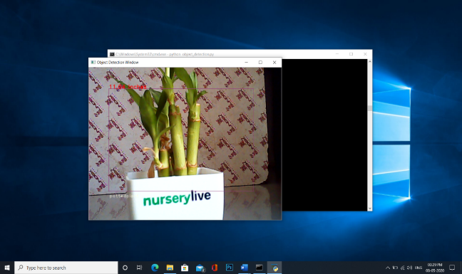**Result**

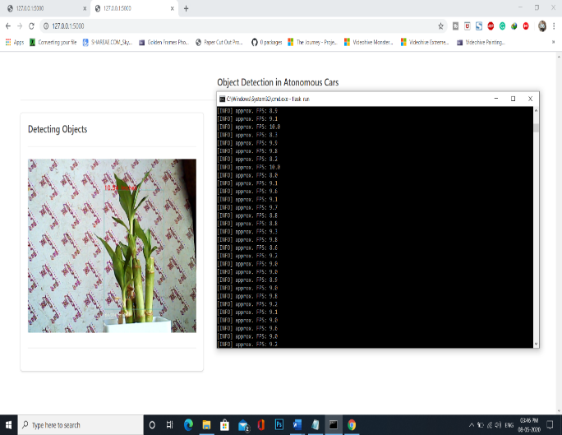 Fig 5.1 Output of object detection.py file

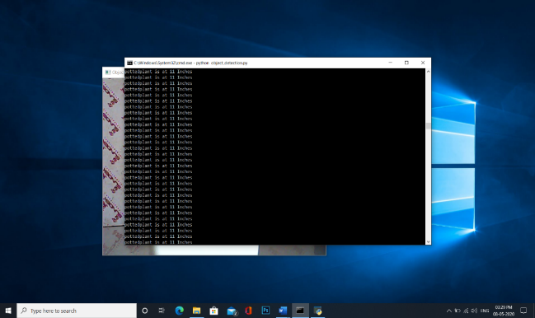 Fig 5.2 showing output in command prompt

Fig 5.3 Showing results in both user interface and in command prompt

1. **CONCLUSION**

The proposed system will detect the object near the camera and finds the distance between the camera and the object. Traditionally, we determine the distance travelled by any object using ultrasonic sensors like the HC-sr04 or other high frequency devices that produce sound

As you have already integrated a camera for object recognition, you can determine an object's distance from the camera by using the depth information the camera uses to create the bounding boxes for localizing objects. The "You Only Look Once" name for the proposed system comes from the yolo v3 detection technique, which uses a single activation map to forecast classes and bounding boxes at a time. Yolo-v3's pre-trained version, which can recognize 80 different items, has been employed. Additionally, the depth information is used to calculate the distance.

Therefore, this system can do object detection and distance measuring simultaneously utilizing a camera without the need for extra hardware.

1. **FUTURE SCOPE**

Autonomous driving has transitioned over the past few years from "may be possible" to "inevitable". As we get closer to a world with self-driving cars, how we use technology will alter. In a dynamic driving environment, a variety of technologies will be utilized to help vehicles comprehend their surroundings, and the vehicle must be able to react to certain environmental changes. For these cars to function properly, a variety of technologies and infrastructures are needed. Each vehicle must continuously gather and analyze massive volumes of data. To ensure that autonomous vehicles function in a variety of situations, technological breakthroughs must be made and every system of the automobile must interact with the surroundings.

To assist the car's software in determining traffic signals and cross-traffic warnings, cameras will receive visual data. For parking assistance, ultrasound will be employed to gather data about the immediate area. Each of these technologies will gather various data for the automobile, and based on the data gathered, the car will understand the data and choose the best course of action. So, the future scope for this proposed system can be any module that is employed in an autonomous car.

**REFERENCES**

1. M. Simon et al. "Complexer-YOLO: Real-time 3D object detection and tracking on semantic point clouds", Proc. IEEE CVPR Workshops, 2019.
2. Z. Haidi et al. “Real-Time Moving Object Detection in High-Resolution Video Sensing.” Sensors, 2020.
3. T.-Y. Lin et al., “Focal Loss for Dense Object Detection”, In Proceedings of the IEEE international conference on computer vision, pp. 2980-2988. 2017 .
4. R. D. Staff, “Navlab: The self-driving car of the '80s,” Rediscover the '80s, 2016.
5. P. F. Felzenszwalb, et al. "Object Detection with Discriminatively Trained Part-Based Models," in IEEE TPMAI, vol. 32, no. 9, Sept. 2010.
6. J. Redmon et al., "You Only Look Once: Unified, Real-Time Object Detection," IEEE CVPR, 2016.
7. L. H. Wen, et al., "Fast and Accurate 3D Object Detection for LidarCamera-Based Autonomous Vehicles Using One Shared Voxel-Based Backbone," in IEEE Access, vol. 9, pp. 22080-22089, 2021.
8. L. Jiao, et al. "A Survey of Deep Learning-Based Object Detection," in IEEE Access, vol. 7, pp. 128837-128868, 2019.
9. N. Dalal, et al. "Histograms of oriented gradients for human detection", Proc. IEEE CVPR, pp. 886-893, Jun. 2005.
10. P. F. Felzenszwalb, et al. "Object Detection with Discriminatively Trained Part-Based Models," in IEEE TPMAI, vol. 32, no. 9, Sept. 2010.