Human Stress Detection Using Deep Learning

A. Phani Sridhar1, R Jahnavi Pramodhani2, S Padmini Priya3, Ch Kanoj Kumar4

1Aditya Engineering College, CSE, Surampalem.

[phani.addepalli@aec.edu.in](mailto:phani.addepalli@aec.edu.in)1,[19a91a0548@aec.edu.in](mailto:19a91a0548@aec.edu.in)2,[19a91a0549@aec.edu.in](mailto:19a91a0549@aec.edu.in)3,[19a91a0506@aec.edu.in](mailto:19a91a0506@aec.edu.in)4

2,3,4Aditya Engineering College, CSE, Surampalem

***Abstract*—*Stress is a mental condition that develops over time and has a detrimental impact on health as well as other nervous system-related difficulties. Excessive stress can also cause troubles with the muscles. Everybody experiences mental stress because of the fast-paced nature of today's environment, and this issue has spread widely. The individual is stressed as a result of the pressure on their mind and body, and as we all know, stress is a major problem in today's society. Every aspect of society is under pressure, and this has an impact on the mental health of the social people. Even many corporate sectors offer a range of mental health-related problems in an effort to lessen stress-related problems in the workplace. Due to the heavy workload, long hours and poor management most of the employees are facing immense stress and there are several changes in the lifestyle of the employee resulting in incrementation of stress in the minds of jobholders. There is a need to show a way for coming out of the stressed state. Employee stress from work has a negative effect on their health, their conduct, and even how well they perform for the company. To trigger these negative effects, stress needs to be well controlled. The easiest technique to identify stress and avoid interfering with working conditions is to analyze facial expressions. The stress levels are recognized by the facial expressions and movements of parts of the face and facial recognition is handled using deep learning which is a part of artificial intelligence. The feelings and expressions of the employees are considered as the input of the system and the stress is predicted which helps the organization for proper work adjustment among the employees. The idea deals with the usage of deep learning algorithms such as Convolutional Neural Networks, image processing and determining the amount of stress on an employee working in corporate sectors.***

***Keywords: Convolutional neural networks, deep learning, image processing, stress***

# Introduction

Due to the rapid pace of today's society, mental stress is a problem that affects everyone, and it is now quite widespread. The individual gets stressed as a result of the pressure on their body and minds. Physical tension and a sense of emotional or mental condition are both defined as stress. Stress is a common mental health disorder that is brought on by the things or circumstances that irritate, anger, or over excite us. The body responds to hardships, and stress damages this state of the brain. In some circumstances, stress is advantageous since it can help people escape danger and miss deadlines. Research on stress detection is crucial because it has the potential to have an impact on many industries, including healthcare, education, and workplace productivity. Deep learning techniques, which have been proved to be efficient at processing vast volumes of data and recognizing complicated patterns, are one method for stress detection. Physiological signals (including heart rate variability and electrodermal activity), voice patterns, facial expressions, and text data are just a few of the inputs that can be used to train deep learning models. These models can then be applied to forecast stress levels based on fresh inputs, enabling the monitoring and management of stress in real-time. Deep learning algorithms have the ability to automatically extract features from these signals, making it possible to identify stress more precisely and consistently. Coming to the scenario of the corporate sector, due to the heavy workload, long hours and poor management most of the employees are facing immense stress and there are several changes in the lifestyle of the employee and results in the incrementation of the stress in the minds of jobholders. There is a need to show a way for coming out of the stressed state. In order to detect the stress and not interrupt the working conditions, the best way is to detect the stress on the basis of facial expressions. The stressed face results in physiological changes negatively impacting the skin and even the stress leads to chronic mental health disorders. The stress is recognized based on the facial expressions and mainly focused on the eye-brows movement and position. Using a deep learning method called Convolution Neural Network, we can estimate a stressed person by his/her facial images. The implementation of the Convolution Neural Network can be done by using Python Libraries. The detection of stress can save the person from mental health disorders, physiological diseases, Muscular related diseases attack.

# Related Work

**1. Detecting Moments of Stress from Measurements of Wearable Physiological Sensors:**

Kalliopi Kyriakou from the department of Geoinformatics at the University of Salzburg from Australia and other persons proposed a system to detect stress based on the Measurements of Wearable Physiological Sensors. Through the use of a rule-based system that combined the skin's galvanic response with physiological sensor-measured skin temperature, they were able to identify the stress. As part of the project, a framework of rules with corresponding weights and critical values for stress detection will be developed using a number of experimental and research-based procedures.

**2. Machine Learning and IoT for Prediction and Detection of Stress:**

A prototype was created by Mr. Purnendu Shekhar Pandey from BML, Munjal University in Haryana, India, to determine a person's level of stress based on variations in their heart rate over time. It recognizes patterns of changes in heartbeat frequency whether people are stressed out or exercising in a gym. The user needs to be in resting mode while the device is calibrated to them. The baseline is created, and the device uses it to evaluate whether or not a person is stressed out. When the server receives the heartbeat reading, scatter plots are created as visualization. And the stress is mapped to the object known as a detector by use of these stress labels.

**3. An Efficient Machine Learning Framework for Stress Prediction via Sensor Integrated Keyboard Data:**

The goal of P.B. Pankajavalli, G.S. Karthick, and R. Sakthivel was to create an effective machine learning framework for predicting stress in people who use computers primarily. It processes the data produced by the sensor built into the laptop or computer's keyboard, and the dataset is gathered through pre-processing and supports demographic information. To identify the standout features and analyze the various features in the set, the Three feature selection technique is utilized. Data acquisition is the process of generating data using a sensor that is integrated into a keyboard. Additionally, pre-processing methods are performed, and ANFIS WHO is employed to forecast stress.

**4. Applying machine learning algorithms to sensor-coupled IoT devices in the prediction of cardiac stress:**

A method that focuses on the identification of stress levels in four categories using physiologic characteristics that are collected by observing an intended individual was proposed by M. Safa and A. Pandian from the School of Computing of the SRM Institute in Chennai. The classifier model is trained using the cardiac database dataset and oxygen meter sensors. Based on the database connected to heart disease, analysis is carried out. The intelligent IOT-based technology puts this into practice. Compared to the SVM technique, the K neighbors classification approach produces more accurate results.

**5. Machine Learning for Stress Detection from ECG Signals in Automobile Drivers:**

The project "Machine learning for stress detection from ECG signals in automobile drivers" was proposed by Keshan, N., P. V. Parimi, and Isabelle Bichindaritz. By using machine learning algorithms to ECG readings, we can identify different types of stress with greater accuracy. Low, medium, and high stress levels are the three categories. High amounts of stress can be detected using Naïve Bayes.

**6. Recognition of stress levels among students with wearable sensors:**

To explain the high percentage of recognition accuracy for various nations, Amir Hasanbasic, Mustafa Spahic, and Dino Bosnjic conducted research using a relatively modest set of data and equipment. All of the students had high levels of tension and anxiety both before and during presentations, according to the measurement data. They have shown that the wearable sensors can be utilized to create automated systems for stress detection.

# Methodology Used

Employees' health, conduct, and even performance inside the organization are all negatively impacted by stress they face on the work. In order to trigger these negative effects, stress needs to be appropriately handled. In our initiated project, the detection of stress is implemented based on the study of facial expressions and mainly concentrates on movements of eyebrows and position. The examination of facial expressions of an employee is handled using a deep learning algorithm named Convolution Neural Network(CNN) and even based on image processing using open-source as OpenCV.

The extension of the system is facial recognition and does not include any devices interacting the employee physically. The feelings and expressions of the employees are considered as the input of the system and the stress levels are predicted which helps the organization for proper work adjustment among the employees. A camera is used to collect the face photos, which are then processed to extract information and the convolution neural network, which identifies stressful reactions and applies predictions to the stressed person. Convolution neural networks are having superior performance with image, speech and audio signal inputs and In our project it is used to detect the shape or position of the facial part and detect the stress.

**Advantages:**

➢ Stress can be easily determined using advanced features of deep learning and tools dealing with image processing.

➢ The periodical collection of images comforts jobholders and does not interrupt the employees in working hours.

➢ Proper detection and management of stress on the jobholders of an organization results in higher productivity and harmonic working environment in the company.

➢ The symptoms of stress on employees result in more missed days, overall lower productivity, medical insurance and there is a clear relationship between stress and job performance.

➢ It eliminates stress at work and there is no need of investment in stress management by company

**Objectives of the Project**

➢ The objective of the project is to provide a system that analyze and predict the stress existence in a person by using deep learning algorithm techniques.

➢ The Detection helps in prevention of the mental health of the employees and creates a scope to organization to boost the profits and the Detection is the prior step before the prevention and the system alerts the person and then his/her can boost the confidence towards affective work

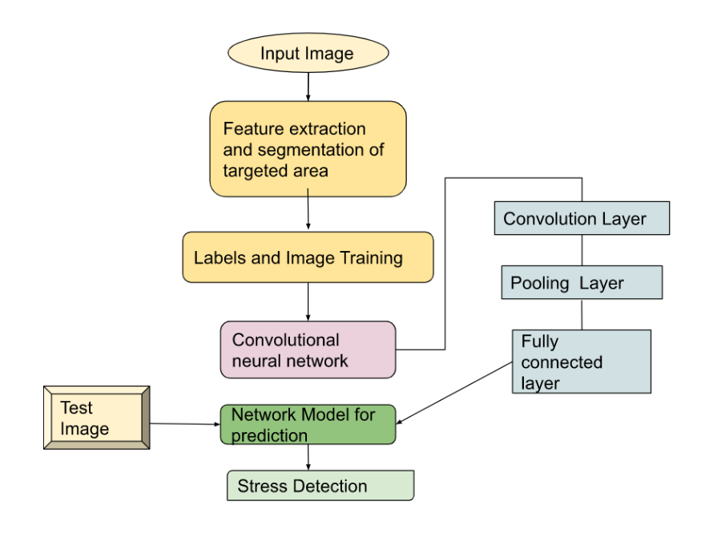

1. Stress Detection Process by using CNN

The Detection of the stress is implemented by using convolutional neural networks. The system takes the input as an image of the person's face and we train the algorithm by images. The photos are used to extract features. The images are introduced along with labels to the algorithm. Convolution layer, one or more pooling layers, and fully connected layer are possible layers in CNN algorithms. A network model is created after the algorithm has been processed. The network model, which makes the predictions, is given information from the camera. The model in the system can be able to determine whether or not the individual is stressed based on the input image. The complete system can be implemented in the corporate sector as a stress relief technique for employees.

**Tools and Technologies:**

**OpenCV (version 3.4.2.16):**

A computer vision and machine learning software library called OpenCV is available for free use. A standard infrastructure for computer vision applications was created with OpenCV in order to speed up the incorporation of artificial intelligence into products. More than 2500 optimized algorithms are available in the collection, including a wide range of both traditional and cutting-edge computer vision and machine learning techniques.

**TensorFlow in Python:**

Machine learning models can be created using the free and open-source software TensorFlow. Deep neural networks are the main emphasis of this end-to-end open-source machine learning platform. Massive volumes of unstructured data are analyzed through deep learning, a subtype of machine learning. Python is used to build the front-end API for building high-performance apps.

**Python :**

Python is a dynamic, high-level, general-purpose, and interpreted programming language. It supports the development of applications using an Object-Oriented programming methodology. It offers a large number of high-level data structures and is straightforward and simple to learn. Python is a programming language that is appealing for application development since it is simple to learn yet also strong and flexible.

**Convolution Neural Network:**

A deep learning neural network called a convolutional neural network is made for processing structured data sets like photographs. The state-of-the-art for many visual applications, including image classification, convolutional neural networks are widely employed in computer vision. They have also been successful in natural language processing. The power of a CNN derives from a specific layer called the convolutional layer, which is a feed-forward neural network that can include up to 20 or 30 layers.

**Data Collection**

The dataset is known as fer2013 and is an open-source data collection that is made available to the public on the Kaggle website designed by Goodfellow et al. It contains grayscale images of the faces of different expressions and contains approximately 30000 facial images of different expressions and there are 7 categories present in the data ( 0 indicates Angry, 1 indicates Disgust, 2 indicates Fear, 3 indicates Happy, 4 indicates Sadness, 5 indicates Surprise, 6 indicates Neutrality )

The csv file has two columns: emotion, which is a string of integers ranging from 0 to 6, and pixel, which is a string of numbers denoting the image. Dataset contains 3589 samples of training data and remaining 28709 samples for testing the model.

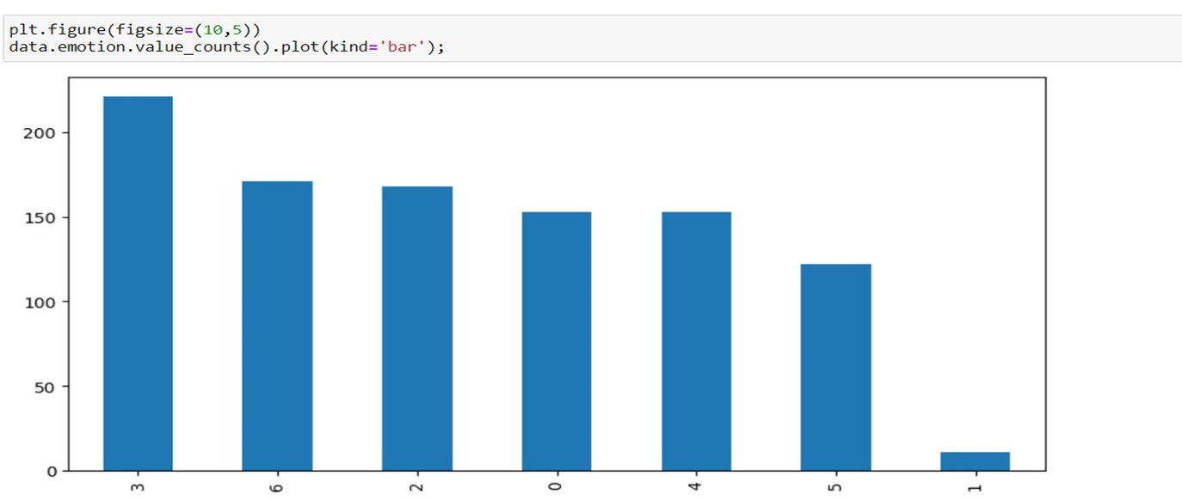

1. Emotion data distribution in the Dataset

The dataset consists of 3 variables (emotions of int data type and pixels, usage of object data type).The graph represents the number of images having the same expression and the sample dataset consists of more images with happy(3) as an emotion. The CNN model is built for the recognition of facial expressions and combined with the emotion detection the stress is predicted. The model is trained on the specific training dataset values and detects the features as per the requirement. We assess the model's performance on our validation set after each training iteration. At training time, when we supply a validation set, Keras takes care of this automatically. We can predict how well our model will function on brand-new, unforeseen data taken by the camera based on how well it performed on the validation set.

**System Design:**

The process of creating a software or hardware system's architecture, parts, and infrastructure is known as system design. Understanding the system's requirements, defining the system's scope, and building a solution that satisfies those objectives while also taking variables like scalability, maintainability, performance, and security into account are all involved. The project system consists of an algorithm that can identify a person's level of stress, and a trained CNN algorithm can identify their emotions when they are captured on camera.

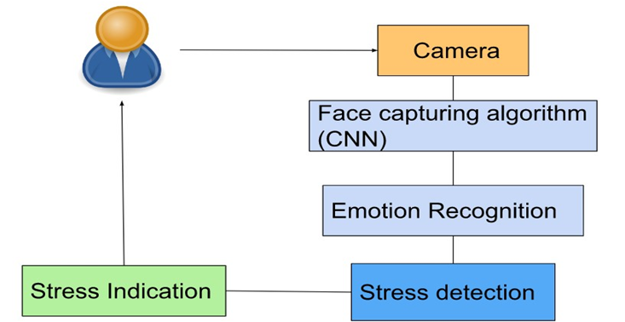

Fig. 3. System Design of Stress Detection

**Emotion Detection**

The model can tell what emotion the camera has captured on the subject's face. The stress can be predicted based on facial expressions.

**Stress Indication**

The wording that is visible in the frame denotes the person's prediction of stress, and the project focuses on identifying the face in a frame of video.

**OpenCV**

Using OpenCV and the camera, the build model is employed for real-time emotion recognition. The model is loaded after importing the Cv2 and keras libraries. In order to recognize the frontal face, OpenCV imported the Haar cascade algorithm. Once the code is executed, a new window will appear and the webcam or camera will switch on.

**Output (sample representation)**

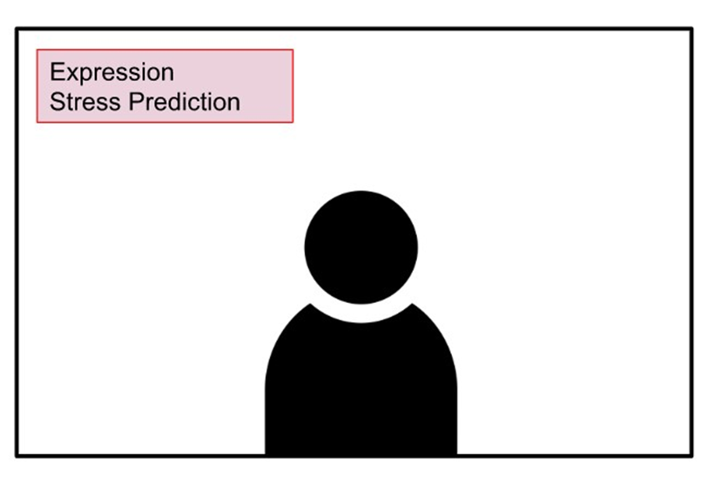

Fig. 4. Output Frame model

The sample output is a frame consisting of the capturing image by the camera and the output in a text format indicating the emotion and the stress prediction of the face. The emotion of face captured by the camera is detected by the model. Based on the facial expressions the stress is predicted. The stress prediction of the person is indicated by the text displayed in the frame and the project works on locating the face in a video/image frame.

The built-in model employs OpenCV and a camera to detect emotions in real time. The model is loaded and the Cv2 and Keras libraries are imported. When the code for OpenCV's Haar Cascade detects the frontal face, a new window will open and the webcam or camera will be turned on. Haar Cascade is an algorithm that can recognize the objects in an image and run in real-time.

**Outputs:**

The project is depicted in the screenshots, and all of the emotions that the algorithm was trained on are recognized. The program can accurately identify the presence of stress and record the user's feelings.

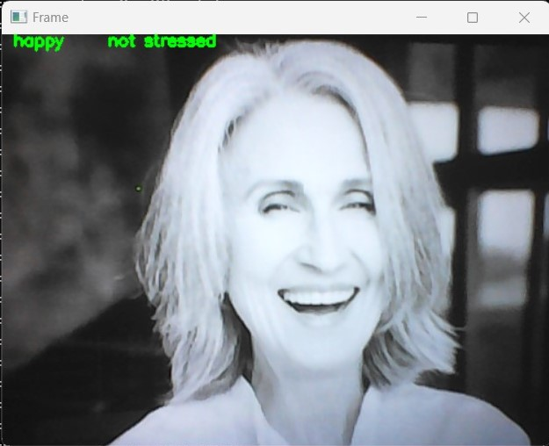

Fig. 5. Happy emotion with no stress

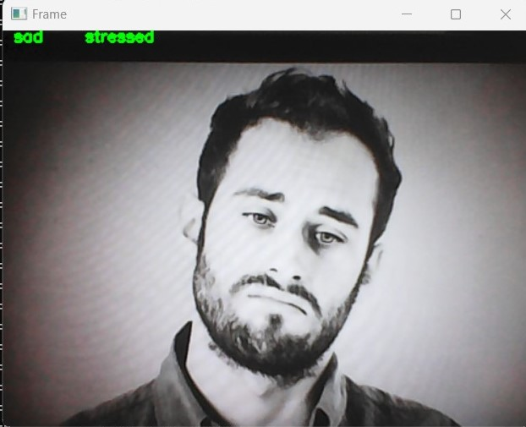

Fig. 6. Sad emotion with stress

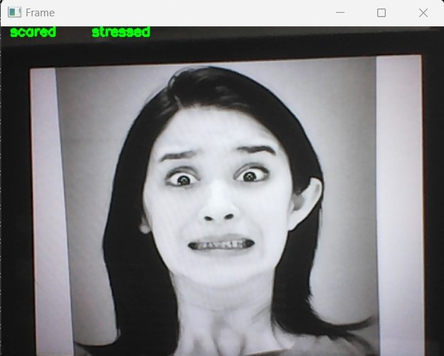

Fig. 7. Scared emotion with stress

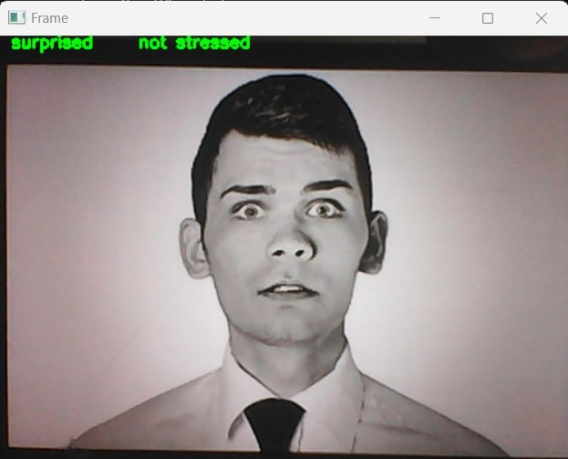

Fig. 8. Surprise emotion with no stress

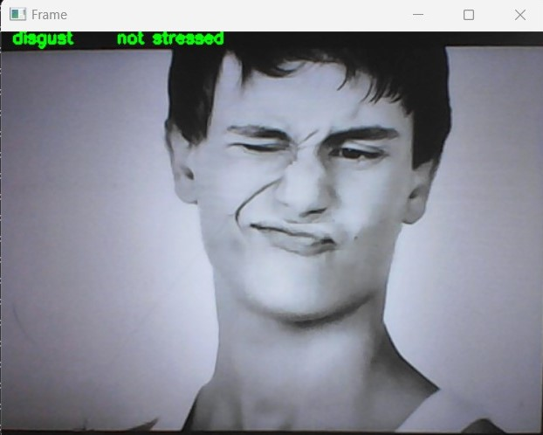

Fig. 5. Disgust emotion with no stress

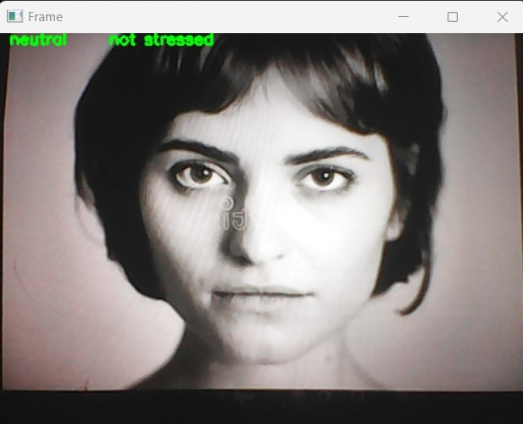

Fig. 5. Neutral emotion with no stress

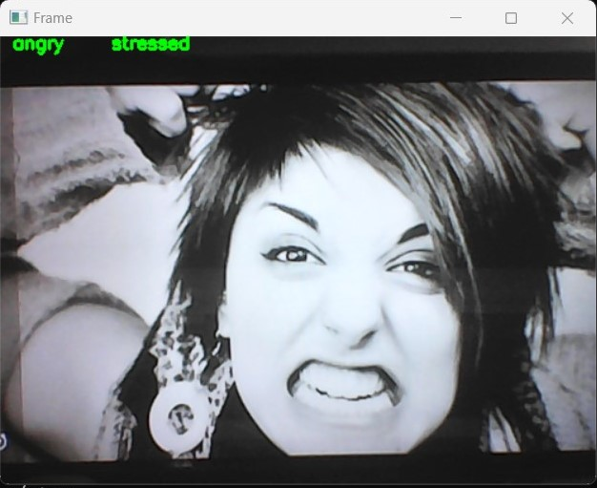

Fig. 5. Angry emotion with no stress

The output for the user in the frame indicates whether tension is present as well as their current emotion.

# Results and Discussions

Table 1 was created by comparing the various strategies and algorithms utilized in the various ways that stress detection was implemented.

1. Various techniques in stress detection

|  |  |  |  |
| --- | --- | --- | --- |
| **S.No** | **Techni-que** | **Advantages** | **Disadvantages** |
| 1 | Using measurements from wearable physiological sensors, one can identify stressful situations.  Kalliopi Kyriakou and colleagues 2019, | Using rule-based algorithms based on the skin temperature and galvanic skin reaction measured by wearable sensors, stressful moments are detected. | Self-reported stress level is dependent on personality and focused more, which is not an effective feature for stress detection.  Wearables discomfort the users. |
| 2 | IoT and machine learning for stress detection and prediction.  PURNENDU SHEKHAR PANDEY | Using a heartbeat, a remote stress detector (IoT gadget) may identify stress. | Logistic regression and SVM algorithms are resulting accuracy not more than 68 percentage and Naive Bayes results 50% accuracy |
| 3 | An Effective Machine Learning Framework for Stress Prediction Using Keyboard Data Integrated with Sensors.  In 2021, P.B. Pankajavalli and colleagues | For the purpose of predicting stress, the Fire Works Grey Wolf Optimization classification system assisted by the Adaptive Neuro-Fuzzy Inference System has been presented. | The Dataset having least number of Features is selected and The sensor is not effective. |
| 4 | Heart stress is predicted using machine learning techniques on sensor-coupled IoT devices.  A. Pandian and M. Safa, 2021 | Stress analysis uses coupled IoT sensors, MQTT protocol and the algorithms in machine learning as Decision Tree, KNN and SVC. | Focus on only cardiac related diseases. Gained least accuracy using the Decision tree. |
| 5 | Automated Stress Detection from ECG Signals in Drivers of Automobiles.  Nishant Keshan and P. V. Parimi | An effective and reliable system for precise stress detection was created using ECG monitoring together with minimally invasive wearable patches and sensors. | The application of personalized signal classification to other stressful circumstances, such as those faced by factory workers, athletes on the pitch, warriors in battle, and so on, is not now available. |
| 6 | Using wearable sensors to identify kids' levels of stress.  Amir Hasanbasic and colleagues 2019, | The ECG and electrodermal activity signals' characteristics are fed into the numerous, intricate categorization techniques employed by ML. | Students face discomfort with wearing automated devices all the time and this is a failure in focusing on the stress of elderly people. |

# Conclusion

By using a range of peripheral sensor devices and monitoring apps, people can fight mental illness. This study found that using common digital tools that can assess stress levels can enhance a person's overall well being. Human Stress detection is an important application to avoid the victims of the stress and prevent there mental health as well as physical health. The corporate sector employees are benefited by the implementation of stress relief and stress detecting techniques. The organization has the capability to make the employees work efficiently and gain the maximum benefits in business growth and attract the employees to join and continue in the organization for longer years. The employees are made to be concerned for their mental state issues. Humans can combat mental-illness by implementing the stress detection by facial expressions and the system adds scope to improve the person’s overall well-being. There is an efficient accuracy of prediction of stress by deep learning technology. The usage of several open-source libraries like TensorFlow, Google colab, and some libraries in python effect and result in a Network Model for Prediction. The image data along with labels is trained to the convolutional algorithm to achieve accurate predictions.

# Future Scope

The updates in algorithms can be done easily since we do modular implementation and work could be continued in future for change in implementation of the model. We can also improve the project by introducing the new future that can detect stress by audio processing techniques. The implementation of the stress detection can also be extended by playing a relaxed music to reduce the employee stress and can alert the manager to take appropriate measures to reduce the workload and have a profitable and pleasant way of managing the implementation of tasks.

##### References

1. Aristizabal, Sara, et al. "The feasibility of wearable and self-report stress detection measures in a semi-controlled lab environment." IEEE Access 9 (2021): 102053-102068.
2. Shahbazi, Zeinab, and Yung-Cheol Byun. "Early Life Stress Detection Using Physiological Signals and Machine Learning Pipelines." Biology 12.1 (2023): 91.
3. Banerjee, Jyoti Sekhar, Mufti Mahmud, and David Brown. "Heart Rate Variability-Based Mental Stress Detection: An Explainable Machine Learning Approach." SN Computer Science 4.2 (2023): 176.
4. Febriansyah, Mochamad Rizky, Rezki Yunanda, and Derwin Suhartono. "Stress detection system for social media users." Procedia Computer Science 216 (2023): 672-681.
5. Zu, Ruili, et al. "A stress detection method for metal components based on eddy current thermography." NDT & E International 133 (2023): 102762.
6. Kuttala, Radhika, Ramanathan Subramanian, and Venkata Ramana Murthy Oruganti. "Multimodal Hierarchical CNN Feature Fusion for Stress Detection." IEEE Access (2023)
7. Phukan, Orchid Chetia, et al. "An Automated Stress Recognition for Digital Healthcare: Towards E-Governance." Electronic Governance with Emerging Technologies: First International Conference, EGETC 2022, Tampico, Mexico, September 12–14, 2022, Revised Selected Papers. Cham: Springer Nature Switzerland, 2023.
8. Nijhawan, Tanya, Girija Attigeri, and T. Ananthakrishna. "Stress detection using natural language processing and machine learning over social interactions." Journal of Big Data 9.1 (2022): 1-24
9. AlShorman, Omar, et al. "Frontal lobe real-time EEG analysis using machine learning techniques for mental stress detection." Journal of Integrative Neuroscience 21.1 (2022): 20.
10. Bin Heyat, Md Belal, et al. "Wearable flexible electronics based cardiac electrode for researcher mental stress detection system using machine learning models on single lead electrocardiogram signal." Biosensors 12.6 (2022): 427.
11. Gil-Martin, Manuel, et al. "Human stress detection with wearable sensors using convolutional neural networks." IEEE Aerospace and Electronic Systems Magazine 37.1 (2022): 60-70.
12. Sharma, Lakhan Dev, et al. "Evolutionary inspired approach for mental stress detection using EEG signal." Expert Systems with Applications 197 (2022): 116634.