**ILLUMINATION BASED LIGHT CONTROL FOR VEHICLE MOVEMENT**

**K. Rajasekhara Reddy1, B.Mahesh2, S.Mohammed Rafi3, Y.Palrahul4,K.Ramesh5,K.Nikhil6**

1Associate Professor, Department of EEE, Santhiram Engineering College, Nandyal, A.P,

(1raju.eee@srecnandyal.edu.in)

2,3,4,5,6, UG Student Scholar,Department of EEE, Santhiram Engineering College, Nandyal, A.P

(2butharajumahesh2002@gmail.com,3shaikmohammedrafi888@gmail.com,4rahullearnvisual258@gmail.com,5krameshramesh05077@gmail.com,6kummarinikhilkumar29@gmail.com)

**Abstract:**

The majority of the energy used today is consumed by illumination, including both indoor and outdoor lighting. Although some locations will have a significantly reduced number of vehicles in traffic, cars are constantly passing by. But in an ordinary street lighting setup, all lights are turned on at night. The problem can be fixed by installing energy-saving lighting controls. The planned work would include two sets of controls, such as dimming the lighting for pedestrians while switching to a brighter setting when vehicles are parked along the roadside, and turning the lights off when there are no cars on the road and turning them back on when cars return. LEDs are utilised for street lighting, while photo diodes and infrared (IR) sensors detect the location and speed of passing vehicles. Sensor control signals have been sent to the 8051 microcontroller. The microcontroller contains the circuitry needed to toggle between bright and dim modes of operation based on the presence or absence of automobiles and pedestrians, and to completely turn off the lights when neither condition is present. The proposed solution will help in reducing the amount of energy currently used for lighting. Greater complexity is required for controlling the city's lighting infrastructure as cities grow and people's living standards increase.

Keyword : Arduino IDE, Sensors,NodeMCU.

**INTRODUCTION:**

This article describes the creation of a system that can detect when a car is on the road and only turn on the section of the road lights that are in front of it, while turning off the section of the road lights that are behind it to save energy.To make it easier for passing road users, all of the road's lights are on all over the night; however, the road is dark whenever there are no cars visible. The proposed design works well in terms of energy usage reduction.The device does this by detecting when a car arrives into the street and turning on a line of street lighting ahead of the car. As the vehicle moves forward, the tracking lights turn off automatically [8].The amount of energy saved is considerable. The lights are left off when there are no vehicles on the road [1, 3]. The lights can also operate in a different mode that allows them to dim 10% from maximum brightness rather than turning off completely [7].The block of road lighting illuminates to full power when an approaching car is detected, and the remaining lights dim back to 10% after it has passed. High-intensity discharge (HID) lights are used in cities to light roads [5, 9].The intensity cannot be controlled by reducing the voltage because HID depends on the idea of gas discharge. High intensity discharge (HID) lights on roads are rapidly being replaced by white light emitting diode (LED) lights.Intensity control is also possible due to the PWM output of the microcontroller. The microcontroller will power up or power down depending on the status of the operation as provided by the photodiode and IR LEDs [2, 4].Since the switch is made gradually between both on and off states, a lot of energy is saved as an effect. For this undertaking, a microcontroller from the 8051 family was utilised. Installing sensors to recognise when a road light is not working and using a GSM modem to send a text message to the operations centre would enhance the proposed project. These System can be used on Highways, Normal roads and streets.

**Literature survey:**

**Combining an Infrared Sensor and an Arduino to Create a Smart Street Light:**

In-depth instructions on how to construct a completely automated lighting control system are provided by the system. The more recent electronic answer has all of the issues that affected the earlier ones fixed.The microprocessor performs calculations and automatically recognises the area, retrieving the essential data for sunrise and sunset in the area to ensure a very accurate ON/OFF mode for the lighting system. A light sensor is used in this circuit to detect illumination. Both routine upkeep and initial installation are unnecessary. The electronic device's dimmer feature increases the lifespan of bulbs. However, cutting back on the light also cuts down on the electricity required to keep the lighting at the same level. Microcontrollers, switches, and light sensors make up the project's main components. Relays are electromagnetic devices that are used to magnetically link two circuits while electrically isolating them, similar to how human eyes detect the presence of an object in a space.

**Intelligent Traffic Signal Control:**

Because the majority of the fuels we use, like coal and natural gas, are non-renewable we need to find methods to use less energy overall. They will be permanently gone once we are done with them. In order to save energy, power should not be used when it is not necessary Any city's street lighting uses a lot of energy. Despite being an energy waste, street lights are frequently left on well after dawn. Here, a system prevents the problem by turning the street lights on and off automatically at set times or when the outside light level drops below a present level. To measure ambient lighting, each device has a light-dependent resistor (LDR). The lights turn on when the quantity of available light falls below a predetermined level[3].The pic18f452 microcontroller is connected to a light-dependent sensor that monitors the sun's rays, turning on an LED when it finds darkness and turning it off when it detects light.It provides a very clear illustration of the cut-off and saturation regions of a transistor's function. Relay operation employs microcontrollers, which are also well-known. Their programmes are written in C using the MikroC IDE, and their output values can be watched through UART or LCD.It is simple and efficient to use a transistor as a button in an automated street light control system. There is no need for any physical labour at all when using this technique. The lights will come on when the sun sinks below the horizon. This is achieved by a sensor called a Light Dependent Resistor (LDR), which works similarly to how our eyes sense light. utilises wireless command and control for street lighting and the global positioning system to automatically turn off lights when daylight is sensed.

**The steps and tools involved in operating a system of public illumination are described:**

The needed GPS coordinates must be provided by a GPS system linked to the streetlight's control system. Based on the GPS coordinates that have been transmitted, the streetlight's precise location can be calculated. The GPS coordinates allow for the calculation of the true local time, from which the times of sunrise and sunset may be calculated. Once the sunrise and sunset times have been identified, the streetlight's LED illumination modules can be turned on and off accordingly.

**Existing system:**

Current procedures, such as filing a complaint or turning the lights on and off by hand, are labor-intensive and time-consuming. The new technique of automatic ON/OFF and defect detection without human involvement appears more simple when compared to the current system. We present a self-sufficient lighting control system that overcomes the limitations of existing solutions by retrieving the current date and time from the GPS, which also provides information on the system's position. In order to ensure a highly accurate ON/OFF mode for the lighting system, the microprocessor conducts calculations and automatically identifies the region, retrieving the relevant data for dawn and sunset in the area, respectively. The lifetime of the bulbs is increased because they are dimmed. The Demerit of Existing system manual opearation requires man power and consumes time. So, These problems can be avoided in proposed system by Automatic Street lighting, it reduces the man power and time, cost.

**Proposed system:**

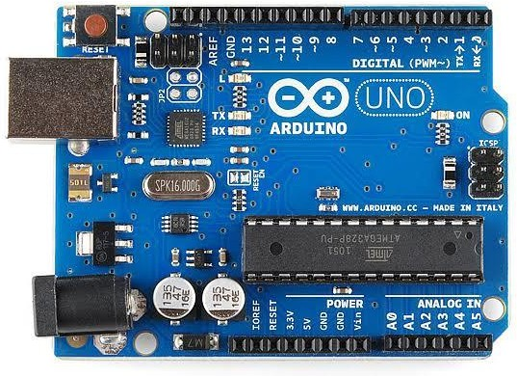Because the majority of the fuels we use, like coal and natural gas, are non-renewable, we need to find methods to use less energy overall. They'll be permanently gone once we're done with them. It is preferable to switch off the power when it is not necessary

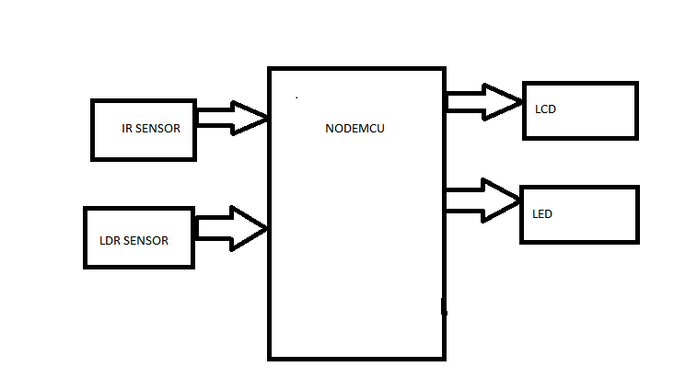

Fig 3.1 Block diagram

to conserve energy. Any city's street lighting uses a lot of energy. Despite being an energy waste, street lights are frequently left on well after dawn. In this nation, we have a system that turns on and turns off the street

lights automatically at set times or when the ambient light level falls below a present thresholdTo measure ambient lighting, each device has a light-dependent resistor (LDR). The lights will instantly turn on in dim lighting. A light-dependent sensor is connected to the pic18f452 microcontroller to watch the sun's rays; it turns on an LED when it senses darkness and turns it off when it senses light[6]. It provides a very clear illustration of the cut-off and saturation regions of a transistor's function. Microcontrollers are used to control relays, and the C code created within the MikroC IDE can be used to determine how they work. The output value can be viewed via UART or LCD.

**ARDUINO UNOBOARD :**

The Arduino Uno is a microcontroller board based on the ATmega328. It has 14 digital input/output pins (of which 6 can be used as PWM outputs), 6 analog inputs, a 16 MHz ceramic resonator, a USB connection, a power jack, an ICSP header, and a reset button. It contains everything needed to support the microcontroller; simply connect it to a computer with a USB cable or power it with a AC-to-DC adapter or battery to get started

Fig 3.2 Arduino Uno Board

The Uno differs from all preceding boards in that it does not use the FTDI USB- to-serial driver chip. Instead, it features the Atmega16U2 (Atmega8U2 up to version R2) programmed as a USB-to-serial converters.

**LIQUID CRYSTAL DISPLAY (LCD)**

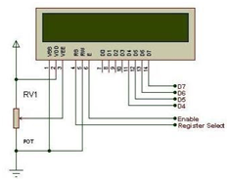

Fig 3.3 LCD

LCD stands for Liquid Crystal Display. LCD is finding wide spread use replacing LEDs (seven segment LEDs or other multi segment LEDs) because of the following reasons:

* The declining prices of LCDs.
* The ability to display numbers, characters and graphics. This is in contrast to LEDs, which are limited to numbers and a few characters.
* Ease of programming for characters and graphics.

These components are “specialized” for being used with the microcontrollers, which means that they cannot be activated by standard IC circuits. They are used for writing different messages on a miniature LCD.

A model described here is for its low price and great possibilities most frequently used in practice. It is based on the HD44780 microcontroller (Hitachi) and can display messages in two lines with 16 characters each. It displays all the alphabets, Greek letters, punctuation marks, mathematical symbols etc. Automatic message on display (shift left and right), appearance of the pointer, backlight etc. are considered as useful characteristics.

**IR SENSOR:**

An infrared (IR) sensor[6&7] is an electronic device that measures and detects infrared radiation in its surrounding environment. Infrared radiation was accidentally discovered by an astronomer named William Herchel in 1800. While measuring the temperature of each color of light (separated by a prism), he noticed that the temperature just beyond the red light was highest. IR is invisible to the human eye, as its wavelength is longer than that of visible light (though it is still on the same electromagnetic spectrum). Anything that emits heat (everything that has a temperature [above around five degrees Kelvin](https://www.livescience.com/50260-infrared-radiation.html)) gives off infrared radiation.

There are two types of infrared sensors: active and passive. Active infrared sensors both emit and detect infrared radiation. Active IR sensors have two parts: a light emitting diode (LED) and a receiver. When an object comes close to the sensor, the infrared light from the LED reflects off of the object and is detected by the receiver. 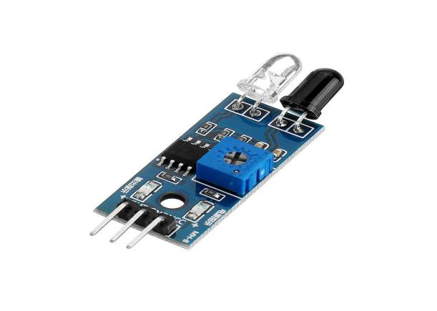

Fig 3.4 IR Sensor

Active IR sensors act as [proximity sensors](https://www.fierceelectronics.com/sensors/what-a-proximity-sensor), and they are commonly used in obstacle detection systems (such as in robots)

**LDR SENSOR:**

Photoresistors, also known as light dependent resistors (LDR), are light sensitive devices most often used to indicate the presence or absence of light, or to measure the light intensity.[7&9] In the dark, their resistance is very high, sometimes up to 1 MΩ, but when the LDR sensor is exposed to light, the resistance drops dramatically, even down to a few ohms, depending on the light intensity. LDRs have a sensitivity that varies with the wavelength of the light applied and are nonlinear devices. They are used in many applications, but this light sensing function is often performed by other devices such as photodiodes and phototransistors. Some countries have banned LDRs made of lead or cadmium over environmental safety concerns.

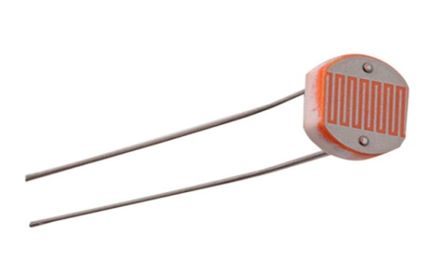

Fig 3.5 LDR Sensor

**LED SENSOR:**  **Due to the high efficiency of LED sensor systems, they are highly sought-after for multiple applications. One particular application for LEDs is their use as photodiodes for light detection. While acting as photodiodes, LEDs are very sensitive to wavelengths that are equal to or shorter than the predominant wavelength they emit. For instance, a green LED is sensitive to blue light and some green light, but not to red or yellow light.** LEDs can be added to systems having only minor modifications in the circuitry. LEDs multiplexed in such a circuit can be used for both light emission and light detection. This sensor system can perform this dual function in the same circuit without changing its electrical or physical connections making them ideal for a number of applications including bidirectional communications and ambient light detection

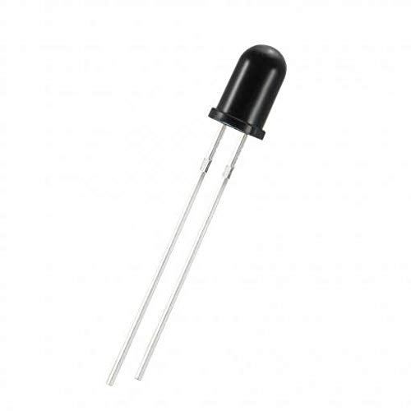

Fig 3.6 LED Sensor

**RESULT:**

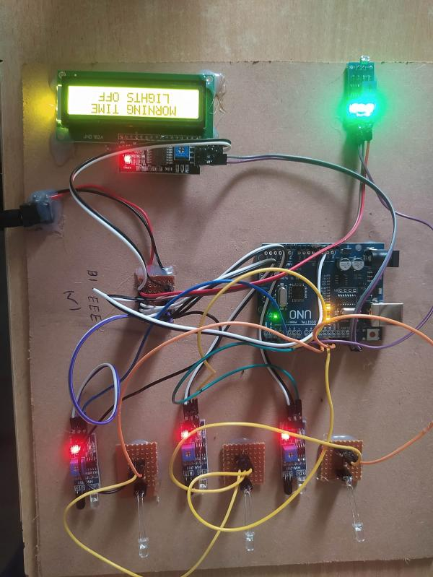

**Conclusion:**

Using Smart Street Light, which replaces sodium vapour lights with LEDs and adds an additional security feature, one can save extra electricity. It prevents unnecessary wastage of electricity, caused due to manual switching of streetlights when it’s not required. With the help of IR sensors, it offers an effective and clever automatic streetlight management system. It can keep costs the same while reducing energy usage. The system is flexible, scalable, and completely adaptable to customer requirements. The system is now used only for One way traffic in highways. LDR and IR sensors are continuously used, even during the day, and are not switched on until after sunset. To add two-way traffic, improve system adaptability for rainy days, and add techniques for controlling the lights using GSM-based services, the smart light system can be further developed.

**References:**

1. International Journal of Innovative Research in Computer and Communication Engineering (An ISO 3297: 2007 Certified Organization) Website: www.ijircce.com Vol. 5, Issue 3, March 2017 Smart Street Light Using Arduino Uno Microcontroller
2. S. Suganya, R. Sinduja, T. Sowmiya& S. Senthilkumar, Street light glow on detecting vehicle movement using sensor
3. K.SanthaSheela,S.Padmadevi, Survey on Street Lighting System Based On Vehicle Movements
4. Srikanth M, Sudhakar K N,ZigBee Based Remote Control Automatic Street Light System
5. M.Abhishek, Syed ajram shah, K.Chetan, K,Arun Kumar, Design and implementation of traffic flow based street light control system with effective utilization of solar energy, International journal of Science Engineering and Advance Technology, IJSEAT, Vol 3, Issue
6. V.Jyothi, Dr. M. V.Subramanyam “ An Enhanced technique to improve the Network Lifetime of Cognitive Sensor Networks , International Journal of Wireless Personal Communications’ pp. 12757 – 12763, May-2021
7. Dr.M. V. Subramanyam et al ‘ Multiple Sensor Data Fusion Based Top-Down Embedded System for Automatic Plant Pot WateringJournal of Algebraic Statistics,e-ISSN: 1309-3452,Marmara University Istanbul University, Istanbul, Vol. 13, No. 1,PP: 884 – 891,2022, No.3
8. V.Jyothi, Dr.M. V. Subramanyam “An energy efficient fuzzy clustering-based congestion controlalgorithm for cognitive radio sensor networks’, Wireless Networksl. Oct-2022.

.

1. Saraswati, B. Alekyahimabindu, Dr. M. V. Subramanyam “Multiple Sensor Data Fusion Based Top-Down Embedded System for Automatic Plant Pot Watering” JOURNAL OF ALGEBRAIC STATISTICS Volume 13, No. 1, 2022, p. 884 – 891
2. V.Jyothi, Dr.M. V. Subramanyam “Design and Implementation of Solar Energy Monitoring System using LoRafor Solar Power Plants’, International Journal on Advanced Science & Technology, Vol. 29, No. 03, (2020), pp.
3. M.Yerri Veeresh, Dr.V.Nagabhaskar Reddy, Dr.R.Kiranmayi, Modeling and Analysis of Time Response Parameters of a PMSM-Based Electric Vehicle with PI and PID Controllers, in Engineering, Technology & Applied Science Research (ETASR), ISSN: 2241-4487, Vol. 12, Issue. 6, December 2022, PP.No. 9737-9741.
4. M.Yerri Veeresh, Dr.V.Nagabhaskar Reddy, Dr.R.Kiranmayi, Range Estimation of Battery Electric Vehicle by Mathematical Modelling of Battery’s Depth of Discharge, in International Journal of Engineering and Advanced Technology (IJEAT), ISSN: 2249-8958, Vol. 8, Issue. 6, August 2019, PP.No. 3987-3992.
5. M.Yerri Veeresh, A.Mallikarjuna Prasad &U.Chaithanya, A Strategy of High Voltage GainSwitched–Capacitor DC-DC Converter with Reduced Rating Component Rating and Count Fed DC Drive System, International Journal of Engineering Research & Technology (IJERT), ISSN: 2278-0181, Volume 2, Issue 9, September 2013, Pg.no: 1835-1843.
6. K.Rajasekharareddy"Comparative Analysis of MC-SPWM and MSVPWM for Seven Level Diode Clamped Multilevel Inverter" in Journal of Mechanics of Continua and Mathematical Sciences (JMCMS) (ISSN: (Online) : 2454 -7190, Vol.-15, No.-1, January (2020) pp 192-208)

1. K.Rajasekharareddy "Improved Robust Controller Design for Stabilization of Grid-Tied Photovoltaic System " in Journal of Scientific and Industrial Research (JSIR) ( ISSN: 0975-1084 (online), 0022-4456 (Print), PP- 431-436,Volume-78, July 2019 ) v
2. V.Ramanjaneyulu"DTMF Based Irrigation Water Pump Control System" in International Journal of Research Available at https://edupediapublications.org/journals p-ISSN: 2348-6848 e-ISSN: 2348-795X Volume 05 Issue 12 April 2018