**RESEARCH & DEVELOPMENT OF E-COMMERCE WEBSITE USING “ASP.NET”**

**Sudhir Singh Mushuni1, Pritam2, Dr. Shalini Goel3**

1,2Student, Dept. Of Computer Science and Engineering, HMR Institute of Technology and Management,

Hamidpur, Delhi, India

1Email :- [sudhirmushuni29@gmail.com](mailto:sudhirmushuni29@gmail.com)  2Email :- [pri111nah@gmail.com](mailto:sudhirmushuni29@gmail.com)

3Associate Professor, Dept. Of Computer Science and Engineering, HMR Institute of Technology and Management, Hamidpur, Delhi, India

Email :-  [drshalinigoel1803@gmail.com](mailto:sudhirmushuni29@gmail.com)

**ABSTRACT**

This paper describes the design and development of an e-commerce website using ASP.NET framework, which was motivated by seen popularity and importance of the web development community and web based applications. We have attempted to ensure that this project meets a high standard of production, includes high-level languages, comprehensive testing, and explicit extensibility.

In this research paper we have covered discussion and development of a project which is an ecommerce website called az-kart.com. This project allows making and viewing various products available enables registered users to purchase desired products instantly using payment processor (Instant Pay) and also can place order by using Cash on Delivery (Pay Later) option. This project provides an easy access to Administrators and Managers to view orders placed using Pay Later and Instant Pay options.

This is a project with the objective to develop a basic website where a consumer is provided with a shopping cart application and also to know about the technologies used to develop such an application.The objective of this project is to develop a general purpose e-commerce store where product packaging as well as stationary items can be bought from the comfort of home through the Internet. However, for implementation purposes, this project will deal with an online shopping website for packaging items as well as accessories.

In order to develop an e-commerce website, a number of Technologies must be studied and understood. These include multi-tiered architecture, server and client side scripting techniques, implementation technologies such as ASP.NET, programming languages (such as HTML, CSS, PHP,JS) and relational databases. This is a project with the objective to develop a basic website where a consumer is provided with a shopping cart application. This research will discuss each of the underlying technologies to create and implement an e- commerce website.

This project helps in understanding the creation of an interactive web page and the technologies used to implement it. The design of the project which includes Data Model and Process Model illustrates how the database is built with different tables, how the data is accessed and processed from the tables. The building of the project has given a precise knowledge about how ASP.NET is used to develop a website, how it connects to the database to access the data and how the data and web pages are modified to provide the user with a shopping cart application.

A good shopping cart design must be accompanied with user-friendly shopping cart application logic. It should be convenient for the customer to view the contents of their cart and to be able to remove or add items to their cart. The shopping cart application described in this project provides a number of features that are designed to make the customer more comfortable. It is reasonable to say that the process of shopping on the web is becoming common place.In today’s fast-changing business environment, it’s extremely important to be able to respond to client needs in the most effective and timely manner.

**Keywords:** Asp.net website, E-Commerce website, online packaging retailer, corrugated boxes, packaging products, corrugated sheets, packing accessories, shopping bags, envelopes, courier.

1. **INTRODUCTION**

The E-commerce means electronic commerce. It means dealing in goods and services through the electronic media and internet. E-commerce involves carrying on a business with the help of the internet and by using the information technology like Electronic Data Interchange (EDI). E-Commerce relates to a website of the vendor on the Internet, who trades products or services directly to the customer from the portal. The portal uses a digital shopping cart or digital shopping basket system and allows payment through credit card, debit card or EFT (Electronic fund transfer) payments.

The main types of electronic commerce are :-

* business-to-business (B2B)
* business to- consumer (B2C)
* business-to-government (B2G)
* consumer-to-consumer (C2C)
* mobile commerce (m-commerce).

1. commerce is a boon in the modern business. Electronic commerce involves buying and selling of goods and services, or the transmitting of funds or data, over an electronic network, predominantly the Internet. It is a paradigm shift influencing both marketers and the customers. Rather e-commerce is more than just another way to boost the existing business practices. It is leading a complete change in traditional way of doing business. Moreover E-Commerce has significant influences on the environment.It is leading a complete change in traditional way of doing business.

An online store is a virtual store on the Internet where customers can browse the catalog and select products of interest. The selected items may be collected in a shopping cart. At checkout time, the items in the shopping cart will be presented as an order. At that time, more information will be needed to complete the transaction. Usually, the customer will be asked to fill or select a billing address, a shipping address, a shipping option, and payment information such as credit card number. An e-mail notification is sent to the customer as soon as the order is placed. Modern electronic commerce typically uses the World Wide Web for at least one part of the transaction's life cycle although it may also use other technologies such as e-mail.

Typical e-commerce transactions include the purchase of online books (such as Amazon) and music purchases (music download in the form of digital distribution such as iTunes Store), and to a less extent, customized/personalized online liquor store inventory services.

E-commerce businesses may also employ some or all of the followings :-

* Online shopping for retail sales direct to consumers via Web sites and mobile apps, and conversational commerce via live chat, chatbots, and voice assistants;
* Providing or participating in online marketplaces, which process thirdparty business-to-consumer (B2C) or consumer-to-consumer (C2C) sales;
* Business-to-business (B2B) buying and selling;
* Gathering and using demographic data through web contacts and social media;
* Business-to-business (B2B) electronic data interchange;
* Marketing to prospective and established customers by e-mail or fax (for example, with newsletters);
* Engaging in pretail for launching new products and services;
* Online financial exchanges for currency exchanges or trading purposes.

The major objectives of the project work on E-commerce industry are :-

* To understand about E-commerce and its role in the economy.
* To understand the types of E-commerce and its functioning.
* Industry with respect to the consumers perspective.
* To understand the major academic disciplines contributing to e-commerce research.

1. **LITERATURE SURVEY**

To understand about the growth prospects. In [1], authors proposed about E-commerce Website Design Based on User Experience which is the first task requirement needed for making a website. According to relevant research reports, the user experience is no longer rigidly defined in the definition of text, user experience is an extension of interactive technology, it is a sentiment research that is produced through the quality and function of the product itself and the user's needs. Therefore, to define the experience, the first thing to consider is the user's subjectivity. This contribution posits that e-commerce websites’ ought to be appealing, functional and offer secure transactions. More importantly, it suggests that online merchants should consistently deliver a personalized service in all stages of an online purchase, including after the delivery of the ordered products.

In [2], authors proposed about users satisfaction and sales fulfillment. The findings reported that consumers valued the e-commerce websites’ features and their consumer order fulfillment capabilities. These factors increase the consumers’ satisfaction with online shopping experiences, generate repeat business as well as positive reviews in social media.

In recent years, e-commerce platforms have emerged in an endless stream, including Amazon and eBay in the high-end international market, It is not so difficult for many companies to share a piece of the online shopping business. However, due to the serious homogeneity of online shopping platforms, it is difficult for users with special purchasing needs to

find suitable e-commerce platforms [3].

According to A New Marketing Paradigm suggested that a fundamental lack of faith between most online stores and consumers has prevented people from shopping online or even providing information to web providers in exchange for access to information [4]. The effects of e-commerce are already appearing in all areas of business, from customer service to new product design [5]. It facilitates new types of business processes for reaching and interacting with customers like online advertising and marketing, online order taking and online customer service. There has been a rise in the number of companies' taking up in the recent past. Major Indian portal sites have also shifted towards e-commerce instead of depending on advertising revenue.

This significant change in business model is seeing huge growth around the globe and India is no exception. In fact, e-commerce has every ability to curb emissions and thus generate important environmental impacts. The purchasing of goods and services through e-commerce gives consumers the freedom to choose when and where to buy and the ability to study the commodity, the retailer and any other options available. The provision of online information revolutionized the buying cycle. It is possible to buy just about anything that can be bought at a merchandise store via e-commerce, including perishables such as groceries. Yet customers around the world have welcomed those possibilities [5].

The effects of e-commerce are already appearing in all areas of business, from customer service to new product design. It can also reduce costs in managing orders and interacting with a wide range of suppliers and trading partners, areas that typically add significant overheads to the cost of products and services [6].

According to 2021 data, it was estimated that one in every three Indians shopped using a smartphone [7]. ASSOCHAM Study (2021) found the highest growth rate in the apparel segment, almost 69.5 per cent over 2014, followed by electronic items, up 62 per cent, baby care products, up 53 per cent, beauty and personal care products at 52 per cent and home furnishings at 49 per cent. Rapid growth of digital commerce in India is mainly due to increased use of smartphones. Mobiles and mobile accessories have taken up the maximum share of the digital commerce market in India, noted the study. Moreover, almost 45 per cent online shoppers reportedly preferred cash on delivery over credit cards (16 per cent) and debit cards (21 per cent). Only 10 per cent opted for internet banking and a scanty 7 per cent preferred cash cards, mobile wallets, and other such modes of payment. The 18-25 years of age group has been the fastest growing age segment online with user growth being contributed by both male and female segments. The survey highlights that 38 per cent of regular shoppers are in 18-25 age group, 52 per cent in 26-35, 8 per cent in 36-45 and 2 per cent in the age group of 45-60. Nearly 65 per cent online shoppers are male and 35 per cent female. E-commerce must be a boom within the modern business. It’s leading to a whole change in the traditional way of doing business.

1. **METHODOLOGY**

In order to develop this e-commerce website, a number of Technologies must be studied and understood, these includes :-

- multi-tiered architecture,

- server and client side scripting techniques

- implementation technologies such as ASP.NET

- programming languages (HTML, CSS, PHP, JS)

- relational databases.

FRONT-END :

HTML :- for ‘marking up’ text in order to turn it into a web page, it will form the backbone of any web application.

CSS :- for setting style rules for the appearance of web pages.

JavaScript :- used to add functionality and interactivity to web pages.

Bootstrap :- framework for the creation of website.

BACK-END :

Back-end scripts are written in many different coding languages and frameworks, such as -

PHP :- interact with databases to retrieve information, storing, and provides content to pages to display on screen.

ASP.NET :- used to produce interactive, data-driven web applications over the internet.

MICROSOFT VISUAL STUDIO :- (Software used for coding)

Microsoft Visual Studio is an integrated development environment which helps to create applications with an innovative interface and functionality that will satisfy the most demanding customer requirements. This tool simplifies performing complex tasks to provide the best Web Development Services. Using Microsoft Visual Studio, we can develop high-quality applications for Windows, Microsoft Office, Windows Phone, the Internet and the cloud. Visual Studio is the fastest IDE for productivity. Target any platform, any device. Build any type of application. Work together in real time. Diagnose and stop problems before they happen. It makes the stuff you do every day more fluid and responsive.

This product from Microsoft Corporation is designed to make the work operational and convenient by:

- use of wide functionality

- the ability to test apps and correct errors

- convenient navigation

XAMPP :- (Provides IDE)

XAMPP is a [free and open-source](https://en.wikipedia.org/wiki/Free_and_open-source" \o "Free and open-source) [cross-platform](https://en.wikipedia.org/wiki/Cross-platform" \o "Cross-platform) [web server](https://en.wikipedia.org/wiki/Web_server" \o "Web server) [solution stack](https://en.wikipedia.org/wiki/Solution_stack" \o "Solution stack) package developed by Apache Friends, consisting mainly of the [Apache HTTP Server](https://en.wikipedia.org/wiki/Apache_HTTP_Server" \o "Apache HTTP Server), [MariaDB](https://en.wikipedia.org/wiki/MariaDB" \o "MariaDB) [database](https://en.wikipedia.org/wiki/Database" \o "Database), and [interpreters](https://en.wikipedia.org/wiki/Interpreter_(computing)" \o "Interpreter (computing)) for scripts written in the [PHP](https://en.wikipedia.org/wiki/PHP" \o "PHP) and [Perl](https://en.wikipedia.org/wiki/Perl" \o "Perl) [programming languages](https://en.wikipedia.org/wiki/Programming_language" \o "Programming language). Since most actual web server deployments use the same components as XAMPP, it makes transitioning from a local test server to a live server possible.

XAMPP is one of the widely used cross-platform web servers, which helps developers to create and test their programs on a local webserver. It was developed by the Apache Friends, and its native source code can be revised or modified by the audience. It consists of Apache HTTP Server, MariaDB, and interpreter for the different programming languages like PHP and Perl. It is available in 11 languages and supported by different platforms such as the IA-32 package of Windows & x64 package of macOS and Linux.

XAMPP is an abbreviation where X stands for Cross-Platform, A stands for Apache, M stands for [MYSQL](https://www.javatpoint.com/mysql-tutorial), and the Ps stand for PHP and Perl, respectively. It is an open-source package of web solutions that includes Apache distribution for many servers and command-line executables along with modules such as Apache server, [MariaDB](https://www.javatpoint.com/mariadb-tutorial), PHP, and Perl.

These are the Processes ( in Fig. 1) to be followed during this project of making an E-commerce website :-

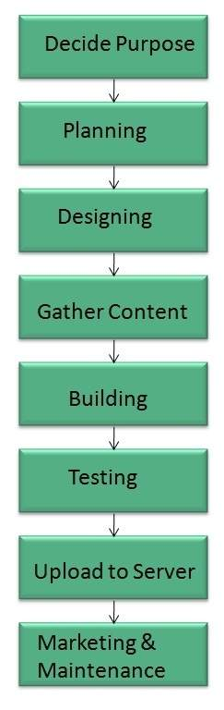

**Figure 1:** Goal Processes.

This (Fig. 2) chart shows the relationship between the ADMIN, USER and VISITOR for shopping as well as payment method.

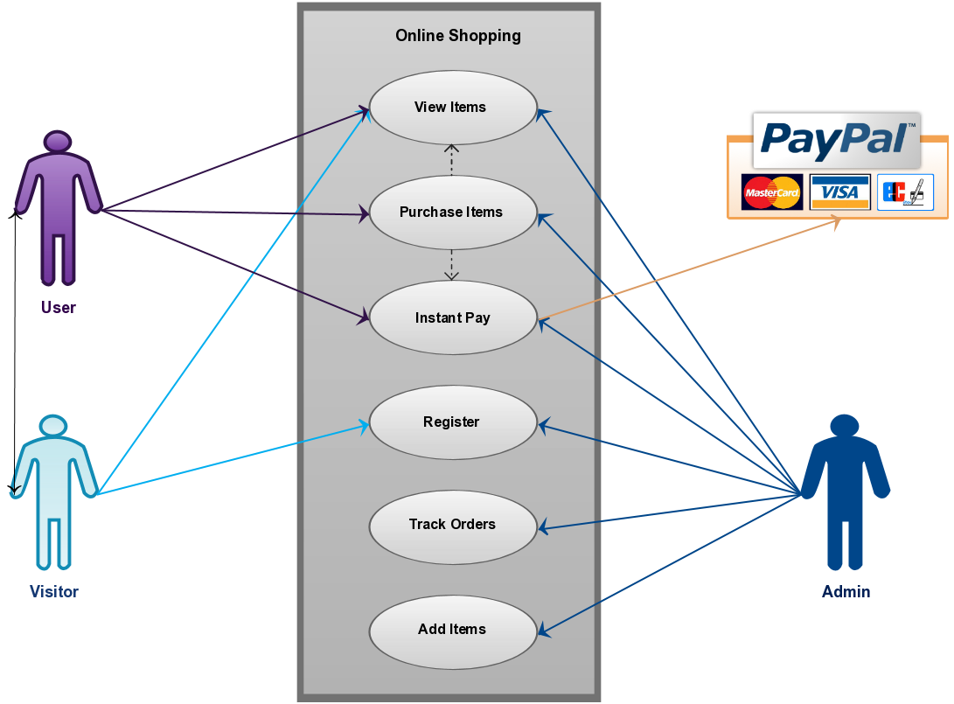**Figure 2:** Relation Chart.

Data Design :-

A database model is a type of data model that determines the logical structure of a database and fundamentally determines in which manner data can be stored, organized and manipulated, (refer Fig. 3,4,5).

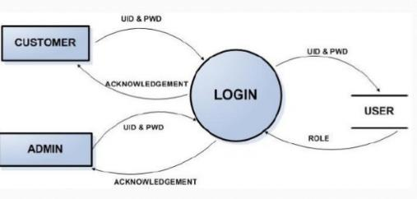

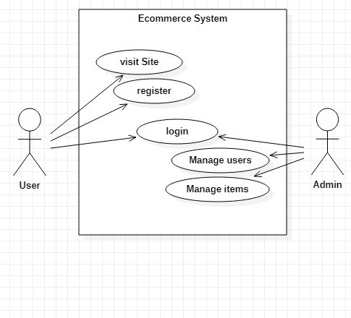

**Figure 3:** Data Flow chart. **Figure 4:** UC Diagram.

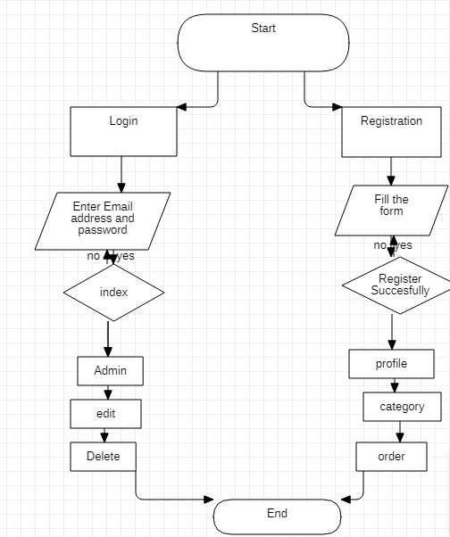

**Figure 5:** Flowchart of Register/Login Proces

1. **IMPLEMENTATION**

* Any member can register, view available products.
* Only registered member can purchase multiple products regardless of quantity.
* Contact Us page available to contact Admin for queries.
* Three roles available: Visitor, User and Admin.
* Visitor can view available products.
* User can view and purchase products.
* An Admin has some extra privilege including all privilege of visitor and user.
* Admin can add products, edit product information and add/remove product.
* Admin can add, edit, remove user information.
* Admin can ship order to the user based on order placed by sending confirmation mail.

Data Management

* Attach the database in "SQL Server Management Studio Express".
* Run the application on Microsoft Visual Studio as web site.
* Locate the database.

This database consists of ;

* Users :- User and Admin information is added to database with Unique ID based on their roles.
* Shopping :- Complete products information is stored in this table.
* Orders :- Customer ordered products, status and delivery information is stored in this table.

Data Objects

* User :- ID, UserName, Password, Email, Role
* Shopping :- ID, Product, Product ID, Cost, Category, Image, Description
* Orders :- ID, Client, Product, Quantity, Price, Date, Order Shipped

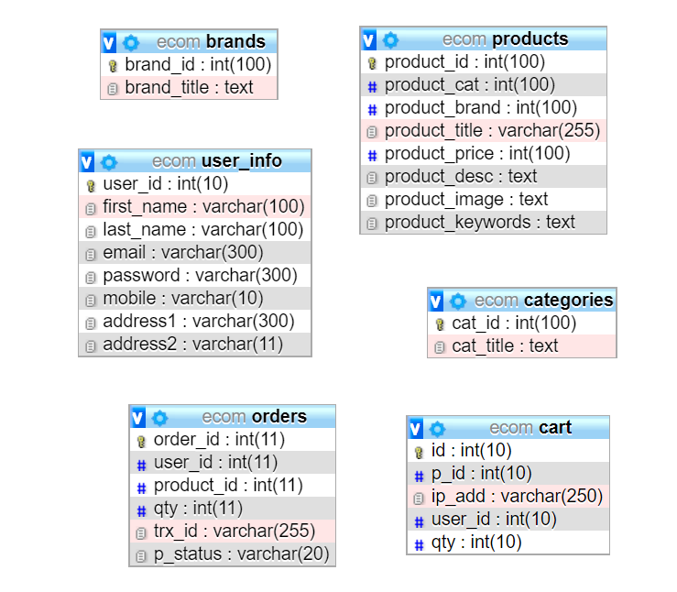

**Figure 6:** Schema Diagram.

Pages to be created :-

* Home Page
* Products Page
* Order Page
* Contact Us Page
* About Us Page
* Register Page
* Login Page
* Admin Page
* Order view Page
* Payment Page
* Payment success Page
* Payment Failure Page
* Privacy Policy Page
* Terms & Condition Page
* Cart Page
* Track for Admin Page

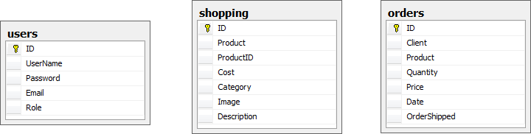

**Figure 7:** Database Table.

1. **WEBSITE TARGET**

* Anyone can view Online Shopping portal and available products, but every user must login by his/her Username and password in order to purchase or order products.
* Unregistered members can register by navigating to registration page.
* Only Admin will have access to modify roles, by default developer can only be an ‘Admin’.
* Once user register site, his default role will be ‘User’.

Security

* Pages of the website must be access in the way they were intended to be accessed.
* Included files shall not be accessed outside of their parent file.
* Administrator can only perform administrative task on pages they are privileged to access.
* Customers will not be allowed to access the administrator pages.

Efficiency and Maintainability

* Page loads should be returned and formatted in a timely fashion depending on the request being made.
* Administrators will have the ability to edit the aspects of the order forms, product descriptions, prices and website directly.

Admin login

I.D :

Role :- Admin wishes to login to the system

Precondition :- Username and Password

Success end Condition :- Main option of screen display

Failed end Condition :- User has entered incorrect Username and Password or both.

To Edit :

Precondition :- User has successfully navigated to the search result

Success end Condition :- User has successfully made the changes

Structure of the project :-

(Before Login) :

* Login
* Register
* Forget Password
* Administrator Login
* About Us
* Contact Us
* After Administrator Login
* Edit Website Details
* Add Brands
* Add Category
* Add Items
* Delete Brands
* Delete Category
* Delete Items
* Manage User
* See Users
* Users Shopping
* Add Users
* Delete Users
* Logout 

(After User Login) :

* My Profile
* Edit Profile
* Change Password
* Buy Products
* Categories (Controlled by Admin. which can be add dynamically acc. to needs)
* My Cart
* My Shopping’s
* Checkout
* Logout

Debugging

One must know what the problem is before it can be solved. The basis for ecommerce is to buy products online and save the timing. To know the facts and understanding of the problem in detail, System Analysis is carried out. It is the process of studying the business processes and procedures, generally referred to as business systems, to see how they can operate and whether improvement is needed.

1. **RESULTS**

1. Home Page :- The Home Screen will consist of screen where one can browse through the products which we have on our website.

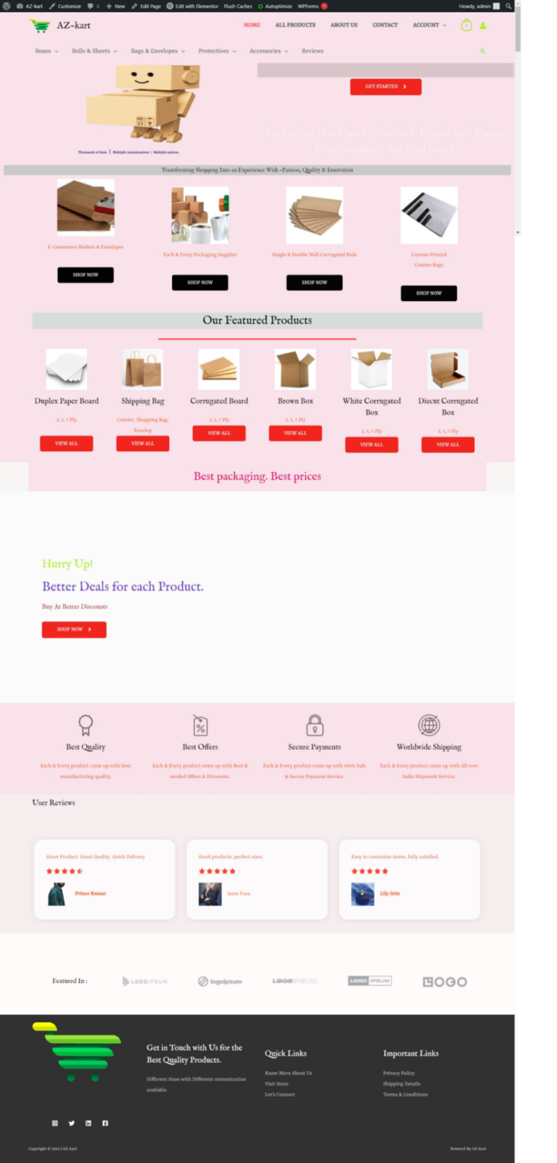

**Figure 8:** Home Page.

2. Products Page :- This page consists of product details. This page appears same for both visitors and users.

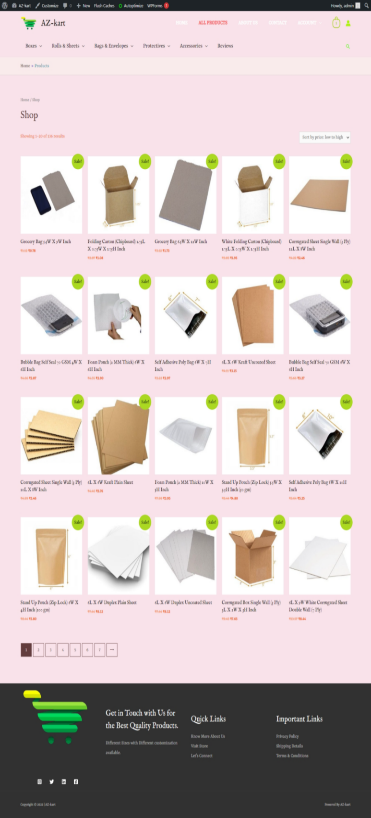

**Figure 9:** Products Page.

3. Order Page :- Registered users can order desired products from here.

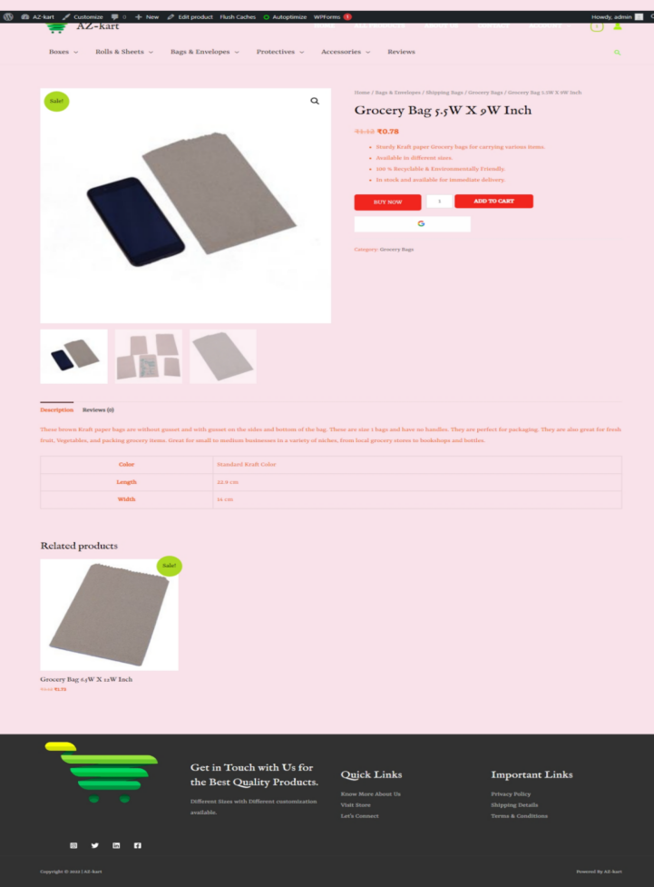

**Figure 10:** Order Us Page.

4. Contact Us Page :- Visitors and Registered users can contact website owners or administrators from here.

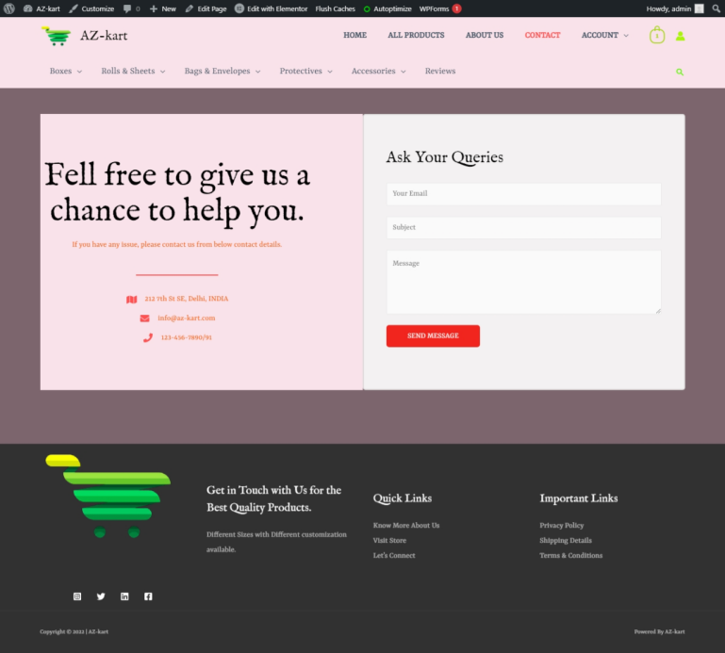

**Figure 11:** Contact Us Page

5. Register Page :- New users register here.

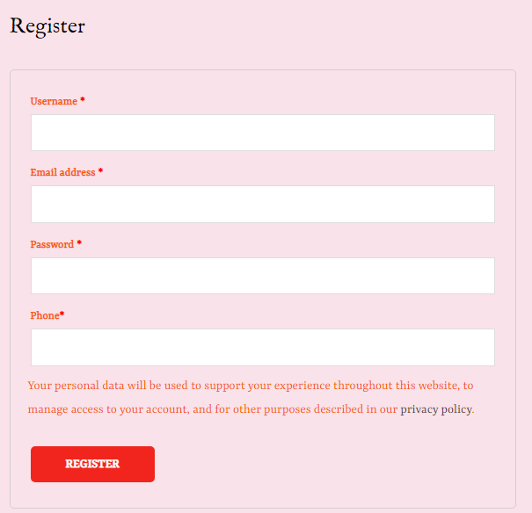

**Figure 12:** Register Page

6. Login Page :- Login page for both users and administrators.

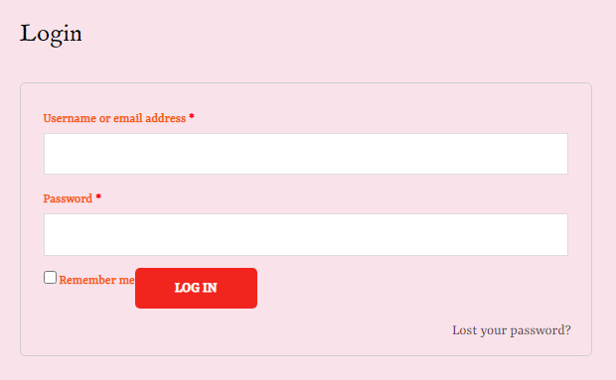

**Figure 13:** Login Page

7. Admin Page :- Only difference you see in this page is Role: Admin. User and Admin role will be checked once the page was login and Session [“role”] will be either Admin or User. If credentials belong to Admin then role will be Admin and if credentials belong to User then role will be User.

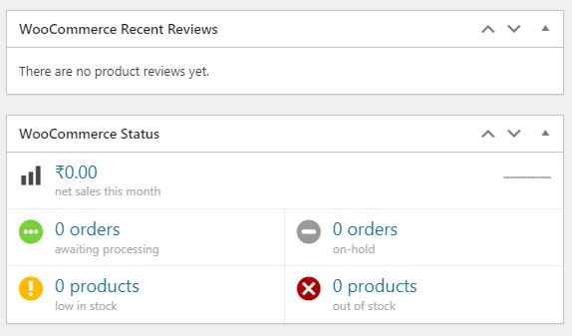

**Figure 14:** Admin Page

8. Order view Page :- Once users order item they are able to see ordered products and total.

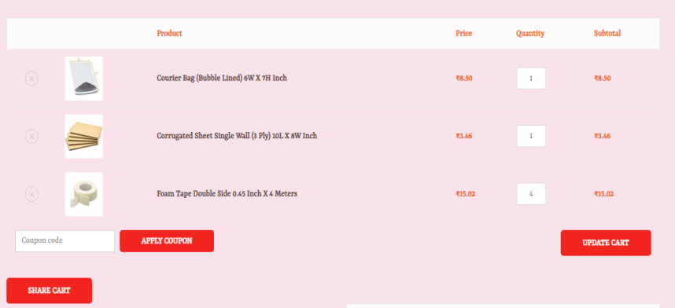

**Figure 15:** Order View Page

9. Payment Page :- Once users orders products they are redirected to payment page.

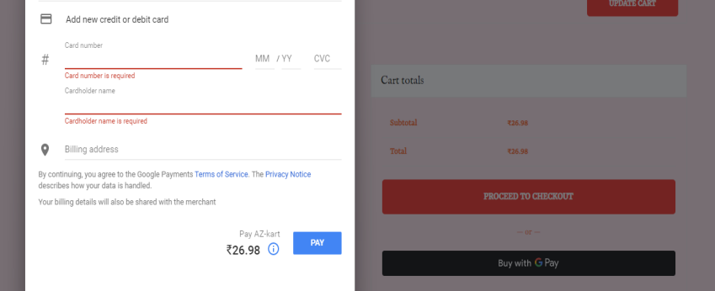

**Figure 16:** Payment Page

10. Payment Success Page :- Once users orders products they will receive success notification of the payment.

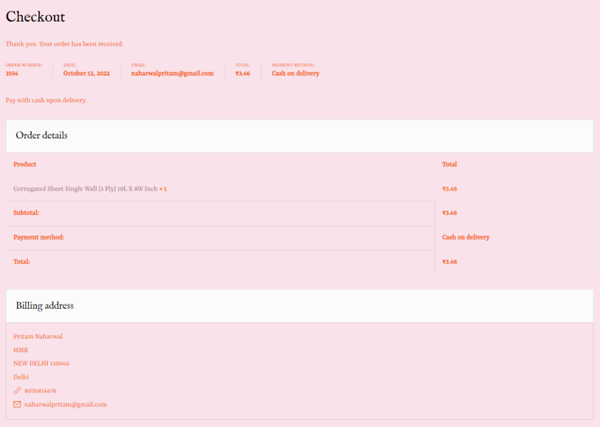

**Figure 17:** Payment Success Page

11. Payment Failure Page :- Users will receive products payment fail notification.

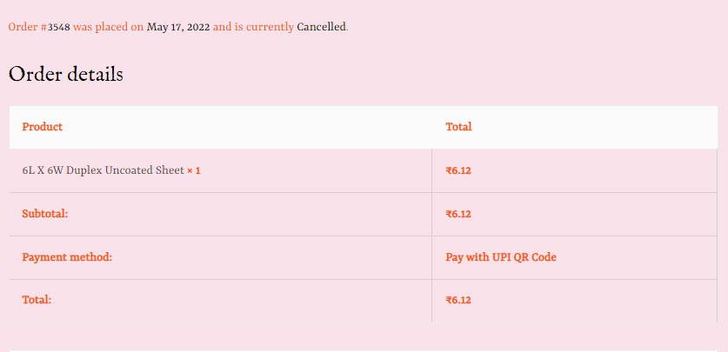

**Figure 18:** Payment Failure Page.

12. Privacy Policy Page :- It contains the policies of website.

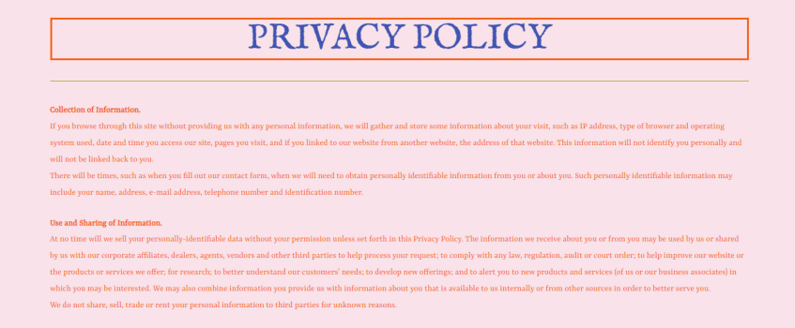

**Figure 19:** Privacy Policy Page

13. Terms & Conditions Page :- It contains all terms of the website.

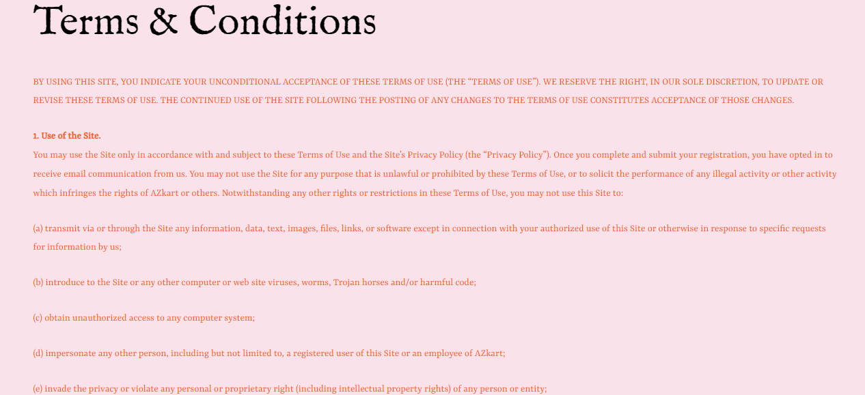

**Figure 20:** Terms & Conditions Page

14. Cart Page :- Users can track, ship orders here.

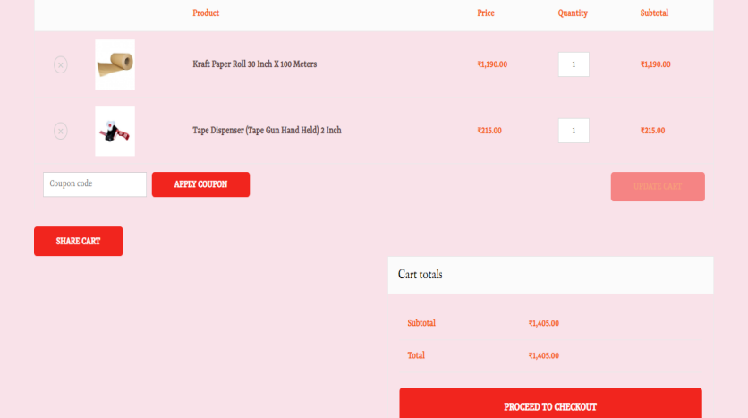

**Figure 21:** Cart Page

15. Track For Admin Page :- Website Administrators can track and ship orders here.

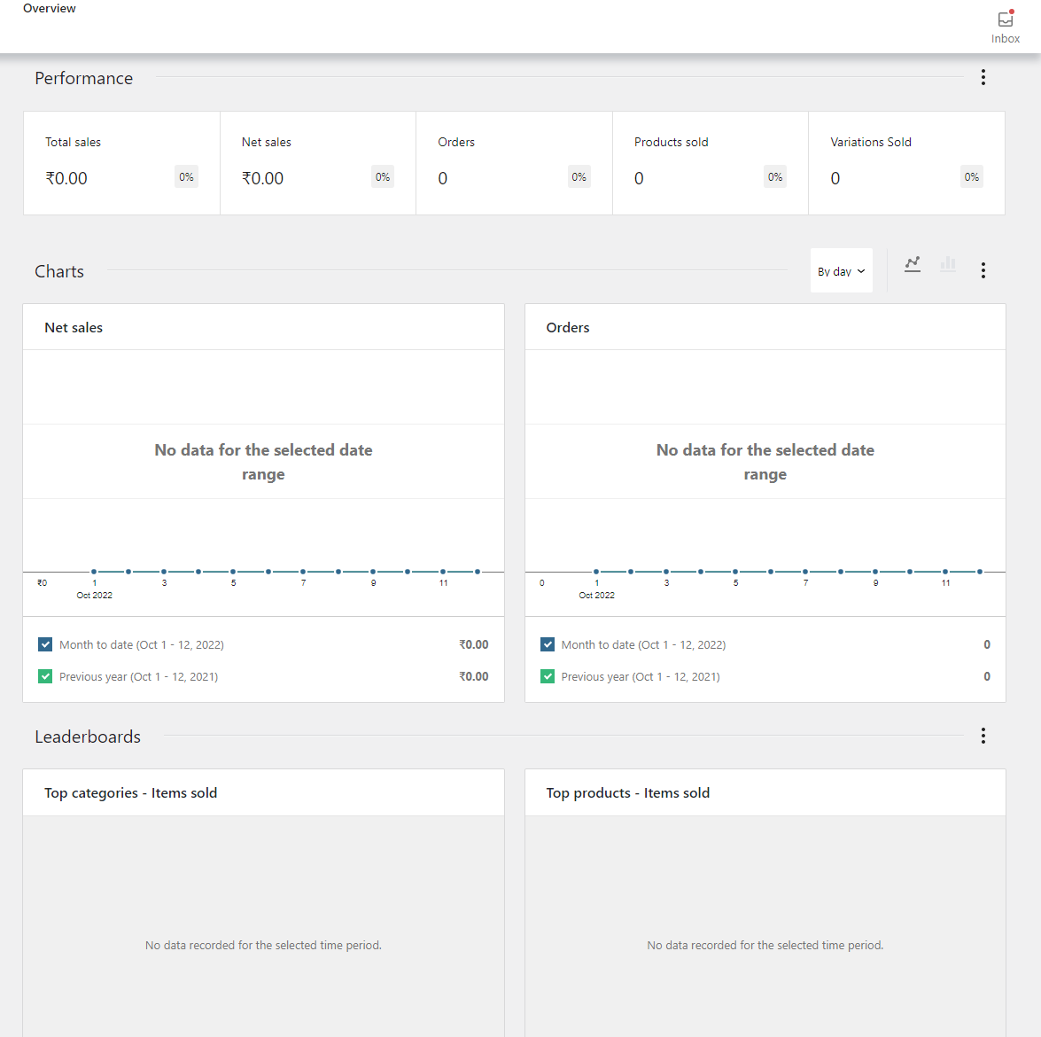

**Figure 22:** Tracking Page for Admin.

1. **FUTURE SCOPE**
2. commerce has grown at an exponential rate during the unprecedented outbreak of the COVID-19. Many companies, including small businesses have recognized the potential of selling their products through the Internet. COVID-19 has accelerated the shift towards a more digital world. It led to the expansion of e-commerce transactions, ranging from luxury goods and services to everyday necessities. E-commerce has increased across different product categories during the pandemic. More online users are using digital and mobile technologies to search about products or services.

Our designed online shopping system provides a 24×7 service, that is customers can surf the website, place orders anytime they wish to. Also, the delivery system works 24×7 hours a week. Some of the features that can be modified and added to this system in the future involve its implementation by local shopkeepers, where shops will be providing an online interface to customers for shopping and placing orders. Then some delivery persons can perform their work. This will be adding on benefit for the customers as it will save their time, plus it adds on for the shopkeepers also, as people will continue to shop from local shops rather than preferring to supermarkets every time.

Also, since the deliveries from these local vendors will not be as time-consuming as these days Flipkart, Amazon, etc. take but rather will be delivered the same day of an order placed. Else the shopkeeper can ask the customer that the product will be available by the next day, so if he/she still wants to place the order, it can be done. Again, return or exchange will be easy since the delivery boy can even do it as the store is nearby. Including a chatbox for public benefit is also a great idea via which people can directly have a conversation with some officials regarding any type of queries.

1. **CONCLUSION**

To conclude the description about the project: The project, developed using PHP and MySQL is based on the requirement specification of the user and the analysis of the existing system, with flexibility for future enhancement. The expanded functionality of today’s software requires an appropriate approach towards software development. This ecommerce software is designed E-commerce site project is developed using PHP, CSS, Bootstrap, and JavaScript. Talking about the project,it has all the required essential features. This project has a user side where he/she can view product category and add products to cart and proceed for checkout whereas from administration side he/she can view sales, number of product, users, daily sales report, add product and categories. The user can also leave comments on each product if he/she wants. In this project, all the main functions are performed from the Admin side.

Following is some of the key features of our system, which distinguishes it from others:

* Display all the available categories for shopping on the home page.
* Display all the subcategories on the home page, that are associated with any particular item.
* Admin has the authority to add new particulars to the items list whenever needed.
* Permission to the administrator to remove items, anytime.
* Allows the admin to modify the price of each item, whenever required or felt like.
* Admin has the authority to update the description of each item.
* Permission to the admin to view information about each customer who checkouts the items list.

This project helps in understanding the creation of an interactive web page and the technologies used to implement it. The design of the project which includes Data Model and Process Model illustrates how the database is built with different tables, how the data is accessed and processed from the tables. The building of the project has given me a precise knowledge about how ASP.NET is used to develop a website, how it connects to the database to access the data and how the data and web pages are modified to provide the user with a shopping cart application.Now it’s at ease to enter to a new market and marketers’ can easily evaluate their product and company’s performance. A growing number of firms in various industries, such as banking, education, commerce, and tourism, etc. have improved their services by both incorporating technologies into their service delivery process. Integration of technology in services is becoming very common; however, very little academic research has been conducted to examine its influence. The issues related to E-commerce are also on the rise which is posing serious threat to its tall future and hence demands right strategies on part of marketers.

The research works on E-commerce propose good number of variables to be taken care of if marketers need to be successful in this newly business model. The factors which will significantly contribute to the success of the E-Commerce industry and focused upon should be consistency of transaction steps, consistency of Web site design, replacement guarantee, M-Commerce services, consistency of promotions, consistency of in-stock indications, consistency of product variety, location based services, multiple payment option, right content, shipment option, legal requirement of generating invoices for online transactions, quick Service, T & C should be clear & realistic, the product quality should be same as shown on the portal. Our study, being conceptual in nature, raises a number of opportunities for future research, both in terms of theory development and concept validation. More empirical research will in fact be necessary to refine and further elaborate findings in the area of ecommerce. The study is an eye opener for the researchers who have ample interest in E-commerce. This review paper will offer them the leads towards the better understanding of the key variables of the recent E-commerce platform that is revolutionizing the business.

1. **REFERENCES**

[1] “Research on B2B2C E-commerce Website”, Lulu Cai, Xiangzhen He, Yug Dai, Kejian Zhu, IOP Conf. Series: 1087 (2018).

[2] “E-commerce websites, consumer order fulfillment and after-sales service satisfaction”, Mark Anthony Camilleri , MU, Scotland, Camilleri, M.A. (2021).

[3] “Research on E-commerce Platform of Online Shopping Consumers”, Yidan Wang, (ICEMCI 2021).

[4 ]“A Review Paper on E-Commerce & Business”, S. A. Bhat, J.M. Khan, K. Kansana, Asian Journal Research Paper.

1. “A Review Paper on E-Commerce”, Arul V, Galgotias University, Yamuna,Noida,, JETIR March 2019, Volume 6.
2. “Amazon, E-Commerce Website”, Sachin, Saurabh, (IJRASET), Vol 10 Issue VI June 2022.

[7] “Study & Development of E-Commerce Website”, Aaftab Aalam, Shivansh Mishra, Satyam Sharma, Richa Gupta, IRJET Vol 7, Issue: May 2020