PHP PROJECT FOR CREATING NEWS WEBSITE

# Vikas Rathod1 Yash Gupta 2

1Dept. of Computer Science & Engg.,1Tha.Shiv Kumar Memorial Engg.College, Burhanpur(M.P.), India.

# ABSTRACT

# The “Newsverse” basically a website ,provide a news of sports , movies and science. It can suggest top movies and web shows rating based on imdb, we can also read the news and articles on this website and also suggest a books like think and grow rich, as a man thinketh , the power of your subconscious mind.

# INTRODUCTION

We are living in the modern world where we starting consuming news form internet. Getting news from tv and news pepper are started getting old. So there comes news website who provide news from around the world. And our website provides news about almost everything happening the world with true stories and true events.

**Methodology**

**1.SDLC**

Software Development Life Cycle (SDLC) is a process used by the software industry to design, develop and test high quality softwares. The SDLC aims to produce a high-quality software that meets or exceeds customer expectations, reaches completion within times and cost estimates

.

quality of software and the overall development process..

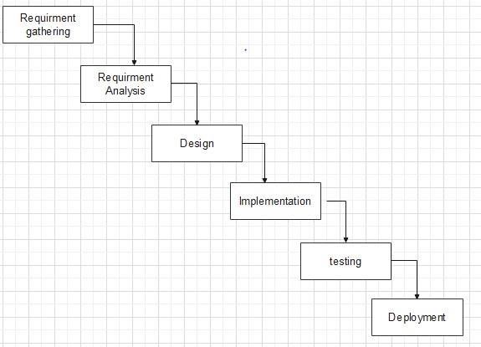

**Type of SDLC:-**

1. Waterfall Model
2. RAD Model
3. Spiral Model
4. Incremental Model
5. Iterative Model
6. Agile Model
7. V-Model

**a)Iterative Model**

In the Iterative model, iterative process starts with a simple implementation of a small set of the software requirements and iteratively enhances the evolving versions until the complete system is implemented and ready to be deployed.

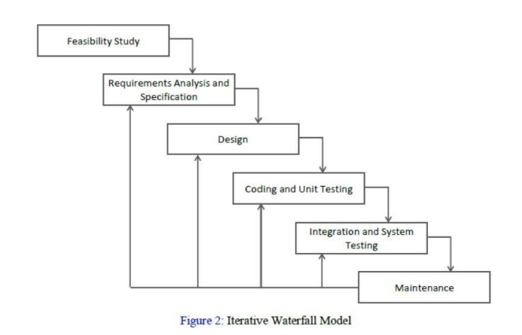

**2.Diagram**

**a) DFD (Data Flow Diagram):-** The data flow diagrams (DFD) depict the information flow and the transforms that are applied on the data as it moves from to output

**a.1)DFD LEVEL- 0 :-** Highest abstraction level DFD is known as Level 0 DFD, which depicts the entire information system as one diagram concealing all the underlying details. Level 0 DFDs are also known as context level DFDs.

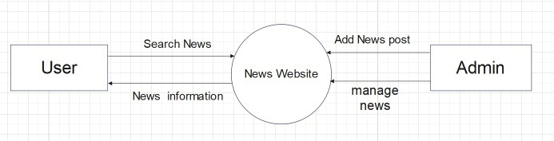

**b)Sequence Diagram** The sequence diagram represents the flow of messages in the system and is also termed as an event diagram. It helps in envisioning several dynamic scenarios. It portrays the communication between any two lifelines as a time-ordered sequence of events, such that these lifelines took part at the run time. In UML, the lifeline is represented by a vertical bar, whereas the message flow is represented by a vertical dotted line that extends across the bottom of the page.

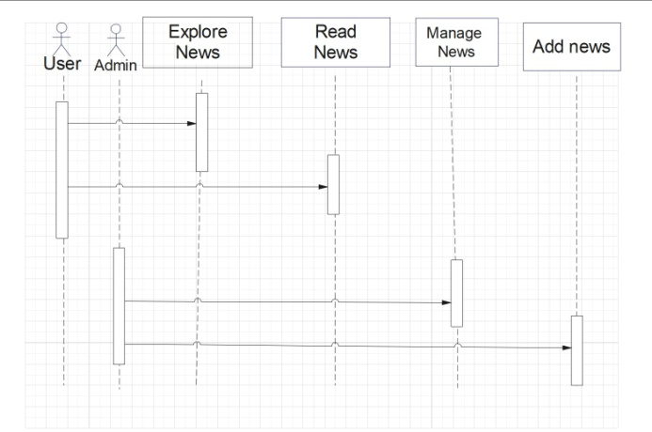

**c)Activity Diagram:-** In UML, the activity diagram is used to demonstrate the flow of control within the system rather than the implementation. It models the concurrent and sequential activities.The activity diagram helps in envisioning the workflow from one activity to another. It put emphasis on the condition of flow and the order in which it occurs.

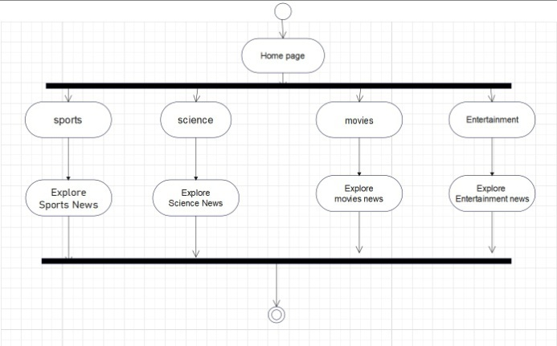

**d)Usecase diagram :-** A use case diagram is used to represent the dynamic behavior of a system. It encapsulates the system's functionality by incorporating use cases, actors, and their relationships. It models the tasks, services, and functions required by a system/subsystem of an application. It depicts the high-level functionality of a system and also tells how the user handles a system.

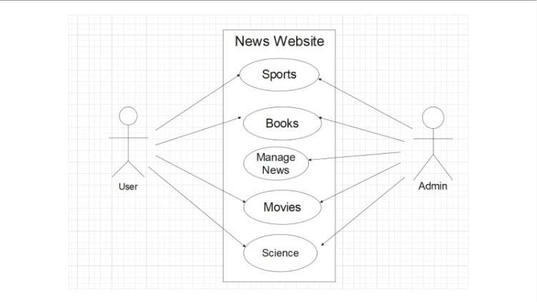

**IMPLEMENTATION**

**A.Technologies Used**

Various front-end and back-end technologies are available in this era of digitalization. The technologies used in this project are discussed briefly in the following sections.

**1.Front End Technologies**

***a) HTML***

HTML is a Markup Language which means you use HTML to simply "mark-up" a text document with tags that tell a Web browser how to structure it to display (Musciano & Kennedy,1996). Originally, HTML was developed with the intent of defining the structure of documents like headings, paragraphs, lists, and so forth to facilitate the sharing of scientific information between researchers.

***b) CSS***

CSS (Powell, 2010) stands for Cascading Style Sheets. CSS describes how HTML elements are to be displayed on the screen, paper, or in other media. CSS saves a lot of work. It can control the layout of multiple web pages all at once.

**c)JavaScript/JQuery**

JavaScript (JS) is a high level, interpreted programming language. JavaScript has curly-bracket syntax, dynamic typing, prototype-based object-orientation, and first-class functions.

Alongside HTML and CSS, JavaScript is one of the core technologies of the World Wide Web (Flanagan, 2006). JavaScript enables interactive web pages and is an essential part of web applications.

**d)BootStrap**

To use bootstrap, we are required to either install in our system or use CDN. CDN is short for content delivery network. A CDN is a system of distributes servers that deliver pages and other web content to a user, based on the geographic locations of the user, the origin of the

webpage and the content delivery server

**2. Back End Technologie**

**a)PHP**

# PHP, a server-side language that has been around for more than 25 years, tends to evoke some strong opinions among developers today. Whenever a new programming language or tool emerges, you’ll probably find a discussion over where PHP is ‘dead’. It is true that PHP has slipped down the rankings of the most popular programming languages, from 5th in 2017 to 8th in 2020 as per the Stack Overflow annual developer survey

## C:\Users\hp\Desktop\php-features.png

**RESULTS**

**Home :** This. the home page of Golden India

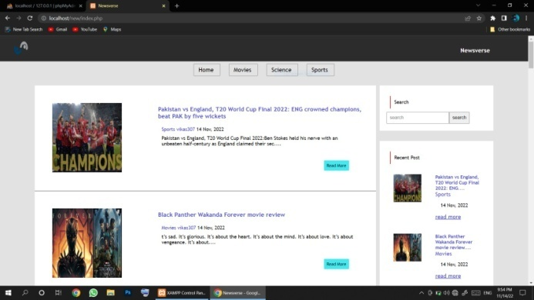

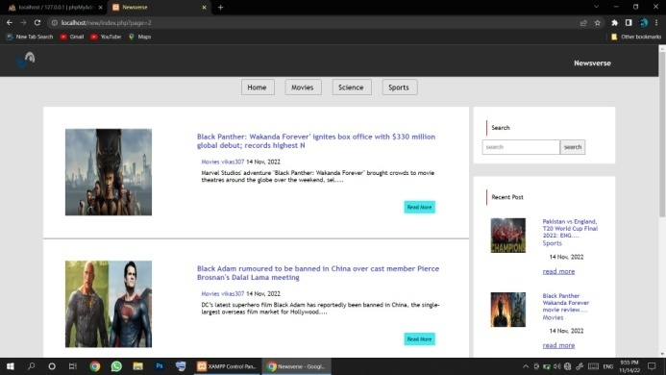

**CONCLUSION**

Fake information is very big problem on the internet. So many peoples manipulate peoples with the help of fake information. Many of the website gives you fake information and they paid by so many peoples who want do it for their own benefits. And there comes our website who gives you right information about every news as possible everyday and 24 hours. Regular updates on all genre and many more

**REFERENCES**

**a) Websites**

1. [**https://www.php.org/**](https://www.php.org/)
2. [**https://code.visualstudio.com/**](https://code.visualstudio.com/)
3. [**https://www.w3schools.com/php/**](https://www.w3schools.com/php/)
4. [**www.google.com**](http://www.google.com/)
5. [**https://itsourcecode.com**](https://itsourcecode.com/)

**c)Reference Research Paper**

**1**. Samra J. Comparing Performance of Plain PHP and Four of Its Popular Frameworks. Thesis Project. Linnaeus University, Sweden.

Available:<https://www.diva-portal.org/smash/get/diva2:846121/FULLTEXT01.pdf>

.

**2.** Nylén. H. PHP Framework Performance for Web Development Between Codeigniter and CakePHP. Bachelor Thesis. School of

Computing Blekinge Institute of Technology, Sweden. Available: http://www.diva-

portal.org/smash/get/diva2:831188/FULLTEXT01.pdf.