**Construction Chain Web Portal**

**Vaishnavi Rajaram Dhongade1, Sakshi Hemant Bhoir2, Yash Chandrakant Palde3, Atharva Prakash Mali4, N.S.Joshi5**

1Student, Information Technology, Sandip Foundation's Sandip Polytechnic, Nashik, Maharashtra, India

2Student, Information Technology, Sandip Foundation's Sandip Polytechnic, Nashik, Maharashtra, India

3Student, Information Technology, Sandip Foundation's Sandip Polytechnic, Nashik, Maharashtra, India

4Student, Information Technology, Sandip Foundation's Sandip Polytechnic, Nashik, Maharashtra, India

5 Professor, Information Technology, Sandip Foundation's Sandip Polytechnic, Nashik, Maharashtra, India

**ABSTRACT**

The construction industry is complex and involves a variety of stakeholders, from contractors and architects to engineers and suppliers. These stakeholders need to work together effectively to ensure the success of a construction project. However, communication and collaboration can be challenging, especially when working on large-scale projects that involve multiple parties. This is where a construction chain web portal comes in.

A construction chain web portal is a digital platform that connects various stakeholders in the construction industry. It is designed to facilitate communication and collaboration throughout the entire construction process, from the planning phase to project completion. The portal provides a range of features and tools to help users manage their projects effectively, including document sharing, project management tools, and communication channels. One of the key benefits of a construction chain web portal is that it provides a centralized platform for all stakeholders to communicate and share information. This helps to eliminate the need for multiple emails, phone calls, and meetings, which can be time-consuming and inefficient. Instead, all project-related information is stored in one place, making it easy for stakeholders to access and update as needed. Document sharing is an essential feature of a construction chain web portal. All project-related documents, including plans, specifications, and contracts, can be stored and accessed through the portal. This makes it easy for all stakeholders to access the latest versions of these documents, reducing the risk of errors or misunderstandings.

Project management tools are also an important feature of a construction chain web portal. These tools enable users to manage their projects effectively, from scheduling and budgeting to resource allocation and task delegation. They can also help to track progress and identify potential issues early on, allowing stakeholders to take corrective action as needed. Communication channels are another critical feature of a construction chain web portal. The portal can provide various communication channels, including messaging, video conferencing, and forums. These channels allow stakeholders to communicate in real-time, reducing the risk of miscommunication and delays. They also make it easier for stakeholders to stay up-to-date on project developments and address any issues promptly. In addition to these features, a construction chain web portal can also offer educational resources, such as training videos and articles, to help stakeholders improve their skills and stay up-to-date with industry developments. This can be especially useful for small businesses and independent contractors who may not have access to the same resources as larger companies.

Overall, a construction chain web portal is a valuable tool for stakeholders in the construction industry. By providing a centralized platform for communication and collaboration, it can help to streamline project management, reduce the risk of errors and delays, and improve the overall quality of construction projects.

**Keywords:** Construction industry, Stakeholders, Collaboration, Project management, Document sharing, Communication channels, Resource allocation, Real-time communication, Educational resources, Centralized platform.

1. **INTRODUCTION**

The construction industry is a highly complex and multi-faceted field that requires the cooperation and collaboration of a wide range of stakeholders to complete any given project successfully. The stakeholders include architects, engineers, contractors, sub-contractors, suppliers, and clients. With so many different parties involved, effective communication and coordination are crucial. This is where a construction chain web portal comes in.

A construction chain web portal is a digital platform that connects the different stakeholders involved in a construction project. The platform helps streamline communication and collaboration among stakeholders throughout the project lifecycle, from planning and design to construction and completion. The portal provides a range of features and tools to help stakeholders manage their projects effectively, including document sharing, project management tools, and communication channels. One of the key benefits of a construction chain web portal is that it provides a centralized location for all project-related information. Instead of relying on numerous emails, phone calls, and meetings, all project-related information is stored and accessed through the portal. This makes it easy for stakeholders to stay up-to-date on the latest developments and track progress.

Document sharing is another important feature of a construction chain web portal. All project-related documents, such as plans, specifications, contracts, and invoices, can be stored and accessed through the portal. This ensures that stakeholders always have access to the latest versions of these documents, reducing the risk of errors or misunderstandings. Project management tools are also a critical feature of a construction chain web portal. These tools enable stakeholders to manage their projects effectively, from scheduling and budgeting to resource allocation and task delegation. The portal can also provide tools to help stakeholders track progress and identify potential issues early on, allowing stakeholders to take corrective action as needed.

Communication channels are another essential feature of a construction chain web portal. The portal can provide various communication channels, including messaging, video conferencing, and forums. These channels allow stakeholders to communicate in real-time, reducing the risk of miscommunication and delays. They also make it easier for stakeholders to stay up-to-date on project developments and address any issues promptly. In addition to these features, a construction chain web portal can also provide educational resources, such as training videos and articles. These resources can help stakeholders improve their skills and stay up-to-date with industry developments. This can be especially useful for small businesses and independent contractors who may not have access to the same resources as larger companies.

In summary, a construction chain web portal is an essential tool for stakeholders in the construction industry. By providing a centralized platform for communication and collaboration, the portal can help to streamline project management, reduce the risk of errors and delays, and improve the overall quality of construction projects.

1. **METHODOLOGY**

The development of a construction chain web portal involves several steps and methodologies. The following is an overview of the typical methodology used in the development of a construction chain web portal:

* **Requirements gathering:** The first step in developing a construction chain web portal is to gather requirements from all stakeholders. This involves conducting interviews, surveys, and workshops to identify the needs and expectations of each stakeholder group. The requirements are then compiled into a comprehensive list that serves as the basis for the development of the portal.
* **Design:** Once the requirements have been gathered, the next step is to design the portal. This involves creating wireframes and prototypes to visualize the layout and functionality of the portal. The design phase is iterative, with multiple rounds of feedback and refinement from stakeholders.
* **Development:** After the design has been finalized, the development phase begins. This involves coding the portal and integrating the various features and functionalities. The development team works closely with the stakeholders to ensure that the portal meets their needs and expectations.
* **Testing:** Once the portal has been developed, it undergoes rigorous testing to identify and resolve any bugs or issues. The testing phase involves both automated and manual testing to ensure that the portal is reliable, secure, and user-friendly.
* **Deployment:** Once the portal has been tested and approved, it is deployed to the production environment. The deployment phase involves setting up the necessary infrastructure, configuring the portal, and training stakeholders on how to use the portal effectively.
* **Maintenance:** After the portal has been deployed, it requires ongoing maintenance to ensure that it remains secure and up-to-date. This involves monitoring the portal for bugs and issues, updating software and security patches, and providing support to stakeholders as needed.

Throughout the development process, agile methodologies are often used to facilitate collaboration and flexibility. Agile methodologies involve breaking the development process into small, manageable tasks that can be completed quickly and efficiently. This allows stakeholders to provide feedback and make changes throughout the development process, ensuring that the final product meets their needs and expectations.

1. **MODELING AND ANALYSIS**

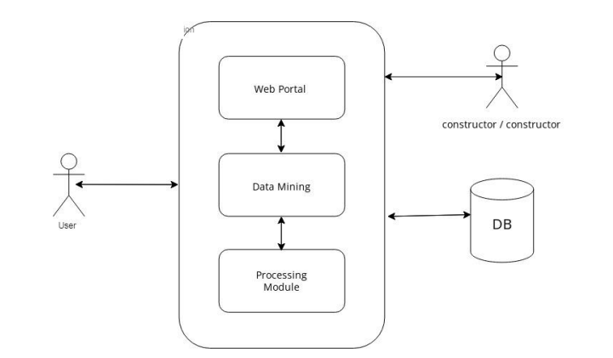

**Figure 1:** System Architecture.

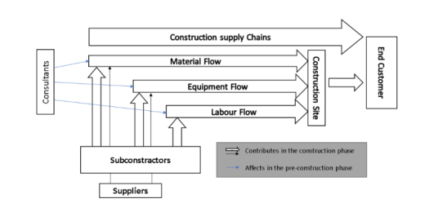

**Figure 2:** Construction Supply Chain.

An analysis of a construction chain web portal involves evaluating the portal's effectiveness in meeting the needs of stakeholders in the construction industry. The following are some key areas to consider when analyzing a construction chain web portal:

* **Communication and Collaboration:** One of the primary benefits of a construction chain web portal is its ability to facilitate communication and collaboration among stakeholders. An analysis of the portal should consider how well it enables stakeholders to communicate in real-time and collaborate effectively throughout the project lifecycle. The portal should provide various communication channels, such as messaging, video conferencing, and forums, to accommodate the different communication needs of stakeholders.
* **Document Management:** Another critical aspect of a construction chain web portal is its ability to manage project-related documents effectively. The portal should provide a centralized location for all project-related documents, including plans, specifications, contracts, and invoices. Stakeholders should be able to access the latest versions of these documents easily, and the portal should provide tools to track document changes and revisions.
* **Project Management:** A construction chain web portal should also provide project management tools to help stakeholders manage their projects effectively. The portal should enable stakeholders to schedule tasks, allocate resources, track progress, and manage budgets. It should also provide tools to identify potential issues early on, allowing stakeholders to take corrective action as needed.
* **User Experience:** The portal's user experience is another crucial factor to consider when analyzing a construction chain web portal. The portal should be user-friendly, intuitive, and easy to navigate. It should provide a seamless experience for stakeholders, with a consistent design and interface throughout the portal.
* **Security:** A construction chain web portal must be secure to protect project-related information from unauthorized access and cyber threats. The portal should employ robust security measures, such as data encryption, firewalls, and access controls. The portal should also comply with industry standards and regulations, such as GDPR and HIPAA.
* **Integration:** The portal should be integrated with other software and tools commonly used in the construction industry, such as CAD software, scheduling tools, and accounting software. This integration should be seamless and transparent to stakeholders, enabling them to work with their preferred software while still accessing all project-related information through the portal.
* **Support:** The portal should provide comprehensive support to stakeholders, including technical support, training, and resources. The support should be responsive and timely, addressing any issues or concerns raised by stakeholders promptly.

1. **RESULTS AND DISCUSSION**

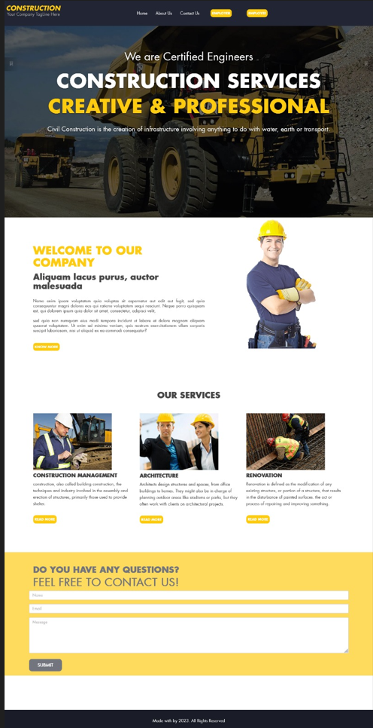

**Figure 1:** Snapshot.

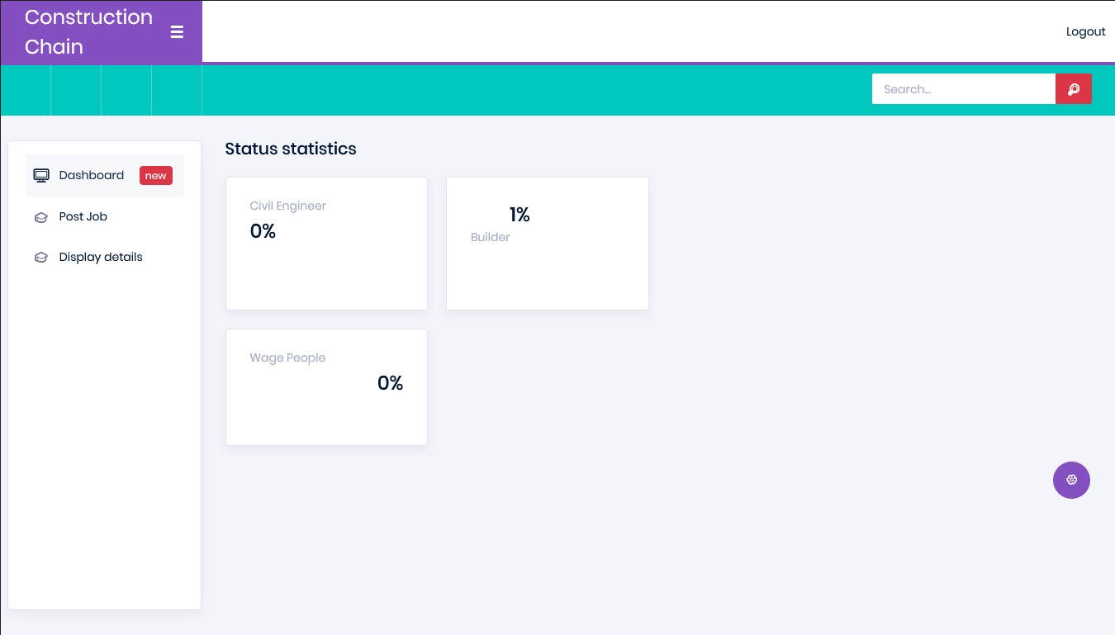

**Figure 2:** Snapshot.

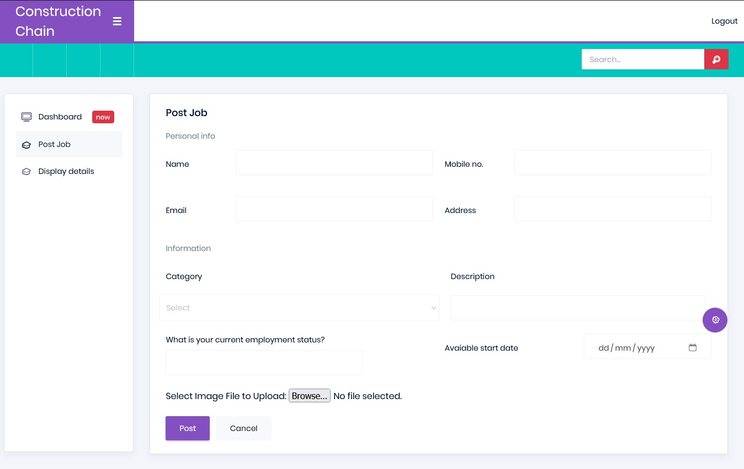

**Figure 3:** Snapshot.

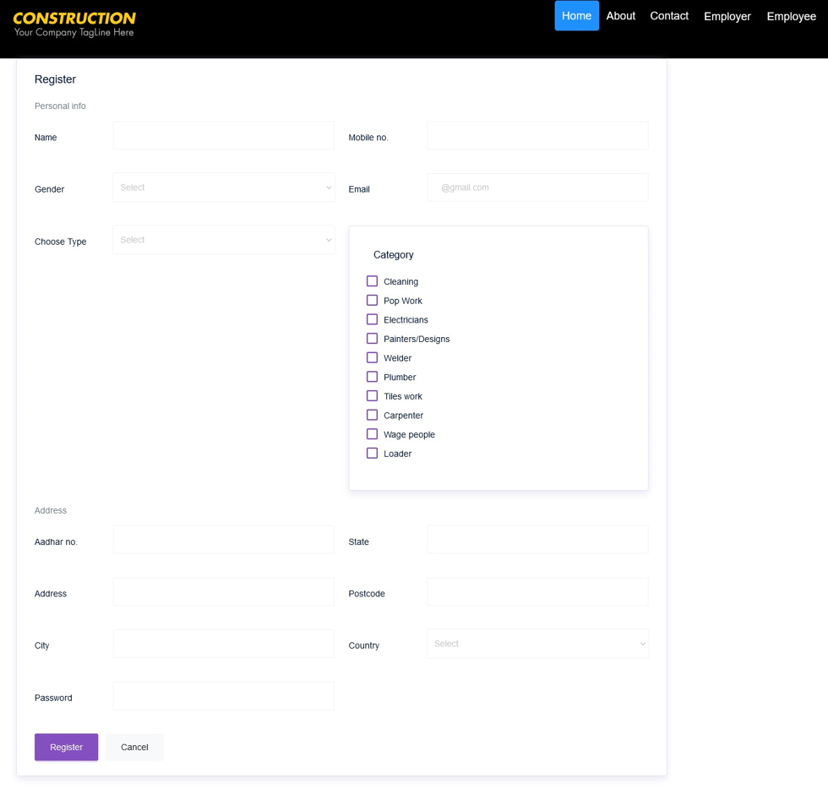

**Figure 4:** Snapshot.

The development and implementation of a construction chain web portal can have a significant impact on the construction industry. By providing a centralized location for project-related information, the portal can improve communication, collaboration, and efficiency among stakeholders, leading to better project outcomes and customer satisfaction.

One of the main advantages of a construction chain web portal is that it allows stakeholders to access project information from anywhere at any time. This can be particularly valuable for stakeholders who are working remotely or who need to access project information while on-site. The portal can also help reduce project timelines by providing real-time access to project status updates, allowing stakeholders to quickly identify and address issues as they arise. Another key benefit of a construction chain web portal is that it can improve communication and collaboration among stakeholders. By providing a centralized location for all project-related information, the portal can help ensure that all stakeholders are on the same page and have access to the same information. This can help reduce misunderstandings and conflicts, leading to better project outcomes.

However, there are also challenges associated with the development and implementation of a construction chain web portal. One of the main challenges is ensuring that the portal is user-friendly and meets the needs and expectations of stakeholders. This requires careful planning and design, as well as ongoing feedback and support to ensure that the portal continues to meet the needs of users over time. Another challenge is ensuring the security of the portal and its data. Because the portal may contain sensitive project-related information, it is important to implement robust security measures to protect against unauthorized access and data breaches.

Despite these challenges, the potential benefits of a construction chain web portal are significant. By embracing this technology, stakeholders in the construction industry can optimize their performance, reduce costs and timelines, and achieve successful project outcomes.

1. **CONCLUSION**

In conclusion, a construction chain web portal is a powerful tool that can transform the way stakeholders in the construction industry collaborate, communicate, and manage their projects. By providing a centralized location for all project-related information, the portal can help stakeholders work more efficiently and effectively, reducing project timelines and costs. The portal can also improve communication and collaboration among stakeholders, leading to better project outcomes and customer satisfaction.

To develop a successful construction chain web portal, it is essential to follow a rigorous methodology that involves gathering requirements, designing the portal, developing it, testing it, deploying it, and maintaining it. Throughout the development process, agile methodologies can help facilitate collaboration and flexibility, ensuring that the final product meets the needs and expectations of stakeholders. An analysis of a construction chain web portal should consider various factors, including communication and collaboration, document management, project management, user experience, security, integration, and support. By evaluating these factors, stakeholders can identify areas for improvement and optimize the portal's performance to achieve successful project outcomes.

In summary, a construction chain web portal has the potential to revolutionize the construction industry, enabling stakeholders to work more effectively, efficiently, and collaboratively. By embracing this technology, stakeholders can unlock new opportunities for growth and success in an increasingly competitive market.

1. **REFERENCES**
2. B. A. M. Sauer and M. Heine, "Development and implementation of a web-based construction chain management system," in Journal of Construction Engineering and Management, vol. 133, no. 5, pp. 345-354, 2007. <https://doi.org/10.1061/(ASCE)0733-9364(2007)133:5(345)>
3. C. Zhang and Y. Li, "A Construction Chain Management System Based on Web Service," in 2012 Second International Conference on Instrumentation, Measurement, Computer, Communication and Control, 2012, pp. 209-212. <https://doi.org/10.1109/IMCCC.2012.48>
4. F. Froschauer, C. Diendorfer and A. Kolbe, "Construction Supply Chain Management Using a Web-based Collaboration Platform," in Journal of Information Technology in Construction (ITcon), vol. 17, pp. 166-180, 2012. <http://www.itcon.org/2012/10>
5. H. K. Lee, K. Kim and J. J. Kim, "A web-based construction supply chain management system," in Automation in Construction, vol. 14, no. 6, pp. 768-776, 2005. [https://doi.org/10.1016/j.autcon.2005.04.011](%20https:/doi.org/10.1016/j.autcon.2005.04.011)
6. P. M. D. Silva, H. Almeida, L. Soibelman and G. G. de Melo, "A web-based platform for construction supply chain management," in Journal of Computing in Civil Engineering, vol. 30, no. 2, 2016. <https://doi.org/10.1061/(ASCE)CP.1943-5487.0000516>
7. T. R. Ahmed, S. S. Ahmed, M. A. Hasan and M. S. Alam, "A Framework for Web-based Construction Chain Management System," in 2018 International Conference on Electrical, Computer and Communication Engineering (ECCE), 2018, pp. 71-74. <https://doi.org/10.1109/ECACE.2018.8477317>