AUTOMATIC TRAFFIC OVERCROWDING USING DEEP LEARNING

|  |  |  |  |
| --- | --- | --- | --- |
| N.Akhila | N.Sri Ramya | K.Shivani | P.Tanuj Kumar |
| Senior Assistant Professor | Student | Student | Student |
| *Department of CSE* | *Department of CSE* | *Department of CSE* | *Department of CSE* |
| *AEC*, Surampalem | *AEC*, Surampalem | *AEC*, Surampalem | *AEC*, Surampalem |
| [akhila.nalla@aec.edu.in](mailto:akhila.nalla@aec.edu.in) | [19A91A0537@aec.edu.in](mailto:19A91A0537@aec.edu.in) | [19A91A0529@aec.edu.in](mailto:19A91A0529@aec.edu.in) | [19A91A0541@aec.edu.in](mailto:19A91A0541@aec.edu.in) |

***Abstract:* A prototype used to handle issues with traffic congestion is the traffic control management. One of the major variables affecting the traffic flow is the traffic lights. Traffic congestion causes accidents in which people may perish. The research involves autonomously calculating the green light period based on current traffic at the signal and identifying license plates of vehicles that violate traffic laws. The proposed system includes a feature that looks for the license plate of a car that is disobeying traffic signals. Additionally, the proposed system has autonomous traffic light switching based on vehicle density.Depending on how many vehicles are in the line, the signal will change automatically. As opposed to the way with less traffic, the direction with more traffic will receive a green signal for a longer period of time because of this. When cars disregard traffic signals, their license plates are photographed.In order to do this, we use camera footage as our input and identify the moving objects that are disobeying the law. We also offer an automatic traffic light adjustment.Depending on the density of the vehicles, we adjust the signals. By doing this, we can lessen the amount of times cars violate traffic signals. Additionally, we can lessen accidents brought on by high traffic.**

**Technologies Used: Python, Jupyter notebook, and other technologies You Only Look Once [YOLO] V3 model, Region of Interest [ROI], Convolution Neural Network [CNN], YOLOV3, signal switching algorithm, and Pygame for simulation model are some examples of deep learning techniques.**

***Keywords: Traffic, License plate,Vehicles, Accidents***

I.INTRODUCTION

Recently, there have been more accidents on the highways. The majority of these collisions take place at signal and highway crossings.The increased traffic in our quickly populating world is the cause of that issue. Traffic has increased as a result of the growing population. This generation is willing to purchase a single automobile, which is the primary cause of the rise in traffic in society. To reduce the risks and challenges that arise when the traffic regulations are not adhered to as stated, the traffic must be regulated at all costs. Manually enforcing traffic laws and regulations to ensure traffic flow is becoming more and more challenging as there are more vehicles on the road.Traffic management tools are used at traffic lights to spot automobiles and bicycles that are operating illegally. Automating these processes will improve their effectiveness and require a system that can instantly identify a vehicle.

Traffic violations are serious crimes that put both drivers and

pedestrians lives in danger. Real-world issues including longer travel times, excessive fuel use, weariness, and higher pollution can be seen as a result of the infractions. Drivers frequently have to pay fines, receive tickets for moving offenses, or even face arrest as a result of charges.

Minor and significant violations are the two categories into which traffic infractions fall. Parking in a prohibited location, a no parking zone, a handicapped zone, or trespassing areas are examples of minor infractions. More serious offenses including reckless driving and accident-related problems are considered major offenses. Each city and state has its own set of traffic laws. Before entering the city, it is the individual's responsibility to be aware of their legal rights.Most nations have harsh penalties for breaching traffic laws, which can result in license suspension. Documents you must have with you when riding a two-wheeler on Indian highways

1. ARCHITECTURAL DESIGN FOR PROPOSED SYSTEM:
2. *Existing system****:***

This traffic law was broken. System for detection:

The system consists of two primary parts: a graphical user interface (GUI) and a model for detecting vehicles. The developed algorithm successfully identified the types of violations stated for this project, including disobeying traffic signals, parking in no-parking zones, and going in the incorrect direction. Given that each has a different threshold condition, the convergence of detection for the three types of traffic offenses listed is varied.

Image processing is used in the smart traffic control system:

Instead of employing electronic sensors buried in the pavement, the system will detect automobiles using photographs. There will be a camera set up next to the traffic light. It will record video clips.The acquired photos are successively matched using image matching, utilizing an image of a deserted road as the reference image. Edge detection has been performed for this purpose using the Prewitt edge detection operator, and it can be regulated based on the percentage of matching traffic light durations.

1. *Proposed system:*

The proposed system aims to reduce traffic violations and improve traffic flow through various tasks such as object detection, image segmentation, and traffic signal control. The system involves detecting license plates, traffic violations such as crossing red signals and not wearing helmets, and classifying different types of vehicles. To achieve these tasks, the system will use machine learning techniques such as YOLOv3 for object detection and CNNs for vehicle classification. YOLOv3 is a neural network architecture known for its speed and accuracy in detecting objects,

# 1

including small objects like license plates and helmets. CNNs, on the other hand, are commonly used for image classification and are good at identifying visual patterns and features in images. However, developing such a system will require a significant amount of data and expertise in designing, training, and evaluating machine learning models.

1. BLOCK DIAGRAM

The proposed system aims to reduce traffic violations and improve traffic flow through various tasks such as object detection, image segmentation, and traffic signal control. The system involves detecting license plates, traffic violations such as crossing red signals and not wearing helmets, and classifying different types of vehicles. To achieve these tasks, the system will use machine learning techniques such as YOLOv3 for object detection and CNNs for vehicle classification. YOLOv3 is a neural network architecture known for its speed and accuracy in detecting objects, including small objects like license plates and helmets. CNNs, on the other hand, are commonly used for image classification and are good at identifying visual patterns and features in images. However, developing such a system will require a significant amount of data and expertise in designing, training, and evaluating machine learning models.

In software engineering, a system architecture is a conceptual model that defines the structure and behavior of a system. It showcases the connections between the different components of the system and describes the functions that the system performs. In the context of traffic control management, the system architecture depicts how the traffic violation detection system and automatic signal switching work in tandem to manage traffic flow. Additionally, a workflow diagram is a visual representation of the steps involved in a project or process, providing a clear understanding of the sequence of tasks, who is responsible for performing them, and how they will be completed. It is a highly effective tool for simplifying complex business processes and improving their efficiency. Together, a well-designed system architecture and workflow diagram are essential for ensuring the successful implementation of a project and achieving its objectives.

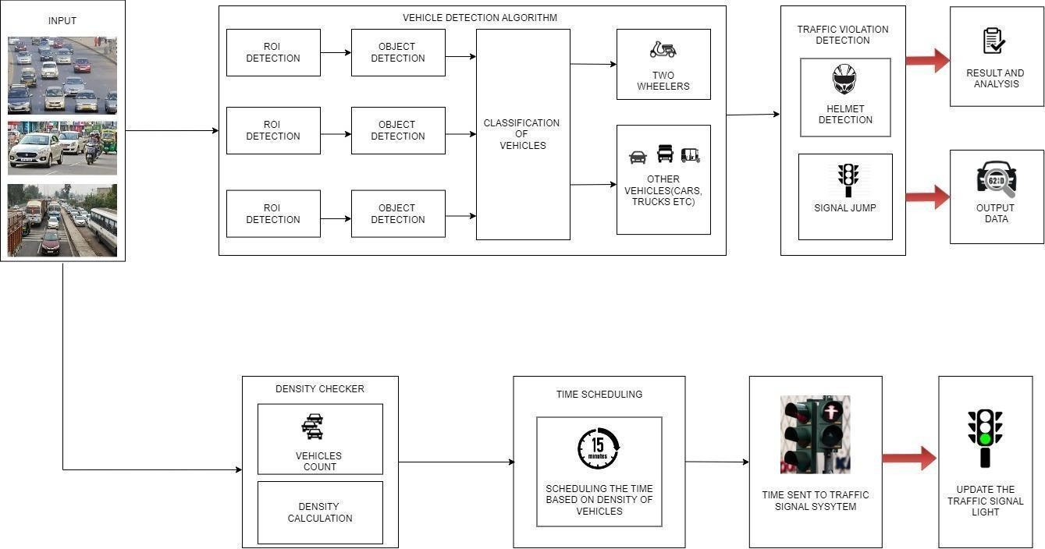

Fig 1.Block Diagram

1. RESULTS
   1. *OUTPUT OF HELMET DETECTION*

Fig 2 represents to image as input containing two wheelers wearing helmet.It should detect the person who wears helmet and gives the confidence percentage of person and helmet.

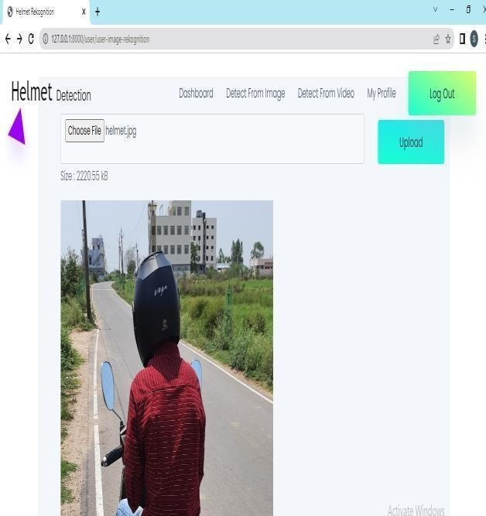

Fig 2. Detection of Helmet

* 1. *OUTPUT OF AUTOMATIC TRAFFIC SIGNAL SWITCHING*

For the first cycle , the green signal timer for the four lanes are given defaultly as 10 sec. After the first cycle of signal switching is completed , then automatically vehicle detection and simulation algorithm comes into play

For the remaining cycles , the green signal timer for four lanes updates according to the density of vehicles on the particular lane.

Only one green signal timer of a lane switches at a time , while the remaining lane signals switch to red and yellow.

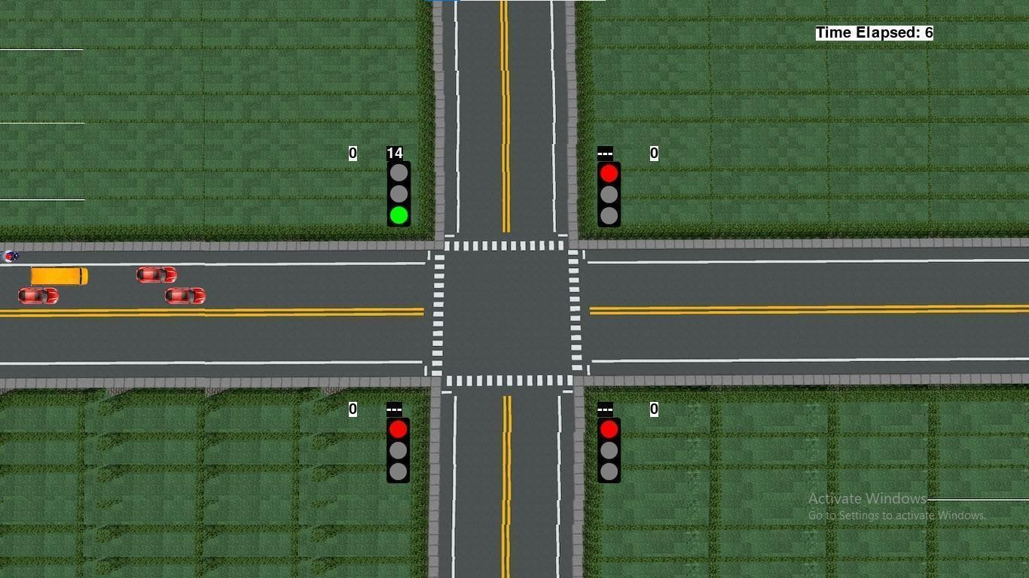

Fig 3. Way traffic signal stimulation

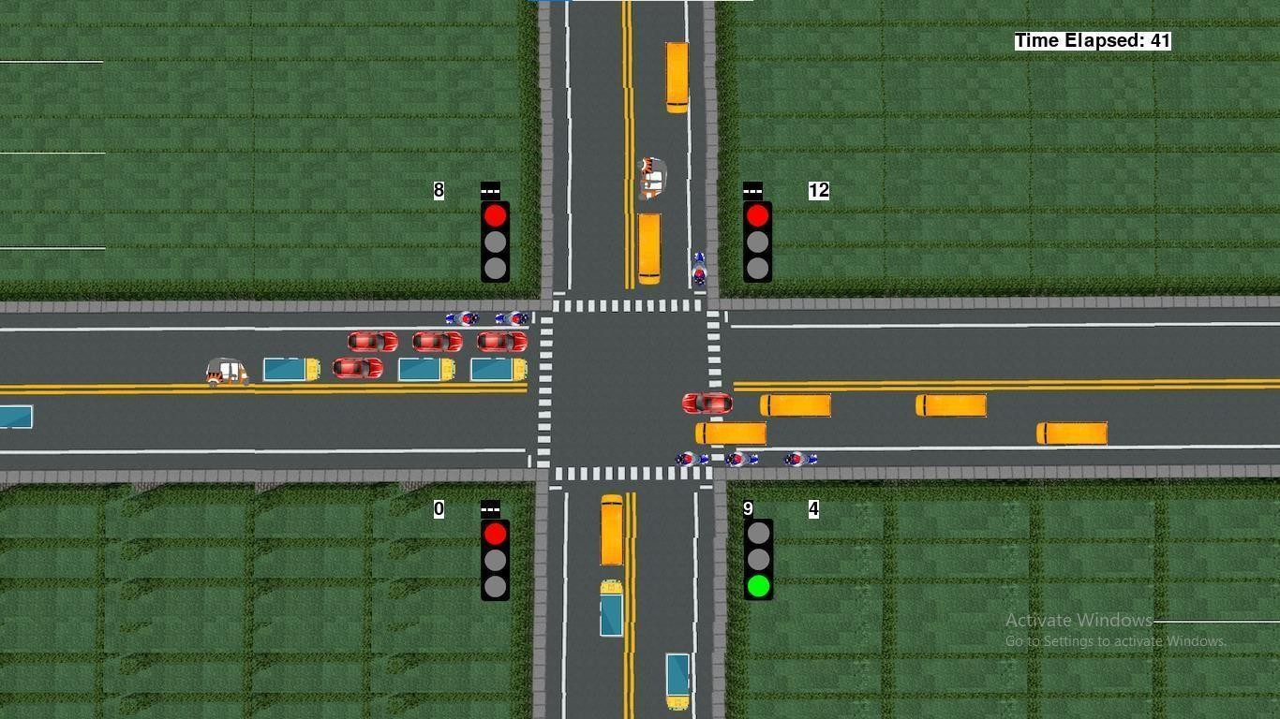 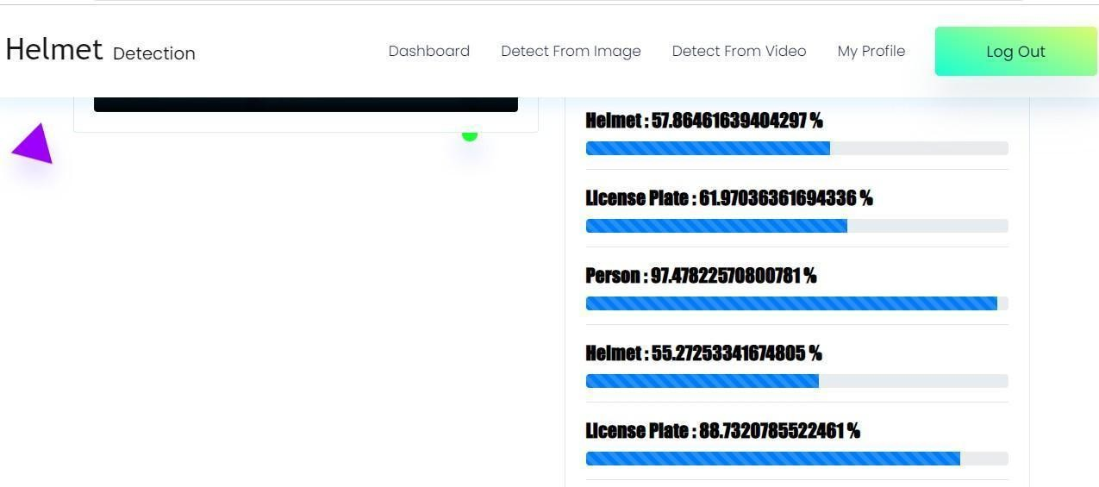

Fig 4. Green signal timer is 10 seconds for 3rd lane during first cycle

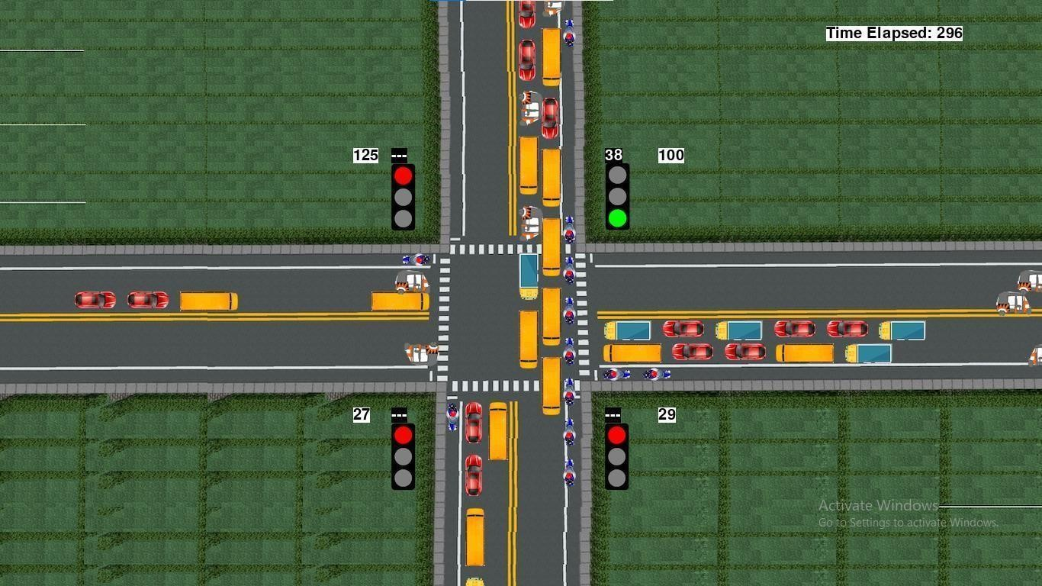

Fig 5.Green signal timer updates to 38 seconds based on its density on 2nd lane

* 1. *OUTPUT OF LICENSE PLATE DETECTION*

Fig 6 represents the license plate detection if there is no helmet.

A video was uploaded as an input to detect the number plate and helmet.

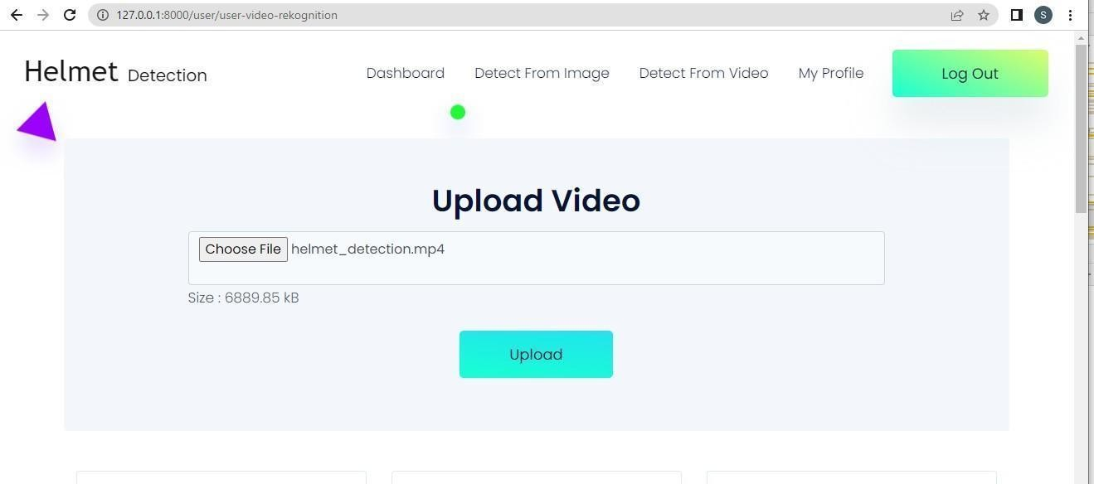

Fig 6. Video was given as input

Fig 7. Accuracy of helmet and license plate detection

1. CONCLUSION AND FUTURE SCOPE

*A.Conclusion:*

Current estimates of deep learning calculations based on the current NSL dataset include ANN, CNN, Random Forest, and help vector machine estimates. Results indicate that the profound learning calculation outperformed SVM, ANN, RF, and CNN in terms of fundamental performance. On the basis of this dataset, we will eventually use port sweep operations as well as other sorts of assault using AI and deep learning calculations, Apache Hadoop, and sparkle technologies. All of these computations aid in the network cyber attack detection. When we go back over many years, there may have been several attacks; when these attacks are recognized, the features at which values these attacks are occurring are saved in various datasets.

We will therefore be able to forecast whether or not a cyberattack will be carried out using these datasets. Four algorithms, including SVM, ANN, RF, and CNN, are capable of making these predictions. This study assists in determining which algorithm has the highest accuracy rates and best results in predicting whether or not cyberattacks will occur.

*A. Future Scope:*

To improve accuracy, we will incorporate some ML algorithms. In the future, we would like to use machine learning technology to implement a project. We will be able to stop hacker attacks thanks to this project. To obtain accurate findings, we shall test after training the data set. People learned how to secure their information from this project.

Network packets are examined for common patterns to carry out this attack. DDoS security frequently resembles a game of cat and mouse. Defenders look for recurring patterns in the spoofed requests while attackers aim to make DDoS packets unique by forging every field. Attackers can produce DDoS packets that closely resemble actual user actions with the aid of machine learning (ML).Normal communication can be sniffed, and after that, neural networks like GAN can be trained to send reliable packets. This space may undergo major modifications as a result of the employment of ML in DDoS attacks. The results of current research and its application in goods demonstrate that ML genuinely functions and is here to stay. Otherwise, hackers will begin to

anticipate opportunities and gain from ML.

Modern cybersecurity solutions are supported by machine learning in a variety of ways. Each one is valuable on their own, but taken as a whole, they change the game when it comes to maintaining a strong security posture in a shifting threat environment. By creating robust machine learning models, we can stop network assaults in addition to detecting them in the future.In the future, we'll develop more functionality by integrating new machines and technology.

1. REFERENCE
2. Junho Hong*, Student Member, IEEE, Chen-Ching Liu*+, Fellow, IEEE, Manimaran Govindarasu#, Senior Member, IEEE

* Washington State University, + University College Dublin, # Iowa State University.

1. Kamran Shaukat, Suhuai Luo, Shan Chen The University of Newcastle, Australia [Kamran.shaukat@uon.edu.au](mailto:Kamran.shaukat@uon.edu.au) Dongxi Liu, Data61, Commonwealth Scientific and Industrial Research Organization, Australia.
2. Kurt, Mehmet Necip; Ogundijo, Oyetunji; Li, Chong; Wang, Xiaodong (2018). Online Cyber-Attack Detection in Smart Grid: A Reinforcement Learning Approach. IEEE Transactions on Smart Grid, (), 1–1. doi:10.1109/tsg.2018.2878570.
3. LAN LIU 1 , PENGCHENG WANG 1 , JUN LIN 2 , AND LANGZHOU LIU 1 1School of Electronic and Information Engineering, Guangdong Polytechnic Normal University, Guangzhou 510655, China 2 China Electronic Product Reliability and Environmental Testing Research Institute, Guangzhou 510610, China.
4. Treepop Wisanwanichthan Navaminda Kasatriyadhiraj Royal Air Force Academy,Bangkok, Thailand Mason Thammawichai Navaminda Kasatriyadhiraj Royal Air Force Academy, Bangkok, Thailand.
5. R. Vijayanand Assistant Professor Department of CSE J.B.Institute of Engineering & Technology Hyderabad, Telangana, India D. Devaraj Senior Professor Department of EEE, Kalasalingam Academy of Research & Education, Srivilliputur, Tamil Nadu, India B. Kannapiran Associate Professor Department of ICE Kalasalingam Academy of Research & Education, Srivilliputur, Tamil Nadu, India.