ABSTRACT

As tourism is one of the fastest growing industries today, thus within the tourism industry events are getting more and more important. People have become more interested in events of all kinds, and will travel far away to participate in events that they find interesting. Events can offer various economical and social benefits for destinations, and therefore destination managers can and should employ events effectively in a tourism role. The knowledge and understanding of quality standards of guests helps hotel managers improve the quality of hotel services and increase guests satisfaction with the hotel stay. Different aspects of a hotel offer participate in the guests evaluation of the hotel experience.

INTRODUCTION

Tourism is an activity of the movement of people that deserves the praise of all human beings. It can further be called activity of movement of people (visitors) and activities of the provider (the person or agency which supplies various services and products to the visitors) during the course of the travel. Tourism is a temporary movement of people to destinations outside of the place where they normally live and work and their activities during their stay at these destinations. Further tourism can also be called not only the activities of the provider to a visitor but it is also a process involving people and is about people, i.e. knowing people better. It is not only a short time process but is a long term relationship between consumer and provider. Hence tourism can be called as the process of organised travel. Tourism is the theory and practice of travelling. Tourism is a structured break from routine life. It involves a separation from everyday life and offers an entry into another moral and mental state, where expressive and cultural needs become more important.

METHODOLOGY

**Software Development Life Cycle (SDLC):-**

A software development life cycle (SDLC) model is a conceptual framework describing all activities in a software development project from planning to maintenance. This process is associated with several models, each including a variety of tasks and activities. SDLC provides a series of steps to be followed to design and develop a software product efficiently.

**SDLC framework includes the following steps:-**

Planning, Design, Implementation, Testing, Deployment and Maintenance.

**Block Diagram :-**



SDLC Life Cycle Mode

**Type of SDLC:-**

1. Waterfall Model

2. RAD Model

3. Spiral Model

4. Incremental Model

5. Iterative Model

6. Agile Model

7. V-Model

**Iterative Model:-**

In the Iterative model, iterative process starts with a simple implementation of a small set of the software requirements and iteratively enhances the evolving versions until the complete system is implemented and ready to be deployed.

An iterative life cycle model does not attempt to start with a full specification of requirements. Instead, development begins by specifying and implementing just part of the software, which is then reviewed to identify further requirements. This process is then repeated, producing a new version of the software at the end of each iteration of the model.



**Iterative SDLC Model**

**Diagram**

1. **Data Flow Diagram (DFD):-**

The data flow diagrams (DFD) depict the information flow and the transforms that are applied on the data as it moves from input to output. The data flow diagrams are used to represent the system at any level of abstraction. The DFD can be partitioned into levels that represent increase in information flow and detailed functionality.

**1.1 Level 0 DFD:-**

In level 0 of DFD represent the main module of the project & the whole system is represented with the help of input, processing and output.

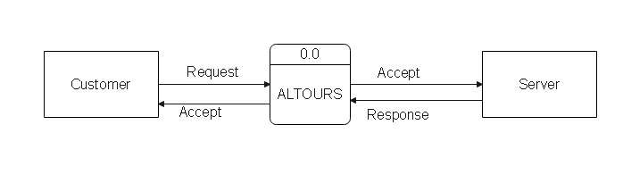Fig1.1. DFD level 0

**1.1. Level 1 DFD:-**

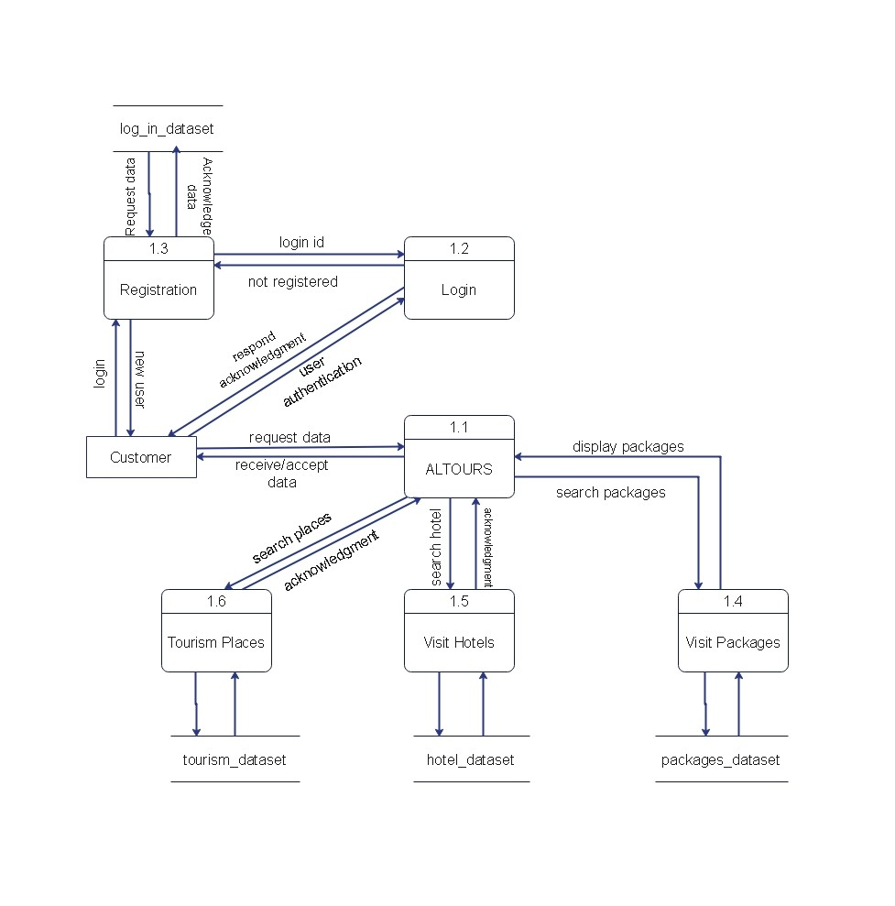

Fig1.1. DFD level 0

**1.1.1. Level 2 DFD:-**

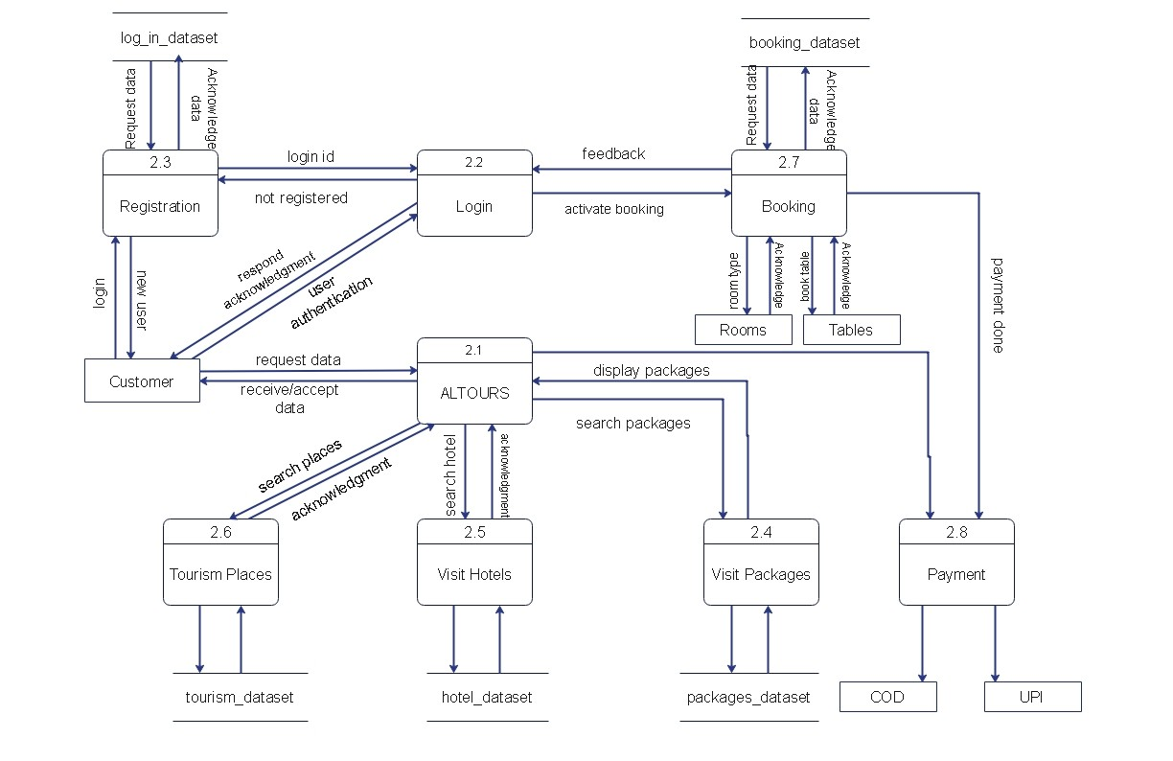

Fig.1.1.1 DFD Level 2

1. **Use Case Diagram :-**

Use case diagram represent the overall scenario of the system. A scenario is nothing but a sequence of steps describing iteration between a user and a system. Use cases represent the behavior of the system. Typically various functions are represented as use cases.

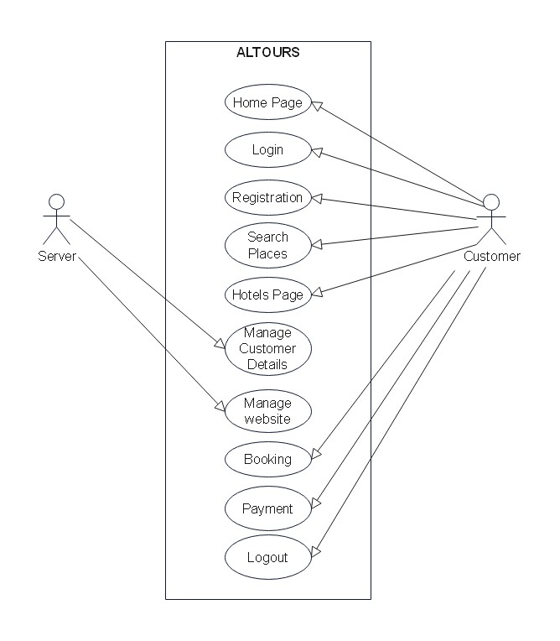

1. **Sequence Diagram:-**

In the sequence diagram how the objects interact with the other objects is shown. There are sequences of events that are represented by a sequence diagram.

**Symbols that used in sequence diagram are:-**

 Actor – who is responsible for activating various events.

Simulation.

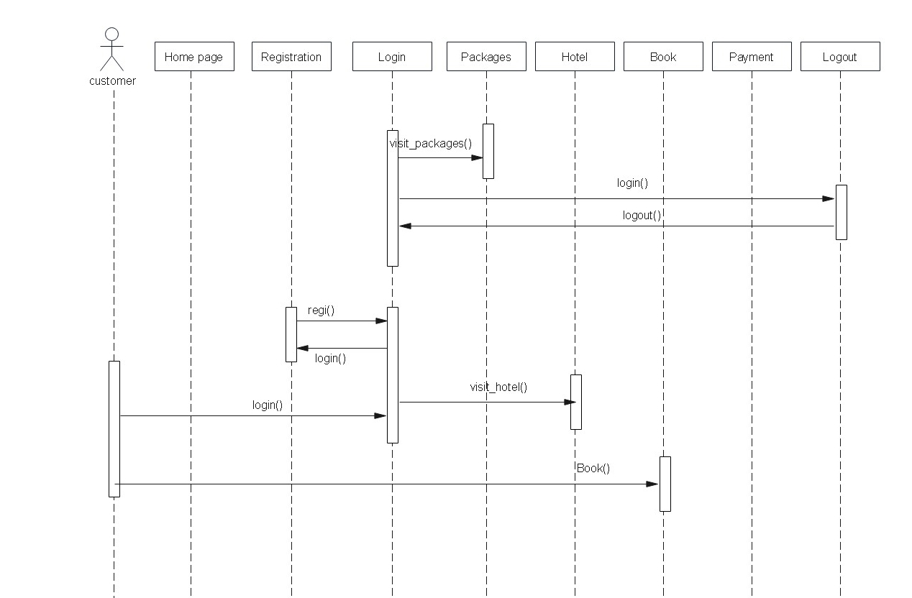

Fig Sequence Diagram

1. **Activity Diagram :-**

The activity diagram is a graphical representation of representing the flow of interaction within specific scenarios. It is similar to a flowchart in which various activities that can be performed in the system are represented. This diagram must be read from top to bottom.

Simple State

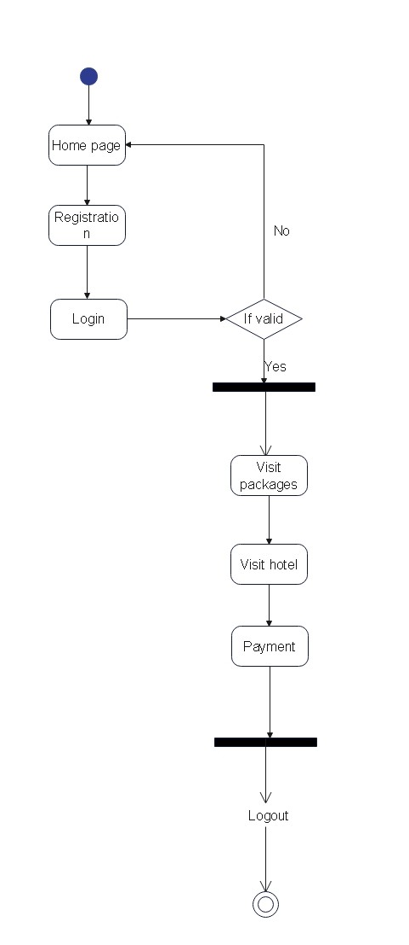

Fig Activity Diagram

**RESULTS**

First Home Page will be visible to User .

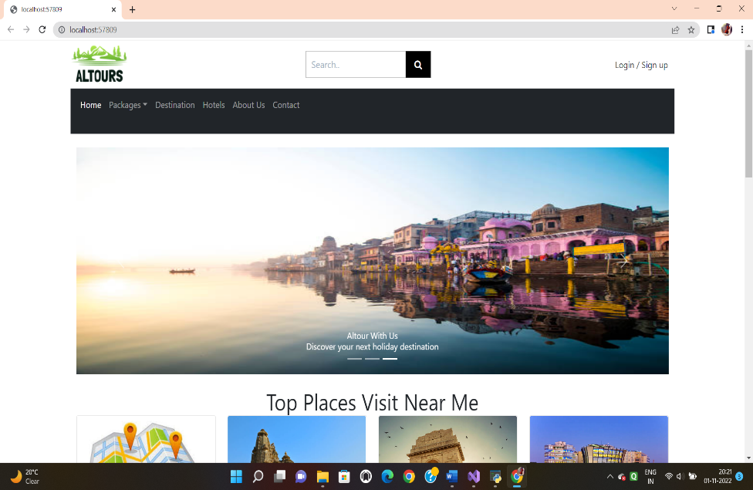

For new User this Registration Page will appear.

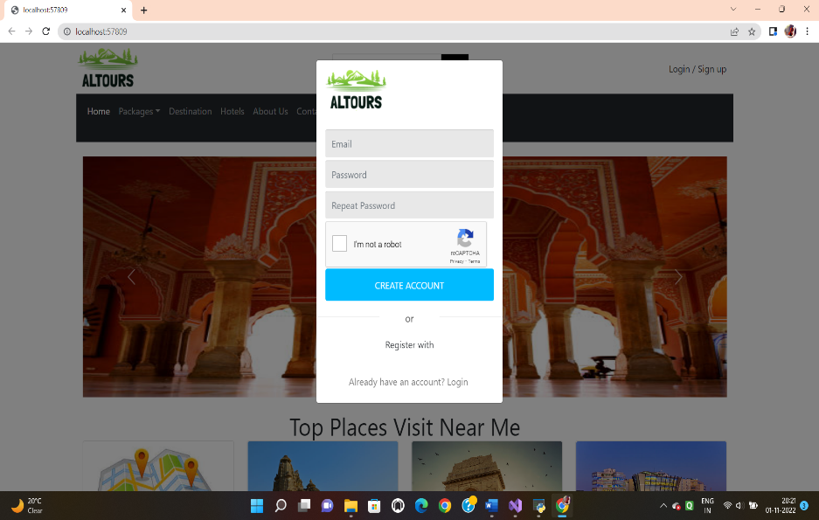

**Conclusion :-**

This website give all information about best tourist places in india and you can book any place with this. You can also reserve your room in hotel near by your visiting place through this website