“Food Servicing”

1. **Author name: Durga Mahajan**

Student, Department of Computer Science Thakur Shivkumar Singh Memorial Engineering College, Burhanpur, Madhya Pradesh, India

E-mail: kmahajan317@gmail.com

1. **Author name: Neha Patil**

Student, Department of Computer Science Thakur Shivkumar Singh Memorial Engineering College, Burhanpur, Madhya Pradesh, India

E-mail: sp028905@gmail.com

**Guide name: Prof. Jinal Patel**

Assistant professor, Department of Computer Science Thakur Shivkumar Singh Memorial Engineering College, Burhanpur, Madhya Pradesh, India

E-mail:Jinal.p5678@gmail.com

# ABSTRACT

The main purpose of designing online grocery ordering system is to manage the details of grocery, item category, cart, customer, and order. Manages all information about food, delivery address, order, food. The project is built entirely on the administration side, so only the administrator is granted access. Tracks all cart, customer, and order details. Integration of all order records.

# INTRODUCTION

The "Online Food Ordering System" was developed to circumvent the problems of the manual training system. This software is supported to eliminate and, in some cases, reduce the difficulties faced by this legacy system. In addition, this system is tailored to the specific needs of the company in terms of effective and efficient business operations. The application is minimized to avoid data entry errors. It also shows an error message when invalid data is entered. No formal knowledge is required to use this system. Because of this, it proves that it is easy to use. An online grocery ordering system as outlined above can result in a seamless, secure, reliable and fast processing system. This can help the user focus on other tasks instead of keeping logs. In this way, it will help the organization to make the best use of the resources.Every business, large or small, faces the challenge of managing and managing information about item categories, groceries, customers, shipping addresses, and orders. Every online grocery ordering system has different nutritional needs, which is why we design unique employee management systems to meet your management needs. This is to aid in strategic planning and to

ensure your business is armed with the right information and details for future needs. Additionally, for busy executives who are always on the go, our systems are equipped with remote access capabilities. with which you can manage your employees anytime and anywhere. These systems will eventually allow you to better manage your resources.

# EXPLANATION

Before creating a website, you need to go through various processes related to it. Many processes come together to form a model used by every developer to keep the cycle going that builds all kinds of applications.

**SDLC** (Software Life Cycle Model) includes many phases from requirements gathering to design, coding, testing, implementation, and maintenance. There are also many models available to choose based on your needs and budget.

**Iterative Model:** - In the iterative model, the iterative process begins with a simple implementation of a small set of software requirements and iteratively improves on successive releases until the entire system is implemented and ready for use. The iterative lifecycle model does not begin with a full requirements specification. Instead, development begins with the definition and implementation of only part of the software, which is then reviewed to identify other requirements. This process is then repeated, creating a new software version at the end of each model iteration**.**

The flow of our project can be seen in the diagram below, which gives a quick introduction of how our project will go through the many phases and all the features within, and how the processes are connected across the many phases.

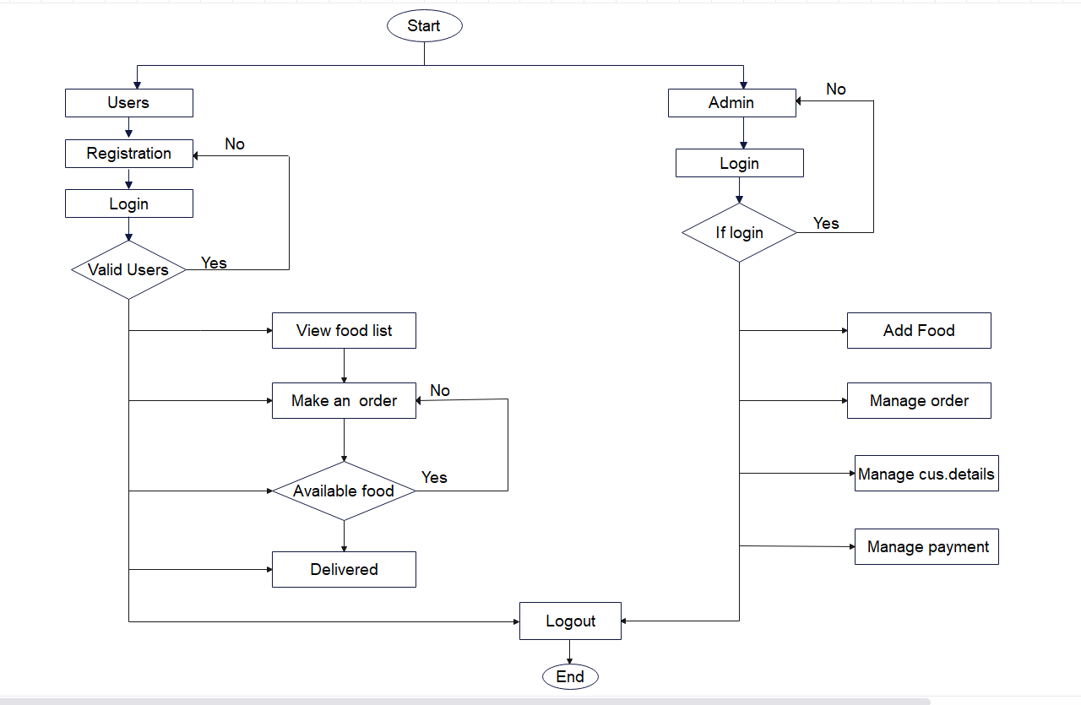

**Objective of Project**

The purpose of these projects is the main purpose of the online grocery ordering system is to manage the grocery details, item category, cart, customer, and order. Manage all information about groceries, delivery address, order, groceries. The project is built entirely on the administration side, so only the administrator is granted access. Tracks all details about cart, customer, order. Integration of all order data records. Manage customer information. Integration of all order data records.

Gastronomy When creating our website we went through many phases, first we tried to find a problem with different groups of people. So we came to the conclusion that due to the unavailability of a trading platform, we decided to create a website that should be accessible to anyone worldwide on desktop, laptop, mobile or any other device with internet access. Putting focuses on the designing perspective we have created a website rather than choosing a mobile application, website easily loads on the user’s devices without consuming memory. We have designed our website in such manner that it is compatible to almost all devices including the laptops of different brands, mobile phone, tablets and many more.

The multiple pages in our website are home page, category page, trending food service page, sign in and login page.

**Home Page|** It includes the short description of the different categories of renting including with the button of the sign in, login page, trending trade and category.

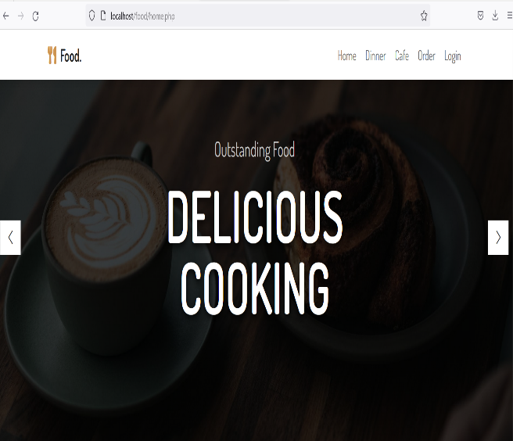

**Sign in page|** This page is maintained for maintaining the track of users who have visited on our website, using their name, email-id, DOB, and password they can register their account on **Renting website.**

**Login page|** This page will allow registered user to access on the system by using the email-id and password they can login to the system. We have kept an option of forgot password if a user forgot their password, then by using their email- id they will get their password.

**Category page|** It will contain multiple categories and by clicking on them user can see a wide variety of foods available in that kind of category, but for viewing the food present in different category user first have to login on website.

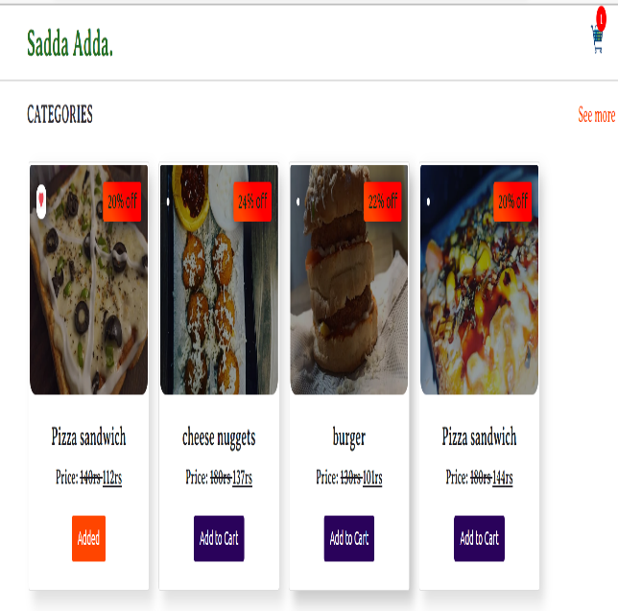

# Future use

We can offer more advanced software for online grocery ordering, including other services. We host the platform on online servers to make it available worldwide. Creation of a master and slave database structure to reduce database query overload. Implementing a backup mechanism to periodically back up the code base and database to different servers.

The user does not require any kind of special application to view the site just need a browser and the internet connection for renting. it is the most widely used format which is comfort to use. The technology which we have used in our project including the front and back-end are HTML, CSS, JS, PHP for making our website responsive such that it can easily be compatible with the other devices, language, Java JSP, Servlet, my-sql for the back- end in storing data we have used the my-sql to store the database.

# CONCLUSION

An online grocery ordering system as outlined above can result in a seamless, secure, reliable, and fast processing system. This can help the user focus on other tasks instead of keeping logs. In this way, it will help the organization to make the best use of the resources. The organization can maintain computerized logs without redundant entries. This means you don't have to be distracted by irrelevant information and still have access to the information. Basically, the project describes how to manage for good performance and better services for the clients.

# FUTURE SCOPE

# • We can offer more advanced online meal ordering software with more features.

# • We host the platform on online servers to make it available worldwide.

# • Creation of a master and slave database structure to reduce database query overload.

# • Implementing a backup mechanism to periodically back up the code base and database to different servers.

# ACKNOWLEDGEMENT

We wish to express our deepest gratitude to our project guide **Prof. Jinal Patel** and **HOD Vikas Kumar Yadav** for their continuous support in the completion of this project which led us to be inspired and motivated with their guidance at all times, providing with the best facilities for completion of our work. Also we are thankful the support of the lab technicians and the departmental help provided by them.

# REFRENCES

1. Software Engineering & Project Management (Technical Publication)
2. [www.w3school.com](http://www.w3school.com/)
3. [www.scribd.com](http://www.scribd.com/)
4. [www.google.com](http://www.google.com/)
5. [www.wikipedia.com](http://www.wikipedia.com/)
6. [www.youtube.com](http://www.youtube.com/)
7. PHP API Documentation Online @ <https://docs.oracle.com/en/xamp/mysql/11/> (php).
8. P. Lugosi, “Campus foodservice experiences and student wellbeing: an integrative review for design and service interventions,” *International Journal of Hospitality Management*, vol. 83, pp. 229–235, 2019.View at: [Publisher Site](https://doi.org/10.1016/j.ijhm.2018.10.019) | [Google Scholar](https://scholar.google.com/scholar_lookup?title=Campus%20foodservice%20experiences%20and%20student%20wellbeing%3A%20an%20integrative%20review%20for%20design%20and%20service%20interventions&author=P.%20Lugosi&publication_year=2019)
9. S. Price, G. Vigia, H. Hartwell et al., “What are we eating? Consumer information requirement within a workplace canteen,” *Food Quality and Preference*, vol. 53, pp. 39–46, 2016.View at: [Publisher Site](https://doi.org/10.1016/j.foodqual.2016.05.014) | [Google Scholar](https://scholar.google.com/scholar_lookup?title=What%20are%20we%20eating%3F%20Consumer%20information%20requirement%20within%20a%20workplace%20canteen&author=S.%20Price&author=G.%20Viglia&author=H.%20Hartwell&publication_year=2016)
10. M. McWilliams, “Foods: experimental perspectives (2nd ed.). New York: measure consumer satisfaction, ” *Hospitality Research Journal*, vol. 17, no. 2, pp. 63–74, 2000. View at: [Google Scholar](https://scholar.google.com/scholar_lookup?title=Foods%3A%20experimental%20perspectives%20(2nd%20ed.).%20New%20York%3A%20measure%20consumer%20satisfaction&author=M.%20McWilliams&publication_year=2000)