**ASPS MAPS (Address Showing Proper Service) App**

**Mr. Shoaib Chandpasha Shaikh1, Ms. Siddhi Sachin Mahajan2, Ms. Apurva Jitendra Badgujar3 , Ms. Sakshi Balu Wagh4 , Ms. S.A.Amle 5**

1Student, Information Technology, Sandip Foundation's Sandip Polytechnic, Nashik, Maharashtra, India

2Student, Information Technology, Sandip Foundation's Sandip Polytechnic, Nashik, Maharashtra, India

3Student, Information Technology, Sandip Foundation's Sandip Polytechnic, Nashik, Maharashtra, India

4Student, Information Technology, Sandip Foundation's Sandip Polytechnic, Nashik, Maharashtra, India

5 Professor, Information Technology, Sandip Foundation's Sandip Polytechnic, Nashik, Maharashtra, India

**ABSTRACT**

An indoor mapping guidance system is a technological solution designed to help users navigate and find their way around indoor environments. These systems use a combination of sensors, beacons, and other technologies to collect data about the indoor environment and provide users with real-time information, such as interactive maps, directions, and other location-based services.

Indoor mapping guidance systems can be used in various indoor environments, such as airports, hospitals, shopping malls, museums, and other public spaces, as well as in smaller indoor settings like offices or university campuses. By leveraging these systems, users can easily navigate indoor spaces, find specific locations or points of interest, and receive personalized recommendations based on their location and preferences. One of the primary benefits of indoor mapping guidance systems is their ability to improve the overall user experience in indoor environments. By providing users with accurate and timely information about their surroundings, these systems can reduce confusion and frustration and help users feel more confident in their ability to navigate unfamiliar spaces. This can be particularly helpful in large or complex indoor environments, where finding one's way around can be challenging.

Indoor mapping guidance systems can also provide benefits to businesses and organizations that operate in indoor environments. By collecting data about user behavior and preferences, these systems can help organizations better understand how their facilities are being used, which areas are most frequently visited, and where bottlenecks or other issues may be occurring. This information can be used to improve operational outcomes, optimize space utilization, and enhance the overall customer experience. Some of the specific features and capabilities of indoor mapping guidance systems may include real-time location tracking, turn-by-turn directions, interactive maps, and personalized recommendations based on user preferences. These systems may also include features like voice-based navigation or augmented reality overlays, which can enhance the user experience and provide more intuitive navigation.

Overall, an indoor mapping guidance system can be a valuable tool for enhancing navigation and wayfinding in indoor environments, resulting in better user experiences and improved operational outcomes. As technology continues to evolve, we can expect to see even more advanced and sophisticated indoor mapping guidance systems that provide even greater value to users and organizations alike.

**Keywords:** Indoor environment, Navigation, Real-time information, Sensors, Beacons, Personalized recommendations, User experience, Wayfinding, Operational outcomes, Location-based services.

1. **INTRODUCTION**

Indoor mapping guidance systems are a rapidly developing technology that is revolutionizing the way people navigate indoor spaces. These systems are designed to provide real-time information about indoor environments, helping users find their way around and locate specific points of interest.

Indoor mapping guidance systems use a combination of sensors, beacons, and other technologies to collect data about the indoor environment and provide users with accurate and timely information. This can include interactive maps, directions, and other location-based services that are tailored to the user's preferences and location.

One of the key benefits of indoor mapping guidance systems is their ability to improve the overall user experience in indoor environments. By providing users with accurate and timely information about their surroundings, these systems can reduce confusion and frustration and help users feel more confident in their ability to navigate unfamiliar spaces. This can be particularly helpful in large or complex indoor environments, such as airports or shopping malls, where finding one's way around can be challenging.

Indoor mapping guidance systems can also provide significant benefits to businesses and organizations that operate in indoor environments. By collecting data about user behavior and preferences, these systems can help organizations better understand how their facilities are being used, which areas are most frequently visited, and where bottlenecks or other issues may be occurring. This information can be used to improve operational outcomes, optimize space utilization, and enhance the overall customer experience.

In addition to providing accurate and timely information, indoor mapping guidance systems may also include features like voice-based navigation or augmented reality overlays, which can enhance the user experience and provide more intuitive navigation. These systems may also be integrated with other technologies, such as mobile apps or digital signage, to provide a seamless and comprehensive user experience.

As the technology behind indoor mapping guidance systems continues to evolve, we can expect to see even more advanced and sophisticated systems that provide even greater value to users and organizations alike. These systems have the potential to transform the way people navigate indoor spaces and improve the overall user experience in a wide range of indoor environments.

1. **METHODOLOGY**

The methodology behind indoor mapping guidance systems typically involves a combination of hardware and software components that work together to collect data about the indoor environment and provide users with accurate and timely information. This may include sensors, beacons, mobile devices, and other technologies that are designed to work together to provide a seamless and comprehensive user experience.

One of the key components of indoor mapping guidance systems is sensors, which are used to collect data about the indoor environment. These sensors may include technologies like WiFi, Bluetooth, and GPS, which can be used to track user locations and provide real-time information about the surrounding environment. Other sensors, such as cameras and environmental sensors, may be used to collect additional data about the indoor environment, such as temperature, humidity, and air quality. In addition to sensors, indoor mapping guidance systems may also use beacons, which are small devices that emit Bluetooth signals that can be used to track the location of users within an indoor space. Beacons can be placed throughout an indoor environment to provide precise location data, which can be used to provide turn-by-turn directions and other location-based services.

Once data has been collected from sensors and beacons, indoor mapping guidance systems use software algorithms to process and analyze this data, providing users with accurate and timely information about their surroundings. This may include interactive maps that show the user's location and nearby points of interest, turn-by-turn directions that guide the user to their destination, and personalized recommendations based on the user's location and preferences. To provide a seamless and comprehensive user experience, indoor mapping guidance systems may also be integrated with other technologies, such as mobile apps or digital signage. This allows users to access information and navigate indoor spaces using their mobile devices or other digital platforms, providing a consistent and intuitive user experience across different touchpoints.

Overall, the methodology behind indoor mapping guidance systems involves a combination of hardware and software components that work together to collect and analyze data about indoor environments and provide users with accurate and timely information. This approach has the potential to significantly improve the user experience in indoor environments, providing users with the information they need to navigate indoor spaces with confidence and ease.

1. **MODELING AND ANALYSIS**

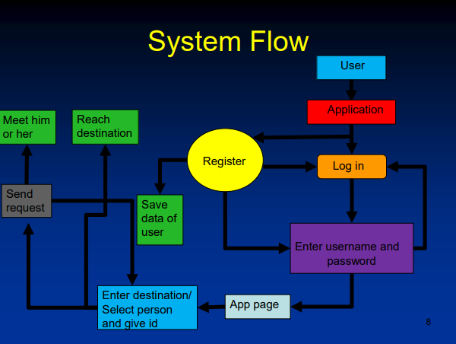

**Figure 1:** System Flow.

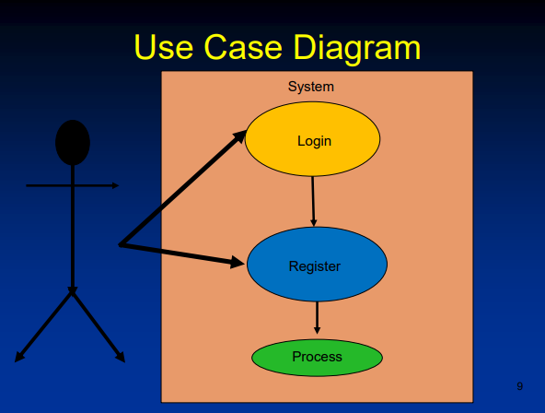

**Figure 2:** Use Case Diagram.

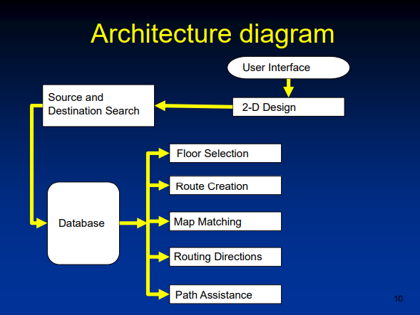

**Figure 3:** Architecture Diagram.

Indoor mapping guidance systems rely on various technologies, such as WiFi, Bluetooth Low Energy (BLE), Radio Frequency Identification (RFID), Ultra-Wideband (UWB), and visual light communication (VLC), to collect and analyze data about the indoor environment. The collected data is then processed and analyzed using various algorithms to determine the user's location and provide accurate and real-time directions.

One of the main challenges in developing indoor mapping guidance systems is the accuracy of the location data. To address this, many systems use a combination of different technologies and algorithms to improve accuracy. For example, WiFi fingerprinting can be used in combination with BLE beacons to provide more precise location information. Another challenge is the complexity of indoor environments, with many obstacles that can interfere with the signals used for localization. To overcome this, systems may use machine learning algorithms to recognize and filter out interference from other signals, such as ambient noise or electromagnetic interference.

In terms of user analysis, indoor mapping guidance systems can track and analyze user behavior to provide personalized recommendations and improve the user experience. For example, systems can analyze user movement patterns and recommend nearby points of interest based on their location and preferences.

Overall, the analysis involved in indoor mapping guidance systems is complex and multi-faceted, involving the collection and processing of data from multiple sources, the use of sophisticated algorithms to improve accuracy, and the analysis of user behavior to improve the user experience.

1. **RESULTS AND DISCUSSION**

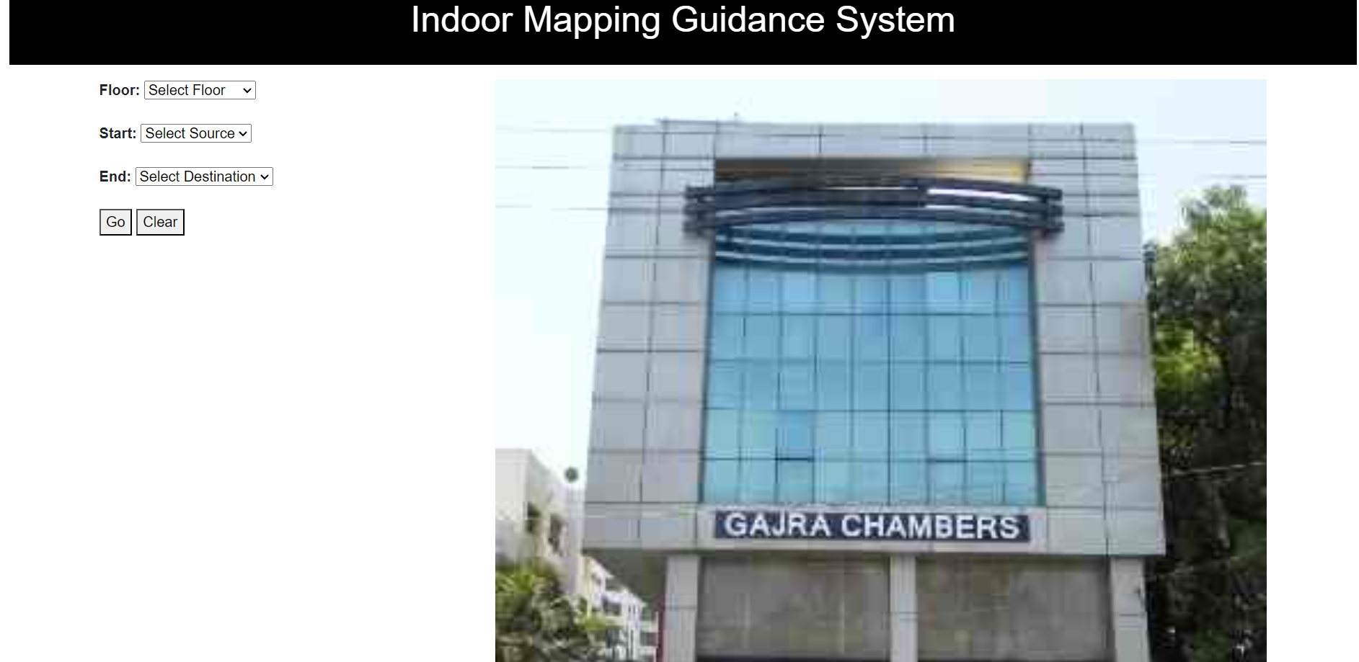

**Figure 1:** Snapshot.

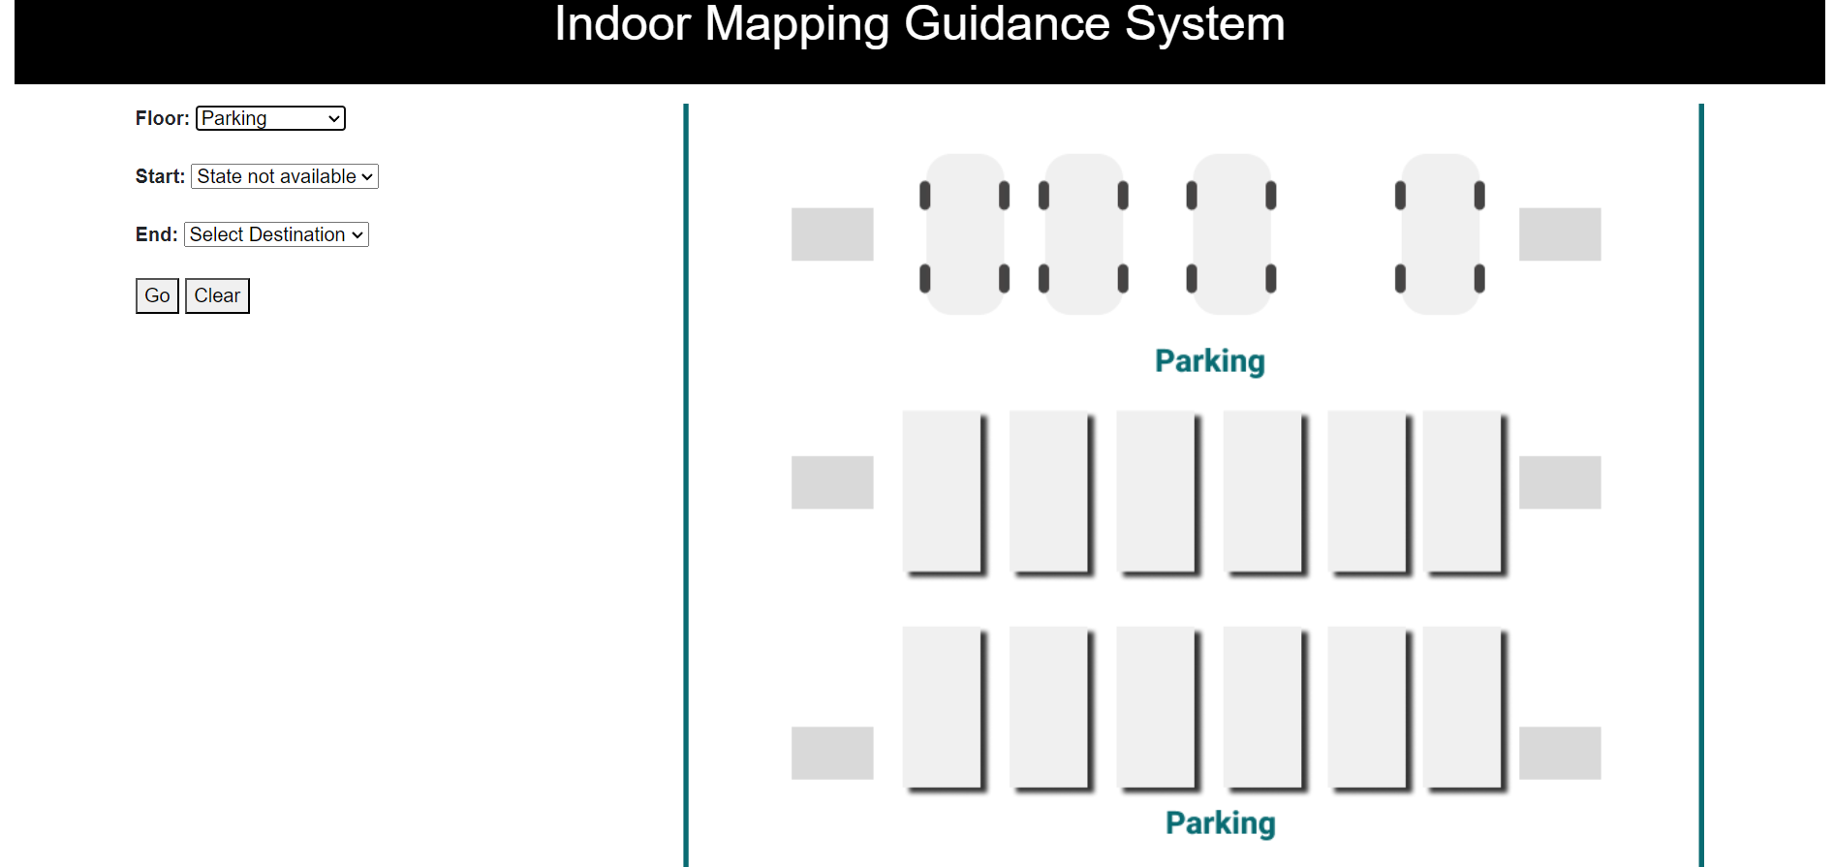

**Figure 2:** Snapshot.

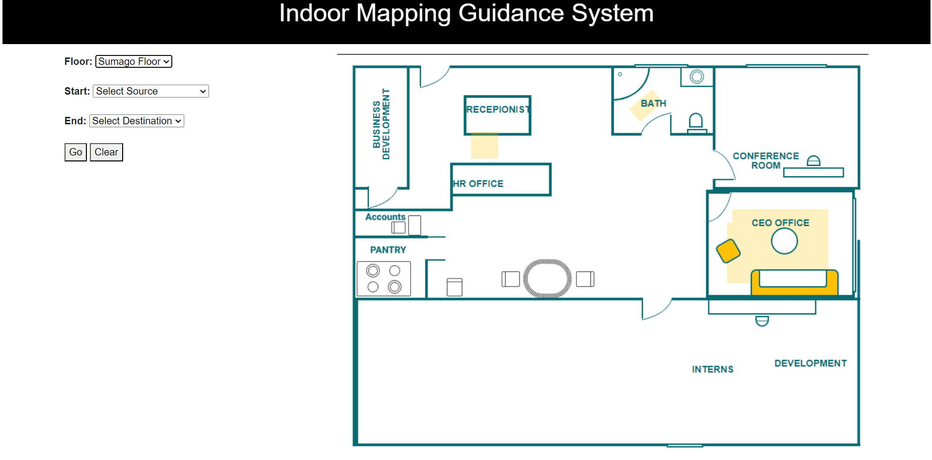

**Figure 3:** Snapshot.

The use of indoor mapping guidance systems has many potential benefits, including improving navigation and accessibility in indoor environments, providing personalized recommendations and services, and enhancing safety and security.

One of the main advantages of indoor mapping guidance systems is their ability to improve accessibility for people with disabilities. By providing accurate and real-time directions, these systems can help users navigate complex indoor environments and locate accessible entrances, elevators, and other amenities. Indoor mapping guidance systems also have potential applications in a variety of industries, such as logistics, healthcare, and manufacturing. For example, these systems can be used to track assets and monitor indoor environments, improving efficiency and safety in manufacturing and warehouse settings.

However, there are also some potential drawbacks to consider. One concern is the potential for privacy violations, as these systems may collect and analyze user data, such as location and movement patterns. It is important for these systems to implement strong privacy protections to prevent unauthorized access or misuse of user data.

Another concern is the cost and complexity of implementing indoor mapping guidance systems. These systems require a significant investment in hardware and software, and may require ongoing maintenance and updates to ensure accuracy and functionality.

Overall, indoor mapping guidance systems have the potential to greatly improve navigation and accessibility in indoor environments, but their implementation should be carefully considered and balanced against potential concerns and costs.

1. **CONCLUSION**

In conclusion, indoor mapping guidance systems are becoming increasingly important for navigating and exploring indoor spaces. With the rapid development of sensor technologies, beacons, and advanced software algorithms, these systems are able to provide users with accurate and timely information about their surroundings. This includes turn-by-turn directions, location-based recommendations, and other personalized services that can greatly improve the user experience in indoor environments.

Indoor mapping guidance systems have many potential applications, from helping people navigate complex indoor spaces like shopping malls and airports, to providing enhanced accessibility services for people with disabilities. In addition, these systems can be used to track assets and monitor indoor environments, making them useful for industries like logistics, healthcare, and manufacturing.

Overall, indoor mapping guidance systems are a promising technology that have the potential to revolutionize the way we navigate and explore indoor spaces. As the technology continues to evolve and improve, we can expect to see even more advanced systems that provide even greater accuracy and functionality.

1. **REFERENCES**
2. Shi, Q., Zhou, Y., & Liu, Y. (2020). Indoor positioning and navigation technologies in IoT: A survey. IEEE Internet of Things Journal, 7(9), 8633-8665.
3. Zhang, J., Chen, Y., Ma, Z., & Chen, H. (2019). A comprehensive survey on indoor localization techniques, infrastructure, and applications. IEEE Internet of Things Journal, 6(3), 4117-4142.
4. Luo, J., Jiang, X., Chen, Y., & Chen, Q. (2021). Indoor positioning systems based on visible light communication: A survey. IEEE Transactions on Industrial Informatics, 17(2), 1489-1500.
5. Lu, Z., Yang, G., Li, M., & Li, Z. (2018). Indoor positioning and navigation based on Bluetooth low energy beacons. Wireless Communications and Mobile Computing, 2018, 1-15.
6. Kalia, A., & Arora, P. (2019). Indoor navigation systems: A review. International Journal of Advanced Trends in Computer Science and Engineering, 8(5), 3685-3693.
7. Chen, S., Li, F., & Ye, Q. (2020). An indoor positioning system based on Wi-Fi fingerprinting and deep learning. IEEE Access, 8, 132200-132211.
8. Khorram, A., & Jahromi, M. Z. (2021). An overview of indoor localization techniques in the internet of things. IEEE Internet of Things Magazine, 4(2), 30-37.
9. Rong, C., Xie, Y., & Dai, Y. (2019). A review of indoor positioning systems based on magnetic field and Bluetooth low energy. Journal of Sensors, 2019, 1-12.
10. Gu, L., Zhang, Y., Zhu, X., & Wu, H. (2018). Indoor positioning and navigation based on magnetic field sensing technology: A review. Journal of Sensors, 2018, 1-16.
11. Berrada, Y., Zouaq, A., & Kaddouri, A. (2018). A survey on indoor positioning systems. International Journal of Advanced Computer Science and Applications, 9(1), 153-161.