**Abstract-**The problem of plastic bottle waste is one of the most serious environmental problems. Other issues that have received extensive public attention are turbidity and air emissions. These anthropogenic sources originate from the indiscriminate disposal of toxic and hazardous wastes, which has raised sensitive issues in terms of both quantity and quality. Technological progress is known to increase faster. But the use of technology in various sectors is very low. It is known that there are no suitable arrangements for waste disposal. As the use of plastics in our daily lives is ever increasing, there is no proper disposal of plastics. So we propose a system where plastics are detected using a machine learning based video processing technique and processed by checking whether the placed item is a plastic bottle or not. The plastic is then automatically collected using a bin mechanism. This simultaneously checks the user data with the user's stored RF sticker. This RF sticker helps to get the details of the user and the money will be credited to the account associated with the user only if the item placed is plastic and depending on the weight of the plastic bottle waste, the corresponding value of the amount will be credited and displayed. This automated money crediting technique creates awareness among the public about plastic disposal and motivates them to put plastic only in dustbins, which will help in efficient disposal of plastic and avoid plastic accumulation in public places. This promotes digital India as the money is credited directly to the user's account.

**I.INTRODUCTION**

Plastic products have become an integral part of our daily lives, as a result of which the polymer is produced on a massive scale around the world. On average, global plastic production exceeds 150 million tons per year. A wide range of uses are in packaging films, packaging materials, shopping bags and garbage bags, liquid containers, clothing, toys, household and industrial products, and construction materials. It is estimated that approximately 70% of plastic packaging products will turn into plastic waste in a short period of time. About 9.4 million TPA of plastic waste is generated in the country, which is 26,000 TPD. About 60% of this is recycled, most of it by the informal sector. While India's recycling rate is significantly higher than the global average of 20%, there is still more than 9,400 tonnes of plastic waste that is either landfilled or ends up polluting streams or groundwater sources. While some types of plastic do not decompose at all, others can take up to 450 years to decompose. Plastics are not inherently bad and have many beneficial environmental properties. Many of the techniques we use in our designs involve the targeted use of plastic products. Their durability and low maintenance requirements reduce material replacement, their light weight reduces transportation energy, their formulation into adhesives enables the creation of lumber and board products from recycled wood, and their formulation into excellent insulation and sealing products improves the energy performance of our structures. Once the plastic is thrown away after its use, it is called plastic waste. The fact is that plastic waste never decomposes and remains in the landscape for several years. Plastic waste is mostly recyclable, but recycled products are more harmful to the environment because they contain additives and dyes. The recycling of the original plastic material can only be done 2-3 times, because after each recycling the plastic material deteriorates due to thermal pressure and its service life is shortened. Recycling is therefore not a safe and permanent solution for the disposal of plastic waste. It has been observed that disposal of plastic waste is a serious problem due to improper collection and sorting system.

**II.OBJECTIVE**

• Motivate people to throw away plastic waste.  
• Increase the rate of implementation of effective plastic waste management.

• Create awareness among people about disposal of plastic waste.

• Eliminate the harmful effects that occur due to the accumulation of plastic waste in several areas.  
• To prevent the dangerous effects of global warming due to improper disposal of plastics.  
• Create a clean environment by implementing effective technologies on site.

**III.LITERATURE REVIEW**

In this work, an ultrasonic sensor is used to detect the amount of waste in the dustbin, and the presence of an obstacle is detected using an IR sensor. Once the bin is full, it is communicated to the relevant authorities via the GSM module. If multiple bins are placed in the same location, the second can only be used if the first bin is full, otherwise the second cannot be used. The first will remain closed until it is cleared once it is full. [1] In this work, a photoelectric sensor is used to detect what kind of waste is thrown into the dustbin. An individual user is identified using RFID Tags, with which an SMS is sent to the user with information on what type of waste they have thrown away. A weight sensor is used to transmit information about the amount of waste in the bin to the controller.[2] The microcontroller sends data on the amount of waste in this bin to the city office. The municipality will communicate the same information to the truck driver. Therefore, the bins that need to be emptied are identified. The route is thus optimized and saves fuel and money. [3] Modern traceability devices such as volumetric sensors, Radio Frequency Identification (RFID), General Packet Radio Service (GPRS) and Global Positioning System (GPS) technologies enable real-time data acquisition, which is essential for implementation an efficient and innovative waste collection routing model.[4] Currently, there is no automated approach to waste sorting at the household level in India, and a compact, low-cost and user-friendly sorting system for urban households to streamline the waste management process is a must. In order to manage waste properly, it needs to be handled, sorted, transported and disposed of in a way that reduces risks to public life and a sustainable environment. [5]

**IV.EXISTING SYSTEM**

• This existing method uses an image processing technique that is used to detect plastics.

• The system has a yolo v3 model for training the dataset, which has a low-light working environment, which is a disadvantage of this method.

• The static recognition accuracy rate is 91.3% and the average frame rate of the dynamic recognition test has reached 26 frame rates, satisfactorily meeting the current target.

• Manual classification of waste, which has problems of low efficiency and poor safety, to improve the efficiency of the waste identification system.

**A. DISADVANTAGES**

• Difficulty understanding the complexity of the algorithm. Bugs can't be fixed that soon and output takes a long time to implement.  
• The cost of this application will be very high and it will not be easy to use.

**V. THE PROPOSED SYSTEM**

This system uses a convolutional neural network algorithm to detect waste like plastic bottles in real time.  
• An image is taken and divided into grid cells. The image is divided into matrix grids. Divides the image into any number of grids and resizes based on the complexity of the image.  
• After image segmentation, image classification and localization is performed in each grid cell. Noise is removed using a Weiner filter and the shape and size of the bottle is detected by a morphological process.  
• It uses a convolutional neural network algorithm that detects plastic bottle objects by comparing them to a dataset.  
• Now we perform keypoint extraction to match the keypoints in the object and then the image of the detected object marked with bounding boxes.  
• After the plastic detected, the hardware part will be activated by receiving the signal from the serial communication.  
• It uses high frequency technology to detect the presence of a person and also to find out the identity of the person.  
• When the waste is detected as plastic, the dustbin lid will be opened and the waste will be dumped out after the process of weighing the waste using a load cell.  
• After dumping the waste, the person will be credited according to the weight of the waste dumped using the account details of the person who is picked up using the data of the RF reader they are wearing.

**A. ADVANTAGE**

• The shortcomings of the existing system are overcome by this system.

• This system can detect any type of plastic waste because it not only uses trained images as a reference for comparison, but uses a tensor flow database as a reference. It uses video processing instead of image processing techniques.  
• Since it credits the money only after dumping the waste, there is no chance of any fraud like not dumping the waste after getting the money as in the existing method.

**DISADVANTAGES**

• Difficulty understanding the complexity of the algorithm. Bugs can't be fixed that soon and the output takes a long time to implement.  
• The cost of this application will be very high and it will not be easy to use

**VI.ARCETECTURE DESIGN**



**Fig No:1. Block diagram**

**VII. MODULE**

**Five modules follow**

• Video processing module

• Segmentation module by region

• Tensor flow database module

• RCNN algorithm module

• Output module

**VIII.MODUULE DISCRIPTION**

**1.Video processing module:**

In this module, a live camera will follow a plastic waste bottle and hide 25 frames per second into one frame for plastic bottle analysis. With the help of preprocessing, resizing the image and increasing the image quality for better detection of the plastic bottle. This pre-processing is done for better image quality and brightness.

**2. Region based segmentation module:**

Segmentation module based on regions. In this segmentation process, the background of the images will be ignored and a clean image of the bottle will be obtained from the image. This segmentation process is done due to the clarity of the plastic bottle to identify the plastic bottle in its pure form. They will be analyzed with this clean plastic bottle.

**3. Tensor flow database module**

Tensor flow is a database that is trained to identify a plastic bottle. TensorFlow Datasets is the collection of datasets ready to be used with other Python ML frameworks. All datasets are exposed as tf. data. Datasets that enable easy-to-use, high-performance input channels.

**4. RCNN algorithm module**

in this RCNN algorithm module, the trained database will be implemented with the RCNN algorithm. The first stage identifies the subset of regions in the image that may contain the object. The second stage classified the object in each area. Application for R-CNN object detectors of plastic bottles.

**5. Output module**

A bounding box will be marked in the output module if plastic is identified. If someone throws a lot of plastic in the trash, the amount of the fine will be displayed and the user should pay the fine. In this module we introduced the concept of "No plastic use".

**XI.SYSTEM FUNCTION**

1. **SEGMENTATION PROCESS**

Segmentation is the process of dividing your data into distinct groups. This is a key activity in most business problems. A well-defined segment is one in which members of the segment are similar to each other and also different from members of other segments. There are a number of different techniques for creating clusters, the two most common being k-means and hierarchical clustering. Clustering falls into three general categories: unsupervised, partially supervised, and supervised. Some organizations create their own segments, while others purchase them from external vendors. One of the biggest challenges in creating segments is determining how many segments actually exist in the data. Recent work on the box alignment criteria (ABC) method helps to determine the "correct" number of clusters.

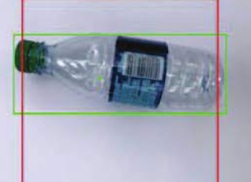

**Fig no:2 segmentation process**

**2.IMAGE ENHANCEMENT**

Image Enhancement is the process of modifying a digital image the result more suitable for display analysis. you can remove noise, sharpen or brighten digital images, making it easier to identified key features.

**Methods:**

* Filtering with morphological operation.
* Histogram alignment
* Noise removal.
* Linear contrast adjustment
* Median filtering.

**3. MORPHOLOGICAL OPERATION**

Morphological transformation is a technique that is based on the shape of the image. Usually applied to a digital image. Two important morphological operations are erosion and dilation. The image taken from the camera is smoothly processed using weiner blur and using a certain threshold. Basic morphological operations such as opening and closing transformations are used to remove noise from the image. The desired area is then extracted. Edge detection methodology is used to detect the plastic bottle from the image.

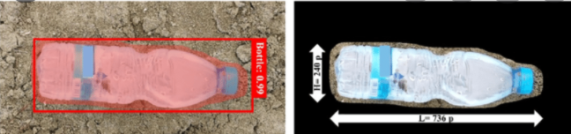

**Fig no:3 Morphological process**

**4**. **KEY POINT EXTRACTIONS**

Once the locations of potential key points are found, they need to be refined to get more accurate results. The Taylor series expansions of the scale space to get a more accurate location of the extrema, intensity at that extremum is less than a threshold value, it is rejected. This method threshold is called the contrast threshold in open CV.  
DoG has a higher response to edges, so edges also need to be removed. This uses a concept similar to the Harris corner detector. They used a 2x2 Hessian matrix (H) to calculate the principal curvature. From the Harris corner detector, we know that for edges one eigenvalue is larger than the other.

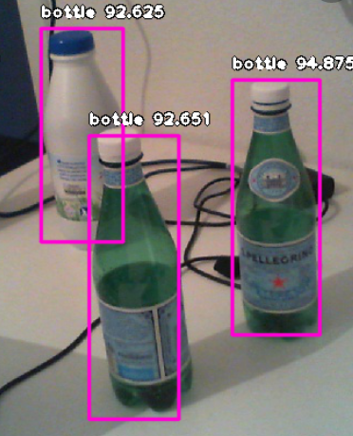

**Fig no: 4 key point extractions**

**5. CONVOLUTIOAL NEURAL NETWORK (CNN)**

Now when we think of neural network we think of matrix multiplication but that is not the case with ConvNet. It uses a special technique called convolution. CNN is incredibly slow because it predicts a selected region for each run. The following category is based on regressions. A sample dataset consisting of sample objects such as a plastic bottle represents an image for detection and classification. Neural networks have greatly simplified the work. All Fast CNN models shared a key role in computer vision. This project focuses on the area of ​​classification and detection from single-class objects to multi-class objects. A convolutional neural network is real-time object detection.

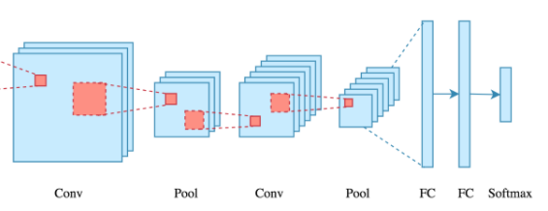

**Fig no:5 convolutional neural network**

**X. RESULTS**

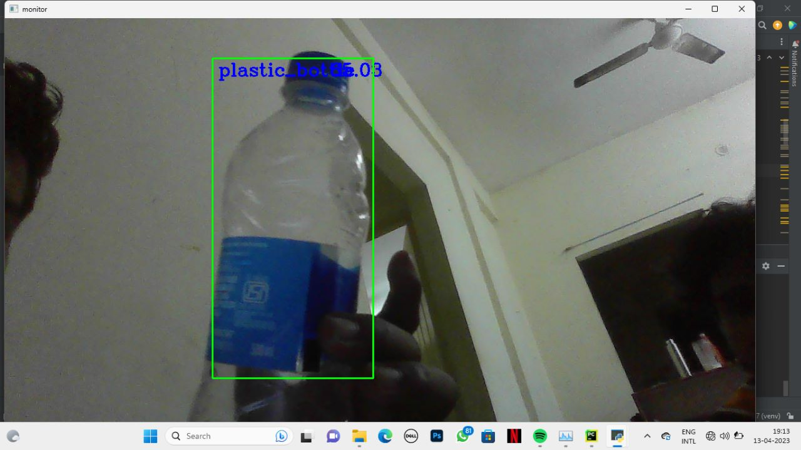

**XI. CONCLUSION**

If we want machines to revolutionize the waste industry, we have to teach them to see. This study found that a convolutional neural algorithm is well on its way to doing just that. This automated money crediting technique creates awareness among the public about plastic disposal and motivates them to put plastics only in dustbins, which will help in efficient disposal of plastics and prevent plastic from piling up in public places. Indeed, the machine learning proof of concept developed in this research successfully detected plastic objects by material type (plastic bottle) with up to 98% accuracy. Therefore, during its implementation, the system works with a huge data set, pattern prediction for object detection and training algorithms. Other works include optimization of prediction results and accuracy for various discrete real-time inputs. This approach therefore helps to reduce pollution levels and, in the long term, aims to develop a universal framework for sorting plastic waste. Work is therefore an important contribution to society.

**REFERENCES**

[1]G Sai Rohit; Bharat Chandra Shaurabsaha; DebanjanDas, Dr.SP Mukherjee Smart dual dustbin model for waste management in smart cities, 2021.

[2] SonuDhanasatyamanikanta; M.Narayanan Smart garbage monitoring system using sensors with RFID over IoT Journal of Advanced research in dynamical and control system Vol 9,SP-6/2019.

[3]D.Anuradha; A.Vanitha, S.padmapriya, S.Maheshwari Waste management system using IoT, 2019.

[4] M. Faccio, A. Persona, and G. Zanin: Waste collection multi objective model with real time traceability data, 2020.

[5]Waste Management in India - Shifting Gears, been prepared by ASSOCHAM in association with PwC India, 2020.

[6] AayushTripathi; chinmayPandey; AnkurNarwad; Deva shisnegi Cloud based smart dustbin system for metro station IEEE 2018

[7]SharaddhaZavaare;RashmiParashore;Shivanipatil;poojarathod;Vanithababanne Smart city waste management system using GSM International Journal of computer science trends and technology(ICST) Vol-5, Issue 3,may-Jun 2017 .

[8]Aref, M. M., &Mattila, J. (2018). ―Deep Learning of Robotic Manipulator Structures by Convolutional Neural Network‖ Ninth International Conference on Intelligent Control and Information Processing

(ICICIP).

[9]Qiurui Wang , Chun Yuan , and Yan Liu , (2019) ―Learning Conventional Neural Network for Image Segmentation‖ , IEEE Transactions On Multimedia, Vol. 21, No. 7

[10] Takuya Kiyokawa , Keita Tomochika, Jun Takamatsu , And Tsukasa Ogasawara , (2019) ―Fully Automated Annotation With Noise-masked Visual Markers For Deep-learning-based Object Detection‖, IEEE

Robotics And Automation Letters, VOL. 4, No. 2.

[11] MohdHelmyAbdWahab , Aeslina Abdul Kadir , MohdRazaliTomari , MohamadHairolJabbar , (2014) ―Smart recycle bin‖ , IEEE journal , vol. 5, no.4, pp.483-494

[12] Pushpa M. K, Aayushi Gupta, Shariq Mohammed Shaikh, StutiJha, Suchitra.V, (2015)―Microcontroller Based Automatic Waste Segregator ‖, International journal of innovative research in Electrical, Electronics, Instrumentation and Control Engineering Vol. 3, issue 5,

[13] Yuesheng He and Lionel M. Ni, (2019) ―A Novel Scheme Based on the Diffusion to Edge Detection‖ , IEEE transactions on image processing, vol. 28, no.

[14] Redmon Joseph, et al. "You only look once: Unified, realtime object detection." proceedings arXiv in May 2020.

[15] Geethapriya. S, et al. “Real-Time Object Detection with Yolo” proceedings of the International Journal of Engineering and Advanced Technology (IJEAT) inFeb 2019

[16] Swetha M S, et al. “Object Detection and Classification in Globally Inclusive Images Using Yolo” proceedings of the International Journal of Advance Research in Computer Science and Management Studies (IJARCM) in Dec 2018

[17] Keerthana T, et al. “A REAL TIME YOLO HUMAN DETECTION IN FLOOD AFFECTED AREAS BASED ON VIDEO CONTENT ANALYSIS” proceedings of the International Research Journal of Engineering and Technology (IRJET) in Jun 2019

[18] Sandeep Kumar, et al. “Object Detection and Recognition in Images” proceedings of the International Journal of Engineering Development and Research (IJEDR)in 2017

[19] M R Sunitha, etal. “A Survey on Moving Object Detection and Tracking Techniques” proceedings of the International Journal of Engineering and Computer Science (IJEAC) in 2020.

[20] Jifeng Dai, et al. “R-FCN: Object Detection via Regionbased Fully Convolutional Networks”, proceeding of the Advances in Neural Information Processing Systems 29 (NIPS) in 2019.