“Renting System (Festival Product Renting Platform)”

1. **Author name: Kalyani Mahajan**

Student, Department of Computer Science Thakur Shivkumar Singh Memorial Engineering College, Burhanpur, Madhya Pradesh, India

E-mail: kmahajan317@gmail.com

1. **Author name: Nikita Bhalode**

Student, Department of Computer Science Thakur Shivkumar Singh Memorial Engineering College, Burhanpur, Madhya Pradesh, India

E-mail: nikkibhalode@gmail.com

**3. Author name: Vaishnavi Mahajan**

Student, Department of Computer Science Thakur Shivkumar Singh Memorial Engineering College, Burhanpur, Madhya Pradesh, India

E-mail: Vaishnavim438@gmail.com

**Guide name: Prof. Jinal Patel**

Assistant professor, Department of Computer Science Thakur Shivkumar Singh Memorial Engineering College, Burhanpur, Madhya Pradesh, India

E-mail:Jinal.p5678@gmail.com

# ABSTRACT

The Renting Website Mainly Focuses on user where they can Renting with various Rent trade .The goal of this website is to offer financial security for the people who lost their livelihood during this time. They can sell anything worth something on this website and earn. They can sell products online as well as manage the products added by the customer. First, add the products and services you want to rent and sell to Rental and determine the quantities in Rental’s inventory management system. That way, your availabilities are always up to date, and you do not get overbooked. Next, set up your payment options so your customers can book and pay their rentals in advance.

# INTRODUCTION

Rent - A rental property often refers to the person or parties who live or occupy the property and pay rent to the owner, often referred to as (or landlord). A rental property can be all or part of almost any property, such as a B. an office, an office or apartment, a plot of land, a farm or simply an indoor or outdoor space for parking a vehicle or a real estate business, all within the meaning of tenancy law. Various products will be offered including Navratri and Janmashtami Independent Day products, home accessories, clothing, electronics and more. Customers can sell their products on this site. Anyone can sell their products and find economic stability. The Shopify Store provides a platform for people to sell their products online.

This website offers a marketplace for every type of product; it can be a painting, a piece of wood or whatever the buyer wants. This page can be used by both the buyer and the seller. A buyer or customer can either buy a product they like or sell their own product. The main purpose of this website is to sell all products online and manage the products added by the customer. Many people have lost their livelihoods during the pandemic. Many people are struggling with a downturn at work or financial problems. This project gives them the opportunity to sell any product or start their own business anywhere, anytime. This site looks promising for both the established and the inexperienced. When a buyer wants to buy a product, a request is sent to the product administrator and owner. If they accept the buyer's request, they will receive a response to purchase the product. Therefore, the product will not be sold without the consent of the owner. The Shopify platform benefits both the shopper and the customer. It also offers custom installs where the user can upload an image of their desires and category and the product will be created just for the client.

# EXPLANATION

Before creating any website, one has to go through the various processes involved in it. The multiple processes combined together to form a model which is used by every software developer to maintain the flow of cycle which creating any kind of application.

The **SDLC** (Software development life cycle model) it consists of multiple phases from requirement gathering, designing, coding, testing, deployment and maintenance also multiple models are available which according to the requirements and budgets are selected.

**Waterfall Model: -** The waterfall model was the first process model introduced. It is also known as the linear sequential lifecycle model. It's very easy to understand and use. In the waterfall model, each stage must be completed before the next stage can follow, and the stages do not overlap. The waterfall model illustrates software development in a linear sequential process.This means that each stage of the development process is only possible after the previous stage has been completed. In this waterfall model, the phases do not overlap.

The flow of our project can be seen in the following diagram which gives a quick introduction of how our project will flow through multiple stages and what all functionality it will include and how the processes are related to each other through multiple stages.

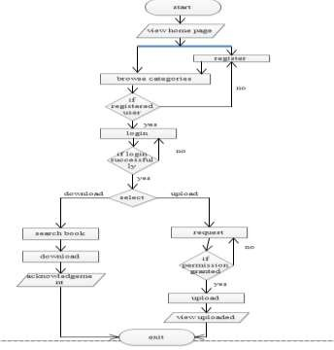

**Objective of Project**

To provide a right platform for peoples who have skills and uniqueness in their work but they are unable to put their works in front of the world due to the lack of money for the advertisement. And on other hand it will be a platform for the buyers who are located in remote areas to buy needed products. The main objective of the Rental System is to manage the details of Car, Payment, Customer, Supplier, Insurance.

**Renting** While creating our website we have gone through multiple phases, at first, we have tried to find the problem which is existing among various groups of peoples. After that we figured out that due to unavailability of single platform for the trade, we decided to create the website which must be accessible to all over the world on desktop, laptops, mobile or any other devices which have internet connection.

Putting focuses on the designing perspective we have created a website rather than choosing a mobile application, website easily loads on the user’s devices without consuming memory. We have designed our website in such manner that it is compatible to almost all devices including the laptops of different brands, mobile phone, tablets and many more.

The multiple pages in our website are home page, category page, trending cloths page, sign in and login page.

**Home Page|** It includes the short description of the different categories of renting including with the button of the sign in, login page, trending trade and category.

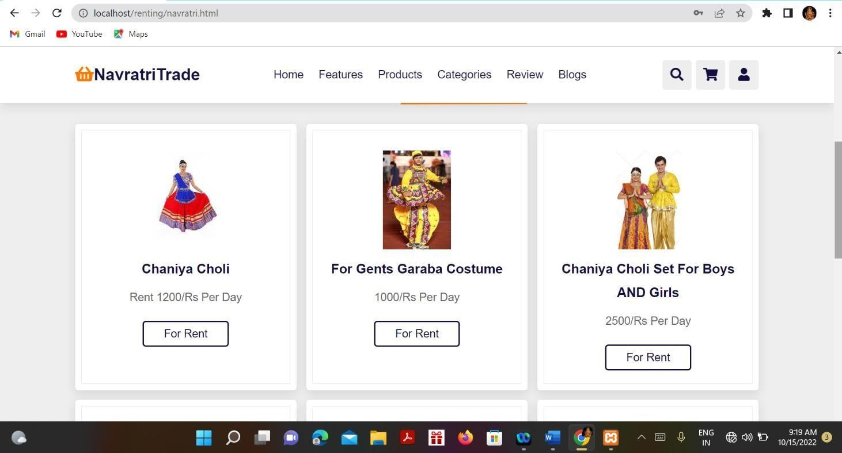

**Sign in page|** This page is maintained for maintaining the track of users who have visited on our website, using their name, email-id, DOB, and password they can register their account on **Renting website.**

**Login page|** This page will allow registered user to access on the system by using the email-id and password they can login to the system. We have kept an option of forgot password if a user forgot their password, then by using their email- id they will get their password.

**Category page|** It will contain multiple categories and by clicking on them user can see a wide variety of cloths available in that kind of category, but for viewing the cloths present in different category user first have to login on website.

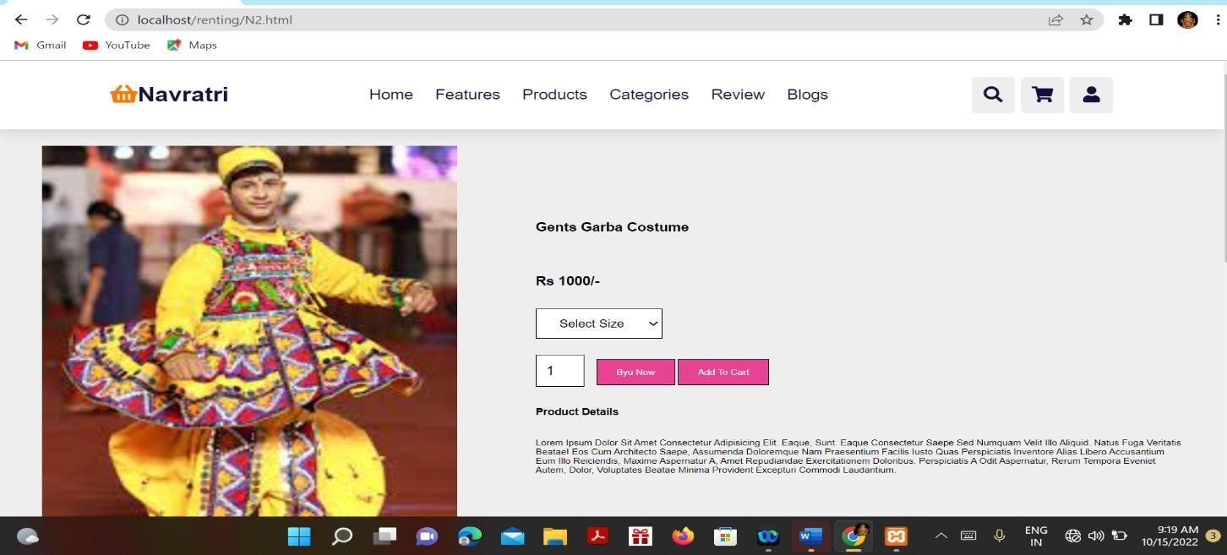

future use. The user does not require any kind of special application to view the site just need a browser and the internet connection for renting. it is the most widely used format which is comfort to use. The technology which we have used in our project including the front and back-end are HTML, CSS, JS, PHP for making our website responsive such that it can easily be compatible with the other devices, language, Java JSP, Servlet, my-sql for the back- end in storing data we have used the my-sql to store the database.

# CONCLUSION

Our project “Renting (Festival product renting platform)” will be efficient and less time consuming. The purpose of this project was to develop a web application. A php application for purchasing items from a store. The entire system is secured. This project can be implemented to any nearby shops of Clothing, Accessories, for Navaratri Diwali independent day any other festival It will manage the details of Products payment, cash, bill, stock. It will maintain or increase the customer satisfaction. The Renting (Festival product renting platform) help Shopkeepers, local artists, and crafts dealers to rent their work online. The Rent (Festival product renting platform) provides a platform for the artistic people to sell their stuff on internet. This website provides a market for any type of products.

# FUTURE SCOPE

* Many people can earn a living by renting their precious works. Shops make their business online under our website.
* Skilled people from remote areas as well as all around the world can sell and buy the products. An online payment gateway can be added. Deliveries can be managed using a third party.

# ACKNOWLEDGEMENT

We wish to express our deepest gratitude to our project guide **Prof. Jinal Patel** and **HOD Vikas K Yadav** for their continuous support in the completion of this project which led us to be inspired and motivated with their guidance at all times, providing with the best facilities for completion of our work. Also we are thankful the support of the lab technicians and the departmental help provided by them.

# REFRENCES

1. [www.w3school.com](http://www.w3school.com/)
2. [www.scribd.com](http://www.scribd.com/)
3. [www.google.com](http://www.google.com/)
4. [www.wikipedia.com](http://www.wikipedia.com/)
5. [www.youtube.com](http://www.youtube.com/)
6. PHP API Documentation Online @ <https://docs.oracle.com/en/xamp/mysql/11/> (php).
7. Kang, J., Kim, S.-H., (2013). What are consumers afraid of? Understanding perceived risk toward the consumption of environmentally sustainable apparel. Family and Consumer Sciences Research Journal. 41(3), 267–283.
8. Kim, N.L.; Jin, B.E. Why buy new when one can share? Exploring collaborative consumption motivations for consumer goods. Int. J. Consum. 2020,44, 122–130. [CrossRef]
9. Lang, C.; Armstrong, C.M.J. Collaborative consumption: The inﬂuence of fashion leadership, need for uniqueness, and materialism on female consumers’ adoption of clothing renting and swapping. Sustain. Prod. Consum. 2018,13, 37–47. [CrossRef]
10. Garcia, H. Consumption 2.0. Futurist 2013,47, 6–8.