**Eco-Friendly Paint the Colour Revolution in Chhattisgarh**

**Abhinav Agrawal1**,**Dr. Minal Shah2**,**Abhishek Agrawal3**

*1Assistant Professor, Department of Management,Agrasen Mahavidyalaya, Purani Basti Raipur,C.G.India & Research Scholar CSVTU Bhilai,C.G. India.

**\***2Assistant Professor Department of Management Bhilai Institute of Technology Durg,C.G.India

*3Assistant Professor Department of Commerce Agrasen Mahavidyalaya, Purani Basti Raipur,C.G.India

**-----------------------------------------------------------------------------**

**ABSTRACT**

Sustainable economic and environmental development is the prime focus of every nation, for this purpose demand for production and sales of eco-friendly products has been increased as it is assumed that the in future those product who aware about their role for environment protection can survive better in the market, this research paper focused on the study of one of the innovative eco-friendly product wall paint, paper focus on study of awareness of this product among customers , prospective market and challenges of this product, study is based on both Primary and Secondary data, Primary data is collected through observation and interview method from visiting the one of the leading manufacturing unit of eco-friendly paint LAXMI ORGANICS HIRAPUR, RAIPUR (C.G.) and it is observed that there is great potential for growth of such great innovative product as it is environmental friendly as well as good for human health, apart from this it is opening door for employment among rural men and women. As it is new concept so there is so many challenges associated with this product as- completion with existing brands, promotion and marketing, raw-material(Cow dung) availability challenge, low cost production and price, distribution channel etc.

***Key-Words -*** Paint, Eco-Friendly, Prakritik, Organic.

--------------------------------------------------------------------------------------------------------------------------------------------

**INTRODUCTION**

Innovation is the key element of entrepreneurship which motivates the entrepreneur to bring some new idea for product and services, since the demand for eco-friendly products are being increased among the consumers because of its health benefits and price constraints it has opened the door for innovators to introduce innovation in product with organic eco-friendly characteristics, one of the recent innovation is being seen in the field of wall paint manufacturing with cow dung which makes it eco-friendly and harm less as the regular wall paint can cause both short- and long-term health effects during painting and after painting gets dry some people may feel symptoms like headaches, watering eye, dizziness and problem in breathing, eco-friendly wall paint protects the human body from all these harms.

In January 2021 Union Minister for Road Transport & Highways & MSME Sh. Nitin Gadkaritoday launched an innovative new paint – India’s first cow dung paint -  developed by Khadi and Village Industries, the name given to this eco-friendly and non-toxic paint is “Khadi Prakritik Paint” which contains anti-fungal, anti-bacterial characteristics made by cow dung and is certified by Bureau of Indian Standards.

Khadi Prakritik Paint comes in two forms – distemper paint and plastic emulsion paint**.** The project was conceptualized by Chairman KVIC in March 2020, and later developed by Kumarappa National Handmade Paper Institute, Jaipur (a KVIC unit).

**LITERATURE REVIEW**

Challener, Cynthia. (2006) Architects, builders are search for environmentally friendly material for construction which bring the attention for many manufacturers for this innovative paint.

Shim, H. S., Lee, Y. Y., Cho, D. Y., & Choi, G. H. (2011) Researcher found that there is need for matching the quality of such paint with the global standard for high demand of this product.

**OBJECTIVES OF THE STUDY**

* To spread awareness about the new Eco-friendly revolution of paint made by cow dung.
* To study about the prospective market for Eco-friendly paint.
* To study challenges of Eco-friendly paint.

**RESEARCH METHODOLOGY**

This study is based on both Primary and Secondary data, Primary data is collected through observation and interview method from visiting the one of the leading manufacturing unit of eco-friendly paint LAXMI ORGANICS HIRAPUR, RAIPUR (C.G.) and secondary data is collected through various relevant websites, e-newspapers, Chhattisgarh government website etc.

**ECO-FRIENDLY PAINT PROJECT IN CHHATTISGARH**

Following eco-friendly initiative the state government of Chhattisgarh has begun using organic paints manufactured by cow dung in its government buildings, state government assisted ‘gauthans’(livestock shelters) established in many districts and villages for manufacturing the eco-friendly paint using cow dung as a raw material. The use of eco-friendly paint not only contribute towards the conservation of environment but also helps the rural economic growth and bringing employments for both male and females.

As part of the state government's ambitious Suraji Gaon Yojana, a flagship scheme Godhan Nyay Yojana was launched two years ago, under which more than 8,000 gauthans have been set up where cow dung and urine are being procured from cattle-rearers and farmers at Rs 2 per kg and Rs 4 per litre respectively.

Chhattisgarh government signed a Memorandum of Understanding (MoU) with Khadi and Village Industries Commission (KVIC) for the transfer of technology for paint manufacturing using cow dung.

Till November 2021 there were total 31 Prakritik (Natural) Paint had been operational in Raipur and Kanker districts which is expanded to 77 as informed by Mr. Rameshwar Sharma ji of Laxmi Organics Hirapur, Raipur. On the direction of State Chief Minister Mr. Bhupesh Baghel department of state agriculture has issued instructions to District Collectors and Chief Executive Officer to gear up the paint manufacturing units in gauthans and use produced paint in all the government associated buildings replacing the chemical paint.

**Material Use for Manufacturing Paint**

Carboxymethyl cellulose (CMC) is key ingredient of natural paint manufactured from cow dung. About 10 kg dry CMC is prepared from 100 kg of cow dung. CMC accounts for 30 percent composition of the paint.

**ABOUT LAXMI ORGANICS HIRAPUR, RAIPUR (C.G.)**

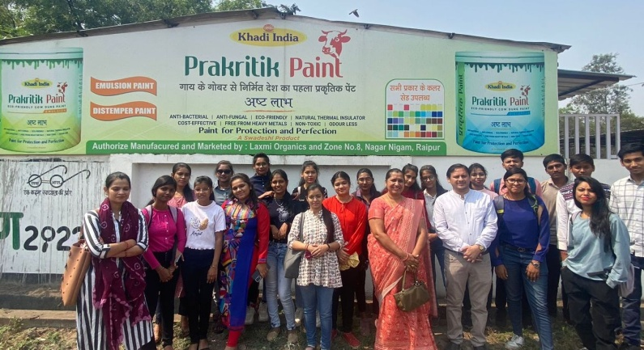Laxmi Organics located in Jargaon Near Atari Hirapur, Raipur Chhattisgarh is one of the leading manufacturing unit of wall paint and vermi-compost using cow dung, in this manufacturing unit women are employed for production activities around 25 women employed in this unit which exhibit the importance of this gauthan for employment creation among women.

**Figure 1:** Laxmi Organics Hirapur, Raipur (C.G.)

**Manufacturing in Laxmi Orgnics**

***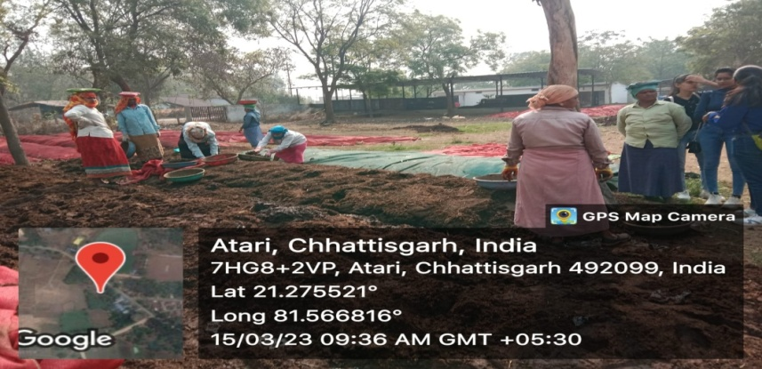*Vermi-compost -** In this manufacturing unit women are employed for vermi-compost product which goes through three process in first process cow dung is dumped and proper sequence in the open land and the earthworm is mixed with the cow dung and then it covered to protect from direct sun light and for effective processing, it takes around two month for cow dung to go for next process , in second process earthworm are separated so that it can be used for other first process these earthworm are also sold to the nearby state by this unit, in third process separated dried cow dung are pass into the machine which convert it into finished product of vermin-compost and then it is sold directly from this unit.

**Image 2:** Women involved on manufacturing vermin-compost

**KHADI PRAKRITIK PAINT**

In villages cow dung is directly used by so many villagers to paint their hut walls and for cleaning the grounds because of its antibacterial characteristics, it also keeps the temperature of room cool in summer, following this characteristics of cow dung organic cow dung paint is being produced with high business potential. The paint is free from heavy metals like lead, mercury, chromium, arsenic, cadmium and others. It can boost the local production along with creating local employment. This technology will  increase consumption of cow dung as a raw material for eco-friendly products and will generate additional revenue to farmers and gaushalas**.**Utilization of cow dung will also clean the environment and prevent clogging of drains.

Khadi Prakritik Distemper & Emulsion Paints have been tested at 3 reputed National Laboratories

* National Test House, Mumbai
* Shri Ram Institute for Industrial Research, New Delhi
* National Test House, Ghaziabad

Khadi Prakritik Emulsion paint fulfills BIS 15489:2013 standards**;**however Khadi Prakritik Distemper paint fulfills BIS 428:2013 standards. The paint has passed many test parameters such as application of paint, thinning properties, drying time and finish, among others. It dries in less than 4 hours, and has a smooth and uniform finish. The paint can be applied on interior as well as exterior walls. Both distemper and emulsion paints are available in white base colour, and it can be developed in any color by suitably mixing colorants.

**PROSPECTIVE MARKET OF ECO-FRIENDLY PAINT**

From Direct interview in ***Laxmi Organics Hirapur, Raipur*** we come to know that the marketing activities are required for this paint as no distribution to the Retailers (Hardware’s) is started yet in credit only cash purchase system is available for Retailers. Advertisement and awareness activity among the consumers are needed for this product as not many consumers aware about this unique and environmental protective and cost effective product, usage of this paint has made compulsory in government offices which can promote the usage of this paint among households.

**CHALLENGES TOWARDS ECO-FRIENDLY PAINT**

There are significance challenges for this product:   
1. Challenge for Replacement of existing brands.

2. Challenge of promotion and market expansion.

3. Challenge of raw material cow dung which is the prime raw material and if the demand for this product increases then there will be need for large amount of resource supply.

4. Distribution Channel Challenge.

5. One of the major challenge is to maintain the standard quality of the product in low cost, because the consumers will be attracted towards this new product if they are offered this product in less price continuously

**FINDING AND CONCLUSION**

Study is basically based on observation and direct interview at the manufacturing plant of eco-friendly paint and it is found that the awareness of this paint among the people is not significance as the group of students were also accompanied by the researcher at the plant and it was assumed that it was totally new experience for the young consumers who keep characteristics of present as well as future buyer, they found the product very useful for environment as well as for human health, there is significant need for the promotional activities of such kind of products which will attract large number of consumers as well as capturing the market. More research are required in this field as such kind of products can lead towards the overall sustainable development.

**REFERENCES**

[1]Challener, Cynthia. (2006). Environmentally friendly paints and coatings: Making the world a greener place. Jct Coatings Tech. 3. 28-34.

[2]Shim, H. S., Lee, Y. Y., Cho, D. Y., & Choi, G. H. (2011). *A Study on R&D Process for an Eco Friendly Inorganic Paint. Advanced Materials Research, 368-373, 3816–3820.* doi:10.4028/www.scientific.net/amr.368-373.3816

<https://swadeshivip.com/blog/cow-dung-paint-manufacturing-business/>

https://www.pib.gov.in/PressReleasePage.aspx?PRID=1687954