AN ECOMMERCE WEBSITE

ALPHA DESIGN

# Khushi Songirkar1 Mansi Songirkar2

1Dept. of Computer Science & Engg.,1Tha.Shiv Kumar Memorial Engg.College, Burhanpur(M.P.), India.

# ABSTRACT

This Research paper studies about ecommerce website.The online shopping is a process where customers directly buy goods and services over the internet. Through online shopping one can save his/her valuable time one can watch and select things he wants to buy. Nowadays, online shopping has become more popular because of online shopping one can save their time and money. Online shopping system is the application that allows the users to shop online without going to the shops to buy them. These shops are available 24 hrs. a day and 7 days a week which means customers can shop day or night while relaxing at his/her home. These shops come in various forms such as online shops, e- store, internet shops, web store, web shop, online store or virtual store. Alpha Design is a website where yo can buy home decoration items which is handmade. We sell Tablecloths, Macrame mirror, Wall Hangings, Plant Holders, Boho Bags. You can also customize products, select colors and designs. here cash on delivery is available. These shop is available 24 hrs. a day and 7 days a week which means customers can shop day or night while relaxing at his/her home.

# INTRODUCTION

The online shopping is a process where customers directly buy goods and services over the internet. Through online shopping one can save his/her valuable time one can watch and select things he wants to buy. Nowadays, online shopping has become more popular because of online shopping one can save their time and money. Online shopping system is the application that allows the users to shop online without going to the shops to buy them.

These shops are available 24 hrs. a day and 7 days a week which means customers can shop

day or night while relaxing at his/her home. These shops come in various forms such as online

shops, e-store, internet shops, web store.

1. **METHODOLOGY**

#### Software Development Life Cycle (SDLC):-

A software development life cycle (SDLC) model is a conceptual framework describing all activities in a software development project from planning to maintenance. This process is associated with several models, each including a variety of tasks and activities.

SDLC provides a series of steps to be followed to design and develop a software product efficiently.

#### SDLC framework includes the following steps:-

* + - **Planning: -**The most important parts of software development, requirement gathering or requirement analysis are usually done by the most skilled and experienced software engineers in the organization. After the requirements are gathered from the client, a scope document is created in which the scope of the project is determined and documented.
    - **Design:-**In this third phase, the system and software design documents are prepared as per the requirement specification document. This helps define overall system architecture. This design phase serves as input for the next phase of the model.
    - **Implementation: -** The software engineers start writing the code according to the client's requirements.
    - **Testing**: -This is the process of finding defects or bugs in the created software.
    - **Deployment and maintenance: -** The software is deployed after it has been approved for release.
    - **Maintaining: -** Software maintenance is done for future reference. Software improvement and new requirements (change requests) can take longer than the time needed to create the initial development of the software.

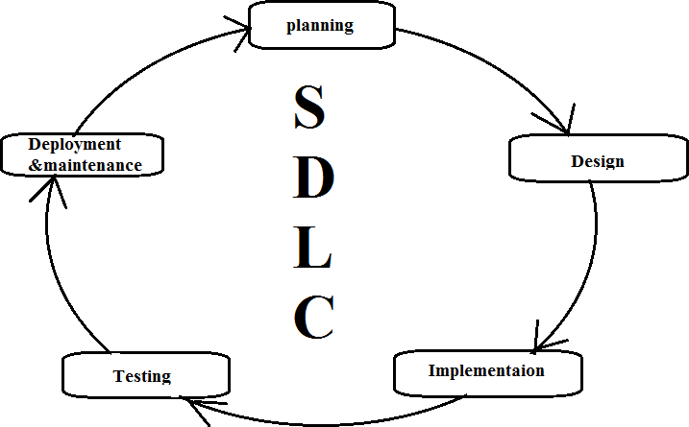

### Type of SDLC:-

* 1. Waterfall Model
  2. RAD Model
  3. Spiral Model
  4. Incremental Model
  5. Iterative Model
  6. Agile Model
  7. V-Model

### a)Iterative Model

In the Iterative model, iterative process starts with a simple implementation of a small set of the software requirements and iteratively enhances the evolving versions until the complete system is implemented and ready to be deployed.

An iterative life cycle model does not attempt to start with a full specification of requirements. Instead, development begins by specifying and implementing just part of the software, which is then reviewed to identify further requirements. This process is then repeated, producing a new version of the software at the end of each iteration of the model.

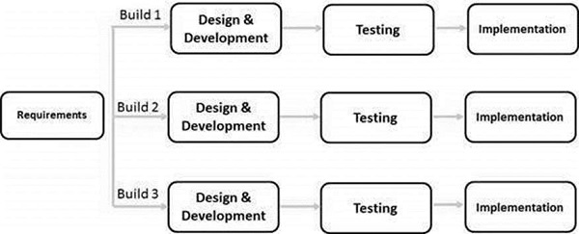

# Diagram

1. **DFD (Data Flow Diagram):-** The data flow diagrams (DFD) depict the information flow and the transforms that are applied on the data as it moves from to output. The data flow diagram are used to represent the system at any level of abstraction information flow. A Data flow diagram is graphical tool that allows system analysis (and system user) to depict the flow of data in information system
   1. **DFD LEVEL- 0 :-** Highest abstraction level DFD is known as Level 0 DFD, which depicts the entire information system as one diagram concealing all the underlying details. Level 0 DFDs are also known as context level DFDs.

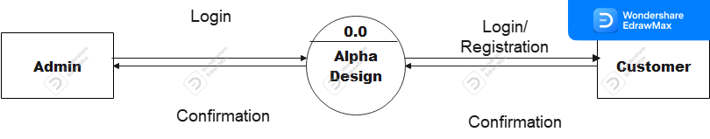

* 1. **DFD LEVEL- 1 :-** In 1-level DFD, a

context diagram is decomposed into multiple bubbles/processes. In this level, we highlight the main objectives of the system and breakdown the high-level process of 0-level DFD into subprocesses.

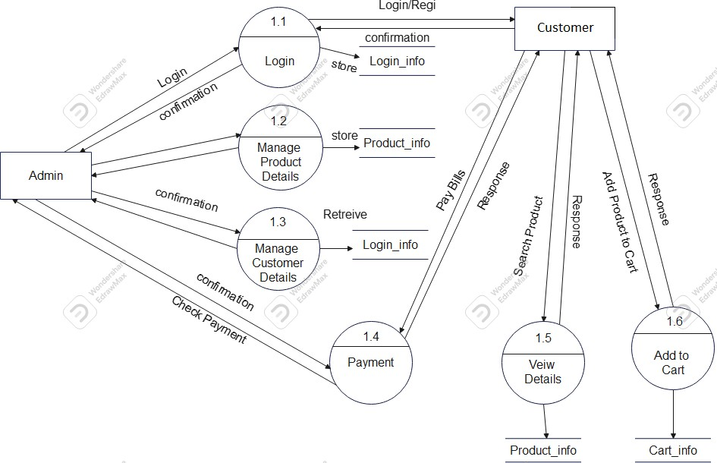

## **Sequence Diagram** The sequence diagram represents the flow of messages in the system and is also termed as an event diagram. It helps in envisioning several dynamic scenarios. It portrays the communication between any two lifelines as a time-ordered sequence of events, such that these lifelines took part at the run time. In UML, the lifeline is represented by a vertical bar, whereas the message flow is represented by a vertical dotted line that extends across the bottom of the page. It incorporates the iterations as well as branching.

Purpose of a Sequence Diagram

1. To model high-level interaction among active objects within a system.
2. To model interaction among objects inside

a collaboration realizing a use case.

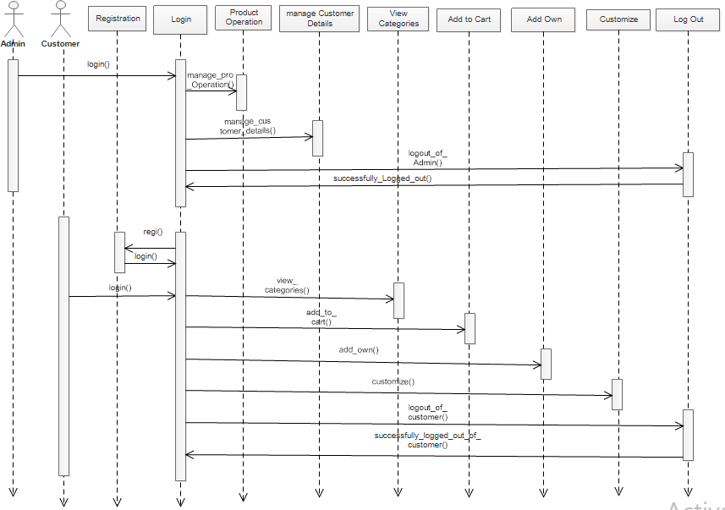

## **Activity Diagram:-** In UML, the activity diagram is used to demonstrate the flow of control within the system rather than the implementation. It models the concurrent and sequential activities.The activity diagram helps in envisioning the workflow from one activity to another. It put emphasis on the condition of flow and the order in which it occurs. The flow can be sequential, branched, or concurrent, and to deal with such kinds of flows, the activity diagram has come up with a fork, join, etc.It is also termed as an object-oriented flowchart.

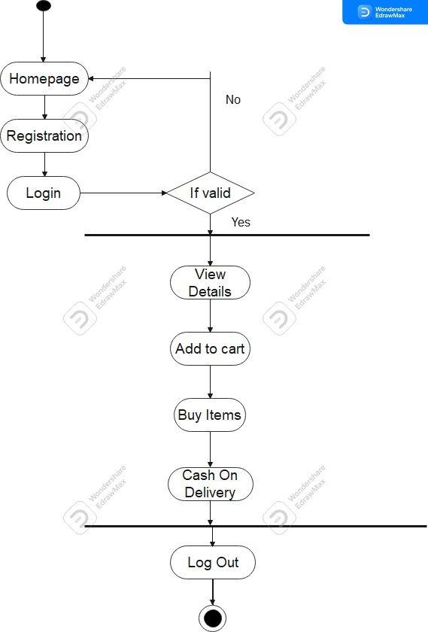

1. **Usecase diagram :-** A use case diagram is used to represent the dynamic behavior of a system. It encapsulates the system's functionality

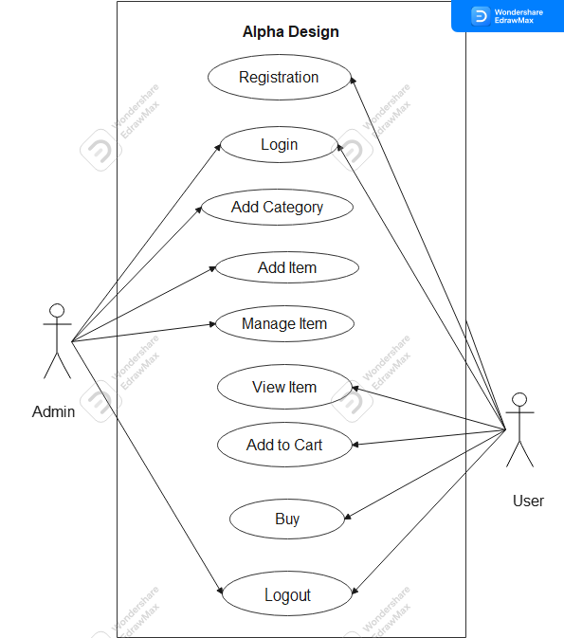

### IMPLEMENTATION

**A. Technologies Used**

Various front-end and back-end technologies are available in this era of digitalization. The technologies used in this project are discussed briefly in the following sections.

### Front End Technologies

#### HTML

It stands for Hypertext Markup Language, and it is the most widely used language to write Web Pages. Hypertext refers to the way in which Web pages (HTML documents) are linked together. Thus, the link available on a webpage is called Hypertext. As its name suggests, HTML is a Markup Language which means you use HTML to simply "mark-up" a text document with tags that tell a Web browser how to structure it to display (Musciano & Kennedy,1996).

Originally, HTML was developed with the intent of defining the structure of documents like headings, paragraphs, lists, and so forth to facilitate the sharing of scientific information between researchers. Now, HTML is being by incorporating use cases, actors, and their relationships. It models the tasks, services, and functions required by a system/subsystem of an application. It depicts the high-level functionality of a system and also tells how the user handles a system. widely used to format web pages with the help of different tags available in HTML language.

#### CSS

CSS (Powell, 2010) stands for Cascading Style Sheets. CSS describes how HTML elements are to be displayed on the screen, paper, or in other media. CSS saves a lot of work. It can control the layout of multiple web pages all at once.

### JavaScript

JavaScript (JS) is a high level, interpreted programming language. JavaScript has curly- bracket syntax, dynamic typing, prototype-based object-orientation, and first-class functions.

Alongside HTML and CSS, JavaScript is one of the core technologies of the World Wide Web (Flanagan, 2006). JavaScript enables interactive web pages and is an essential part of web applications. The vast majority of websites use it, and major web browsers have a dedicated JavaScript engine to execute it. JavaScript provides the facility to validate the form on the client-side so data processing will be faster than server-side validation

### BootStrap

Bootstrap (Shenoy & Sossou, 2014) is a free and open-source CSS framework directed at responsive, mobile-first front-end web development. It contains CSS and (optionally) JavaScript-based design templates for typography, forms, buttons, navigation, and other interface components.

To use bootstrap, we are required to either install in our system or use CDN. CDN is short for content delivery network. A CDN is a system of distributes servers that deliver pages and other web content to a user, based on the geographic locations of the user, the origin of the

webpage and the content delivery server

### Back End Technology PHP

We use PHP as a back end language. PHP is an open-source, interpreted, and object-oriented scripting language that can be executed at the server-side. PHP is well suited for web development. Therefore, it is used to develop web applications (an application that executes on the server and generates the dynamic page.).

# User Manual

### Software Requirements:

* Browser: Internet Explorer or Mozilla Firefox or Opera
* IDE : VS Code Studio
* Language : PHP
* Other Tech **:** HTML, CSS and JavaScript
* Operating system: Any Windows version/ MAC

### Hardware Requirements:

* Processor: Intel Pentium IV or above
* Ram: 1GB or more
* Hard Disk: 40 GB or more

### RESULTS

**Home :** This. the home page of Golden India

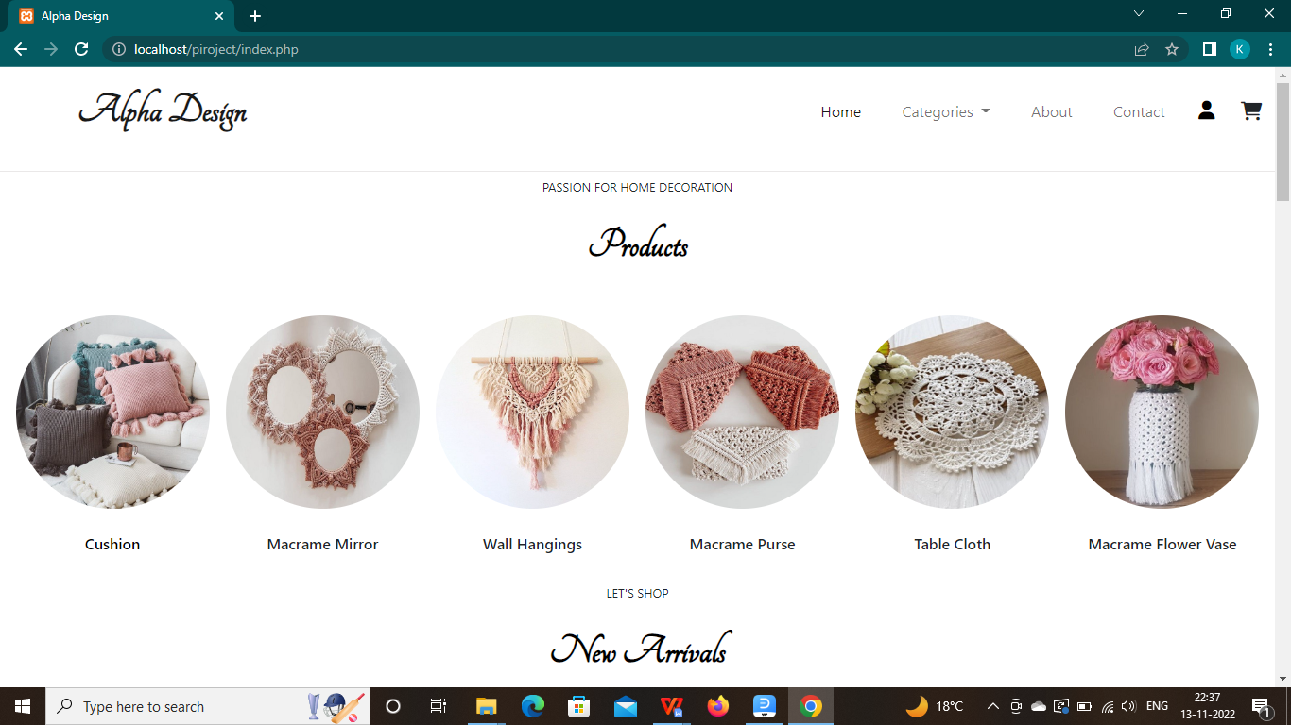

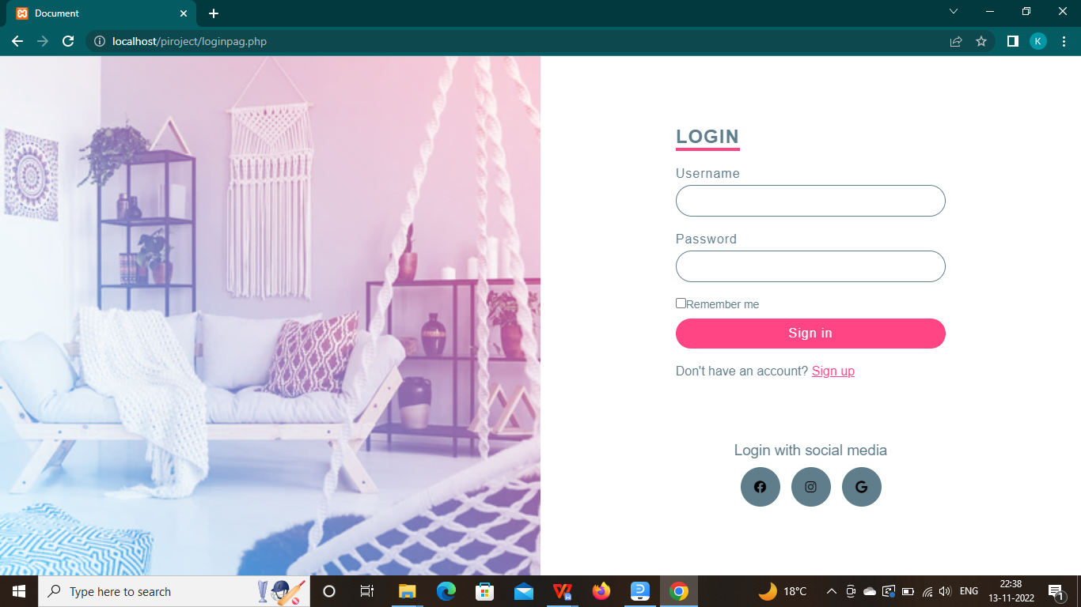

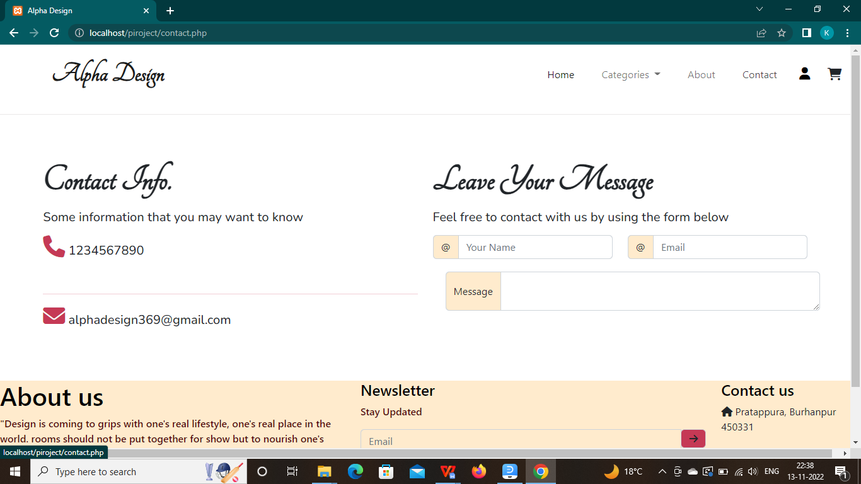 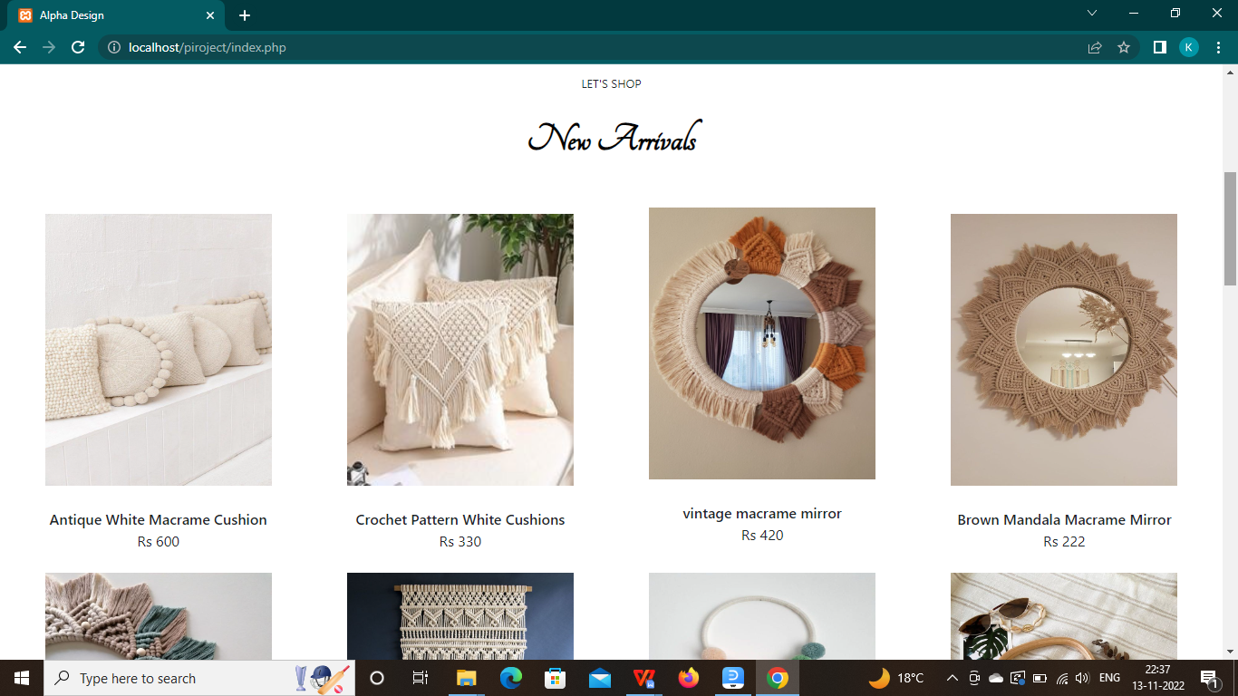

# CONCLUSION

Our project “Alpha Design” will be efficient and less time consuming. The purpose of this project was to develop a web application. A website for purchasing items from a store. The entire system is secured. It will manage the details of Products, payment, cash, bill, stock. It will maintain or increase the customer satisfaction. Alpha Design sells handmade home decoration products like macrame mirror, tablecloth, wall hangings, boho bags, plant holders and many more which makes your room look aesthetic. You may design your own custom products also.

**REFERENCES**

# Websites

* 1. **[www.w3schools.com](http://www.w3schools.com/)**

# [www.geeksforgeeks.com](http://www.geeksforgeeks.com/)

# [www.tutorialspoints.com](http://www.tutorialspoints.com/)

# [www.tutorialshub.com](http://www.tutorialshub.com/)

# [www.javatpoint.com](http://www.javatpoint.com/)