# College Management System

**Rahul Patel1, Aakash Kushwah2, Rahul Prajapat3**

Dept. of Computer Science & Engg.,1Tha.Shiv Kumar Memorial Eng. College, Berhanpur(M.P.), India.*.*

# ABSTRACT

This process is based on COLLEGE MANAGEMENT SYSTEM. College management system is helpful for students as well as the colleges. In the existing system all the activities are done manually. It is very time consuming. It manage the college information , student information, Admission management ,Attendance management and various different types of events going on in our college. . In our proposed system, the data will be stored in the college server. To store the data SQL server will be used. The Admin, Faculty or the student should be a register user. Keywords: College Management, SQL Server, Information Management, Result, Notification

## I. INTRODUCTION

The design and implementation of the system is to provide service in institute and colleges. The system is to provide comprehensive student information system and user interface is to replace the current paper records. College Staff uploads attendance, college notifications through a secure, online interface through admin. Student admission Management module explains how the college handles the admission of their student. The courses and subject management module will do the assigning of subjects for every course that the college offers. The admin of the college can have and monitor the information of the student. This will also do the securing of each student’s information for tracing their transactions. The college management system should have the faculty and student Attendance management system should have this module to check faculty and student attendance. This will record everyday attendance and activities of everyone in the college school.

## II. EXISTING SYSTEM

The system which is used nowadays has some drawbacks which need to be improved for better performance. The system through which the feedback is taken is not good enough. As the technology is developed day by day, we need to use this technology so we can get an efficient result in adequate time. For attendance management in the present system all work is done on paper. The whole session attendance is stored in register and at the end of the session the reports are generated. At the end of session, the students who do not have 75% attendance get a notice. This is a very time-consuming process. In the present system the result is viewed on the notice board. It requires lot of paperwork and is time consuming. College cannot even provide urgent notifications to students in case of emergency.

*A. Drawbacks of Existing System*

1. The existing system is not user friendly because the retrieval of data is very slow and data is stored manually.
2. It requires more calculations to generate the report like attendance calculation, percentage calculation etc. so it is generated at the end of the session. Hence requires more time to display the report.
3. In this existing system the papers can miss placed and documents can be loss. This will cause extra work for the admin department stuffs.

## III. MAIN MODULE OF THE SYSTEM

1. *Student Module:* This module used to store student records. It contains the following information i.e., Students Profile details, Contact information, educational details, etc. The Users can search the students from the database according to different criteria such as name, Course, Roll number, etc.
2. *Admin Module:* The first step in this application is to get the staff members and teaching faculty to register. They need to first register then they t provide his or her id and password for login.
3. *Admin Login:* After registering the admin is allowed to log in. He or she can now view admin homepage where there are options to take attendance, upload results, send notifications to student. He can also view the attendance taken and uploaded results.
4. *Faculty and Student Attendance:* The college management system should have this module to check faculty and student attendance. This will record the everyday attendance and activities of everyone in the college. The attendance data will be stored in the collage database. The generated data will be stored for future use.

1. *Course Module:* The courses and subject management module will do the assigning of subjects for every course that the college offers. This module will also bracket the schedules of each subject and the instruction that handle each subject.
2. *Check Notifications:* Faculty can receive important announcements, information regarding meetings from the HOD or admin through these notifications.

## RESULTS

**Home :** This. the home page of College Management System

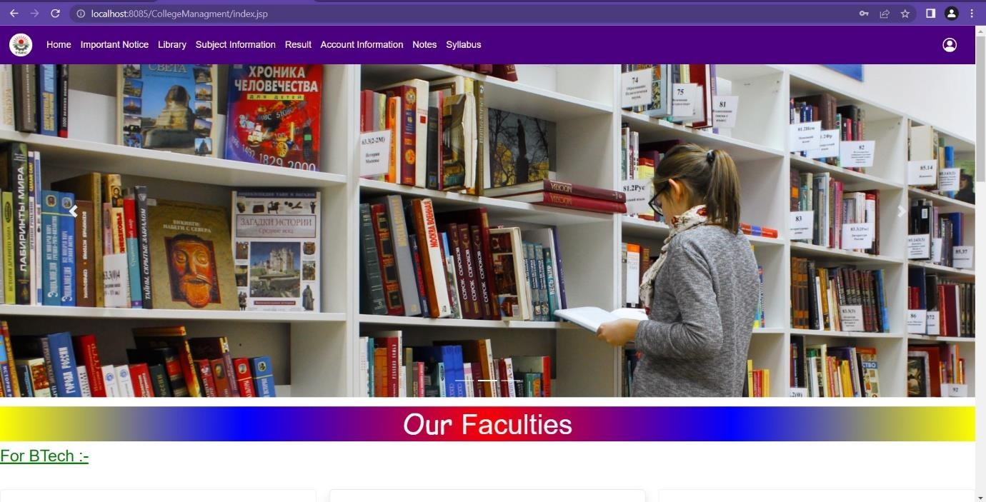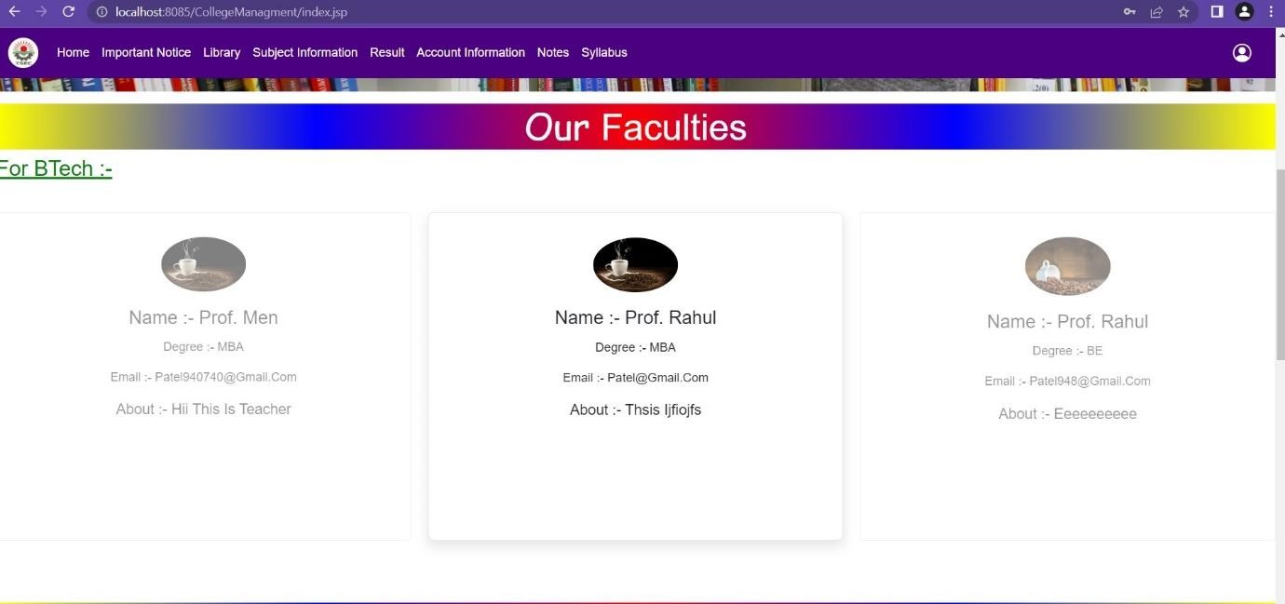

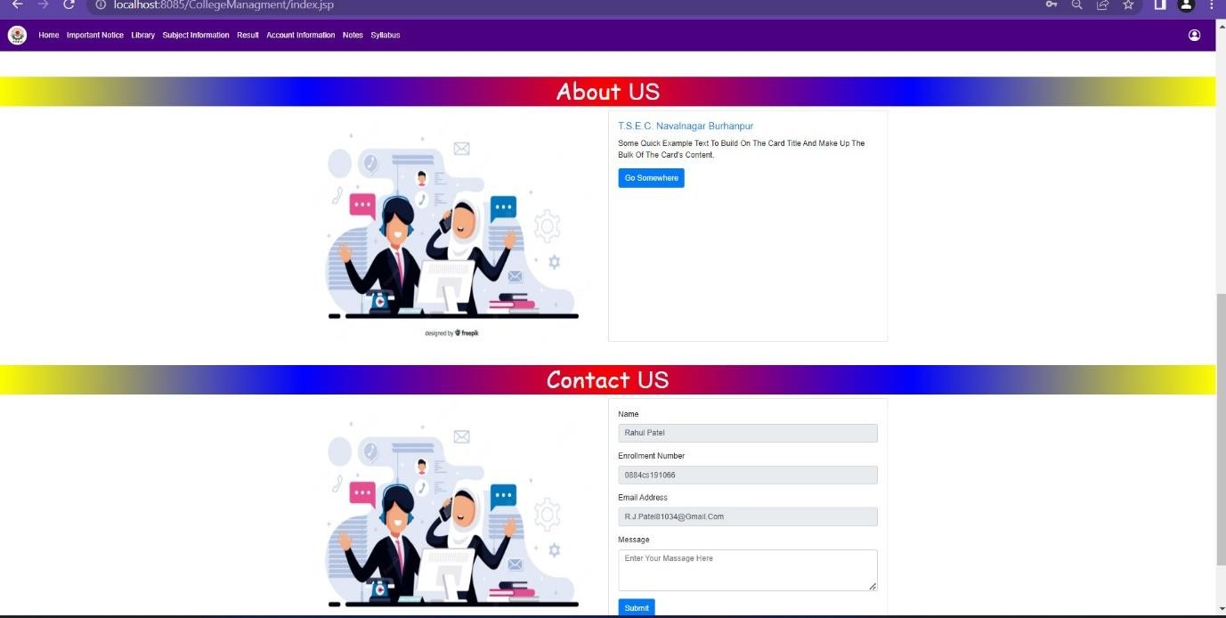

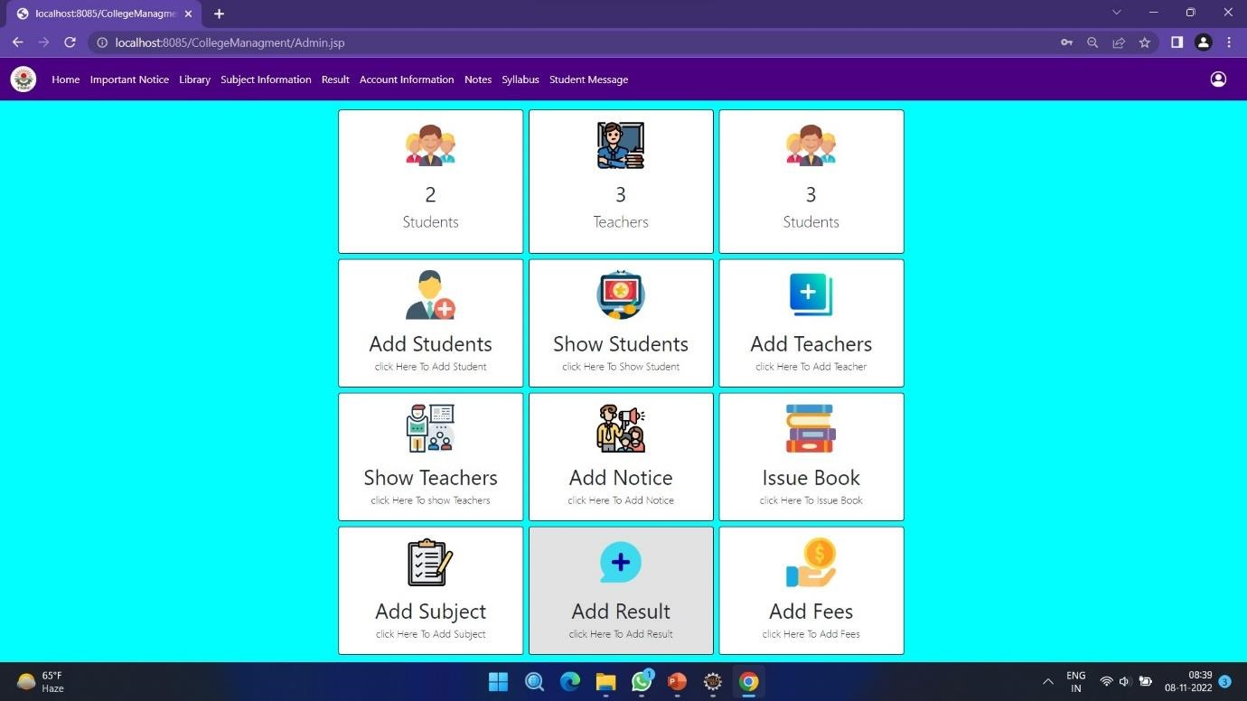

### IV. REQUIREMENT ANALYSIS

***A. Hardware Requirement***

1. Intel Quad core 2.30 GHZ Processor or above.
2. Minimum 4 GB of RAM.
3. Standard Keyboard and Serial Mouse.

***B. Software*** *Requirement*

*1)* MySQL Server.

1. Tomcat Server.
2. Advance Java.

***c)Step to Run Project :***

*There are many steps to run the project:-*

***Step1:****First of all, start the computer.*

***Step2:****Now install Eclipse for coding of java language.*

***Step3:****After that install Mysql for database.*

***Step4:****In Eclipse we create Dynamic web project.*

***Step5:****Now create HTML & CSS file for design and create JSP file for java Coding and jdbc code for database connectivity.*

***Step6:*** *Now Build path and connect the JAR files of MySQL to Dynamic project*

***Step7:*** *To Run the project Select Run on Server.*

***Step8:****Now the Home Page will appear.*

***Step9:*** *In this page many Menus like Home, Categories, About Us, Contact Us, My Account.*

***Step10:*** *Admin have default username & password for login.*

***Step11:****After login of Admin Home page will appear.*

***Step12:****In this page many Menus like Operation on Home, Categories, User Request, Product Operation and Logout.*

***Step13****:On Home page Customer if registered than login and if not registered than first do Registration.*

***Step14****: Fill Registration details of customer like Name, Email, Mobile no., Address, Password.*

***Step15:*** *Then customer selects the product from different categories and add it to cart or buy it.*

***Step16:*** *If customer Want to sell their products the they can select Add Own product then if*

*Admin accepts the request of add own than customers products are added*

***Step17:****If customer wants to Customize the products select Customize.*

### V. BENEFITES OF PROPOSED SYSTEM

1. This management system will be very simple and it will also simplify the and speed up the result preparation and management process.
2. Students do not need to check the notice board every day and every one will stay updated.
3. This project will cater facilities to all the existing versions of the system.

### VI. CONCLUSION

The system will greatly simplify and speed the management process. It will describe the paper work. The admin, faculty or the student will perform all the task very easily and more convenience way. The system offers reliability, security, time savings and easy control. The proposed system will describe the work time of the admin as well as the faculty. This will bring more perfection to the work.

It provide the details of users who are registered on website. This project provide easier way to download novel’s which is useful for novels lover This project provide user to explore their ideas online.

### REFERENCES

1. S. R. Bharamagoudar, Geeta R.B., S. G. Toted “Web Based Student Information Management System”, International Journal of Advanced Research in Computer and Communication Engineering -June 2013, ISSN : 2319-5940.
2. Siddhant Gokul, Rohit Jadhav, Mruganayani Mane, Sanhita Chafed “An Application to Enhance the Admission Process and Communication between Members of an Institute”, International Journal on Recent and Innovation Trends in Computing and Communication- ISSN: 2321-8169.
3. Miss. Namrata N. Shahada, Miss. Priya A. Kawada, Mr. Satish L. Thom bare “Student Attendance Tracker System in Android”, INTERNATIONAL JOURNAL FOR ENGINEERING APPLICATIONS AND TECHNOLOGY- ISSN: 2321-8134
4. Srikant Patnaik, Khushboo kumari Singh, Rashmi Ranjan, Niki Kumari, “College Management System”, in 2016,Dept of ECE, Orissa, e-ISSN: 2395-00556.
5. R. M. Leod, Management Information Systems, Third Ed., Science Research Associates, 1986, pp. 17-19.
6. L. Long, Management Information System, Prentice Hall, 1989, pp.116-11.