**UTILIZING CNN AND TRANSFER LEARNING TO CLASSIFY RICE LEAF DISEASES**

|  |  |  |
| --- | --- | --- |
| Karri Siddartha Reddy1  (19A91A0524),  CSE, B.Tech,  Aditya Engineering College,  Surampalem  Email:[19A91A0524@aec.edu.in](mailto:19A91A0524@aec.edu.in)1 | Authors:  Tekumudi Hemanth Pavan2 (20A95A0505),  CSE, B.Tech,  Aditya Engineering College,  Surampalem  [20A95A0505@aec.edu.in](mailto:20A95A0505@aec.edu.in)2 | Gollapalli  Sairam3(20A95A0504),  CSE, B.Tech,  Aditya Engineering College,  Surampalem  [20A95A0504@aec.edu.in](mailto:20A95A0504@aec.edu.in)3 |

Guide: Dr. Veluri Ravi kishore4, M.Tech, Ph.D

Associate Professor

Aditya Engineering College

[ravikishore1985@aec.edu.in4](mailto:ravikishore1985@aec.edu.in4)

**ABSTRACT:** Agriculture is a major source of income and livelihood in many countries. There are numerous food crops, with rice being the most important, particularly in Asian countries, where it is affected by various diseases at various stages. Several diseases affect crop quality and growth. Because some diseases have similar symptoms, it can be difficult to diagnose the disease using traditional methods or with the naked eye at an early stage. An automated system is very useful in detecting disease at the right time, allowing farmers to protect their crops from damage earlier. Deep learning advances have had a major effect on agricultural disease detection. The damage that insects and bacterial diseases to rice plants are well known, and this is a significant issue in areas where rice is a staple food. This study suggests a highly accurate, transfer-learned model that could provide armies and agricultural organizations with a mobile solution for quickly identifying rice leaf illnesses. A generative adversarial network is also used in this study to control the count of disease samples. Furthermore, we

contrast our model with other transfer learning architectures. The proposed framework outperformed paradigm classification architectures by more than 80% when tested on transfer learning and CNN algorithms.

***Keywords*** *–* :*Deep Learning, Convolutional neural network, Transfer Learning, vgg16.*

**1. INTRODUCTION**

The main purpose of this project is to detect the three diseases that are impacting the rice leaf Brown Spot, Hispa, and Tungro. The project aims to process a leaf image using the CNN algorithm with transfer learning to find diseases that have impacted the plant and assess the model's accuracy. Because rice is such a valuable commodity, the infestation of rice leaf diseases is a common problem that many cultivators face. Early diagnosis of these diseases allows the farmer to counsel with experts and cure one's crop production quite successfully before the illness becomes irrecoverable. Given the variety of diseases that can occur, cultivators have a hard task in identifying these cases individually, particularly in huge fields. AI-assisted systems may be capable of offering remedies for such rapid and accurate identification of these illnesses. Whereas the substantial ai - base tackles issues in regions such as crop, pest, disease prevention, soil irrigation, and storage monitoring, these sectors still have significant room for development. Data augmentation was employed as an approach in this work to apply modifications for improving feature visualization and resolving the unbalanced dataset problem. A technique called picture data augmentation turns existing photographs into new ones. You can achieve this by making a few minor adjustments to them, such as changing the image's brightness, rotating it, or moving the subject horizontally or vertically. This is used to generate extra samples for the Leaf Diseases dataset's Brown Spot and Hispa classes, resulting in a more balanced distribution. Following the expansion, the total number of images in the Brown Spot class increased from 965 to 1930, and the number of samples in the Hispa class increased from 1000 to 2000, bringing the overall amount of images in the dataset to 8130 from 4065.

**2. LITERATURE REVIEW**

In this paper the authors proposed one of the world's staple foods is rice. The main paddy diseases include leaf disease. Farmers who operate in rural regions typically find that recognizing paddy leaf diseases is extremely time-consuming and difficult due to a lack of knowledge. A framework that is advanced can reduce these problems. For the purpose of identifying three common paddy leaf diseases (Brown spot, Leaf blast, and Bacterial leafblight), an advanced framework is suggested in this study. Using K-means clustering, the damaged area is separated from the image of a paddy leaf Color, texture, and shape in visual content are used as characteristics for categorizing these disorders. Following identification, a precautionary measure is advised that can assist people and organizations involved in agriculture respond to all of these diseases in an appropriate fashion. [1]

In this paper K.S. Archana, and Arun Sahayadhas., proposed a system for the Indian economy that is mostly responsible for agricultural productivity. Therefore, disease prediction is crucial in the realm of agriculture. The symptoms are a crucial feature extraction and classification component in image analysis. Some of the obstacles to disease prediction do, however, still exist. The suggested algorithm concentrates on a particular issue to forecast the disease from early signs in order to address those issues. Rice (Oryza sativa) crops are commonly affected by the bacterial diseases brown spot and bacterial leaf blight, which both lower yield and grain quality. [2]

**3. PROPOSED METHODOLOGY**

The benefits of an automated rice disease detection system can be extremely beneficial to agricultural organisations and growers. This study provided a novel approach for detecting and properly classifying rice illnesses. We increase the size of the dataset by employing data augmentation techniques, and we anticipate higher outcomes and accuracy by applying CNN and transfer learning algorithms. The accuracy of the proposed framework alongside every other architecture evaluated with the dataset Rice Disease Imaging Data - the set was noticeably good. To train the model that produces correct results, we employ the deep learning CNN algorithm. The neural network is fed a huge dataset of pictures that have been labelled with their appropriate class labels during CNN training. The CNN network processes each picture with randomly given values and then compares them to the input image's class label.

The following are the stages involved in developing our model:

* Before training the model, this technique begins by conducting all essential processes such as data collecting and pre-processing.
* The model is then trained using classification techniques such as the CNN algorithm, and the pattern and kind of leaf are recognised by doing both training and testing on the dataset.
* Following training, the model is saved for testing, which is accomplished by uploading a picture from the dataset, which may then be categorised and forecasted.

After classifying the leaf from the dataset we are going to give some confident value for the image, confident value is that comparison of each and every image in the dataset to produce the value.

**Hardware requirements:**

* Hard Disk - 500GB
* Monitor
* RAM - 8GB
* Input Devices - Keyboard, Mouse

**Software requirements:**

* Google Colab
* Windows 10 OS
* Python and Html
* Libraries Used – Numpy, Flask, Keras, Pandas, TensorFlow

**4. ALGORITHMS USED**

**CNN Algorithm:**

Convolutional Neural Networks (CNNs) are artificial neural networks that are mostly utilised for image and video processing. It is a deep learning model that is meant to extract and learn features from photos or other multidimensional input data automatically. CNNs are made up of several layers of linked nodes, each of which conducts a convolution operation on a tiny part of the input data. The convolution process applies to the input data a series of learnable filters, allowing the network to recognise distinct patterns and characteristics at different levels of abstraction. CNNs often feature pooling layers, which minimise the spatial scale of the output from the convolution layers, and fully connected layers, which aggregate the output from the previous layers to form a final prediction, in addition to the convolution layers. Because of its capacity to automatically learn and extract relevant characteristics from vast volumes of data, CNNs have become increasingly popular in computer vision and other fields of deep learning.

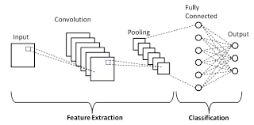

**Fig.1: CNN**

**VGG-16 Algorithm:**

Convolutional neural network (CNN) model VGG16 is used. The VGG16 model's architecture is made up of three fully connected layers, two max-pooling layers, and three convolutional layers with 3x3 filters each. The pre-trained model VGG16 is frequently used for transfer learning. A pre-trained model, such as VGG16, is used as a starting point in the transfer learning technique to train a new model on a different but related task or dataset. Fully connected layers are typically used in transfer learning with a pre-trained model to extract pertinent features from the input, while convolutional layers are typically used in transfer learning with VGG16 as feature extractors, replacing or fine-tuning fully connected layers to adapt the model to a new task or dataset images.

Because VGG16 has been extensively trained to identify and extract meaningful features from images, using it can save a considerable amount of time and computational resources. This can be especially helpful for tasks in environments with little training data or limited resources.

**5. EXPERIMENTAL RESULTS**

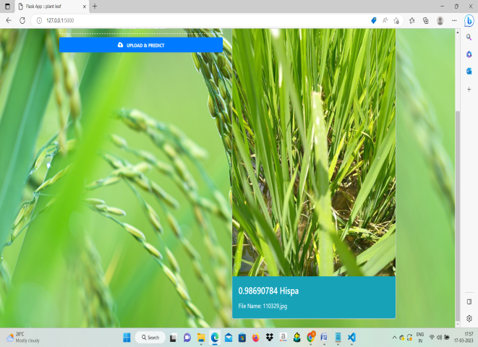

**6. FLOWCHART**

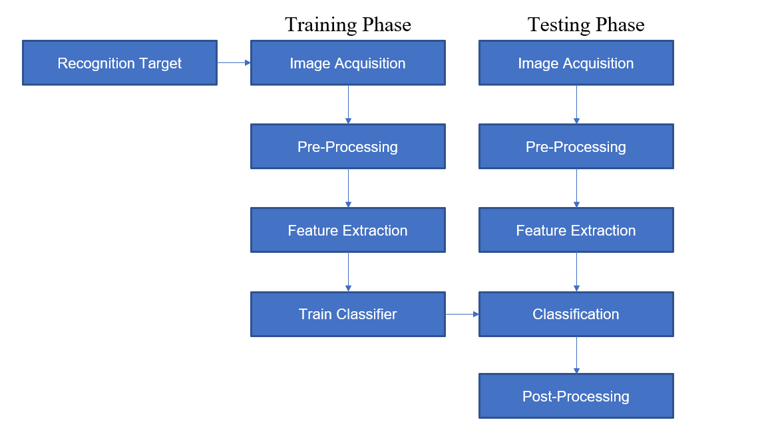

**7. ADVANTAGES**

* Getting a good accuracy and gives good results.
* Better records on the dataset.
* Runtime is high.
* A simple and cost-effective approach to diagnose the rice leaf.
* Good production and quality of yield can be achieved.
* Less Complexity and Easy Identification.

**8. CONCLUSION AND FUTURE SCOPE**

New methods for identifying and classifying the rice leaf have been proposed. Using deep learning and machine learning methods, we successfully classified images of rice leaves, which are either affected by their water or by insects. We considered a dataset of rice leaf images of various types (healthy or unhealthy) and trained it using CNN, and vgg-16 transfer learning method. After training the dataset, we tested the model by uploading and classifying an image. The upsides of a computerized rice sickness identification framework can demonstrate of much worth to rural associations as well as landowners. This work has recommended an imaginative method to identify rice infections proficiently, and precisely group them. Three datasets of changing sizes and numerous worldview characterization structures have been utilized, to look at the presentation of the recommended model. Recognizably the exactness of the recommended model and each and every other engineering looked at, was somewhat admissible for the dataset Rice Sickness Picture Dataset, due to bring down nature of pictures generally. This work has tended to the unequal dataset issue too. This method will be used in farms for the farmers to detect the diseases and to take the preventive measures that need to be taken. Future improvements to this strategy include coordinating additional rice infection classifications and designing low-computational requirement models that can be executed at a low cost.

**9. REFERENCES**

[1] Shrivastava S, Singh SK & Hooda DS, “Soybean plant foliar disease detection using image retrieval approaches”, Multimed. Tools Appl., (2016).

[2] Singh V &Misra AK, “Detection of plant leaf diseases using image segmentation and soft computing techniques", Inf. Process. Agric., (2017).

[3] Clémen A, Verfaille T, Lormel C &Jaloux B, “A new colour vision system to quantify automatically foliar discolouration caused by insect pests feeding on leaf cells”, Biosyst. Eng., Vol.133, (2015), pp.128–14.

[4] R.P. Narmadha. and G. Arulvadivu, “Disease Symptoms Identification In Paddy Leaf Using Image Processing,” Advances in Computational Sciences and Technology, ISSN0973-6107, vol. 10, no. 8, 2017, pp.2213-2223.

[5] B Kassimbekova, G Tulekova, V Korvyakov (2018). Problems of development of aesthetic culture at teenagers by means of the Kazakh decorative and applied arts. Opción, Año 33. 170-186.

[6] Medeiros RS, Scharcanski J & Wong A, “Image segmentation via multi-scale stochastic regional texture appearance models”,Comput. Vis. Image Underst., Vol.142, (2016), pp.23–36.

[7] Hamuda E, Ginley BM, Glavin M & Jones E, “Automatic crop detection under field conditions using the HSV colour space and morphological operations", Comput. Electron. Agric., Vol.133, (2017), pp.97–107.

[8] T. Suman and T. Dhruvakumar, “Classification of paddy leaf diseases using shape and color features,” IJEEE, vol. 7, no. 01, pp. 239–250, 2015.