PREDICTIONS BASED ON THE WEATHER SMART HOUSE VENTILATION SYSTEM WITH AUTOMATIC FAN CONTROL

A.Raghavendra prasad1,G.Pavithra2,B.Sreelekha3,Y.Madhu kumar4,D.Tharun Reddy5,C.J Narasimhudu6 1Assistant Professor, Dept. of EEE, Santhiram Engineering College, Nandyal, A.P., India.

2,3,4,5,6UG Student, Dept. of EEE, Santhiram Engineering College, Nandyal, A.P., India.

Raghavendra.eee@srecnandyal.edu.in, 20x55a0213@srecnandyal.edu.in

# ABSTRACT:

**Today's pace of technological advancement has completely replaced the way humans live. Even though technology is an important part of our daily lives, some people still have habits and values that are totally at odds with how technology is typically used. Therefore, it is our responsibility to offer a collection of tools they can rely on and successfully utilize. One illustration is a fan speed controller that automatically changes depending on the temperature of the room. The devised technique enables a configuration where the fan speed can be kept constant automatically. Adjust the fan power based on the surrounding temperature.The goal of all of these fascinating initiatives to create intelligent systems for humankind is to facilitate the existence of that species. The circuit was built using components that could be readily purchased from local markets in order to keep costs low.**

***Key Word: Arduino UNO, DHT11 Sensor, IR sensor, Fan***

# INTRODUCTION

SINCE The world's weather is constantly changing, and temperatures shift frequently. Monitoring and regulating temperature is crucial in both industrial settings and individual living spaces. In many systems and applications, monitoring industrial temperature is crucial because rapid temperature changes can have negative impacts and cause systems and applications to malfunction. There is a high demand for stable temperature and voltage in many crucial devices and chip components, such as integrated circuits, to prevent immediate breakdown and wide-range fluctuation. To prevent deterioration and defective components, early detection [1] of overheating and appropriate handling of such a situation are crucial. Due to rising power demands and more affordable solutions, thermal management in the semiconductor electronic business is becoming more and more difficult. Human existence is harmful because of the extreme temperature changes. In the field of electronics, we strive to improve the quality of human existence. The home automation device is therefore absolutely necessary. A component of the home automation device is the fan speed controller. Monitoring the room climate is essential for home automation systems. Sensors are frequently employed to detect temperature. The temperature is typically converted into a comparable voltage output by a temperature sensor [2]. Such an instrument is the PT-100. Here, we'll go over a straightforward temperature-controlled fan speed controller that's common due to its affordable price and straightforward circuitry.

# LITERATURE SURVEY:

1. **The Smart Fan's Speed and on /Off Status Can Be Automatically Regulated By A Temperature And Ultrasonic Sensor**

In regions where high temperatures are typical, such as the tropics, using a fan instead of an air conditioner might be more economical. Nevertheless, some problems have arisen, such as users neglecting to turn it off when not in use or becoming irritated and frustrated with having to get up from their seats to adjust the speed. By leaving the fan on when it's not in use, they increase electricity costs and raise the risk of disasters like fires if the motor gets too hot. In this research, a smart fan prototype was created using the ESP8266 microcontroller as the main component, the DHT22 temperature sensor and speed controller, and the HC-SR04 user detection and automatic on/off device. Following the sample testing, the participants were questioned to learn more about their opinions and suggestions. Overall, the findings show that they were happy with the comfort the technology offered. Determining which groups used less energy [3] also aided. Some users appear to have found the area to be more comfortable when the fan was running in the background. Based on these findings, it can be said that the prototype made a significant contribution to the participants' feeling more comfortable and relaxed, while also contributing to a decrease in energy use and related costs.

# FAN SPEED REGULATOR THAT REACTSTO ROOM TEMPERATURE

The goal of this project is to create a self- contained, automated fan speed controller that can change an electric fan's rotational speed as required. Embedded technologies are used in this closed- loop feedback management system to increase dependability and efficiency[4]. A microcontroller (ATMega8, 168, or 329) is used to facilitate quicker and more responsive handling. Using LCD displays, you can easily navigate the device. Both the present temperature and the fan speed are displayed on the LCD screen. It is compact, only requires a small number of components, and has a wide range of possible applications, including, but not limited to, HVAC systems, water heaters, snow melters, ovens, heat exchangers, mixers, furnaces, incubators, thermal baths, and veterinary operating tables. An ARDUINO microcontroller[5] is in charge of all circuit functions. The microcontroller receives the recorded temperature as an electrical (analogue) signal from the LM35 temperature sensor. The temperature that was previously set as well as the present temperature are both displayed on the 16- by- 2-line LCD. A microcontroller sends electricity through a transistor to control airflow. The current project needs a controlled 12V, 2A power source. Process industries can use this initiative to maintain to regulate boiler temperature.

# PROPOSED SYSTEM

# Existing system:

A temperature-dependent fan speed control system can be implemented using an electronic circuit built on an Arduino board. To stay current, we controlled the fans' rate of movement using an Arduino board. The suggested system is designed to gather information about the outside temperature and transmit it to the Arduino board. Finally, the Arduino board compares the real temperature to the desired temperature using the software that is pre-installed on it. To relay the outcome of the procedure, an Arduino board's o/p port communicates with an LCD display that is connected. The motor circuit feeds the fan with the desired signal after receiving the board's output pulses.

# Proposed system:

The systems that are suggested for the development of clever ones include the microcontroller as a key component. The cutting- edge technologies that are constantly being launched now include microcontrollers as standard parts. It is described how an Arduino-based system can monitor and control fan speed in relation to the outside temperature. The room temperature as determined by this system can be used to autonomously adjust the air conditioner's output. The brains of the system's management system are an Arduino board. As this system is meant to control the cooling system, it is essential to have a thorough knowledge of Arduino-controlled systems.[6]

**Working:**

In this Arduino-based project, we'll use Arduino to construct a temperature- controlled fan. With the help of this circuit, we will be able to control the fan speed in our home or place of business in accordance with the ambient temperature and showcase changes in both the temperature and fan speed on a 16x2 LCD screen. An LCD, a DHT11[7] sensing module, an Arduino UNO board, and a PWM- controlled DC fan will all be used in this project. If any object can be distracted by the IR sensor , then the fan will start to rotate otherwise it will be in the stationary position

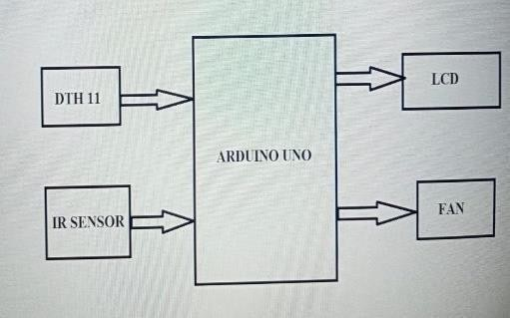

Fig1: Block diagram

# IV FUNCTIONAL BLOCKS OF PROPOSED SYSTEM

**ARDUINO UNO BOARD:**

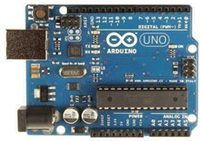

Fig2: Arduino Uno

A microcontroller board called the Arduino Uno is built on the ATmega328. It has a 16 MHz ceramic resonator, six analogue inputs, 14 digital input/output pins (of which six can be used as PWM outputs), a USB port, a power jack, an ICSP header, and a reset switch. It comes with everything required to support the microcontroller; to get started, simply attach it to a computer using a USB cable or power it using an AC-to-DC adapter or battery (Fig. 3.2).

The FTDI USB-to-Serial driver chip is not used by the Uno, which is how it varies from all earlier boards. Rather, it has an Atmega16U2 (or an Atmega8U2 up to version R2) that has been designed to function as a USB-to-serial converter.

# DHT11:

The widely used DHT11 temperature and humidity sensor includes an exclusive NTC for temperature measurement and an 8-bit microcontroller to output the temperature and humidity readings as serial data.

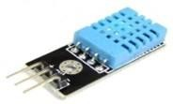

Fig3: DHT11 sensor

# DHT11 Specifications

* Operating Voltage: 3.5V to 5.5V
* Operating current: 0.3mA (measuring) 60uA(standby)
* Output: Serial data
* Temperature Range: 0°C to 50°C
* Humidity Range: 20% to 90%
* Resolution: Temperature and Humidity both are16-bit
* Accuracy: ±1°C and ±1%

**DHT11 Pinout Configuration:**

|  |  |  |  |
| --- | --- | --- | --- |
| No: | Pin Name | Description | |
| For DHT11 Sensor | | |  |
| 1 | VCC | Power supply 3.5V to 5.5V |  |
| 2 | Data | Outputs both Temperature and Humidity through serial Data |  |
| 3 | NC | No Connection and hence not used |  |
| 4 | Ground | Connected to the ground of the circuit |  |
| For DHT11 Sensor module | | |  |
| 1 | VCC | Power supply 3.5V to 5.5V |  |
| 2 | Data | Outputs both Temperature and Humidity through serial Data |  |

**FAN:**

Technology advancements[8] have made itbe refreshed by the CPU to keep displaying the data simpler and more practical to watch machinery. We are now providing controllers and sensors for fans to help gather data that can be used for operational monitoring, maintenance planning, and failure analysis because we recognize how important it is to keep machines operating smoothly. Our Industrial Internet of Things (IoT) sensor systems include these items. There are a variety of fan sensors available,[9] and each one may add to some of the advantages listed below. The temperature and speed of the motor, bearings, and drives are measured using mechanical sensors, as well as vibration measurements. Particle sensors and humidity sensors can both be used to check the quality of the air inside the fan, while the latter measures moisture. Additionally, current and voltage sensors enable ongoing power input monitoring so that AI software can make adjustments for the best possible power.

Machine-to-machine (M2M) interfacing comes in a variety of forms, and we will keep growing our selection based on client needs. Please get in touch with your local sales representative if you're interested in buying a monitoring gadget for your fan or just want more information[10].

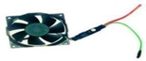

Fig4: fan

# LIQUID CRYSTAL DISPLAY (LCD)

Liquid Crystal Display is referred to as LCD. Due following factors, LCD is increasingly being used in place of LEDs (seven-segment LEDs or other multi-segment LEDs):

* Declining prices of LCDs.
* The ability to display numbers, characters and graphics. This is in contrast to LEDs, which are limited to numbers and few characters.
* Incorporation of a refreshing controller into the LCD, thereby relieving the CPU of the task of refreshing the LCD. In contrast, the LED must be refreshed by the CPU to keep displaying the data.
* Ease of programming for characters and graphics .

These parts cannot be actuated by conventional IC circuits because they are "specialized" for use with microcontrollers. They are employed to write various messages on a tiny LCD. The model detailed here is the one that is most frequently used in practice due to its low cost and enormous potential.

The HD44780 microcontroller, on which it is based, allows for the display of messages in two lines of sixteen characters each. The entire alphabet, Greek letters, punctuation, mathematical symbols, etc., are displayed. Moreover, it is possible to display custom symbols that the user creates. The appearance of the pointer, the lighting, and the automatic message on display (shift left and right) are all regarded as useful characteristics .[11-12]

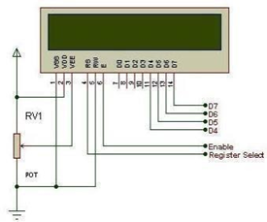

Fig5: Lcd Pin Configuration

# IR SENSOR:

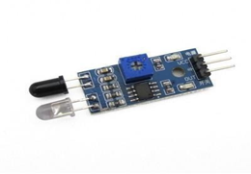

Fig6: IR sensor

An electrical device that monitors and detects infrared radiation in its environment is called an infrared (IR) sensor. William Herchel, an astronomer, made the unintentional discovery of infrared radiation in 1800. He saw that the temperature was highest just beyond the red light as he measured the temperatures of each colour of light (separated by a prism). Since IR's wavelength is longer than that of visible light, it is invisible to the human eye[13].

Types of IR sensors:

1. Active
2. Passive

# HARDWARE EXPERIMENTAL RESULT:

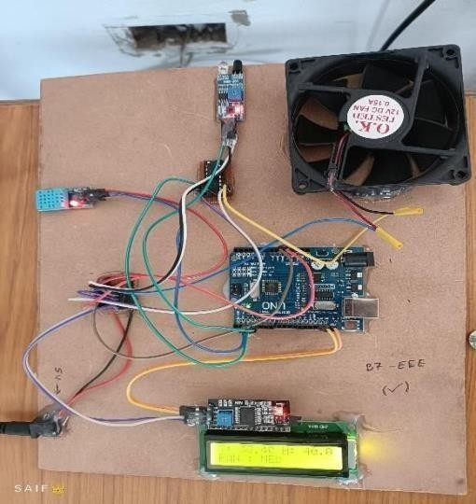

Fig7: At normal time

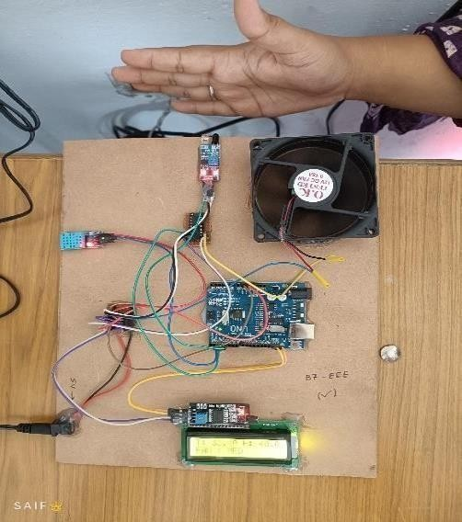

Fig8: At room temperature

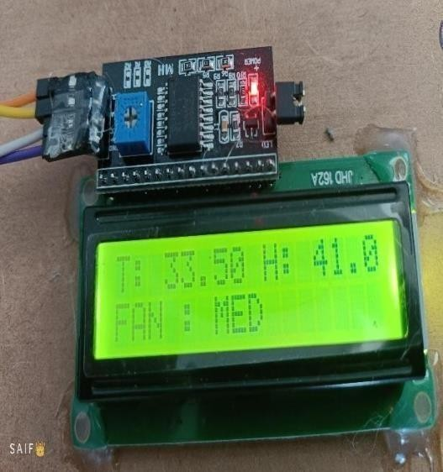

Fig9: display of room temperature

# CONCLUSION:

A series of experiments were conducted on the automatic room temperature-regulated fan speed controller unit to determine its performance as a controller device, and extremely positive findings were achieved. Also, it was determined that this device is swift enough to protect the equipment's safety from any undesirable transitory conditions of the main supply. The sensitivity of this instrument is really high. Also, it has a straightforward design, is dependable in use, and is priced similarly to comparable products on the market. This gadget can easily adjust the fan automatically based on room temperature, according to the analysis above.

# REFERENCES:

1. ***M.Y.Veeresh,*** *S. Seetharamudu, A. Raghavendra Prasad, Heart Stroke Detection & Alert System Using Arduino - GSM Technology, Journal of Emerging Technologies and Innovative Research (JETIR), ISSN: 2349-5162, Vol. 5, Issue No. 9, Sep-18, Pg.No: 653-655.* ***(UGC Approved) Impact Factor: 5.87.***
2. V.Jyothi, Dr.M. V. Subramanyam “ An Enhanced technique to improve the Network Lifetime of Cognitive Sensor Networks’, International Journal of Wireless Personal Communications’ pp. 12757 – 12763, May-2021,
3. B.Dastagiri Reddy, ***M. Yerri Veeresh***, K.Rajasekhara Reddy, Hybrid Power Generation System, in National Conference on Recent Advances in Communications and Energy Systems (RACES-2011), held at Vignan’s Lara Institute of Technology and Science, Vadlamudi, Guntur (Dist) on 29th & 30th, April 2011. Pp: 93-101.

[4] V.Jyothi, Dr.M.V.Subramanyam “An energy efficient fuzzy clustering-based congestion control algorithm for cognitive radio sensor networks’, WirelessNetworksl.Oct-2022.

[5] Dangi, Nagendra. 2017Monotoring Environmental Parameters: Humidity and Temperature Using Arduino Based Microcontroller and sensors

[6]Ms.C.V.Subhakar Reddy,” Information Masters Course the Context of Embedded System Design”,19- 112018,Santhiram Engineering College, Nandyal. [7]P.Raghunath, Dr.M.V.Subramanyam, “Communication coverage in wireless passive sensor networks”, International conference on recent advances in communication & I technologies.

[8]Saraswati, B. Alekya himabindu, Dr. M. V. Subramanyam “Multiple Sensor Data Fusion Based Top-Down Embedded System for Automatic Plant Pot Watering” JOURNAL OF ALGEBRAICSTATISTICS Volume 13, No.1,2022,p.884 – 891(ESCI) S( fvfdvfdvfdCIS23456789().

1. N.Sreenivasa Rao and Dr. P.Thimmaiahpublished a journal on A HIGHLY SECURED SYSTEM FOR HOME APPLIANCES EMBEDDED WITH ELECTRONICS SOFTWARE AND SENSORS in IJEIR, Vol. 6, Issue. 5 ICEMS-2017, Septembeer 2017.
2. K.Sudhakar, Dr.M.V.Subramanyam, “Calculation of Phase Delay Induced by humidity and Dry Air at Microwave Frequencies”, National Conference on Emerging Trends in Micro/Nano Electronic Technology, Saveetha School of Engineering, Chennai,8 April,2011.

[11]A.RaghavendraPrasad, K.Rajashekara Reddy, N.V.S.Prasad “Smart Home Automation system BY USING GSM AND ARDUINO TECHNOLOGIES”, *Journal of Emerging Technologies and Innovative Research (JETIR), ISSN: 2349-5162, Vol. 5, Issue No. 9, Sep-2018, Pg.No: 832-837.* ***(UGC Approved)***

[12]A.Raghavendra Prasad,M.Siva Sankar,N.V.S Prasad “Fault investigation in three phase power transmission systems with tripping mechanism at temporary and permanent fault” *Journal of Emerging Technologies and Innovative Research (JETIR), ISSN: 2349-5162, Vol. 4, Issue No. 10, oct-2017, Pg.No: 830-833.*

1. K. Singh, M. Dhar, P. Roy, Automatic fan speed control system using Arduino, ISSN: 2456-4184 International Journal of Novel Research and Development(IJNRD)4 April 2017