Arduino Based Accident Prevention System with Eye Twitch

&Alcohol Sensor.

1. Ramanjaneyulu1, S. Muhetulla2, C. Jayachandrudu3, S. M. Ganesh Naik4, K. Yugandhar5, M. Hussain Basha6 1Assistant Professor, Dept of EEE, Santhiram Engineering College,Nandyal, A.P., India.

2,3,4,5,6UG Student, Dept of EEE, Santhiram Engineering College, Nandyal, A.P., India. [ramanjaneyulu.eee@srecnandyal.edu.in,](mailto:ramanjaneyulu.eee@srecnandyal.edu.in) [20x55a0239@srecnandyal.edu.in](mailto:20x55a0239@srecnandyal.edu.in)

# ABSTRACT:

**The purpose of this paper is to lay the groundwork for creating a shield that may be placed around the vehicle to protect it from the intruder. While we are rushing by less alert people, we can't even take care of ourselves. As we equip every car with an automatic safety system that safeguards the driver to a great extent, we will also equip them with alarms. The vehicle-mounted alcohol sensor and the eye-blink detector in this equipment are both highly accurate. Every time the driver opens his eyes after turning the key, the sensors record it and conduct a breathalyzer test for alcohol. It provides sensor outputs that can be compared to those of an ARDUINO. The relay module sends a signal to the alcohol sensor or eye blink sensor if the value reaches a predetermined threshold, at which point the buzzer begins vibrating, the LED lights up, and the car comes to a slow stop.**

# INTRODUCTION:

Driver incompetence in traffic accidents is a major contributor to the dangers facing society. Due to the ineptitude of most drivers, it can lead to catastrophic collisions. Accidents on the road can be caused by many factors, including excessive speed, drowsiness behind the wheel, and the presence of passengers or other passengers' activities (such as conversing, texting, or playing with children). People are aware that driving a car can be risky, but they are unsure of how dangerous it actually is. fatigue. Over 1374 people lose their lives each day, while another 400 are born. There are about

57 incidents involving motor vehicles[1] every hour,

resulting in about 17 fatalities. 54.1 percent of people involved in car accidents are between the ages of 18 and

34. India's central government, including the Ministry of Road Transport and Highways, has set a goal of halving the number of road fatalities and accidents by the year 2022. One of the world's most pressing security issues is the prevalence of automobile collisions. In 2015, there were roughly 5 million car accidents in India. Drowsy drivers are more likely to make mistakes when behind the wheel, so it's important to keep an eye on them to reduce the likelihood of an accident. We targeted this problem with the introduction of a programme to reduce car accidents utilizing an eye twitch sensor. In this study, we take a closer look at the methods used to identify collisions and scale down such a system.

# LITERATURE SURVEY:

**This system uses a GPS and a GSM module to automatically detect accidents involving vehicles and send out alerts:**

Technology and infrastructure have improved dramatically, making our lives much less complicated. The proliferation of modern technologies has also exacerbated traffic dangers, leading to an increase in the frequency and severity of road accidents, which in turn result in a disproportionately high number of casualties and material damages due to inadequate emergency services. When completed, our project will be the best possible answer to this problem. The signal from the Micro electro mechanical system (MEMS)

sensor will be picked up and evaluated by Arduino in the event of a collision, as proposed by this project. The GSM Module relays the alert message from the Arduino to the police station or rescue squad, including the precise position. That way, after the authorities have the information, they can use the GPS Module to pinpoint the exact location. The location will be verified, and then the next step will be taken. The goal of this effort is to automatically detect an accident and send a signal to the nearest hospital or emergency services, detailing precisely where the accident occurred.

# Sensors for Monitoring Blood Alcohol Content and Impact Velocity in a Smart Helmet:

Now that Electronic Stability Control and other systems are standard, automobiles are far more advanced and secure than in the past. Smart Helmet is an idea with the similar intention for motorcycles. With safety features like a built-in Black Box and GPS logging, which can be accessed in an emergency, this bike is ready for anything. In the event of a crash or drunk driving, the rider will receive an alarm from the collision detector. For GPS data logging, collision detection, and emergency SMS transmission, the helmet employs an ATMega32u4 with AI Thinker's A7 GSM-GPS module. An alcohol[2] sensor in the helmet can be used as a breathalyzer and will notify emergency contacts, who will receive the rider's location, through text message. The Raspberry Pi Black Box will aid in determining what caused an accident. In the event of an accident, film of the incident will be recorded automatically. It will make the roads safer for motorcyclists and aid them in an emergency.

# EXISTING SYSTEM:

Driver incompetence in traffic accidents is a major contributor to the dangers facing society. Due to the ineptitude of most drivers, it can lead to catastrophic collisions. Accidents on the road can be caused by many factors, including excessive speed, drowsiness behind the wheel, and the presence of passengers or other passengers' activities (such as conversing, texting,

or playing with children). People are aware that driving a car can be risky, but they are unsure of how dangerous it actually is. fatigue. Over 1374people lose their lives each day, while anothe400

are born. There are about 57 incidents involving motor vehicles every hour, resulting in about 17 fatalities.

54.1 percent of people involved in car accidents are between the ages of 18 and 34. India's central government, including the Ministry of Road Transport and Highways, has set a goal of halving the number of road fatalities and accidents by the year 2022. One of the world's most pressing security issues is the prevalence of automobile collisions. In 2015, there were roughly 5 million car accidents in India. Drowsy drivers are more likely to make mistakes when behind the wheel, so it's important to keep an eye on them to reduce the likelihood of an accident. We targeted this problem with the introduction of a programme to reduce car accidents utilizing an eye twitch sensor. In this study, we take a closer look at the methods used to identify collisions and scale down such a system.

# PROPOSED SYSTEM:

By implementing the Arduino-based prevention system with the eye twitch and alcohol sensor, we can reduce the number of accidents and the resulting human suffering. People are aware that driving a car can be risky, but they are unsure of how dangerous it actually is. fatigue. Over 1374 people lose their lives each day, while another 400 are born.

The Arduino based prevention system with eye twitch and alcohol sensor. Once the driver starts the engine by wearing respective glasses, the eye blink sensor which is attached to the glasses is automatically detects whether the eye is closed or not. If it is closed for a while then after few seconds it will gives the buzzer sound loudly to alert the driver. And also it has alcohol sensor which can tests the alcohol level in his breath. In this device sensor outputs are given for comparison to the ARDUINO. If the value hits t level, then buzzer automatically emits sound with vibration and the vehicle is slowly stopped automatically.

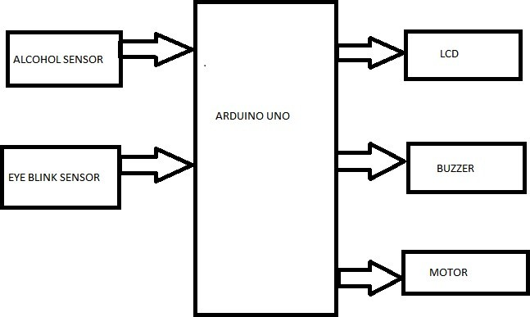

# ARDUINO UNO

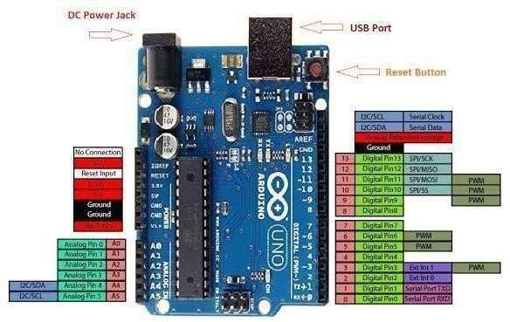

**Fig 3.1 Arduino Uno with pin description**

The Arduino Uno is a microcontroller [3] board based on the ATmega328 (datasheet). It has 14 digital input/output pins (of which 6 can be used as PWM outputs), 6 analog inputs, a 16 MHz crystal oscillator, a USB connection, a power jack, an ICSP header, and a reset button. It contains everything needed to support the microcontroller; simply connect it to a computer with a USB cable or power it with a AC-to-DC adapter or battery[4] to get started.

The Uno differs from all preceding boards in that it does not use the FTDI USB- to- serial driver chip. Instead, it features the Atmega8U2 [5] programmed as a USB-to-serial converter. "Uno" means "One" in Italian and is named to mark the upcoming release of Arduino

* 1. The Uno and version 1.0 will be the reference versions of Arduino, moving forward.

The uno is the latest in a series of USB Arduino boards, and the reference model for the Arduino platform; for a comparison with previous versions, see the index of Arduino boards.

The Arduino Uno can be powered via the USB connection or with an external power supply. The power source is selected automatically. External (non-USB) power can come either from an AC-to-DC adapter (wall- wart) or battery . The adapter can be connected by plugging a 2.1mm center-positive plug into the board's power jack. Leads from a battery can be inserted in the G and Vin pin headers of the POWER connector.

The board can operate on an external supply of 6 to 20 volts. If supplied with less than

V, however, the 5Vpin may supply less than five volts and the board may be unstable. If using more than 12V, the voltage regulator may overheat and damage the board. The recommended range is 7 to 12 volts.

# Buzzer

A buzzer or beeper is an audio signaling device, which may be mechanical, electromechanical, or piezoelectric (piezo for short). Typical uses of buzzers and beepers include **alarm devices, timers, and confirmation of user input such as a mouse click or keystroke**.

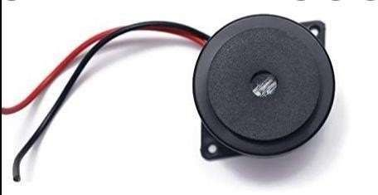

# EYE BLINK SENSOR

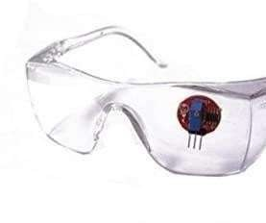receiver. The transmitter continuously emits infrared waves onto the eye. While the receiver continuously looks for variations in the reflected waves which indicates that the eye has blinked.

If the eye is closed that means it will give high output. If the eye is open then it will give a low output.

# LIQUID CRYSTAL DISPLAY (LCD)

LCD stands for Liquid Crystal Display. LCD is finding wide spread use replacing LEDs (seven segment LEDs or other multi segment LEDs) because of the following reasons:

* The declining prices of LCDs.
* The ability to display numbers, characters and graphics. This is in contrast to LEDs, which are limited to

numbers and a few characters.

* Incorporation of a refreshing controller into the LCD, thereby relieving the

CPU of the task of refreshing the LCD. In contrast, the LED must be refreshed by the CPU to keep displaying the data.

* Ease of programming for characters and graphics.
* These components are “specialized” for being used with the microcontrollers, which means that they cannot be activated by standard IC circuits. They are used for writing different messages on a miniature LCD.

**FEATURES OF LCD**

* Operating voltage is 4.7V to 5.3V.and Current consumption is 1 mA without backlight.
* Alphanumeric LCD display module, meaning it can display alphabets and numbers.
* It consists of two rows, and each row can print 16 characters.
* Each character is built from a 58 pixel box and Can work on both 8-bit and 4-bit mod.
* Available in green and blue backlight.
* The eye blink sensor[6] is an infrared sensor[7]. It contains two parts. A transmitter and a

# WORKING CONDITION

**MOTOR:**

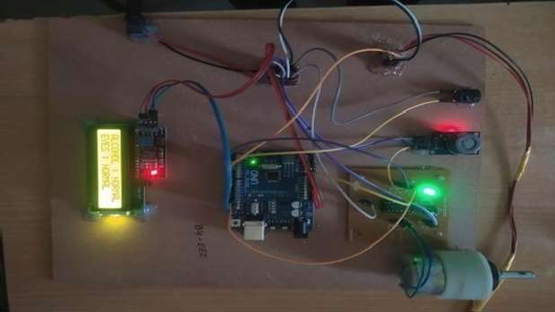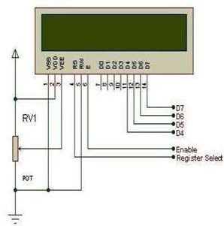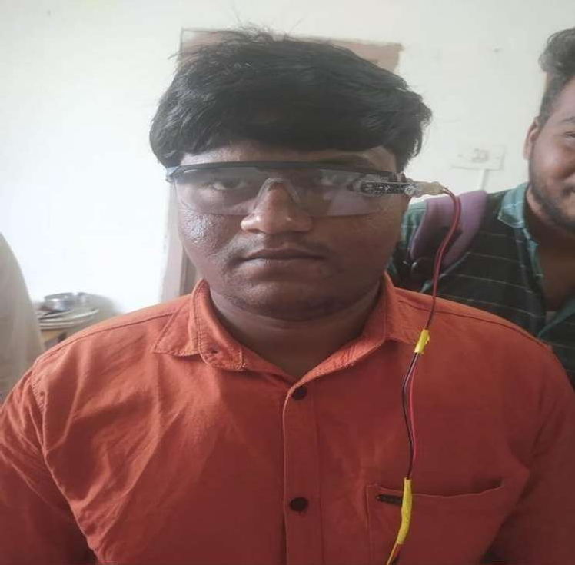

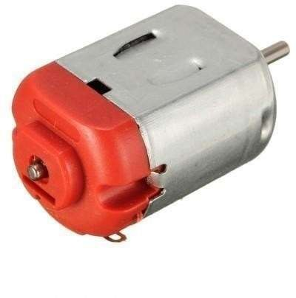

Electric motors can be powered by direct current (DC) sources, such as from batteries, or rectifiers, or An electric motor is an electrical machine that converts electrical energy into mechanical energy. Most electric motors operate through the interaction between the motor's magnetic field and electric current in a wire winding to generate force in the form of torque applied on the motor's shaft. An electric generator is mechanically identical to an electric motor, but operates with a reversed flow of power, converting mechanical energy into electrical energy.

**Result:**

# V. CONCLUSION:

People are increasingly exposed to dangers today. Therefore, we need to take action against this as an engineer and have the solution we need. Any

automation is designed to protect a person. Such a model is tasked with developing a system for diagnosing and controlling the speed of vehicles to prevent accidents. To some extent, modern technology offers some hope of stopping these. This paper includes monitoring the blink of an eye with the help of an IR sensor[8]. On this device the output of the sensor[9] is provided for comparison with ARDUINO. When the value reaches the set level, the buzzer automatically vibrates, the LED glows, and the car stops automatically when the eye blink sensor[10] receives a signal from the transmission component.[11].

# REFERENCES:

1. C.Prabha, R.Sunitha, R.Anitha “Automatic Vehicle Accident Detection and Messaging System Using GSM and GPS Modem”, IJAREEIE, Vol. 3, Issue 7, pp: 10723 – 10727, July 2014.
2. S. Gupta, K. Sharma, N. Salvekar and A. Gajra, "Implementation of Alcohol and Collision Sensors in a Smart Helmet," 2019 International Conference on Nascent Technologies in Engineering (ICNTE), Navi Mumbai, India, 2019, pp. 1-5, doi: 10.1109/ ICNTE44896.2019. 8945979.
3. M.Yerri Veeresh, Dr.V.Nagabhaskar Reddy, Dr.R.Kiranmayi, Modeling and Analysis of Time Response Parameters of a PMSM-Based Electric Vehicle with PI and PID Controllers, in Engineering, Technology & Applied Science Research (ETASR), ISSN: 2241-4487, Vol. 12, Issue. 6, December 2022,

PP.No. 9737-9741

1. M.Yerri Veeresh, Dr.V.Nagabhaskar Reddy, Dr.R.Kiranmayi, Range Estimation of Battery Electric Vehicle by Mathematical Modelling of Battery’s Depth of Discharge, in International Journal of Engineering and Advanced Technology (IJEAT), ISSN: 2249-8958, Vol. 8, Issue. 6, August 2019, PP.No. 3987-3992..
2. Tushara, D. B., & Vardhini, P. A. H. (2016). Wireless vehicle alert and collision prevention system design using Atmel microcontroller.In International Conference on Electrical, Electronics, andOptimization Techniques, ICEEOT 2016 (pp. 2784– 2787). Institute of Electrical and Electronics EngineersInc.
3. K. Akkaya, F. Senel, A. Thimmapuram, and S. Uludag, “Distributed recovery from network partitioning in movable sensor/actor networks via controlled mobility,” IEEE Trans. Comput., vol. 59, no. 2, pp. 258–271, Feb. 2010.
4. V.Jyothi, Dr.M. V. Subramanyam “ An Enhanced technique to improve the Network Lifetime of Cognitive Sensor Networks’, International Journal of Wireless Personal Communications’ pp. 12757 – 12763, May-2021.
5. Dr.M. V. Subramanyam et al ‘Multiple Sensor Data Fusion Based Top-Down Embedded System for Automatic Plant Pot WateringJournal of Algebraic Statistics,e-ISSN: 1309-3452,Marmara University Istanbul University, Istanbul, Vol. 13, No. 1,PP: 884 – 891,2022, No.3.
6. V.Jyothi, Dr.M. V. Subramanyam “An energy efficient fuzzy clustering-based congestion control algorithm for cognitive radio sensor networks’, Wireless Networksl. Oct-2022.
7. Saraswati, B. Alekya Himabindu, Dr. M. V. Subramanyam “Multiple Sensor Data Fusion Based Top-Down Embedded System for Automatic Plant Pot Watering” JOURNAL OF ALGEBRAIC STATISTICS Volume 13, No. 1, 2022, p. 884 – 891.
8. V. Ramanjaneyulu, "DTMF Based Irrigation Water Pump Control System" in International Journal of Research Available at https://edupediapublications.org/journals p-ISSN: 2348- 6848 e-ISSN: 2348-795X Volume 05 Issue 12 April 2018.