**RESCUE OF COAL AND MINE WORKERS USING ZIG-BEE TECHNOLOGY**

**R. Revathi1, Dr.S.Rathinavel2**

1,2Department of Electronics and Instrumentation, Bharathiar University,

Coimbatore-641046, Tamilnadu, India

E-mail: rathinavel@buc.edu.in

**ABSTRACT**

To study the real-time perception of coal mining regions of underground mine workers affected by physical condition. The environment and accidents in coal areas are very dangerous and that is the main reason for safety and production. The existing system cannot offer useful data because it lacks a precise location-tracking function. The proposed system produces worker protection to address these issues. The information is transferred from the sensors that are attached to the personal protective equipment kit to the computer on the ground level. It will improve by the numerous sensors that are connected in the LPC 2148 and also by the use of zig-bee wireless technology. Here, sensors play a crucial role. The primary goal of this project can monitor the worker's condition in real-time. This project offers a cost-effective, adaptable solution for underground mine employees' safety and developed a reliable communication system inside the underground miners. Zig-bee module transfers the received data to the control unit on the ground level that is combined with the RS232. The technology can also significantly increase the effectiveness of the management of mine safety.

**Keywords**: Sensors, Zig-bee module, Liquid crystal display (LCD), personal protective equipment kit, and communication cable.

1. **INTRODUCTION**

**M**ining as defined by the Oxford Dictionary is the process or industry of obtaining coal or other minerals from a mine. The activities carried out to obtain these minerals have a dangerous element to them. The International Organization of Standardization or ISO has a standard namely the ISO 45001. This standard aims to reduce the liability of occupational injuries and diseases not only to benefit the workers but also the economy upon which this work builds [1]. The average mine worker is exposed to the harsh underground environment Production of coal increased by 6% to 5 million tonnes in 2022. (MT) A total of 607.97 million tonnes of coal will be produced between April and December 2022. In comparison to December 2021, India's total coal output climbed from 74 to 79 MT to 82.87 MT in December 2022, a 10.81% increase. Humans must travel well below the surface to transfer coal to the top for use in daily life [2]. Throughout this mission, they encounter several challenges in the subterranean environment. Leaks of hazardous gases, including CH4 and other gases, are another factor in mining accidents [3]. India mines 89 minerals, employing millions of people directly via the operation of 569 coal mines, 67 oil and gas mines, 1770 non-coal mines, and several other minor mines totalling over a lakh. Individuals on a daily average, while the sector's overall contribution to India's gross domestic product is roughly 5%. Several wireless sensors are used to give protection in this instance. We utilize the miners to provide those who work in coal and mining regions with a high sense of security [4]. Zig-bee standards use IEEE 802.15.4 for data transport since it is a cutting-edge, dependable radio technology with over 44 years of expertise. This criterion is very consistently met by low-range wireless communication technology [5].

Zig-bee technology was recommended for this usage because it has some benefits, including a widely recognized frequency range for wireless communication between the base station and the sensors [6]. India produces 89 minerals by running 569 coal mines, 67 oil and gas mines, 1770 non-coal mines, and numerous additional small mines totalling more than a lakh. All of these operations directly employ millions of people daily, and the sector as a whole contributes about 5% of India's GDP. It uses several unlicensed radio bands to function. (2.4 GHz, 900MHz & 868MHz) [7]. For fast identification in locations with limited connection, a microcontroller might be incorporated into the design of this coal miners' rescue kit [8] Monitoring the working conditions of miners is becoming more and more crucial because of the variety and complexity of environmental disasters that occur in mines as well as the numerous hazardous factors that increase the likelihood of accidents, such as fire, petrol leaks, and high temperatures [9].

While several safety monitoring systems are useful for coal and mine safety, some of them still fall short of providing adequate life protection [10]. The many construction methods and strategies employed demonstrate a variety of approaches to save the lives of the workers. By utilizing an embedded system that aids in tracking the physical conditions underneath, the project's main goal is to preserve the lives of the miners while also improving public safety. Since these accidents result in fatalities, it is essential to keep a watch on the coal and mine workers down there. As a result, the data that was gathered utilizing wireless communication technologies in the subsurface area is delivered to the base region [11].

**1.1** **OBJECTIVE**

* The major aim of this project is to save the lives of the miners when a hazardous substance is detected.
* To maintain the continuity of the communication system is very much important to know the actual position and condition of the trapped workers.
* Whenever the sensor data exceeds the specified threshold (preset) value of temperature and carbon monoxide, the zig-bee module at the remote monitoring site will transmit an alert signal to the local site by blowing a buzzer continuously.
* Due to this wireless communication system, employees will be alert earlier as compared to the present underground system. So rapid action will be taken by the rescue team.
* In the future, it will improve the scalability of the underground environment and extend the accurate position of miners.
* Inside mines, different parameters are intimated to the workers through voice.

**1.2 LITERATURE SURVEY**

**Shi Wei and Li Li-li [7].** The multi-parameter monitoring system for the coal mine combines the RS485 communication technology with the ZigBee wireless sensor network technology. The approach makes it simple to add or delete monitor nodes, and it also makes it simple to grow the network. It can increase the flexibility of information gathering while lowering the cost of developing a safety system communication network in coal mining as an expansion of current wired security systems in mines. Thus, it increases the practical value of coal mine safety monitoring and control information systems as well as their applied value.

**Zhang Qinghua et al [8].** The use of technology to automatically recognize worker information, quickly detect their locations, and record their movements may significantly raise the level of information management in the coal mine and give the data required for management and rescue. Additionally, GIS is employed to give a visual window to let the Position System manage the workers' whereabouts more conveniently. Here, GIS technology is also utilized to offer the simplest method of tracking. GIS (Geographic Information System) is a system of technology that, with the aid of computer hardware and software, scientifically manages and synthesizes spatial data to provide information for planning, decision-making, management, and research. Anyone entering the inner-mine site must have a wireless identification card (RFID tag) to be tracked by the system; once he passes through or is close to one of the wireless sensors placed in the roadway, the wireless sensor will soon receive the signal and upload it to Host Central Station, which can recognize the specific information (such as identity, location, and time) from the signal and display it simultaneously on the large screen or computer screens of those present. The computer will quickly provide information on the workers in this area.

**Pudke et al [12].** This study examines the design and creation of a LabVIEW and microcontroller-based coal mine monitoring system that uses wireless ZigBee and GSM technologies. (Global System for Mobile Communication). The physical state parameters in a coal mine, such as temperature, gas, humidity temperature, fire, etc., are sensed using a variety of sensors. The base station located underground in the mine continually gathers these parameter signals from the sensors and transmits them to the ground station above. As a result, the control system uses LabVIEW, an ATMEGA 2560 microcontroller, and wireless technologies like GSM and Zig-bee to monitor and manage the conditions in deep mines in real-time. For real-time monitoring and control of the underground mine state, an embedded control system has been designed. The system uses a variety of sensors connected to an embedded control system built on LabVIEW to measure the conditions in the deep mine. GSM-enabled wireless technology is also utilized to make calls and/or deliver messages.

**Arun Katara et al [16].** Because there is no communication or monitoring mechanism to keep track of the miner, the coal and mine employees frequently experience dangerous incidents that result in fatalities in the pit itself. They created a smart helmet with sensors to prevent future instances of this nature. They employed this smart helmet for communication utilizing zig-bee technology since cable connection had so many technical problems in the past. Given that this is a wireless transmission, maintenance is also relatively simple. They were able to communicate and keep each other informed about the miner's status thanks to this communication protocol and module. The miner can identify various parameters which are needed for coal and mine workers with the help of the sensors. This is not only for coal and miners in near future this method can be used for the workers who work underground in their need.

1. **BLOCK DIAGRAM**

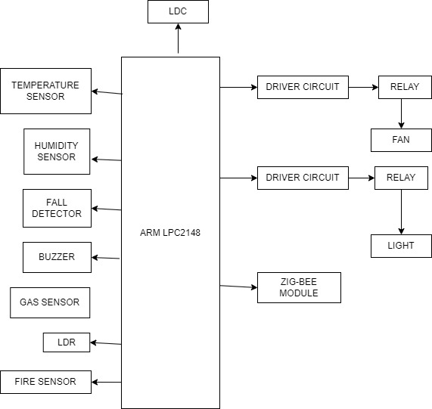

**Figure.1. Overview of hardware set-up**

The above block diagram in Figure 4.1 tells about the working of the safety kit for coal and mine workers. The sensors which are connected to the ARM LPC2148 (Controller), temperature sensor, humidity sensor, gas sensor, LDR, buzzer, LCD, fire sensor, fall detector, a driver circuit, relay, light, fan, zig-bee transceiver. All these will be working parallel and when a substance is detected the concern sensor will get an alert and the sensor sends the signals and the message to the LCD and also to the computer in the base station to take an action to prevent loss of life of the miner before any death.

**2.1 MONITORING UNIT:**

**C:\Users\elcot\Downloads\Untitled Diagram.jpg**

**Figure.2. block diagram of monitoring setup**

The monitoring unit’s work is to pass the information which is received from the zig-bee module and that passes to the computer via RS232. That makes the technicians make steps to save the miner. Otherwise, it will lead to the loss of life of the worker, as the wired system has so many drawbacks and that leads to so many technical issues. So, the wireless system has made work easier for people.

1. **METHODOLOGY**

The ARM microcontroller (LPC2148) is used in this project's suggested methodology, where the microcontroller plays a crucial role. First coupling every sensor to the CPU, sending every bit of data from the microcontroller’s ADC port to the zig-bee module, and then sending every bit of data from the zig-bee module to the PC in the base station through the RS232 communication cable. Now when the workers are in a risky scenario, the base station's technicians will provide another route or a solution to get them out of it, from the communication to the module to the LCD that shows the message or command they provided. The PPE kit that the miner will wear while working within the coal mine pit now includes this kit, which has been integrated into it. The LEDs will be installed in the miners' helmets so that they can work in the dark as they see fit. When needed, the LEDs illuminate and emit light from a 360-degree angle.

As the temperature rises over the threshold value, the temperature sensor (LM-35) included in the CPU will begin to monitor the temperature inside the coal mine and the pit. The data will be delivered to the microcontroller's ADC port, and the microcontroller will then send the data to the PC within the base station via a wireless zig-bee module and RS232 (communication cable). The driver circuit can now be used to drive the fan to the ON position from the OFF position if the temperature rise is to a moderate level; if the temperature rise is greater, professionals will provide a solution. The sensor won't send any data to the microcontroller while the temperature is below the threshold value, but it will continue to monitor the temperature range until it does.

When the darkness deepens, the LED will gradually begin to illuminate in a manner proportional to the LDR. The LED won't glow and the LDR won't function if the amount of light within the coal mine pit is zero or below the threshold value. As the darkness deepens, the LED will likewise begin to illuminate gradually thanks to the driver circuit. The base station's PC will display the message via the zig-bee module and RS232 while also displaying the percentage of darkness. Moreover, a buzzer will sound to indicate that a warning is present. The LED will be attached to the worker's helmet so that he may operate without having to use his hand to hold the lamp like he would a torch. The worker's PPE kit will get the connection for this and contain it. To inform the worker of the current state of his surroundings, the LCD will also show the worker the level of a rising darkness.

The temperature and humidity sensors can be used together (DHT-11) as a single sensor since they operate similarly. Nevertheless, under certain circumstances, the results of the sensors may be impacted. The LCD and PC of the base station will both display the humidity message as soon as the humidity level rises above the threshold value. As a result, the worker will notice an increase in humidity in the coal mine pit. When the humidity level exceeds the threshold, only then will the warning message be shown and a buzzer will ring, signaling that a warning has been issued and the message will be displayed on the LCD (16x2).

Gas sensors are used to detect the most dangerous gases underground that might kill a person. Because butane and methane are the two most dangerous gases, we are employing them here to identify other gases. The base station technicians are alerted as soon as these gases are discovered, and the alarm will sound and the LCD will indicate the range of gases present in the pit. Using this, the worker can prevent a fatality. As a result, harm to human organs may occasionally result even before the gas has been inhaled.

The most important sensor for workers in coal and mine pits is the fire or flame sensor because it can save lives when a fire breaks out for no apparent reason. It is important to note it as soon as it is detected because this can cause accidents and without any notification, to the worker, it might lead to some burns on his body. The buzzer sounds an alert, and then the sensor displays a warning message on the LCD and sends a message to the base station Computer, which the technicians use to monitor the worker's safety. At this point, the worker searches for a different path or makes an effort to prevent the accident.

The fall detector (ADXL-335) is used to detect if there is a fall of a person or any other object, here it detects the fall of the person detector is very much useful. This has happened so many times as people have fallen and at times the technicians in the base station are not aware of the matter and they just keep waiting for the worker to come up. So this fall detector (accelerometer) is very much useful for not only coal and mine worker. The kit is also used for any underground work.

1. **HARDWARE DESCRIPTION**

**4.1 TEMPERATURE SENSOR (LM35)**

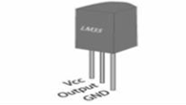

**Figure.3. Temperature sensor**

The system employs an LM35 temperature sensor. Due to its ease of connection and ability to measure a variety of temperatures. The use of adequate packaging prevents issues like oxidation. The LM35 provides more precise and linear temperature readings as compared to the thermistor. It can operate between 55 and 150 degrees Celsius. Moreover, it does not raise the temperature of still air by more than 0.1 degrees Celsius due to its modest self-healing capability.

**4.2 GAS SENSOR (MQ-4 &MQ-7)**

The range of concentrations in which this semiconductor gas sensor can detect the presence of methane (CNG) gas is between 300 ppm and 10,000 ppm, making it useful for locating gas leaks. Your microcontroller needs just one analog input pin to interact with the sensor's straightforward analog voltage.

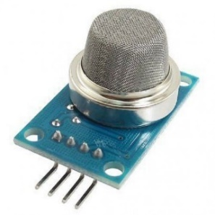

**Figure.4. Methane gas sensor**

**FEATURES**

* Natural gas;
* High sensitivity to CH4.
* Less susceptibility to smoke from alcohol.
* Quick response.
* Straightforward driving circuit
* Stable and extended life

**4.3 MQ-7 (Carbon monoxide)**

The MQ7 Gas Sensor belongs to the Metal Oxide Semiconductor (MOS) type Gas Sensor family, which also includes the MQ 2, MQ 4, MQ 3, MQ 8, MQ 135, and others. The main purpose of it is to detect carbon monoxide. This sensor has a detecting element made mostly of ceramic with an aluminum oxide base that has been coated in tin dioxide (SnO2) and is housed in a stainless steel mesh.



**Figure.5. Carbon Monoxide gas sensor**

**FEATURES:**

* High sensitivity to carbon monoxide
* Stable and long life

**4.4 HUMIDITY SENSOR**

The relative humidity (RH) of air is sensed, measured, and reported by a humidity sensor, which also calculates how much water vapour is present in pure gas or gas mixtures like air. The process of water adsorption and desorption is connected to humidity sensing.

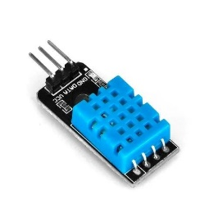

**Figure.6. Humidity sensor**

**4.5 FIRE SENSOR**

Flames with a wavelength between 760 and 1100 nanometers can be detected by the Fire Sensor Module. At around 0.8m, little flames, such as a lighter flame, may be seen. The sensor has a detection angle of around 60 degrees and is very responsive to the flame spectrum. The sensor includes a digital and analog output, and the blue potentiometer may be used to change the sensitivity. This Flame Sensor Module is used to find sources of flame or other light with wavelengths between 760 and 1100 nm.

Maximum operating voltage: 4.75 to 5V. 20 mA is the working current. Range of the spectral

Bandwidth: 760–1100 nm. Range of detection: 0–1 m.

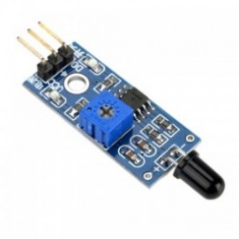

**Figure.7. Fire sensor**

**4.6 LDR**

It is a unique kind of resistor whose operation is based on the photoconductivity principle, which causes resistance to vary with light intensity. With an increase in light intensity, its resistance falls.

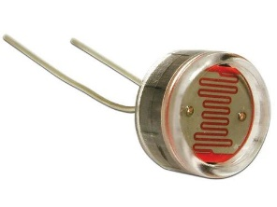

**Figure.8. Light-dependent resistor**

**4.7 FALL DETECTOR (ADXL-335)**

Every pin of the ADXL335 is exposed on this breadboard-friendly module, which also includes two supply pins, a self-test pin, and three analog outputs for X, Y, and Z axis measurements. The full sensing range of the ADXL335 is 3g. Hence, the ADXL335 can precisely measure acceleration up to 3 g and output that value as an output.

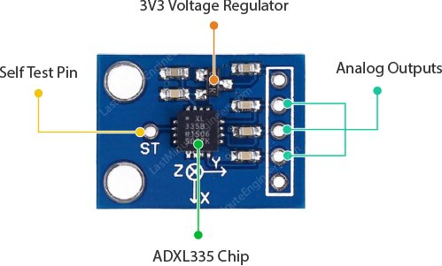

**Figure.9. Fall detector**

**4.8 LCD (16x2)**

A type of flat panel display known as an LCD (Liquid Crystal Display) operates primarily on liquid crystals. As they are often used in cellphones, televisions, computers, and instrument panels, LEDs offer a wide range of applications for consumers and enterprises.

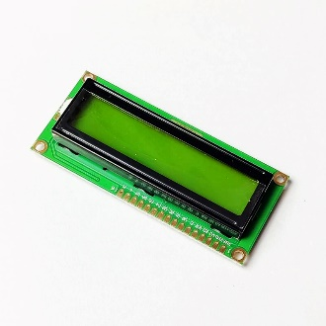

**Figure.10. LCD**

**4.9 MICROCONTROLLER (LPC2148)**

A high-performance 32-bit RISC microcontroller with thumb extensions, the LPC2148 is based on the ARM7TDMI-S architecture. 32KB RAM, Vectored Interrupt Controller, 512KB on-chip Flash ROM with In-System Programming (ISP) and In-Application Programming (IAP), Two 14-channel, 10-bit ADCs, a complete modem interface on one of the UARTs, and a USB 2.0 Full Speed Device Controller. There are two I2C and two SPI serial interfaces. Two 32-bit timers, a watchdog

timer, a PWM unit, a real-time clock with an optional battery backup, general-purpose I/O pins, and a brown-out detect circuit are included. An on-chip crystal oscillator, PLL, and CPU clock up to 60 MHz.

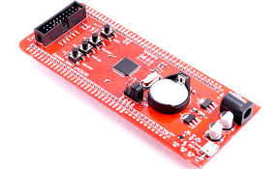

**Figure.11. ARM7TDMI-S Controller**

**4.10 BUZZER**

A beeper or buzzer, for example, might be electromechanical, piezoelectric, or mechanical in design. The signal is converted from audio to sound as its primary function. It is often powered by DC voltage and used in timers, alarm clocks, printers, computers, and other electronic equipment. It may produce a variety of sounds, including alarm, music, bell, and siren, according to the varied designs.

3,300 Hz is the frequency range. Working temperatures vary from -20 to +60 degrees Celsius. Operating voltages between 3V to 24V DC The noise intensity is 85 dBA or 10 cm. Low supply current of less than 15 mA.

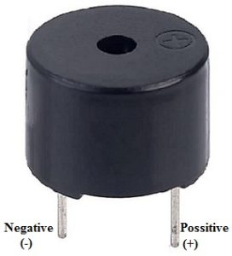

**Figure.12. Buzzer**

**4.11** **ZIG-BEE MODULE**

Battery-powered devices used in wireless control and monitoring applications are the target market for the low-power zig-bee wireless mesh network standard. The low-latency communication offered by zig-bee. Radios and microcontrollers are frequently incorporated with zig-bee chips in electronic devices. Zig-bee uses the ISM (industrial, scientific, and medical) radio bands for its operation.

* Range physically: 10 to 100 meters
* IEEE 802.15.4 is a global standard created by the Connectivity Standards Association.

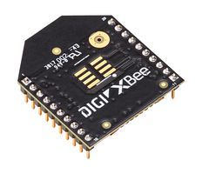

**Figure.13. Zig-bee module**

**V. RESULT AND DISCUSSION**

The outcome of the project's software simulation is depicted in Figure 7.1. We achieved this outcome by combining many sensors. The humidity, low/high temperature, darkness, fire detection, CO, and CH4 presence alerts have all been detected, and only the aberrant parameter is displayed on the LCD for the miner to know so that he may protect himself. When the temperature rises over 30 degrees and falls below 20 degrees, the sensor sends a message to the computer through a zig-bee transceiver and RS232, and the buzzer begins to sound. When a fire is detected in a coal or mine pit, the sensor detects it and sends a signal to the sensor, which displays the information on the LCD and sends it to the computer. When the humidity falls below 70%, the sensor sends a notification to the computer, which is also shown on the computer in the ground station. Similarly, the same operation occurs for all additional sensors. As the material hits or falls below the threshold value, the buzzer begins to buzz, and the information is sent to the base station through the zig-bee module, which then sends the information to the PC via RS232.

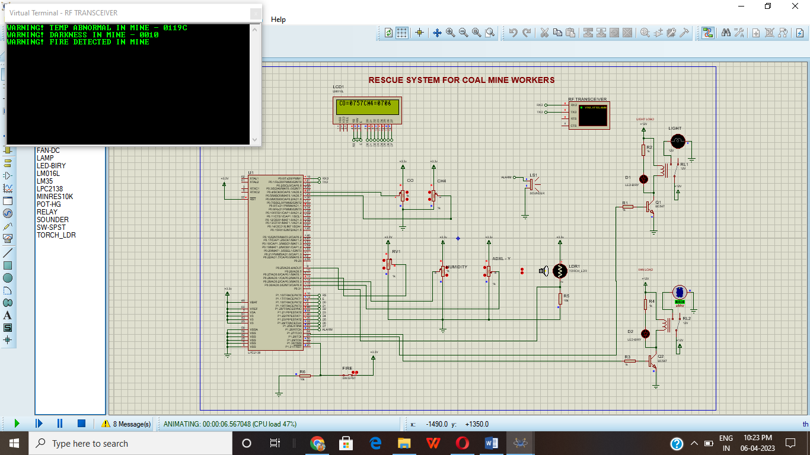

**Figure.14. Stimulation result for the system**

1. **CONCLUSION**

The quick advancement of information technology today offers coal and mine information a fantastic opportunity as well as a solid foundation for the establishment of this system to prevent numerous accidents and disasters. To prevent coal and mine accidents, this study evaluates the function and shortcomings of the safety management information system for the coal industry. It then proposes and develops a coal mine safety dynamic evaluation system with real-time functionality. By this method, it is possible for mine-related management employees to not only more rapidly find various workplace hazards and unsafe conditions, but also to instantly comprehend the state of underground safety, production, and security. Also, a distinction is made between precise data and real-time reports and specific numerical information with weight determination. This is not just for coal and mine workers; in the future, we can utilize this technology anywhere workers perform subterranean labor.

**REFERENCES**

1. Jayabharata, S., and C. N. Marimuthu. "Wearable Real-Time Health and Security Monitoring Scheme for Coal Mine Workers." *Journal of Electrical & Electronics* 4.2 (2015): 1.
2. Kumar, Subhash, et al. "Evolution of applicability of robotics in underground mine services." *Journal of Mines, Metals, and Fuels* (2018): 171-175.
3. Dohare, Yogendra S., et al. "Design of surveillance and safety system for underground coal mines based on low power WSN." *2014 International Conference on Signal Propagation and Computer Technology (ICSPCT 2014)*. IEEE, 2014.
4. Talpur, Mir Sajjad Hussain, et al. "SMART HELMET FOR COAL MINES SAFETY MONITORING WITH MOBILE APP."
5. Krithika, N., and R. Seethalakshmi. "Safety scheme for mining industry using Zigbee module." *Indian Journal of Science and Technology* 7.8 (2014): 1222-1227.
6. Shakunthala, M., et al. "IOT Based Coal Mine Safety Monitoring and Controlling." *Annals of the Romanian Society for Cell Biology* (2021): 12381-12387.
7. Wei, Shi, and Li Li-Li. "Multi-parameter monitoring system for coal mine based on wireless sensor network technology." *2009 International Conference on Industrial Mechatronics and Automation*. IEEE, 2009.
8. Qinghua, Zhang, et al. "Object position tracking based on e-map and RFID in the coal mine." *2009 4th IEEE Conference on Industrial Electronics and Applications*. IEEE, 2009.
9. Wang, Yangyang, et al. "Application of Rescue Simulation and Training System for Coal Mines Based on UWB Technology and TDOA Algorithm." *2020 IEEE 4th Information Technology, Networking, Electronic, and Automation Control Conference (ITNEC)*. Vol. 1. IEEE, 2020.
10. Jiangshi, Zhang, et al. "The Design and Research of Coal Mine Safety Dynamic Evaluation System." *2011 Fourth International Conference on Intelligent Computation Technology and Automation*. Vol. 1. IEEE, 2011.
11. Qi-dong, Pan, Duan Dong-sheng, and Sun Gang. "Data Integration Research of Coal Mine Safety Production System for Emergency Decision-Making." *2009 International Forum on Computer Science-Technology and Applications*. Vol. 3. IEEE, 2009.
12. Pudke, Ashwini J., Sanket N. Bhagat, and S. L. Nalbalwar. "LabVIEW-based coal mine monitoring and alert system with data acquisition." *2017 International Conference on Intelligent Computing and Control Systems (ICICCS)*. IEEE, 2017.
13. Chen, Xuhui, and Peiqiang Yu. "Research on hierarchical mobile wireless sensor network architecture with mobile sensor nodes." *2010 3rd International Conference on Biomedical Engineering and Informatics*. Vol. 7. IEEE, 2010.
14. Boddu, Rajkumar, P. Balanagu, and N. Suresh Babu. "Zigbee-based mine safety monitoring system with GSM." *International Journal of Computer & Communication Technology* 3.5 (2012): 63-67.
15. Gomathi, V., et al. "Design of an adaptive coal mine rescue robot using wireless sensor networks." *International Journal of Computer Applications* 975 (2015): 8887.
16. Katara, Arun, et al. "Zig-bee based intelligent helmet for coal miners." *2015 Fifth International Conference on Communication Systems and Network Technologies*. IEEE, 2015.