**CLASSIFICATION OF SOIL AND CROP SUGGESTION USING DEEP LEARNING TECHNIQUES**

|  |  |  |
| --- | --- | --- |
| V. Ch. Karthikeya Sarma (19A91A0560),  CSE, B.Tech,  Aditya Engineering College, Surampalem | Authors: V.Keerthana (19A91A0562), CSE, B.Tech,  Aditya Engineering College, Surampalem | R. Jaya Kumar (19A91A0547), CSE, B.Tech,  Aditya Engineering College, Surampalem |

Guide: Dr. K. Swaroopa, M.Tech, Ph.D

Associate Professor

Aditya Engineering College

**ABSTRACT:** Horticulture heavily depends on soil. Different types of soil exist. Different components can be found in different types of soil, and different types of harvests can grow on different types of soil. To compare whether crops perform better in particular soil types, we need to know the components and characteristics of various soil types. AI tactics may be helpful in this circumstance. In the study of horticulture information, artificial intelligence is still a developing and experimental topic. We have suggested a model that forecasts the appropriate crops that will successfully harvest in a given soil scenario. We are using a few deep learning algorithms to perform a few AI computations, which provides us with the best accuracy and prediction outcomes in the shortest amount of time.. The primary goal of this project is to recommend the most effective crop that should be grown in the provided soil input image. We employed a number of deep learning techniques for this scenario, including CNN (Convolutional Neural Networks), which is mostly used for object detection and image classification. A model should be trained and tested using CNN while receiving input in the form of fresh images. The model will categorise the different types of soil and recommend the best plants to grow there.

***Keywords*** *–* : *Deep Learning, Convolutional neural network, Transfer Learning, vgg16.*

**1. INTRODUCTION**

Deep learning is the process of extracting relationships between hidden samples from large datasets in order to solve a problem through information analysis. The development of information mining in outlying places has helped science. In all scientific domains, characterisation is necessary to lay forth the principles. Finding diversity among the items and ideas could be useful. It also offers the crucial details required to carry out a thorough assessment. The soil is one important element for harvests in rural farms. Following the presence data are the circumstances at ground level and the explanation behind soil order. Grouping of soil creates a connection between soil testing and various sorts of common substance on the land surfaces of the earth. Two data sets—one for soil types and another for crop types—are used in our project model. The crop that is most suited to that soil will be advised based on the relationship between the given input soil input picture and the existing soil dataset.

**2. LITERATURE REVIEW**

The technology utilised in this study is called machine learning. In this situation, machine learning approaches can be useful. It has made significant progress in recent years. In the realm of agricultural data analysis, machine learning is still a young and difficult study area. In this study, we present a model that predicts soil series with regard to land type and, in accordance with prediction, suggests appropriate crops. For soil classification, a number of machine learning techniques are utilized, including weighted k-Nearest Neighbor (k-NN), bagged trees, and Support Vector Machines (SVM) based on a Gaussian kernel. The suggested SVM-based technique outperforms many current methods, according to experimental results.[1]

Support Vector Machine (SVM) for Digital Image Processing was employed in this study. In an effort to classify soil, this study has devised a system that takes into account both the nature and characteristics of the soil. Support Vector Machine (SVM) and Gabor Wavelet are used by the system to identify the different types of soil and classify them in order to make better recommendations about what sort of soil is needed for specific types of agriculture. Here, the system has been developed utilising a machine learning approach to identify the type of soil and its characteristics. Although there has been much advancement in this subject, accuracy still suffers. The best method for analysing data collected through harvesting is machine learning, according to experience. In order to provide a high level soil categorization system for rural ranchers at a low cost, this examination's goal is to deal with the soil images. The primary consideration prior to achieving an improvement is the soil surface. It deals with the water transfer property and has an effect on reap assurance. Sand, slit, and clay content in a soil are determined by the standard hydrometer approach test. [2]

The technology employed in this article was data mining. The effects of the Green Revolution, however, were not consistent across the nation. Both the influence on different types of crops as well as the impact on various geographical regions and farmer types have not been consistent. The sample and amount of rainfall determine whether rain-fed vegetation succeeds or fails. However, other elements like temperature, photoperiod, and grid also significantly affect crop production and growth. Planning better farming infrastructure to boost and stabilise yields and create effective crop breeding techniques both heavily rely on climate analysis. By utilising technology, Technology has made it possible to lessen the risks associated with agriculture, which the early farmers were terribly exposed to. In particular, there are two methods for predicting rainfall. dynamical approach and empirical methods. In our approach, we employ an empirical technique that analyses historical data on rainfall and dates it to a variety of climatic variables over various regions of the country. [3]

**3.METHODOLOGY**

CNN(Convolutional Neural network):

Using Python and the Keras deep learning framework, we can categorise photos using convolutional neural networks (particularly, VGG16) that have been previously trained on the ImageNet dataset. The Keras module now completely incorporates the pre-trained networks (VGG16, VGG19, ResNet50, Inception V3, and Xception). Five Convolutional Neural Networks pre-trained on the ImageNet dataset:VGG16 are included with Keras out of the box.Officially, the ImageNet project aims to (manually) categorise and classify photos into nearly 22,000 distinct object categories for computer vision research.

The CNN algorithm with deep learning. A large dataset of images that have been assigned the proper class labels during CNN training are input to the neural network. The CNN network examines each image using values that are generated at random and then compares them to the class label of the input image. The following are the stages involved in developing our model:

* This method starts by doing all necessary steps, like data collection and pre-processing, before training the model.
* The model is then trained using classification techniques like the CNN algorithm, and the dataset is used for both training and testing to identify the pattern and kind of soil
* Following training, the model is saved for testing, which is accomplished by uploading a picture from the dataset, which may then be categorised and forecasted.

**Hardware requirements:**

* Hard Disk - 500GB
* Monitor
* RAM - 8GB
* Input Devices - Keyboard, Mouse

**Software requirements:**

* Google Colab
* Windows 10 OS
* Python and Html
* Libraries Used – Matplotlib, gtts, Keras, vgg16, TensorFlow**.**

**4. ALGORITHMS USED**

**CNN Algorithm:**

Artificial neural networks known as convolutional neural networks (CNNs) are used mostly for processing images and videos. It is a deep learning model designed to automatically extract and learn features from images or other types of multidimensional input data. Each layer of linked nodes in a CNN consists of a number of layers, and each layer performs a convolution operation on a very small portion of the input data. The network can distinguish distinctive patterns and traits at various levels of abstraction because to the convolution process, which applies to the input data a sequence of learnable filters. CNNs frequently have pooling layers., which minimise the spatial scale of the output from the convolution layers, and fully connected layers, which aggregate the output from the previous layers to form a final prediction, in addition to the convolution layers. Because of its capacity to automatically learn and extract relevant characteristics from vast volumes of data, CNNs have become increasingly popular in computer vision and other fields of deep learning.

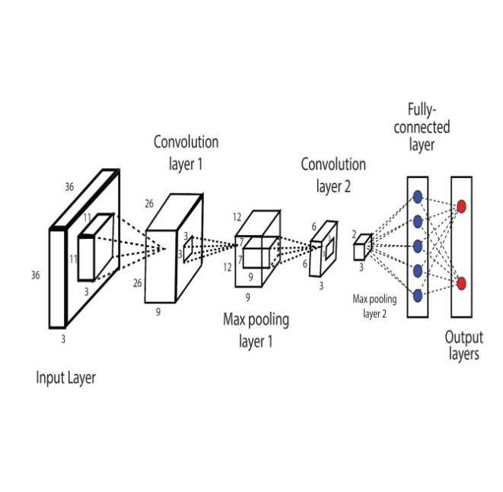

**VGG-16 Algorithm:**

Convolutional neural network (CNN) model VGG16 is used. The VGG16 model's architecture is made up of three fully connected layers, two max-pooling layers, and three convolutional layers with 3x3 filters each. The pre-trained model VGG16 is frequently used for transfer learning. A pre-trained model, such as VGG16, is used as a starting point in the transfer learning technique to train a new model on a different but related task or dataset. Fully connected layers are typically used in transfer learning with a pre-trained model to extract pertinent features from the input, while convolutional layers are typically used in transfer learning with VGG16 as feature extractors, replacing or fine-tuning fully connected layers to adapt the model to a new task or dataset images. Utilizing VGG16 can help save a significant amount of time and computational resources because it has been thoroughly trained to recognise and extract valuable characteristics from photos. This is especially useful for jobs when there is minimal training data or a lack of resources.

**5. EXPERIMENTAL RESULTS**

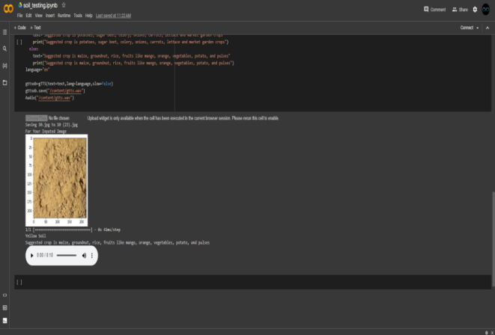

**6. FLOWCHART**

**DataSet of Soil Images**

**Image PreProcessing like resizing,**

**augmentation process**

**Image Classification**

**validation**

**Performance analysis using different algo like vgg16,CNN etc**

**DataSet Creation**

**Image Preprocessing**

**CNN Modelling**

**Performance Analysis**

**7. ADVANTAGES**

* Getting a good accuracy and gives good results.
* Better records on the dataset.
* Runtime is high.
* A simple and cost-effective approach to classify the soil type.
* Good production and quality of yield can be achieved.
* Less Complexity and Easy Identification.

**8. CONCLUSION AND FUTURE SCOPE**

I deduced from the project that only specified crops will grow well in a particular sort of soil. Therefore, we created this project to be farmer-friendly. The most effective cropping for the inputted image are recommended. We deduced from the suggested model that we can avoid overfitting the data collected for soil attributes. Our proposed model CNN(Convolutional neural networks) with algorithms vgg16,vgg19(visual geometry group),inceptionv3 will work with good accuracy in prediction and classification. As we conclude that we are taking input as Image(soil),So Deep Learning is preferable. Future improvements can be made to this strategy, such as organising additional soil type classifications and developing low-cost, low-computational need models. Numerous scholars used hybrid models to achieve their research objectives after taking note of prior studies. This project can be improved by increasing the number of soil types we used and the variety of crops we used.

**9. REFERENCES**

[1]https://www.techopedia.com/definition/1181/data-mining. [Accessed date:19thAugust,2018]

[2]http://www.library.arizona.edu/exhibits/swetc/azso/body.1_div.6.html . [Accessed date:19th August, 2018].

[3] Eswaran, H., Ahrens, R., Rice, T. J., & Stewart, B. A. (2002). Soil classification: a global desk reference. CRC Press.

[4]http://en.banglapedia.org/index.php?title=Bangladesh_Soil. Last Accessed date: 25th August, 2018.

[5]http://en.banglapedia.org/index.php?title=Soil_Series. Last Accessed date: 25th August, 2018

[6] Ramesh, V. and Ramar, K., 2011. Classification of agricultural land soils: a data mining approach. Agricultural Journal, 6(3), pp.82-86..

[7] Gholap, J., Ingole, A., Gohil, J., Gargade, S. and Attar, V., 2012. Soil data analysis using classification techniques and soil attribute prediction. arXiv preprint arXiv:1206.1557.

[8] Devi, M. P. K., Anthiyur, U., & Shenbagavadivu, M. S. (2016). Enhanced Crop Yield Prediction and Soil Data Analysis Using Data Mining. International Journal of Modern Computer Science, 4(6).