**E-Bridge Mobile Application**

1G.Sai Sree 2G. Tarun Venkata Ramesh 3J.Yohan 4Dr.S.Rama Sree

Roll No:19A91A0517 19A91A0515 19A91A0518 Professor

1,2,3 B.Tech VIII Semester 4Professor in CSE

Department of Computer Science and Engineering

Aditya Engineering College (A) ,Surampalem

Email ID: 1 [19A91A0517@aec.edu.in](mailto:19A91A0517@aec.edu.in) 2 [19A91A0515@aec.edu.in](mailto:19A91A0515@aec.edu.in) 3 [19A91A0518@aec.edu.in](mailto:19A91A0518@aec.edu.in) 4 [ramasree_s@aec.edu.in](mailto:ramasree_s@aec.edu.in)

**ABSTRACT:** The College Management System supports headmasters in obtaining the most correct data for subsequent successful judgements. Executive time-saving tools are provided to preceptors and headmasters, parents have fast access to their children's grades, and students may monitor their own progress. It is possible to generate schedules and reports quickly using the functionalities of the College Management System, and to retrieve information such as attendance system, grading inspections, test scores, restatements, and format letter with only a few simple clicks of a mouse.

Also, it makes it easier for students to access assignments and examinations online and to examine attendance logs, scores, examination results, and performance reports. Students can engage with instructors and other students online through forums and chat rooms as well. My College (CMS) is a mobile and web-enabled application created in FLUTTER and PHP with a significant MYSQL database backend. Colleges only need a connection to the internet and the My College operation to use it; they do not need pricey hardware or software computers and smart phones. Our solution operates as a central repository, allowing colleges to easily access it from any location using their login information. Practically any person can access the operating system My College system from any location using a typical internet-connected device. For each student's specific college needs, we can also modify My College.

***Keywords*** *–: College Management System, Web Enabled application, Information generate*

1. **INTRODUCTION**

The system was created with the intention of providing service in institutes and colleges. A comprehensive student information system will be provided, and a stoner interface will take the place of the previous original documents. Automation of all council or university functions is the major goal of College Management Application. You may manage all council operation tasks with this system, including admittance, freight submission, time table operation, and affect protests. You may simply access or update data and information on staff and scholars to use this council operation system. Our suggested operation includes a module that is similar to Login. When a stoner registers their institution, they take on the role of council director. All information is safely kept in a database that the council director manages. The technology reduces the amount of paperwork and time needed to access student and teacher records. Before a factual record is revised, every data is thoroughly examined and verified. The administration has access to every scholar's collaborative record from every branch. Administrators have access to all faculty records from all departments at any time, and this system makes it simple to locate specific student information. Also, it helps with uploading alerts to the lot's most outdated information. College professors can post information to students, such as attendance, grades, assignments, and notices. He can also view his daily schedule and plan his class schedule accordingly. This general function is also intended to provide Information on courses, subjects, courses, tasks, scores, and class schedules are provided to students at an institution. This technique of activity recording helps to keep track of all opiate abusers' access and assures adherence to the rules of data access. It is expected to increase the council's record-keeping efficiency, speeding up the process of giving drug users access to and delivery of staff and student records.

1. **LITERATURE REVIEW**

The goal of this article is to create an important Online Intranet College Administration System for either a college or a school. The platform is an Intranet-based software that can be used by any department or the entire school. The college may utilise this technology to track student attendance. Students and staff members who log in can view or search any education information. Staff will provide updates on student attendance, grades, and staff attendance. For the purpose of maintaining and facilitating simple information accessibility, this system is being created for an engineering institution. [1]

This essay describes a technique that can be implemented within an organisation or a particular department. This technique can be used to look up college attendance. Staff members and students who log in may indeed access or search any departmental information. Staff will work to raise student attendance rates and grade averages. Users must first register with the system in order to view and modify data according to the permissions granted to them. [2] Every method to track the status of the specific person must include attendance. In the educational system, it is a necessary practise to monitor students' progress in real time. Due to the use of smartphones, we are not required to maintain an attendance log. It is easy to finish in a mobile application. The professor will take attendance when class starts. Students will initially log in to the system using a mobile application. The faculty can also complete the necessary activities, such like introducing new classmates to the database, erasing or updating data on a certain student, etc. [3] The model makes use of computer assistance. The model is crucial to the management of a college or institution. The system was initially built with four tiers based on a scale resembling a Web displays subcaste where operations are stationed and shown to drug addicts. The business acumen subcaste is in charge of managing the product's functionality. The data is viewed by the data pierce subcaste. The database subcaste is in charge of keeping the student information. The purpose of the database subcaste ER example is to provide data normalisation. All information on the student, faculties, and educational institution is provided by the process. ( 4 )

**3. METHODOLOGY**

This chapter explains the approach taken to achieve the design's goals. The Software Engineering Life Cycle is the process by which software is created, developed, and maintained ( SDLC). The steps, milestones, and extensions of the method for developing software are illustrated. In the design and development of software, several different types of models are employed. Helicopter models, rapid-fire development models, evolutionary models, cascade models, prototype models, and others are among them. This operation has been created using a prototyping model. The prototyping method is a popular way to quickly construct an imperfect but structural domains of the information management. The goal of all prototypes, which come in a variety of forms, is to lessen threat by constructing a crude facsimile or replica of the planned system. In situations where there is a significant specialised threat, it can be employed to show specialised feasibility. It may also be employed to better comprehend and evoke the conditions of stoners. In either scenario, the goal is to decrease risk and restrict expenses by incorporating knowledge of the suggested outcomes before committing further coffers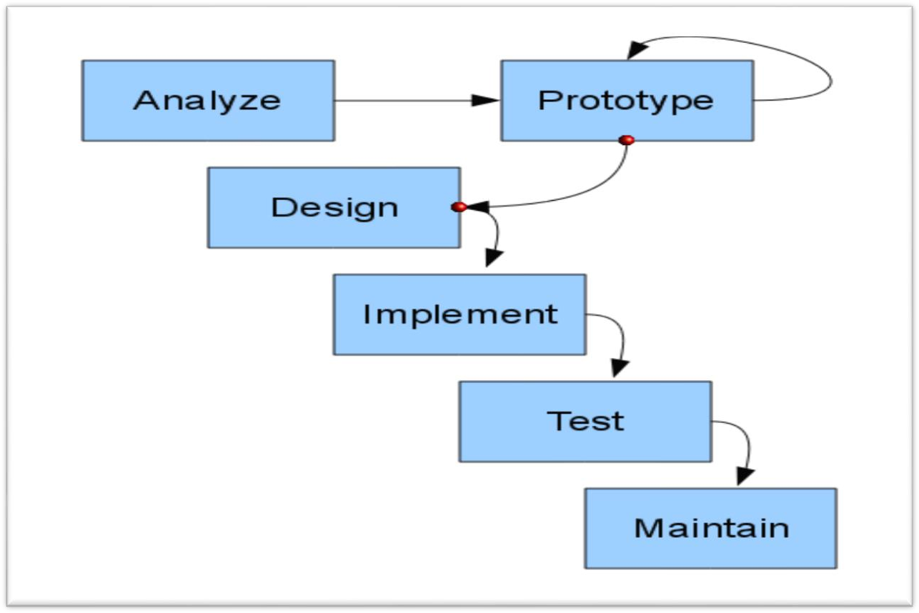

Fig.2: Prototype Model Process.

**Proposed Methodology**

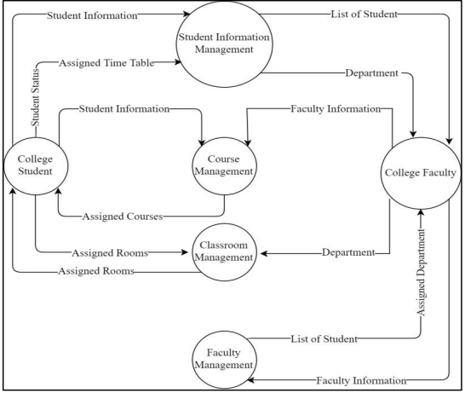

Fig.3: DFD

• Login: After completing the enrolment process, the user can log in by providing accurate information. The user's login information must match what they provided throughout the enrolment procedure. But, if the individual enters wrong information to login, an error message will also be displayed stating that the chosen identity or word is incorrect. It will be ineffective for the stoner to attempt to log in without first registering. The registered stoner can utilise the forgot word option to reset the password if they know their username but not the password. The user will stay on that particular login page if the login attempt is unsuccessful.

• Forgot: Word Any registered stoner who forgets their password can reset it at that point. When a user selects "forgot word," the operation requests their Dispatch ID and runs a Firebase check on them. But if the separate stoner exists, a message is sent to them that includes a link to restore the word. Stoner can easily log into the operation after adjusting the word.

• Admin The administrator who signs up as a stoner has ready control to each and every company's data.

The administrator can develop plans, schedule leaves appropriately, manage council expenses, add or remove faculty members, view faculty and pupil attendance, add or remove faculty members, manage hotel information, see grades of the students, transportation details, and view the canteen menu..

• FacultyA person who has enrolled as a college professor has access to applications for faculty leave, student leaves, attendance data, the ability to add or remove students, administration of academics, the ability to produce report cards, and the ability to check the timetable.

Student: When ever a stoner enters as a student, they allow entry to each and every student's privileges, such as the potential to require leaves of absence, offer feedback, view documents, see who must return, view classes, see report cards, see announcements, see schedules, see transport positions, and see canteen menus.

1. **EXPERIMENTAL RESULTS**

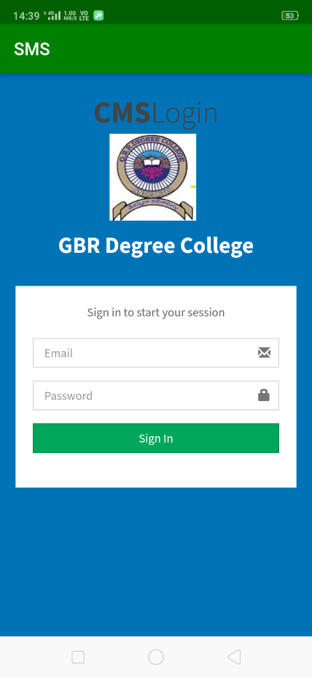

Fig.3: Login Screen

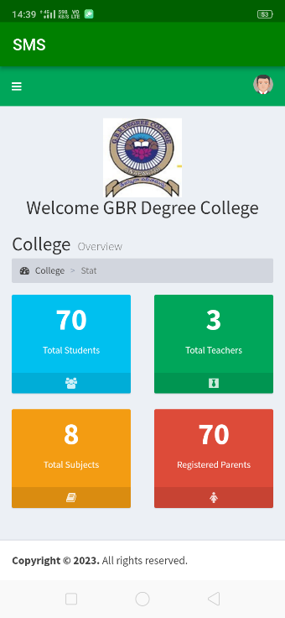

Fig.4: Dashboard

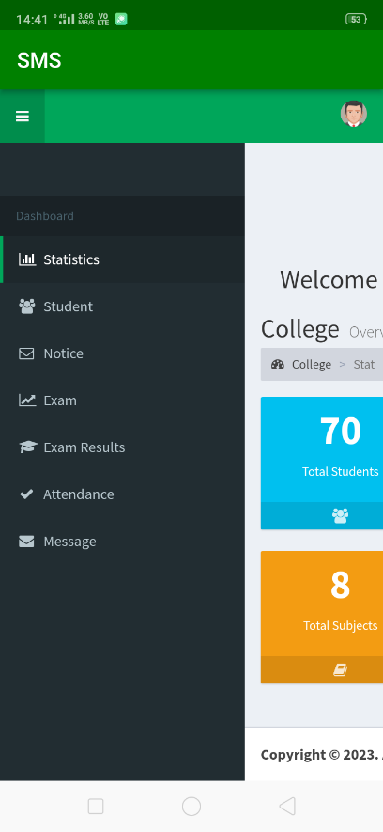

Fig.5: Parent login Dashboard

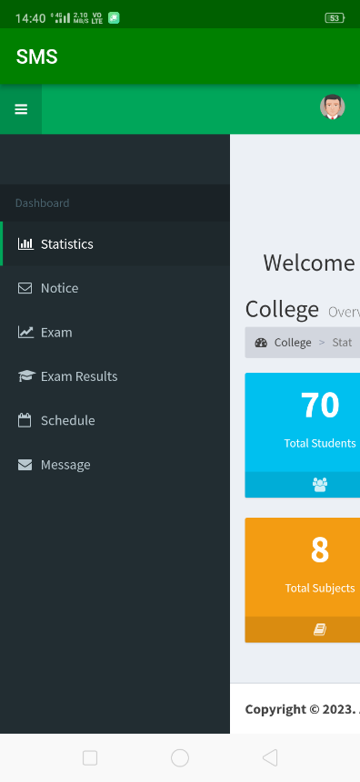

Fig.6: Student-login-Dashboard

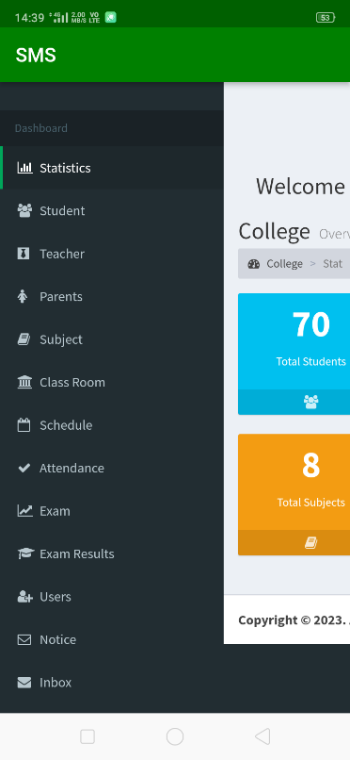

Fig.7: Admin-login-Dashboard



Fig.8: Parent-login-Dashboard

**6. CONCLUSION**

This institutional management system action offers a result that is apart from the effort that was anchored in paper. Admin is in charge of and responsible for this. By adopting this procedure, the force is decreased. As requested by the instructor or the student, it consistently offers accurate information. The information that is kept in the institution database garçon can be used by the council operation to make smart decisions. Thus, having an Android Based College Management like Breeze is preferable. All of the director, officials, faculty, students, and guardians will receive the requested information directly.

7.**REFERENCES**

[1] Lalit Mohan Joshi, "A Research Report on College Administration System," International Review of Computer Applications, Volume 122, Number 11, July 2015.

[2] Arshadkhan Pathan, Prof. Gangotri Nathaney, Priyanka Jichkar, Kalyani Gawande, and an Android-based department app using a smartphone. ISSN 2321-8169, 190–193; International Journal on Current and Innovative Developments in Computing and Communication. January 2017 issue of volume 5

[3] Android Based Smartphone Attendance System, the International Journal of Innovative Research in Software Engineering and Computer Science, Chapter 6, Problem: 2 Feb 2016, pp. 369–371. Freya J. Vora, Pooja L. Yadav, Rhea P. Rai, and Nikita M. Yadav.

[4] Liangqiu MENG, "College Student Management Platform Design Using Computer Assisted System," 2015 International Convention on Innovative Technology, Big Data & Smart City, proceedings, pp. 212-215, doi:10.1109/ICITBS.2015.59.