**Security Access Control Using RFID (Radio Frequency Identification)**

Krishnakkanth P1, Ms. Sri Lakshmi. R2, Ms. Sarika Jain3, Dr. S. Geetha4

1M.Sc – CFIS, Department of Computer Science and Engineering, Dr. M.G.R Educational and Research Institute, Chennai 600 095, Tamilnadu, India

2,3Center of Excellence in Digital Forensics, Chennai 600 089, Tamilnadu, India

4Head of the Department, Department of Computer Science and Engineering, Dr. M.G.R Educational and Research Institute, Chennai 600 095, Tamilnadu, India

**Abstract**

How often have you become weary of having to enter the password each time to authenticate access? Nothing is more aggravating than having to repeatedly type the password or pin every time I want to unlock it. I'm used to locking it down quite a few times each day. When a need turns into a necessity, you are compelled to find a means to fulfil it. Since "necessity is the mother of invention," as the proverb goes, I began to think of quick, inexpensive ways to unlock my laptop or personal computer whenever I had to lock it. I discovered an EM-18 RFID module while sorting through my belongings. I then made the decision to create an RFID system. You may avoid phishing attacks and other problems with authentication by using RFID access authentication to unlock your window. The major objective of this is to grant people access to their systems via RFID, which reduces shoulder surfing and authenticate only authorized person who has the access card with the needed information.

1. **Introduction**

RFID: One of the first forms of wireless technology is radio-frequency identification, or RFID. Digital information is stored on RFID chips and exchanged between items using radio waves and electromagnetic fields. Though the technology may not be particularly cutting-edge, many makers believe it still has a lot of potential. To show you how to build a basic RFID system that lets you authenticate or unlock your windows computer with the wave of an RFID card or tag. No more headaches of having to login your laptop or computer each time you lock it down with this solution in place. RFID technology is intriguing because it allows for more than simply product identification, like barcode technology, it also allows for data writing on the RFID tag that is attached to the product (data about process times, ERP product data, or similar). The project's brain is the Node MCU ESP8266. The development board you selected has an ESP8266 chip that is essential for this project. We are unable to use development boards like the Node MCU for our application.

1. **Literature Review**

Thomas Plos et al. (2012): It is demonstrated how security-enhanced RFID systems can be implemented and attacked using newly created semi-passive RFID tags. Its primary uses include creating hardware prototypes for passive tags, adding security features to RFID protocols, and using side-channel analysis to target actual RFID devices. Singh Sanjay et al. (2010).]: A library is an evolving entity. The issues related to the upkeep and security of the documents expand as they get larger. The librarian has always received assistance from the researchers in resolving issues. They have provided classification schemes in order to address the issues with

Daniel M. Dobkin and others, 2005: Every RFID system consists of a minimum of one interrogator, also known as a reader, which communicates with a minimum of one transponder over a radio link. The tag typically has one or more integrated circuits and a non-volatile memory component that stores a special identification number. In order to effectively utilise the identifying data, it gathers, the reader is frequently (though not always) connected into a network. The frequency (roughly comparable to the mode of coupling), how the tag is powered, and the communications protocol are the three main architectural factors that determine the sort of RFID system being used.

1. **Existing System**

We require authentication in order to access or log in to it. I'm utilising an access card with radio frequency identification (RFID) in place of passwords in this case to validate access by tapping the card. Since only the cardholder can access the system and the organisation may only issue this access card to someone, they want to have access to their data, this gives us security. The main goal of this RFID card is to control how tap access is used, which lowers phishing attacks, which are committed most commonly when we provide our credentials in an unapproved location**.**

1. **Proposing System**

We propose that the security of the organization will be high and the data of the organization will be secured and highly safe because of the method of authentication using in this system and also since it is an access card others cannot open or access the system of an individual in the organization. The one who have given the access card is responsible for the security of his data.

***4.1 Advantages***

* + High security and more effective.
  + No one can easily access the system since it need the access card to identify the user.
  + Protects from stealing others passwords without their permission.

1. **Architecture Diagram**

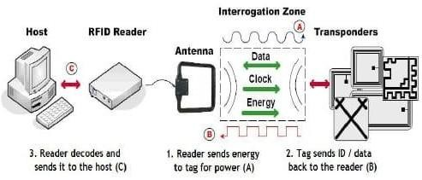

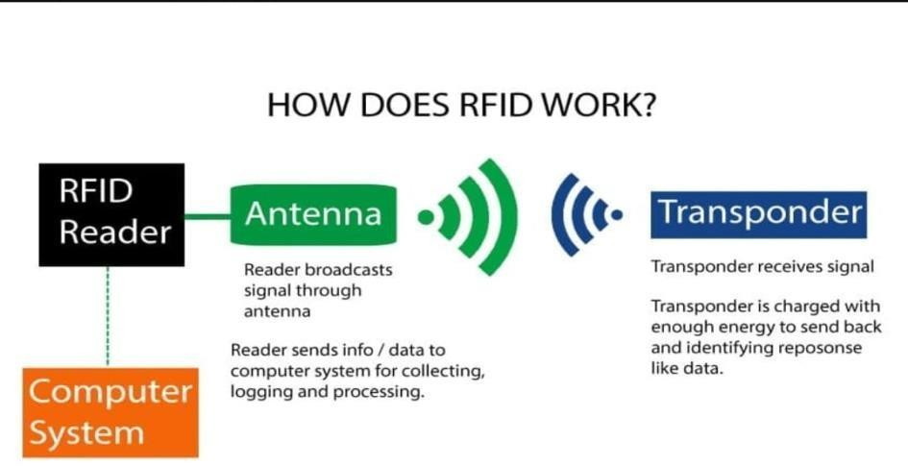

1. **Module**
   1. ***Node MCU ESP8266***

A single 2.4 GHz Wi-Fi and Bluetooth combination chip called ESP8266 was created using TSMC's ultra-low-power 40 nm technology. It is made with the best RF and power performance in mind, and it exhibits resilience, adaptability, and dependability in a number of power scenarios. The ESP32 line of chips contains the following models: ESP32-D0WD-V3, ESP32-D0WDQ6- V3, ESP32-D0WD, ESP32-D0WDQ6, ESP32-D2WD, ESP32-S0WD, and ESP32-U4WDH, three of which are based on the ECO V3 wafer.

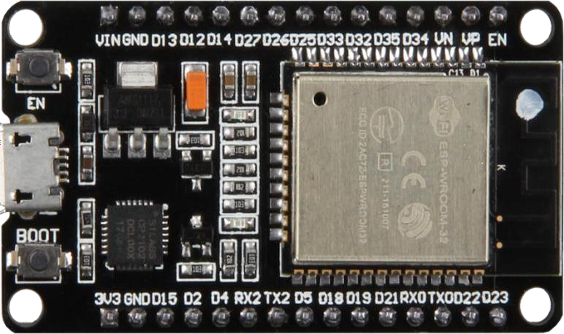

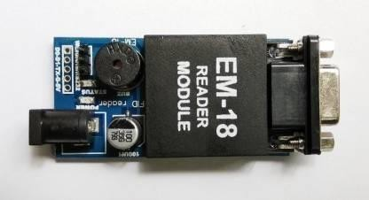

* 1. ***Circuit Diagram***

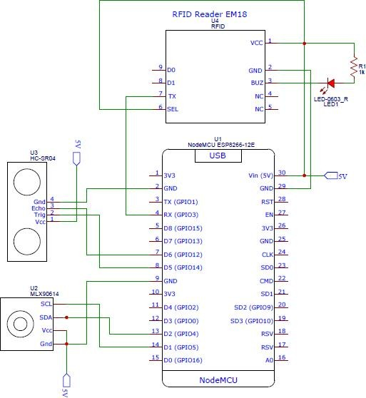

1. **Screenshots**

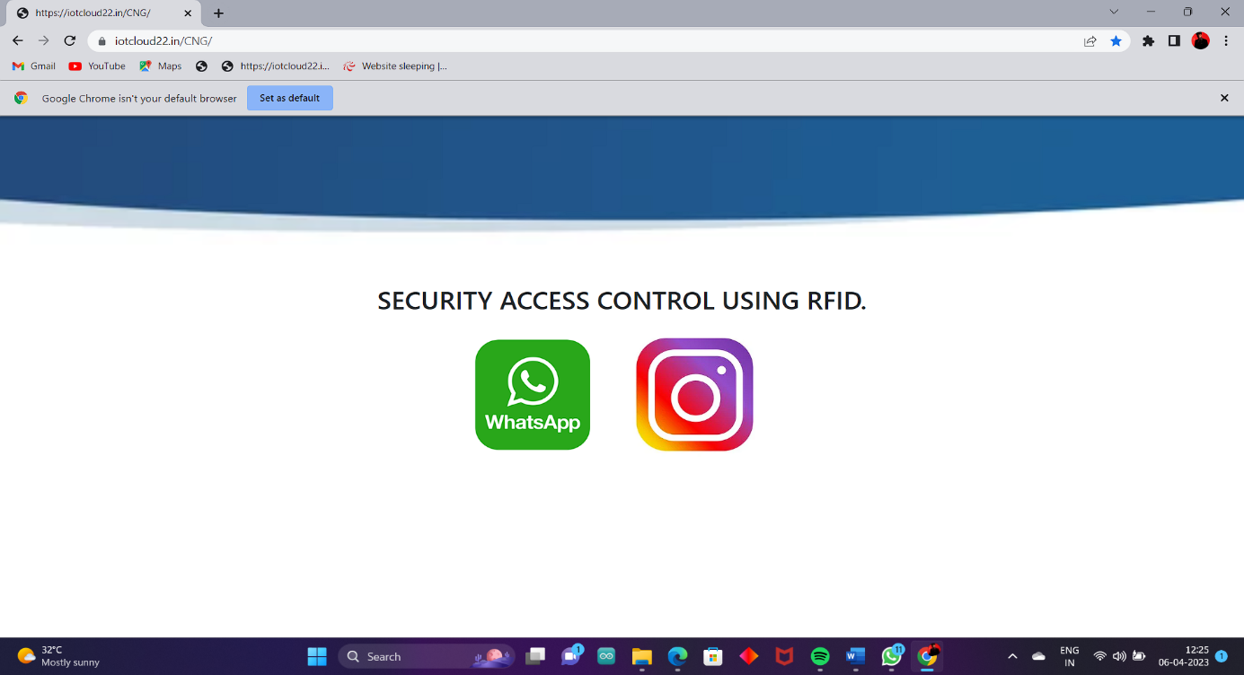

**Two Ways of Login**

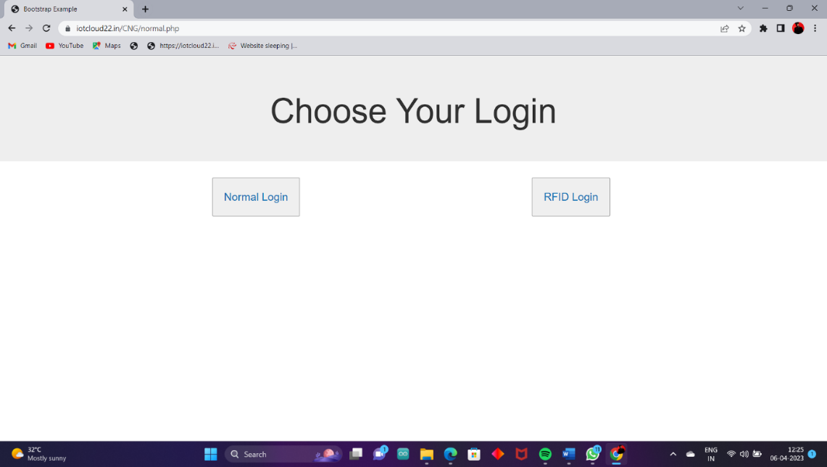

**Manual Login**

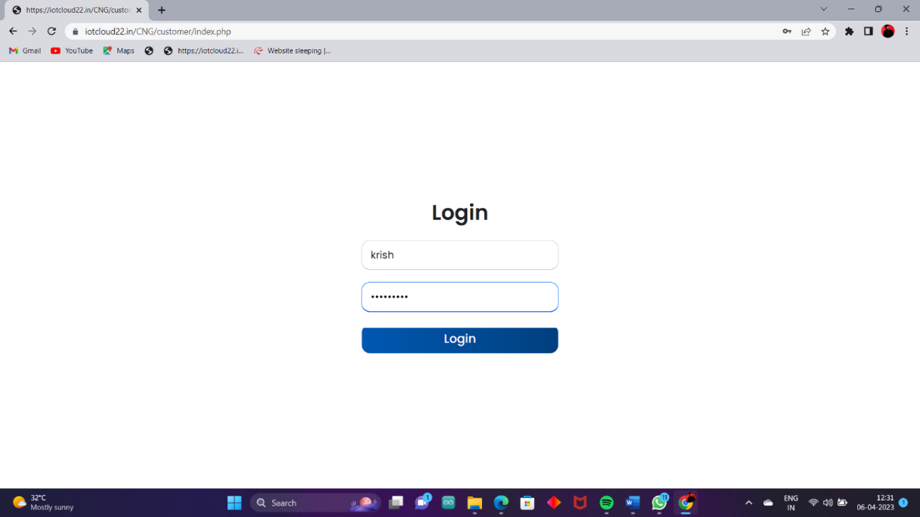

**RFID Login**



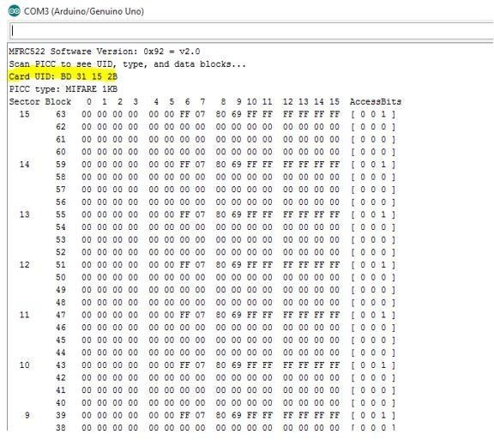

**UID Code**

1. **Conclusions**
   * By using RFID to login provides us the access touch free.
   * Only the user who has the access card are allowed to access or view the data by login to the PC and also low in cost. (e.g., places like colleges and organization have users’ needs to login to the system, here the RFID access card can be given to the user to login to the PC.
   * Tracking assets and managing inventory.
   * Saving time and money through automation.

**References**

1. “RFID Applications: An Introductory and Exploratory Study” in IJCSI International Journal of Computer Science Issues, Vol. 7, Issue 1, No. 3, January 2010 ISSN (Online) BY Kamran AHSAN1, Hanifa SHAH2 and Paul KINGSTON3.
2. “RFID Technology Principles, Advantages, Limitations & Its Applications” BY Mandeep Kaur, Manjeet Sandhu, Neeraj Mohan and Parvinder S. Sandhu in 2011.
3. “Radio frequency identification (rfid) based attendance system with automatic door unit” in 2012.
4. Sumita Nainan, Romin Parekh, Tanvi Shah presented a paper on “RFID Technology Based Attendance Management System” in 2013.
5. Jianqiang Wang, Daiheng Ni, and Keqiang Li presented a paper on “RFIDBased Vehicle Positioning and Its Applications in Connected Vehicles” in 2014.
6. Enrique Valero, Antonio Adan and Carlos Cerrada presented a paper “Evolution of RFID Applications in Construction a Literature Review” in 2015.
7. Dr. Vinit Kotak, Ms. Archana Chaugule, Aakanksha Utkhede, Tushar Chemburkar, Saurabh Tendulkar in 2016 presented a paper on “RFID-based Bus Ticketing System”.