A FLEXIBLE PRIVACY PRESERVING DATA SHARING SCHEME IN CLOUD ASSISTED IOT

Submitted in partial fulfillment of the requirements
For the award of the degree in

MASTER OF SCIENCE
in
CYBER FORENSICS AND INFORMATION SECURITY

by
RAHUL M S (213182101036)



DEPARTMENT OF
COMPUTER SCIENCE AND ENGINEERING

APRIL-2023

DEPARTMENT OF COMPUTER SCIENCE AND ENGINEERING

BONAFIDE CERTIFICATE

This is to certify that this Project Report is the bonafide work of Mr. Rahul M S (213182101036), who carried out the project entitled “ A flexible privacy preserving data scheme in cloud assisted IOT” under our supervision from December 2022 to March 2023

Internal Guide Project Coordinator Department Head
Ms. Sarika Jain Ms.Sri Lakshmi R Dr.S.Geetha
CoEDF Faculty CoEDF Faculty Professor and Head
Dept of CSE
Dr.M.G.R Educational and
Research institute

Submitted for Viva Voce Examination held on _________________

Internal Examiner External Examiner

DECLARATION

I Rahul M S (213182101036.),hereby declare that the Project Report entitled
“A flexible privacy preserving data scheme in cloud assisted IOT”
is done by me under the guidance of Ms. Sarika Jain is submitted in partial fulfillment of the requirements for the award of the degree in MASTER OF SCIENCE in CYBER FORENSICS AND INFORMATION SECURITY

DATE:

PLACE: SIGNATURE OF THE CANDIDATE

ACKNOWLEDGEMENT

I would first like to thank our beloved Chancellor
Dr. A.C. Shanmugam, B.A., B.L. and President Er. A.C.S. Arunkumar, B.Tech., M.B.A., and for all the encouragement and support extended to us during the tenure of this project and also our years of studies in his wonderful University.

I express my heartfelt thanks to our Vice Chancellor
Prof. Dr. S. Geethalakshmi in providing all the support of my Project (Project Phase-I).

I express my heartfelt thanks to our Head of the Department,
Prof. Dr. S.Geetha, who has been actively involved and very influential from the start till the completion of our project.

Our sincere thanks to our Project Coordinator Ms. Sri Lakshmi R and Project guide Ms. Sarika Jain for their continuous guidance and encouragement throughout this work, which has made the project a success.

I would also like to thank all the teaching and non teaching staffs of Computer Science and Engineering and Information Technology department, for their constant support and the encouragement given to us while we went about to achieving my project goals.

CHAPTER | TITLE | PAGE NO
1 | 1.1 ABSTRACT OF THE PROJECT  1.2 INTRODUCTION | 6
2 | 2.1 REQUIREMENT SPECIFICATION | 7
3 | 3.1 EXISTING SYSTEM  3.2 DISADVANTAGES OF EXISTING SYSTEM  3.3 PROPOSED SYSTEM  3.4 ADVANTAGES OF PROPOSED SYSTEM  3.5 MODULE DESCRIPTION | 8-10
4 | 4.1 ARCHITECTURE  4.2 ENTITY RELATIONSHIP DIAGRAM | 11-12
5 | 5.1 SOFTWARE ENVIRONMENT | 13-15
6 | 6.1 MYSQL DATABASE | 16-21
7 | 7.1 SYSTEM IMPLEMENTATION  7.2 SYSTEM DOCUMENTATION  7.3 SYSTEM MAINTENANCE  7.4 SYSTEM TESTING  7.5 SYSTEM DESIGNING | 22-29
8 | 8.1 PROJECT CODE | 30-64
9 | 9.1 OUTPUT SCREENSHOTS | 65-69
10 | 10.1 CONCLUSION  10.2 REFERENCE | 70-71

CHAPTER 1

1.1 ABSTRACT
In this research, I provide a flexible method for IoT with cloud assistance that protects privacy while exchanging data (FPDS). An IoT user can use identity-based encryption to encrypt data before sending it to a receiver using the FPDS protocol. I discuss how to build a productive PDP (Provable Data Possession) system for distributed cloud storage to facilitate service scalability and data migration, in which we take into account the existence of several cloud service providers to cooperate store and preserve the clients' data. I describe a cooperative PDP (CPDP) approach based on a hash index hierarchy and homomorphic verifiable response. I use a multi-prover zero-knowledge proof system to demonstrate the security of our method, which can satisfy its completeness, knowledge soundness, and zero-knowledge features. In addition, I define methods for our scheme's performance optimization and, in particular, I present a quick approach for choosing the best parameter values to reduce computation costs for both clients and storage service providers. My research demonstrates that, in compared to non-cooperative approaches, my strategy results in lower computing and communication overheads.

1.2 INTRODUCTION
The endeavor of distributed computing gives a huge Advancement in the field of IT industry. It is perhaps of the most encouraging innovation out in this present reality which gives various advantages to any association or a person. It accompanies additional engaging information stockpiling, on request benefits, omnipresent organization access and advantageous information trade for the clients. Distributed computing offers answers for information capacity independent of nearby foundation limits as well as outfits the clients with a stage to handle their data. The primary focal point of this innovation is to extend the adequacy of shared assets accessible in the cloud and furthermore to redistribute them progressively if necessary. Despite the fact that the innovation gives vast advantages, it needs close security capacities and makes protection issues for the information proprietors.
CHAPTER 2
2.1 REQUIREMENT SPECIFICATION

HARDWARE REQUIREMENT SPECIFICATION
Processor : Dual Core or i3
Ram : 2 GB
Hard Disk : 160GB
Clock speed : 1.8 GHz
Pointing device : Scroll Mouse
Keyboard : 101 Standard Key-board

SOFTWARE REQUIREMENT SPECIFICATION
Programming Language : Java
Technology : JSP,Servlet
Operating System : Windows
Server : Apache Tomcat
Backend Tool : Heidi SQL
Developing Tool : NetBeans IDE 8.0.1

CHAPTER 3
3.1 EXISTING SYSTEM
There exist various tools and technologies for multi cloud, such as Platform VM Orchestrator, VMware vSphere, and Overt. These tools help cloud providers construct a distributed cloud storage platform for managing clients’ data. However, if such an important platform is vulnerable to security attacks, it would bring irretrievable losses to the clients. For example, the confidential data in an enterprise may be illegally accessed through a remote interface provided by a multi-cloud, or relevant data and archives may be lost or tampered with when they are stored into an∙ uncertain storage pool outside the enterprise. Therefore, it is indispensable for cloud service providers to provide security techniques for managing their storage services.

3.2 DISADVANTAGES OF EXISTING SYSTEM
The data stored at server can be compromised by some internal or external threats. The existing data integrity verification techniques are quite slow in encryption and in overall processing. After outsourcing the data user deletes the local copy of his data and has no more access from the local machine. So, if any problem like modification of data, deletion of data, malicious attack, and server failure is occurred, user is not aware of it. One of the main problems is the user’s data is completely handled by the CSP and the CSP can manage in his own way. A need of Third-Party Auditor is required for transparent verification of data which must be strong as well as fast.

3.3 PROPOSED SYSTEM
To check the accessibility and honesty of reevaluated information in cloud storages, scientists have proposed two essential methodologies called Provable Information Ownership and Verifications of Retrievability. first proposed the PDP model for guaranteeing ownership of records on untrusted stockpiles and gave an RSA-based plan to a static case that accomplishes the correspondence cost. I likewise proposed a freely unquestionable variant, which permits anybody, in addition to the proprietor, to challenge the server for information ownership. I proposed a lightweight PDP plot in view of cryptographic hash capability and symmetric key encryption; however, the servers can trick the proprietors by utilizing past metadata or reactions because of the absence of irregularity in the difficulties. The quantities of updates and difficulties are restricted and fixed ahead of time and clients cannot perform block inclusions anyplace.

3.4 ADVANTAGES OF PROPOSED SYSTEM
• A safe and secure method for data sharing on a cloud storage system
• Easy to search and identify a data even though the data is stored in a encrypted format.
• Easy access and retrieval of encrypted files.
• Improved security with better user experience with Less computation complexity

3.5 MODULE DESCRIPTION:
Multi cloud storage
Distributed computing is used to refer to any large collaboration in which many individual personal computer owners allow some of their computer's processing time to be put at the service of a large problem. In this system each cloud admin consists of data blocks . the cloud user uploads the data into multi cloud. cloud computing environment is constructed based on open architectures and interfaces, it has the capability to incorporate multiple internal and/or external cloud services together to provide high interoperability. We call such a distributed cloud environment as a multi-Cloud .A multi-cloud allows clients to easily access his/her resources remotely through interfaces.
Cooperative PDP
Cooperative PDP (CPDP) plans taking on zero-information property and three-layered file progressive system, individually. Specifically productive strategy for choosing the ideal number of areas in each block to limit the calculation expenses of clients and capacity specialist organizations. cooperative PDP (CPDP) conspire without compromising information security in view of current cryptographic strategies.

Data Integrity
Data Integrity is very important in database operations in particular and Data warehousing and Business intelligence in general. Because Data Integrity ensured that data is of high quality, correct, consistent and accessible.

Third Party Auditor
Trusted Third Party (TTP) who is trusted to store verification parameters and offer public query services for these parameters. In this system the Trusted Third Party, view the user data blocks and uploaded to the distributed cloud. In distributed cloud environment each cloud has user data blocks. If any modification tried by cloud owner a alert is send to the Trusted Third Party.

Cloud User
The Cloud User who has a large amount of data to be stored in multiple clouds and have the permissions to access and manipulate stored data. The User’s Data is converted into data blocks . the data blocks are uploaded to the cloud. The TPA view the data blocks and uploaded in multi cloud. The user can update the uploaded data. If the user wants to download their files, the data’s in multi cloud is integrated and downloaded.

CHAPTER 4

4.1 ARCHITECTURE
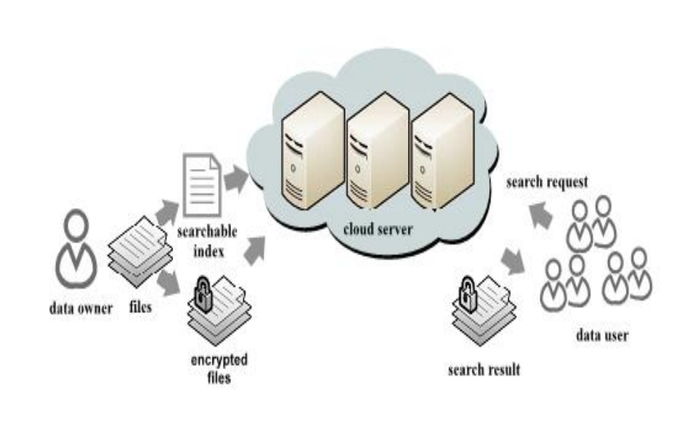

4.2 ENTITY RELATIONSHIP DIAGRAM
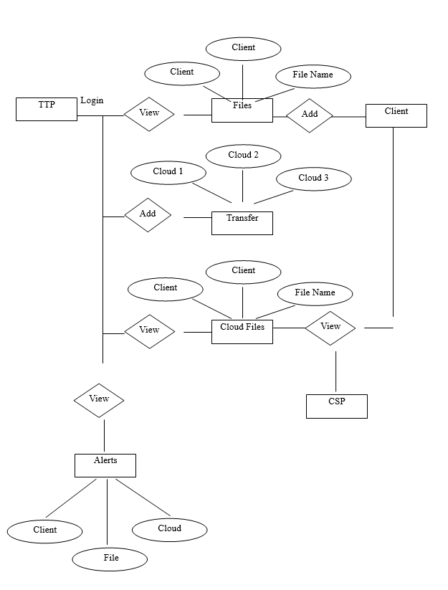

CHAPTER 5

5.1 SOFTWARE ENVIRONMENT

The Java Programming Language

The Java programming language is an undeniable level language that can be described by the accompanying trendy expressions as a whole:

Straightforward

Design unbiased

Object situated

Convenient

Appropriated

Superior execution

Deciphered

Multithreaded

Vigorous

Dynamic

Secure

With most programming languages, you either incorporate or decipher a program so you can run it on your PC. The Java programming language is uncommon in that a program is both ordered and deciphered. With the compiler, first you make an interpretation of a program into a middle of the road language called Java byte codes — the stage free codes deciphered by the mediator on the Java stage. The mediator parses and runs every Java byte code guidance on the PC. Accumulation happens only a single time; understanding happens each time the program is executed. The accompanying figure shows how these functions.

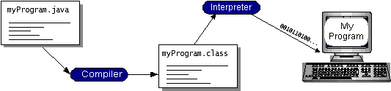

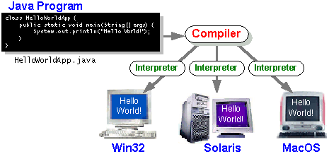

The Java Platform
A platform is the equipment or programming climate where a program runs. We've previously referenced probably the most famous stages like Windows 2000, Linux, Solaris, and MacOS. Most stages can be portrayed as a mix of the working framework and equipment. The Java stage varies from most different stages in that a product just stage runs on top of other equipment-based stages.

The Java stage has two parts:
- The Java Virtual Machine (Java VM)
- The Java Application Programming Point of interaction (Java Programming interface)
It is the base for the Java stage and is ported onto different equipment-based stages.The Java Programming interface is an enormous assortment of instant programming parts that give numerous helpful capacities, like graphical UI (GUI) gadgets. The Java Programming interface is gathered into libraries of related classes and points of interaction; these libraries are known as bundles.
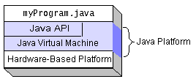
Each full execution of the Java stage gives you the accompanying highlights:
•The basics: Articles, strings, strings, numbers, information and result, information structures, framework properties, date, and time, etc.
•Applets: The arrangement of shows utilized by applets.
•Organizing: URLs, TCP (Transmission Control Convention), UDP (Client Information gram Convention) attachments, and IP (Web Convention) addresses.
•Internationalization: Help for composing programs that can be confined for clients around the world. Projects can naturally adjust to explicit areas and be shown in the proper language.
•Security: Both low level and undeniable level, including electronic marks, public and confidential key administration, access control, and authentications.
•Programming parts: Known as JavaBeans, can plug into existing part models.
•Object serialization: Permits lightweight steadiness and correspondence by means of Distant Strategy Summon (RMI).
•Java Data set Network (JDBCTM): Gives uniform admittance to a large number of social data sets.
The Java stage additionally has APIs for 2D and 3D illustrations, openness, servers, coordinated effort, communication, discourse, movement, and that's just the beginning. The accompanying figure portrays what is remembered for the Java 2 SDK.

CHAPTER 6

6.1 MYSQL DATABASE
It has three important stages
1.connecting to and disconnecting from the server
2.Entering Queries
3. Making and Utilizing an Information base
- Connecting to and Disconnecting from the Server

When using MYSQL, you will typically need to enter a password and a MYSQL user name in order to connect to the server. You must also provide a host name if the server is running on a different computer than the one where you log in. For information on the connection parameters, you should use to connect, speak with your administrator (that is, what host, user name, and password to use). When you are aware of the correct parameters, you should be able to connect like follows:

shell: "MYSQL -h host -u user -p"

Key in password: ********

The host name on which your MySQL server is running and the user’s name associated with your MySQL account are represented by the terms "host" and "user." For your configuration, replace the appropriate values. The ******** is an image of you.
2. Entering Queries
As mentioned in the last step, make sure you are connected to the server. By itself, doing so does not choose a database to use, but that is alright. At this stage, learning a little bit about how to run queries is more crucial than creating tables, populating them with data, and extracting data from them straight away. This section explains the
fundamentals of query entry using examples of queries that you may use to get a feel for how MySQL functions.
Here is a straightforward request that asks the server to provide the current date and its version number. Following the MYSQL> prompt, enter the following information as displayed:
from MySQL: SELECT CURRENT DATE, VERSION(); +——————+——————+ | CURRENT DATE | VERSION() |

+———————+———————+\s| 5.7.1-m4-log | 2012-12-25 |

+———————+———————+
One row per set (0.01 sec)
MYSQL>
This query demonstrates a number of features of MySQL:
A semicolon is typically followed by a SQL statement to form a query. (In some cases, it's acceptable to skip the semicolon. One of these is the earlier mentioned word, QUIT. Later, we'll discuss the others.)
MYSQL> Select current DATE, Version();
Here is a different question. It explains how MYSQL can be used as a basic database.
A query is sent to the server by MYSQL, which then displays the results and prints another MYSQL> prompt to let you know it is ready for another query.
Tabular query output is displayed by MySQL (rows and columns). The labels for the columns are in the first row. These rows represent the outcomes of the query. The names of the columns you retrieve from database tables typically appear as column labels. In the example just given, getting the value of an expression rather than a table column results in MYSQL labelling the column with the value of the expression.
Any letter case can be used while entering keywords. The following questions are interchangeable:
SELECT VERSION(), CURRENT DATE; SELECT VERSION(), current date; SELECT VERSION(), current DATE;
Here is a different question. It demonstrates how MYSQL may be used as a straightforward calculator:
SELECT SIN(PI()/4), (4+1) FROM MYSQL
*5; \s+—————————+————-+
| SIN(PI()/4) | (4+1)
*5 | \s+—————————+————-+ \s| 0.70710678118655 | 25 | \s+—————————+————-+
One row per set (0.02 sec)
The inquiries that have been displayed thus far are all single-line, reasonably brief statements. Even several statements can be entered on a single line. Just add a semicolon at the end of each one:
MYSQL> SELECT NOW(), VERSION(), and
+—————————+
Version() is represented by | +—————————+.
| 5.7.10-ndb-7.5.1 | \s+—————————+
One row per set (0.00 sec)

+——————————-+
| NOW() | \s+——————————-+ \s| 2016-01-29 18:02:55 |
+——————————-+
One row per set (0.00 sec)
Long inquiries that span multiple lines are acceptable since a query does not have to be presented in its entirety on a single line. Instead of looking for the end of the input line, MYSQL looks for the final semicolon to decide where your statement finishes. In other words, MySQL accepts free-format input; but, it does not begin to process the lines until it sees the semicolon.
A short, multi-line statement is provided here:
SELECT -> USER() ->, -> CURRENT DATE in MySQL;
+———————-+———————+
the current date; USER();
+———————-+———————+
Jon at localhost | August 6, 2010
+———————-+———————+
In this illustration, observe how the prompt switches from MYSQL> to -> following the entry of a multi-line query. This is how MYSQL displays the fact that it hasn't yet seen the entirety of a statement and is awaiting it. The prompt is helpful to you since it offers insightful criticism. Utilizing such feedback will allow you to always know what MYSQL is waiting for.
When entering a query, you can cancel it if you change your mind and don't want to run it by typing c: MYSQL> SELECT.

-> USER()
-> \c
MYSQL>
Also note the prompt in this case. After you enter c, it returns to MYSQL> and gives feedback to show that MYSQL is prepared for a new query.
The following table lists each prompt you could receive along with a brief explanation of what it means in terms of the condition of MySQL.
When you intend to run a query on a single line but forget the last semicolon, you frequently wind up with multi-line statements by mistake. When further data is provided, MySQL waits:
MYSQL> SELECT USER() ->
The likelihood is that MYSQL is awaiting the semicolon if this occurs to you (you believe you have entered a statement but the only answer is a -> prompt). It may take some time for you to realise what you need to do if you don't pay attention to what the prompt is telling you. For the statement to be executed by MySql, a semicolon must be included.
MYSQL> SELECT USER ()
Jon@localhost | +———————-+ | USER() | +———————-+ | +———————-
The "" and "> during string collecting, prompts appear (another way of saying that MYSQL is waiting for completion of a string). You can write strings in MYSQL that are enclosed by either the'or'characters (for example, 'hello' or 'goodbye') "), and you can input strings that span many lines with MYSQL. A '> or "> prompt indicates that you have entered a line with a string that starts with a'or " quotation character but have not yet done so with the corresponding quote that ends the string. This frequently means that you have unintentionally omitted a quote character. MYSQL> SELECT * FROM my table, as an illustration IF name = "Smith AND age 30;
MYSQL> SELECT * FROM my_table WHERE name = 'Smith AND age < 30;
"Nothing happens if you type this SELECT command, hit Enter, and then wait for the outcome. Instead of pondering the reason why this query takes so long, pay attention to the hint the '> prompt provides. You can infer from it that MYSQL expects to see the rest of an unterminated string. (Do you perceive the assertion's mistake? The subsequent single statement mark is missing from the string "Smith."
Right now, how would it be advisable for you to respond? The most straightforward activity is to drop the inquiry. Be that as it may, you can't simply type c in that frame of mind since MYSQL sees c as a piece of the string it is gathering. To tell MySQL the string is done, enter the last statement character.
'> '\c
MYSQL>
At the point when the brief re-visitations of MYSQL>, MYSQL is ready for another question.
Like the '> and "> prompts, the '> brief connotes that you have begun yet not completed a backtick-cited identifier.
Knowing what the '>, ">, and '> prompts mean is pivotal since, in such a case that you coincidentally type an unterminated string, MYSQL might disregard any extra lines you type, even ones that contain QUIT. This may be exceptionally puzzling, especially assuming you are uninformed that you should give the finishing up statement to drop the ongoing inquiry.
3 Making and Utilizing an Information base

• Picking and Building an Information base
• Building a Table
• Adding Data to a Table
• Recovering information from a table,
• You can get to an information base once you are know about entering SQL explanations.
Suppose you need to monitor an assortment of data on the animals you have at home (your zoo). You can achieve this by making tables to house your data and filling them with the normal nuances. Then, by getting information from the tables, you can answer various solicitations connecting with your animals.
Yet the zoo informational index is intentionally kept essential, there are various circumstances wherein an informational collection of this sort could be important. A farmer would use such an informational index to screen their animals, or a veterinarian could use it to screen patient records. You can get a zoological presentation pack from the MySQL site, which consolidates a piece of the inquiries and test data used in the going with sections. http://dev.mysql.com/doc/has it open in stuffed tar record and Zip plans.
To take a gander at which informational indexes are at present running on the server, use the SHOW clarification:
mysql> SHOW Data bases;
+----------+
| Data base |
+----------+
| mysql |
| test |
| tmp |
+----------+
mysql> SHOW Data bases; Informational collection | Informational index | + — — — — — + | Mysql | Test | Tmp | + — — — — — +
Client access praises are portrayed in the MySQL informational index. Clients routinely approach the test informational index as a workspace where they can attempt.
If you don't have the SHOW Informational indexes honor, informational collections for which you have no entry won't be kept there of brain of informational collections

CHAPTER 7

7.1 SYSTEM IMPLEMENTATION

implementation is the stage in the undertaking where the hypothetical plan is transformed into a functioning framework. The most critical stage is accomplishing a fruitful new framework and giving a client trust in that the new framework will work proficiently and successfully in the execution stage. The stage comprise of

• Testing a created program with test information

• Recognition and adjustment of mistake

• Making whether the framework meets a client necessities

• Rolling out fundamental improvements as wanted by clients.

• Preparing client individual

IMPLEMENTATION PROCEDURES
System design is more innovative than implementation. Although it becomes more challenging as it enters the design phase, a system design may be abandoned at any point prior to deployment. The implementation phase's final report comprises record layouts, procedural flowcharts, and a practical plan for converting the candidate system design into an operational design.

USER TRAINING
It is intended to set up the clients for testing and changing over the framework. There is multiple ways of following the clients they are:
- user manual
- Help screens
- Training demonstrations.

User manual:
A paper that lists the system's and software's key features can be sent to the user. The purpose of user training is to get the user ready for configuring and testing a system. The user may be given a document that includes a summary of the system's and software's key features.

- Open http page

- Dot net is opened existing user the type the username and password

- Click the submit button

Help Screens:
These functions are now included in every software package, and they work best when combined with a menu. The user chooses the menu item labelled "Help." The system was successful in providing the user with the appropriate description or information.

Training Demonstration:
A training demonstration is another component of user training. For user training, in-person, live demonstration is quite beneficial.

7.2 SYSTEM DOCUMENTATION
The project's design and performance criteria are established through documentation, which also serves as a communication tool. Information that describes how to use and/or operate a system is known as documentation. In order to participate in the auction, the user must submit their user name and password. Otherwise, he must register if a new user. Documentation is a tool for communication that also provides performance standards for project phases. Documentation is information that describes how a system is used and/or operated.

DOCUMENTATION TOOLS:
Tools for desktop publishing and document production help almost all aspects of software development. The majority of software development companies spend a lot of time creating documents, and frequently the documentation process itself is extremely ineffective. A software development effort that includes documentation is not unusual. Because of this, documentation tools offer a significant chance to boost productivity.

DOCUMENT RESTRUCTURING:
The time required to create a document is excessive. We will make due with what we have if the system is effective. This strategy is suitable in some circumstances. Documents for hundreds of computer programs cannot be recreated. The documentation needs to be updated; however we are resource constrained. An application may not require a complete re-documentation. Instead, the parts of the system that are changing right now are completely documented. The system needs to be completely redocumented because it is business-critical. Even in this situation, it would be wise to keep documentation to a bare minimum.
7.3 SYSTEM MAINTENANCE
Maintenance is really execution of the audit plan however significant as it could be software engineers and investigator is to perform or relate to oneself with the
support. There are mentally character and expert explanations behind this. Expert and software engineers invest fair more energy keeping up with developer then they do thinking of them Systems for upkeeps represent 50-80% of absolute framework improvement. Support is costly .One method for lessening the upkeep costs are through upkeep mgt and programming change reviews Sorts of support are
•Perfective maintenance
•Preventive maintenance
PERFECTIVE MAINTENANCE:
alterations made to the system to add functionality or boost efficiency. Future additions of functionality to "Network Communication" will be simple to implement.
PREVENTIVE MAINTENANCE:
system modifications performed to prevent new issues. Future modifications may be made, and our project will be able to incorporate them.
7.4 SYSTEM TESTING
TESTING AND METHODLOGIES
System testing is the condition of execution, which is pointed toward guaranteeing that the framework works precisely and productively as anticipate before live activity, begins. It ensures that the entire arrangement of projects hang together Framework testing requires a test plan, that comprises of a few vital exercises and steps for run program, string, framework and client acknowledgment testing. The execution of recently configuration bundle is significant in taking on an effective new framework Testing is significant stage in programming improvement.
Framework test is execution ought to be an affirmation that everything is right and a chance to show the clients that the framework functions as they expected It accounts the biggest level of specialized exertion in programming improvement process. Testing stage is the advancement stage that approves the code against the utilitarian particulars. Testing is an essential to the accomplishment of the framework objectives. The goal of testing is to find mistakes. To satisfy this objective a series of test step such as the unit test, integration test, validation and system test where planned and executed.

7.5 SYSTEM DESIGNING

FILE DESIGN
A code generator is a set-up of projects that matches the contribution to a proper code layout and from these produces modules of code. The code is simplified so that another developer can without much of a stretch comprehend and chip away at that in future. The significant stage in the framework advancement life cycle is the fruitful execution of the new framework plan. The method involved with changing over as new or modified framework into a functional one is known as framework execution. This incorporates that multitude of exercises that occur to change over from an old framework to another framework. The framework can be carried out solely after a through testing is finished and in the event that it is found to work as per the particulars.
INPUT DESIGN
Input design is the method involved with interfacing the client began inputs into a PC to utilized designs. The objective of the info configuration is to make information section Coherent and liberated from blunders. Mistakes in the info data set constrained by input plan this application is being created in an easy to use way. The structures are being planned so that during the handling the cursor is set in the position where the information should be placed. A choice of choosing a proper contribution from the upsides of approval is made for every one of the information entered. Concerning clients solace the venture is planned with ideal approval on each field and to show mistake messages with fitting ideas. Help directors are likewise given at whatever point client passage to another field he/she can comprehend what is to be placed. Whenever client enter a mistake information blunder supervisor showed client can move to next handle solely after entering a right information

OUTPUT DESIGN
Computer output is the most significant and direct wellspring of data to the client. Productive coherent result configuration ought to work on the framework's relationship with the client and administrator in navigation. Yield configuration for the most part alludes to the outcomes created by the framework. For the overwhelming majority end clients based on the result the assess the handiness of the application. Proficient programming should have the option to create and productive viable reports.
DATABASE DESIGN
The database design includes making of tables that are addressed in actual data set as put away documents. They have their own reality. Each table comprise of lines and segments where each column can be seen as record that comprises of related data and section can be seen as field of information of same kind. The table is likewise planned with some position can have an invalid worth. The data set plan of venture is planned in such a manner values are kept without overt repetitiveness and with standardized design. Allude the supplement for screen shots of Database design.

7.6 FEASIBILITY STUDY
Feasibility is the degree to which a project can actually be carried out successfully. A feasibility study is conducted to assess the solution's viability. This study analyses whether the solution is practicable and implementable in the programme. The availability of resources, the estimated cost of developing the software, the advantages of the software to the company, and the cost associated with maintaining it are all taken into account. Establishing the justifications for creating software that is user-friendly, flexible, and compliant with standards is the goal of the feasibility study.
TYPES OF FEASIBILITY
- Technical feasibility.
- Operational feasibility.
- Economic feasibility.

FEASIBILITY STUDY PROCESS:-

Information assessment: Determines whether the system contributes to the accomplishment of the organization's goals. It also confirms whether the system can be integrated with the current system and whether it can be executed using new technologies and within the budget.

Information gathering: Identifies the sources from which it is possible to gain information on software. These sources typically consist of users and the programme development team.

Writing a report utilises a feasibility report, which is the software development team's assessment of the feasibility. It contains a recommendation regarding whether or not software development should proceed.

Table design:
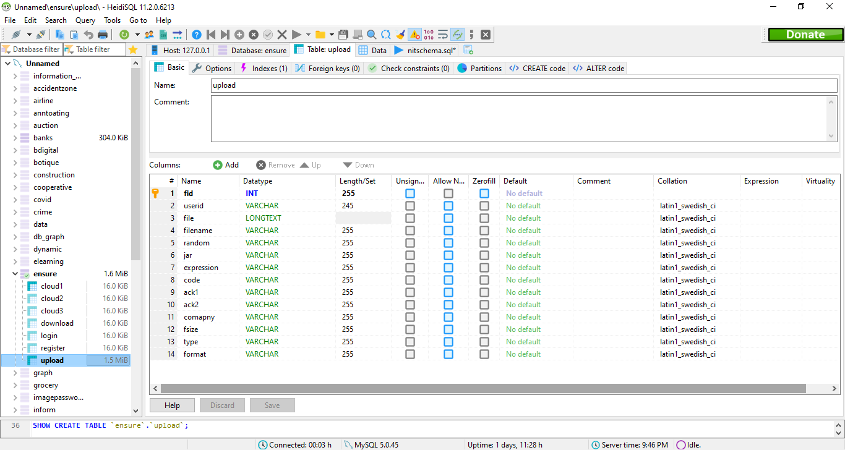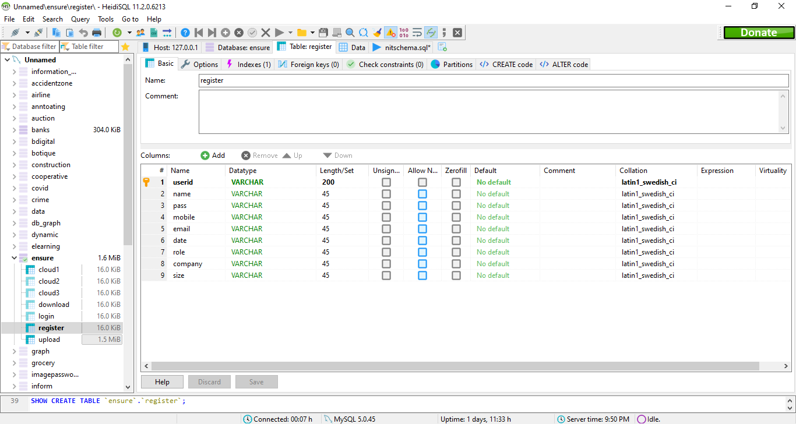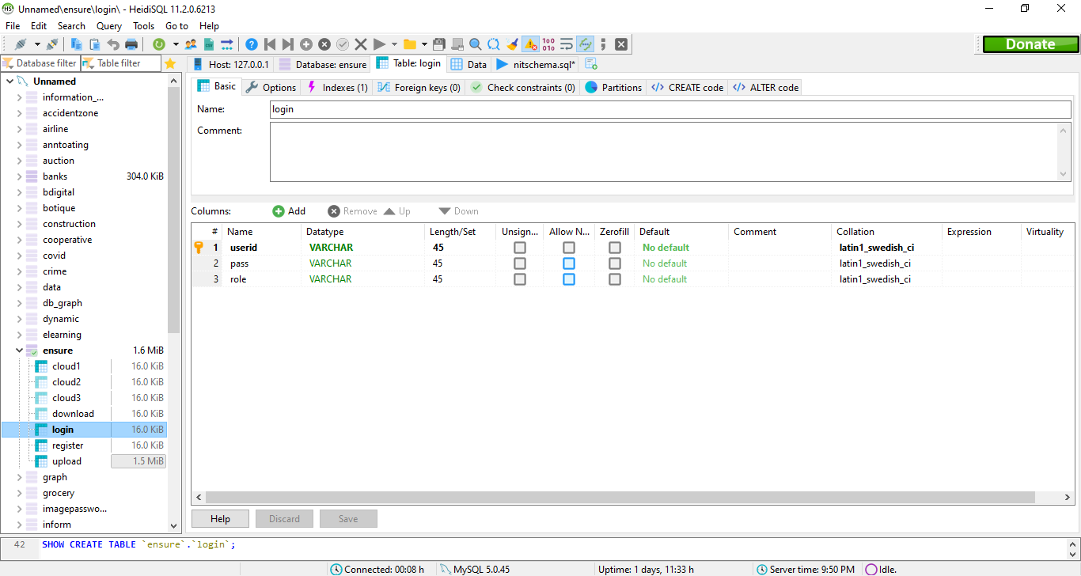

CHAPTER 8

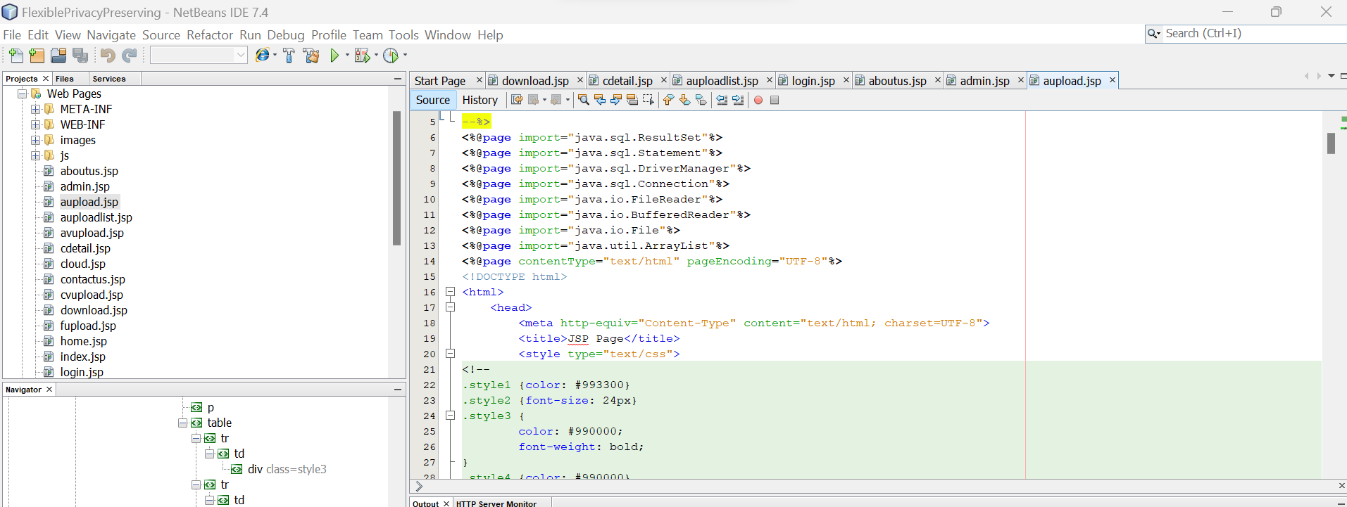

8.1 Project Code:

<%@page import="java.sql.ResultSet"%>

<%@page import="java.sql.Statement"%>

<%@page import="java.sql.DriverManager"%>

<%@page import="java.sql.Connection"%>

<%@page import="java.io.FileReader"%>

<%@page import="java.io.BufferedReader"%>

<%@page import="java.io.File"%>

<%@page import="java.util.ArrayList"%>

<%@page contentType="text/html" pageEncoding="UTF-8"%>

<!DOCTYPE html>

<html>

<head>

<meta http-equiv="Content-Type" content="text/html; charset=UTF-8">

<title>JSP Page</title>

<style type="text/css">

<!--

.style1 {color: #993300}

.style2 {font-size: 24px}

.style3 {

color: #990000;

font-weight: bold;

}

-->

</style><script type="text/javascript" src="js/datetimepicker_css.js"></script>

<script type="text/javascript" src="js/general.js"></script>

<script language="JavaScript" src="js/security.js"></script>

<link rel="stylesheet" type="text/css" href="style.css" />

</head>

<body bgcolor="#CCCCCC">

<form action="upload" method="post">

<% int a111=0;

String a13="",a1="",a2="",a3="",msg="",a12="",a11="";

int a112=0;

String ok=(String)request.getAttribute("ok");

if(ok!=null)

{

msg=(String)request.getAttribute("msg");

}

String ok1=(String)request.getAttribute("ok1");

if(ok1!=null)

{

a12=(String)request.getAttribute("a2");

a11=(String)request.getAttribute("a1");

msg=(String)request.getAttribute("msg");

}

%>

<table width="980" border="0" align="center" bgcolor="#FFFFFF">

<tr>

<td width="974" height="85"><h2 align="center" class="style1 style2">DATA LEAKAGE DETECTION </h2></td>

</tr>

<tr>

<td ><img src="images/ecommerce.jpg" width="972" height="215"/></td>

</tr>

<tr>

<td><table width="974" border="0" bgcolor="#999999">

<tr>

<td width="160"><div align="center" class="style1"><a href="user.jsp"><strong>Home</strong></a></div></td>

<td width="127"><div align="center" class="style1"><a href="fupload.jsp"><strong>File Upload </strong></a></div></td>

<td width="192"><div align="center" class="style1"><a href="userlist.jsp"><strong> My File List </strong></a></div></td>

<td width="192"><div align="center" class="style1"><a href="uploadlist.jsp"><strong> File List</strong></a></div></td>

<td width="190"><div align="center" class="style1"><a href="udownloader.jsp"><strong> Downloader List</strong></a></div></td>

<td width="175"><div align="center" class="style1"><a href="login.jsp"><strong>Logout</strong></a></div></td>

</tr>

</table></td>

</tr>

<tr>

<td heighT="516" align="center"><table width="455" border="0" align="center">

<tr>

<td height="45"> <div align="center"><strong>FILE UPLOAD </strong></div></td>

</tr>

<tr>

<td height="145"> <table width="404" border="0" align="center"> <% int index=0;

try

{

System.out.println(a11);

String url="jdbc:mysql://localhost:3306/ensure";

Class.forName("com.mysql.jdbc.Driver");

Connection con=DriverManager.getConnection(url,"root","root");

Statement st=con.createStatement();

ResultSet rs = st.executeQuery("select max(fid) from upload ");

%> <%

if (rs.next()) {

a111=Integer.parseInt(rs.getString(1));

a112=a111+1;

a13=a112+"";

%> <%}else{

a112=1000;

a13=a112+"";

}

%>

<tr>

<td width="129"><div align="left"><strong>File ID </strong></div></td>

<td width="10">&nbsp;</td>

<td width="251"><label>

<div align="left">

<input type="text" id="a1" name="a1" style="width:180px" maxlength="25"class="displayValue" onKeyPress="return nospecialcharacters();" onChange="return val_zero('a1','err_a1');"

onBlur="return txt_empty('a1','err_a1','Should Not Be Blank');" value="<%=a13%>" />

</div>

</label></td>

</tr><%

}

catch (Exception e) {

out.println(e);

}

%>

<tr>

<td><div align="left"><strong>File Name </strong></div></td>

<td>&nbsp;</td>

<td><label>

<div align="left">

<input type="file" name="a2" value="">

</div>

</label></td>

</tr>

<tr>

<td><div align="left"><strong>File Key </strong></div></td>

<td>&nbsp;</td>

<td><label>

<div align="left">

<input type="text" id="a3" name="a3" style="width:180px" maxlength="4"class="displayValue" onKeyPress="return numbersonly();return nospecialcharacters();" onChange="return val_zero('a3','err_a3');" onBlur="return txt_empty('a3','err_a3','Should Not Be Blank');"/>

</div>

</label></td>

</tr>

<tr>

<td><div align="left"><strong>Type</strong></div></td>

<td>&nbsp;</td>

<td><label>

<div align="left">

<select name="a4">

<option value="Select Type">Select Type</option>

<option value="Private">Private</option>

<option value="Public">Public</option>

</select>

</div>

</label></td>

</tr>

<tr>

<td><div align="left"><strong>Format</strong></div></td>

<td>&nbsp;</td>

<td><label>

<div align="left">

<select name="a5">

<option value="Select">Select </option>

<option value="pdf">pdf</option>

<option value="doc">doc</option>

</select>

</div>

</label></td>

</tr>

<tr>

<td><div align="left"></div></td>

<td>&nbsp;</td>

<td><div align="left"></div></td>

</tr>

<tr>

<td>&nbsp;</td>

<td>&nbsp;</td>

<td><label>

<input type="submit" name="t1" value="Add">&nbsp;&nbsp;&nbsp;&nbsp;&nbsp;<input type="reset" name="t2" value="Cancel">

</label></td>

</tr>

</table> </td> </tr>

</table>

<p class="style3"><%=a11%></p>

<p class="style3"><%=a12%></p>

<p class="style3"><%=msg%></p></td>

</tr>

<tr>

<td bgcolor="#999999">&nbsp;</td>

</tr>

</table>

</form>

</body>

</html>
/*
* To change this template, choose Tools | Templates
* and open the template in the editor.
*/

import dataset.AesEncryption;
import java.io.File;
import java.io.FileInputStream;
import java.io.IOException;
import java.io.PrintWriter;
import java.sql.*;
import java.text.SimpleDateFormat;
import java.util.Random;
import javax.servlet.RequestDispatcher;
import javax.servlet.ServletException;
import javax.servlet.http.HttpServlet;
import javax.servlet.http.HttpServletRequest;
import javax.servlet.http.HttpServletResponse;
import javax.servlet.http.HttpSession;

/**
*
* @author ASV perumal
*/
public class upload extends HttpServlet {

/**
* Processes requests for both HTTP
* <code>GET</code> and
* <code>POST</code> methods.
*
* @param request servlet request
* @param response servlet response
* @throws ServletException if a servlet-specific error occurs
* @throws IOException if an I/O error occurs
*/
protected void processRequest(HttpServletRequest request, HttpServletResponse response)
throws ServletException, IOException {
response.setContentType("text/html;charset=UTF-8");
PrintWriter out = response.getWriter();
try {
AesEncryption aes=new AesEncryption();
String url = "jdbc:mysql://localhost:3306/ensure";
Class.forName("com.mysql.jdbc.Driver");
Connection con = DriverManager.getConnection(url, "root", "root");
PreparedStatement ps;
Statement st = con.createStatement();
Statement st1 = con.createStatement();
String s1=request.getParameter("t1");
String a1= request.getParameter("a1");
String a2 = request.getParameter("a2");
String a3 = request.getParameter("a3");
String a4 = request.getParameter("a4");
String a5 = request.getParameter("a5");
String a10=" ";
int randomInt = 0;
String a="",d="",d1="";
int b11=0,b12=0,b13=0,h11=0,h12=0,h13=0,c=0,aa=0,aa1=0,aa2=0,aa3=0,aa4=0;
HttpSession so = request.getSession(true);
String v3=null,v1=null,v2=null,v4=null,v5=null;
if((s1!=null) )
{
if((a1!=null)|| (a2!=null)|| (a3!=null) )
{
java.util.Date st11 = new java.util.Date();
// Formatting date into yyyy-MM-dd HH:mm:ss e.g 2008-10-10 11:21:10

Random randomGenerator = new Random();
for (int idx = 1; idx <= 10; ++idx) {
randomInt = randomGenerator.nextInt(100000);

}
SimpleDateFormat formatter = new SimpleDateFormat("yyyy-MM-dd");
String f = formatter.format(st11);
System.out.println("Formatted date is ==>" + f);
File file = new File(a2);
FileInputStream fis = new FileInputStream(file);
long filesize = file.length();
long filesizeInKB = filesize / 1024;
System.out.println("Size of File is: "
+ filesizeInKB + " KB");
ResultSet rs = st1.executeQuery("select * from register where userid='"+so.getAttribute("un")+"'");

if(rs.next())
{
v1=rs.getString(1);
v2=rs.getString(2);
v3=rs.getString(8);
aa1=Integer.parseInt(rs.getString(9));

}
ResultSet rs12 = st1.executeQuery("select sum(fsize) from upload where userid='"+so.getAttribute("un")+"'");

if(rs12.next())
{
if(rs12!=null)
{
aa2=Integer.parseInt(rs12.getString(1));
} else{
aa2=0;
} }

System.out.println(so.getAttribute("un"));
System.out.println(aa1+": ");
System.out.println(aa2);
System.out.println(aa3);
aa3=aa1-aa2;
System.out.println(aa3);

if(aa3>=filesizeInKB){
aa4=(int) (aa3-filesizeInKB);
int r=Integer.parseInt(a3);
a="(((b11*b12*b13)-b11)+((b11*b12*b13)-b12)+((b11*b12*b13)-b13))";
d="import/v1.jar";
d1="import/import/v1.jad";
c = 9;
b11 = (r / 1000) + c;
h11 = r % 1000;
b12 = (h11 / 10) + c;
h12 = h11 % 10;
b13 = h12 + c;
aa = (((b11 * b12 * b13) - b11) + ((b11 * b12 * b13) - b12) + ((b11 * b12 * b13) - b13));
System.out.println(r);
System.out.println("b11"+ " "+b11);
System.out.println("c11"+" "+h11);
System.out.println("b12"+" "+b12);
System.out.println("c12"+" "+h12);
System.out.println("b13"+" "+b13);
System.out.println("c13"+" "+h13);
System.out.println("Enter the number one=" + aa);
System.out.println("Enter the number one=" + aa);

PreparedStatement pstmt = con.prepareStatement("insert into upload values ( ?,?,?,?,?,?,?,?,?,?,?,?,?,?)");
pstmt.setString(1, a1);
pstmt.setString(2, v1);
pstmt.setBinaryStream(3, fis, file.length());
pstmt.setString(4, file.getName());
pstmt.setInt(5, r);
pstmt.setString(6, d);
pstmt.setString(7, a);
pstmt.setInt(8, aa);
pstmt.setString(9, a10);
pstmt.setString(10, a10);
pstmt.setString(11, v3);
pstmt.setString(12, filesizeInKB+"");
pstmt.setString(13, a4);
pstmt.setString(14, a5);
ResultSet rs1 = (ResultSet) st.executeQuery("select * from upload where fid='"+a1+"'");
if(rs1.next())
{
request.setAttribute("ok", "1");
request.setAttribute("msg", "already exist");
RequestDispatcher requestdispatcher = request.getRequestDispatcher("fupload.jsp");
requestdispatcher.forward(request, response);
}else{
int i= pstmt.executeUpdate();
if(i==1){
request.setAttribute("ok1", "1");
request.setAttribute("a1", "File Size:"+filesizeInKB+"");
request.setAttribute("a2", "Balance File Size:"+aa4+"");
request.setAttribute("msg", "Sucessfully registered");
RequestDispatcher rs5=request.getRequestDispatcher("fupload.jsp");
rs5.forward(request, response);
}else{

request.setAttribute("ok", "1");
request.setAttribute("msg", "Password didnot match");
RequestDispatcher requestdispatcher = request.getRequestDispatcher("fupload.jsp");
requestdispatcher.forward(request, response);
}
}
}else{
request.setAttribute("ok", "1");
request.setAttribute("msg", "Cross the Limit");
RequestDispatcher requestdispatcher = request.getRequestDispatcher("fupload.jsp");
requestdispatcher.forward(request, response);
}
}else {
request.setAttribute("ok", "1");
request.setAttribute("msg", "Please Enter all the Values");
RequestDispatcher requestdispatcher = request.getRequestDispatcher("fupload.jsp");
requestdispatcher.forward(request, response);
}
}else {
request.setAttribute("ok", "1");
request.setAttribute("msg", "Please Enter all the Values");
RequestDispatcher requestdispatcher = request.getRequestDispatcher("fupload.jsp");
requestdispatcher.forward(request, response);
}
}catch(Exception e) {
e.printStackTrace();
} finally {
out.close();
}
}

// <editor-fold defaultstate="collapsed" desc="HttpServlet methods. Click on the + sign on the left to edit the code.">
/**
* Handles the HTTP
* <code>GET</code> method.
*
* @param request servlet request
* @param response servlet response
* @throws ServletException if a servlet-specific error occurs
* @throws IOException if an I/O error occurs
*/
@Override
protected void doGet(HttpServletRequest request, HttpServletResponse response)
throws ServletException, IOException {
processRequest(request, response);
}

/**
* Handles the HTTP
* <code>POST</code> method.
*
* @param request servlet request
* @param response servlet response
* @throws ServletException if a servlet-specific error occurs
* @throws IOException if an I/O error occurs
*/
@Override
protected void doPost(HttpServletRequest request, HttpServletResponse response)
throws ServletException, IOException {
processRequest(request, response);
}

/**
* Returns a short description of the servlet.
*
* @return a String containing servlet description
*/
@Override
public String getServletInfo() {
return "Short description";
}// </editor-fold>
}

<%@page import="java.sql.ResultSet"%>

<%@page import="java.sql.DriverManager"%>

<%@page import="java.sql.Statement"%>

<%@page import="java.sql.Connection"%>

<%@page contentType="text/html" pageEncoding="UTF-8"%>

<!DOCTYPE html>

<html>

<head>

<meta http-equiv="Content-Type" content="text/html; charset=UTF-8">

<title>JSP Page</title>

<style type="text/css">

<!--

.style1 {color: #993300}

.style2 {font-size: 24px}

</style>

</head>

<body bgcolor="#CCCCCC">

<form action="" method="post"><table width="921" border="0" align="center" bgcolor="#FFFFFF">

<tr>

<td width="990" height="85"><h2 align="center" class="style1 style2">DATA LEAKAGE DETECTION </h2></td>

</tr>

<tr>

<td ><img src="images/ecommerce.jpg" width="957" height="215"/></td>

</tr>

<tr>

<td><table width="974" border="0" bgcolor="#999999">

<tr>

<td width="160"><div align="center" class="style1"><a href="user.jsp"><strong>Home</strong></a></div></td>

<td width="127"><div align="center" class="style1"><a href="fupload.jsp"><strong>File Upload </strong></a></div></td>

<td width="192"><div align="center" class="style1"><a href="userlist.jsp"><strong> My File List </strong></a></div></td>

<td width="192"><div align="center" class="style1"><a href="uploadlist.jsp"><strong> File List</strong></a></div></td>

<td width="190"><div align="center" class="style1"><a href="udownloader.jsp"><strong> Downloader List</strong></a></div></td>

<td width="175"><div align="center" class="style1"><a href="login.jsp"><strong>Logout</strong></a></div></td>

</tr>

</table></td>

</tr>

<tr>

<td height="516"><table align="center" width="757" height="158" border="0">

<tr>

<td width="751" height="154"><table align="center" width="751" border="0">

<tr>

<td width="745" height="41" align="center"><div align="center"><table width="100%" height="27" border="1" >

<tr>

<td width="127"><div align="center" class="style19 style6 style9"><strong>User Id</strong></div></td>

<td width="296"><div align="center" class="style22 style6 style9"><strong>File Name</strong></div></td>

<td width="162" height="23" ><div align="center" class="style19 style6 style9"><strong>Date</strong></div></td>

<td width="132"><div align="center" class="style19 style6 style9"><strong>Status</strong></div></td>

</tr>

</table>

</div></td>

</tr>

<tr><td>

<div class="text" id="navvylist" border-color:#FFFF00;">

<table width=100% align="center" border="1">

<%!int index = 1;%>

<%

HttpSession so = request.getSession(true);

try {

int flag = 0;

String url = "jdbc:mysql://localhost:3306/ensure";

Class.forName("com.mysql.jdbc.Driver");

Connection con = DriverManager.getConnection(url, "root", "root");

Statement st = con.createStatement();

ResultSet rs = st.executeQuery("select * from download where fname='"+so.getAttribute("un")+"' ");

if (rs != null) {%>

<% while (rs.next()) {

%>

<tr>

<td width="129" ><div align="center"><%=rs.getString(1)%></div></td>

<td width="295"><div align="center"><%=rs.getString(4)%></div></td>

<td width="162"><div align="center"><%=rs.getString(5)%></div></td>

<td width="131"><div align="center"><%=rs.getString(6)%></div></td>

<% index++;

}

} else {

%>

No items found....!

<% }

} catch (Exception e) {

out.println(e);

}

%>

</table>

</div>

</td>

</tr>

</table>

</td>

</tr>

</table></td>

</tr>

<tr>

<td bgcolor="#999999">&nbsp;</td>

</tr>

</table>

</form>

</body>

</html>
/*
* To change this template, choose Tools | Templates
* and open the template in the editor.
*/

import java.io.File;
import java.io.FileInputStream;
import java.io.IOException;
import java.io.InputStream;
import java.io.PrintWriter;
import java.sql.Connection;
import java.sql.DriverManager;
import java.sql.PreparedStatement;
import java.sql.ResultSet;
import java.sql.Statement;
import java.text.SimpleDateFormat;
import java.util.Random;
import javax.servlet.RequestDispatcher;
import javax.servlet.ServletException;
import javax.servlet.http.HttpServlet;
import javax.servlet.http.HttpServletRequest;
import javax.servlet.http.HttpServletResponse;
import javax.servlet.http.HttpSession;

/**
*
* @author Administrator
*/
public class udownload extends HttpServlet {

/**
* Processes requests for both HTTP
* <code>GET</code> and
* <code>POST</code> methods.
*
* @param request servlet request
* @param response servlet response
* @throws ServletException if a servlet-specific error occurs
* @throws IOException if an I/O error occurs
*/
protected void processRequest(HttpServletRequest request, HttpServletResponse response)
throws ServletException, IOException {
response.setContentType("text/html;charset=UTF-8");
PrintWriter out = response.getWriter();
try {

String url1;

HttpSession so = request.getSession(true);
Class.forName("com.mysql.jdbc.Driver");
Connection con = DriverManager.getConnection("jdbc:mysql://localhost:3306/ensure", "root", "root");
Statement st = con.createStatement();
Statement st1 = con.createStatement();
Statement st2 = con.createStatement();
Statement st3 = con.createStatement();
Statement st4 = con.createStatement();
Statement st5 = con.createStatement();
Statement st6 = con.createStatement();
int size;
int flag=0;
String a11=request.getParameter("a1");
String a12=request.getParameter("a2");
long mob = 0;
String b = request.getParameter("b");
String b1 = request.getParameter("b1");
String a1= request.getParameter("a1");
String a2 = request.getParameter("a2");
String a3 = request.getParameter("a3");
String a4 = request.getParameter("a4");
String a5 = request.getParameter("a5");
if (request.getParameter("t5") != null) {
String v = null;
java.util.Date st11 = new java.util.Date();
// Formatting date into yyyy-MM-dd HH:mm:ss e.g 2008-10-10 11:21:10

SimpleDateFormat formatter = new SimpleDateFormat("yyyy-MM-dd HH:mm:ss");
String f = formatter.format(st11);
System.out.println("Formatted date is ==>" + f);

System.out.println("select * from upload where fid='" + b + "' ");
int vs=st1.executeUpdate("delete from upload where fid='"+b+"'");
if(vs==1){
request.setAttribute("ok", "1");
request.setAttribute("msg", "Deleted Succesfully");
RequestDispatcher requestdispatcher = request.getRequestDispatcher("userlist.jsp");
requestdispatcher.forward(request, response);
}else{
request.setAttribute("ok", "1");
request.setAttribute("msg", "Deletion Failed");
RequestDispatcher requestdispatcher = request.getRequestDispatcher("userlist.jsp");
requestdispatcher.forward(request, response);
}

} else if (request.getParameter("t7") != null) {

RequestDispatcher requestdispatcher = request.getRequestDispatcher("userlist.jsp");
requestdispatcher.forward(request, response);
}else if (request.getParameter("t8") != null) {
String a10=" ";
int randomInt = 0;
String a="",d="",d1="",v1="",v2="",v3="";
int b11=0,b12=0,b13=0,h11=0,h12=0,h13=0,c=0,aa=0,aa1=0,aa2=0,aa3=0,aa4=0;

if((a1!=null)|| (a2!=null)|| (a3!=null) )
{
long b2=0;
java.util.Date st11 = new java.util.Date();
// Formatting date into yyyy-MM-dd HH:mm:ss e.g 2008-10-10 11:21:10

Random randomGenerator = new Random();
for (int idx = 1; idx <= 10; ++idx) {
randomInt = randomGenerator.nextInt(100000);

}
SimpleDateFormat formatter = new SimpleDateFormat("yyyy-MM-dd");
String f = formatter.format(st11);
System.out.println("Formatted date is ==>" + f);
File file = new File(a2);
FileInputStream fis = new FileInputStream(file);
long filesize = file.length();
long filesizeInKB = filesize / 1024;
System.out.println("Size of File is: "
+ filesizeInKB + " KB");
ResultSet rs = st1.executeQuery("select * from register where userid='"+so.getAttribute("un")+"'");

if(rs.next())
{
v1=rs.getString(1);
v2=rs.getString(2);
v3=rs.getString(8);
aa1=Integer.parseInt(rs.getString(9));

}
ResultSet rs2= st1.executeQuery("select * from upload where fid='"+a1+"'");

if(rs2.next())
{

b2=Integer.parseInt(rs2.getString(12));

}
ResultSet rs12 = st1.executeQuery("select sum(fsize) from upload where userid='"+so.getAttribute("un")+"'");

if(rs12.next())
{
if(rs12!=null)
{
aa2=Integer.parseInt(rs12.getString(1));
} else{
aa2=0;
} }

System.out.println(so.getAttribute("un"));
System.out.println(aa1+": ");
System.out.println(aa2);
System.out.println(aa3);
aa3=aa1-aa2;
System.out.println(aa3);
filesizeInKB=filesizeInKB-b2;
if(aa3>=filesizeInKB){
aa4=(int) (aa3-filesizeInKB);
int r=Integer.parseInt(a3);
a="(((b11*b12*b13)-b11)+((b11*b12*b13)-b12)+((b11*b12*b13)-b13))";
d="import/v1.jar";
d1="import/import/v1.jad";
c = 9;
b11 = (r / 1000) + c;
h11 = r % 1000;
b12 = (h11 / 10) + c;
h12 = h11 % 10;
b13 = h12 + c;
aa = (((b11 * b12 * b13) - b11) + ((b11 * b12 * b13) - b12) + ((b11 * b12 * b13) - b13));
System.out.println(r);
System.out.println("b11"+ " "+b11);
System.out.println("c11"+" "+h11);
System.out.println("b12"+" "+b12);
System.out.println("c12"+" "+h12);
System.out.println("b13"+" "+b13);
System.out.println("c13"+" "+h13);
System.out.println("Enter the number one=" + aa);
System.out.println("Enter the number one=" + aa);

PreparedStatement pstmt = con.prepareStatement("update upload set userid=?,file=?,filename=?,random=?,jar=?,expression=?,code=?,ack1=?,ack2=?,comapny=?,fsize=?,type=?,format=? where fid=? ");
pstmt.setString(1, v1);
pstmt.setBinaryStream(2, fis, file.length());
pstmt.setString(3, file.getName());
pstmt.setInt(4, r);
pstmt.setString(5, d);
pstmt.setString(6, a);
pstmt.setInt(7, aa);
pstmt.setString(8, a10);
pstmt.setString(9, a10);
pstmt.setString(10, v3);
pstmt.setString(11, filesizeInKB+"");
pstmt.setString(12, a4);
pstmt.setString(13, a5);
pstmt.setString(14, a1);

int i= pstmt.executeUpdate();
if(i==1){
request.setAttribute("ok1", "1");
request.setAttribute("msg", "Sucessfully registered");
RequestDispatcher rs5=request.getRequestDispatcher("userlist.jsp");
rs5.forward(request, response);
}else{

request.setAttribute("ok", "1");
request.setAttribute("msg", "Password didnot match");
RequestDispatcher requestdispatcher = request.getRequestDispatcher("userlist.jsp");
requestdispatcher.forward(request, response);
}

}else{
request.setAttribute("ok", "1");
request.setAttribute("msg", "Cross the Limit");
RequestDispatcher requestdispatcher = request.getRequestDispatcher("userlist.jsp");
requestdispatcher.forward(request, response);
}
}

}else {
RequestDispatcher requestdispatcher = request.getRequestDispatcher("userlist.jsp");
requestdispatcher.forward(request, response);
}
} catch (Exception e) {
e.printStackTrace();
} finally {
out.close();
}
}

// <editor-fold defaultstate="collapsed" desc="HttpServlet methods. Click on the + sign on the left to edit the code.">
/**
* Handles the HTTP
* <code>GET</code> method.
*
* @param request servlet request
* @param response servlet response
* @throws ServletException if a servlet-specific error occurs
* @throws IOException if an I/O error occurs
*/
@Override
protected void doGet(HttpServletRequest request, HttpServletResponse response)

throws ServletException, IOException {
processRequest(request, response);
}
/**
* Handles the HTTP
* <code>POST</code> method.
*
* @param request servlet request
* @param response servlet response
* @throws ServletException if a servlet-specific error occurs
* @throws IOException if an I/O error occurs
*/
@Override
protected void doPost(HttpServletRequest request, HttpServletResponse response)
throws ServletException, IOException {
processRequest(request, response);
}

/**
* Returns a short description of the servlet.
*
* @return a String containing servlet description
@Override
public String getServletInfo() {
return "Short description";
}// </editor-fold>
}

CHAPTER 9

9.1 OUTPUT SCREENSHOT

Homepage

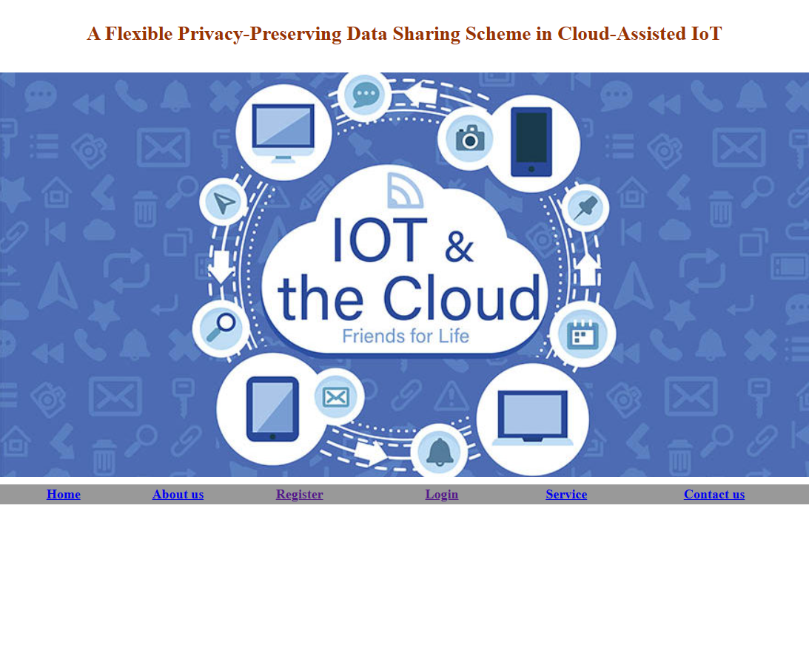

Registration page

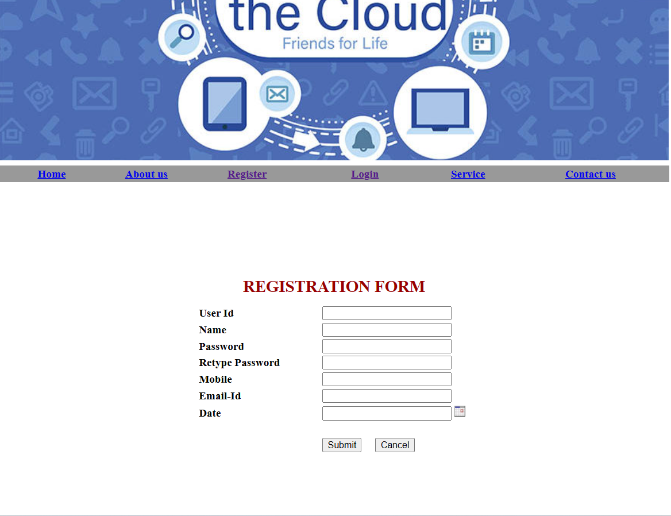

Login page

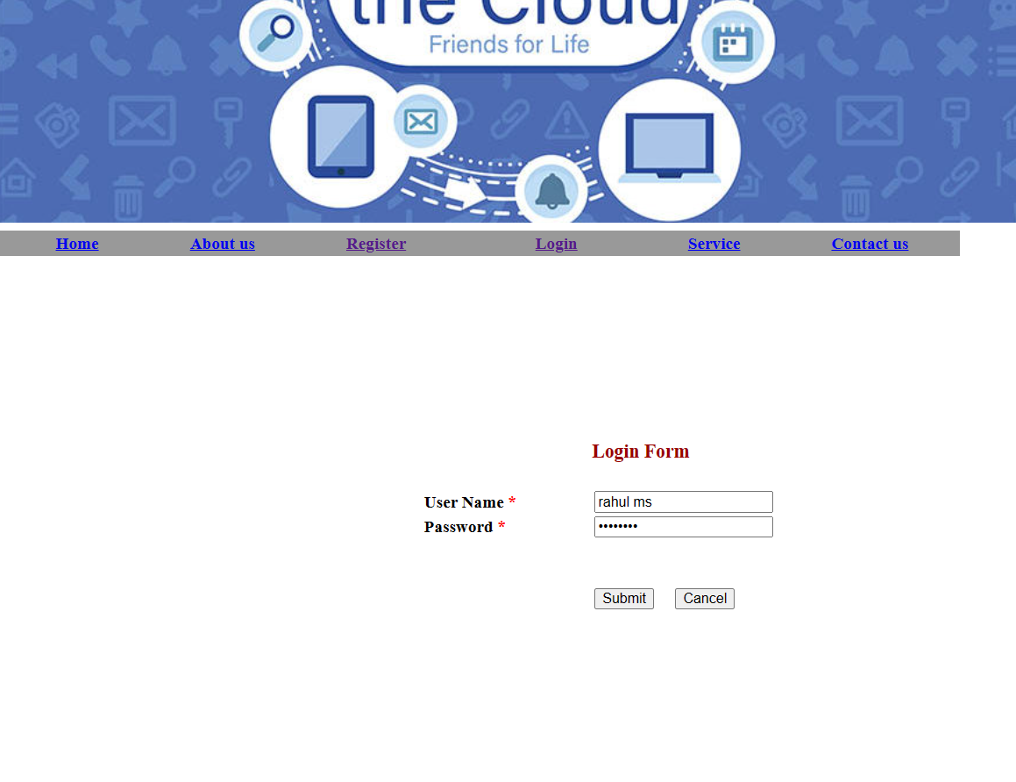

Welcome page

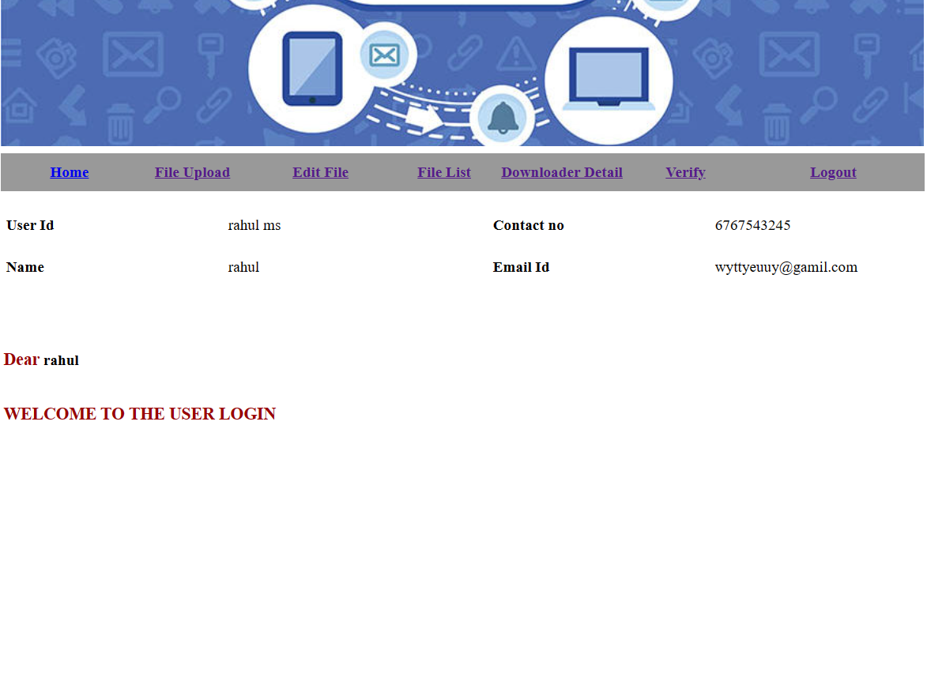

Encryption-Decryption process

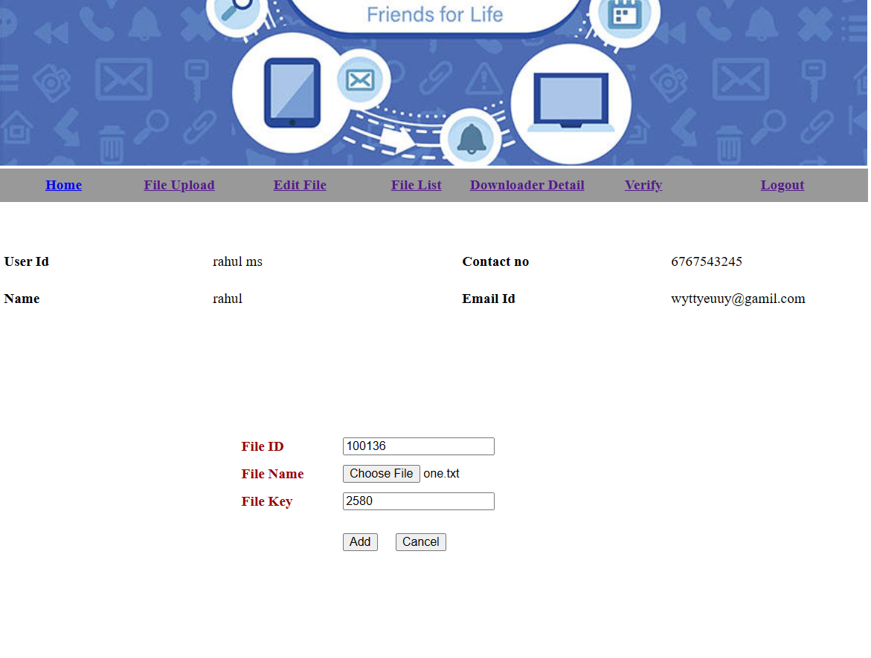

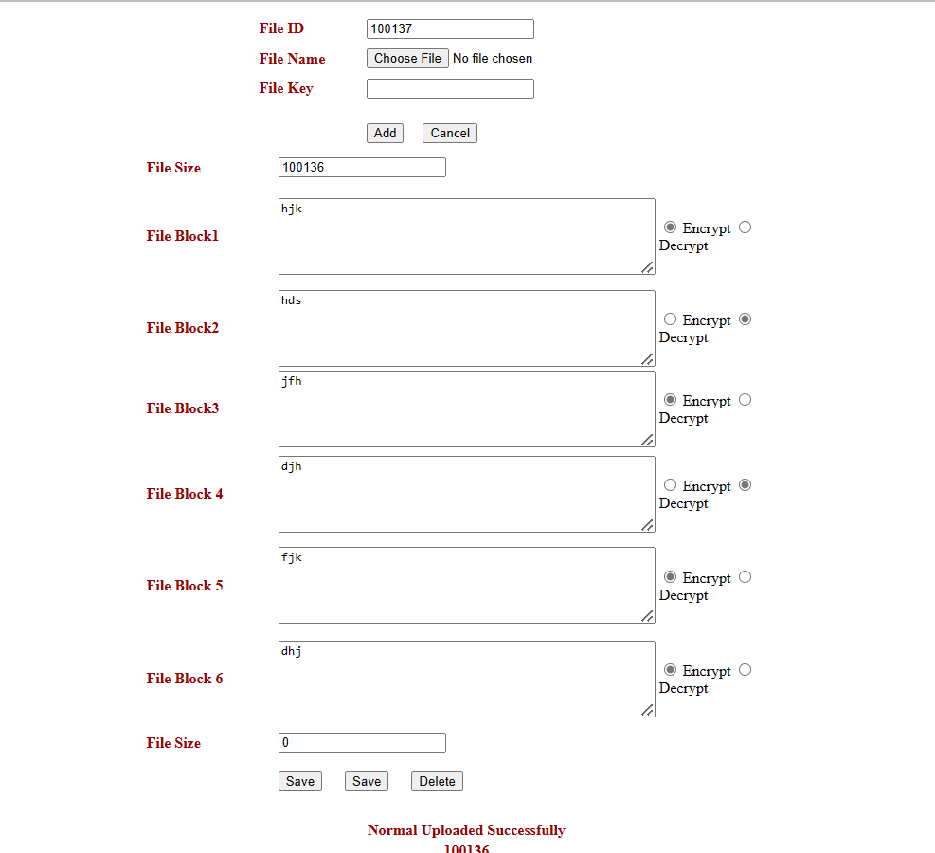

File downloading page

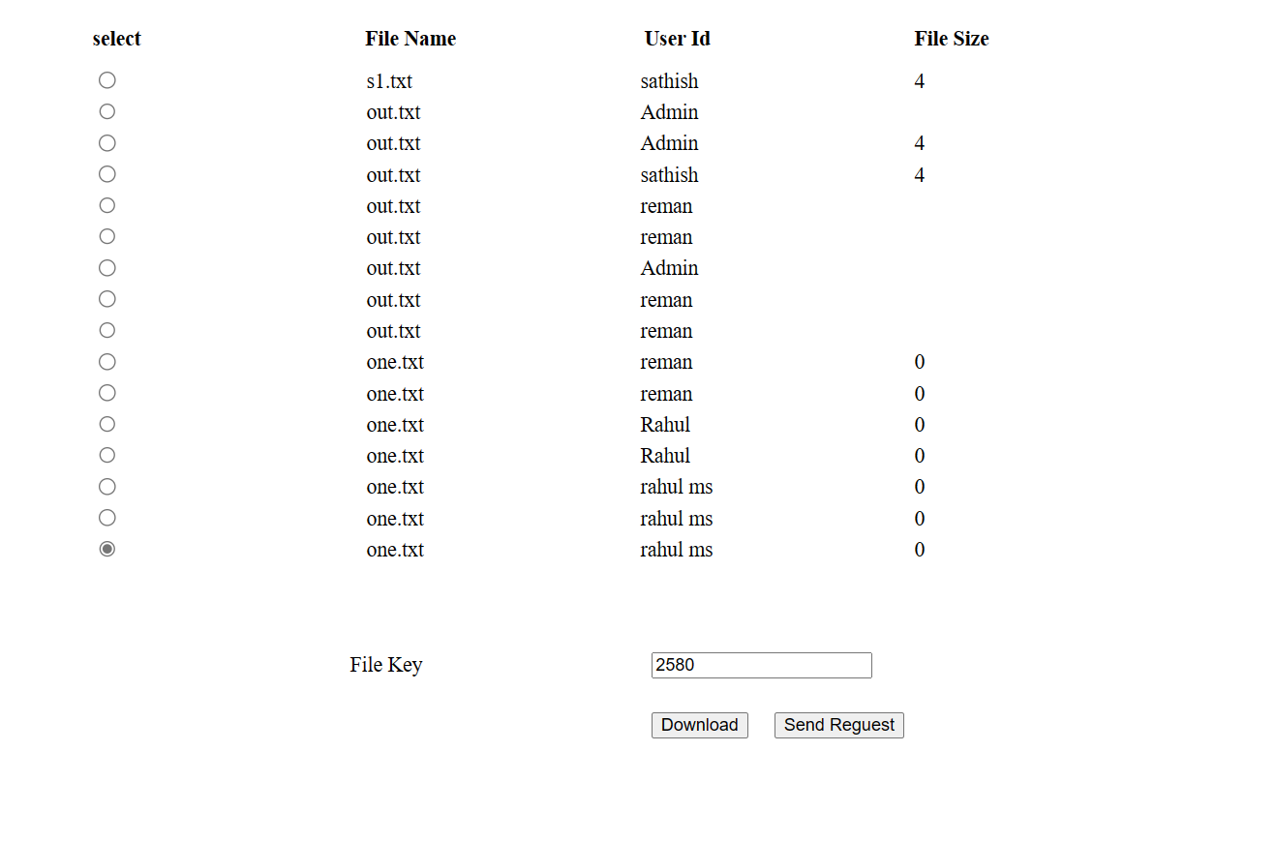

Downloaders details

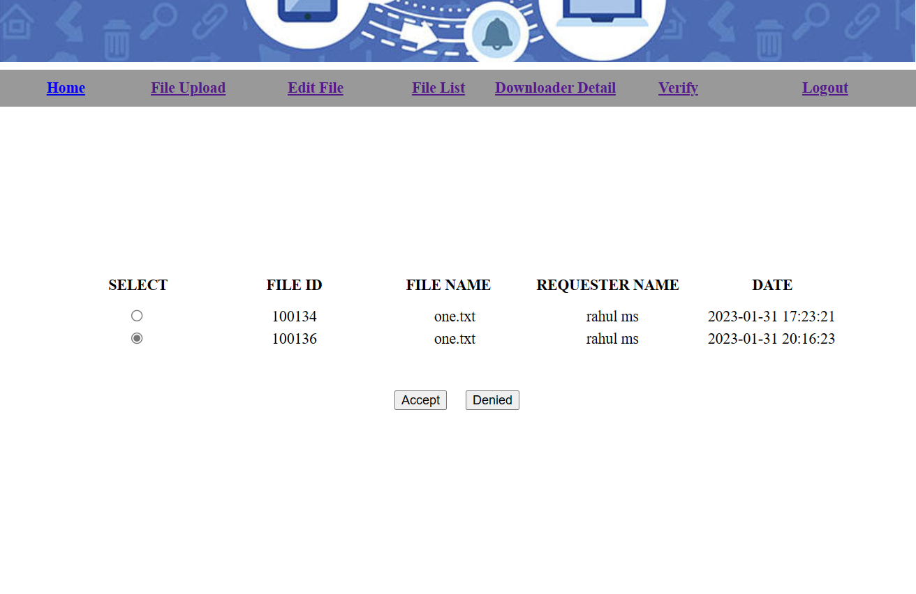

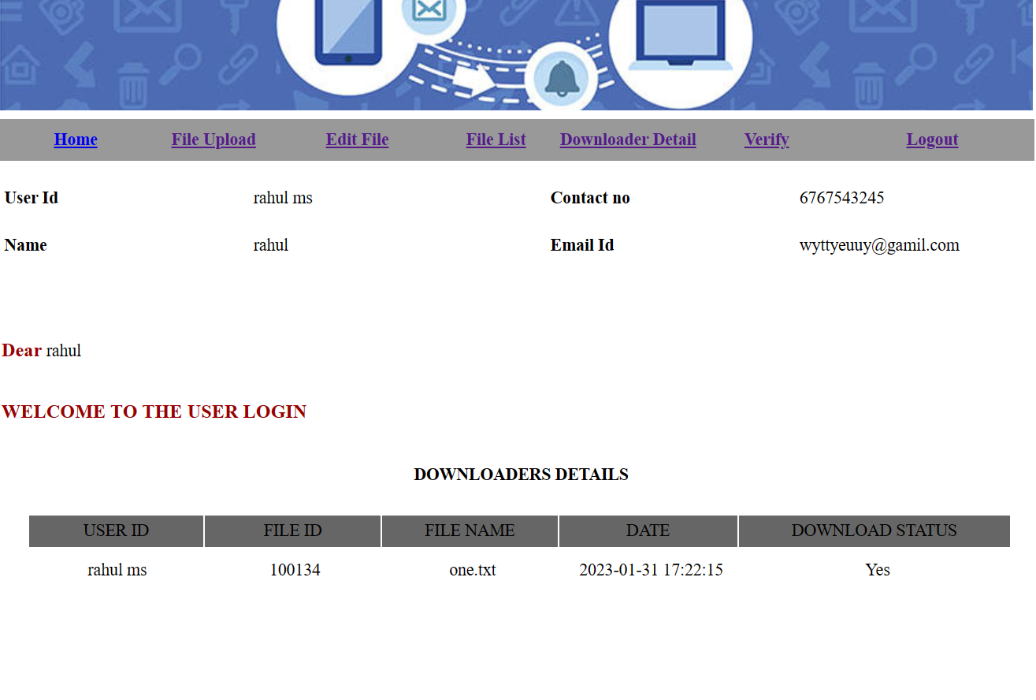

CHAPTER-10
CONCLUSION
I portrayed how to construct a useful PDP methodology for conveyed distributed storage. I have introduced a helpful PDP approach in view of homomorphic evident reaction and hash file ordered progression to give dynamic versatility on numerous capacity servers. I likewise showed that my plan has all the essential security highlights for a zero-information intuitive verification framework, permitting it to endure different goes after in any event, when utilized as a cloud-based public review administration. To upgrade the review execution, I additionally enhanced the probabilistic question and occasional confirmation. My tests abundantly showed that my techniques just altogether increment correspondence and handling overheads. Subsequently, my methodology can be viewed as a new competitor for information honesty really looking at in rethinking information stockpiling frameworks.

REFERENCE
- William Grosso, “JAVA”, O'Reilly Media, Inc.; 1 edition, 2001

John Zukowski, “Definitive Guide to Swing for Java 2”,1999
- Roger S.Pressman, “SOFTWARE ENGINEERING –A PRACTIONERS APPROACH “, Tata McGraw Hill Publishing Company, 1997.
- JAVA 2 Platform, standard Edition, V 1.3.1 API Specification
- Java RMI: Remote method Invocation(Paperback) Troy Bryan Downing
- Patrick Naughton “The Java Hand Book” Tata McGraw Hill, 2006
- Mark Grand and Jonathan Knudsen, “Java Fundamental Classes Reference”, Tata McGraw-Hill Publishing Company Limited, 1st Edition, May 1997.
- Dietel & Deitel, Java How To Program, BPB Publishers, New Delhi, 2000.
- O’reilly, Java Swings, Tata McGrawHill, Fifth Edition, 2002.

Websites
- www.java.sun.com
- www.samba.org
- http://www.db.cs.ucdavis.edu
- Java Database Programming Bible.
- Principles of Database Systems With Internet and Java Applications
- www.microsoft.com
- www.smartdraw.com
- www.laynetworks.com

