DETECTION OF CARDIAC ILLNESS UTILIZING AI

submitted in partial fulfillment of the requirements
for the award of the degree in

MASTER OF SCIENCE
in
CYBER FORENSICS AND INFORMATION SECURITY

by
LIDHIYA HIJAS (213182101025)



DEPARTMENT OF
COMPUTER SCIENCE AND ENGINEERING

APRIL- 2023

DEPARTMENT OF COMPUTER SCIENCE AND ENGINEERING

BONAFIDE CERTIFICATE

This is to certify that this Project Report is the bonafide work of Ms. Lidhiya Hijas Reg. No 213182101025, who carried out the project entitled “DETECTION OF CARDIAC ILLNESS UTILIZING AI” under our supervision from December 2022 to March 2023.

Internal Guide Project Coordinator Department Head
Ms. Sarika Jain Ms. Sri Lakshmi Dr.S. Geetha
CoEDF Faculty CoEDF Faculty Professor and Head
Dept of CSE
Dr. MGR Educational
And Research Institute

Submitted for Viva Voce Examination held on _________________

Internal Examiner External Examiner

DECLARATION FORMAT

I Lidhiya hijas (213182101025) hereby declare that the Project Report entitled “Detection of Cardiac illness utilizing AI” is done by me under the guidance of Ms. Sarika Jain and is submitted in partial fulfillment of the requirements for the award of the degree in MASTER OF SCIENCE in CYBER FORENSICS AND INFORMATION SECURITY.
.
.

DATE:

PLACE: SIGNATURE OF THE CANDIDATE

ACKNOWLEDGEMENT

I would first like to thank our beloved Chancellor
Dr. A.C. Shanmugam, B.A., B.L. and President Er. A.C.S. Arun Kumar, B.Tech., M.B.A., and for all the encouragement and support extended to us during the tenure of this project and also our years of studies in his wonderful University.

I express my heartfelt thanks to our Vice Chancellor
Prof. Dr. S. Geethalakshmi in providing all the support of my Project.

I express my heartfelt thanks to our Head of the Department,
Prof. Dr. S. Geetha, who has been actively involved and very influential from the start till the completion of our project.

Our sincere thanks to our Project Coordinator Ms. Sri Lakshmi and Project guide Ms. Sarika Jain for their continuous guidance and encouragement throughout this work, which has made the project a success.

I would also like to thank all the teaching and non-teaching staff of the Cyber forensics and Information Technology department, for their constant support and the encouragement given to us while we went about achieving my project goals.

CHAPTER | TITLE | PAGE NO
1 | INTRODUCTION  - Abstract of the project  - Introduction  - Objectives  - Literature survey  - Scope | 8  9  10-11  11-14  14-15
2 | REQUIREMENT SPECIFICATIONS AND ANALYSIS  2.1 Existing system  2.2 Proposed system  2.3 Collection of data-set  2.4 Selection of attributes  2.5 Pre-processing of data  2.6 Prediction | 16  16-17  17  18  18  19-20
3 | REQUIREMENT ANALYSIS | 21-22
4 | MACHINE LEARNING | 23
5 | FUTURE ENHANCEMENT | 24
6 | DESIGN  6.1 System architecture | 25
7 | IMPLEMENTATION  7.1 Frequentist statistics  7.2 Inherent flaws in frequent statistics  7.3 Bayesian statistics | 28-30  30-31  31-35
8 | KNN | 36-39
9 | SOFTWARE ENVIRONMENT  9.1 Python Programming language  9.2 Where is python used?  9.3 Python libraries | 40-42  41  41-42
10 | VISUAL STUDIO CODE | 43-44
11 | DATASET EXPLANATION | 45-48
12 | PERFORMANCE ANALYSIS | 49
13 | CODING  13.1 Execution code | 50-55  55-61
14 | OUTPUT | 62-66
15 | CONCLUSION | 67
16 | REFERENCE | 68
List of Figures

FIGURE | PARTICULARS | PAGE NUMBER
Fig 1 | Architecture diagram | 25
Fig 2 | Plot graph | 26
Fig 3 | Data flow diagram | 27
Fig 4 | Probability graph | 35
Fig 5 | Dataset diagram | 47
Fig 6 | Dataset diagram | 48
Fig 7 | Output diagram 1 | 62
Fig 8 | Output diagram 2 | 63
Fig 9 | Output diagram 3 | 64
Fig 10 | Output diagram 4 | 65
Fig 11 | Output diagram 5 | 66
CHAPTER 1
INTRODUCTION

1.1 Abstract
The principal objective of this exploration is to develop a Clever Framework utilizing information mining displaying strategy, specifically, Naive Bayes. It recovers concealed information from put-away data sets and contrasts the client values and a prepared informational collection. It can answer complex inquiries for diagnosing coronary illness and hence help medical care experts to go with clever clinical choices that customary choice emotionally supportive networks can't. Giving successful medicines additionally assists with diminishing treatment costs.
The heart is the most fundamental or significant part of our body. The heart is utilized to keep up with and form blood in our body. There are a ton of cases on the planet connected with heart illnesses. Individuals are passing on because of coronary illness. Different side effects are referenced. The medical services ventures tracked down a lot of information. This paper anticipates coronary illness utilizing AI calculations. Here, we will utilize AI calculations KNN and Naive Bayes. The calculations are utilized based on highlights and for anticipating coronary illness.

1.2 Introduction

A significant test confronting medical care associations (emergency clinics, clinical focuses) is the arrangement of value administrations at sensible costs. Quality assistance suggests diagnosing patients appropriately and overseeing medicines that are viable. Poor clinical choices will bring about critical results that are so unsuitable. Clinics ought to moreover lessen the cost of clinical tests. They'll get through these outcomes by utilizing material PC-based data or potentially calling emotionally supportive networks. Most clinics today utilize some type of emergency clinic data framework to deal with their medical services or patient information. These frameworks ordinarily produce enormous measures of information that take the state of numbers, text, graphs, and pictures. Unfortunately, this information is seldom acclimated with supporting clinical independent direction. There's an abundance of stowed-away data in this information that is generally undiscovered. This brings up a vital issue: "How we will generally flip information into supportive information that might change medical services specialists to make wise clinical choices?" Despite the fact that information digging has been around for more than 20 years, its true capacity is scarcely being achieved now. Information mining consolidates applied science examination, AI, and data innovation to separate concealed examples and connections from goliath data sets. Naive Bayes or Bayes' Standard is the reason for a few AI and information handling ways. The standard (calculation) is utilized to make models with prescient capacities. It gives better approaches for investigating and grasping information. It gains from the "proof" by ascertaining the connection between the objective (i.e., reliant) and unique (i.e., autonomous) factors.

Data Mining is the nontrivial cycle of recognizing substantial, novel, possibly valuable, and at last reasonable examples in information with the wide utilization of data sets and the hazardous development in their sizes. Information mining alludes to removing or "mining" information from a lot of information. Information digging is the quest for the connections and worldwide examples that exist in huge data sets yet are tucked away among a lot of information. The fundamental course of Information Disclosure is the transformation of information into information to support navigation, alluded to as information mining. The Information Disclosure process comprises an iterative grouping of information cleaning, information joining, information determination, information mining design acknowledgment, and information showing. Information digging is the quest for the connections and worldwide examples that exist in huge data sets but are tucked away among a lot of information. Numerous medical clinic data frameworks are intended to help patient charging, stock administration, and the age of basic measurements.

1.3 Objectives
Most emergency clinics today utilize kind of clinic data frameworks to deal with their medical services or patient information. These frameworks regularly produce colossal measures of information. There is an abundance of stowed-away data in this information that is generally undiscovered. How information is transformed into helpful data that can empower medical care professionals to pursue savvy clinical choices. The principal objective of this exploration is to foster a Choice Help in Coronary illness Expectation Framework (DHDPS) utilizing one information mining displaying method, to be specific, Guileless Bayes. DSHDPS is carried out as an online survey application. In light of client replies, it can find and concentrate stowed away information (examples and connections) related to coronary illness from a verifiable coronary illness data set. We give the report of the patient in two ways utilizing outline and pdf which demonstrates regardless of whether that specific patient has a coronary illness. This idea is promising as information demonstrating and investigation devices, e.g., information mining, can possibly produce an information-rich climate that can serve to work on the nature of clinical choices altogether. The determination of illnesses is a critical and drawn-out task in medication. The discovery of coronary illness from different elements or side effects is a multifaceted issue that isn't liberated from misleading assumptions frequently joined by flighty impacts. Subsequently, the work to use information and experience of various trained professionals and clinical screening information of patients gathered in data sets to work with the finding system is viewed as an important choice. Offering valuable types of assistance at reasonable expenses is a significant imperative experienced by medical care associations (emergency clinics, clinical focuses).
Significant quality help indicates the precise conclusion of patients and giving effective treatment. Poor clinical choices might prompt catastrophes and subsequently are rarely engaged. Furthermore, it is fundamental that the clinics decline the expense of clinical tests. Suitable PC-based data or potentially choice emotionally supportive networks can help with accomplishing clinical tests at a decreased expense. Gullible Bayes or Bayes' Standard is the reason for some AI and information mining techniques. The standard (calculation) is utilized to make models with prescient capacities. It gives better approaches for investigating and grasping information. It gains from the "proof" by ascertaining the connection between the objective (i.e., reliant) and other (i.e., autonomous) factors.

1.4 Literature survey
There are numerous works have been done related to disease prediction systems using different data mining techniques and machine learning algorithms in medical centers.

K. Polaraju, proposed the Prediction of Heart Disease using the Multiple Regression Model and it proves that Multiple Linear Regression is appropriate for predicting heart disease chance. The work is performed using a training data set consisting of 3000 instances with 13 different attributes which have been mentioned earlier. The data set is divided into two parts that are 70% of the data is used for training and 30% is used for testing. Based on the results, it is clear that the classification accuracy of the Regression algorithm is better compared to other algorithms.

Marjia, developed heart disease prediction using KStar, j48, SMO, and Bayes Net and Multilayer perception using WEKA software. Based on performance from different factors SMO and Bayes Net achieve optimum performance than KStar, Multilayer perception, and J48 techniques using k- fold cross-validation. The accuracy performances achieved by those algorithms are still not satisfactory. Therefore, the accuracy’s performance is improved more to give better decisions to the diagnosis of disease.

S. Seema, focus on techniques that can predict chronic disease by mining the data contained in historical health records using Naïve Bayes, Decision tree, Support Vector Machine(SVM), and Artificial Neural Network(ANN). A comparative study is performed on classifiers to measure better performance at an accurate rate. From this experiment, SVM gives the highest accuracy rate, whereas for diabetes Naïve Bayes gives the highest accuracy.

Ashok Kumar Dwivedi, recommended different algorithms like Naive Bayes, Classification Tree, KNN, Logistic Regression, SVM, and ANN. The Logistic Regression gives better accuracy compared to other algorithms.

MeghaShahi, suggested Heart Disease Prediction System using Data Mining Techniques. WEKA software is used for the automatic diagnosis of disease and to give qualities of services in healthcare centers. The paper used various algorithms like SVM, Naïve Bayes, Association rule, KNN, ANN, and Decision Tree. The paper recommended SVM is effective and provides more accuracy as compared with other data mining algorithms.

Chala Beyene, recommended Prediction and Analysis of the occurrence of Heart Disease Using Data Mining Techniques. The main objective is to predict the occurrence of heart disease for early automatic diagnosis of the disease within result in a short time. The proposed methodology is also critical in healthcare organizations with experts that have no more knowledge and skill. It uses different medical attributes such as blood sugar and heart rate, age, sex are some of the attributes are included to identify if the person has heart disease or not. Analyses of the dataset are computed using WEKA software.

R. Sharmila, proposed to use of a non-linear classification algorithm for heart disease prediction. It is proposed to use big data tools such as Hadoop Distributed File System (HDFS), MapReduce along with SVM for the prediction of heart disease with an optimized attribute set. This work made an investigation into the use of different data mining techniques for predicting heart diseases. It suggests using HDFS for storing large data in different nodes and executing the prediction algorithm using SVM in more than one node simultaneously using SVM. SVM is used in a parallel fashion which yielded better computation time than sequential SVM.

Jayami Patel, suggested heart disease prediction using data mining and machine learning algorithm. The goal of this study is to extract hidden patterns by applying data mining techniques. The best algorithm J48 based on UCI data has the highest accuracy rate compared to LMT.

Purushottam, proposed an efficient heart disease prediction system using data mining. This system helps medical practitioner to make effective decision making based on certain parameters. By testing and training phase a certain parameter, it provides 86.3% accuracy in the testing phase and 87.3% in the training phase.

K.Gomathi, suggested multi-disease prediction using data mining techniques. Nowadays, data mining plays a vital role in predicting multiple diseases. By using data mining techniques the number of tests can be reduced. This paper mainly concentrates on predicting heart disease, diabetes, breast cancer, etc.,

P. Sai Chandrasekhar Reddy, proposed Heart disease prediction using the ANN algorithm in data mining. Due to the increasing expenses of heart disease diagnosis disease, there was a need to develop a new system that can predict heart disease. The prediction model is used to predict the condition of the patient after evaluation on the basis of various parameters like heart beat rate, blood pressure, cholesterol, etc. The accuracy of the system is proved in java.

Ashwini Shetty, recommended developing a prediction system that will diagnose heart disease from a patient’s medical dataset. 13 risk factors of input attributes have been taken into account to build the system. After analysis of the data from the dataset, data cleaning, and data integration was performed.

Jaymin Patel, suggested data mining techniques and machine learning predict heart disease. There are two objectives to predicting the heart system. 1. This system does not assume any knowledge in prior about the patient’s records. 2. The system chosen must be scalar to run against a large number of records. This system can be implemented using WEKA software. For testing, the classification tools and explorer mode of WEKA are used.

1.5 Scope
Here the extent of the task is that incorporation of clinical choice help with computer-based patient records could diminish clinical blunders, upgrade patient well-being, decline undesirable practice variety, and work on the understanding result. The application is taken care of with fluctuated subtleties and hence the cardiovascular infection connected with those subtleties. The application licenses the client to share heart-associated issues. It then processes the client's explicit subtleties to discover changed sickness that may be connected with it. Here we will quite often utilize a few wise information-mining strategies to figure out the preeminent right disease that may be connected with the patient's details. In view of the result, the framework consequently shows the outcome of explicit specialists for greater treatment. The framework grants clients to see specialists' subtleties. The framework can be used in the event of a crisis.

CHAPTER 2
REQUIREMENT SPECIFICATION AND ANALYSIS

2.1 Existing system
In this framework, the pieces of information are taken from the patient. Then from the client inputs, utilizing ML procedures coronary illness is examined. Presently, the got results are contrasted, and the aftereffects of existing models inside a similar space and viewed as moved along. The information on heart disease patients gathered from the UCI lab is utilized to find designs with NN, DT, and support Vector machines SVM, and Naive Bayes. The outcomes are compared for performance and precision with these algorithms. The proposed hybrid technique returns results of 87% for F-measure, contending with the other existing strategies.
Disadvantages
1. Prediction of cardiovascular disease is not accurate.
2. data mining strategies don’t assist with giving successful direction.
3. Cannot handle large datasets of patient records.

2.2 Proposed system
After assessing the outcomes from the current strategies, we have utilized python and pandas operations to perform Heart disease classification for the information got from the UCI repository. It gives a simple to-utilize visual portrayal of the dataset, working climate, and building the prescient examination. ML process begins from a pre-handling information stage followed by including choice in light of information cleaning, and order of demonstrating execution assessment. The Random Forest method is utilized to work on the accuracy of the outcome.

Advantages
1. Expanded precision for powerful coronary illness conclusion.
2. Handles the roughest (enormous) measure of information utilizing Random Forest calculation and component choice.
3. Decrease the time complexity of specialists.
4. Practical for patients.

2.3 Collection of data set
At first, we gather a dataset for our coronary illness expectation framework. After the assortment of the dataset, we split the dataset into preparing information and testing information. The preparing dataset is utilized for expectation model learning and testing information is utilized for assessing the expectation model. For this venture, 70% of preparing information is utilized and 30% of information is utilized for testing. The dataset utilized for this task is Coronary illness UCI. The dataset comprises of 76 qualities; out of which, 14 credits are utilized for the framework.
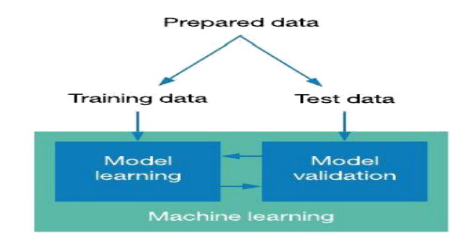

2.4 Selection of attributes

Feature selection incorporates the determination of suitable properties for the expectation framework. This is utilized to expand the proficiency of the framework. Different traits of the patient like gender, chest pain type, fasting bp, serum cholesterol, and so on are chosen for the expectation. The correlation matrix is utilized for property determination for this model.
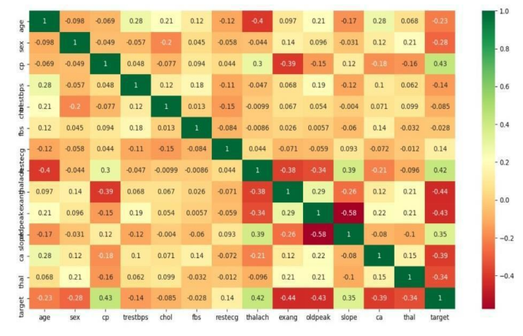

2.5 Pre-processing of data

Information pre-processing is a significant stage for the production of an AI model. At first, information may not be spotless or in the expected configuration for the model which can cause deceiving results. In the pre-processing of information, we change information into our required design. It is utilized to manage commotions, copies, and missing upsides of the dataset. Information pre-processing has the exercises like bringing in datasets, parting datasets, attributes scaling, and so forth. Pre-processing of information is expected for working on the precision of the model.
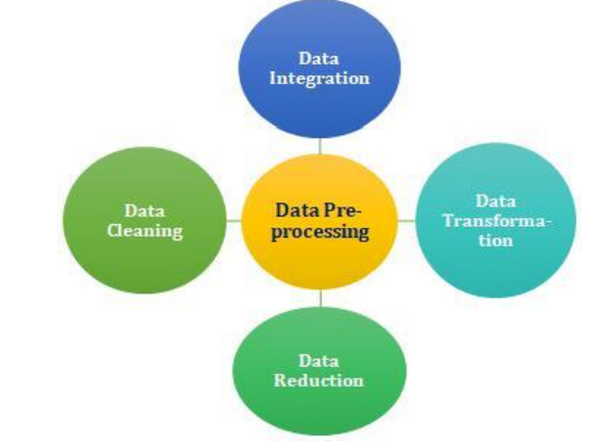
2.6 Prediction of disease

Different AI calculations like SVM, Naive Bayes, Decision Tree, Random Tree, Logistic Regression, Ada-boost, and Xg-boost are utilized for characterization. A similar investigation is performed among calculations and the calculation that gives the most noteworthy exactness is utilized for coronary illness expectation.
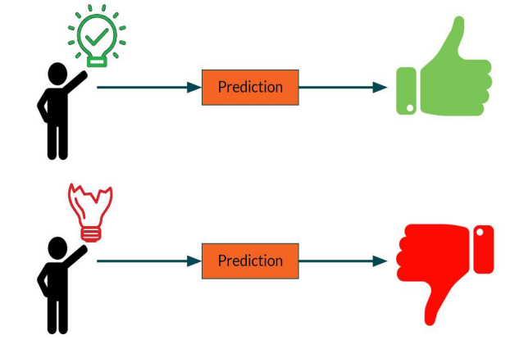

CHAPTER 3
REQUIREMENT ANALYSIS

These are the requirements for doing the project. Without using these tools and software we can’t do the project. So we have two requirements for it. They are
1. Hardware Requirements.
2. Software Requirements.

HARDWARE REQUIREMENTS

The hardware requirements might act as the reason for a contract for the execution of the framework and ought to in this manner be a finished and steady detail of the entire framework. They are involved by programmers in the beginning stage of the framework plan. It shows what the framework does and not how it ought to be carried out.
Processor : Intel® Core™ i3
Processor speed: 3.06 GHz
Ram: 2 GB
Hard Disk Drive: 250GB
Floppy Disk Drive: sony
CD-ROM Drive: sony
Monitor: 17 inches
Keyboard: TVS Gold
Mouse: Logitech

SOFTWARE REQUIREMENTS
The software requirements document is the specification of the system. It should include both a definition and a specification of requirements. It is a set of what the system should do rather than how it should do it. The software requirements provide a basis for creating the software requirements specification. It is useful in estimating the cost, planning team activities, performing tasks and tracking the team’s and tracking the team’s progress throughout the development activity.
SERVER:
Operating system: Windows
Technology Used: Python
Database : HTML,CSS
Database Connectivity: Native Connectivity
Web Server: Apache
Browser: Internet Explorer
CLIENT:
Operating system: Windows
Browser: Internet Explorer

CHAPTER 4
MACHINE LEARNING
Artificial intelligence is the capacity of a computer system framework to emulate human cognitive capabilities, for example, learning and critical thinking. Through Artificial intelligence, a PC framework utilizes math and rationale to mimic the thinking that individuals use to gain from new data and simply decide.
Machine learning is an application of AI. It's the most common way of utilizing numerical models of information to assist a PC with learning without direct guidance. This empowers a computer system framework to keep learning and enhancing its own, in light of involvement.
One method for preparing a computer system to copy human thinking is to utilize a neural network, which is a progression of calculations that are designed according to the human mind. The brain network assists the PC framework with accomplishing man-made intelligence through profound learning. This nearby association is the reason the possibility of simulated intelligence versus AI is truly about the manners in which man-made intelligence and AI cooperate.

CHAPTER 5
FUTURE ENHANCEMENT
*There are many possible improvements that could be explored to improve the scalability and accuracy of this prediction system.
*In the future we can be made to produce an impact in the accuracy of the Decision Tree and Bayesian Classification for additional improvement after applying genetic

* Algorithm in order to decrease the actual data for acquiring the optimal subset of attributes that is enough for heart disease prediction. The automation of heart disease prediction using actual real-time data from healthcare organizations and agencies can be built using big data. They can be fed as streaming data and by using the data, investigation of the patients in real-time can be prepared.

*In the future Genetic algorithm will be used in order to reduce the actual data size to get the optimal subset of attributes sufficient for heart disease prediction.

*Prediction of heart disease will be evaluated according to the result produced from it.

*Improvement is done to increase its consistency and efficiency. The benefit of using a genetic algorithm is the prediction of the heart can be done in a short time with the help of a reduced dataset.

CHAPTER 6

DESIGN

6.1 SYSTEM ARCHITECTURE
Taking into account the oddities in the current system computerization of the entire movement is being proposed after the initial examination. It could have happened so often that you or a person of your requirements specialists help right away, yet they are not accessible because of some explanation. Here, we propose a web application that permits clients to help moment direction on their coronary illness through an insightful framework on the web. The application is taken care of with different subtleties and the coronary illness related to those subtleties. The application permits clients to share their heart-related issues. It then, at that point, processes the client's data to check for the different illnesses that could be related to it. Here we utilize a few smart information mining methods to figure out the most dependable sickness that could be related to a patient's data.

Fig 1
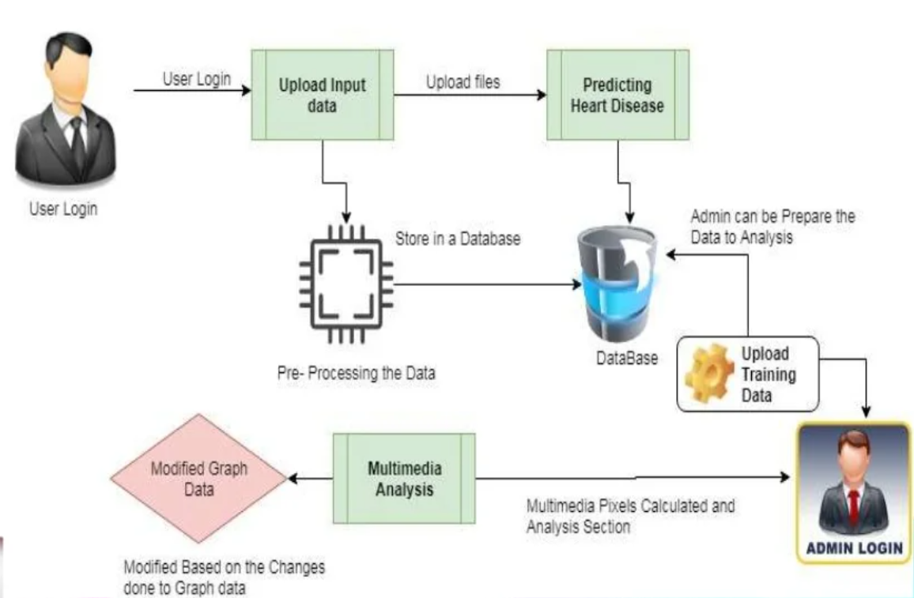

Plot graph
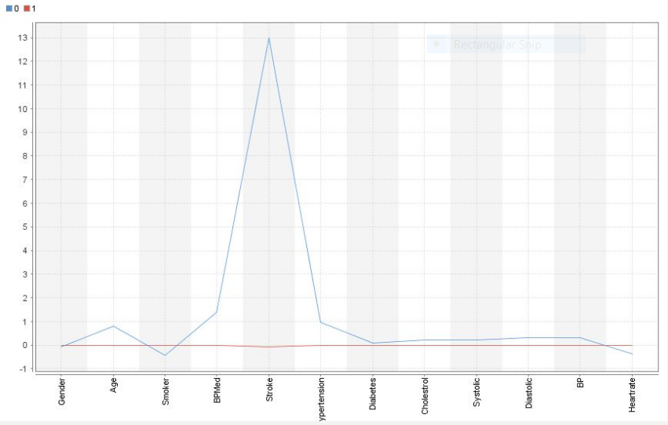
Fig 2

Data flow diagram

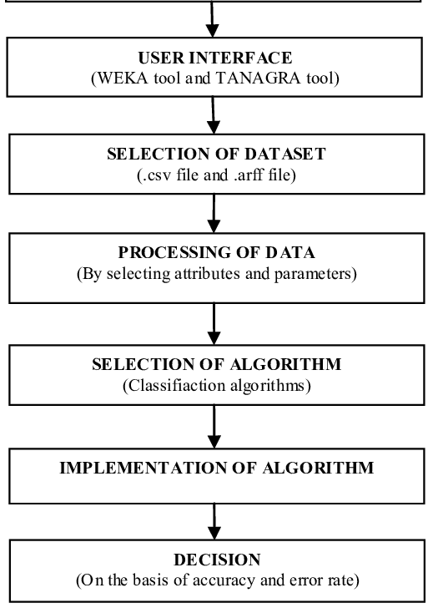
Fig 3

CHAPTER 7
IMPLEMENTATION
In probability theory, Bayes' theorem (often called Bayes' law after Thomas Bayes) relates the conditional and marginal probabilities of two random events. It is often used to compute posterior probabilities given observations. For example, a patient could also be ascertained to possess certain symptoms. Bayes' theorem is often used to compute the likelihood that a projected diagnosis is correct, as long as observation. A Naive Bayes classifier may be a term addressing a simple probabilistic classification supported by applying Bayes' theorem. In easy terms, a Naïve Bayes classifier assumes that the presence (or absence) of a specific feature of a category is unrelated to the presence (or absence) of the other feature. As an example, a fruit could also be thought of to be an apple if it's red, round, and regarding 4" in diameter. Even supposing these options rely on the existence of the opposite options, a Naive Bayes classifier considers all of those properties to independently contribute to the likelihood that this fruit is an apple. The Naïve Bayes algorithm is based on Bayesian Theorem.
Bayesian Statistics continues to remain incomprehensible in the ignited minds of many analysts. Being amazed by the incredible power of machine learning, a lot of us have become unfaithful to statistics. Our focus has narrowed down to exploring machine learning. Isn’t it true? We fail to understand that machine learning is not the only way to solve real-world problems. In several situations, it does not help us solve business problems, even though there is data involved in these problems. To say the least, knowledge of statistics will allow you to work on complex analytical problems, irrespective of the size of the data. In the 1770s, Thomas Bayes introduced the ‘Bayes Theorem’. Even centuries later, the importance of ‘Bayesian Statistics’ hasn’t faded away. In fact, today this topic is being taught in great depth in some of the world’s leading universities.

  - Frequentist Statistics
The discussion among frequentist and Bayesians have tormented novices for
hundreds of years. In this manner, it is vital to comprehend the contrast between
the two and how can there exists a meager line of outline.
It is the most generally involved inferential procedure in the factual world.
In fact, for the most part, it is the initial way of thinking that an individual going into the measurements world goes over.
Frequentist Insights tests whether an occasion (theory) happens or not. It
ascertains the likelihood of an occasion over the long haul of the trial (i.e
the investigation is rehashed under similar circumstances to get the
result).
Here, the testing appropriations of fixed size are taken. Then, the
try is hypothetically rehashed a limitless number of times however for all intents and purposes finished with a halting goal. For instance, I play out a trial with a
halting expectation as a primary concern that I will stop the examination when it is rehashed multiple times or I see at least 300 heads in a coin throw.
How about we go further at this point?
Presently, we'll comprehend frequentist measurements utilizing an illustration of a coin throw.
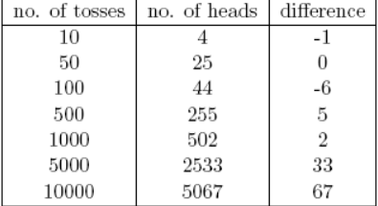
The goal is to appraise the decency of the coin. The following is a table
addressing the recurrence of heads:
We know that the likelihood of getting a head-on flipping a fair coin is 0.5. No.
of heads addresses the genuine number of heads acquired. The distinction is
the distinction between 0.5*(No. of throws) - no. of heads.
Something imperative is to take note of that, however the distinction between the genuine number of heads and anticipated number of heads( half of the number of
throws) increments as the number of throws are expanded, the extent of
a number of heads to add up to a number of throws approaches 0.5 (for a fair coin).
This trial gives us an extremely normal blemish tracked down in frequentist
approach for example Reliance on the consequence of a trial on the quantity of
times the examination is rehashed.
To find out about frequentist factual techniques, you can go to this
incredible seminar on inferential statistics.

7.2 The Inherent flaws in frequentist statistics
Till here, we've seen only one imperfection in frequentist measurements. Indeed, it's simply the starting. The twentieth century saw an enormous upsurge in the frequentist measurements being applied to mathematical models to check whether one example is unique in relation to the other, whether a boundary is sufficiently significant to be kept in the model, and various other appearances of speculation testing. However, frequentist measurements experienced a few extraordinary defects in their plan and translation which represented a serious worry in all genuine issues. For instance:
1. p-values estimated against an example (fixed size) measurement with some
halting goal changes with change in expectation and test size. i.e If
two people work on similar information and have different halting expectations,
they might get two unique p-values for similar information, which is
unwanted.
For instance: Individual A may decide to quit flipping a coin when the aggregate
count arrives at 100 while B stops at 1000. For various example sizes, we
get different t-scores and different p-values. Essentially, aim to stop may
change from a fixed number of flips to adding up to a length of flipping. For this situation as well, we will undoubtedly get different p-values.
2-Certainty Span (C.I) like p-esteem relies vigorously upon the example
size. This makes the halting likely totally ludicrous since regardless
of the number of people that play out the tests on similar information, the outcomes ought to be reliable.
3-Certainty Stretches (C.I) are not likelihood circulations subsequently they
try not to offer the most likely benefit for a boundary and the most
plausible qualities.
These three reasons are sufficient to get you rolling into contemplating the
downsides of the frequentist approach and why there is a requirement for a
Bayesian methodology. We should think that it is out.
From here, we'll initially figure out the basics of Bayesian statistics.

7.3 Bayesian statistics
"Bayesian statistics is a numerical strategy that applies probabilities
to statistical issues. It gives individuals the devices to refresh their convictions in
the proof of new information."
That's what you got? Allow me to make sense of it with a model:
Assume, out of the multitude of 4 title races (F1) between Niki Lauda and
James chase, Niki won multiple times while James oversaw just 1.
In this way, if you somehow managed to wager on the victor of the following race, who might he be?
I bet you would agree that Niki Lauda.
Here is the contort. Imagine a scenario where you are informed that it down-poured once when James won
what's more, once when Niki won and it is distinct that it will rain on the following date.
Thus, who might you bet your cash on now?
By instinct, it is not difficult to see that the possibilities of winning for James have
expanded definitely. Yet, the inquiry is: how much?
To comprehend the front and center concern, we really want to get comfortable with some ideas first is the contingent likelihood (made sense of underneath).
Furthermore, there are sure essentials:
Pre-Requisites:
1. Linear Algebra
2. Probability and Basic Statistics
CONDITIONAL PROBABILITY

It is characterized as the: Likelihood of an occasion A given B rises to the likelihood of B and An event together isolated by the likelihood of B."
For instance: Expect two to some degree converging sets An and B as displayed
underneath.
Set An addresses one bunch of occasions and Set B addresses another. We wish to work out the likelihood of A given B has proactively occurred. Let's
address the occurrence of occasion B by concealing it with red.
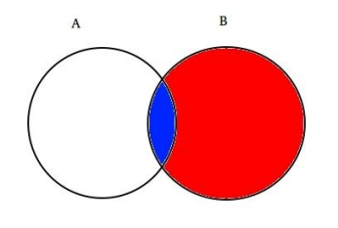
Now since B has happened, the part which now matters for A is the part shaded in blue which is interestingly . So, the probability of A given B turns out to be:
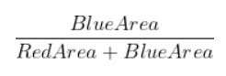

Therefore, we can write the formula for event B given A has already occurred by:
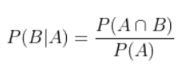
Now, the second equation can be rewritten as:
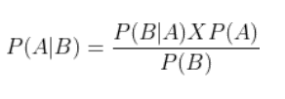
This is known as Conditional Probability.
We should attempt to answer another issue with this procedure.
Assume, B is the occasion of winning James Chase. A be the occasion of
coming down. In this manner,
1. P(A) =1/2, since it came down two times out of four days.
2. P(B) is 1/4 since James came out on top in just a single race out of four.
3. P(A|B)=1, since it came down each time when James won.
Subbing the qualities in the restrictive likelihood recipe, we get the
likelihood to be around half, which is practically double of 25% when the downpour was not considered (Settle it at your end).
This further fortified our conviction of James winning in the illumination of new
proof i.e downpour. You should be pondering that this equation bears a close likeness to something you could have heard a great deal about. Think!
Likely, you got it right. It seems to be Bayes Hypothesis.
Bayes hypothesis is based on top of restrictive likelihood and lies at the heart
of Bayesian Surmising.

Bayes Hypothesis

Bayes Hypothesis happens when various occasions structure a
comprehensive set with another occasion B. This could be perceived with the
help of the below diagram.
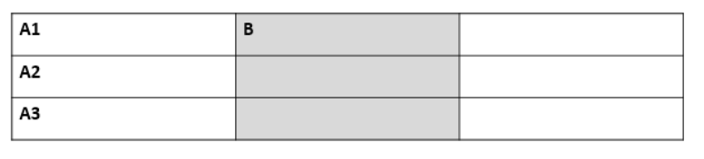
Now, B can be written as
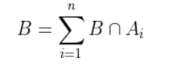
So, probability of B can be written as,
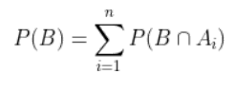
But, 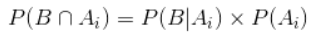
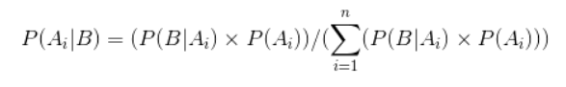
This is the equation for Bayes Theorem.

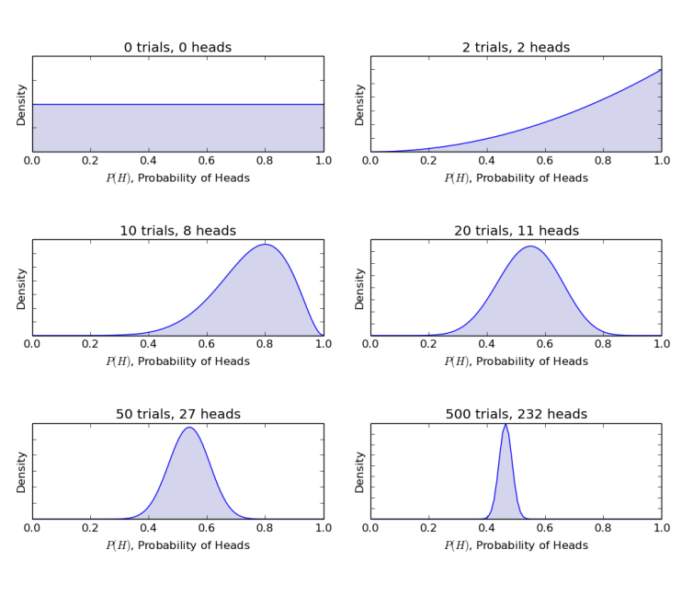
Fig 4

CHAPTER 8
KNN (K-Nearest Neighbour)
K-Nearest Neighbor is one of the easiest AI calculations in light of the Directed Learning method.
K-NN calculation expects the likeness between the new case/information and accessible cases and put the new case into the class that is generally like the accessible classifications.
K-NN calculation stores every one of the accessible information and groups another information point in light of the closeness. This implies when new information shows up then it tends to be effortlessly ordered into a good suite classification by utilizing K-NN calculation.
K-NN calculation can be utilized for Relapse as well with respect to Arrangement yet generally, it is utilized for Order issues.
K-NN is a non-parametric calculation, and that implies it makes no presumption on basic information.
It is likewise called a lazy student calculation since it doesn't gain from the preparation set promptly rather it stores the dataset and at the hour of grouping, it plays out an activity on the dataset.
KNN calculation at the preparation stage simply stores the dataset and when it gets new information, then, at that point, it groups that information into a classification that is much like the new information.

Model: Assume, we have a picture of an animal that seems to be like a feline and canine, yet we need to know possibly it is a feline or canine. So for this distinguishing proof, we can utilize the KNN calculation, as it deals with a closeness measure. Our KNN model will find the comparative highlights of the new informational collection to the felines and canine pictures and in view of the most comparative elements it will place it in one or the other feline or canine class.

How does KNN work?
The K-NN working can be made sense of based on the underneath calculation:
Step-1: Select the number K of the neighbors
Step-2: Compute the Euclidean distance of K number of neighbors
Step-3: Take the K nearest neighbors according to the determined Euclidean distance.
Step-4: Among these k neighbors, count the quantity of the data of interest in every class.
Step-5: Dole out the new information focusing on that class for which the quantity of the neighbor is most extreme.
Step-6: Our model is prepared.
Assume we have another data of interest and we really want to place it in the necessary class. Consider the underneath picture:
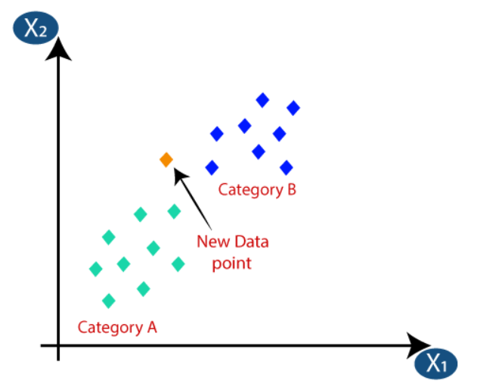
The Euclidean distance is the distance between two focuses, which we have previously concentrated on in math. It very well may be determined as:
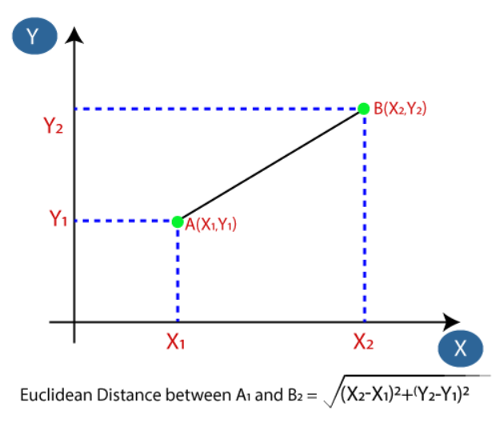
By working out the Euclidean distance we got the nearest neighbors, as three nearest neighbors in classification A and two nearest neighbors in classification B.
Consider the beneath picture:
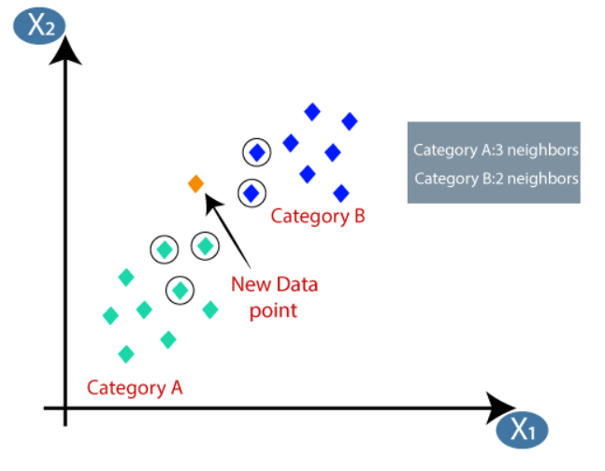
As we can see the 3 nearest neighbors are from class A, subsequently this new information point should have a place with class A.

Implementation of KNN in Python
- Importing modules
- Creating dataset
- Visualize the dataset
- Splitting data into training and testing datasets
- KNN classifier implementation
- Prediction for KNN classifiers
- Predict accuracy for both k values
- Visualize predictions

CHAPTER 9
SOFTWARE ENVIRONMENT

9.1 The python programming language

Python is an interpreted, object-arranged, significant-level programming language with dynamic semantics. Its undeniable level of underlying information structures joined with dynamic composing and dynamic restricting, make it extremely alluring for Quick Application Improvement, as well concerning use as a prearranging or stick language to interface existing parts together. Python's basic, simple-to-learn language structure stresses coherence and hence diminishes the expense of program support. Python upholds modules and bundles, which support program particularity and code reuse. The Python mediator and the broad standard library are accessible in source or parallel structure without charge for every single significant stage and can be uninhibitedly circulated.

Frequently, software engineers fall head over heels for Python due to the expanded efficiency it gives. Since there is no arrangement step, the alter test-troubleshoot cycle is inconceivably quick. Troubleshooting Python programs is simple: a bug or terrible information won't ever cause a division shortcoming. All things being equal, when the translator finds a mistake, it raises an exemption. At the point when the program doesn't get the special case, the translator prints a stack following. A source-level debugger permits investigation of nearby and worldwide factors, assessment of erratic articulations, setting breakpoints, and venturing through the code a line at once, on. The debugger is written in Python itself, vouching for Python's thoughtful power. Then again, frequently the speediest method for troubleshooting a program is to add a couple of print explanations to the source: the quick alter test-investigate cycle simplifies this approach extremely powerfully.

9.2 Where is Python used?

Python is a universally useful, well known programming language and it is utilized in pretty much every specialized field.
The different areas of Python use are given beneath:
- Data science
- Machine learnung
- Data mining
- Desktop applications
- Console-based applications
- Mobile applications
- Software development
- AI
- Web applications
- Speech recognition
- 3D CAD applications
- Computer vision or image processing applications.

9.3 Python libraries (NumPy and Pandas)

- Pandas
Pandas is an exceptionally well-known library for working with information (it will probably be the most impressive and adaptable open-source device, and as we would see it, it has arrived at that objective). DataFrames are at the focal point of pandas. A data frame is organized like a table or bookkeeping sheet. The lines and the sections both have records, and you can perform procedures on lines or segments independently.

A pandas data frame can be effectively different and controlled. Pandas have supportive capabilities for dealing with missing information, performing procedures on sections and columns, and changing information. On the off chance that that wasn't sufficient, a ton of SQL capabilities have partners in pandas, like join, combine, channel by, and bunch by. With these incredible assets, it ought to shock no one that pandas are exceptionally well-known among information researchers.
- NumPy
NumPy is an open-source Python library that works with productive mathematical procedures on enormous amounts of information. There are a couple of capabilities that exist in NumPy that we use on pandas DataFrames. For our purposes, the main part about NumPy is that pandas are based on top of it. Thus, NumPy is reliant on Pandas.

CHAPTER 10
Visual studio code software

Visual Studio Code, likewise regularly alluded to as VS Code, is a source-code proofreader made by Microsoft with the Electron Structure, for Windows, Linux, and macOS. Highlights incorporate help for troubleshooting, grammar featuring, wise code culmination, scraps, code refactoring, and inserted Git. Clients can change the subject, console easy routes, and inclinations, and introduce expansions that add extra usefulness.

In the Stack Overflow 2021 Designer Overview, Visual Studio Code has positioned as the most well-known engineer climate device among 82,000 respondents, with 70% detailing that they use it.

Features of VS code
Visual Studio Code is a source-code manager that can be utilized with an assortment of programming dialects, including C, C#, C++, Fortran, Go, Java, JavaScript, Node.js, Python, Rust. It depends on the Electron framework, which is utilized to foster Node.js web applications that sudden spike in demand for the Flicker design motor. Visual Studio Code utilizes a similar supervisor part (codenamed "Monaco") utilized in Purplish blue DevOps (previously called Visual Studio On the web and Visual Studio Group Administrations).

Out of the crate, Visual Studio Code incorporates essential help for most normal programming dialects. This fundamental help incorporates grammar featuring, section coordinating, code collapsing, and configurable bits. Visual Studio Code likewise sends with IntelliSense for JavaScript, TypeScript, JSON, CSS, and HTML, as well as troubleshooting support for Node.js. Support for extra dialects can be given by uninhibitedly accessible augmentations on the Versus Code Commercial center.
Studio Code highlights are not uncovered through menus or the UI but rather can be gotten to by means of the order range.

Visual Studio Code can be broadened by means of expansions, accessible through a focal store. This incorporates increases to the manager and language support. A striking component is a capacity to make expansions that add support for new dialects, subjects, debuggers, time travel debuggers, perform static code examination, and add code linters utilizing the Language Server Convention.

Source control is an underlying element of Visual Studio Code. It has a committed tab within the menu bar where clients can get to form control settings and view changes made to the ongoing venture. To utilize the component, Visual Studio Code should be connected to any upheld adaptation control framework (Git, Apache Disruption, Perforce, and so forth.). This permits clients to make storehouses as well as to make move around demands straightforwardly from the Visual Studio Code program.

Visual Studio Code incorporates different expansions for FTP, permitting the product to be utilized as a free option for web improvement. Code can be matched up between the supervisor and the server, without downloading any additional product.

Visual Studio Code permits clients to set the code page in which the dynamic report is saved, the newline character, and the programming language of the dynamic archive. This permits it to be utilized at any stage, in any region, and for some random programming language.[promotional language]

Visual Studio Code gathers utilization information and sends it to Microsoft, albeit this can be impaired. Because of the open-source nature of the application, the telemetry code is available to the general society, who can see the precisely exact thing that is gathered.

CHAPTER 11
Dataset Explanation
The dataset comprises 303 people’s information. There are 14 sections in the dataset, which are portrayed beneath.

Age: shows the age of the person.
Sex: shows the gender of the person using the arrangement :
1 = male
0 = female
Chest-pain type: shows the sort of chest pain experienced by the person utilizing the arrangement :
1 = commonplace angina
2 = abnormal angina
3 = non—anginal agony
4 = asymptotic
Resting blood pressure: shows the resting BP of a person in mmHg (unit)
Serum Cholesterol: shows the serum cholesterol in mg/dl (unit)
Fasting Glucose: looks at the fasting glucose worth of a person with 120mg/dl.
In the event that fasting glucose > 120mg/dl: 1 (valid)
else : 0 (bogus)
Resting ECG: shows resting electrocardiographic outcomes
0 = typical
1 = having ST-T wave irregularity
2 = left ventricular hypertrophy
Max heart rate accomplished: shows the maximum pulse accomplished by a person.
exercised-initiated angina :
1 = yes
0 = no
ST depression incited by practice comparative with rest: shows the worth which is a number or floats.
Top activity ST portion :
1 = upsloping
2 = flat
3 = downsloping
A number of significant vessels (0-3) shaded by fluoroscopy: shows the worth as number or float.
Thal: shows thalassemia :
3 = normal
6 = fixed defect
7 = reversible defect
Analysis of Heart disease: Showcases regardless of whether the individual is experiencing Heart disease :
0 = absent
1, 2, 3, 4 = present.

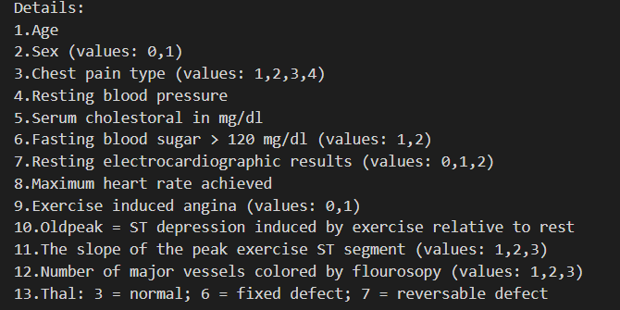

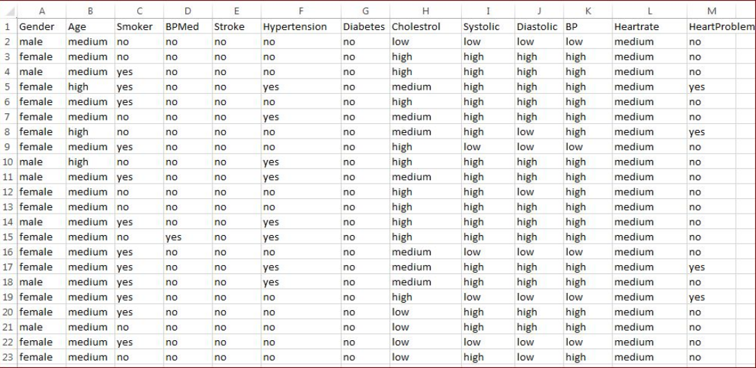

Fig 5

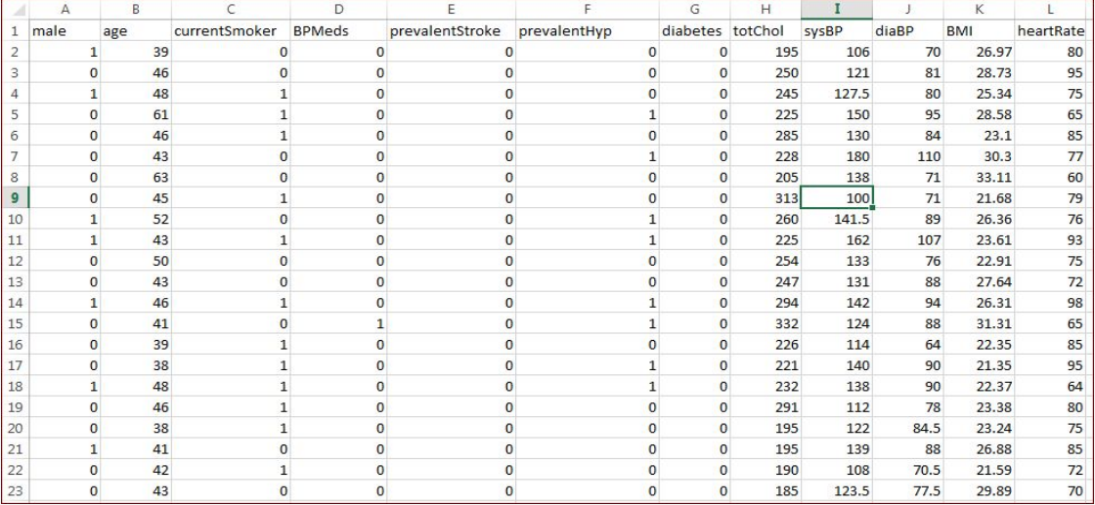

Fig 6

CHAPTER 12
PERFORMANCE ANALYSIS
In this project, different AI calculations like SVM, Naive Bayes, Decision tree, Random forest, Logistic regression, Ada-boost, and XG-boost are utilized to foresee coronary illness. The coronary illness UCI dataset, has a sum of 76 characteristics, out of those as it were 14 credits are considered for the expectation of coronary illness. Different traits of the patient like orientation, chest torment type, fasting pulse, serum cholesterol, and so on are considered for this venture. The precision for individual calculations needs to
measure and whichever calculation is giving the best accuracy, is considered for the coronary illness expectation. For assessing the analysis, different assessment measurements like
exactness, disarray network, accuracy, review, and f1-score are thought of. Precision Exactness is the proportion of the number of right expectations to the aggregate number of contributions to the dataset. It is communicated as:
Accuracy = (TP + TN)/(TP+FP+FN+TN)
Confusion matrix- It gives us a matrix as result and gives the all-out presentation of the framework.
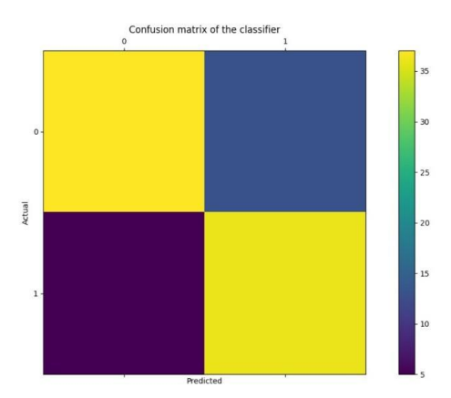
CHAPTER 13
CODING
# -*- coding: utf-8 -*-

try:
#importing the libraries
import warnings
import pickle
import pandas as pd
import numpy as np
from sklearn.preprocessing import OneHotEncoder
from sklearn.compose import ColumnTransformer
from sklearn.model_selection import train_test_split, cross_val_score, RandomizedSearchCV, GridSearchCV
from sklearn.ensemble import RandomForestClassifier
from sklearn.linear_model import LogisticRegression
from sklearn.neighbors import KNeighborsClassifier
from sklearn.metrics import accuracy_score, confusion_matrix, precision_score, recall_score
warnings.filterwarnings('ignore')

except Exception as e:
print("Unable to import the libraries",e)

#==============================Data Preprocessing================================
#loading the dataset
dataset=pd.read_csv('heart_data.csv', sep='\t' )

#to check the diferrent unique values in the dataset
for index in dataset.columns:
print(index,dataset[index].unique())
print(dataset.dtypes)
print('The number of missing dataset:', dataset.isnull().sum().sum())

#splitting the dataset to independent and dependent sets
dataset_X=dataset.iloc[:, 0:13].values
dataset_Y=dataset.iloc[:, 13:14].values

#columns to be encoded: cp(2), restecg(6), slope(10), ca(11), thal(12)
ct=ColumnTransformer([('encoder', OneHotEncoder(drop='first'), [2,6,10,11,12])], remainder='passthrough')
dataset_X = ct.fit_transform(dataset_X)

#splitting data to training set and test set
X_train, X_test, Y_train, Y_test =train_test_split(dataset_X, dataset_Y, test_size=0.3 , random_state=0)

#==============================Evaluation=======================================
#scores

def scores(pred,test,model):
print(('\n==========Scores for {} ==========\n').format(model))
print(f"Accuracy Score : {accuracy_score(pred,test) * 100:.2f}% " )
print(f"Precision Score : {precision_score(pred,test) * 100:.2f}% ")
print(f"Recall Score : {recall_score(pred,test) * 100:.2f}% " )
print("Confusion Matrix :\n" ,confusion_matrix(pred,test))

#====================================LR_Tunned==========================================
#logistic regression

lr = LogisticRegression()
solvers = ['newton-cg', 'lbfgs', 'liblinear']
penalty = ['l2']
c_values = [100, 10, 1.0, 0.1, 0.01]

# define grid search
grid_lr ={"solver":solvers,
"penalty":penalty,
"C":c_values}

grid_search_lr = GridSearchCV(estimator=lr, param_grid=grid_lr, n_jobs=-1, cv=10, scoring='accuracy',error_score=0)

#getting the best parameters
grid_result_lr = grid_search_lr.fit(X_train,Y_train)
best_grid_lr =grid_result_lr.best_estimator_
best_grid_lr.fit(X_train, Y_train)
Y_pred_knn_t =best_grid_lr.predict(X_test)
scores(Y_pred_knn_t,Y_test,'KNeighbors_Classifier_Tunned')

#===================================KNN==========================================
#K Nearest Neighbour

#tunning the k value
accuracy=[]
for index in range(1,20):
knn = KNeighborsClassifier(n_neighbors=index)
score=cross_val_score(knn,X_train, Y_train,cv=10)
accuracy.append(score.mean())

best_k=accuracy.index(max(accuracy))

#fitting the model with best k value
knn = KNeighborsClassifier(n_neighbors = best_k)
knn.fit(X_train, Y_train)
Y_pred_knn=knn.predict(X_test)
scores(Y_pred_knn,Y_test,'KNeighbors_Classifier')

#===================================KNN_Tunned====================================
#K Nearest Neighbour with Hyper parameter

knn_t = KNeighborsClassifier()
n_neighbors = range(1,20)
weights = ['uniform', 'distance']
metric = ['euclidean', 'manhattan', 'minkowski']

# define grid search
grid = {'n_neighbors' : n_neighbors,
'weights' : weights,
'metric' : metric}

grid_search_knn = GridSearchCV(estimator=knn_t, param_grid=grid, n_jobs=-1, cv=10 ,scoring='accuracy',error_score=0)

#getting the best parameters
grid_result_knn = grid_search_knn.fit(X_train,Y_train)
best_grid_knn =grid_result_knn.best_estimator_
best_grid_knn.fit(X_train, Y_train)
Y_pred_knn_t =best_grid_knn.predict(X_test)
scores(Y_pred_knn_t,Y_test,'KNeighbors_Classifier_Tunned')

#====================================RF==========================================
#Random Forest

n_estimators = [int(x) for x in np.linspace(start =10, stop = 200, num = 10)]
max_features = ['auto', 'sqrt','log2']
max_depth = [int(x) for x in np.linspace(10, 1000,10)]
min_samples_split = [2, 5, 10,14,None]
min_samples_leaf = [1, 2, 4,6,8,None]

random_grid = {'n_estimators' : n_estimators,
'max_features' : max_features,
'max_depth' : max_depth,
'min_samples_split' : min_samples_split,
'min_samples_leaf' : min_samples_leaf}

rf=RandomForestClassifier()

randomcv=RandomizedSearchCV(estimator=rf,param_distributions=random_grid,n_iter=300,cv=10,
random_state=100,n_jobs=-1)
#getting the best parameters
randomcv.fit(X_train,Y_train)
best_grid=randomcv.best_estimator_
best_grid.fit(X_train,Y_train)
pred_2=best_grid.predict(X_test)
scores(pred_2,Y_test,'RandomForestClassifier')

#=============================Saving the models==================================
#saving model to disk

pickle.dump(best_grid_lr, open('ml_model.pkl', 'wb'))
pickle.dump(ct, open('encoder.pkl', 'wb'))

#==============================Testing model response============================
#test the pickle file

def test_model(row_number):
model=pickle.load(open('ml_model.pkl', 'rb'))
value,real=dataset_X[row_number,:].reshape(1,-1),dataset_Y[row_number,:]
print(("\n The value predicted is : {} and the real value is : {} ").format(model.predict(value), real))

test_model(102)
print('\nCompleted')

13.1 EXECUTION CODE (flask_app.py)

# -*- coding: utf-8 -*-

try:
#importing the libraries
import warnings
import pickle
import pandas as pd
import numpy as np
from sklearn.preprocessing import OneHotEncoder
from sklearn.compose import ColumnTransformer
from sklearn.model_selection import train_test_split, cross_val_score, RandomizedSearchCV, GridSearchCV
from sklearn.ensemble import RandomForestClassifier
from sklearn.linear_model import LogisticRegression
from sklearn.neighbors import KNeighborsClassifier
from sklearn.metrics import accuracy_score, confusion_matrix, precision_score, recall_score
warnings.filterwarnings('ignore')

except Exception as e:
print("Unable to import the libraries",e)

#==============================Data Preprocessing================================
#loading the dataset
dataset=pd.read_csv('heart_data.csv', sep='\t' )

#to check the diferrent unique values in the dataset
for index in dataset.columns:
print(index,dataset[index].unique())
print(dataset.dtypes)
print('The number of missing dataset:', dataset.isnull().sum().sum())

#splitting the dataset to independent and dependent sets
dataset_X=dataset.iloc[:, 0:13].values
dataset_Y=dataset.iloc[:, 13:14].values

#columns to be encoded: cp(2), restecg(6), slope(10), ca(11), thal(12)
ct=ColumnTransformer([('encoder', OneHotEncoder(drop='first'), [2,6,10,11,12])], remainder='passthrough')
dataset_X = ct.fit_transform(dataset_X)

#splitting data to training set and test set
X_train, X_test, Y_train, Y_test =train_test_split(dataset_X, dataset_Y, test_size=0.3 , random_state=0)

#==============================Evaluation=======================================
#scores

def scores(pred,test,model):
print(('\n==========Scores for {} ==========\n').format(model))
print(f"Accuracy Score : {accuracy_score(pred,test) * 100:.2f}% " )
print(f"Precision Score : {precision_score(pred,test) * 100:.2f}% ")
print(f"Recall Score : {recall_score(pred,test) * 100:.2f}% " )
print("Confusion Matrix :\n" ,confusion_matrix(pred,test))

#====================================LR_Tunned==========================================
#logistic regression

lr = LogisticRegression()
solvers = ['newton-cg', 'lbfgs', 'liblinear']
penalty = ['l2']
c_values = [100, 10, 1.0, 0.1, 0.01]

# define grid search
grid_lr ={"solver":solvers,
"penalty":penalty,
"C":c_values}

grid_search_lr = GridSearchCV(estimator=lr, param_grid=grid_lr, n_jobs=-1, cv=10, scoring='accuracy',error_score=0)

#getting the best parameters
grid_result_lr = grid_search_lr.fit(X_train,Y_train)
best_grid_lr =grid_result_lr.best_estimator_
best_grid_lr.fit(X_train, Y_train)
Y_pred_knn_t =best_grid_lr.predict(X_test)
scores(Y_pred_knn_t,Y_test,'KNeighbors_Classifier_Tunned')

#===================================KNN==========================================
#K Nearest Neighbour

#tunning the k value
accuracy=[]
for index in range(1,20):
knn = KNeighborsClassifier(n_neighbors=index)
score=cross_val_score(knn,X_train, Y_train,cv=10)
accuracy.append(score.mean())

best_k=accuracy.index(max(accuracy))

#fitting the model with best k value
knn = KNeighborsClassifier(n_neighbors = best_k)
knn.fit(X_train, Y_train)
Y_pred_knn=knn.predict(X_test)
scores(Y_pred_knn,Y_test,'KNeighbors_Classifier')

#===================================KNN_Tunned====================================
#K Nearest Neighbour with Hyper parameter

knn_t = KNeighborsClassifier()
n_neighbors = range(1,20)
weights = ['uniform', 'distance']
metric = ['euclidean', 'manhattan', 'minkowski']

# define grid search
grid = {'n_neighbors' : n_neighbors,
'weights' : weights,
'metric' : metric}

grid_search_knn = GridSearchCV(estimator=knn_t, param_grid=grid, n_jobs=-1, cv=10 ,scoring='accuracy',error_score=0)

#getting the best parameters
grid_result_knn = grid_search_knn.fit(X_train,Y_train)
best_grid_knn =grid_result_knn.best_estimator_
best_grid_knn.fit(X_train, Y_train)
Y_pred_knn_t =best_grid_knn.predict(X_test)
scores(Y_pred_knn_t,Y_test,'KNeighbors_Classifier_Tunned')

#====================================RF==========================================
#Random Forest

n_estimators = [int(x) for x in np.linspace(start =10, stop = 200, num = 10)]
max_features = ['auto', 'sqrt','log2']
max_depth = [int(x) for x in np.linspace(10, 1000,10)]
min_samples_split = [2, 5, 10,14,None]
min_samples_leaf = [1, 2, 4,6,8,None]

random_grid = {'n_estimators' : n_estimators,
'max_features' : max_features,
'max_depth' : max_depth,
'min_samples_split' : min_samples_split,
'min_samples_leaf' : min_samples_leaf}

rf=RandomForestClassifier()

randomcv=RandomizedSearchCV(estimator=rf,param_distributions=random_grid,n_iter=300,cv=10,
random_state=100,n_jobs=-1)
#getting the best parameters
randomcv.fit(X_train,Y_train)
best_grid=randomcv.best_estimator_
best_grid.fit(X_train,Y_train)
pred_2=best_grid.predict(X_test)
scores(pred_2,Y_test,'RandomForestClassifier')

#=============================Saving the models==================================
#saving model to disk

pickle.dump(best_grid_lr, open('ml_model.pkl', 'wb'))
pickle.dump(ct, open('encoder.pkl', 'wb'))

#==============================Testing model response============================
#test the pickle file

def test_model(row_number):
model=pickle.load(open('ml_model.pkl', 'rb'))
value,real=dataset_X[row_number,:].reshape(1,-1),dataset_Y[row_number,:]
print(("\n The value predicted is : {} and the real value is : {} ").format(model.predict(value), real))

test_model(102)
print('\nCompleted')

CHAPTER 14
OUTPUT
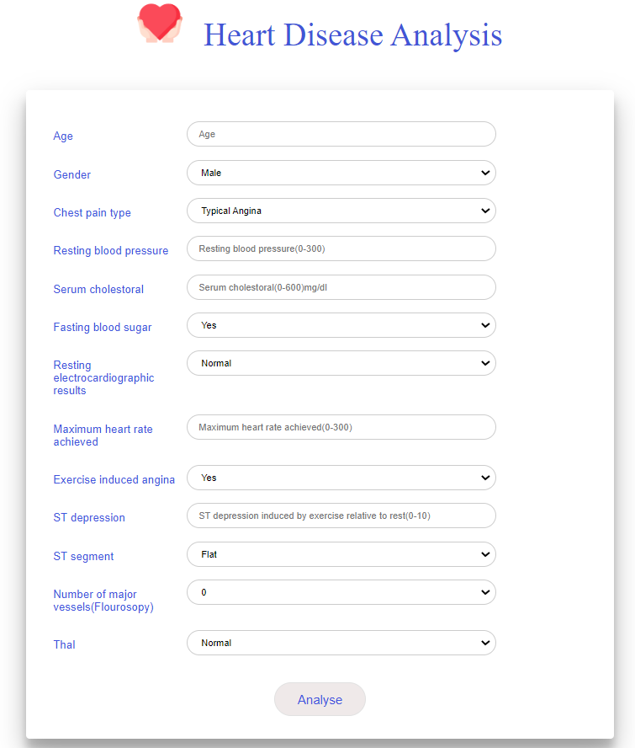
Fig 7

After entering the input:
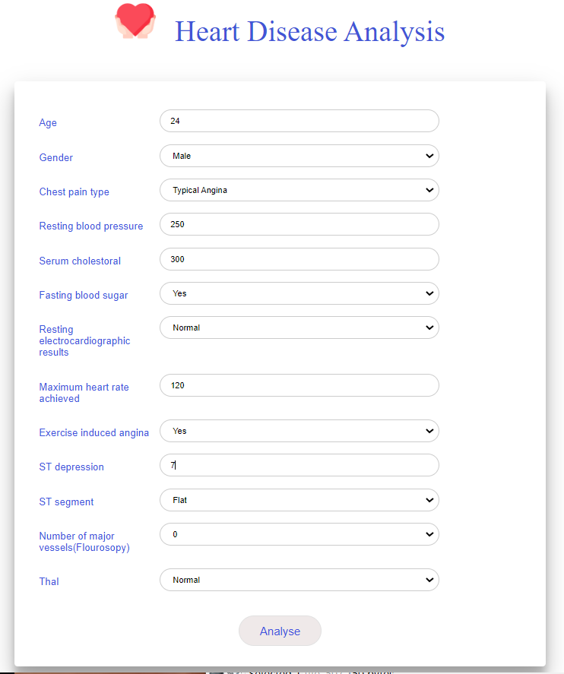

Fig 8

If the data entered aligns with the patient not having a cardiac illness, then output will be:
Fig 9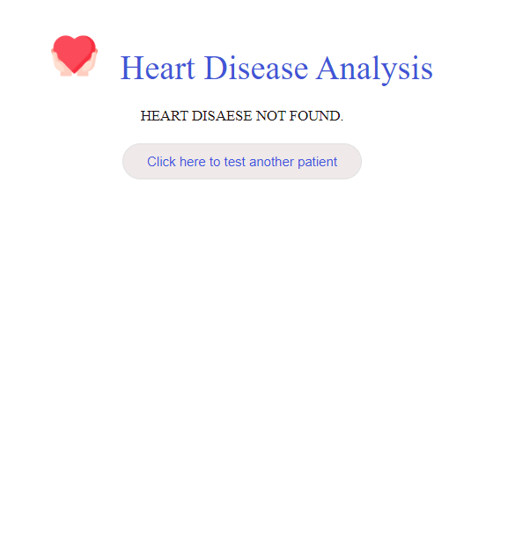

Trying for another patient

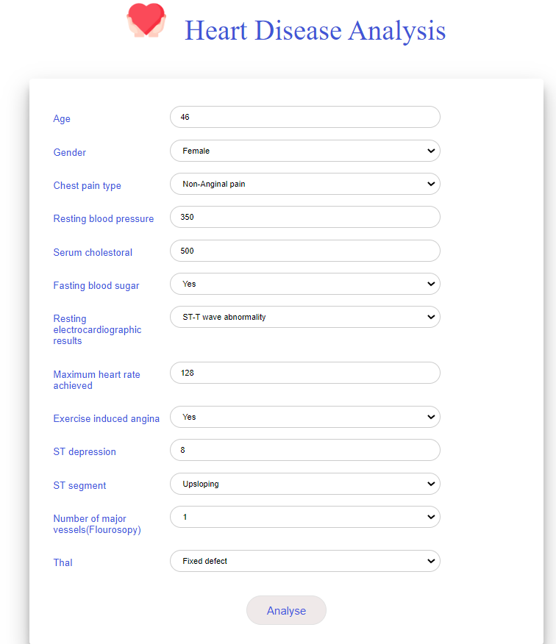

Fig 10

If the data entered matches the characteristics of the presence of cardiac illness, then output will be:
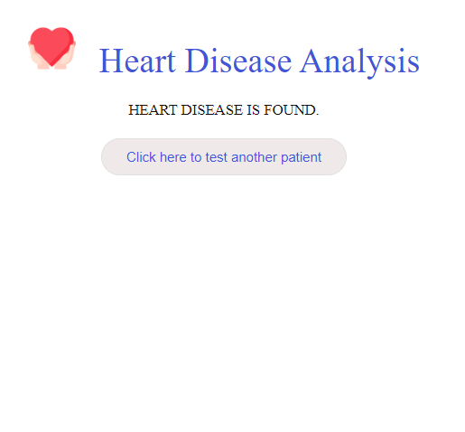
Fig 11

CHAPTER 15
CONCLUSION

Coronary illness expectation, for the most part seen as a central load in clinical work environments, clinical consideration workplaces, and healthcare centers, can be completely computerized through an inefficient electronic programming program. The benefits of doing this advancement contact everyone drew in with the booking framework, as administrators and clients can lead their tasks even more capably and definitively. The system removes disguised data from an unquestionable coronary sickness informational collection. This system can be furthermore redesigned and stretched out for some more ailment assumptions. Coronary ailment assumptions can be extended and expanded. For instance, it can incorporate different clinical properties other than the recorded. It could similarly coordinate different data taking care of techniques, e.g., time series, bundling, and alliance Rules. Consistent information may in like manner be used rather than fundamentally straight-out information.

Computer based intelligence based game plans are for the most part used in the clinical consideration region for separating patients' data, expecting ailments, and proposing possible treatments. With different artificial intelligence strategies open today, it is fundamental to perceive the most capable and accurate method, especially in essential regions like clinical consideration. A close to assessment of the different computer based intelligence estimations used in the coronary sickness assumption is presented. KNN and Naïve Bayes are inspected and appeared differently in relation to perceiving the most fitting classifier for coronary ailment assumption. Various past investigates and thinks associated with coronary ailment assumptions were perceived and explored. disclosures show that a large part of the time simulated intelligence based approaches have shown tremendous potential to change the clinical consideration region and work in general course of disorder figures and proposing treatments.

CHAPTER 16

REFERENCES

[1] Blake, C.L.,: "UCL Machine Learning Databases",

http://mlearn.ics.uci.edu/databases/heartdisease/, 2004.

[2] Chapman,P., Clinton, J., Kerber, R. Khabeza, T., Reinartz, T., Shearer, C., Wirth, R.: "CRISP-DM 1.0: Step by step data mining guide"' SPSS, 1-78,2000.

[3] Sellappan Palaniappan, Rafiah Awang, Intelligent Heart Disease Prediction system Using Data Mining Techniques, 978-1-4244-19685/08/$25.00 ©2008 IEEE.

[4] Han, J., Kamber, M.: “Data Mining Concepts and Techniques”, Morgan Kaufmann Publishers, 2006.

[5] Ho, T.J.: "Data Mining and Data Warehousing", Prentice Hall, 2005.

[6] Sellappan, P., Chua,S.L.: "Model-based Healthcare Decision Support System", Proc. Of Int. Conf. on Information Technology in Asia CITA'05, 45-50, Kuching, Sarawak, Malaysia,2005

[7] Tang, Z.H., MacLennan, J.: "Data Mining With Sql Server 2005"' Indianapolis: Wiley,2005.

[8] Shantakumar B.Patil, Y.S.Kumaraswamy, Intelligent and Effective Heart Attack Prediction System Using Data Mining and Artificial Neural Network, European Journal of Scientific Research ISSN 1450-216X

Vol.31 No.4 (2009), pp.642- 656 © EuroJournals Publishing, Inc. 2009.

[9] Wu, R., Peters, W., Morgan, M.W.: “The Next Generation Clinical

Decision Support: Linking Evidence to Best Practice”, Journal

Healthcare Information Management. 16(4), 50-55, 2002.

[10] Kaur, H., Wasan, S. K.: “Empirical Study on Applications of Data Mining Techniques in Healthcare”, Journal of Computer Science 2(2), 194-200, 2006.

