**Cybercrime Techniques using Data Mining**

J. Kirthivikram1, Mr. Sathyasrinivas2, Dr. S. Geetha3, Mrs. Sarika jain4

1M.Sc-CFIS, Department of Computer Science and Engineering, Dr. M.G.R Educational and Research Institute, Chennai 600 095, Tamilnadu, India

2Department of Computer Science and Engineering, Dr. M.G.R Educational and Research Institute, Chennai 600 095, Tamilnadu, India

3Head of the Department, Department of Computer Science and Engineering, Dr. M.G.R Educational and Research Institute, Chennai 600 095, Tamilnadu, India

4Department of Computer Science and Engineering, Dr. M.G.R Educational and Research Institute, Chennai 600 095, Tamilnadu, India

**Abstract**

The increase in crime data recording coupled with data analytics resulted in the growth of research approaches aimed at extracting knowledge from crime records to better understand criminal behaviour and ultimately prevent future crimes. While many of these approaches make use of clustering and association rule mining techniques, there are fewer approaches focusing on predictive models of crime. In this paper we explore models for predicting the frequency of several types of crimes prediction by LSOA code (Lower layer super output areas an administrative system of area for public) and the frequency of anti-social behaviour crimes. The crime face image and video data are from the police and contain over records before preprocessing. The results looking at predictive performance as well as processing time indicate that decision trees can be used to reliably predict image and video crime frequency in general, as well as anti-social behaviour frequency.

1. Introduction

Over the years, plenty of security approaches are developed that facilitate keep confidential information secured and limiting the probabilities of a security breach. Face recognition that is one among the few biometric ways that possess the deserves of each high accuracy and low aggressiveness maybe a computer virus that uses a person’s face to mechanically establish and verify the person from a digital image or a video frame from a video source. It compares designated face expression from the image and a face information or it can even be a hardware that accustomed attest someone. This technology may be a wide used biometry system for authentication, authorization, verification and identification. plenty of company has been victimisation face recognition in their security cameras, access controls and lots of a lot of. Facebook has been victimisation face recognition in their web site for the aim of making a digital profile for the folks victimization their web site. In developed countries, the enforcement produces face information to be used with their face recognition system to check any suspect with the information. In alternative hand, in Bharat most cases ar investigated by victimisation fingerprint identification to spot any suspect for the case. However, due to unlimited information through web usage, most criminals are awake to fingerprint identification. Therefore, they become a lot of cautious of deed fingerprint by carrying gloves apart from non-premeditated crimes.

1. Literature Survey

TITLE: Segmentation of Indoor Mapping Point Clouds Applied to Crime Scenes Reconstruction AUTHOR: Sandra Zancajo-Blázquez, Susana Lagüela-López, Diego González Aguilera, and Joaquín Martínez-Sánchez ABSTRACT: Data acquisition in forensics science must be performed in a fast and an efficient way, so that the data acquired is maximized at the same time that disturbance and time on the scene are minimized. For this reason, the use of indoor mapping systems appears as a key solution, in contrast with static systems, either laser or photogrammetry based, in which representing big and complex scenes requires acquisition from a high number of positions, and long-time dedication for data processing. This paper presents a methodology for the segmentation of point clouds acquired with a mobile indoor mapping system, and their conversion to 3-D models in CAD format, based on parameterized geometric elements from the scene. This way, all the information required in forensic sciences is stored in an adequate digital format, enabling its availability in the future, and minimizing time dedication in both data acquisition and processing step

TITLE: Crime Sequencing AUTHOR: Joshua Steier, Angela Zigarelli, Emily Giannini, Manfred Minimair ABSTRACT: The initial goal of this research was to understand crime sprees in South Orange, NJ. We wanted to create an algorithm that would help police departments identify characteristics of crime sprees and ultimately predict crime sprees based on these signs. Since crime sprees rarely occurred in South Orange, we refocused our attention to crimes committed in South Orange by area residents (South Orange, East Orange, Irvington, Maplewood, Newark, and Orange). Our second goal was to look at the distribution of these crimes in South Orange in zones defined by us. We wanted to discover how crime location was related to the perpetrators’ starting point or home address.

1. Existing System

• Crime prediction involves the processing, review, evaluation and presentation of crime evidence with the purpose of contributing scientific and objective data in legal processes. • Crime prediction require knowledge encompassing a number of disciplines, since the crime records obtained can identify an individual or afford the information needed by the authorities to establish neglect, fraud or abuse. • The former focuses on depth (many images of one subject) and the latter on breadth (many subjects with limited images per subject). • However, none of these datasets was specifically designed to explore crime variation. • We address that here by designing a dataset generation pipeline to explicitly collect images with a wide range of pose, images, and illumination and ethnicity variations of human faces. • Image crime prediction comparisons in crime cases often require meticulous attention to minute details of patterns, anatomical landmarks, and pathological conditions.

1. Proposing System

• One of the challenges to matching image is the disparate projection geometry between the crime predictions. • That deviation in conventional bitewing image and video crime prediction by as little as five degrees horizontally made identification difficult, utilized computed image crime in a simulated crime prediction case to replicate angulation. • Reference points in images and video with that of manual superimposition of the images during image capture and video capture crime. The reference point method required the use FAG algorithm for translation, rotation, and perspective distortion to achieve the best overlap of images. • The crime image and video selected for analysis was chosen as that most closely approximating the tooth angulation seen in the crime prediction image and video. • The image was then moved onto the crime prediction image and video for a shape comparison evaluation.

1. Architecture Diagram

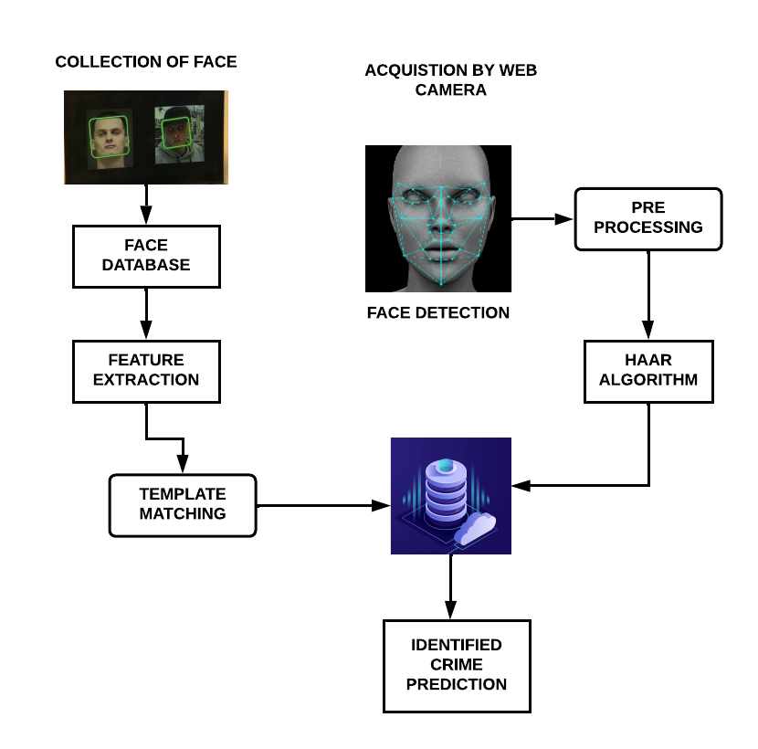

1. List of Phases

* Import the Required Modules
* Load the Face Detection Cascade
* Create the Face Recognizer Object
* Prepare the Training Set and Perform the Training
* Testing
  1. *Import the Required Modules*

The Modules required to perform the facial recognition are cv2, os, image module and numpy. cv2 is the OpenCV module and contains the functions for face detection and recognition. OS will be used to maneuver with image and directory names. First, we use this module to extract the image names in the database directory and then from these names individual number is extracted, which is used as a label for the face in that image. Since, the dataset images are in gif format and as of now, OpenCV does not support gif format, Image module from PIL is used to read the image in grayscale format. Numpy arrays are used to store the images.

* 1. *Load the Face Detection Cascade*

To Load the face detection, cascade the first step is to detect the face in each image. Once we get the region of interest containing the face in the image, we use it for training the recognizer. For the purpose of face detection, we will use the Haar Cascade provided by OpenCV. The haar cascades that come with OpenCV are located in the directory of OpenCV installation. haarcascade frontal face default.xml is used for detecting the face. Cascade is loaded using the cv2 Cascade Classifier function which takes the path to the cascade xml file. if the xml file is in the current working directory, then relative path is used.

* 1. *Create the Face Recognize Object*

The next step involves creating the face recognizer object. The face recognizer object has functions like Face Recognizer train () to train the recognizer and Face Recognizer predict () to recognize a face. OpenCV currently provides Eigen face Recognizer, Fisher face Recognizer and Local Binary Patterns Histograms (LBPH) Face Recognizer. We have used LBPH recognizer because Real life isn’t perfect. We simply can’t guarantee perfect light settings in your images or 10 different images of a person. LBPH focus on extracting local features from images. The idea is to not look at the whole image as a high-dimensional vector but describe only local features of an object. The basic idea of Local Binary Patterns is to summarize the local structure in an image by comparing each pixel with its neighbourhood. LBP operator is robust against monotonic grey scale transformations.

* 1. *Prepare the Training Set and Perform the Training*

To create the function to prepare the training set, we will define a function that takes the absolute path to the image database as input argument and returns tuple of 2 list, one containing the detected faces and the other containing the corresponding label for that face. For example, if the ith index in the list of faces represents the 4th individual in the database, then the corresponding ith location in the list of labels has value equal to 4. Now to perform the training using the Face Recognizer. Train function. It requires 2 arguments, the features which in this case are the images of faces and the corresponding labels assigned to these faces which in this case are the individual number that we extracted from the image names.

* 1. *Testing*

For testing the Face Recognizer, we check if the recognition was correct by seeing the predicted label when we bring the trained face in front of camera. The label is extracted using the os module and the string operations from the name of the sample images folder. Lower is the confidence score better is the prediction

1. Screenshot

***Step 1***

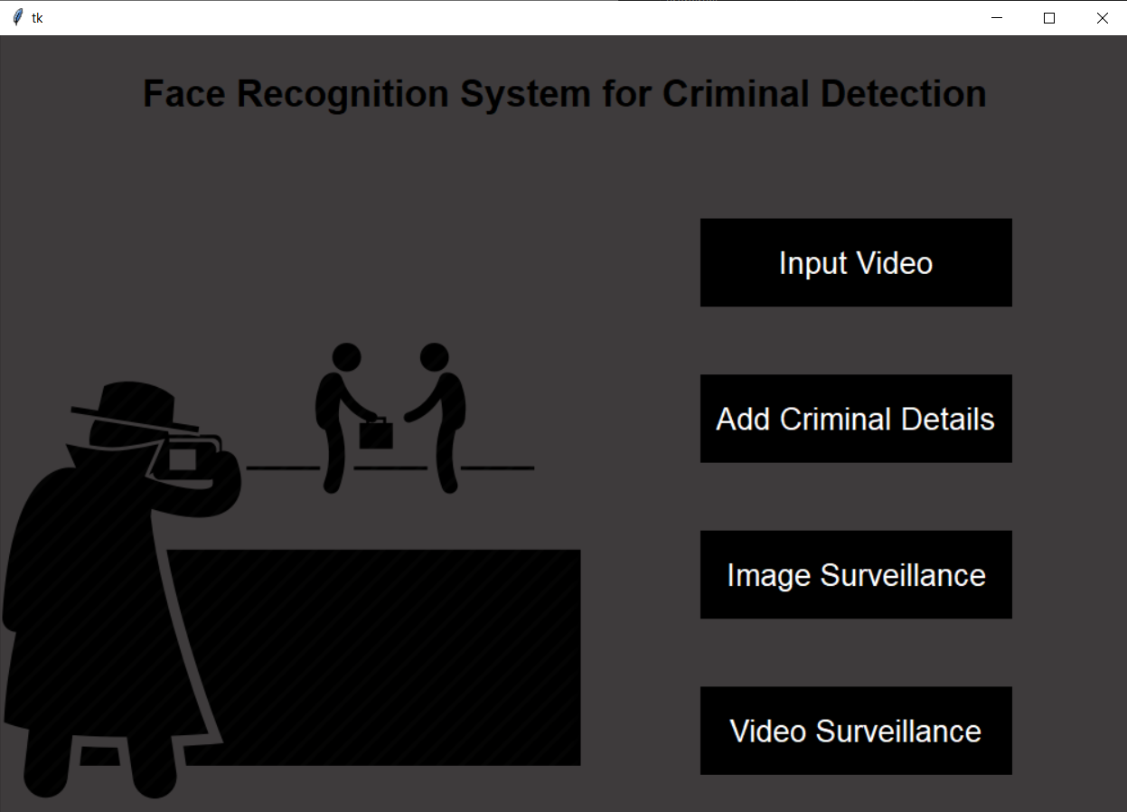

***Step 2***

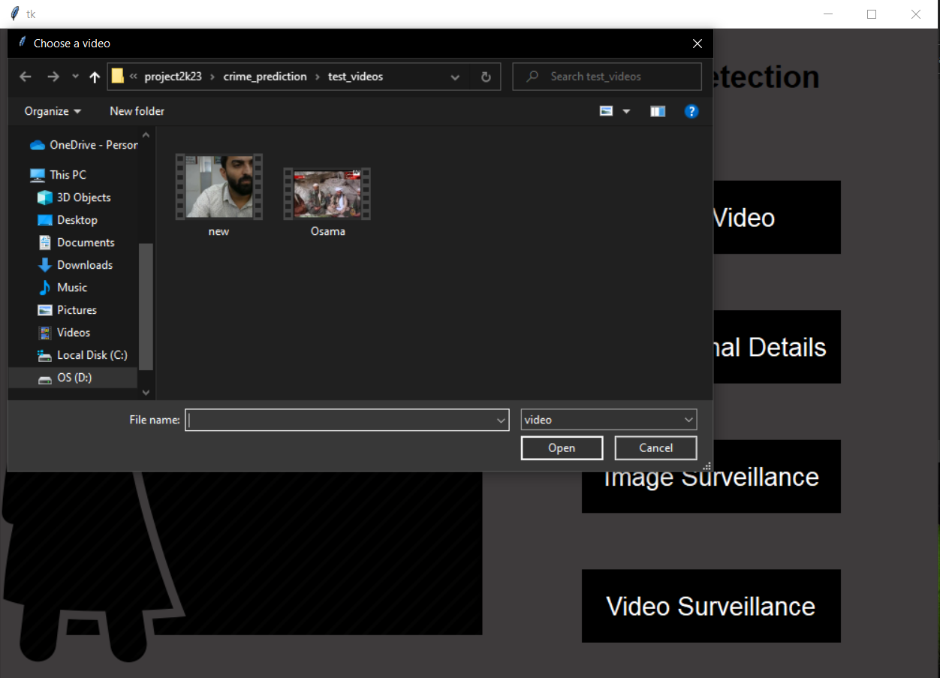

***Step 3***

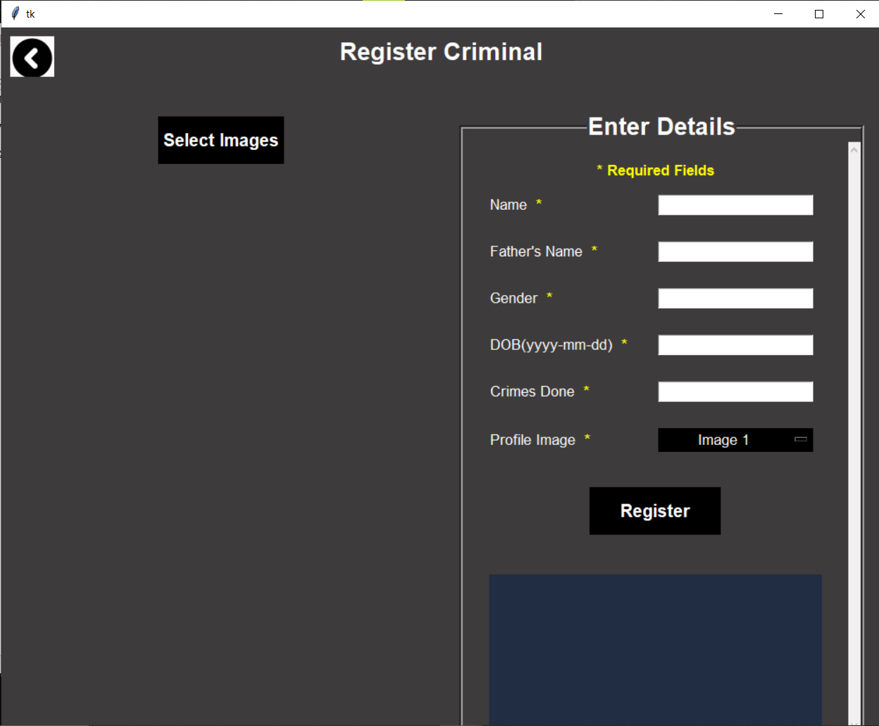

***Step 4***

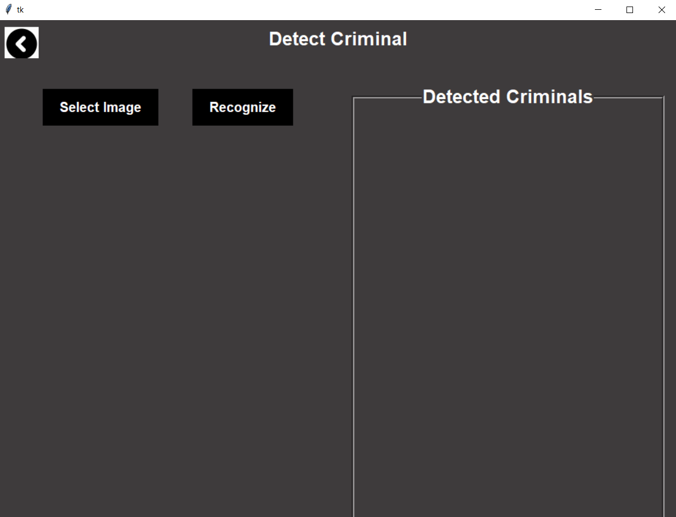

***Step 5***

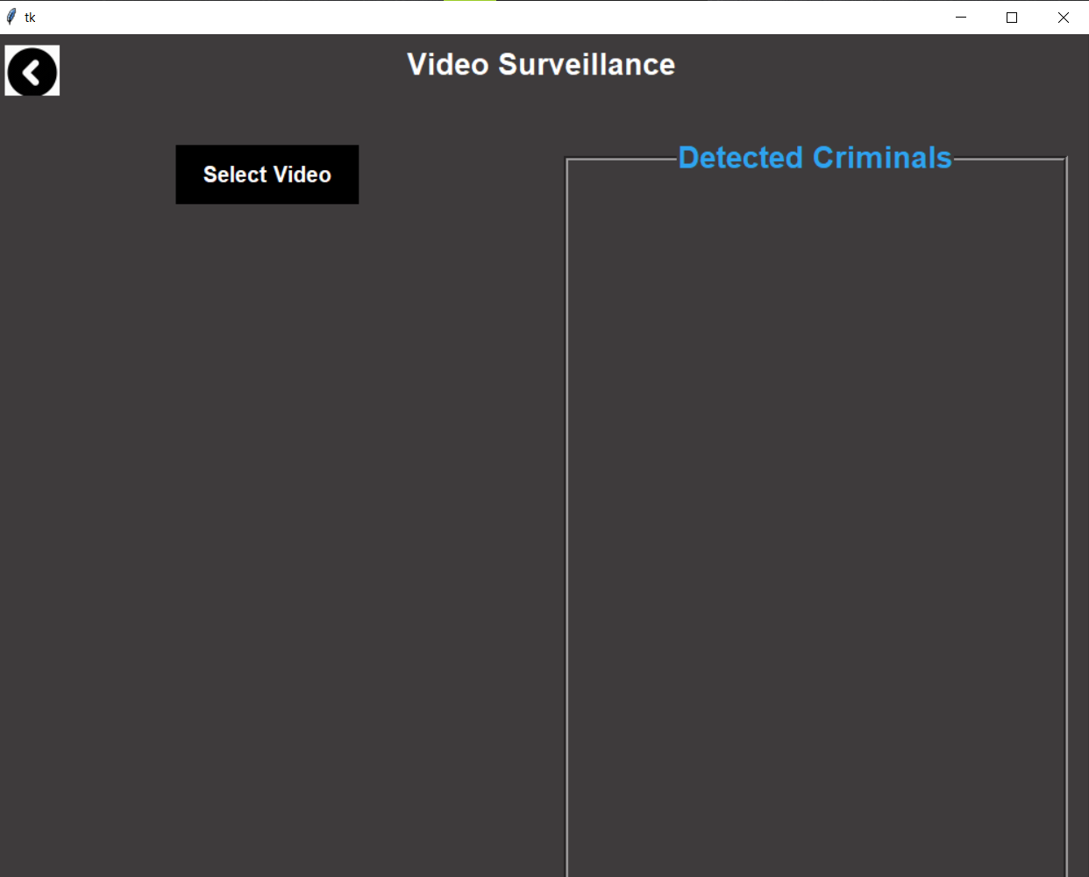

***Step 6***

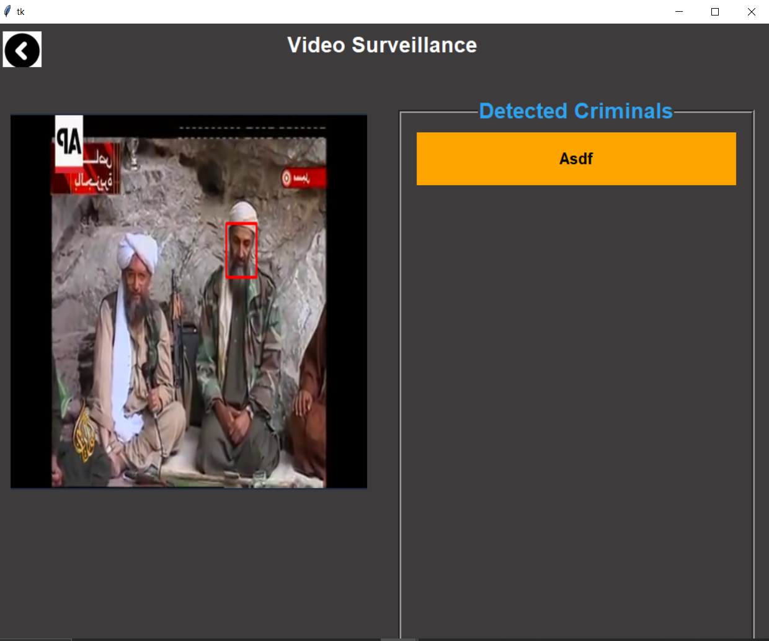

1. Conclusions

* Now a day’s crime rate id frequently increasing day by day in our society. Crime is part of human activities and needs to be managed.
* No human society has ever been totally free of deviants and it is unlikely that society will ever be. This application is made to work proficiently and viably. It results in customary and auspicious activity against wrongdoing detailed. It tends to be seen that the data can be acquired effortlessly and precisely.
* It should likewise lay the better correspondence, diminishing wrongdoing and whole working less tedious.
* By utilizing these application individuals who are apprehensive have enough time to go police headquarters for grievances about their own legitimate issues, or any sort of issues, here they can give their dissensions through online to enlist any kind of protests

1. References

[1] Road Crash Statistics. (Sep. 2016). [Online]. Available: initiatives/informing-road-users/road-safety-facts/road-crash-statistics

[2] C.-M. Tsai, L.-W. Kang, C.-W. Lin, and W. Lin, “Scene-based movie summarization via role-community networks,” IEEE Trans. Circuits Syst. Video Technol., vol. 23, no. 11, pp. 1927–1940, Nov. 2013.

[3] M. Tavassolipour, M. Karimian, and S. Kasaei, “Event detection and summarization in soccer videos using Bayesian network and Copula,” IEEE Trans. Circuits Syst. Video Technol., vol. 24, no. 2, pp. 291–304, Feb. 2014.

[4] S. Parthasarathy and T. Hasan, “Automatic broadcast news summarization via rank classifiers and crowdsourced annotation,” in Proc. IEEE ICASSP, Apr. 2015, pp. 5256–5260.

[5] M. Cote, F. Jean, A. B. Albu, and D. Capson, “Video summarization for remote invigilation of online exams,” in Proc. IEEE WACV, Mar. 2016,