# Privacy and Preserving Image Retrieval and Sharing Social Multimedia Application

Nithya. B1, Ms. K G Siva Raja Sri2, Ms. Sarika Jain3, Dr. S. Geetha4

1M.Sc – CFIS, Department of Computer Science and Engineering, Dr. M.G.R Educational and Research Institute, Chennai 600 095, Tamilnadu, India

2,3Center of Excellence in Digital Forensics, Chennai 600 089, Tamilnadu, India

4Head of the Department, Department of Computer Science and Engineering, Dr. M.G.R Educational and Research Institute, Chennai 600 095, Tamilnadu, India

# Abstract

Every day social multimedia applications generate millions of images. To handle such huge number of images, an optimal solution is using the public cloud, since it has powerful storage capability. Images usually contain a wealth of sensitive information, therefore social service providers need not only to provide services such as retrieval and sharing but also to protect the privacies of the images. In this paper, we propose a privacy-preserving scheme for content-based image retrieval and sharing in social multimedia applications. First, the users extract visual features from the images, and perform locality-sensitive hashing functions on visual features to generate image problem vectors. We then model the retrieval on the images as the equality search on the image problem vectors. To enable accurate and efficient retrieval, we design the secure index structure based on cuckoo hashing, which has constant lookup time. To meet the requirements of dynamic image updating, we enrich our service with image insertion and deletion. In order to reduce the key management overhead and the access control overhead in social applications, we process keys using secret sharing techniques to enable the users holding similar images to query and decrypt images independently. Finally, we implement the prototype of the proposed scheme, and perform experiments over encrypted image databases.

1. **Introduction**

Due to the popularity of mobile devices with cameras, such as mobile phones, tablets, sensors, and etc., the number of images has grown tremendously. Specially, social multi-media applications, that provide platforms to post and share multimedia, generate massive amounts of images. According to Instagram, more than 100 million images are posted per day. Due to the high storage costs, social service providers prefer to outsource such massive number of images to public cloud platforms such as Amazon Cloud. Images usually contain sensitive information that could reveal personal privacies, and encryption is an effective method to protect privacy. Based on cryptography, a number of privacy-preserving schemes.

# Literature Review

**X. Yuan et.al,** images are becoming one of the key enablers of user connectivity in social media applications. Many of them are directly exploring image content to suggest new friends with similar interests. To handle the explosive volumes of images, one common trend is to leverage the public cloud as their robust service backend. Despite the convenience, exposing content-rich images to the cloud inevitably raises acute privacy concerns. In this paper, we propose a privacy-preserving architecture for image-centric social discovery services, designed to function over encrypted images. We first adopt the effective Bag-of-Words model to extract the 'visual content' of users' images into respective image profile vectors. We then model the core problem as similarity retrieval of encrypted high-dimensional vectors. To achieve scalable services over millions of encrypted images, we design a secure and efficient index structure, which enables practical and accurate social discovery from the cloud, without revealing any image profile or image content. For completeness, we further enrich our service with secure updates, facilitating user's image update. Our implementation is deployed at an Android phone and Amazon Cloud, and extensive experiments are conducted on a large Flickr image dataset which demonstrates the desired quality of services.

**Q. Zou et.al,** mobile could computing (MCC) is the availability of cloud computing services in the mobile ecosystem. MCC integrates the cloud computing into the mobile environment and has been introduced to be a potential technology for mobile devices. Although mobile devices brought us lots of convenience, it is still difficult or impossible to perform some expensive tasks due to the limited resources such as computing abilities, battery lifetime, processing abilities, and storage capacity. Therefore, many researchers focus on designing applications which could run on mobile devices in mobile cloud computing. Among them, secure encrypted image search has attracted considerable interest recently. However, it also suffers from some challenges such as privacy of images, and distance matching over ciphertexts. In this paper, we introduce a novel encryption search scheme for content-based image retrieval using comparable encryption and order- preserving encryption technology. Because of avoiding the usage of the homomorphic encryption, our construction greatly reduces computation overhead on client side and improves the precision of fuzzy search compared with previous solutions.

**Agrawal R et.al,** encryption is a well-established technology for protecting sensitive data. However, once encrypted, data can no longer be easily queried aside from exact matches. We present an order-preserving encryption scheme for numeric data that allows any comparison operation to be directly applied on encrypted data. Query results produced are sound (no false hits) and complete (no false drops). Our scheme handles updates gracefully and new values can be added without requiring changes in the encryption of other values. It allows standard database indexes to be built over encrypted tables and can easily be integrated with existing database systems. The proposed scheme has been designed to be deployed in application environments in which the intruder can get access to the encrypted database, but does not have prior domain information such as the distribution of values and annot encrypt or decrypt arbitrary values of his choice. The encryption is robust against estimation of the true value in such environment.

# Existing System

To handle such huge number of images, an optimal solution is using the public cloud, since it has powerful storage capability. Images usually contain a wealth of sensitive information, therefore social service providers need not only to provide services such as retrieval and sharing but also to protect the privacies of the images. Images usually contain sensitive information that could reveal personal privacies, and encryption is an effective method to protect privacy. Based on cryptography, a number of privacy-preserving schemes that support remote image retrieval and sharing have been proposed. Considering that social multimedia application is becoming one of the main platforms for image retrieval and sharing, this paper proposes a privacy-preserving image retrieval and sharing scheme for social multimedia applications.

# Proposed System

We propose a privacy-preserving scheme for content-based image retrieval and sharing in social applications. First, the users extract visual features from the images, and perform locality-sensitive hashing functions on visual features to generate image problem vectors. We then model the retrieval on the images as the equality search on the image problem vectors. To enable accurate and efficient retrieval, we design the secure index structure based on cuckoo hashing, which has constant lookup time. To meet the requirements of dynamic image updating, we enrich our service with image insertion and deletion. In order to reduce the key management overhead and the access control overhead in social applications, we process keys using secret sharing techniques to enable the users holding similar images to query and decrypt images independently. Finally, we implement the prototype of the proposed scheme, and perform experiments over encrypted image databases.

# System Architecture

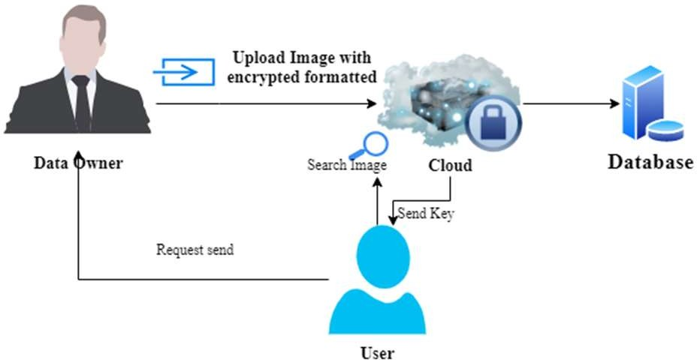

# Dataflow Diagrams

***Level 0***

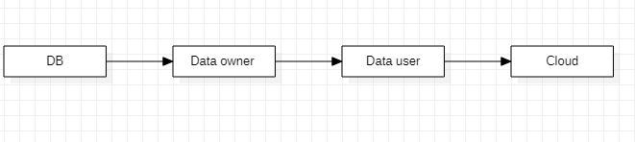

# *Level 1*

***Level 2***



***Level 3***



***Level 4***

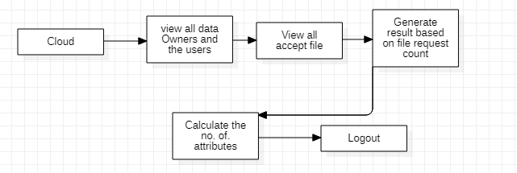

# Screenshots



***Cloud Server***

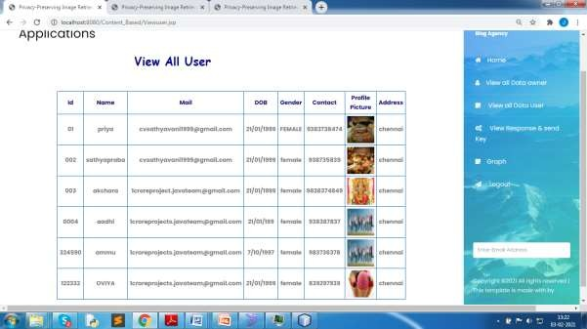

***Data Owner***



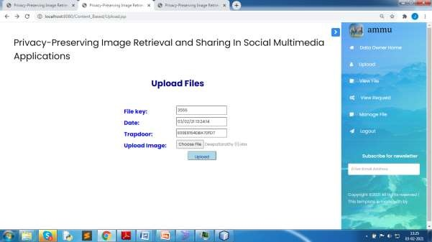

***Data User***



***User Download***

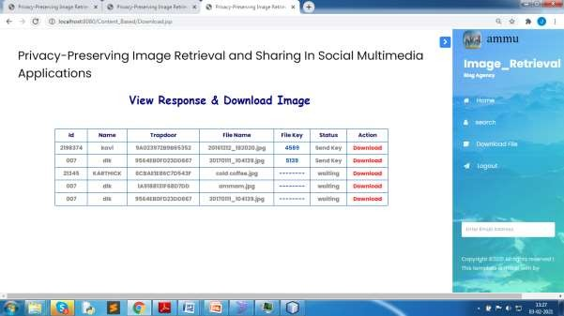

# Conclusions

In this paper, we proposed and implemented a privacy- preserving content-based image retrieval and sharing scheme, which can be used for friend recommendation in social multimedia applications. We measured image similarity through image visual features. We used *leash* to reduce the dimensionality of visual features and realize similarity search on visual features. We designed the index based on cuckoo hashing to speed up the similarity search. Based on secret sharing, we allowed the user to query and recover images on his own, which eliminates key management overhead and access control overhead compared with other schemes. Finally, we implemented a prototype to evaluate the efficiency of our proposed scheme. The results showed that our scheme achieves practical performance under the UK Bench database.

# References

1. E. Rublee, V. Rabaud, K. Konolige, and G. Bradski, ``ORB: An efficient alternative to SIFT or SURF,'' in *Proc. Int. Conf. Comput. Vis.*, Nov. 2011, pp. 2564_2571.
2. D. Xiaoding Song, D. Wagner, and A. Perrig, ``Practical techniques for searches on encrypted data,'' in *Proc. IEEE Symp. Secur. Privacy.*, May 2000, pp. 44_55.
3. X. Yuan, X. Wang, C. Wang, A. C. Squicciarini, and K. Ren, ``Towards privacy- preserving and practical image-centric social discovery,'' *IEEE Trans. Dependable Secure Comput.*, vol. 15, no. 5, pp. 868_882, Sep. 2018.
4. K. W. Ahmed, M. Z. Hasan, and N. Mohammed, ``Image-centric social discovery using neural network under anonymity constraint,'' in *Proc. IEEE Int. Conf. Cloud Eng. (ICE)*, Apr. 2017, pp. 238_244.
5. Facebook. (2019). *Keeping Passwords Secure*. [Online]. Available: https://newsroom.fb.com/news/2019/03/keeping-passwords-secure/.