**Phishing-Aware: A Neuro-Fuzzy Approach for Anti-Phishing on Fog Networks**

V. Ilavarasan, Mr. S. Arun raj, Ms. Sarika Jain, Dr. S. Geetha

1M.Sc – CFIS, Department of Computer Science and Engineering, Dr. M.G.R Educational and Research Institute, Chennai 600 095, Tamilnadu, India

2,3Center of Excellence in Digital Forensics, Chennai 600 089, Tamilnadu, India

4Head of the Department, Department of Computer Science and Engineering, Dr. M.G.R Educational and Research Institute, Chennai 600 095, Tamilnadu, India

Abstract

In fashion websites i.e., online shopping (e.g., Flipkart, Myntra, Amazon), popular or high-quality fashion outfits are usually designed by fashion experts and followed by large audiences. Composing fashion outfits involves deep understanding of fashion standards while incorporating creativity for choosing multiple fashion items (e.g., Jewelry, Bag, Pants, Dress). An existing user can view a comment of others of that particular product and can view related products for user viewing product with irrelevant of color. In this proposed project we are introducing a new concept known as outfit automatically. In this concept when a user views a product, they can view relevant products based on color and on the appearances based on the meta-data. Also, we propose to leverage outfit popularity on fashion-oriented websites to supervise the scoring component. The scoring component is a multi-modal multiinstance deep learning system that evaluates instance aesthetics and set compatibility simultaneously. In online shopping we can watch advertisements, here we have a chance of fake, hackers, and unwanted URL’s. To avoid this, we are going to filter these advertisements by using concept known URL pattern matching technique. By this we will filter all advertise and allow only needful advertisement to the user end.

1. Introduction

We propose a generic composition algorithm based on outfit quality scorer. The outfit quality scorer is an end-to-end trainable system, which achieves promising performance, detecting phishing websites and review analysis using NLP. To find a good outfit composition, we need not only follow the appropriate dressing codes but also be creative in balancing the contrast in colours and styles. Although there have been a number of research studies on clothes retrieval and recommendation, none of them considers the problem of fashion outfit composition. In fashion websites i.e., online shopping (e.g., Flipkart, Myntra, Amazon), popular or high-quality fashion outfits are usually designed by fashion experts and followed by large audiences. Composing fashion outfits involves deep understanding of fashion standards while incorporating creativity for choosing multiple fashion items (e.g., Jewellery, Bag, Pants, Dress). In existing User can able to view a comment of others of that particular product and can view related products for user viewing product with irrelevant of colour. In proposed we are introducing a new concept known as outfit automatically. In this concept when user view a product user can view relevant products based on colour and product or on the appearances and meta-data. And also, we propose to leverage outfit popularity on fashion-oriented websites to supervise the scoring component. The scoring component is a multi-modal multi-instance deep learning system that evaluates instance aesthetics and set compatibility simultaneously. In online shopping we can watch advertises, here have a chance of fake, hacker, and unwanted URL’s. To avoid this, we going to filter these advertises by using concept known URL pattern matching technique. By this we will filter all advertise and allow only needful advertises to the user end.

1. Literature Survey

(Vijaya R Saraswathi et al, 2022) the need for Recon automation is rapidly increasing as ethical hackers are being lazy in performing every little check manually. to make the Recon process of penetration testing easy, fast, and accurate, a Recon framework with highly sophisticated tools written in languages like bash, go and python needs to be developed and made open source to everyone. Manually doing this task can be very intimidating since a lot of time and efforts are needed in accomplishing this task. so, automation of this task can be very handy to the penetration testers and saves a lot of time as they can focus on other tasks of the further tasks of a penetration test.

(Aswathy Mohan et al, 2022) Penetration Testing in Ethical Hacking is one of the most efficient methods used by high end organizations to overcome this data threat caused by cyber criminals. Penetration Testing uses a group of Pen testers to perform the cyber-attack done same by unknown hackers but with legal consent from the owners of the organization. They create a generalized report which specifies the set of identified vulnerabilities in the target system in the organization. They also advise countermeasures or solutions to overcome the security weaknesses of the organization.

(Sushmita Reddy Mamilla,2021) Information is more vulnerable than ever, and every technological advance raises new security threat that requires new security solutions. Penetration testing is conducted to evaluate the security of an IT infrastructure by safely exposing its vulnerabilities. It also helps in assessing the efficiency of the defense mechanisms tools and policies in place. The Penetration testing is conducted regularly to identify risks and manage them to achieve higher security standards.

(R. Sri Devi & M. Mohan Kumar,2020) In the digital world, everything gets connected through the network, and when various services are provided by web applications people are susceptible to hacking. According to the 2019 internet security threat report by Symantec, an average of 4, 800 websites are vulnerable to digital information theft attacks. The main intent of this paper is to recognize openness and flaws in networks and web applications using penetration testing to protect institutions from cyber threats.

(Sudhanshu Raj & Navpreet Kaur Walia,2020) the usage of internet is everywhere. It plays an important part in the life of humans. As we all know that the Internet has made the life of humans much easier not only in personal but also in professional aspect. This ease in life has given birth to so many threats and ﬂaws that are further giving access to the intruders known as ‘Hackers’ to enter in a user’s private space and perform some activities which can be very harmful for that particular user. In this paper, we will discuss about the Metasploit Framework tool which is always used by the Hackers & Pen-testers to perform activities i.e., from Scanning to exploiting the systems.

1. Existing System

Late years have seen the fast improvement of infections, and the wide assortment of safety dangers brought about by infections has elevated the need to concentrate on infection spread. For instance, another danger, called the web crawler poison has as of late appeablack, compounding what is happening by spreading infections like margarine in the desert heat. Hund blacks of thousands, even millions, of individuals all around the globe have become casualties. By and large, the web search tool assumes an imperative part in the engendering of infections. For instance, a client distributes a post on a specific subject wherein the vindictive codes are concealed on Facebook; other informal community clients, like 3 Twitter clients, may look for that point and thusly visit the malevolent Facebook pages. Through the web search tool, the noxious codes are then engendered from Facebook to Twitter.

1. Proposing System

We want to address these difficulties by investigating the infection engendering impacts of the web index, which gives off an impression of being a secret power for infection spread. To accomplish our exploration objective, we first need to examine how a web search tool increments spread sources and courses in informal organizations. As a virtual infection pool, a web crawler might contain a ton of infections to increment engendering sources: any client getting to pages might be tainted, and in this way those exercises increment the spread courses. Second, we want to quantitatively examine the spread impact of the web search tools. In building the particular proliferation model that consolidates the informal organization and the web crawler, a few vital measurements of infection engendering should be dissected. Third, we configuration examinations to confirm this investigation. Informational indexes of current genuine interpersonal organizations ought to be tried and talked about.

1. Architecture Diagram

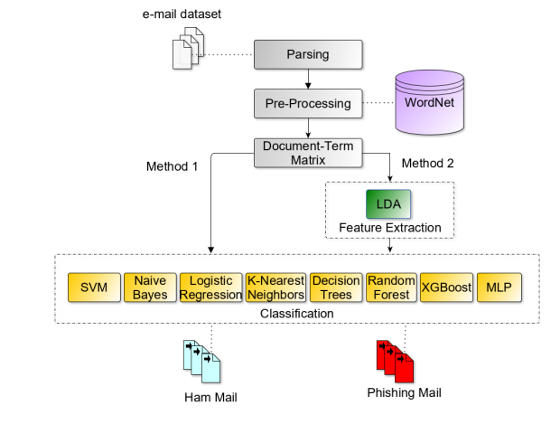

1. System Implementation

*Modules Explanation*

* User/Admin characteristics
* Assumptions & Dependencies
* SystemTesting
* System Development

***User/Admin Characteristics***

Admin shall give various types of images(data) of the same category to let the classifier give the output with more accuracy. 14 There shall be huge number of images to be given as input to the classifier

***Assumptions and Dependencies***

The program highly depends on the quality (feature extraction) and number of images given as input, so we shall maintain them precisely.

***System Testing***

Testing is the process of detecting errors. Testing plays a critical role in assuring quality and ensuring the reliability of software. The results of testing are used later on during maintenance also.

***System Development***

When the framework has been planned, the following stage is to change over the planned one in to genuine code, to fulfil the client prerequisites as excepted. Assuming the framework is supported to be sans mistake it tends to be carried out. At the point when the underlying plan was finished for the framework, the division was counselled for acknowledgment of the plan so that further procedures of the framework advancement can be continued. After the improvement of the framework, a show was given to them about working of the framework. The point of the framework outline was to recognize any failing of the framework. Execution incorporates appropriate preparation to end-clients. The executed programming ought to be kept up with for delayed running of the product. At first the framework was run lined up with manual framework. The framework has been tried with information and has ended up being sans blunder and easy to understand.

***Algorithm***

The Naive Bayesian classifier is based on Bayes’ theorem with the independence assumptions between predictors. A Naive Bayesian model is easy to build, with no complicated iterative parameter estimation which makes it particularly useful for very large datasets. Despite its simplicity, the Naive Bayesian classifier often does surprisingly well and is widely used because it often outperforms more sophisticated classification methods.

***Screen Shots***

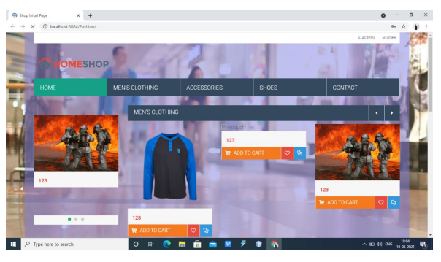

*Online Shopping Website*

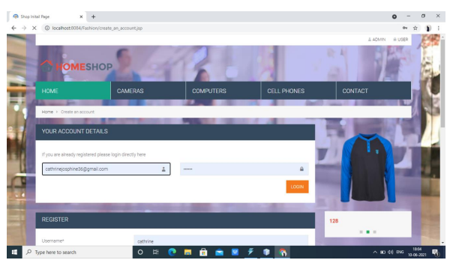

*Login*

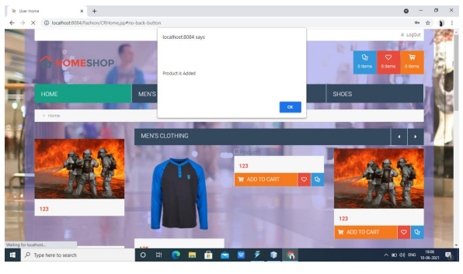

*Adding Products*

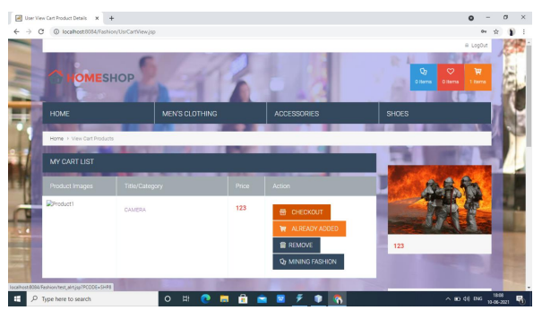

*Viewing Cart and Give Checkout*



*URL contains phishing content*

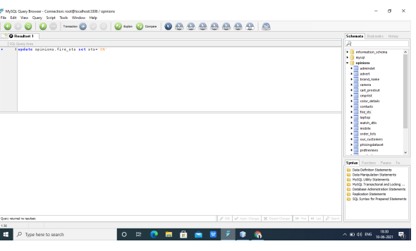

*Update MySQL Query*

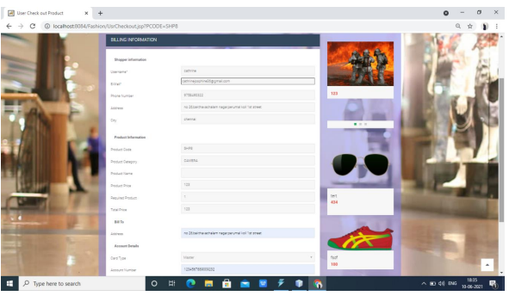

*Billing Information*

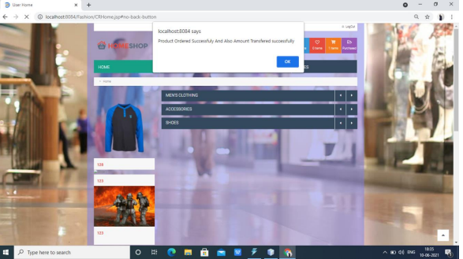

*Product Ordered Successfully*

1. Conclusion

With the expansion of informal communities and their always expanding use, infections have become considerably more common. We explore the spread impact of web crawlers, and portray the positive criticism impact and the proliferation wormhole impact. The virtual infection pool and virtual disease ways that are shaped by a web index make engendering happen substantially more rapidly. We show that engendering speed is faster, contamination thickness is bigger, the pestilence edge is lower and the fundamental proliferation number is more noteworthy within the sight of a web search tool. At long last, we lead explores that check the proliferation impact regarding both disease thickness and infection spread speed. Results show the huge impact of a web search tool especially its capacity to speed up infection engendering in informal communities.

1. References

[1] (Jun. 2019). Total Global Email & Spam. [Online]. Available: https://www.talosintelligence.com/reputation_center/email_rep

[2] E. E. H. Lastdrager, ‘‘Achieving a consensual definition of phishing based on a systematic review of the literature,’’ Crime Sci., vol. 3, no. 9, pp. 1–10, 2014. [Online]. Available: https://crimesciencejournal.springeropen.com/articles/10.1186/s40163- 014-0009-y

[3] A. Aleroud and L. Zhou, ‘‘Phishing environments, techniques, and countermeasures: A survey,’’ Comput. Secur., vol. 68, pp. 160–196, Jul. 2017, doi: 10.1016/j.cose.2017.04.006.

[4]<http://www.kecl.ntt.co.jp/as/members/iwata/ijcai2011.pdf> (Fashion Coordinates Recommend System Using Photographs from Fashion Magazines) [5] https://arxiv.org/abs/1509.07473(Learning Visual Clothing Style with Heterogeneous Dyadic Co-occurrences).