**Text File Encryption and Decryption System Based on ASE Algorithm using Java**

T. Harishankar1, Ms. Sarika Jain2, Ms. Sarika Jain3, Dr. S. Geetha4

1M.Sc-CFIS, Department of Computer Science and Engineering, Dr. M.G.R Educational and Research Institute, Chennai 600 095, Tamilnadu, India

2,3Center of Excellence in Digital Forensics, Chennai 600 089, Tamilnadu, India

4Head of the Department, Department of Computer Science and Engineering, Dr. M.G.R Educational and Research Institute, Chennai 600 095, Tamilnadu, India

Abstract

Distributed storage has turned into an essential industry in far off information the executive’s administration yet in addition draws in security concerns, where the most ideal that anyone could hope to find approach for forestalling information revelation is encryption. Among them the public key encryption with watchword search (PKSE) is viewed as a promising method, since clients can productively look through over encoded information records. That is, a client initially creates a pursuit token when to question information records, the cloud server utilizes the hunt token to continue the inquiry over scrambled information documents. In any case, a serious assault is raised when PKSE meets cloud. Officially talking, the cloud server can become familiar with the data of a recently added encoded information record containing the catchphrase that recently questioned by utilizing the pursuit tokens it has gotten, and can additionally find the security data. To resolve this issue, we propose a forward secure public key accessible encryption conspire, in which a cloud server can't gain proficiency with any data about a recently added encoded information record containing the catchphrase that recently questioned. To all the more likely comprehend the plan guideline, we present a structure for developing forward secure public key accessible encryption plans in light of property based accessible encryption. At last, the trials show our plan is productive.

1. Introduction

The development of distributed computing has extraordinarily disposed of the particular errands of overseeing information records by permitting clients to appreciate on-request quick calculation and monstrous stockpiling assets at an exceptionally low cost. Notwithstanding the accommodations, in the component, clients lost actual command over their information documents, which will prompt the worries of security revelation. Cryptographic strategies have been viewed as a long-laid out way to deal with mitigate the worries which advocate that information documents ought to scramble before rethink. As a grouping of encryption, numerous valuable capabilities, for example, search over the reevaluated information documents can't be productively finished. Besides, proficient pursuit process is crucial for a cutting-edge distributed storage framework. Accessible encryption is a cryptographic crude that permits to execute search tasks over scrambled information documents, which was presented by Melody, and can be acknowledged in either symmetric key setting and public key setting. The previous is known as symmetric accessible encryption, despite the fact that it appreciates high proficiency in search process, it gives a horrible presentation in information sharing for its convoluted mystery key dissemination, since clients need to share the mystery key which will be utilized for unscrambling while sharing a scrambled information record to other people. The last option is known as open key accessible encryption [6], which is more adaptable than symmetric accessible encryption at the part of information sharing. Openly key accessible encryption, a client's public key can be utilized by others to scramble an information document shared to the client, and the client can utilize its mystery key to produce scan tokens for its inquiries, the server can utilize an inquiry token to test whether an encoded information record matches the question comparing to the hunt token while advancing nothing about the question

1. Existing System

Regardless of its predominance in information sharing, the public key accessible encryption system experiences different assaults while being conveyed in distributed storage, and may prompt protection spillage. A cloud server can't get familiar with any data about a recently added scrambled information record containing the watchword that recently questioned.

1. Proposing System

To accomplish the forward security for public key accessible encryption, our instinct is to tie a pursuit token (or a scrambled information record) and its age time together. While handling search, the calculation first checks whether the scrambled information document is produced before the hunt token. Notwithstanding, also known, executing number examination tasks over encoded data is troublesome.

1. Architecture Diagram

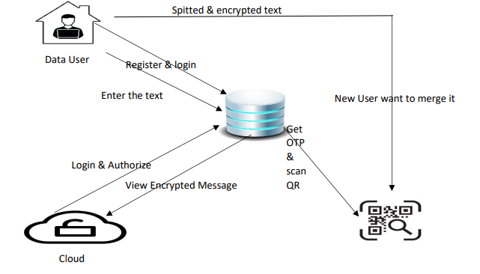

1. **J2ME (Java 2 Micro Edition)**

Sun Microsystems characterizes J2ME as "an exceptionally enhanced Java runtime climate focusing on an extensive variety of buyer items, including pagers, cells, screen-telephones, computerized set-top boxes and vehicle route frameworks." Reported in June 1999 at the Java One Designer Meeting, J2ME brings the cross-stage usefulness of the Java language to more modest gadgets, permitting versatile remote gadgets to share applications. With J2ME, Sun has adjusted the Java stage for customer items that consolidate or depend on little registering gadgets.

* General J2ME architecture
* Developing J2ME applications
* Design considerations for small devices
* Configurations overview
  1. ***General J2ME Architecture***

J2ME utilizes setups and profiles to tweak the Java Runtime Climate (JRE). As a total JRE, J2ME is included a setup, which decides the JVM utilized, and a profile, which characterizes the application by adding space explicit classes. The design characterizes the fundamental run-time climate as a bunch of center classes and a particular JVM that sudden spike in demand for explicit sorts of gadgets. We'll examine arrangements exhaustively in the profile defines the application; explicitly, it adds space explicit classes to the J2ME setup to characterize specific purposes for gadgets. We'll cover profiles top to bottom in the accompanying realistic portrays the connection between the different virtual machines, arrangements, and profiles. It likewise draws a lined up with the J2SE Programming interface and its Java virtual machine. While the J2SE virtual machine is by and large alluded to as a JVM, the J2ME virtual machines, KVM and CVM, are subsets of JVM. Both KVM and CVM can be considered a sort of Java virtual machine - - it's simply that they are contracted variants of the J2SE JVM and are intended for J2ME.

* 1. ***Developing J2ME Applications***

Show In this part, we will go over specific considerations you truly need to keep in mind while making applications for additional unassuming contraptions. We'll research how the compiler is called while using J2SE to arrange J2ME applications. Finally, we'll explore packaging and course of action and the work preverification plays in this cycle.

* 1. ***Design Considerations for Small Devices***

Creating applications for little gadgets expects you to remember specific techniques during the plan stage. It is ideal to decisively plan an application for a little gadget before you start coding. Remedying the code since you neglected to think about all of the "gotchas" prior to fostering the application can be an excruciating cycle. Here are some plan procedures to consider:

• Keep it straightforward. Eliminate pointless elements, potentially making those highlights a different, optional application. Smaller is better. This thought ought to be a "easy decision" for all designers. More modest applications utilize less memory on the gadget and require more limited establishment times. Consider bundling your Java applications as packed Java Document (container) records. 20

• Limit run-time memory use. To limit how much memory utilized at run time, utilize scalar sorts instead of item types. Likewise, don't rely upon the trash specialist. You ought to deal with the memory effectively yourself by setting object references to invalid when you are done with them. One more method for diminishing run-time memory is to utilize languid launch, just distributing objects dependent upon the situation. Alternate approaches to decreasing by and large and pinnacle memory use on little gadgets are to deliver assets rapidly, reuse protests, and stay away from exemptions.

* 1. ***Configurations overview***

The design characterizes the essential run-time climate as a bunch of center classes and a particular JVM that sudden spike in demand for explicit sorts of gadgets. At present, two setups exist for J2ME, however others might be characterized from now on:

• Associated Restricted Gadget Arrangement (CLDC)is utilized explicitly with the KVM for 16-digit or 32-bit gadgets with restricted measures of memory. This is the design (and the virtual machine) utilized for growing little J2ME applications. Its size limits make CLDC seriously fascinating and testing (according to an improvement perspective) than CDC. CLDC is additionally the design that we will use for fostering our drawing instrument application. An illustration of a little remote gadget running little applications is a Palm hand-held PC.

• Associated Gadget Arrangement (CDC)is utilized with the C virtual machine (CVM) and is utilized for 32-digit designs requiring multiple MB of memory. An illustration of such a gadget is a Net television box.

1. **Screen Shots**

***6.1 Homepage***

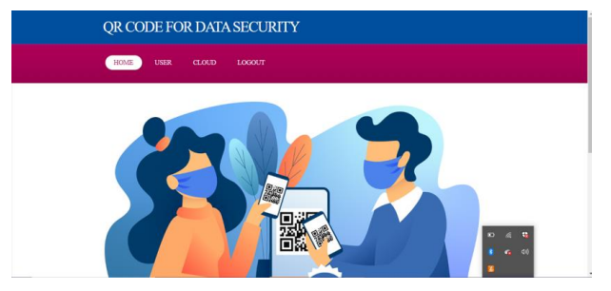

***6.2 User Register Page***

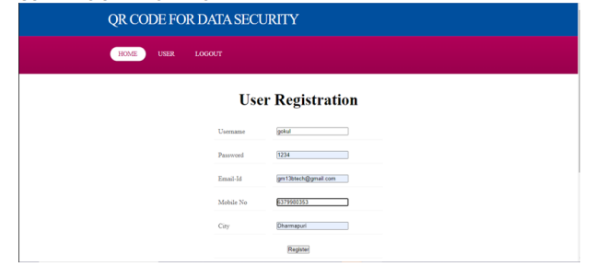

***6.3 User Login***

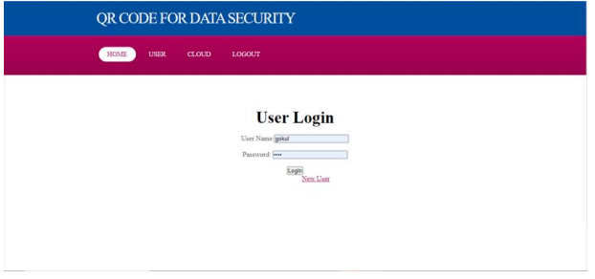

***6.4 Cloud Login Page***

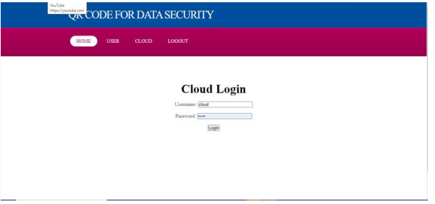

***6.5 Sent to Receiver***

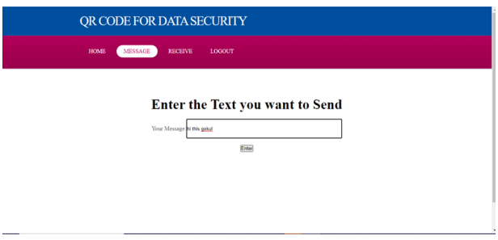

***6.6 Encrypted Text***

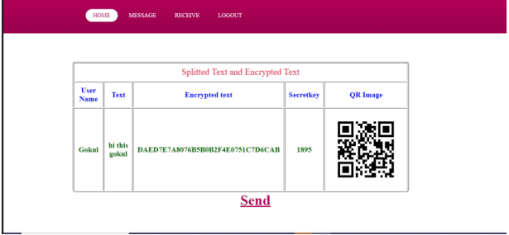

***6.7 Send to Whom You Want***

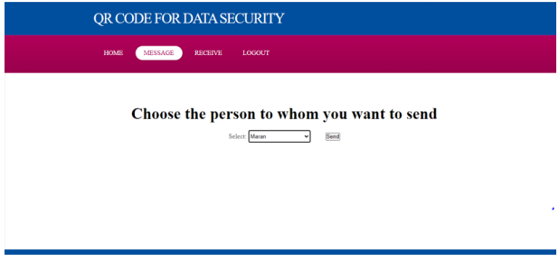

***6.8 Final Output***



1. **Conclusions**

In this venture, we concentrate on the forward security for public key accessible encryption, and that implies another additional encoded information record can't be looked through by the pursuit tokens created before the scrambled information document. This security is earnestly expected for the public key accessible encryption plans conveyed in distributed storage, and can extraordinarily lessen the protection data spilled to a cloud server. As an answer, we propose a substantial plan in light of the 0-Encoding and 1-Encoding approach and give its security evidence, further, we likewise tell the best way to get a forward secure public key accessible encryption conspire from a characteristic based accessible encryption plot by presenting a conventional system. At long last, we configuration examinations to delineate the reasonableness of our proposed conspire regarding encryption, token age and search.

# **References**

[1] Q. Wang, M. Du, X. Chen, Y. Chen, P. Zhou, X. Chen, and X. Huang, “Privacy preserving collaborative model learning: The case of word vector training,” IEEE Trans. Knowl. Data Eng, vol. 30, no. 12, pp. 2381–2393, 2018.

[2] J. Cui, J. Zhang, H. Zhong, and Y. Xu, “SPACF: A secure privacy preserving authentication scheme for VANET with cuckoo filter,” IEEE Trans. Vehicular Technology, vol. 66, no. 11, pp. 10 283–10 295, 2017.

[3] H. Zhong, W. Zhu, Y. Xu, and J. Cui, “Multi-authority attribute-based encryption access control scheme with policy hidden for cloud storage,” Soft Comput., vol. 22, no. 1, pp. 243–251, 2018.

[4] D. X. Song, D. A. Wagner, and A. Perrig, “Practical techniques for searches on encrypted data,” in IEEE Symposium on Security and Privacy, 2000, pp. 44–55.

[5] R. Curtmola, J. A. Garay, S. Kamara, and R. Ostrovsky, “Searchable symmetric encryption: improved definitions and efficient constructions,” in ACM Conference on Computer and Communications Security, 2006, pp. 79–88.