A Trusted Blockchain Based Traceability System for Fruits and Vegetables

B. Abishek Roshan1, Mr. Arunraj2, Ms. Sarika Jain3, Dr. S. Geetha4

1M.Sc – CFIS, Department of Computer Science and Engineering, Dr. M.G.R Educational and Research Institute, Chennai 600 095, Tamilnadu, India

2,3Center of Excellence in Digital Forensics, Chennai 600 089, Tamilnadu, India

4Head of the Department, Department of Computer Science and Engineering, Dr. M.G.R Educational and Research Institute, Chennai 600 095, Tamilnadu, India

# Abstract

Traditional traceability system has problems of centralized management, opaque information, untrustworthy data, and easy generation of information islands. To solve the above problems, this paper designs a traceability system based on blockchain technology for storage and query of product information in supply chain of agricultural products. Leveraging the characteristics of decentralization, tamper-proof and traceability of blockchain technology, the transparency and credibility of traceability information increased. A dual storage structure of ‘‘database + blockchain’’ on-chain and off-chain traceability information is constructed to reduce load pressure of the chain and realize efficient information query. Blockchain technology combined with cryptography is proposed to realize the safe sharing of private information in the blockchain network. In addition, we design a reputation- based smart contract to incentivize network nodes to upload traceability data. Furthermore, we provide performance analysis and practical application, the results show that our system improves the query efficiency and the security of private information, guarantees the authenticity and reliability of data in supply chain management, and meets actual application requirements.

# Introduction

Fruit and vegetable agricultural products have excellent production advantages in China, which is a large agricultural country with superior climate conditions and abundant species resources. According to data from the National Bureau of Statistics of China [1], the total output of fruit and vegetable agricultural products in 2019 was 995.03 million tons, accounting for 54.48% of all agricultural products (1826.55 million tons). Fruit and vegetable agricultural products have the characteristics of green, healthy and high nutritional value [2], which are deeply loved by people. However, the short storage time and the low storage temperature of storage requirements for fruit and vegetable agricultural products, leading to food safety incidents are extremely prone to occur

# Literature Survey

Abstract: Food safety and traceability are nowadays a constant concern for consumers, and indeed for all actors in the food chain, including those involved in the fruit and vegetable sector. For the EU, the principles and legal requirements of traceability are set out in Regulation 178/2002. Currently however the regulation does not describe any analytical traceability tools. Furthermore, traceability systems for fruits and vegetables face increasing competition due to market globalization. The current challenge for actors in this sector is therefore to be sufficiently competitive in terms of price, traceability, quality and safety to avoid scandal and fraud. For all these reasons, new, flexible, cheap.

**D. Arya et.al,** **Foodborne disease** remains a major public health problem worldwide. To understand the epidemiology and changes of foodborne disease in China, data reported to the National Foodborne Disease Outbreak Surveillance System during2003–2017 were collected. A total of 19,517 outbreaks, which resulted in 235,754 illnesses, 107,470 hospitalizations, and 1,457 deaths, were reported in this period. Of the 13,307 outbreaks with known etiology, 31.8% of outbreaks were caused by poisonous mushrooms, followed by [**Vibrio**](https://www.sciencedirect.com/topics/food-science/vibrio) ***parahaemolyticus*** (11.3%), saponin (8.0%), ***Salmonella*** (6.8%), nitrite (6.4%), pesticide (4.8%), [**Staphylococcus**](https://www.sciencedirect.com/topics/food-science/staphylococcus-aureus)[**aureus**](https://www.sciencedirect.com/topics/food-science/staphylococcus-aureus)(4.2%) and [**Bacillus cereus**](https://www.sciencedirect.com/topics/food-science/bacillus-cereus)(3.0%). Among 18,955 outbreaks with reported setting, 46.6% were associated with food prepared in a household, followed by 22.5% with food prepared in a restaurant, and 18.4% prepared in a canteen. Of the 13,305 outbreaks associated with a single food category, fungi (mainly poisonous mushroom) were the most commonly implicated food category, followed by meats, vegetables, aquatic animals, [**condiments**](https://www.sciencedirect.com/topics/food-science/condiment), poisonous plants (such as saponin, tung oil or seed, aconite) and grains (such as rice, noodle, rice noodle). Analysis of foodborne disease outbreaks can provide insight into the most important causative agents and sources of foodborne disease, and assist public health agencies determine the high-risk etiology and food pairs, specific points of contamination and settings to reduce foodborne disease illnesses.

**AN Desai et.al,** the purpose of this study was to identify global trends in ***Listeria monocytogenes*** epidemiology using ProMED reports. ProMED is a publicly available, global outbreak reporting system that uses both informal and formal sources. In the context of ***Listeria***, ProMED reports on atypical findings such as higher than average case counts, events from unusual sources, and multinational outbreaks.

# Existing System

In our existing system a complex issue because of perishability factor. Farmers producing fruits and vegetables, market it only after consumption. There are heavy post-harvest and handling losses, resulting in low productivity per unit area and high cost of production. Traditional traceability system has problems of centralized management opaque information, untrustworthy data, and easy generation of information.

# Proposed System

In this we proposed to designs a traceability system based on block chain technology for storage and query of product information in supply chain of agricultural products. We provide performance analysis and practical application; the results show that our system improves the query efficiency and the security of private information.

# System Architecture

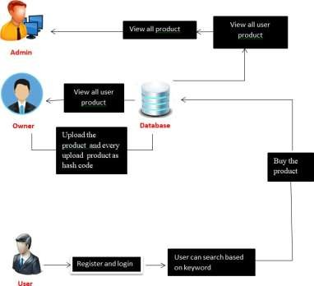

***Level 0***

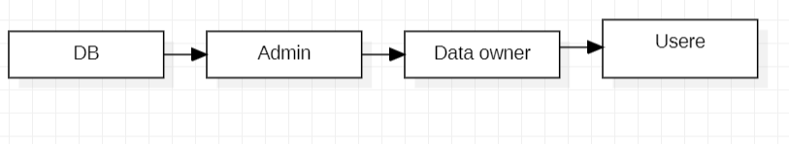

***Level 1***

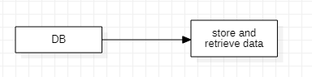

***Level 2***

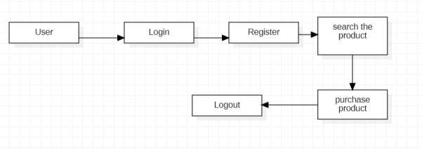

***Level 3***

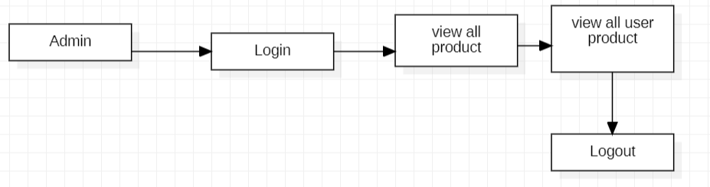

# *Level:4*

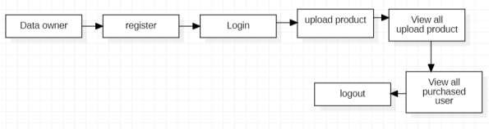

# Screenshots

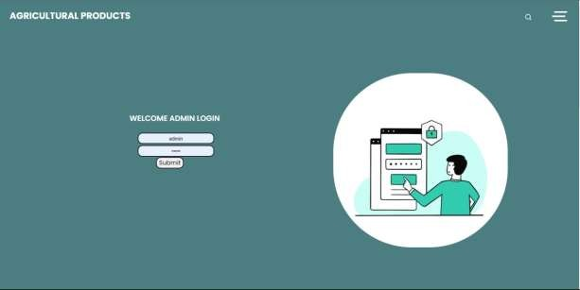

* 1. ***Admin Login Page***

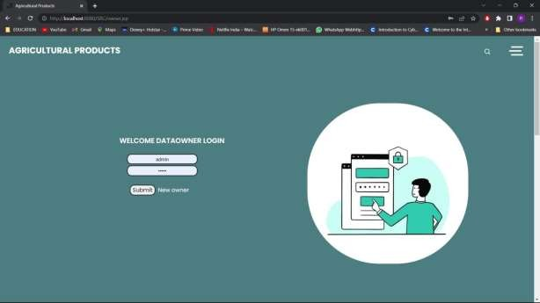

* 1. ***Data Owner Login Page***

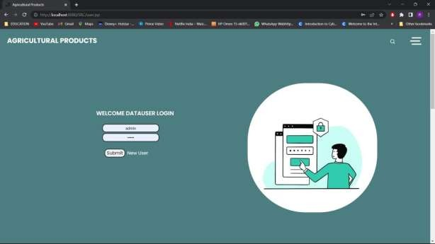

* 1. ***Data User Login Page***



* 1. ***Authorize User Block and Owner Block***

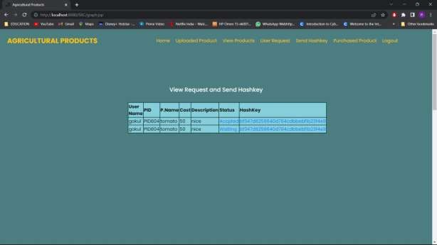

* 1. ***User Request Details Page***

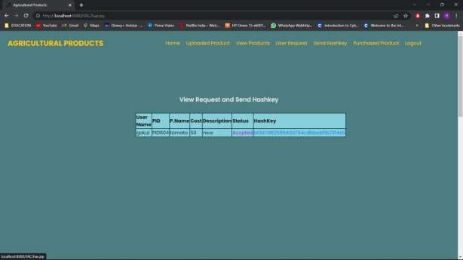

* 1. ***Generated Hash Key Page***

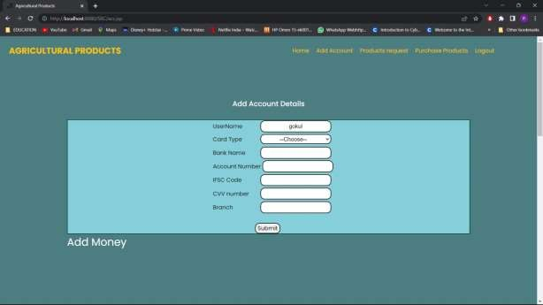

* 1. ***Adding Account Details Page***

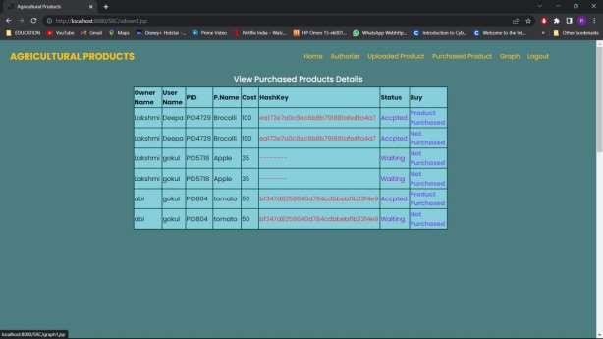

* 1. ***View Purchased Details Pag***

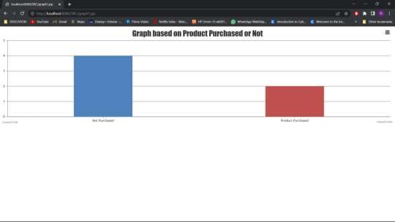

* 1. ***Graph Based on Product Page***

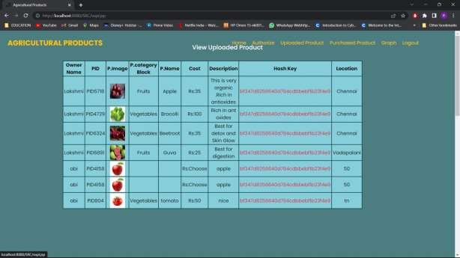

* 1. ***View Uploaded Product Page***

# Conclusions

In this project, we designed and implemented the traceability system of fruits and vegetables agricultural products based on the non-tampering and traceable characteristics of blockchain, and discussed the storage and query design of the system. To overcome the problems of high data load pressure and poor private security of the blockchain traceability system as the data grows, an on-chain and off- chain data storage method using ‘‘database + blockchain’’ is proposed. The public information displayed to consumers is stored in the supply chain to the local database, whose hash value by SHA256 algorithm was upload to the blockchain system. The private information encrypted by the CBC encryption algorithm is stored into the blockchain for sharing with relevant companies. The storage method proposed in this paper combines the actual situation, taking into account the need for encryption of corporate private information as well as the need for public supervision of supply chain public information, and reduce the pressure of data load on the chain. By storing the block number of the public information on the database, the association between the blockchain and the database is realized. The consumer obtains the public information from the database by scanning the QR code, and the system verifies the information according to the corresponding block number stored in the database to determine whether the product information has been tampered with. With the development of blockchain, in order to meet actual business needs, multi-chain is the future development direction. For future research, we will further explore the cross-chain technology between multiple chains and a new type of consensus mechanism suitable for traceability.

**References**

1. NBSC National Bureau of Statistics of China. (2019). National Data. [Online]. Available: https://data.stats.gov.cn/
2. G. Francois, V. Fabrice, and M. Didier, ‘‘Traceability of fruits and vegetables,’’ Phytochemistry, vol. 173, May 2020, Art. no. 112291, doi: 10.1016/j.phytochem.2020.112291.
3. J. Hu, X. Zhang, L. M. Moga, and M. Neculita, ‘‘Modeling and implementation of the vegetable supply chain traceability system,’’ Food Control, vol. 30, no. 1, pp. 341–353, Mar. 2013, doi: 10.1016/j. foodcont.2012.06.037.
4. W. Li, S. M. Pires, Z. Liu, X. Ma, J. Liang, Y. Jiang, J. Chen, J. Liang, S. Wang, L. Wang, Y. Wang, C. Meng, X. Huo, Z. Lan, S. Lai, C. Liu, H. Han, J. Liu, P. Fu, and Y. Guo, ‘‘Surveillance of foodborne disease outbreaks in China, 2003–2017,’’ Food Control, vol. 118, Dec. 2020, Art. no. 107359, doi: 10.1016/j.foodcont.2020. 107359.
5. Desai N A, A. Anyoha, L. C. Madoff, and B. Lassmann, ‘‘Changing epidemiology of listeriamonocytogenes outbreaks, sporadic cases, and recalls globally: A review of ProMED reports from 1996 to 2018,’’ Int. J. Infectious Diseases, vol. 84, pp. 48–53, Jul. 2019, doi: 10.1016/j.ijid.2019.04.021.