**A Novel Smart Assistive Aid for the Visually Impaired using Yolo V7**

**R.Leena Sri**

**Associate Professor Department of Computer Science and**

**Engineering Thiagarajar College of Engineering**

**Madurai, India**

[rlsit@tce.edu](mailto:rlsit@tce.edu)

**S. Madhava Ramanujam**

**UG Student**

**Department of Computer Science and Engineering**

**Thiagarajar College of Engineering**

**Madurai, India**

[**madhavaramanujam@student.tce.edu**](mailto:madhavaramanujam@student.tce.edu)

**M. Pranav Elumalai**

**UG Student**

**Department of Computer Science and Engineering**

**Thiagarajar College of Engineering Madurai, India** [**pranav@student.tce.edu**](mailto:pranav@student.tce.edu)

**S.P.Renish Gandhi**

**UG Student**

**Department of Computer Science and Engineering**

**Thiagarajar College of Engineering Madurai, India** [**renish@student.tce.edu**](mailto:renish@student.tce.edu)

**Visually Impaired people need an assistance all day every day for their mobility and survival. This paper offers a suggestion for creating a smart system that can help persons who are visually impaired in their regular occurrences. Those who are visually impaired confront difficulties in walking and navigating themselves in a new environment. Other difficulties include finding obstacles and recognizing people. This paper suggests a "Smart Assistive Aid System" to counteract this circumstance. This system is a voice-activated system that would guide a person with vision loss through daily tasks. The device combines and incorporates many technologies that are already available. This is achieved by using the YOLO V7 Tiny model for the purpose of the computer vision model. The novelty of this work is that, the visually impaired will get alerts regarding the distance between the obstacles. All the devices are powered by the Nvidia Jetson development kit.**

**Keywords:**Obstacle detection, computer vision, YOLO V7.

1. **INTRODUCTION (Font-Times New Roman, Bold, Font Size -12)**

**According to the World Health Organization’s latest reports, there are approximately 39 million completely visually impaired people worldwide and 76 million with low visual abilities. This number is expected to increase as the global population ages and the prevalence of conditions that cause the visually impaired, such as diabetic retinopathy and age- related macular degeneration, increases. Visually Impaired people are individuals who have no or limited vision. They face various challenges in their daily lives, including limited mobility and access to information[5], as well as social stigma and lack of employment opportunities. Additionally, they often have to rely on assistive technologies and support from others to navigate their environment and complete tasks that may be difficult or impossible for them to do on their own. Despite these challenges, many visually impaired people lead fulfilling lives and work to break down barriers and improve accessibility for themselves and others with disabilities. Visually impaired individuals always rely on other individuals for their day-to-day indoor and outdoor activities. Visually impaired[7] people are now being assisted using canes, guide dogs, echolocation, and human guides, and some visually impaired people are using their memory of a familiar environment to walk. Different visually impaired individuals may use a combination of these techniques or may prefer one method over the others. The most effective technique for a particular visually impaired person depends on many factors, including their personal preference and the environment in which they are walking. There are various technological[3] [6] aids that help visually impaired people. They include a Talking navigation system, GPS, Audio Description device, Braille Displays, and some smartphone apps that are designed specifically for the mobility of visually impaired individuals. These technologies can greatly improve the independence and mobility of visually impaired individuals and help them navigate their environment more effectively. technologies or may choose not to use them for personal or financial reasons.**

1. **METHODOLOGY**

**There were challenges in the above-mentioned works such as the system being expensive, not accurate, and involving some complex technological aids.**

**The Smart Assistive Aid System for visually impaired individuals typically involves a wearable device with a camera and sensors that capture visual information and convert it into auditory or tactile feedback. The device may use computer vision and machine learning algorithms to recognize objects[8][9] and people, read text, and detect obstacles or hazards. The feedback is then delivered through bone-conduction headphones or vibration motors, allowing the user to interpret their surroundings without relying on vision. Some smart eye devices may also include GPS and navigation features to help users navigate unfamiliar environments.**

EXPERIMENTAL SETUP

1. *Methodology*

The Smart Eye consists of Jetson Nano as a System on Chip (SoC) with a camera, USB Audio adapter, and Headphones to assist the Visually Impaired by delivering Voice commands. The Linux Operating System will be present in the SD card present in the Jetson Nano[7]. The Portable Jetson Nano device will be powered by a Power bank to take it anywhere they wish. Headphones and cameras will relate to Jetson Nano to calculate the distance between the source and the object to provide correct navigation to the visually impaired. [4][7][10]

1. *Jetson Nano Kit*

Jetson Nano is a small and powerful single-board computer developed by NVIDIA, designed for AI and robotics applications. The Jetson Nano is particularly useful for running AI models in edge devices, enabling real-time processing and analysis of data without relying on a cloud or remote server.

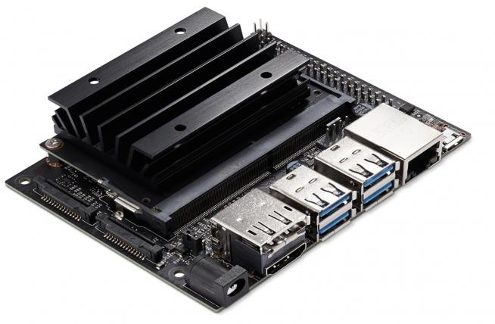

Fig.1. Jetson Nano Developer Kit

1. *Webcam*

Web Cam will be attached to one of the ports present in the Jetson Nano device. Focal length configuration will be done on the Webcam for the perfect capturing of images. This is done to capture the depth of the objects in the real-time image or videos[8] [9]. The focal configuration of a webcam refers to the adjustments that can be made to the camera's focus to get clear, sharp images. Most webcams have a fixed-focus lens that is optimized for capturing images at a specific distance. However, some webcams may allow for manual or automatic adjustments to the focus.

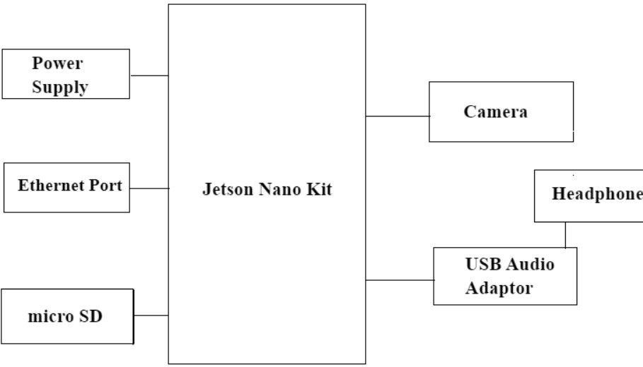

Fig.2. Block Diagram

1. *USB Audio Adapter and Headphone*

A USB adapter with a 3.5mm jack is a device that allows you to connect a 3.5mm audio device, such as headphones or speakers, to a USB port on a computer or other device. The USB adapter typically has a female 3.5mm jack and a male USB connector[9] [10]. When the adapter is connected to a USB port, it receives power from the USB port and converts the digital audio signal from the device into an analog signal that can be output through the 3.5mm jack. This enables you to listen to audio from your computer or another device through your headphones or speakers that have a 3.5mm jack, without requiring a dedicated audio port on your device. Since Jetson Nano doesn’t have an inbuilt 3.5mm Audio Jack, a USB Audio converter with a 3.5 mm Jack will be used to give Voice commands at right time to guide the Visually Impaired at the right time.

**3.WORKING OF SMART ASSISTIVE AID**

1. *Work Flow of the Smart Assistive Aid*

The YOLO V7 – tiny is a pre-trained model that is being used as the computer vision algorithm. The model is loaded into the Jetson Nano Developer kit[15][16][17][18][19]. The system then predicts the objects and calculates the distance of the object from the point of view of the visually impaired. The system then predicts and suggests to take a left or right using the detected objects as a voice command which is converted from text to speech using the Google text-to- speech algorithm.

1. *Smart Assistive Aid – Approach*

The entire problem relies on the Jetson Nano Board. Jetson Nano powered by Linux Operating System has inbuilt support for Python which will make the system lighter to perform tasks very faster. An object detection model is a type of machine learning model that identifies and localizes objects within an image or video. The model typically consists of a convolutional neural network[12][14][15] that extracts features from the input image, followed by a region proposal network that suggests candidate object locations. Object detection models are widely used in a variety of applications such as autonomous driving, surveillance, and image search. Some popular object detection models include YOLO (You Only Look Once), Faster R-CNN (Region- based Convolutional Neural Network), and SSD (Single Shot Detector)

The Camera connected with Jetson Nano will identify the objects with the help of the YOLOv7 Tiny object detection model which will help us to capture and identify objects in higher frames per second in order to avoid lags. YoloV7 Tiny is a computer vision model for real-time object detection, and it is a smaller and faster version of the YOLO (You Only Look Once) algorithm. YoloV7[9] Tiny uses a smaller neural network architecture compared to the full YoloV7 model, which results in faster processing and lower memory usage[15][16] [17] [18]. Despite being smaller, YoloV7 Tiny can still detect multiple objects in an image or video stream with high accuracy and is suitable for embedded or low- power devices[1][8][9][10]. YoloV7 Tiny is a popular choice for many real-time object detection applications, including surveillance, robotics, and autonomous vehicles. So YOLOv7 Tiny algorithm will be suitable for Indoor Environments. This will assist Visually Impaired people to navigate inside a new Indoor Environment without any fear.

[4] Regarding accuracy, YOLO v7 performs well compared to other object detection algorithms. It achieves an average precision of 37.2% at an IoU (intersection over union) threshold of 0.5 on the popular [COCO dataset,](https://www.v7labs.com/blog/coco-dataset-guide) which is comparable to other state-of-the-art object detection algorithms.

The Machine Learning Model along with Artificial Intelligence will calculate the distance between the source (user) and the Obstacle (Object detected in the Camera) to assist the Visually Impaired. With Depth Learning, the real- time images are classified into 2D images in Black and White format which will correctly analyze the distance between the source and the object. Now to assist Visually Impaired people, we need to attach a Headphone to Jetson Nano to Provide a Voice assisted Navigation gestures. With the help of the YOLOv7 Tiny algorithm, the obstacles will be identified and the distance between them will be calculated with Depth Learning. With the combination of both, The Smart eye model will be able to guide the visually impaired by commanding them to move right or left at a particular distance.

The libraries such as imutilis, cv2[14][15][16], and NumPy are imported into the program. The distance of the object is calculated using Triangle Similarity Theorem. The formula is,

D = (F x W) / P 🡪 (Eqn 1)

Where W is the Known Width, F is Focal Length, P is per Width, and D is the Distance to be calculated.

The text-to-speech conversion is done using Google Text to Speech. Google's Text-to-Speech (TTS) technology uses a natural-sounding voice to convert written text into spoken words[11]. The technology is based on deep neural networks, which are a type of artificial intelligence that mimics the way the human brain works. The technology is designed to be highly customizable, allowing users to select from a range of voices and adjust the speed and pitch of the speech. Google TTS has a wide range of applications, from helping visually impaired users to read web pages to providing speech feedback for voice-based applications.

**4. EXPERIMENTAL RESULTS**

The Jetson Nano Kit is powered using the power bank and the computer vision model is deployed. Using the webcam[10], we take a live feed of the inputs and look out for obstacles. If there is an obstacle, the individual is altered with a voice saying that “There’s an obstacle” and it also predicts the distance and takes the decision of turning left or right[20][18][16][4][7][10]

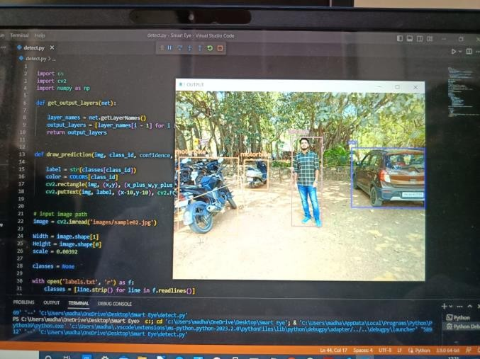Our Yolo v7 tiny model was tested and the results were very clear and this helps in spotting the obstacle using the bounding box that is bounded around the object.

Fig.3. Yolo V7 Tiny Model Results for Object Detection

Followed by which, the Jetson is connected to the Audio adapter from which the audio output is given using the headphones to the visually impaired individual.

1. **RESULTS AND DISCUSSIONS**

Overall, the choice of object detection model depends on the specific application and the trade-off between accuracy and speed. While YOLO[4][5][6] models are faster and easier to implement, R-CNN models can achieve higher accuracy at the cost of increased computation time. The recently introduced YOLOv7 offers a balance between accuracy and speed and may be a good choice for real-time object detection applications.

The integration of YOLOv7 with BlendMask is used to perform instance segmentation. Therefore, the YOLOv7 object detection model was fine-tuned on the MS COCO instance segmentation dataset and trained for 30 epochs. It achieves state-of-the-art real-time instance segmentation results.

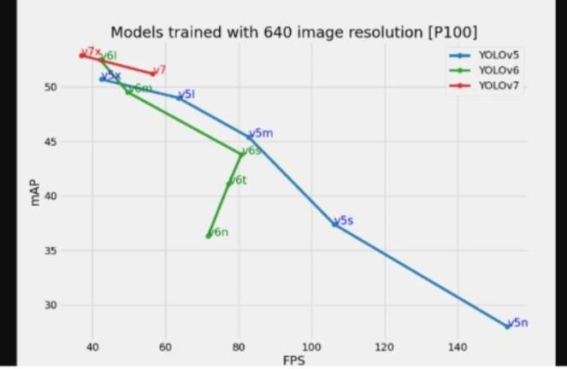

Fig.4. Comparison of YOLO v5,v6, and v7

**CONCLUSION**

The suggested system unifies the operation of the numerous modules, providing a versatile tool for those who are visually impaired. The gadget is made to be convenient and transportable. When obstructions are seen in the path, the device identifies the object and calculates the distance between them[20][18][16]. It also gives warnings. Based on the previously saved photographs, also aids in identifying certain things. It can also be carried in a pocket, which eliminates the requirement for the user to hold on to the object for an extended period like with sticks. Since the output is sent as voice commands through headphones, the output's clarity is great. Given that all data are supplied to the Jetson Nano development kit properly, we can expect the predictions to be accurate enough

ACKNOWLEDGMENT

We thank NVIDIA Jetson 2GB Grant for providing the necessary equipment required for implementing Smart Assistive Aid System for visually impaired people under the student’s internally funded project scheme.

1. **REFERENCES**
2. Mamatha C, Kumuda H R, Nethra P D, Rajashekar S A,” Virtual Eye for Visually impaired People using Deep Learning”, International Journal for Research in Applied Science & Engineering Technology, Volume 10 Issue VII July 2016.
3. Esra Ali Hassan and Tong Boon Tang, "Smart Glasses for Visually Impaired People”, International Conference on Computers Helping People with Special Needs, 2016.
4. Md. Razu Miah, Md. Sanwar Hussain, “A Unique Smart Eye Glass for Visually Impaired People”, International Conference on Advancement in Electrical and Electronic Engineering, November 2018.
5. Chien-Yao Wang, Alexey Bochkovskiy, and Hong-Yuan Mark Liao,” YOLOv7: Trainable bag-of-freebies sets new state-of-the-art for real-time object detectors”, Institute of Information Science, Academia Sinica, Taiwan, July 2016.

[5]Federica Barontini, Manuel G. Catalano, Lucia Pallottino, Barbara Leporini, and Matteo Bianchi, “Integrating Wearable Haptics and Obstacle Avoidance for the Visually Impaired in Indoor Navigation: A User-Centered Approach”, IEEE TRANSACTIONS

[6]World Health Organization, WHO (2014)., “Visual impairment and blindness - Fact Sheet N 282,” 2014, [Online]. Available: http://http:// [www.who.int/mediacentre/factsheets/fs282/en//,](http://www.who.int/mediacentre/factsheets/fs282/en//) Accessed: Nov. 30, 2016.

[7]European Forum Against Blindness, EFAB (September 2013), [Online]. Available: https://[www.euractiv.com/section/health-consumers/news/](http://www.euractiv.com/section/health-consumers/news/) single-eu-defini tion-of-blindness-could-help-save-billions- of-euros-study/.

[8] D. Dakopoulos and N. G. Bourbakis, “Wearable obstacle avoidance electronic travel aids for blind: a survey,” IEEE.

[9]R. Velazquez, “Wearable assistive devices for the blind,” in Wearable and Autonomous Biomedical Devices and Systems for Smart Environment. Berlin, Germany: Springer, 2010, pp. 331–349.

[10]H. SungMin, “Haptic aids for the visually impaired,” in Pervasive Haptics. Berlin, Germany: Springer, 2016, pp. 218–169.

[11]K. Moller, J. Moller, K. Arras, M. Bach, S. Schumann, and J. Guttmann, “Enhanced perception for visually impaired people evaluated in a real time setting,” in Proc. World Congr. Med. Phys. Biomed. Eng., 2009, pp. 283–286.

[12]M. R. Adame, J. Yu, K. Moller, and E. Seemann, “A wearable navigation aid for blind people using a vibrotactile information transfer system,” in Proc. Int. Conf. Complex Med. Eng., May 2013, pp. 13–18.

[13]Y. Wei, X. Kou, and M. C. Lee, “A new vision and navigation research for a guide-dog robot system in urban system,” in 2014 IEEE/ASME International Conference on Advanced Intelligent Mechatronics. IEEE, 2014, pp. 1290– 1295.

[14]V. V. Meshram, K. Patil, V. A. Meshram, and F. C. Shu, “An astute assistive device for mobility and object recognition for visually impaired people,” IEEE Transactions on Human-Machine Systems, vol. 49, no. 5, pp. 449–460, Oct 2019.

[15]Y. Wang and K. J. Kuchenbecker, “Halo: Haptic alerts for low-hanging obstacles in white cane navigation,” in 2012 IEEE Haptics Symposium (HAPTICS). IEEE, 2012, pp. 527– 532.

[16]B. Ando, S. Baglio, V. Marletta, and A. Valastro, “A haptic solution to ` assist visually impaired in mobility tasks,” IEEE Transactions on HumanMachine Systems, vol. 45, no. 5, pp. 641–646, 2015.

[17]M. H. A. Wahab, A. A. Talib, H. A. Kadir, A. Johari, A. Noraziah, R. M. Sidek, and A. A. Mutalib, “Smart cane: Assistive cane for visuallyimpaired people,” arXiv preprint arXiv:1110.5156, 2011.

[18]A. Kassim, T. Yasuno, H. Suzuki, H. Jaafar, and M. Aras, “Indoor navigation system based on passive rfid transponder with digital compass for visually impaired people,” Int. J. Adv. Comput. Sci. Appl., vol. 7, no. 2, pp. 604–611, 2016.

[19]S. Saegusa, Y. Yasuda, Y. Uratani, E. Tanaka, T. Makino, and J.-Y. Chang, “Development of a guide-dog robot: human–robot interface considering walking conditions for a visually handicapped person,” Microsystem Technologies, vol. 17, no. 5-7, pp. 1169–1174, 2011.

[20]A. Keyes, M. D’Souza, and A. Postula, “Navigation for the blind using a wireless sensor haptic glove,” in 2015 4th

Mediterranean Conference on Embedded Computing

**.**

