**Intelligent Vehicle Black Box using IoT**

O. Hemanth1, Mr. E.R. Ramesh2, Ms. Sarika Jain3, Dr. S. Geetha4

1M.Sc – CFIS, Department of Computer Science and Engineering, Dr. M.G.R Educational and Research Institute, Chennai 600 095, Tamilnadu, India

2,3Center of Excellence in Digital Forensics, Chennai 600 089, Tamilnadu, India

4Professor and Head, Department of Computer Science and Engineering, Dr. M.G.R Educational and Research Institute, Chennai 600 095, Tamilnadu, India

**Abstract**

Automobiles and computing technologies are creating a new level of data services in vehicles. The Automobile Black Box has functions similar to an airplane black box. It is used to analyze the cause of vehicular accidents and prevent the loss of life and property arising from vehicle accidents. This paper proposes a prototype of an Automobile Black Box System that can be installed into vehicles. The system aims to achieve accident analysis by objectively tracking what occurs in vehicles. The system also involves enhancement of security by preventing tampering of the Black Box data.

1. **Introduction**

A vehicle accident is one of the most important issues around the world. According to the World Health Organization, over one million people die every year due to transportation related accidents. Although various vehicle manufacturers have taken several steps to improve the safety of the vehicle, the problem remains for the above reasons. Due to the delay in medical aid, death rates are high, causing economic and social burdens for people involved. Like aircraft data recorders on a plane, "black box" technology now plays a major role in motor vehicle accident investigation. The black box is defined as an electronic device, which is used to record and store information in particular. We used the same concept in implementing a black box in the car for help. Here the black box is used to record and store vehicle acceleration, temperature, pressure, interruption values in real time and store the vehicle's driving history. We can analyze and monitor the driving conditions of the vehicle and the accident. We used an analog to digital converter (ADC) to collect analog values collected by the sensors and convert them into a digital value to feed into the microcontroller.

1. **Existing System**

As per the World Health Organization, a million people are dying everyday due to accidents. To take care of the issue in numerous nations, where the arrangement is being raised with the assistance of the vehicle Black Box. Not with standing a few missions the issue is as yet expanding step by step, such cases are smashed and drive, speed driving and inadequate rest. Due to the consistent work lately, the automation should further develop utilizing IoT.

***2.1 Existing System Disadvantages***

* There is no automatic monitoring of vehicles. In the event that any accident happens, it is challenging to track down the specific area.
* The automotive vehicles don't have a black box system.
* The accident information isn't stored in any spot.
* No pollution control of the vehicle.

1. **Proposed System**

The proposed system is planned to such an extent that the factual contrivance sends information to the IOT and this cycle is finished by ESP32 chip with detectors when an accident is met. Proposed frame utilizes an Arduino board that gives simple entrance to enter/ result and simple legs and simple consuming transferring of a program. To cover the different detectors, for illustration, temperature detector, gas detector, speed detector, vibration detector, GPS are associated with the Arduino board. Arduino board is associated with pall. I am exercising a microcontroller to cover vehicle boundaries. Speed test detector monitors the speed of the vehicle. The temperature detector and gas detector will cover the motor. Vibration detector will cover the vibration position of the vehicle. Assuming that any unusual condition is set up by these detectors, the area will be refreshed in the IOT runner. The result of the detectors is perused from Arduino and yield values are shown on TV. The information is stored in the pall; the given system is proposed in IoT.

1. **Proposed System Advantages**

* In the trend setting innovation every vehicle is monitored and the information is stored in memory.
* The information is persistently transferred to the cloud.
* Less time consumed.
* Inconvenience allowed to utilize.
* High accuracy.

1. **Literature Survey**

**A. Tsuge et.al,** the traffic control system was adopted on the Hanshin expressway in 1969 to maintain a smooth traffic flow and to ensure safety, comfortable and efficient transportation. Since then, the system has developed and expanded. We have installed four television cameras at a curved area on the expressway where motor vehicle accidents frequently occur, to experiment and verify whether accidents can be detected by processing the images taken by these cameras. As a result, we have found an effective method for detecting accidents or stationary vehicles. At present, we have developed a prototype system using 7 cameras at two locations for the detection. In this paper, we report on the method used and the experimental results

**Adnan Bin Faiz et.al,** vehicle accident is the paramount thread for the people's life which causes a serious wound or even dead. The automotive companies have made lots of progress in alleviating this thread, but still the probability of detrimental effect due to an accident is not reduced. Infringement of spFieed is one of the elementary reasons for a vehicle accident. Therewithal, external pressure and change of tilt angle with road surface blameworthy for this mishap. As soon as the emergency service could divulge about an accident, the more the effect would be mitigated. For this purpose, we developed an Android based application that detects an accidental situation and sends emergency alert message to the nearest police station and health care center. This application is integrated with an external pressure sensor to extract the outward force of the vehicle body. It measures speed and change of tilt angle with GPS and accelerometer sensors respectively on Android phone. By checking conditions, this application also capable of reducing the rate of false alarm.

**Tiago De Freitas Pereira et.al,** the task of Heterogeneous Face Recognition consists in matching face images that are sensed in different domains, such as sketches to photographs (visual spectra images), thermal images to photographs or near-infrared images to photographs. In this work we suggest that high level features of Deep Convolutional Neural Networks trained on visual spectra images are potentially domain independent and can be used to encode faces sensed in different image domains. A generic framework for Heterogeneous Face Recognition is proposed by adapting Deep Convolutional Neural Networks low level features in, so called, “Domain Specific Units”. The adaptation using Domain Specific Units allow the learning of shallow feature detectors specific for each new image domain. Furthermore, it handles its transformation to a generic face space shared between all image domains. Experiments carried out with four different face databases covering three different image domains show substantial improvements, in terms of recognition rate, surpassing the state-of-the-art for most of them. This work is made reproducible: all the source code, scores and trained models of this approach are made publicly available

**Iván García-Magariño et.al**, the Internet of vehicles (IoV) provides new opportunities for the coordination of vehicles for enhancing safety and transportation performance. Vehicles can be coordinated for avoiding collisions by communicating their positions when near to each other, in which the information flow is indexed by their geographical positions or the ones in road maps. Vehicles can also be coordinated to ameliorate traffic jams by sharing their locations and destinations. Vehicles can apply optimization algorithms to reduce the overuse of certain streets without excessively enlarging the paths. In this way, traveling time can be reduced. However, IoV also brings security challenges, such as keeping safe from virtual hijacking. In particular, vehicles should detect and isolate the hijacked vehicles ignoring their communications. The current work presents a technique for enhancing security by applying certain prioritization rules, using digital certificates, and applying trust and reputation policies for detecting hijacked vehicles. We tested the proposed approach with a novel agent-based simulator about security in IoT for vehicle-to-vehicle (V2V) communications (ABS-SecIoTV2V). The experiments focused on the scenario of avoidance of collisions with hijacked vehicles misinforming other vehicles. The results showed that the current approach increased the average speed of vehicles with a 64.2% when these are giving way to other vehicles in a crossing by means of IoT.

**Javier Galbally et.al,** thanks to Mr James Bond we are aware that diamonds are forever but, are fingerprints? It is well known that biometrics brings to the security field a new paradigm: unlike traditional systems, individuals are not identified by something that they have or they know, but by what they are. While such an approach entails some clear advantages, an important question remains: Is what we are today the same as what we will be tomorrow? The present paper addresses such a key problem in the fingerprint modality based on a database of over 400K impressions coming from more than 250K different fingers. The database was acquired under real operational conditions and contains fingerprints from subjects aged 0-25 years and 65-98 years. Fingerprint pairs were collected with a time difference which ranges between 0 and 7 years. Such a unique set of data has allowed us to analyse both the age and ageing effects, shedding some new light into issues like fingerprint permanence and fingerprint quality.

1. **Block Diagram**

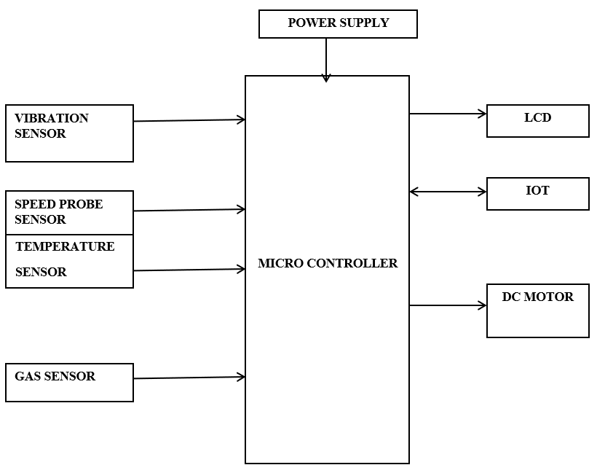

1. **Hardware Requirements**

* Micro Controller Vibration Sensor
* Speed Probe Sensor
* Gas Sensor
* Temperature Sensor
* LCD
* Driver Circuit
* DC Motor

1. **Software Requirements**

* Embedded C
* Arduino IDE

1. **Hardware Description**
   1. ***Power Supply***

The ac voltage, typically 220V rms, is connected to a transformer, which steps that ac voltage down to the level of the desired dc output. A diode rectifier then provides a full-wave rectified voltage that is initially filtered by a simple capacitor filter to produce a dc voltage. This resulting dc voltage usually has some ripple or ac voltage variation. A regulator circuit removes the ripples and also remains the same dc value even if the input dc voltage varies, or the load connected to the output dc voltage changes. This voltage regulation is usually obtained using one of the popular voltage regulator IC units.

* 1. ***Microcontroller: ESP32***

ESP32 is a series of low-cost, low-power system on a chip microcontroller with integrated Wi-Fi and dual-mode Bluetooth. The ESP32 series employs either a Tensilica Xtensa LX6 microprocessor in both dual-core and single-core variations, Xtensa LX7 dual-core microprocessor or a single-core RISC-V microprocessor and includes built-in antenna switches, RF balun, power amplifier, low-noise receive amplifier, filters, and power-management modules. ESP32 is created and developed by Espressif Systems, a Shanghai-based Chinese company, and is manufactured by TSMC using their 40 nm process.

* 1. ***IOT***

The Internet of things (IoT) is the network of everyday objects — physical things embedded with electronics, software, sensors, and connectivity enabling data exchange. Basically, a little networked computer is attached to a thing, allowing information exchange to and from that thing. Be it lightbulbs, toasters, refrigerators, flower pots, watches, fans, planes, trains, automobiles, or anything else around you, a little networked computer can be combined with it to accept input (especially object control) or to gather and generate informational output (typically object status or other sensory data). This means computers will be permeating everything around us — ubiquitous embedded computing devices, uniquely identifiable, interconnected across the Internet. Because of low-cost, networkable microcontroller modules, the Internet of things is really starting to take off.

* 1. ***DC Motor***

The relationship between torque vs speed and current is linear as shown left; as the load on a motor increase, Speed will decrease. The graph pictured here represents the characteristics of a typical motor. As long as the motor is used in the area of high efficiency (as represented by the shaded area) long life and good performance can be expected. However, using the motor outside this range will result in high temperature rises and deterioration of motor parts. A motor's basic rating point is slightly lower than its maximum efficiency point. Load torque can be determined by measuring the current drawn when the motor is attached to a machine whose actual load value is known.

* 1. ***Temperature Sensor***

The LM35 series are precision integrated-circuit temperature devices with an output voltage linearly-proportional to the Centigrade temperature. The LM35 device has an advantage over linear temperature sensors calibrated in Kelvin, as the user is not required to subtract a large constant voltage from the output to obtain convenient Centigrade scaling. The LM35 device does not require any external calibration or trimming to provide typical accuracies of ±¼°C at room temperature and ±¾°C over a full −55°C to 150°C temperature range. The low-output impedance, linear output, and precise inherent calibration of the LM35 device makes interfacing to readout or control circuitry especially easy.

* 1. ***Gas Sensor***

In current technology scenario, monitoring of gases produced is very important. From home appliances such as air conditioners to electric chimneys and safety systems at industries monitoring of gases is very crucial. Gas sensors spontaneously react to the gas present, thus keeping the system updated about any alterations that occur in the concentration of molecules at gaseous state. The gas sensor module consists of a steel exoskeleton under which a sensing element is housed.

This sensing element is subjected to current through connecting leads. This current is known as heating current through it, the gases coming close to the sensing element get ionized and are absorbed by the sensing element. This changes the resistance of the sensing element which alters the value of the current going out of it. The connecting leads of the sensor are thick so that sensor can be connected firmly to the circuit and sufficient amount of heat gets conducted to the inside part. They are casted from copper and have tin plating over them.

* 1. ***Speed Sensor***

Speed Sensor is an electro-mechanical device used to measure the acceleration of the object, it's the dimension of change in the velocity or speed divided by time.Speed sensors are used to measure the rotating speed within devices. numerous vehicles demand speed sensors including; automotive vehicles, aerospace vehicles, off- highway & construction vehicles, railway and military vehicles. Within these vehicles, the specific operations are crankshaft transmission speed, engine speed, dynamometers, fan control, test equipment and engine control.

* 1. ***Vibration Sensor***

The vibration sensor is also called a piezoelectric sensor. These sensors are flexible devices which are used for measuring various processes. This sensor uses the piezoelectric effects while measuring the changes within acceleration, pressure, temperature, force otherwise strain by changing to an electrical charge. This sensor is also used for deciding fragrances within the air by immediately measuring capacitance as well as quality. The working principle of vibration sensor is a sensor which operates based on different optical otherwise mechanical principles for detecting observed system vibrations. The sensitivity of these sensors normally ranges from 10 mV/g to 100 mV/g, and there are lower and higher sensitivities are also accessible. The sensitivity of the sensor can be selected based on the application. So, it is essential to know the levels of vibration amplitude range to which the sensor will be exposed throughout measurements.

* 1. ***16×2 LCD***

LCD stands for liquid crystal display. They come in many sizes 8x1, 8x2, 10x2, 16x1, 16x2, 16x4, 20x2, 20x4, 24x2, 30x2, 32x2, 40x2 etc. Many multinational companies like Philips Hitachi Panasonic make their own special kind of LCD'S to be used in their products. All the LCD'S performs the same functions (display characters numbers special characters ASCII characters etc). Their programming is also same and they all have same 14 pins (0-13) or 16 pins (0 to 15). Alphanumeric displays are used in a wide range of applications, including palmtop computers, word processors, photocopiers, point of sale terminals, medical instruments, cellular phones, etc.

1. **Software Description**
   1. ***Embedded C***

Embedded C is designed to bridge the performance mismatch between Standard C and the embedded hardware and application architecture. It extends the C language with the primitives that are needed by signal-processing applications and that are commonly provided by DSP processors. The design of the support for fixed-point data types and named address spaces in Embedded C is based on DSP-C. DSP-C [1] is an industry-designed extension of C with which experience was gained since 1998 by various DSP manufacturers in their compilers. For the development of DSP-C by ACE (the company three of us work for), cooperation was sought with embedded-application designers and DSP manufacturers.

* 1. ***Arduino Software (IDE)***

The Arduino Integrated Development Environment - or Arduino Software (IDE) - contains a text editor for writing code, a message area, a text console, a toolbar with buttons for common functions and a series of menus. It connects to the Arduino hardware to upload programs and communicate with them.

1. **Screenshots**

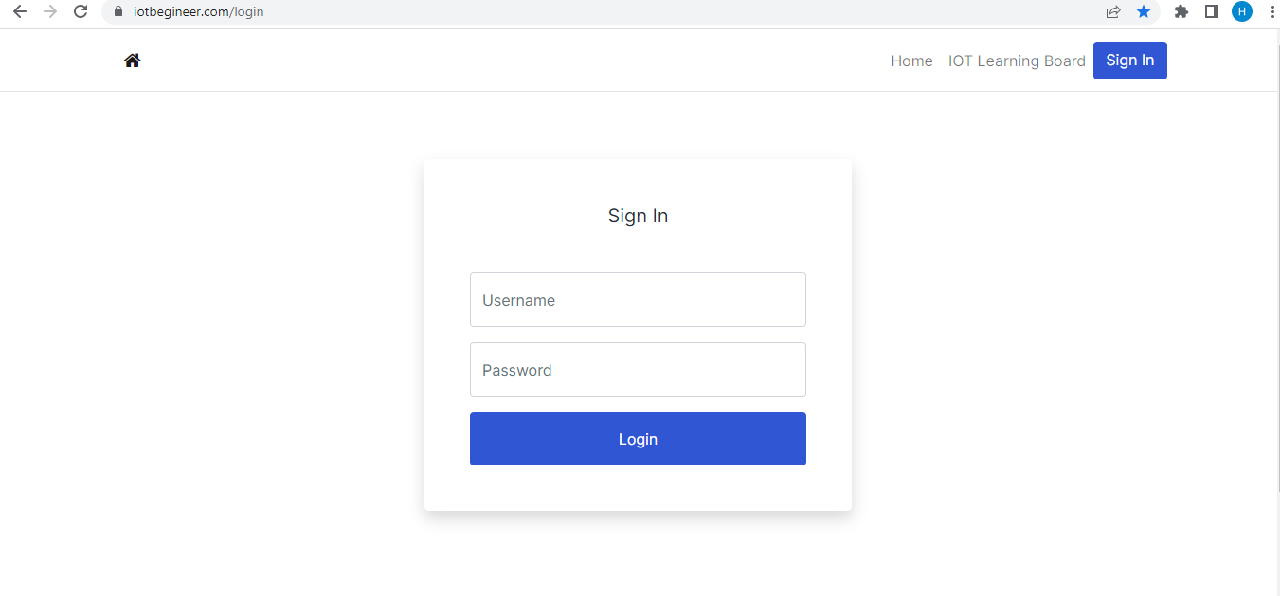

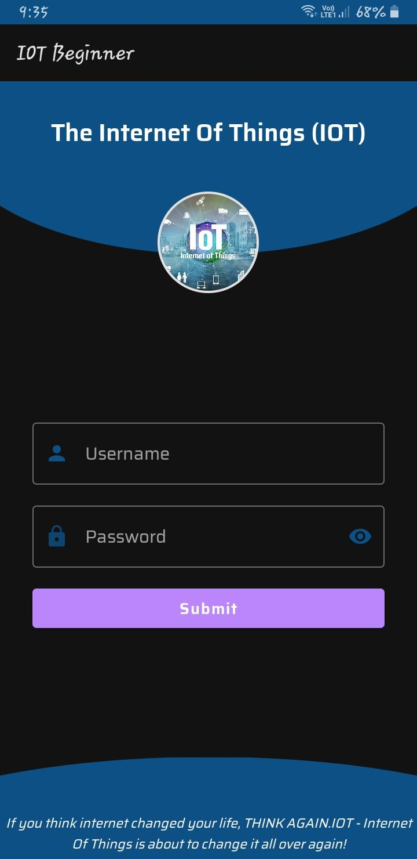

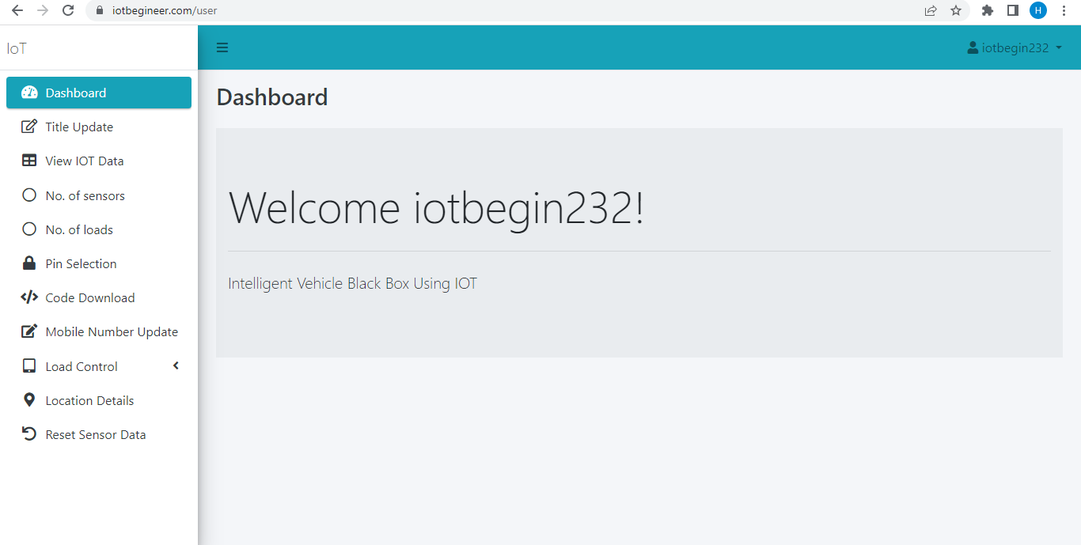

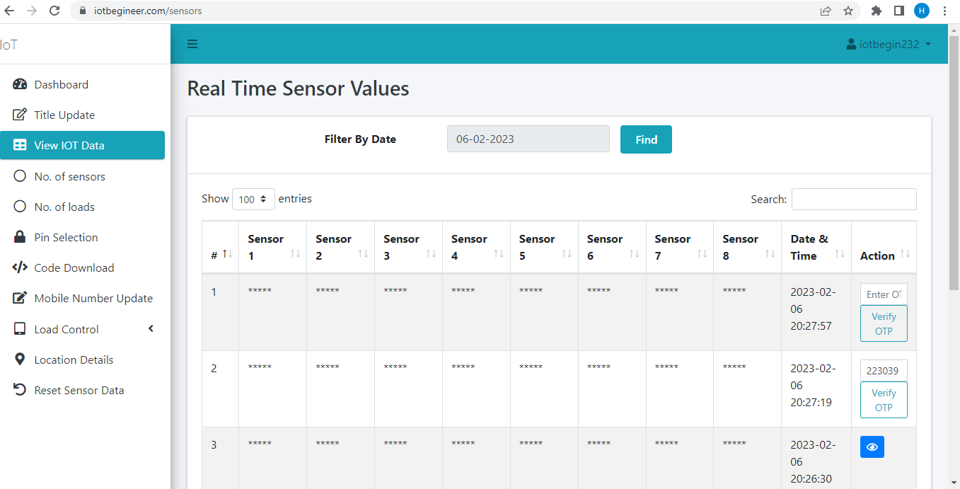

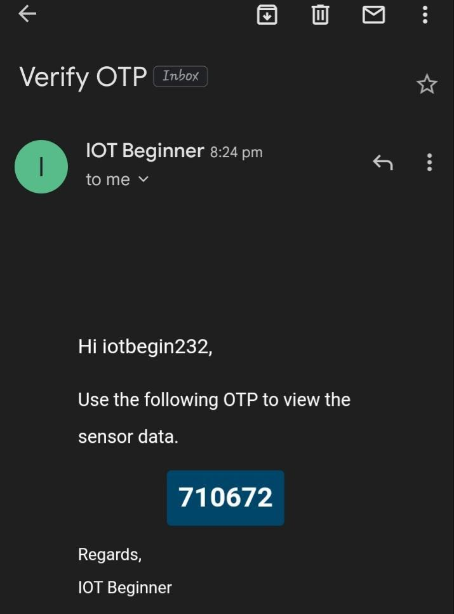

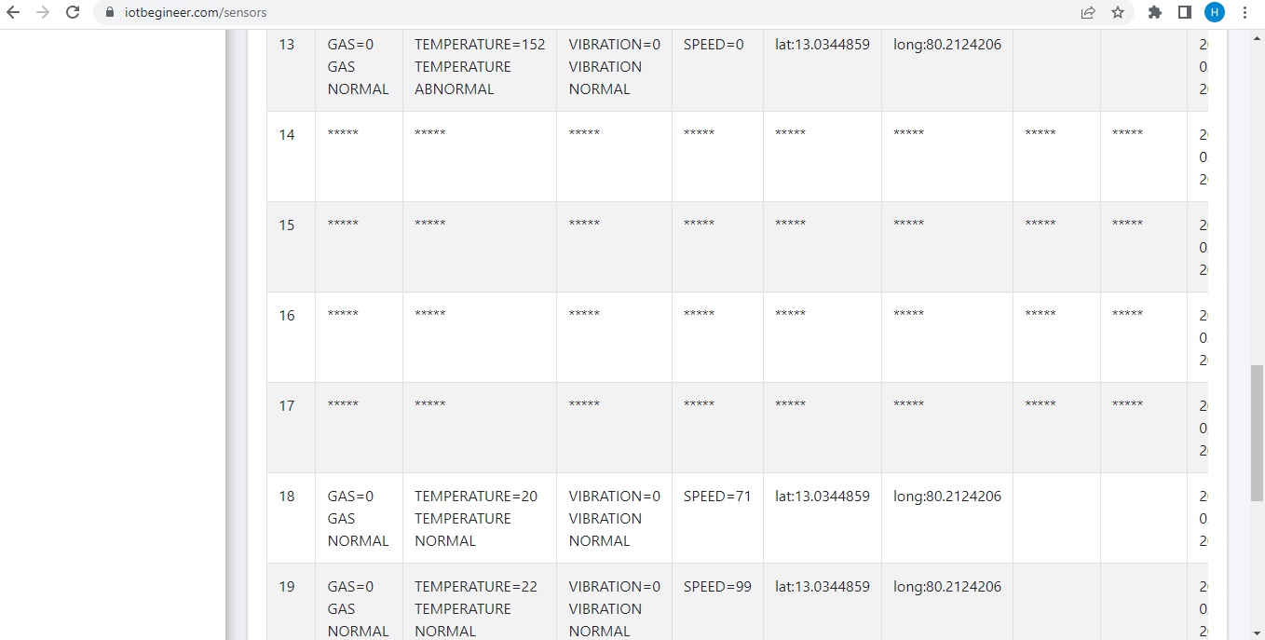

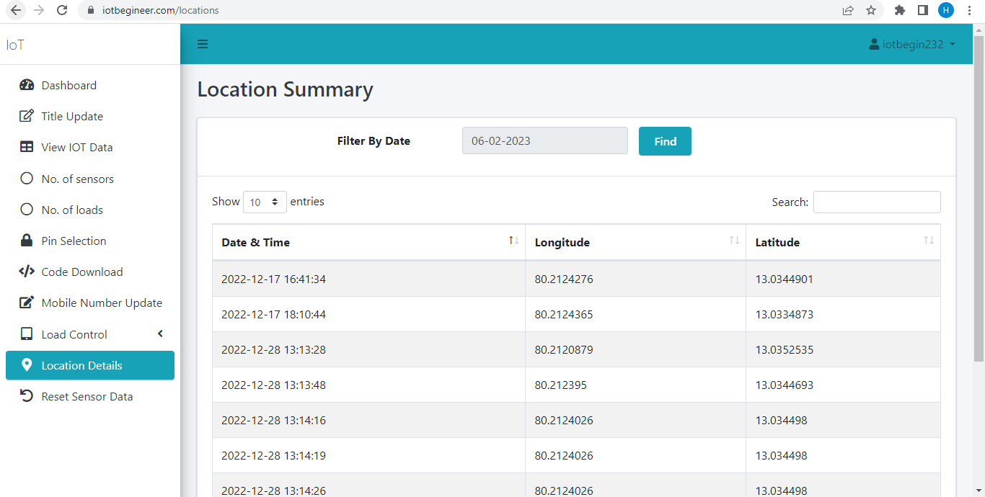

1. **Hardware Module**

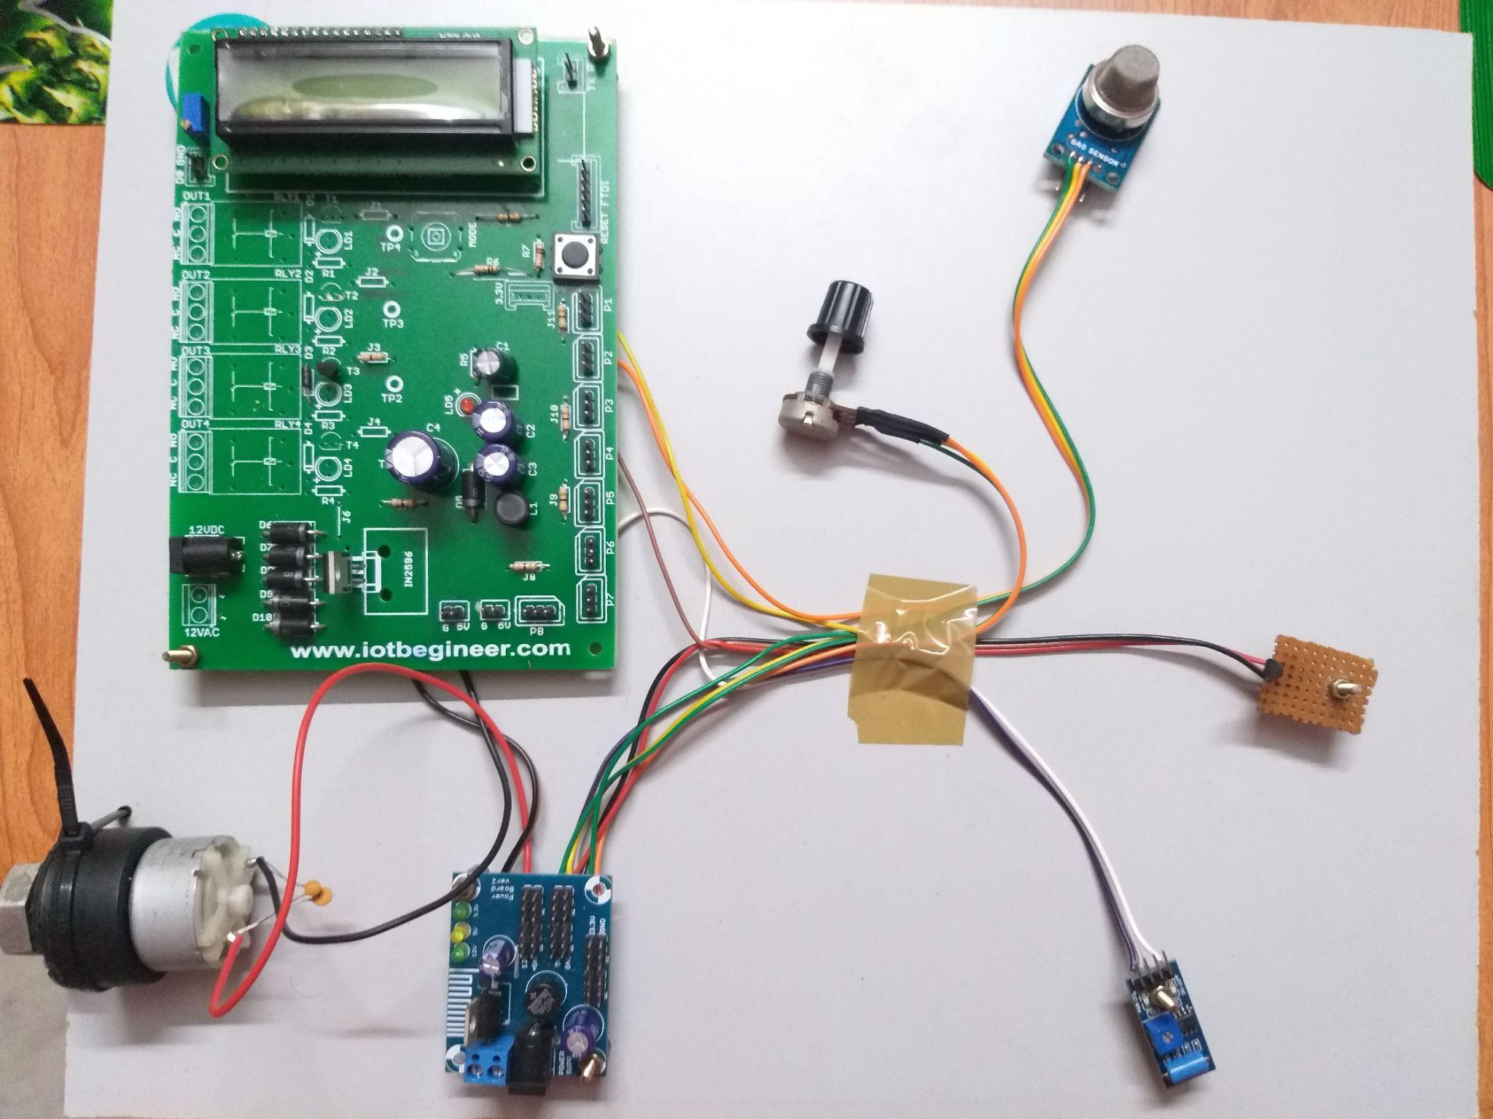

1. **Conclusion**

In this modern era, IoT Technology is improving rapidly to help the issues mostly concern the world. This paper mainly focuses on alerting the driver from the Collision situations and using Cloud Computing Services, the location can be easily traced. Our contribution is that we proposed a low power micro-controller which can be used in the hardware implementation as its main controller in the automation of this device. with the meaningful support of the Embedded systems, IoT and Cloud computing, we strongly believe that Intelligent Vehicle Black Box using IoT will be reliable, power efficient in the real time applications.

**References**

[1]. L. Chen, D. Zhang, G. Pan, X. Ma, D. Yang, K. Kushlev, W. Zhang, and S. Li, “Bike Sharing Station Placement Leveraging Heterogeneous Urban Open Data,” in In Proc UbiComp’15, pp. 571–575.

[2]. L. C. Yifan Zhao, “GreenBicycling: A Smartphone-Based Public Bicycle Sharing System for Healthy Life,” pp. 1335– 1340, 2013.

[3.] D. Zhang, B. Guo, and Z. Yu, “The emergence of social and community intelligence,” Computer, vol. 44, no. 7, pp. 21–28, 2011. [4] H. W. Engl, M. Hanke, and A. Neubauer, Regularization of

[4]. P.Dileep Kumar .G.N.Kodanda Ramaiah *,*A.Subramanyam, M.Dharani, “A Solar Powered SmartHelmet with Multi features”, International Journal ofEngineering Inventions, Volume 4, Issue 10 [June 2015]Pp: 06-11.

[5].Pritpal Singh, Tanjot Sethi, Bibhuti Bhusan Biswal, SujitKumar Pattanayak, “A Smart Anti-Theft System forVehicle Security”, International Journal of Materials,Mechanics and Manufacturing, Vol. 3, No. 4, November2015.

[6]. P.Dileep Kumar, G.N.Kodanda Ramaiah, “A Solar Powered Smart Helmet with Multi features”, International Journal of Engineering Inventions e-ISSN: 2278-7461, p-ISSN: 2319-6491 Volume 4, Issue 10 [June 2015] PP: 06-11.

[7]. Argade Geetanjali Arjun1, Moresh Mukhedkar, H. M. Abdar, “Development of an Intelligent Exercise Platform for Rehabilitation in Parkinson’s Disease”, PhD Dissertation, EECS Department, Case Western Reserve University, August 2014.

[8] H. M. Abdar, A. L. Ridgel, F. M. Discenzo, R. Phillips, B. L. Walter K. A. Loparo, “Test and Validation of a Smart Exercise Bike for Motor Rehabilitation in Individuals with Parkinson’s Disease”, IEEE Transactions on Neural Systems and Rehabilitation Engineering, to be published.

PAPER PUBLISHING PURPOSE