**IOT Based Smart Parking System**

V. Hariharan1, Mr. D. Sathya srinivas2, Ms. Sarika Jain3, Dr. S. Geetha4

1M.Sc – CFIS, Department of Computer Science and Engineering, Dr. M.G.R Educational and Research Institute, Chennai 600 095, Tamilnadu, India

2,3Center of Excellence in Digital Forensics, Chennai 600 089, Tamilnadu, India

4Professor and Head, Department of Computer Science and Engineering, Dr. M.G.R Educational and Research Institute, Chennai 600 095, Tamilnadu, India

**Abstract**

An efficient and smart way to automate the management of a parking system that allocates an efficient parking space using Internet of Things technology. IoT provides wireless access to the system and the user can monitor the availability of the parking space. With the increase in the number of vehicles in metropolitan cities, traffic congestion is the major problem we face. This post aims to solve this problem. The user usually wastes time and effort searching for the availability of a free space in the designated parking lot. Parking information is sent to the user via notifications. This minimizes the user's waiting time when searching for a parking space. RFID technology is used to prevent car theft.

Keyword: RFID, Arduino IDE, IOT Module, IR Sensor, cloud database.

1. **Introduction**

Internet of thing (IoT) has the ability to transfer data through network without involving human interactions. IoT allows user to use affordable wireless technology and also helps the user to transfer the data into the cloud. IoT helps the user to maintain transparency. The idea of IoT started with the identity of things for connecting various devices. These devices can be controlled or monitored through computers over internet. IoT contains two prominent words “Internet” and “Things”, where Internet is a vast network for connecting servers with devices. Internet enables the information to be sent, receive or even communicate with the devices. The parking problem causes air pollution and traffic congestion. In today’s scenario, parking space is hard to search in a day-to-day life for the people. According to the recent survey, there will be a rapid increase in the vehicle’s population of over 1.6 billion around 2035. Around one million barrels of world’s oil is being burnt every day. Thus, smart parking system is the key solution to reduce the waste stage of the fuel. The solution for the problems that is being raised. The smart parking can be a solution to minimise user’s time and efficiency as well as the overall cost of the fuel burnt in search of the parking space. In this, the data is collected from the sensor and through analysing and processing, the output is obtained. This data gets transmitted in the devices which extracts the relevant information and sends it to the Arduino device which gives the command instruction for the data to the particular devices simultaneously. Arduino sends the signal to the servo motor along with IOT module which further gives instructions and notification to the user. When the user enters in the parking area, RFID card allotted to the registered user is scanned by the reader module thus ensuring the security of the user identity. This enables the user to get the information of the available parking space as well as SMS notification to the registered user’s mobile number. It consists of three parts where first part is the parking area which include Arduino devices along with IR Sensor. The user interacts with the parking area with the help of these devices. The second section of the paper includes the cloud web services which act as a mediator between the user and the car parking area. The cloud is updated according to the availability of parking area. The cloud service is administered by the admin but it can also be viewed by the user to check the availability. The third section of the paper is the user side. The user gets notified for the availability via SMS through IOT module. The user interacts with the cloud as well as parking area. The user gets the notification when the parking availability is full which saves the time for the user.

1. **Existing System**

Currently, several states have records that clients can obtain stop region data through the web. This framework can provide the client with data about the parking space, but it will not be able to tell which parking space is empty and engaged. Thus, such a framework cannot prudently deal with this problem. The vehicle rises along a computer-controlled mechanical structure that naturally guides the vehicle to a specific parking spot when the vehicle enters the stage. This framework cannot be implemented by medium malls, cinemas as it may cost them a huge amount. In many public places, the frame only shows accessibility, but cannot show the specific space and path to open accessible. Subsequently, it is necessary to intelligently find a way to an empty place.

1. **Proposed System**

The proposed system is very much similar to many online reservation systems where you are allowed to book prior to your arrival at the destination.

* The user first opens his app/website and enters the destination of his choice.
* Then he proceeds to pick the tentative arrival time and also the amount of time for which he wants to book the slot.
* Once he reaches the destination and checks in at the chosen time, the slot and amount get reduced from his account (online wallet) accordingly.
* When he exits, the sensor notices that there is a state change from blocked to vacant and sends a notification to the server, which updates the database.
* If the user wants to spend more time than the specified booking time, he has the option to extend his time slot through the app by a certain amount of time.

1. **Future Enhancement**

An abandonment framework based on image processing can be done so that we can store subtleties and images of vehicles on a cloud server to recognize all acts of neglect or reduce vehicle break-ins in abandonment areas.

1. **Literature Survey**

This paper depicts a web of things (IOT)- based leaving detecting framework that sends a hearty open air vehicle restriction and acknowledgment strategies. Despite the fact that, stopping inhabitancy checking frameworks have gained a significant headway, shrewd stopping installment is seldom concentrated on in savvy stopping research. This paper proposes an extraordinary failure cost sensor framework permitting ongoing stopping inhabitancy checking alongside stopping installment without requiring any client/driver cooperation. The proposed on-board vehicle handset gadget (VTD) sensor, will be sent without putting in new parts on each parking garage. It has benefits regarding recognition and instalment dependability, and diminished cost by decreasing the framework intricacy, foundation venture, and battery substitution cost. A powerful vehicle acknowledgment and leaving inhabitancy observing is accomplished utilizing two-overlap detecting approach. It is a succession of movement locator and worldwide route satellite framework (GNSS) detecting strategies. The sensor is set off when the vehicle is inside a leaving region because of a proposed radio recurrence (RF) awaken procedure. As outcome, the energy utilization is upgraded and the VTD has a power saving plan with a power utilization as low as 20 μW at 3 V inventory. The VTD can be consistently coordinated into the savvy vehicular specially appointed networks (in VANETs).

Smart leaving frameworks commonly get data about accessible parking spots in a specific geographic region and cycle it progressively to work with vehicle leaving at accessible positions. One of the central points of contention that shrewd urban areas connect with is vehicle leaving offices and traffic the board frameworks. Web of Things (IOT) empowers the availability between encompassing natural things to web and makes simple to get to those things from any distant area. The compelling utilization of an IOT innovation can ease human existence in certain perspectives. The proposed work is one of the utilizations of blend of IOT and distributed computing innovation. The target of this work is to configuration, investigate and execute "IOT based sensor empowered vehicle leaving framework", this empowers the client to pre save leaving opening from remote spot with the assistance of versatile application. Verification of the legitimate booking is integrated to help substantial client. This framework is carried out utilizing minimal expense IR sensors, Raspberry-Pi model 3b for continuous information assortment, E-Stopping portable application. E-Stopping versatile application is created utilizing android studio having baseband variant of android 4.3.

1. **Block Diagram**

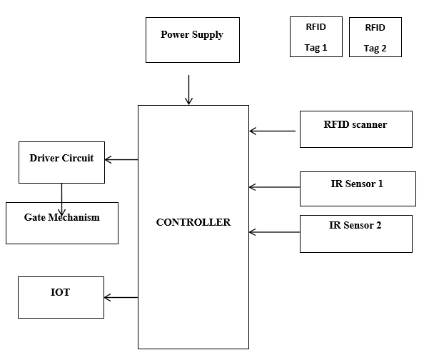

1. **Hardware Required**
   * + Micro controller
     + Driver Circuit
     + Motor
     + RFID reader
     + IoT module
2. **Software Required**
   * + Embedded C
     + Arduino IDE
3. **Hardware Description**
   1. ***Power Supply***

The ac voltage, typically 220V rms, is connected to a transformer, which steps that ac voltage down to the level of the desired dc output. A diode rectifier then provides a full-wave rectified voltage that is initially filtered by a simple capacitor filter to produce a dc voltage. This resulting dc voltage usually has some ripple or ac voltage variation.

A regulator circuit removes the ripples and also remains the same dc value even if the input dc voltage varies, or the load connected to the output dc voltage changes. This voltage regulation is usually obtained using one of the popular voltage regulator IC units.

* 1. ***Microcontroller: ESP32***

ESP32 is a series of low-cost, low-power system on a chip microcontroller with integrated Wi-Fi and dual-mode Bluetooth. The ESP32 series employs either a Tensilica Xtensa LX6 microprocessor in both dual-core and single-core variations, Xtensa LX7 dual-core microprocessor or a single-core RISC-V microprocessor and includes built-in antenna switches, RF balun, power amplifier, low-noise receive amplifier, filters, and power-management modules. ESP32 is created and developed by Espressif Systems, a Shanghai-based Chinese company, and is manufactured by TSMC using their 40 nm process.

* 1. ***IOT***

The Internet of things (IoT) is the network of everyday objects — physical things embedded with electronics, software, sensors, and connectivity enabling data exchange. Basically, a little networked computer is attached to a thing, allowing information exchange to and from that thing. Be it lightbulbs, toasters, refrigerators, flower pots, watches, fans, planes, trains, automobiles, or anything else around you, a little networked computer can be combined with it to accept input (especially object control) or to gather and generate informational output (typically object status or other sensory data). This means computers will be permeating everything around us — ubiquitous embedded computing devices, uniquely identifiable, interconnected across the Internet. Because of low-cost, networkable microcontroller modules, the Internet of things is really starting to take off.

* 1. ***Dc Motor***

The relationship between torque vs speed and current is linear as shown left; as the load on a motor increase, Speed will decrease. The graph pictured here represents the characteristics of a typical motor. As long as the motor is used in the area of high efficiency (as represented by the shaded area) long life and good performance can be expected. However, using the motor outside this range will result in high temperature rises and deterioration of motor parts. A motor's basic rating point is slightly lower than its maximum efficiency point. Load torque can be determined by measuring the current drawn when the motor is attached to a machine whose actual load value is known.

* 1. ***RFID Reader***

Radio frequency identification (RFID) uses electromagnetic fields to automatically identify and track tags attached to objects. The RFID system consists of a small radio transponder, a radio receiver and a transmitter. When triggered by an electromagnetic interrogation pulse from a nearby RFID reader, the tag transmits digital data, usually an identifying inventory number, back to the reader. This number can be used to track stock items.

* 1. ***16×2 LCD***

LCD stands for liquid crystal display. They come in many sizes 8x1, 8x2, 10x2, 16x1, 16x2, 16x4, 20x2, 20x4 ,24x2, 30x2, 32x2, 40x2 etc. Many multinational companies like Philips Hitachi Panasonic make their own special kind of LCD'S to be used in their products. All the LCD'S performs the same functions (display characters numbers special characters ASCII characters etc). Their programming is also same and they all have same 14 pins (0-13) or 16 pins (0 to 15). Alphanumeric displays are used in a wide range of applications, including palmtop computers, word processors, photocopiers, point of sale terminals, medical instruments, cellular phones, etc.

* 1. ***IR Sensor***

An infrared sensor is an electronic device that detects several parts of environmental factors. The IR sensor can measure the intensity of the object and also detect movement. For the most part, in the infrared range, each of the cells emits some type of warm radiation. These types of radiation are undetectable to our eyes, which can be distinguished by an infrared sensor. The manufacturer is only IR Driven (Light Radiating Diode) and the identifier is essentially an IR photodiode that is sensitive to IR light at the exact frequency that the IR drive emits. At the moment the IR light hits the photodiode, the protections and these resulting voltages change with respect to the magnitude of the IR light.

1. **Software Description**
   1. ***Embedded C***

Embedded C is designed to bridge the performance mismatch between Standard C and the embedded hardware and application architecture. It extends the C language with the primitives that are needed by signal-processing applications and that are commonly provided by DSP processors. The design of the support for fixed-point data types and named address spaces in Embedded C is based on DSP-C. DSP-C [1] is an industry-designed extension of C with which experience was gained since 1998 by various DSP manufacturers in their compilers. For the development of DSP-C by ACE (the company three of us work for), cooperation was sought with embedded-application designers and DSP manufacturers.

* 1. ***Arduino Software (IDE)***

The Arduino Integrated Development Environment - or Arduino Software (IDE) - contains a text editor for writing code, a message area, a text console, a toolbar with buttons for common functions and a series of menus. It connects to the Arduino hardware to upload programs and communicate with them.

1. **Software Experimental Results**

*Steps to Verify the Code*

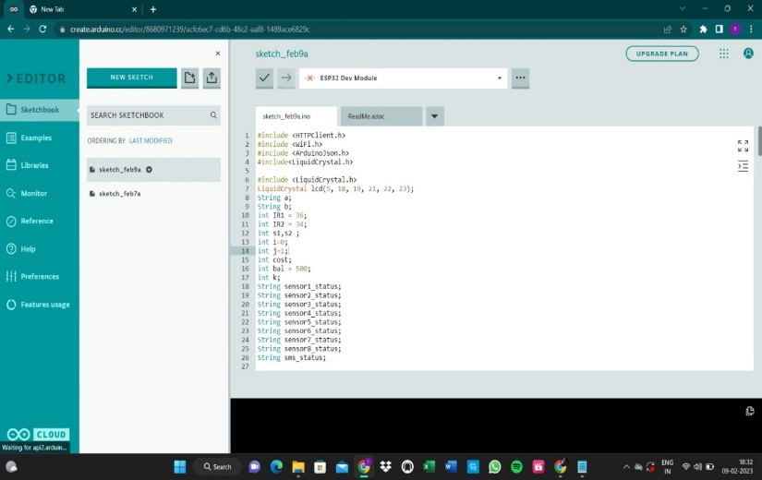

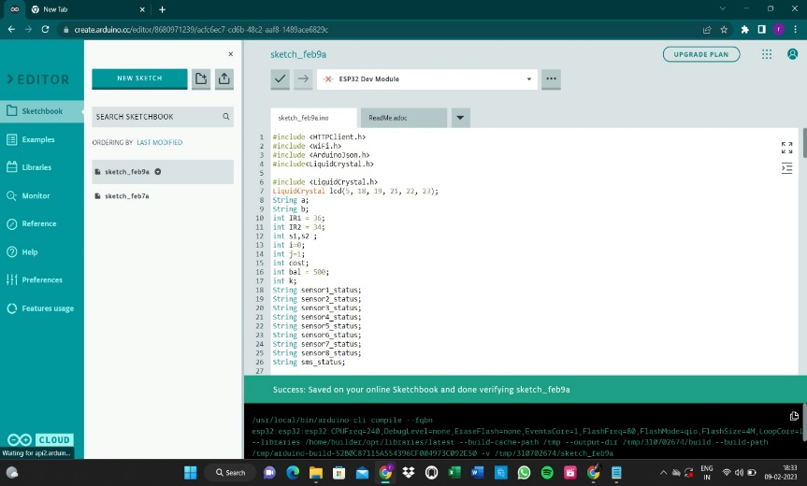

1. **Hardware Experimental Results**

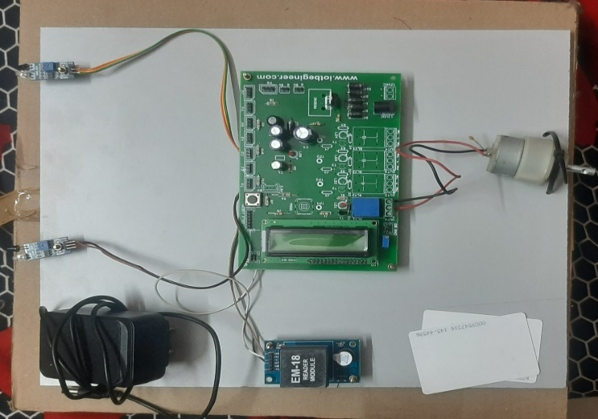

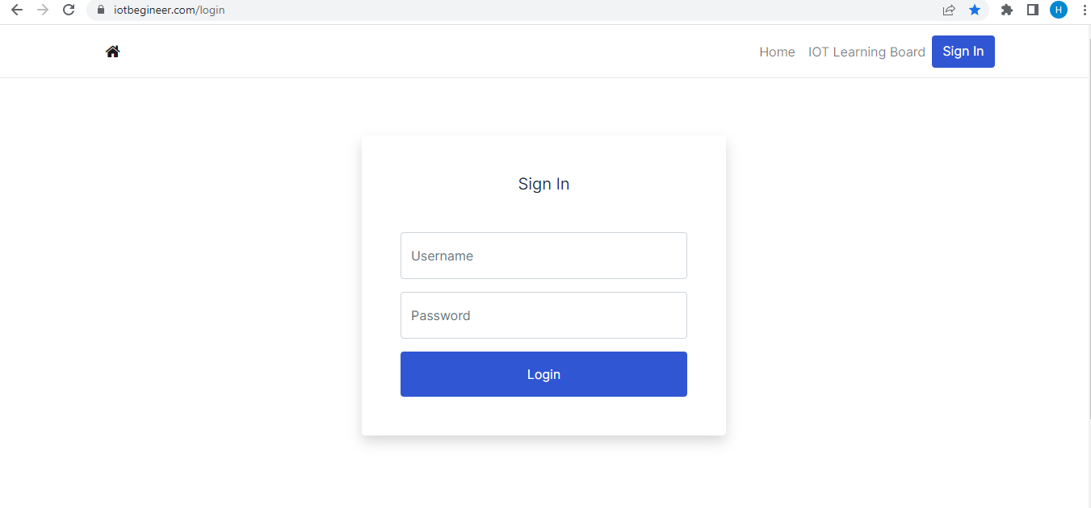

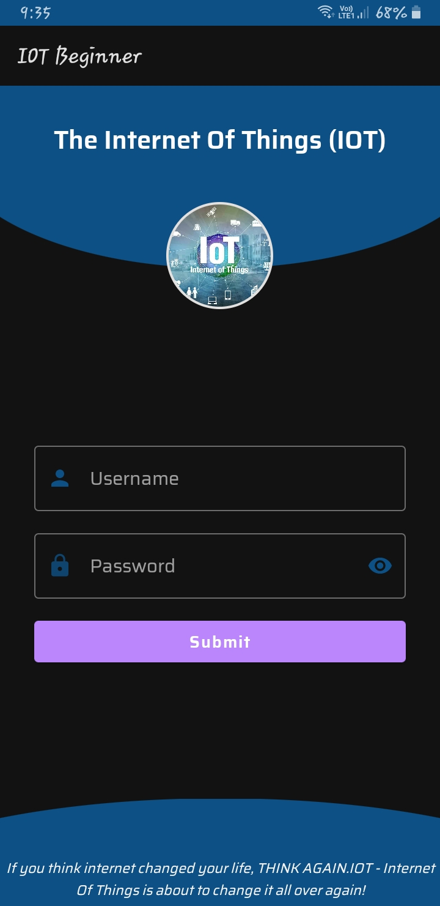

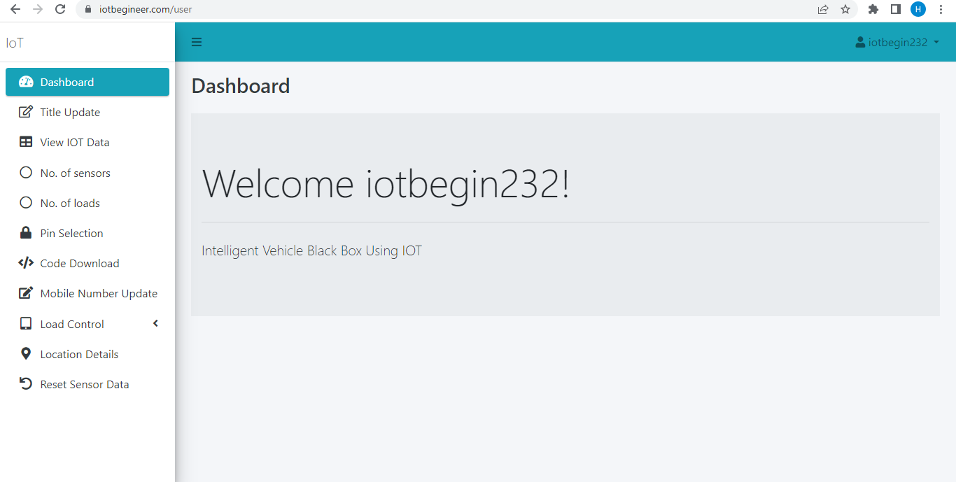

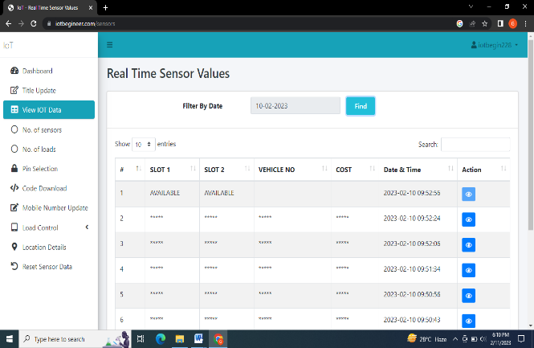

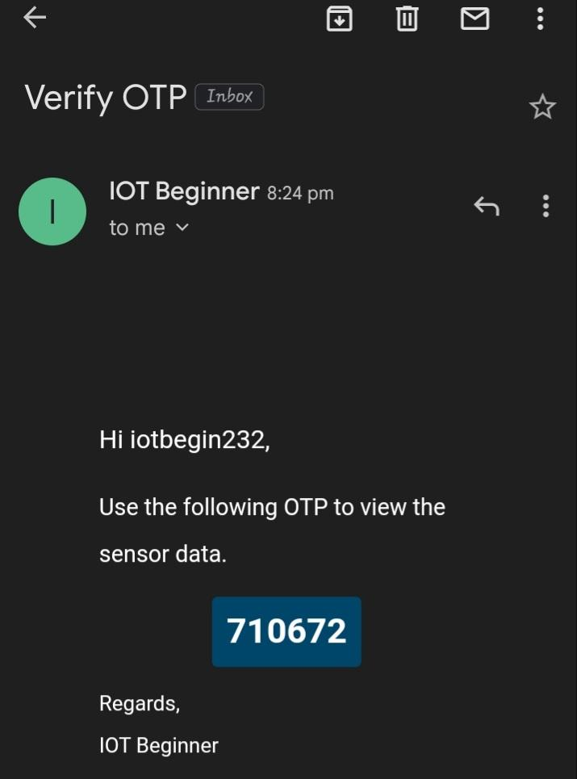

1. **Conclusions**

Smart city concepts have always been a dream. Over the past few years, progress has been made to make the dream of a smart city a reality. Advances in the Internet of Things and cloud technologies have given rise to new possibilities in the field of smart cities. Smart parking devices have always been at the core of building smart cities. The system provides real-time process and information about parking spaces. This document increases performance and saves users time when searching for a suitable parking space. It helps solve the growing problem of traffic jams. For future work, users can reserve a parking space from a remote location. GPS, booking device and license plate scanner may be included in the future.

**References**

1. Z. Zhang, X. Li, H. Yuan, and F.Yu, ―A Street Parking System Using Wireless Sensor Networks,‖ International Journal of Distributed Sensor Networks, 2013.
2. Q.-J. Kong, Z. Li, Y. Chen, and Y. Liu, ―An approach to Urban traffic state estimation by fusing multisource information,‖ IEEE Transactions on Intelligent Transportation Systems, vol. 10, no. 3, pp. 499–511, 2009.
3. G. Alessandretti, A. Broggi, and P. Cerri, ―Vehicle and guard rail detection using radar and vision data fusion,‖ IEEE Transactions on Intelligent Transportation Systems, vol. 8, no. 1, pp. 95–105, 2007.
4. P. N. Pathirana, A. E. K. Lim, A. V. Savkin, and P. D. Hodgson,―Robust video/ultrasonic fusion-based estimation for automotive applications,‖ IEEE Transactions on Vehicular Technology, vol. 56, no. 4, pp. 1631– 1639, 2007.
5. H. Bura, et. al, ―An Edge Based Smart Parking Solution Using Camera Networks and Deep Learning,‖ 2018 IEEE International Conference on Cognitive Computing (ICCC), pp. 17-24, 2018.
6. Q. Wu, C. Huang, S. Y. Wang, W. C. Chiu, and T. Chen, "Robust Parking Space Detection Considering Inter-Space Correlation," IEEE international Conference on Multimedia and Expo, Beijing, China, pp. 659-662, 2007.
7. L. Zhang, R. Wang, and L. Cui, ―Real-time traffic monitoring with magnetic sensor networks,‖ Journal of Information Science and Engineering, vol. 27, no. 4, pp. 1473–1486, 2011.
8. J. Zhu, H. Cao, J. Shen, and H. Liu, ―Data fusion for magnetic sensor based on fuzzy logic theory,‖ in Proceedings of the 4th International Conference on Intelligent Computation Technology and Automation (ICICTA ‘11), pp. 87–92, March 2011.
9. C. Trigona et al., "Implementation and characterization of a smart parking system based on 3-axis magnetic sensors," 2016 IEEE International Instrumentation and Measurement Technology Conference Proceedings, Taipei, 2016, pp. 1-6.
10. B. Yang and Y. Lei, ―Vehicle detection and classification for low speed congested traffic with anisotropic magnetoresistive sensor,‖ IEEE Sensors J., vol. 15, no. 2, pp. 1132–1138,

Feb. 2015

1. Z. Zhang, M. Tao, and H. Yuan, ―A parking occupancy detection algorithm based on AMR sensor,‖ IEEE Sensors J., vol. 15, no. 2, pp. 1261–1269, Feb. 2015.
2. R. Kanan, A. Sweleh, and O. Elhassan, ―A Self-powered and Wireless Parking Sensor with Lux-RSS Correlation for Extra Accuracy,‖ 2019 International Conference on Electrical and Computing Technologies and Applications (ICECTA), 2019.