SEMI-AUTOMATED MONITORING AND CONTROL OF PRAWNCULTURE

**M. Ramyasri, G.S.V. Sai Bhavana, K.Srinu, M.Mohan Phanendra,** **Dr.P.A.Nageswararao**

M. Ramyasri, G.S.V. Sai Bhavana, K.Srinu, M.Mohan Phanendra ,Department of electronics and Communication engineering , Gayatri Vidya Parishad College for Degree & P.G Courses(A), Rushikonda, Visakhapatnam, Andhrapradesh, India.

Dr.P.A.Nageswararao, Associate professor, Department of Electronics and Communication engineering

Gayatri Vidya Parishad College for Degree & P.G Courses(A), Rushikonda, Visakhapatnam, Andhrapradesh, India.

**ABSTRACT**

Aquaculture, commonly referred to as aqua farming, is a technique used to generate food and other commercial goods, restore habitats and replenish natural stocks, as well as to increase the numbers of threatened and endangered species. These days the demand for shrimps has been increased. So this project is introduced to increase the shrimp culture by promoting healthy environment for shrimps with a least man power. Rural farmers in poor countries practice aqua farming to produce food. Traditional methods and techniques are being used by farmers in aquaculture. Prawnculture production using controlled environments has significantly increased, yet losses are enormous because of manual equipment and managerial failure. Building a prawnculture by monitoring and controlling the system is the main goal of this project. Using a traditional approach, farmers measure the aquaculture's water quality, water level, oxygen level and PH level are manually measured and monitored by farmers. In this project, we brought a microcontroller-based smart prawnculture model that measures water quality (pH, water level, temperature) and provide automatic feeding for prawnculture. This system ensures the survival of aquatic life, and ensures the quality of growth and development.

**Keywords:** PH level, Automatic feeding, water level, temperature, smart-based model.

1. **INTRODUCTION**

Aquaculture, sometimes known as aqua- farming, is the practice of breeding, growing, harvesting and fish, prawns and other organisms. Due to the increased food convergence, this process is more efficient than other agricultural methods. It can also be described as a breeding species that grows in an aquatic environment under regulated circumstances. There is a increase of production with less-quality protein and as a result the availability of high quality protein is insufficient. The importance and selection of this project is to promote healthy environment for prawns and to increase the quality of shrimps production. The atmospheric conditions for prawns is monitored using sensors and control the quality of water using automation process

The information about water quality is notified to the mobile and hence controlled from the same device which finally results in less manpower. Using IOT the automation process is performed for prawn culture through blynk application. Thereby it can be controlled through mobile which in turn makes production process easy for farmers. This project was conducted to identify the problems and rising issue especially in agriculture field. Upon researching, we found that the traditional way of monitoring the parameter of shrimp pond might be time consuming, extra labour, and less efficiency. Not only that, the maintenance of motor that keeps running 24 hours daily in order to keep the water at optimum level may have a burden in cost.

1. **METHODOLOGY**

The sensors namely PH, Ultrasonic level sensor, temperature are used to monitor and control the quality of water. A device consisting of both inbuilt wi-fi and Bluetooth module named ES32 microcontroller is accustomed for to send notifications and updates to mobile about the quality of water. A code is constructed by setting the limits to water PH, water level, water temperature. If the parameters of the water are beyond or above the limit, we are notified through Blynk application. The description of controlling and monitoring of each application is explained below briefly

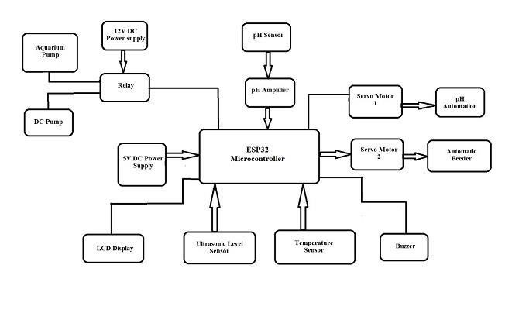**Figure1:**Block diagram of smart based prawnculture model.

**2.1 Monitoring and controlling of Temperature :**

The temperature of water is monitored using temperature sensor which measures temperature ranging from 0 to 100 degrees Celsius. The optimum temperature required for shrimps survival is 25 to 30 degree Celsius . Whenever the temperature is beyond the limit, the inlet and outlet of water is performed automatically. The 5V DC motor is used for pumping the water inside whereas the 12 V DC motor is used for pumping the water out. Whenever the temperature exceeds the limit, the water in the container is pumped out and fresh water is pumped in simultaneously. The amount of water level pumped in is displayed on LCD display , thereby the water level is controlled automatically using the DC motors with pump.

**2.2 Monitoring and controlling of PH :**

PH value of the water is monitored using PH sensor. The fresh water lakes consisting of pH ranging from 6.4 to 8.1 is ideal for growth of shrimps .The automation of pH is performed using servo motor. Whenever power supply is provided to the motor it starts performing rotations. The chemical combination required for balancing pH value is arranged in a container with small portion of outlet , this container is combined to the servo motor which performs one complete rotation for every single switching. Whenever pH value of water is beyond the limits , is notified to the mobile through which the pH is monitored .Thereby the pH chemical combination mixture gets deposited into the water for each rotation of servomotor which results in balancing the pH value of water and hence promotes the growth of shrimps.

**2.3 Monitoring and controlling of Water Level:**

Waterlevel is monitored using ultrasonic level sensor which determines water level .The water level varies according to the selected range of area for prawns growth. According to the container that is present selected for shrimps (45 cm*22.8 cm* 22.8 cm) management, the range 6cm to 17 cm is optimum for free movement of shrimps in the provided container. The water level must not be exceeded than the limit, excess amount of water causes less oxygen supply to the shrimps. Hence higher level of water doesn't promote shrimps growth. Whenever the water level exceeds the limit the device gets notified.5V, 12 V DC motors are used for inlet and outlet of water respectively. If the water level is less than 6cm than the 5V DC motor automatically turns on and fill the container until 17 cm and turns off automatically. Similarly whenever water level exceeds the limit the 12 V DC motor turns on for which the excess amount of water is pumped out . Therefore controlling of water level is performed using DC motors for inlet as well outlet.

**2.4 Automatic feeding:**

Automatic feeding for shrimps is performed using the servo motor. The feed for shrimp is arranged in a container with a small portion of outlet. The container with feed is combined to the servo motor. The servomotor performs rotations for every single switching. The required amount of feed is dropped into the container automatically for every 4.8 hours. Therefore the shrimps are fed through automatic feeding system which runs with servomotor. In this, a container is connected to the servomotor. This motor performs rotations whenever it is connected to power supply. As the automation process is done through blynk application, the servomotor connected to container rotates for every switching .whenever the device gets notified automatically feeding can be performed from the mobile app . So a farmer is not necessarily required to present at the location. The feeding can be done at any time irrespective of farmer’s location.

**3. MODELING AND ANALYSIS**

A container with optimum water level having neutral PH value is initially supplied to prawns. The water temperature is monitored using water proof temperature sensor() containing of water temperature is performed using DC motors(12v,5v) with inlet and outlet pumping system. Similarly water level is also controlled using the DC motors. The pH sensor SKU235871 is used to monitor pH value of water Servo motors are connected to a container with small portion of outlet , is used for controlling pH value of water . The pH value plays major role in maintaining quality of water. Automatic feeding is also performed using servomotor with a container connected to it. By performing the entire process, the water quality is monitored through blynk application in mobile and controlled automatically with no manpower and help the farmers for effective shrimp production.

**Figure1:**materials used for smart based model

**4. RESULTS AND DISCUSSION**

* The temperature, level can be controlled by using the aquarium and DC pump.
* The water levels are maintained.
* The data is monitored through blynk application in mobile and can be control according to the conditions.
* By using ESP32 microcontroller, the sensor’s data is monitored and controlled.
* The pH is monitored using pH sensor and controlled using servomotor.
* Automatic feeding is done using servo motor which is connected to a container with small portion of outlet in it.

**Hardware outcomes:**

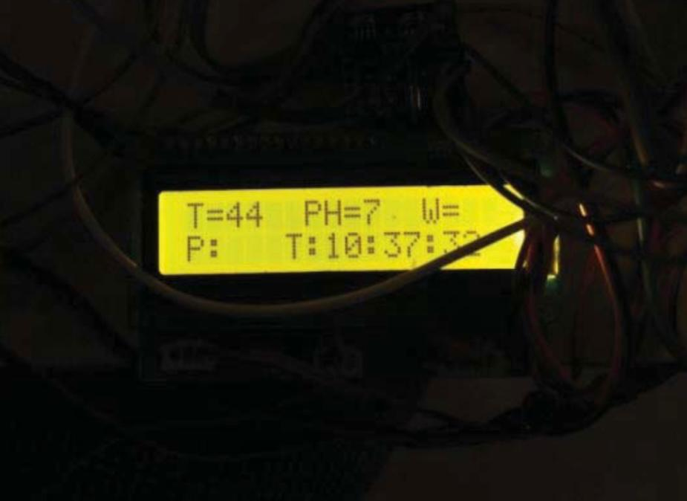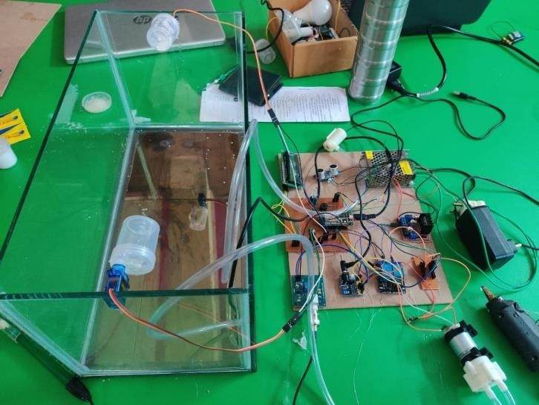

**Figure2.1:** overview of smart based model **Figure2.2:** LCD Display

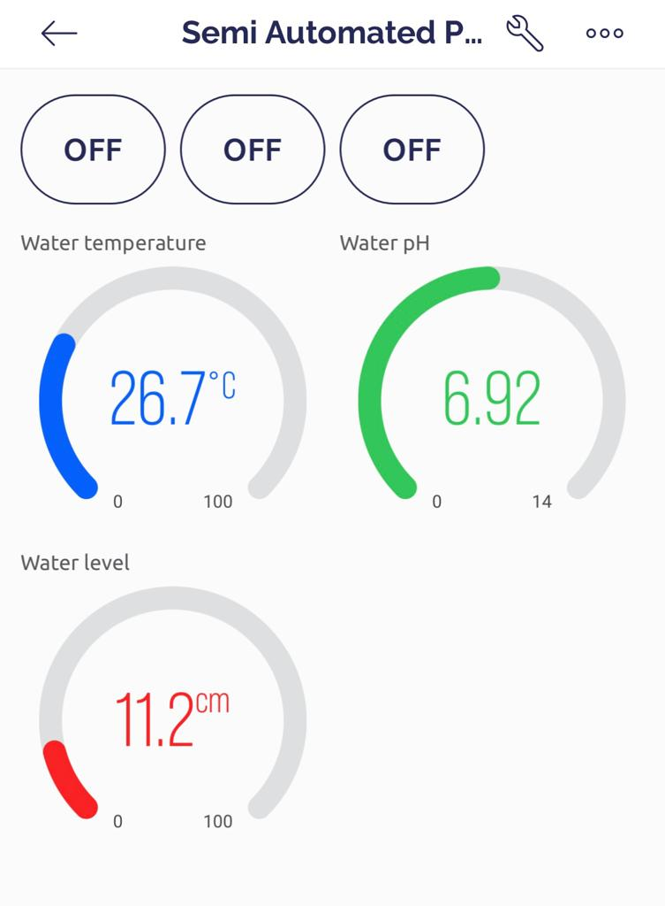**Software outcomes**

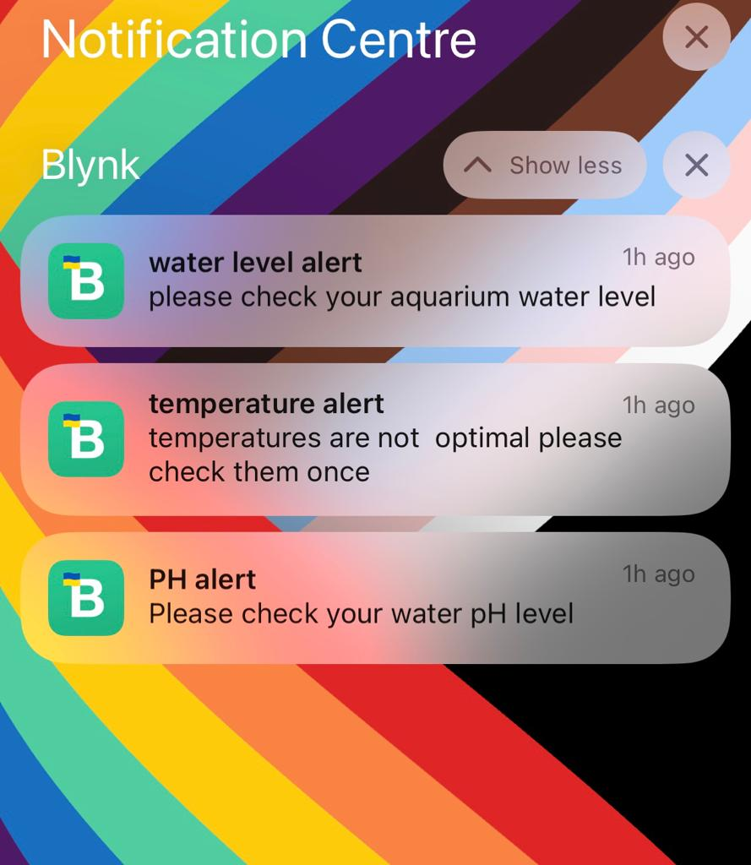**Figure2.3:** readings shown in blink application **Figure2.4:** notification display

**5. CONCLUSION**

The design and implementation of an aquaculture monitoring system is represented in this work. When creating this system, IOT technology is used. It is accurate, scalable, and portable. This will significantly boost aquaculture production. Additionally, manual testing is not necessary, losses are reduced, labour costs are reduced, and critical conditions are also avoided. Using conventional and non-technical methods to manage fish farms is challenging. The created model offers a

technological remedy for real-time water quality monitoring. Due to abrupt climatic change that lowers aqua farm productivity, commercial aquaculture is currently dealing with a lot of issues. The farmers can use this paper to automatically monitor and manage the feeding mechanism, the water quality management process, and the temperature regulation process. With this system's battery backup, the worry of watching over fish during an unplanned power outage is eliminated. From a different location, the farmer can keep an eye on the farm. This system not only lowers labour costs but also boosts the GDP of the country. Only the nursery stage is subject to the feeding process.

**6. REFERENCES**

[1] Sohail karim, 2021. A Multi-functional Aquarium Equipped with Automatic Thermal Control/Fodder Feeding/water Treatment using a Network Remote Control System. Information Technology Journal, 9(7), pp.1458- 1466.

[2]. Noor, M.Z.H., Hussian, A.K., Saaid, M.F., Ali, M.S.A.M. and Zolkapli M., 2012, July. The design and development of automatic fish feeder system using PIC microcontroller. In Control and System Graduate Research Colloquium (ICSGRC), 2012 IEEE (pp. 343-347). IEEE.

[3]. Vijayakumar N. and Ramya R., 2015, March. The real time monitoring of water quality in IoT environment. In Innovations in Information, Embedded and Communication Systems (ICIIECS), 2015 International Conference on (pp. 1- 5). IEEE

[4]. Christian Cawley (2014). Host Your Own Website [online] Available at : http://www.makeuseof.com/tag/hostwebsite (Accessed : 5 February 2017)

[5] T. Zhao, R. Nevatia, and B. Wu, “Segmentation and Tracking of Multiple Humans in Crowded Environments,” IEEE Trans. on Pattern Analysis and Machine Intelligence (TPAMI), vol. 30, no. 7, pp. 1198-1211, 2008.

[6] Nurliani Hidayah Ritonga, Agung Nugroho Jati, Rifki Wijaya, 2016 May. Automatic Arowana Raiser Controller Using Mobile Application Based on Android. In 2016 IEEE Asia Pacific Conference on Wireless and Mobile (APWiMob) (pp.86-87). IEEE.