**A RESEARCH PAPER ON STRENGTH AND DURABILITY CHARACTERISTICS OF SELF COMPACTING CONCRETE CONTAINING INDUCTION FURNACE STEEL SLAG AS FINE AND COARSE AGGREGATE**

**Yash chouhan1 , Komal Bedi2**

1M-Tech Student, Department of Structural Design, Prashanti Institute of Technology and Science Ujjain, India 2Professor, Department of Structural Design, Prashanti Institute of Technology and Science Ujjain, India

**ABSTRACT**

This study compares the fresh, mechanical and durability performance of Self- Compacting Concrete (SCC) mixes comprising conventional aggregates as well as Induction Furnace Slag in different proportions. It also aims to obtain an optimum dosage of Cassava Peel Ash which is used as mineral admixture to produce self- compacting concrete containing Induction furnace aggregate and study its strength and durability characteristics. To evaluate the fresh, strength and strength properties, a series of concrete were produced, and SCC containing M-sand as fine aggregate and crushed stone as coarse aggregate was referred to as reference mix, and comparison among different mixes was established with respect to this reference mix. Fresh characteristics such as filling ability and viscosity of all the SCC mixes were assessed. Their mechanical properties were evaluated through compressive strength and splitting tensile strength. Durability of SCC mixtures were assessed with the help of experiments like rapid chloride permeability test, water absorption test, sorptivity test and alkali aggregate reactivity test. From the above tests, it was inferred that the flowability and segregation resistance of SCC mixes were considerably enhanced with the usage of IFS as both fine and coarse aggregate. The mechanical and durability performance of SCC mixes containing IFS as fine aggregate was superior to the similar mixes made with the natural aggregate but SCC with complete replacement of aggregates with IFS resulted in slight depreciation in mechanical performance. Based on the 56 days strength of mortars, optimum content of cassava peel ash was found to be 10%. SCC produced by incorporating optimum cassava peel ash as mineral admixture and induction furnace slag aggregates as replacements of natural aggregates resulted into decrease in strength and durability properties of SCC.

**Keywords:** Induction Furnace Slag, Cassava Peel Ash, Mineral Admixture, Mechanical Properties, Durability Properties, Waste Valorisation

**INTRODUCTION**

Self-Compacting Concrete (SCC) is a special type of concrete that does not require any vibration effort for placing the concrete in structures with congested reinforcement, restricted and compact areas. It can flow under its weight and achieve full compaction even in the presence of congested reinforcement. In its fresh state, it shows properties like high fluidity, self-compacting ability, and segregation resistance which produces a uniformity in the quality of concrete resulting in improved reliability and durability of reinforced concrete structures. A key factor for a successful formulation of SCC is the clear understanding of the role of various constituents in the mix and their effects on the fresh and hardened properties. A successful SCC must show high fluidity for flow under self-weight, high segregation resistance to maintain uniformity during flow, and sufficient passing ability so that it can flow through and around reinforcement without blocking or segregation. SCC is usually proportioned with one or more mineral and chemical admixtures. Superplasticizers are added to provide better workability and Viscosity Modifying Agents (VMA) are used to improve segregation resistance of SCC.But making it only with conventional constituents arise some severe environmental issues. Waste valorization technique becomes an essential strategy to establish an eco- fiendly and clean environment. Every year the volume of solid waste generation is also reaching new heights, which is explained through the following statistics. Production of 1 ton of crude steel generates about 1 ton of solid waste [Grubeša et al.,2016]. Annually, the large-scale steel-producing industries discard about 29 million tons of slag [Mohapatra et al.,2007]. From 2010 onwards, the worldwide annual steel production exceeded 1500 million tons. Recently the world steel association (WSA) labeled China, Japan, and India as the three major countries that are currently producing> 0.1 billion tons of steel/year and generate a large volume of slags. Effective transformation of agricultural and industrial by-products into useful concreting material plays a significant role to overcome the sustainability issues in the field of construction, and it also safeguards the environment from the toxic solid wastes discarded from industris.

**Induction Furnace Slag -**

The replacement of natural aggregates with Induction Furnace Slag (IFS) and the partial replacement of cement with an agricultural waste named Cassava Peel Ash (CPA) in the concrete would lead to the conservation of natural resources and will also solve the problem of disposal of solid waste resulting into cost effective economy in concrete production.

Induction furnace slag (IFS) is the solid waste discarded from the induction furnace, which is used in metal casting foundries. An induction furnace is an electricity-based furnace that produces high temperatures in the metal bodies and melts them by inducing the eddy currents on them. In India alone, there are more than 600 units of induction furnaces, and each induction furnace unit discards about 15,000 tons of slag per annum.

IFS can be used as concrete material, but limited research is conducted on utilizing IFS as a concrete ingredient. Utilizing 30% of IFS as a fine aggregate enhanced the compressive strength of the mortar and concrete by 7% and 24%, respectively [John, et al., 2013]. 22% reduction in compressive strength was reported when coarse aggregate was completely substituted with IFS [Rezaul et al., 2017]. Replacing the recycled coarse aggregate with IFS particles in recycled aggregate concrete (RAC) resulted in an 8% and 11% reduction in the compressive and split tensile strength, respectively [Ahmad et al., 2018].Till now, studies were not conducted on utilizing IFS as a complete replacement for both fine and coarse aggregate in a special concrete-like SCC. The possibility of improving the properties of concrete containing IFS aggregate with the usage of agro- waste mineral additions was also not attempted.

**Cassava Peel Ash (CPA)-**

Industrial and agricultural wastes such as Fly ash, Silica fume, Ground Granulated Blast Furnace Slag (GGBFS), rice husk ash, etc. are also being used as a partial replacement for cement due to the presence of an adequate quantity of reactive silica. The presence of reactive silica seems to be very beneficial in concrete because it leads to the formation of secondary C–S–H in later ages and it also reduces the formation of calcium hydrates in the concrete. High C–S–H formation and low C–H formation is a typical hydration behavior of high strength and highly durable concrete self-compacting concrete (Chandru et al., 2017).Cassava peel is an agricultural or industrial waste derived as a by-product from the processing of cassava through either at the industrial or domestic level of production. Due to the gross underutilization of this industrial/agricultural waste, they are indiscriminately deposited on our landfill posing a lot of environmental challenges. Thus, processing of the cassava peel into CPA becomes very necessary to encourage its re-use and recycling as an important construction material that possesses pozzolanic properties (Ofuyatan et al., 2018; Owolabi et al., 2015). Cassava peel possesses up to 20 % to 35 % of the cassava tuber’s total weight, especially when processed by hand- peeling. These agricultural waste materials are subjected to controlled incineration to obtain ash products referred to as CPA (Mbadike et al., 2016). Salau and Olonade (2011) studied the pozzolanic potential of CPA and their results showed that CPA possesses pozzolanic reactivity when it is calcined at 7000C for 90 minutes. At these conditions, CPA contained more than 70 percent of combined silica, alumina, and ferric oxide.

**OBJECTIVE**

The objectives of the present study are as follows:

1. To develop a mix design for SCC containing conventional aggregates (control mix) and containing combinations of IFS and conventional aggregates.
2. To obtain optimum replacement % of CPA (by weight of cement) with reference to strength characteristics of cement-CPA mortars.
3. To evaluate the fresh, mechanical and durability properties of SCC containing-
   1. Manufactured sand as fine aggregate and crushed stone as coarse aggregate. (SCC 0/0)
   2. IFS as fine aggregate and crushed stone as coarse aggregate. (SCC 100/0)
   3. M-sand as fine aggregate and IFS as coarse aggregate. (SCC 0/100)
   4. IFS as both fine and coarse aggregate. (SCC 100/100)
   5. IFS as both fine and coarse aggregate along with optimum content of CPA as mineral admixture. (SCC 100/100/10CPA)

**MATERIAL USED**

### Binder

Ordinary Portland Cement satisfying to grade-53 criteria, as specified in IS-269:2015 was used. The specific gravity of cement was found to be 3.14 and had a standard consistency of 28%.

Cassava Peel Ash (CPA) is the mineral additive used as a partial replacement for cement. It was collected from a village named Panruti which is in Cuddalore district of Tamil Nadu. The cassava peel was incinerated in an oven at 100C per minute up to 7000C and was maintained at this temperature for 6 hours to produce the ash. Fig. 3.1 shows the raw and ash form of CPA. The specific gravity was determined. The cassava peel ash (CPA) was sieved, and large particles retained on the 150 μm sieve were discarded while those passing the sieve were used for this work. The physical characteristics of binders were determined as specified in IS-4031(Part 1 to 5). Table 3.1 shows the chemical characteristics of binder materials.

### Induction Furnace Slag (IFS)

The raw induction furnace slag is available with a particle size of 80 – 120 mm which was procured from the nearby metal casting foundries. Further, it was crushed into two zones, one with a particle size lesser than 12 mm ( as a coarse aggregate) and another with particles lesser than 4.75 mm (as a fine aggregate). Iron particles were removed by use of hand magnets and slag was subjected to outdoor weathering as suggested in the literature. Fig.3.2 shows IFS at different crushing levels. Table 3.2 shows the physical characteristics of IFS. In this study, IFS is used as fine aggregate as well as both fine and coarse aggregate in preparation of SCC.

### Sand

Crushed granite sand conforming Zone-II, as provided in IS-383:2016 was used as fine aggregate in few mixes. Their physical characteristics and sieve analysis for the sand used in the project work.

### Natural coarse aggregate

The crushed granite stone having a 12 mm nominal particle size was utilized. The physical properties of M-sand, natural crushed stone aggregate, and IFS were tested as specified in IS:2386 (part IV)-R2002.

### Superplasticizer

Superplasticizer used was Sika Viscoflow 6262NS. It is a modified Polycarboxylic ether (PCE) based admixture appearing hazy brown. It was having a specific gravity of 1.08. It is a A specially designed PCE based superplasticizer to achieve a significantly enhanced slump flow retention without additional retardation.

**EXPERIMENTAL DATA**

**CEMENT-CPA MOTAR**

### Fresh Properties

Figure 4.1 depicts the fresh workability values obtained during the flow table investigation. Slump measured for mixes reported that control mortar mix (0% CPA) had the lowest slump value of 118 mm and maximum slump value was as 207.5 mm when 5% CPA was used as preplacement for cement. It was also observed that as the content of CPA increased in the mix, the slump flow decreased.

### Strength Properties

The compression testing machine was used to assess the influence of CPA in cement mortar on the strength property. The compressive strengths of the cement mortars at different mix are shown in Fig. 4.2. The compressive strength of the mortars was determined after 7, 28 and 56 days of curing. The 56th day compressive strength of control mix was found to be maximum which was reported as 45.6 MPa. The strength of mortar was found to decrease with the use of CPA and the minimum difference was observed as 9% when cement mortar containing 10% CPA was used.

**SCC MIX**

### Fresh Properties

The fresh properties of SCC mix were assessed, and their slump flow and V-funnel values are reported in figure 4.3. Since the target slump flow was restricted within 660 – 700 mm, the mixes were also designed in such a way that it does not exceed the target slump flow range. The slump flow value of natural aggregate SCC was found to 675 mm, whereas for IFS aggregate SCC, it was found between 660mm to 695 mm range. Minimum slump of 590 mm was observed for SCC 100/100/10CPA mix and maximum slump was observed for SCC 100/100 mix. All the slump values except for mix 100/100/10CPA fall under the SF-2 class as per IS:10262-2019 code which shows it.suitability for normal construction whereas mix 100/100/10CPA fall under SF-1 class.

Slump flow

220

200

180

160

140

120

0

10

% CSA

20

Slump flow (mm)

### Fig. 4.1- Slump flow of cement-CPA mortars



50

7 days

28 days

56 days

40

30

20

10

0

0

5

10

%CPA

15

20

Cube compressice strength (MPa)

**Fig. 4.2- Compressive strength of Cement-CPA mortar**

The V-funnel (Tv) value for natural aggregate SCC was found to be 10.5 seconds whereas for IFS aggregate SCC, it was found between 10.3 to 22 second range. All values for viscosity were in limits of V2 class viscosity, which is more likely to exhibit thixotropic effects, which may be helpful in limiting the formwork pressure or improving segregation resistance.

### Strength Properties

SCC cubes with edge length of 100 mm were produced for the experimental studies for determination of strength properties and were tested at different curing ages as shown in fig. 4.4 which is the average value of the experimental results of three identical specimens. The 56-days cube compressive strength of SCC made with natural coarse aggregate was found to 47.2 MPa, whereas the SCC containing IFS aggregate showed a compressive strength between 38.1 MPa and 52.9 MPa. Maximum cube compressive strength was observed when fine aggregate was completely replaced by IFS (SCC- 100/0) and was reported as 52.9 MPa which was nearly 12% higher than that of control mix SCC-0/0 which was supported by the literatures already present. The reason for this is that IFS has a rougher surface than M-sand resulting in a higher bonding strength with cement paste and consists of active C2S and C3S, which can participate in the hydration process and enhance the strength of concrete. The complete replacement of aggregate with IFS showed similar strength at 7th day but there was a decrement of nearly 10% in 28th day strength. Due to the presence of properties like higher crushing value, porous microstructure, and pre-existing microcracks present in IFS, it is less suitable to be used as coarse aggregate for making high strength SCC and therefore SCC-0/100 reported a reduction in 28th day strength by nearly 19% as compared to control mix SCC-0/0. Minimum strength was observed when complete replacement of natural aggregates with IFS aggregates along with 10% replacement of cement with cassava peel ash which showed a depreciation of nearly 34% from control mix and about 27% from mix 100/100. Fig. 4.5 shows the failure pattern of mix SCC-100/0

800 25



SLUMP VALUES (mm)

700

20

600

500 15

V-FUNNEL TIME (sec)

400

300 10

200

5

100

0/0

100/0

0/100

**Fig.4.3 - FRESH PROPERTIES OF SCC**

MIX

100/100

100/100CPA



60

50

40

30

20

10

0

0/0

100/0

0/100

MIX ID

100/100 100/100CPA

|  |  |
| --- | --- |
|  | 7 DAYS |
| 28 DAYS | |

**Fig. 4.4- Compressive strength of SCC**

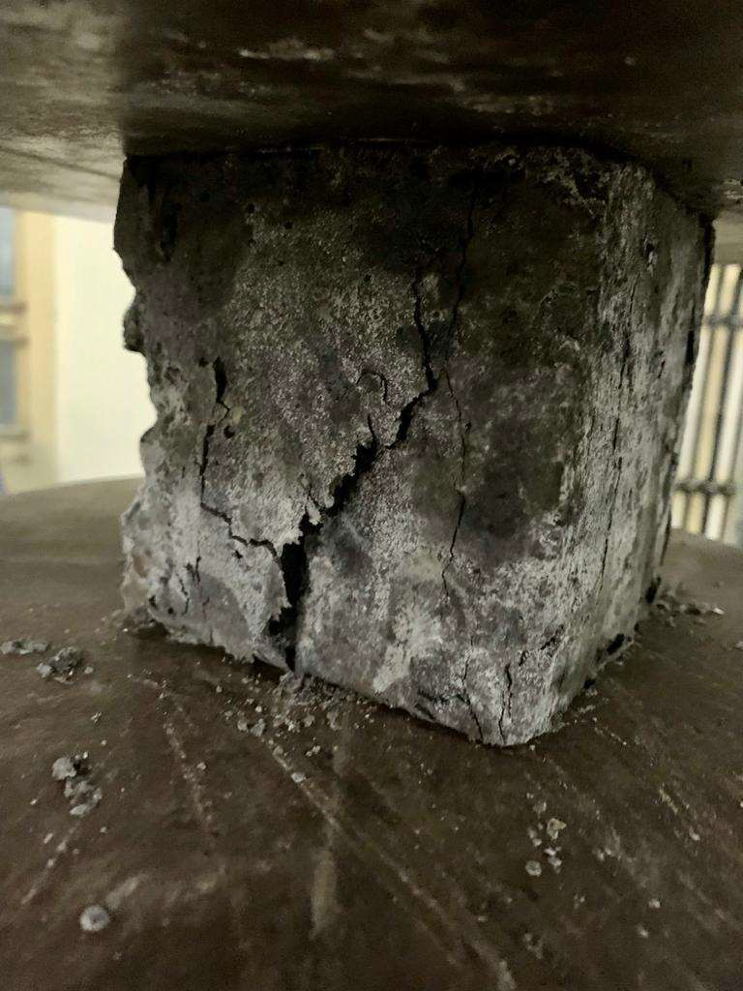

**Fig. 4.5- Compressive failure of SCC-100/0 mix**

The split tensile strength of natural aggregate SCC was found to be 3.55 MPa. In IFS aggregate SCC the values were found between 2.9 and 3.96 MPa whereas IFS aggregate SCC along with 10% CPA replacement reported 2.68 MPa. Variation of split tensile strength of different mix are shown in fig. 4.6. Mix SCC-100/0 produced maximum split tensile strength which was nearly 11% higher than the control mix SCC-0/0 and minimum split tensile strength was observed in SCC-100/100/10CPA being 25% lesser than control mix. The recorded results are agreeing with the study of Ahmad and Rahman, (2018). Due to the low crushing resistance of IFS coarse aggregate, the tensile crack developed in the cement matrix gets easily propagated through the IFS aggregate that fails the specimen at a low ultimate load. Fig. 4.7 shows the failure pattern of mix SCC-100/0

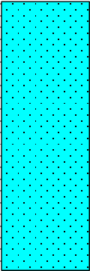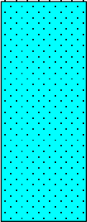

4

3

2

1

0

0/0

100/0

0/100

MIX ID

100/100 100/100CPA

SPLIT TENSILE STRENGTH

**Fig. 4.6- Split tensile strength of SCC**

SPLIT TENSILE STRENGTH (MPa)

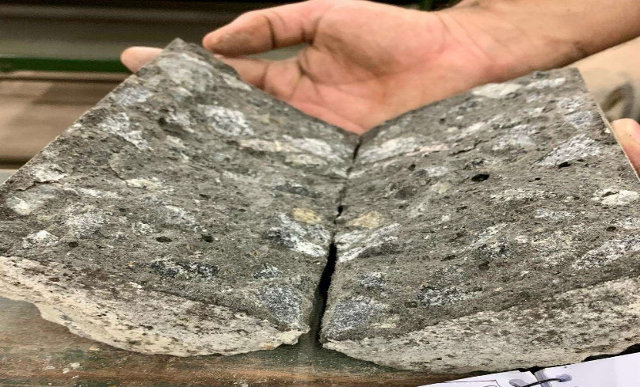

**Fig. 4.7- Split tensile failure of SCC-100/0 mix**

### Durability properties

### Rapid Chloride Permeability Test

The chloride ion penetration resistance of the SCC mixtures was assessed with the values of charge passed in RCPT to find the suitability for using them in an aggressive diffusing environmental condition, especially rich in chloride ions. Fig. 4.8 shows the RCPT values for conventional and IFS aggregate SCC. It can be seen that the charge passed is minimum when IFS is used as fine aggregate (i.e., SCC 100/0) and it falls in the very low category as per ASTM C1202-10. This reduction can be attributed to the fact that the inclusion of IFS as fine aggregate decreased porosity by the improvement of the overall aggregate grading which also enhanced the density of matrix. All other SCC mixtures fall under the range of 1000 to 2000 coulomb which falls in low chloride permeability. Maximum chloride penetration was observed in mix produced when IFS was used as coarse aggregate which could be due to the porous microstructure, high- water imbibing nature of IFS and presence of iron (Fe) based mineral phases in IF-slag.

MODERATE REGION

2000

LOW REGION

1500

1490

1588.5

1000

993.9

500

0

NEGLIGIBLE

0/0

100/0

0/100

MIX

100/100 100/100/10CPA

VERY LOW REGION

615.6

1887

CHARGE (COULOUMB)

### Fig. 4.8- RCPT values for SCC

**Water Absorption**

The water absorption values of the SCC mixtures are presented in Fig. 4.9. At 28 days, the water absorption value of SCC containing natural aggregates (SCC-0/0) was found to be 4.57%. For IFS-slag aggregate, the absorption results were between 4.82 and 5.14%. Due to the porous microstructure of IFS, water absorption increased in each mix as compared to the control mix. Compared to the control mix, SCC-0/100, SCC-100/0, SCC-100/100 and SCC-100/100/10CPA demonstrated 12.4%, 7%, 10%, and 5.4% higher water absorption respectively.

WATER ABSORPTION (%)

6

5

4

3

2

1

0

0/0

100/0

0/100

MIX

100/100 100/100/10CPA

WATER ABSORPTION

WATER ABSORPTION (%)

### 

### Fig.4.9-Water absorption values for SCC

**Sorptivity**

Capillary absorption is a dual-stage process such as initial and secondary, which depends on the interconnected pores existing in the concrete. In initial absorption (0<√𝑡 < j𝑡s), the water gets filled through absorption by capillary pores. In secondary absorption ( √𝑡 > j𝑡s),), the water saturation

occurs by the diffusion and dissolution of air existing in the pore structure, where ‘t’ and ‘ts’ are the time and time to reach saturation. Fig. 4.10 and Fig. 4.11 shows the capillary absorption values and sorptivit values for SCC mixes for different SCC mixes respectively. Capillary absorption value for SCC produced from natural aggregate was reported as 2.42 mm. Maximum absorption of 3.864 mm was observed for SCC containing IFS as coarse aggregate. This increase might be due to the inter-granular porosity and fine capillary pores present in the IF-Slag coarse aggregate. For all mixes, the value of capillary absorption was less than 10 mm which fall under good category as per as per CEB FIP 243-1998.

### Alkali-Aggregate Reaction Test (AAR)

This test was performed according to the ASTM C-1260 standard and was evaluated as per the ASTM C-227 standard. Two mortar specimens were tested, one containing IFS fine aggregate with 100% cement and another with IFS aggregate with 90% cement, and rest with 10% CPA as binder material. The average value of expansion after 16 days was 0.351% for IFS mortar without mineral admixture which shows innocuous behavior and was 0.13% for 10% replacement of cement with CPA which fall in between innocuous and deleterious behavior as per ASTM C 1260 standards. At the age of 28 days and 42 days, observed expansion were 0.0461% and 0.0768% respectively for mortar without mineral admixture and were 0.1697% and 0.2544% respectively for IFS aggregate with 10% CPA as mineral admixture. This variation between the two mixes is due to the presence of higher sodium alkali and magnesium alkali content in cassava peel ash as compared to cement which can be seen in table 3.1. The expansion of length with age due to alkali-silica reactivity is shown in fig. 4.12.

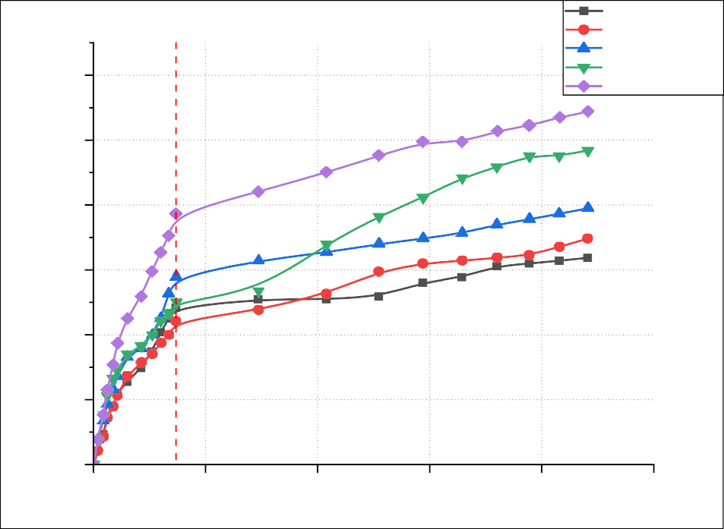

6

**Initial**

**Secondary Absorption**

0/0

100/0

100/100

100/100/10CPA

0/100

5

4

3

2

1

0

0

200

400

600

800

1000

Time (S1/2)

**Absorption**

Capillary Absorption (mm)

**Fig. 4.10- Capillary absorption values for SCC**

Sorpitivity*10-3(mm/s1/2)

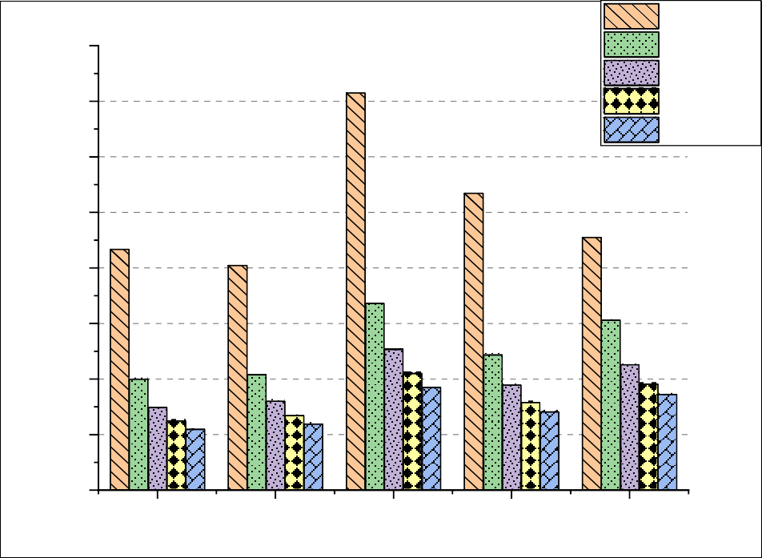

16

14

1-Day

7-Days

14-Days 21-Days 28-Days

12

10

8

6

4

2

0

0/0

100/0

0/100

Design Mix

100/100 100/100/10CPA

**Fig. 4.11- Sorptivity values for SCC mixes**

0.30

0.25

0.25448

0.20

0.15

0.10

0.07682

0.05

0.00

0

10

20

30

40

50

TIME (days)

IFS/10CPA IFS/0CPA

%change in length

**Fig. 4.12- Expansion in length due to ASR**

## **SUMMARY**

Test results obtained for fresh, mechanical, and durability properties of cement-CPA mortar and SCC mixes were reported in this chapter. The optimum content for partial replacement of cement with CPA was found to be 10%. SCC-100/0 was found to perform best in mechanical as well as durability property tests and SCC-100/100 gave satisfactory results as compared to the control mix in terms of fresh and strength characteristics whereas durability properties were not up to the mark. SCC produced with IFS-aggregate along with 10% CPA as mineral admixture (mix SCC- 100/100/10CPA) showed higher deviation in terms of both strength and durability characteristics with respect to the control mix

**RESULTS**

|  |  |  |  |
| --- | --- | --- | --- |
| % CPA | CUBE COMPRESSIVE STR. AT 7 DAYS IN (MPA) | CUBE COMPRESSIVE STR. AT 28 DAYS IN (MPA) | CUBE COMPRESSIVE STR. AT 56 DAYS IN (MPA) |
| 0 | 32 | 45 | 46 |
| 5 | 22.5 | 32 | 37 |
| 10 | 26 | 41 | 42 |
| 15 | 26 | 32 | 33 |
| 20 | 22.5 | 29 | 29.5 |

**Compressive strength of Cement-CPA mortar**

## **CONCLUSIONS**

The conclusions drawn from the experiments performed in this study and literature survey are mentioned below:

* + 1. The optimum content of CPA in cement mortar is reported as 10% by weight of cement.
    2. SCC mixes were designed as per IS 10262-2019 and flowability falls for SF-2 class and viscosity falls for V-2 class.
    3. With the use of CPA as mineral admixture, the flowability of SCC produced got reduced and it falls for SF-1 class and viscosity falls for V-2 class.
    4. Usage of IFS as fine aggregate increased the 56 days cube compressive strength and 28 days split tensile strength of SCC by nearly 12% and 11% respectively as compared to control mix. This mix, SCC 100/0 also reported higher resistance to chloride ion penetration as compared to the control mix, SCC 0/0.
    5. Water absorption as well as capillary absorption values were found to increase with the use of IFS aggregate in SCC and minimum variation was found in the mix SCC 100/0 with respect to control mix, SCC 0/0.
    6. Replacement of coarse aggregate by IFS reported a reduction of 19% and 11% in the 56 days cube compressive strength and 28 days split tensile strength respectively.
    7. Slight variation in 56 days compressive strength and 28 days split tensile strength was found between the control mix and the mix containing IFS as complete replacement for fine as well as coarse aggregate which were nearly 10% and 12.6% respectively.
    8. Accelerate alkali-aggregate reactivity was observed with the use of CPA as replacement for cement. This increment is due to the presence of higher alkali composition in CPA as compared to OPC-53.
    9. With the use of CPA as mineral admixture along with IFS aggregate, the strength and durability properties of the SCC produced were found to get reduced. The main reason behind this decrement could be the presence of lesser quantity of Calcium oxide and higher percentage of alkali oxides as compared to ordinary Portland cement (OPC-53).
    10. Better mechanical and durability performance of SCC-100/0 mix concludes that IFS can be used as a fine aggregate to produce SCC.

Considering the environmental benefits and satisfactory mechanical performance demonstrated by the SCC mixes containing IFS aggregate, it can be concluded that the incorporation of IFS as both, fine and coarse aggregate in SCC is possible and an effective waste valorisation technique

# **REFERENCES**

**Agbenyeku, E. E., & Okonta, F. N.** (2014). Green economy and innovation: compressive strength potential of blended cement cassava peels ash and laterised concrete. African Journal of Science, Technology, Innovation and Development, 6(2), 105-110.

**AASHTO T358. 2017**. Standard Method of Test for Surface Resistivity Indication of Concrete’s Ability to Resist Chloride Ion Penetration. American Associationof State Highway and Transportation Officials, Washington, DC.

**ASTM C1202-19. 2019**. Standard Test Method for Electrical Indication of Concrete’s Ability to Resist Chloride Ion Penetration, ASTM International, West Conshohocken, PA.

**ASTM C597-16. 2016.** Standard Test Method for Pulse Velocity Through Concrete, ASTM International, West Conshohocken, PA.

**Ahmad, S. I., & Rahman, M.** (2018). Mechanical and durability properties of induction-furnace-slag-incorporated recycled aggregate concrete. Advances in Civil Engineering, 2018.

**Baenla, J., Mbah, J. B., Ndjock, I. D. L., & Elimbi, A.** (2019). Partial replacement of low reactive volcanic ash by cassava peel ash in the synthesis of volcanic ash- based geopolymer. *Construction and Building Materials*, *227*, 116689.

**Bello, A. A., Ige, J. A., & Ayodele, H.** (2015). Stabilization of lateritic soil with cassava peels ash. *British Journal of Applied Science and Technology*, *7*(6), 642- 650.

**Chandru, P., & Karthikeyan, J.** (2021). Models to predict the mechanical properties of blended SCC containing recycled steel slag and crushed granite stone as coarse aggregate. Construction and Building Materials, 302, 124342.**Chandru, P., Karthikeyan, J., Sahu, A. K., Sharma, K., & Natarajan, C.** (2021). Performance evaluation between ternary blended SCC mixes containing induction furnace slag and crushed stone as coarse aggregate. Construction and Building Materials, 267, 120953.

**Chandru, P., Karthikeyan, J., Sahu, A. K., Sharma, K., & Natarajan, C.** (2021). Some durability characteristics of ternary blended SCC containing crushed stone and induction furnace slag as coarse aggregate. Construction and Building Materials, 270, 121483.

**Daud, Z., Awang, H., Kassim, A. S. M., Hatta, M. Z. M., & Aripin, A. M.** (2014). Comparison of pineapple leaf and cassava peel by chemical properties and morphology characterization. In *Advanced Materials Research* (Vol. 974, pp. 384- 388). Trans Tech Publications Ltd.

**de Moura, B. L. R., Teixeira, J. E. S. L., Simao, R. A., Khedmati, M., Kim, Y. R., & Pires, P. J. M.** (2020). Adhesion between steel slag aggregates and bituminous binder based on surface characteristics and mixture moisture resistance. Construction and Building Materials, 264, 120685.

**Devi, V. S.** (2018). Durability properties of multiple blended concrete. *Construction and Building Materials*, *179*, 649-660.

### Familusi, Ayokunle O., Kasali A. Mujedu, Babatunde E. Adewumi, Damilola

**A. Ogundare, and Joel O. Olusami** (2019). Converting waste to wealth: cassava peel ash as potential replacement for cement in concrete. *Convert. Environ. Waste Wealth*.

**Guo, Y., Xie, J., Zhao, J., & Zuo, K.** (2019). Utilization of unprocessed steel slag as fine aggregate in normal-and high-strength concrete. Construction and Building Materials, 204, 41-49. Xinhua Xu, Xiangfeng Zhu 2004 Treatment of refectory oily wastewater by electro-coagulation process, Chemosphere 56 (2004) 889–894.

**IS: 269:2015**. Ordinary Portland cement **-** Specifications, Bureau of Indian Standards, New Delhi, India.

**IS 383:2016.** Coarse and fine aggregate for concrete - specification, Bureau of Indian Standards, New Delhi, India.

**Lun, Y., Zhou, M., Cai, X., & Xu, F. (2008)**. Methods for improving volume stability of steel slag as fine aggregate. *Journal of Wuhan University of Technology- Mater. Sci. Ed.*, *23*(5), 737-742.

**Manso, J. M., Polanco, J. A., Losanez, M., & Gonzalez, J. J.** (2006). Durability of concrete made with EAF slag as aggregate. Cement and concrete composites, 28(6), 528-534.

**Mithun, B. M., & Narasimhan, M. C.** (2016). Performance of alkali activated slag concrete mixes incorporating copper slag as fine aggregate. *Journal of Cleaner Production*, *112*, 837-844.

**Mohammed, T. U., Mahmood, A. H., Apurbo, S. M., & Noor, M. A.** (2021). Substituting brick aggregate with induction furnace slag for sustainable concrete. *Sustainable Materials and Technologies*, *29*, e00303.

**Nandhini, K., & Karthikeyan, J.** (2021). Effective utilization of waste eggshell powder in cement mortar. *Materials Today: Proceedings*.

**Ofuyatan, O. M., Ede, A. N., Olofinnade, O. M., Oyebisi, S. O., Alayande, T., & Ogundipe, J.** (2018). Assessment of strength properties of cassava peel ash- concrete. *International Journal of Civil Engineering and Technology (IJCIET)*, *9*(1), 965-974.

**Ofuyatan, O. M., Ede, A. N., Olofinnade, O. M., Oyebisi, S. O., Alayande, T., & Ogundipe, J.** (2018). Assessment of strength properties of cassava peel ash- concrete. *International Journal of Civil Engineering and Technology (IJCIET)*, *9*(1), 965-974.

**Ogunbode, E. B., & Akanmu, W. P.** (2012). Turning waste to wealth: Potential of laterized concrete using cassava peels ash (CPA) blended cement. International Journal of Engineering Research & Technology, 1(3), 1-12.

**Ogunbode, E. B., Nyakuma, B. B., Jimoh, R. A., Lawal, T. A., & Nmadu, H. G.** (2021). Mechanical and microstructure properties of cassava peel ash–based kenaf bio-fibrous concrete composites. *Biomass Conversion and Biorefinery*, 1-11.**Olonade, K. A., Olajumoke, A. M., Omotosho, A. O., & Oyekunle, F. A.** (2014). Effects of sulphuric acid on the compressive strength of blended cement-cassava peel ash concrete. In *Construction Materials and Structures* (pp. 764-771). IOS Press.

**Osuide, E. E., Ukeme, U., & Osuide, M. O.** (2021). An assessment of the compressive strength of concrete made with cement partially replaced with cassava peel ash. SAU SCIENCE-TECH JOURNAL, 6(1), 64-73.

**Pellegrino, C., & Gaddo, V.** (2009). Mechanical and durability characteristics of concrete containing EAF slag as aggregate. Cement and Concrete Composites, 31(9), 663-671.

**Ramesh, S. T., Gandhimathi, R., Nidheesh, P. V., Rajakumar, S., & Prateepkumar, S.** (2013). Use of furnace slag and welding slag as replacement for sand in concrete. *International Journal of Energy and Environmental Engineering*, *4*(1), 1-6.

**Salau, M. A., Ikponmwosa, E. E., & Olonode, K. A.** (2012). Structural strength characteristics of cement-cassava peel ash blended concrete. *Civil and Environmental Research*, *2*(2), 68-77.

**Saxena, S., & Tembhurkar, A. R.** (2018). Impact of use of steel slag as coarse aggregate and wastewater on fresh and hardened properties of concrete. Construction and Building Materials, 165, 126-137.

**Uysal, M., & Yilmaz, K.** (2011). Effect of mineral admixtures on properties of self- compacting concrete. *Cement and Concrete Composites*, *33*(7), 771-776.

**Yüksel, İ.** (2017). A review of steel slag usage in construction industry for sustainable development. *Environment, Development and Sustainability*, *19*(2), 369-384.