**Study of Multi Organization Concept Followed by Enterprise**

P.K. Chaitanyakanth Reddy1, B. Saroj Kumar2, Dr. R.V.Sudarsana Reddy3

1Asst.Professor, Mechanical Engineering Department, S V College of Engineering, Kadapa, A.P, India.

2Asst.Professor, Mechanical Engineering Department, S V College of Engineering, Kadapa A.P, India.

3Professor, Civil Engineering Department, S V College of Engineering, Kadapa, A.P, India.

# ABSTRACT

In this paper how is the multi organization structure framed under that what are the levels are presented and their functionalities are described here. In which levels of the enterprise, taxes and balance sheets to submit to government, human resource requirements, purchasing the goods, account payables, sales of the products to customers, account receivables are described.

**Keywords:** Purchasing, Sales, Inventory.

# 1.INTRODUCTION

What is Multi.Org Model

Multi.Org enables central management and control of operations between business units in an enterprise.

The Multi.Org Model enables an enterprise with multiple business units to consolidate

* Procurement: Multi.Org model consolidates procurement by enabling you to procure products from an operating unit that uses one set of books, but to receive them from another operating unit that uses a different set of books.
* Sales: Multi.Org model consolidates sales by enabling you to sell products from an operating unit that uses one set of books, but to ship them from another operating unit that uses a different set of books. It then automatically records the inter-company sales  Reporting: Multi.Org model consolidates reporting by enabling you to report at any level of enterprise's structure.

**2. Multi org Concepts**

Entities in the Multi.Org Model

Multi.Org model is used to create a model of an enterprise's Organizational Structure.

An Organizational model is a hierarchical diagram that enables you to map the interactions and transaction flows between the business units in an enterprise. In the model, you represent business units as specific business entities.

The Multi.Org model includes the following main Business Entities:

* Business Group
* Set of Books
* Legal Entity
* Operating Unit
* Inventory Organization
* Balancing Entity

**2.1 Business Group**

The Business Group entity represents the highest level of an organizational hierarchy.

The organization model for any enterprise includes at least one Business Group entity, which you represent graphically using an ellipse.

For enterprises that consist of several major business units — such as major divisions in different areas of a countries on organization model may include several Business Group entities.

Authorized users who access the Business Group entity to which they belong can view human resources information for employees in the entity.

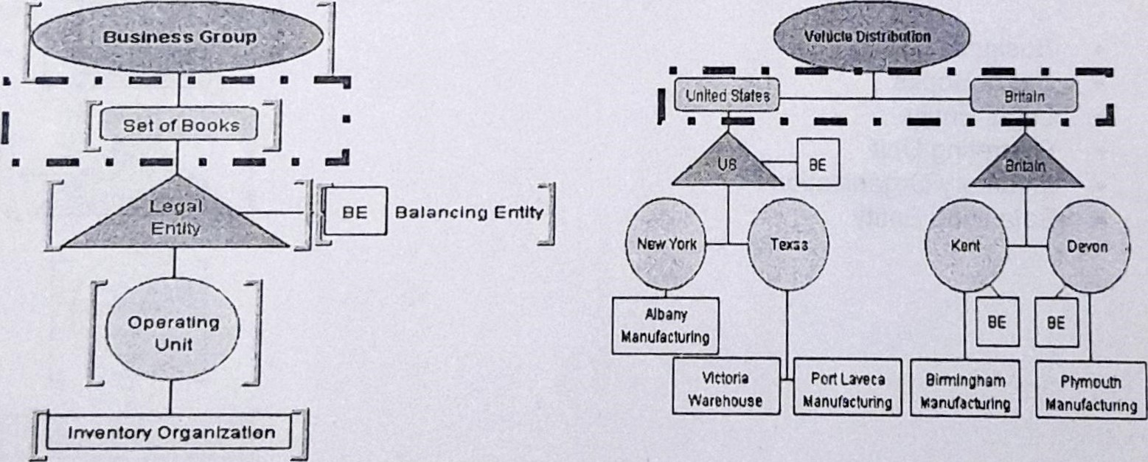

**2.2 Set of Books**

The Set of Books (SOB) entity represents the financial structure of a Business Group entity.  Each SOB uses a specific CCC chart of accounts, currency, and financial accounting calendar.

In a Multi.Org model, you represent one or more SOB entities for each Business Group using a rounded rectangle.

Authorized users who access the SOB entity for their Business Group can view transaction information such as balances and journal entries.

The Set of Books (SOB) entity represents the financial structure of a Business Group entity.  Each SOB uses a specific CCC chart of accounts, currency, and financial accounting calendar.

In a Multi.Org model, you represent one or more SOB entities for each Business Group using a rounded rectangle.

Authorized users who access the SOB entity for their Business Group can view transaction information such as balances and journal entries.

**2.3 Operating Unit**

The Operating Unit entity represents the businesses in an enterprise that use order Management or Payables

You represent one or more Operating Unit entities per Legal Entity using circle symbols. Authorized users who access the Operating Unit level can obtain.

# 2.4 Inventory Organization

Inventory Organization entities represent {he businesses in an enterprise that manufacture and distribute products, such as warehouses and sales offices.

In an organization model, you represent one or more Inventory Organization entities for each Operating Unit entity using rectangle symbols.

Authorized users who access the Inventory Organization level can view production information, such as purchasing and receiving details, bills of material,

**2.5 Balancing Entity**

A balancing segment is a business unit for which your enterprise prepares a balance sheet

 In an organization model, Balancing Entity is graphically represented using a square symbol.

 Balancing Entity indicates that a Set of Books, Legal Entity, or Operating Unit entity uses a balance sheet

**Authors' information**

P K Chaitanyakanth Reddy is an Assistant professor in Mechanical Engineering Dept. S V College of Engineering Kadapa, A.P, India. His research interests include ERP, Manufacturing and Supply chain Management. The teaching experiences are mainly in Production and Operation management, Inventory management, and Industry Management.