**Power Quality Improvement using Hybrid Series Active Power Filter: Review**

**Vikash Kumar 1, Prof. Duirgesh Vishwakarma2**

1M.tech Scholar, Electrical Department, Radharaman Engineering College Bhopal, MP, India

2Assistant Professor, Electrical Department, Radharaman Engineering College Bhopal, MP, India

**ABSTRACT**

**In this paper, a hybrid active power filter is introduced for harmonic filtration in a transmission system with sources and loads. The harmonics which are generated by non-linear loads (diode bridge rectifier) are introduced into the source voltage and currents which could also be injected into other loads connected to the system. These harmonics are eliminated using a series active power filter which is connected to the transmission line through series transformers which eliminates harmonics in the source voltage and currents. The controller of the series active power filter is updated with fuzzy logic controller for faster response rate to the transients caused in the proposed system.**

**Keywords:** *Fuzzy logic controller PI, Shunt active Power filter, Series Active Power Filter*.

1. INTRODUCTION

Power quality is simply the higher calibre of electricity delivered to the electrical apparatus. It establishes the electrical power's suitability. Voltage and current distortion, a low power factor, and other factors are the main causes of poor power quality. The rising use of nonlinear loads is the cause of these voltage and current distortions. We can increase the power quality and provide customers with high-quality power by employing various methods. The poisoning of the electrical power supply by harmonics is a major and hazardous issue. One of the best solutions to these issues is the use of active power filters. Active power filters can be used as shunt type, series type, or other configurations, depending on the specific application or electrical problem to be handled or a mix of active filters in series and shunt. The major functions of the series active power filter are harmonic isolation and voltage regulation. The series active power filter guards against power of low quality for the consumer. For the purpose of compensating for harmonics and reactive power, the design and modelling of a series active power filter are addressed.

1. Power Quality Parameters and Terminologies

Power quality is a measurement of various factors, including voltage, current, and recurrence within a given range. In the unlikely event that there has been any deviation, several problems including voltage droop, voltage swell, transient, glimmer, harmonics, etc. may have been formed and are to blame for the bad power quality.

* **Transient**: - Transient are brief span and sudden unsettling influences which can bring about by an exceptionally fast change in the unfaltering state of voltage present or both. Transient aggravation is characterized into two classifications oscillatory transient and imprudent transient. [15]
* **Short time voltage variation**: - In any supply voltage, in the event that there has any variety for brief time not more than 1 moment is known as a brief span voltage variety. For the brief span voltage variety deficiencies, stimulation of expansive burdens irregular free association in power wiring is capable. Brief term voltage variety is grouped in to three classifications as voltage list voltage swells and interferences.
* **Long time voltage variety**: - for bigger than 1 minute the voltage deviation encompassing the RMS (root mean square) estimation of energy recurrence is called long voltage variety. Long term voltage varieties are arranged in 3 classes as over voltage, under voltage and managed intrusions. [3]
* **Waveform contortion**: - The voltage and current waveform of sound power supply are perfect sine wave .if there power recurrence wave shape has any relentless state deviation is called wave shape contortion. Wave frame twisting is arranged into taking after classifications .dc balance, harmonics, inter harmonics, scoring, and clamor. [3]
* Voltage changes: - The orderly irregular variety of voltage wrap is called voltage variance. The fundamental course of voltage variety is quick change in current extent of load. An exceptionally quick change of supply voltage is called voltage glint, which is a sort of voltage variances.[5] Variation In power frequency: - For the palatable operation of any power framework, a basic recurrence is predefined.[6] on the off chance that there has any variety in its predetermined ostensible esteem (e.g. 50 to 60 Hz) is called control recurrence variation. A rapid change in the heap, which is associated in the framework, is in charge of energy recurrence variety.[8]

**Power Quality Problems**

**Power Factor of Poor Load:-** The proportion of the genuine power streaming to the heap to the evident power in the electric circuit is known as the power element of the power framework . It is a vital term of energy framework .The limit of the circuit for doing work in a specific time is called genuine power and result of current and voltage is called obvious control. In power framework in light of different utilization of semiconductor gadgets or nonlinear load the wave state of voltage and current are mutilated which make the evident power will be more noteworthy than the genuine power and get low control consider the circuit. In the event that the power element is low in an electric power framework the measure of current, streaming in the circuit draws more than a heap with a high power figure for a similar measure of helpful power exchanged. At the point when the circuit has high current, the vitality lost in the circuit is higher and required bigger wires and other electric gear. [16]

**Voltage irregularity:** Voltage awkwardness or unbalance is the proportion of greatest deviation from the normal of 3 stage voltage and current to normal of 3 stage voltage and current. There are numerous locales are in charge of the voltage unbalance, for example, unbalance approaching supply lines, non-equable transformer tap setting

,substantial single stage conveyance transformer on the framework ,blames in control transformer establishing

,open delta associated transformer banks ,unequal impedance in conductors of control supply wiring

,overwhelming responsive single stage load such as welders etc.[8]

Aggravation of supply power: - For a decent control quality of a power framework required totally sin wave of voltage furthermore, current. In any case, interference, bending, list, swell, gleam, over voltage, under voltage and so forth are the unsettling influence in supply control which are in charge of different sorts of control misfortune in the framework

**Classification of Hybrid Active Filter**

The hybrid filter can be classified upon the different parameter.

* **Topology Based**

Three fundamental topologies in literature exist for HAPF. These are series active power filter with the shunt passive power filter, second one is shunt active power filter with shunt passive filter and the third one is active power filter in series with the shunt passive filter. Figure-2.1 shows the outlines of these topologies.

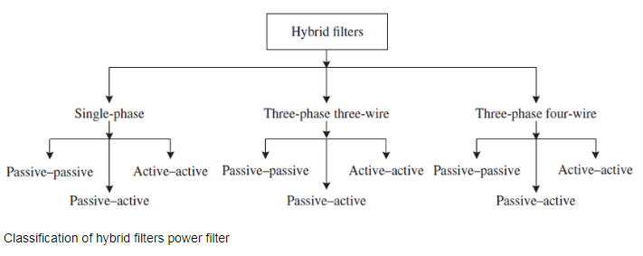

Fig.2.1- Block diagram for the Classification of hybrid power filter

**(i) Series Active Power Filter with Shunt Passive Filter**

This topology joins the arrangement active power filters and shunt passive filter. Series active power filter demonstrates high impedance with providing symphonious seclusion and empowering the symphonious current to stream on passive filter. This sort of filter is intended to repay receptive power, harmonics and lopsided loads in the medium voltage level of a power circulation framework.

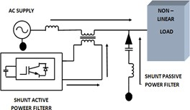

Fig.2.2 –Schematic diagram of the series active power filter with shunt passive filter

In late reviews, multilevel inverter has been utilized to decrease the exchanging misfortunes. This topology isn't favored for common sense application in light of inconveniences of arrangement active filter. In this manner, there are set number of studies on this filter.[20- 21] The schematic diagram of the series active power filter with the shunt passive.

This kind of filter is joined with passive and active control filter in parallel setup. The point of utilizing passive filter is to both filter prevailing harmonics of nonlinear stacks in low recurrence and supply responsive power remuneration. In addition, the parallel active power filter not just repays the harmonics that passive filter proved unable filter additionally bolsters receptive power remuneration. With this topology, the evaluated current of APF is lessened. The point of this work is that while passive.

The schematic diagram of the shunt active power filter with shunt passive filter .This kind of filter is the most widely recognized to others. This topology comprises of shunt passive power filter in arrangement with active power filter. Active power filter part supplies to hold on DC interface voltage that requires for harmonics pay. Passive power filter part hangs on the voltage of central segment in matrix. The evaluated voltage of APF can be lessened the proportion of 1/10 contrasted with parallel active power filter. Along these lines, not just the inverter of APF and dc connect limit additionally cost is fundamentally diminished. Also, the exchanging loss of the inverter can diminish with diminishing the evaluated voltage of APF. This topology is analyzed detail to this article. The schematic arrangement of a active power filter with shunt passive filter is shown in fig. 2.4.

Here Since energy is a need for daily living, it must be delivered to consumers in a consistent, high-quality manner. Due to rising increase in consumption and power generation, the transmission of electricity in the connected cooperative electrical system is gradually expanding. Worldwide transmission systems are constantly changing and being reorganised. They are getting weighed down more and more. For the transmission networks to respond to more varied generation and load patterns, they must be adaptable. The three control parameters that regulate the flow of power in the transmission system are voltage magnitudes, phase angles, and line reactance. When two locations are connected by a symmetrical, lossless transmission line (Fig. 1), the power flow P in the line can be stated as follows:

Whereas (s - r) is the phase angle between the two ends and |Vs| & |Vr| are the voltage magnitudes at the transmitting and receiving ends, respectively. Taking into account that resistance and susceptance are insignificant, XTL is referred to as the transmission line's reactance.

Power flow in the transmission line can be successfully managed, allowing for the system to be operated reliably and securely. This can be done by adjusting voltage magnitudes, phase angles, or line reactance. The sending end or receiving end voltage profile (|Vs| & |Vr|) can be improved to improve the real and reactive power flow of the transmission line. The sending-end and receiving-end voltages' absolute magnitudes control the reactive power flow in the transmission line. When Vs > Vr Then, as depicted in Fig. 1, reactive power moves from the sending end to the receiving end side, or from area-1 to area-2. The phase angles difference (s - r) between the sending end and receiving end voltages in the transmission line, on the other hand, controls the real power flow. Real power flow in the transmission line is significant and flows in the direction from area-1 to area-2 as illustrated in Fig. 1 if the difference between the phase angles (s - r) is large and positive. When the phase angle difference is negative, the power flow is the opposite. Moreover, transmission line reactance (XTL) and real power flow in transmission lines are inversely related to one another. Performance can therefore be enhanced by partially correcting for inherent line reactance. These three factors help the transmission line's electricity flow. Equations 1.1 and 1.2's equations for the power (P and Q) at the receiving end bus

P $=\frac{V^{2 Sin (δs-δr)}}{XTL}………………………(1.1)$

$$Q=\frac{V^{2 Sin (1-COSδ )}}{XTL}…………………(1.2)$$

$$δ=δs-δr…………………………(1.3)$$

1. PROPOSED METHEDOLOGY

3.1 INTRODUCTION

The topology of HSAPF is made out of an arrangement associated active power ﬁlter (SAPF) and a shunt associated latent power ﬁlter (PPF). PPF associated in parallel with the load. The PPF comprises of ﬁfth, seventh tuned LC ﬁlter of rating (𝐿𝑝𝑓= 1.86mH and 𝐶𝑝𝑓= 60µF) for the pay of consonant current on load side. The SAPF associated in arrangement with the source through a coordinating transformer of turn proportion1:2 to guarantee galvanic seclusion. SAPF comprises of three sections, for example, three stage IGBT based SEMIKRON inverter, a DC-connect capacitor of 2200µF and a three-stage high recurrence LC ﬁlter of impedances (𝐶𝑓= 60µF, 𝐿𝑓= 1.35mH). The high recurrence LC ﬁlter is connected to dispose of high recurrence changing swells from the remunerating voltage provided by the inverter. A non-direct load involving a three stage diode connect rectiﬁer (ABC 100V 100A) with RL-load (i.e. resistor of 8.5A, 100 and inductor of 40mH) is considered.

3.2 MODELLING OF THE HSAPF

The arrangement obstruction of the inductors is dismissed. Where 𝑢𝑎 , 𝑢𝑏 and 𝑢𝑐 are the obligation cycle of the inverter legs in an exchanging period, while 𝑉𝑐𝑎 , 𝑉𝑐𝑏, 𝑉𝑐𝑐 are the yield voltage of arrangement active ﬁlter for three stages are appeared in Fig. 3.2 and 𝐼𝑐𝑎 , 𝐼𝑐𝑏 , 𝐼𝑐𝑐 are known as the three stage current yield of active ﬁlter, 𝑉𝑎𝑁 , 𝑉𝑏𝑁 , 𝑉𝑐𝑁 are the stage voltages for three stages, Isa, Isb, Isc are known as the three stage source current, 𝑉𝑛𝑁 is the unbiased voltage. By averaging the inverter legs in the circuit chart, the entire found the middle value of model [13] of the inverter in three stages are acquired as appeared in Fig. 3.3. From this circuit diagram, the dynamic model of the HSAPF under a synchronous reference frame can be expressed by the following differential equations: voltages, 𝑢𝑑 and 𝑢𝑞 are the 𝑑𝑞 -axis obligation proportion.

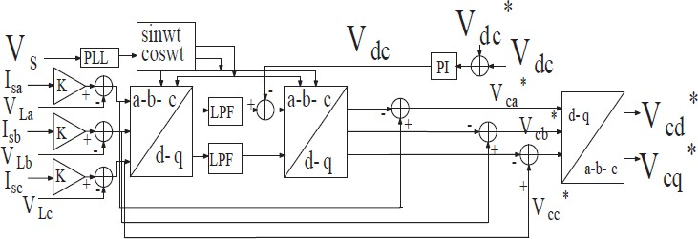

Fig.3.2: Reference Generation Scheme (HSRF)

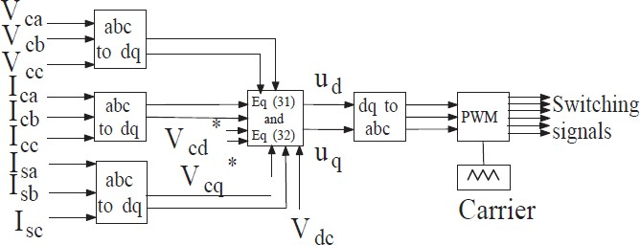

Fig.3.3: Pulse Generation from Controller

In this proposed control approach the control signal satisﬁes all the above conditions, with the goal that the state directions are moved towards the exchanging surface. Consequently, amid the activity of this proposed controller, the HSAPF system accomplishes quick reaction, great power and disposable aggravations successfully.

### 3.3 DESIGN OF FUZZY CONTROL RULES

The fuzzy control rule design involves defining rules that relate the input variables to the output model properties. As fuzzy logic controller is independent of system modal, the design is mainly based on the intuitive feeling for, and experience of, the process. The rules are expressed in English like language with syntax such as If {error *e* is A and change of error *Δe* is B} then {control output is C}For better control performance finer fuzzy petitioned subspaces( NL, NM, NS, ZE, PS, PM, PB ) are used. These seven membership functions are same for input and output and characterized using triangular membership functions. variables make the process similar to that of human think process. It relates output to input, without understanding all the variables, permitting the design of system more accurate and stable than the conventional control system. The fuzzy controller uses two input membership variables error E and change in error dE. There is only one output for the fuzzy function.

# CONCLUSION

The three-phase hybrid active power filter for compensating harmonic currents produced by the non-linear load is described in this work. when the series active power filter's controller is updated with a fuzzy logic controller. A controller with a quicker response time to the transients the proposed system causes. In the MATLAB/SIMULINK environment, the fuzzy logic control-based HPF for a three-phase system is modelled and simulated. This essay also focuses on the issue of electricity quality and how to fix it.

**REFERENCES**

[1] M. Ali, E. Laboure, and F. Costa, “Integrated active ﬁlter for differential-mode noise suppression,” Power Electronics, IEEE Transactions on, vol. 29, no. 3, pp. 1053–1057, 2014.

[2] A. B. Nassif, W. Xu, and W. Freitas, “An investigation on the selection of ﬁlter topologies for passive ﬁlter applications,” Power Delivery, IEEE Transactions on, vol. 24, no. 3, pp. 1710–1718, 2009.

[3] Z. Zeng, H. Yang, S. Tang, and R. Zhao, “Objective- oriented power quality compensation of multifunctional grid-tied inverters and its application in microgrids,” Power Electronics, IEEE Transactions on, vol. 30, no. 3, pp. 1255–1265, 2015.

[4] E. R. Ribeiro and I. Barbi, “Harmonic voltage reduction using a series active ﬁlter under different load conditions,” Power Electronics, IEEE Transactions on, vol. 21, no. 5, pp. 1394–1402, 2006.

[5] B. Ning and Z. Zhang, “Comparison of Total ionizing dose effects for floating and tied body SOI MOSFETs,” International Journal of Electronics and Electrical Engineering, vol. 1, no. 1, March 2013.

[6] S. Diptimayee Swain, P. K. Ray, and K. Mohanty, “Voltage compensation and stability analysis of hybrid series active ﬁlter for harmonic components,” in India Conference (INDICON), 2013 Annual IEEE, pp. 1–6, IEEE, 2013.

[7] W. Tangtheerajaroonwong, T. Hatada, K. Wada, and H. Akagi, “Design and performance of a transformerless shunt hybrid ﬁlter integrated into a three-phase diode rectiﬁer,” Power Electronics, IEEE Transactions on, vol. 22, no. 5, pp. 1882–1889, 2007

[8] Y. Djeghader and L. Zellouma, “Using hybrid power filter to mitigate currents and voltages harmonics in three phase system,” Acta Electrotechnica et Informatica, vol. 15, no. 4, pp. 37-43,

[9] B. Kedjar and K. Al-Haddad, “Dsp-based implementation of an lqr with integral action for a three- phase three-wire shunt active power ﬁlter,” Industrial Electronics, IEEE Transactions on, vol. 56, no. 8, pp. 2821–2828, 2009.

[10] R. Panigrahi, B. Subudhi, and P. C. Panda, “A robust lqg servo control strategy of shunt-active power ﬁlter for power quality enhancement,” Power Electronics, IEEE Transactions on, vol. 31, no. 4, pp. 2860–2869, 2016.

[11] 2015W. Guo, J. Wu, and D. Xu, “A novel sliding mode control of a high-voltage transformerless hybrid shunt active power ﬁlter,” in Industrial Electronics and Applications, 2009. ICIEA 2009. 4th IEEE Conference on, pp. 2908–2913, IEEE, 2009.