**Effect of Diameter of Air Vessel on Efficiency of Hydraulic Ram**

**Mr. Ganesh Rakate, Mr. Tejas Mhetre, Mr. Nikhil Sanjay Mohite, Mr. Vikram Prakash Shembade, Mr. Mayur Mahadev Narale, Mr. Yogesh Yuvraj Nikam, Mr. Akshay Baban Atharabuddhe**

*ADCET , Ashta . Dist- Sangli , Maharashtra.*

|  |  |
| --- | --- |
|  | A B S T R A C T  A hydraulic ram is a water pump that uses the energy of falling water to lift a smaller amount of water to a higher elevation. The efficiency of a hydraulic ram is dependent on various factors, including the diameter of the air vessel. This paper presents an abstract of a study that investigates the effect of the diameter of the air vessel on the efficiency of a hydraulic ram. The study was conducted by varying the diameter of the air vessel of a hydraulic ram and measuring the water output and the efficiency of the pump. The results showed that increasing the diameter of the air vessel increased the efficiency of the hydraulic ram. The optimal diameter of the air vessel was found to be 10-20% of the inside diameter of the supply pipe. This study highlights the importance of selecting the appropriate diameter of the air vessel for a hydraulic ram to achieve optimal efficiency. The findings could be useful in the design and optimization of hydraulic ram systems for various applications, including irrigation, water supply, and wastewater treatment. |

Keywords: Hydraulic, Water, Pump, vessel, Diameter, pressure.

Introduction

The diameter of the air vessel in a hydraulic ram can have a significant impact on its efficiency. Specifically, increasing the diameter of the air vessel can lead to higher efficiency by reducing the amount of energy lost due to water hammer.

Water hammer is a phenomenon that occurs when a flow of water in a pipeline is suddenly stopped, causing a pressure wave to propagate back through the pipeline. This pressure wave can cause significant energy losses, reducing the efficiency of the hydraulic ram. By increasing the diameter of the air vessel, the pressure wave can be dissipated more effectively, reducing the energy losses and improving the efficiency of the ram.

In terms of nomenclature, the diameter of the air vessel can be denoted by the symbol "D". Other relevant parameters include the flow rate of water through the ram (Q), the height of the water source above the ram (H), and the head of water that the ram is able to lift (h).

Overall, the efficiency of a hydraulic ram is a complex function of many different parameters, including the diameter of the air vessel. Careful design and optimization of these parameters can help to maximize the efficiency and effectiveness of the ram.

* 1. ***Structure***

1. Lift water from a source of water to a targeted community.
2. Effect of volume of air vessel on the efficiency of hydraulic ram.
3. Effect of diameter and length of air vessel on the efficiency of hydraulic ram.

**1.4 Scope of work**

A hydraulic ram pump (also called hydram) is a pump that uses energy from a falling quantity of water to pump some of it to an elevation much higher than the original level at the source. No other energy is required and as long as there is a continuous flow of falling water, the pump will work continuously and automatically. Provision of adequate domestic water supply for scattered rural populations is a major problem in many developing countries. Fuel and maintenance costs to operate conventional pumping systems are becoming prohibitive. The hydraulic ram pump (hydram) is an alternative pumping device that is relatively simple technology that uses renewable energy, and is durable. The bydram has only two moving parts; these are impulse valve and delivery valve which can be easily maintained.

Ram Pumps have been used for over two centuries in many parts of the world. Their simplicity and reliability made them commercially successful, particularly in Europe, in the days before electrical power and the intemal combustion engine become widely available.

As technology advanced and become increasingly reliant on sources of power derived from fossil fuels, the ram pump was neglected. It was felt to have no relevance in an age of national electricity grids and large-scale water supplies. Big had become beautiful and small-scale ram pump technology was unfashionable. In recent years an increased interest in renewable energy devices and an awareness of the technological needs of a particular market in developing countries have prompted a reappraisal of ram pumps. In hilly areas with springs and streams, the potential for a simple and reliable pumping device is large. Although there are some examples of successful ram pump installation in developing countries, their use to date has merely scratched at the surface of their potential. The main reason for this being, lack of wide spread local knowledge in the design and manufacture of ram pumps. Hence, the wide spread use of ram pumps will only occur if there isa local manufacturer to deliver quickly; give assistance in system design, installation, and provide an after-sales service.Ram pumps have been around for many decades and are popular for two main reasons:

1. They need no external source of power -- the force of moving water gives them the power they need.

2. They are extremely simple, with just two moving parts.

* 1. ***Tables***

**Literature Review**

|  |  |  |  |
| --- | --- | --- | --- |
| **Title** | **Authors** | **Work carried out** | **Conclusion** |
| Design and Fabrication of A Hydraulic Ram Pump | Nair Suraj, Pranav. P.S.Purusothaman. D, Sivasankar. V | Build a pump called Hydraulic Ram Pump [HRP] that delivers water to higher altitudes with the use of its Kinetic Energy [KE] at inlet and then converting it to pressure energy [PE]. | Hydraulic Ram Pump proves to be a device that is efficient in its working and at the same time is economically viable. |
| Design and analysis of hydraulic ram water pumping system | N S M Hussin, S A Gamil, N A M Amin, M J A Safar, M S A Majid, M N F M Kazim and N F M Nasir | Three design were tested in the experiment study. The best design reached target head of 3 m with 15% efficiency and flow rate of 11.82 *l/min*. | The results from this study show that the less diameter of pressure chamber and higher supply head will create higher pressure. |
| To study Efficiency of a Working Hydraulic Ram Pump System | Soumadeepchatterjee, tanmoysaha, soubhonikbanerje | Focuses on experiments the head & efficiency of the Hydraulic Ram Pump. | Efficiency is about 70-75%.Is extremely affordable and can serve a life of 5yrs without maintenance or any electricity, if kept under shade .Thus it seems very viable option for variety range of application. |
| Design, manufacture and test a hydraulic ram | S.S.Mondol | Preliminary Study on Various Shaped Models of Delivery valve in Hydraulic Ram Pump – Experimental Results | Hydraulic ram pump worked perfectly. It was observed that if the water in tank decreased time taken between strokes increased and pump ceased to work. |
| Design Methodology for Hydraulic Ram-Pum | Sheikh S., Handa C., Ninawe A. | Present generalised design methodology for hydraulic ram pump covering design parameters, design procedure along with mathematical relationship used for the design work. | Mathematically calculated the efficiency of hydraulic ram pump and the suitable design of hydraulic ram pump is produced. The result will be compare with experimental model. |

* 1. ***Construction of references***

**1.3.1 Factors need to be considered**

>Area suitability (head and flow rate)

>Flow rate and head requirement

> Intake design

> Drive system

>Pump house location.

>Delivery pipes routing

>Distribution system

**1.3.2 Maintenance and service life considerations**

The critical parts that require frequent maintenance are bolts, studs and nuts. Therefore, it is usually preferable to have stainless steel bolts, studs and nuts. even though they are costly and difficult to source.

**1.3.3 General considerations**

Shape of hydram has little effect on performance

> Valve design considerations.

> The correct design of valves is a criticalfactor in the overall performance of ram pumps.

Hence, this needs special consideration.

>Strength considerations. This determines thickness of hydram body and air chamber.

**1.3.4 Basic Parts**

From the figure it shows a typical hydraulic ram installation that comprises

> Supply

>Supply pipe (drive pipe)

>Impulse valve/ waste valve/snifter valve

> Delivery valve

> Air chamber

>Delivery pipe 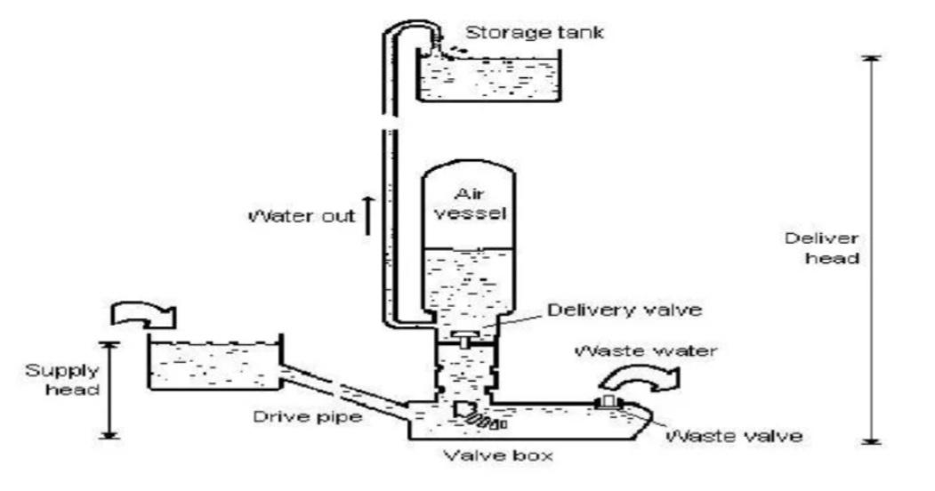

**Fig 1.3.1 basic parts**

**1.3.5 Pipe consideration**

For all pipes being used and the hydram body, the material that we suggested is commercial steel pipe based on the following reason:

>Strength and flexibility

>high resistance to direct heat

>Resistant to very high pressures

> Easy to install, maintain, operate and connect

>Perfect for the extension work in pumping stations, riverbanks, steep

>sloping crossings and reservoirs

> Feature of withstanding traffic vibrations and shocks

Specifically, the types of steel pipe we suggest to use is Galvanized steel since this type of steelis coated with zinc layer to protect steel pipes from conoding. This form of steel provides resistance to corrosion and rust thereby making it highly preferred to make pipes. This also helps in increasing the overall life term of the pipe fittings as well.

**1.3.6 Snifter valve**

It is a device to allow the air to enter the air vessel located above the delivery valve but below the delivery pipe. Is it very important for air to enter because air in the air vessel mixes with water while the hydram is running? As a result, the volume of air in the air vessel decreases and brings about the reduction in the pump's efficiency, thus it is important to have a sniffer valve.

**1.3.7 DESIGN**

When we design water system using ram pumps, we like to know before we build it, how much water it will deliver to how much head and with what efficiency manually manipulating these parameters using design methodology for different input parameters .After that, we then design the hydram using SOLIDWORKS software which a CAD (computer aideddesign ) software as…

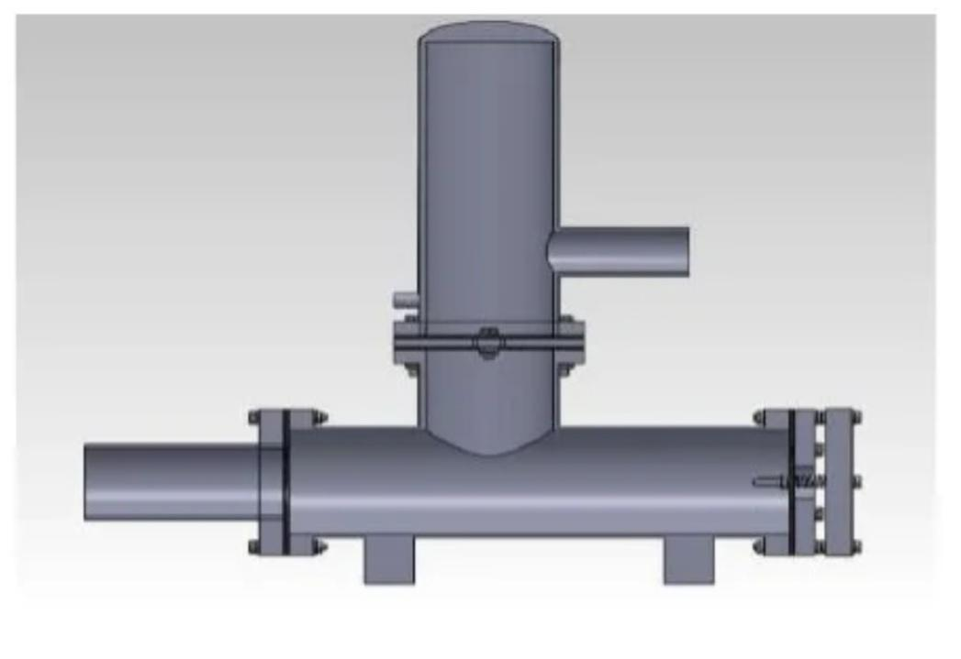

**Fig 1. 3.2 isomertric view of hydraulic ram**

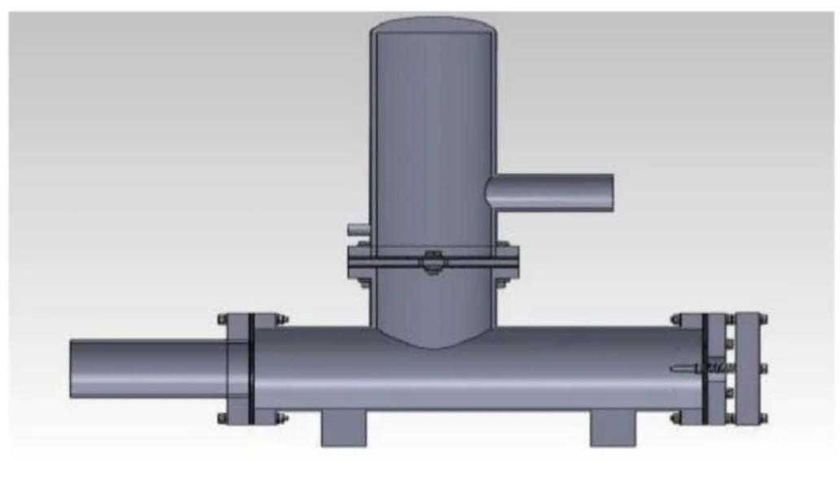

**Fig 1.3.3 cross sectional** **view of hydraulic ram**

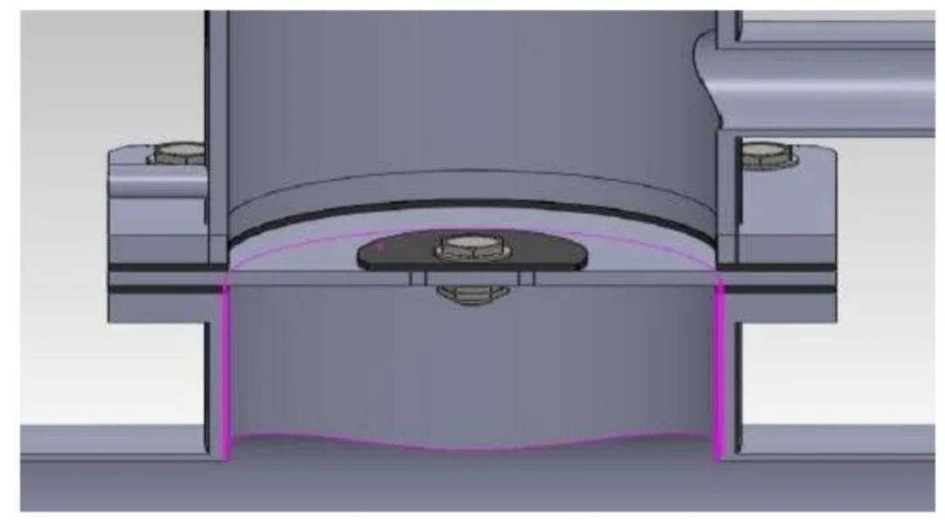

**Fig 1.3.4 sectional view of hydraulic ram pump**

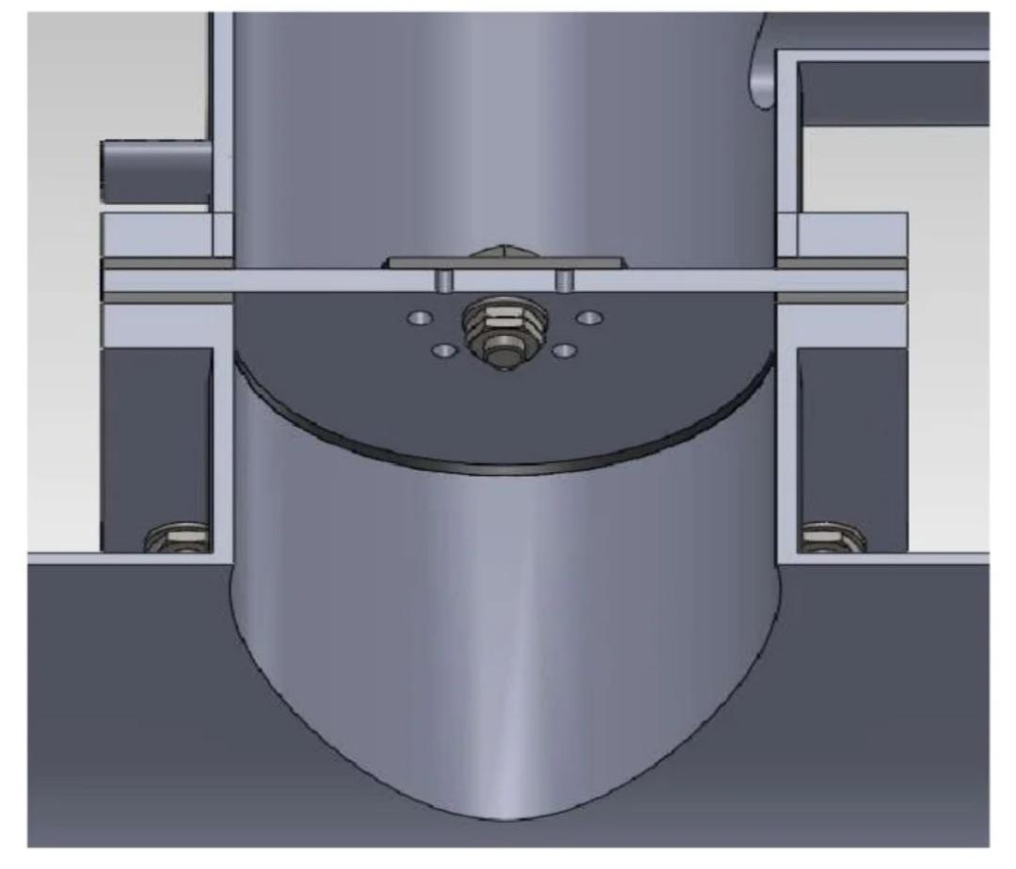

**Fig 1.3.5 sectional view of delivery valve**

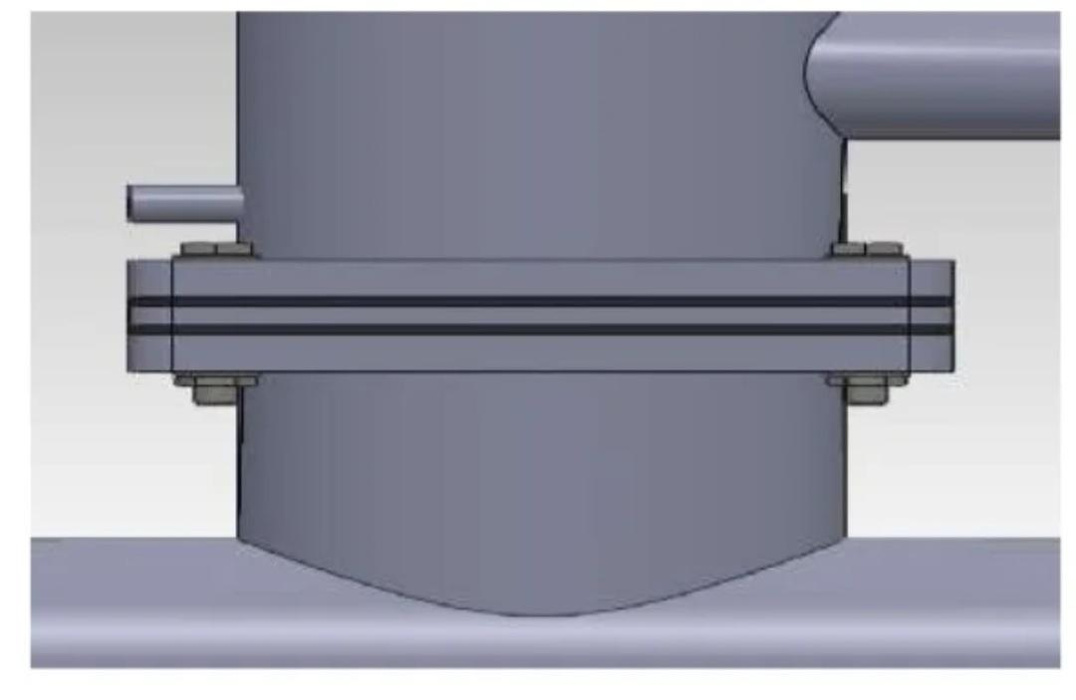

**Fig 1.3.6 Outer view of delivery valve**

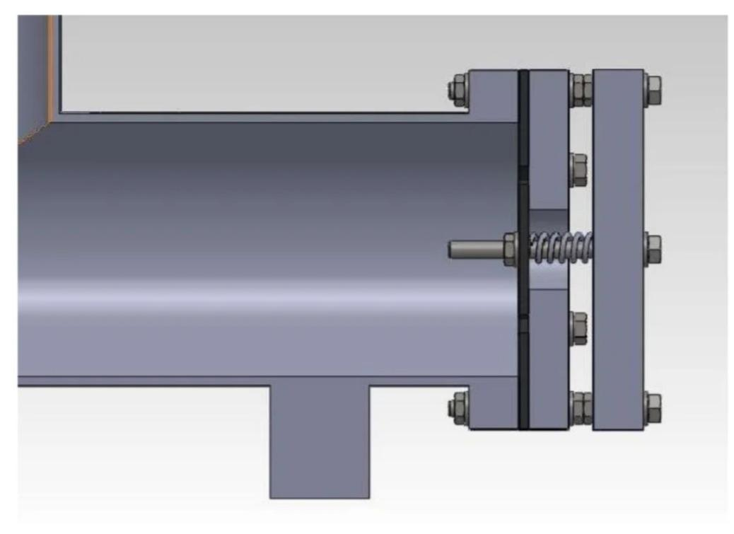**Fig 1.3.7 Cross sectional view of waste valve**

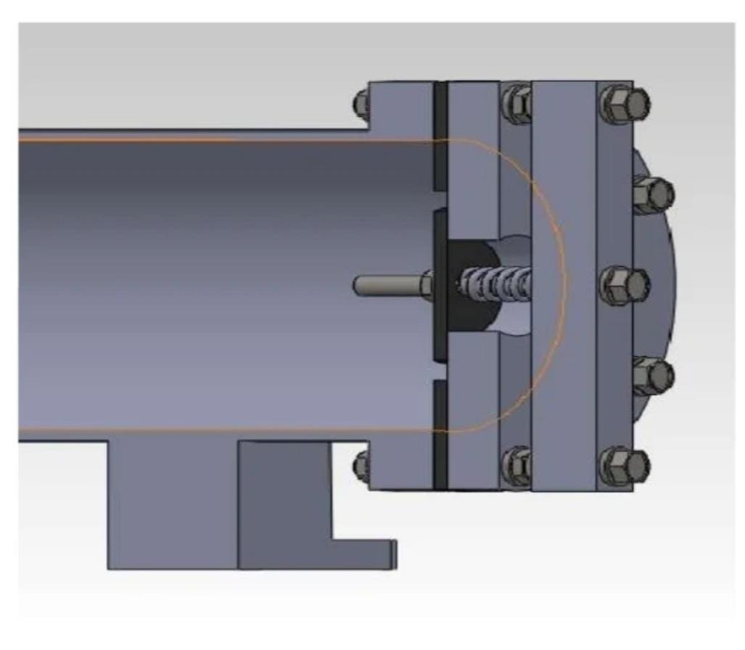 **Fig 1.3.8 sectional view of waste valve**

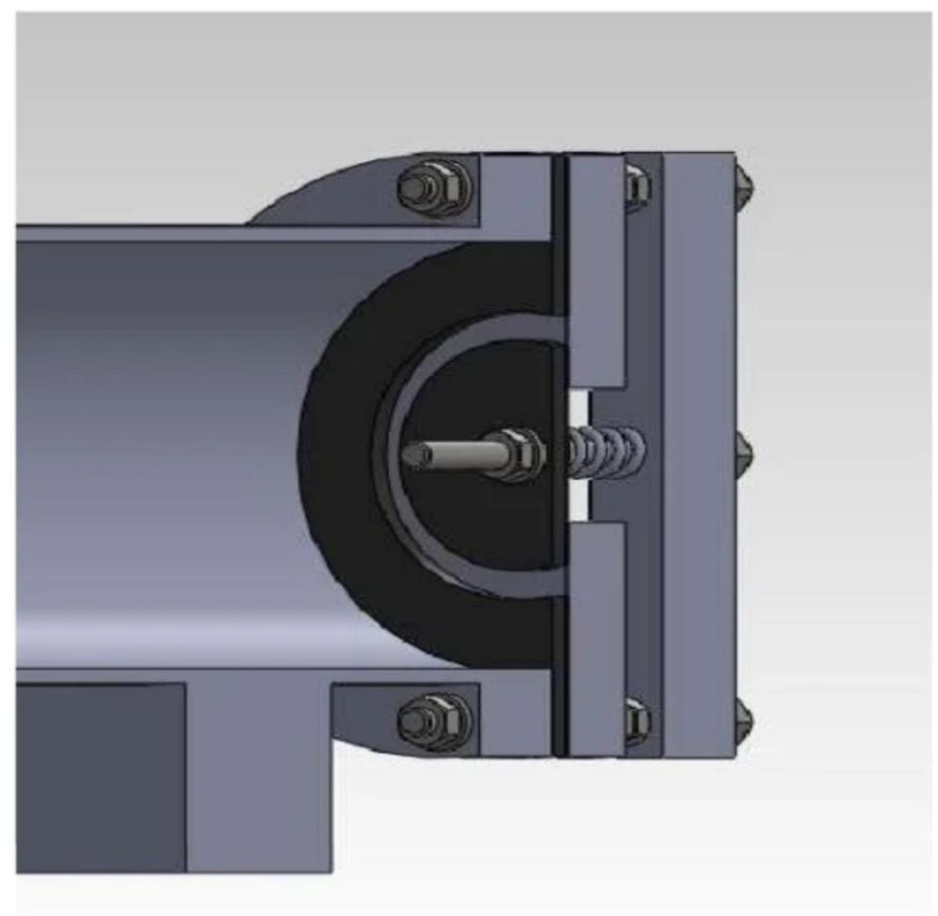 **Fig 1.3.9 sectional view of waste valve**

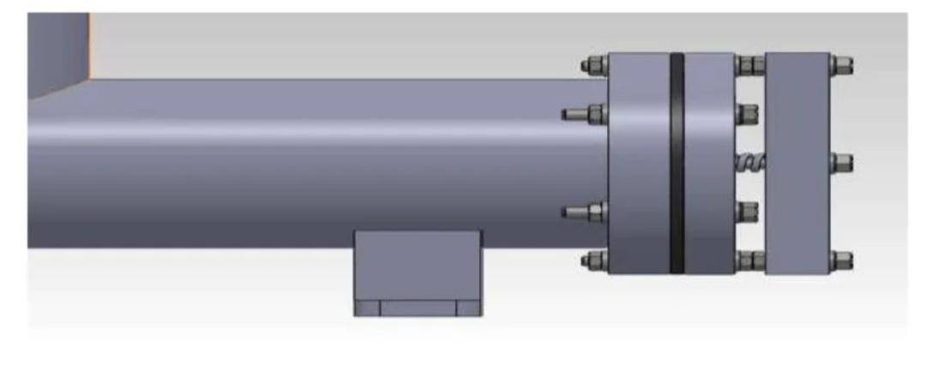**Fig 1.3.10 outer view of waste valve**

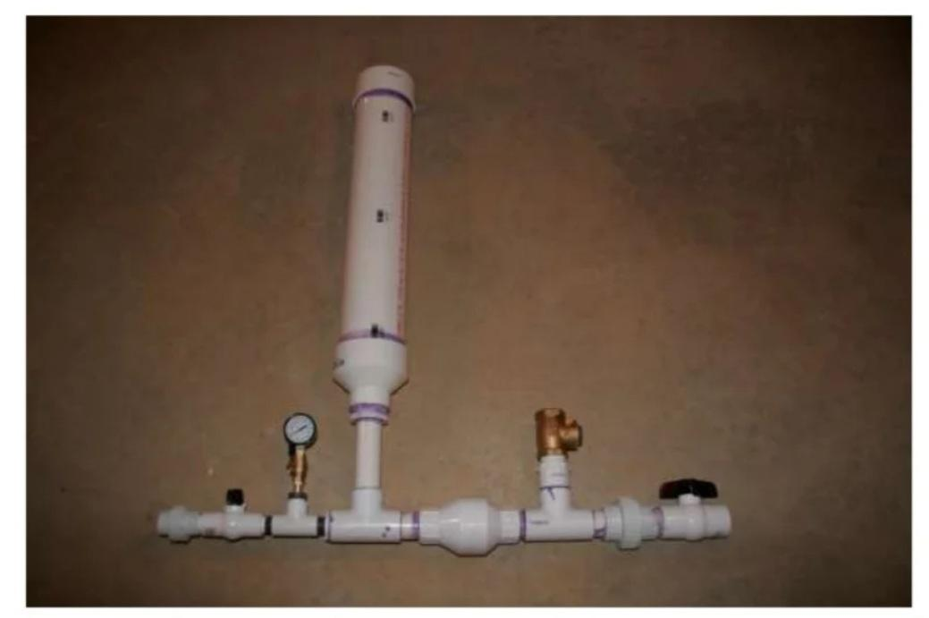

**Fig 1.3.11 Entire assembled figure**

* 1. ***Section headings***

Section headings should be left justified, bold, with the first letter capitalized and numbered consecutively, starting with the Introduction. Sub-section headings should be in capital and lower-case italic letters, numbered 1.1, 1.2, etc, and left justified, with second and subsequent lines indented. All headings should have a minimum of three text lines after them before a page or column break. Ensure the text area is not blank except for the last page.

* 1. ***General guidelines for the preparation of your text***

Avoid hyphenation at the end of a line. Symbols denoting vectors and matrices should be indicated in bold type. Scalar variable names should normally be expressed using italics. Weights and measures should be expressed in SI units. All non-standard abbreviations or symbols must be defined when first mentioned, or a glossary provided.

* 1. ***File naming and delivery***

Please title your files in this order ‘procediaacronym_conferenceacronym_authorslastname’. Submit both the source file and the PDF to the Guest Editor.

Artwork filenames should comply with the syntax “aabbbbbb.ccc”, where:

* a = artwork component type
* b = manuscript reference code
* c = standard file extension
* Component types:
* gr = figure
* pl = plate
* sc = scheme
* fx = fixed graphic
  1. ***Footnotes***

Footnotes should be avoided if possible. Necessary footnotes should be denoted in the text by consecutive superscript letters[1]1. The footnotes should be typed single spaced, and in smaller type size (7pt), at the foot of the page in which they are mentioned, and separated from the main text by a one line space extending at the foot of the column. The Els-footnote style is available in the MS Word for the text of the footnote.

Please do not change the margins of the template as this can result in the footnote falling outside printing range.

1. **Illustrations**

**OPERATIONAL FIGURE EXPLANATION**

As shown in below figures operation perform under these

Water (blue arrows) starts flowing through the drive pipe and out of the "waste" valve (#4 on the diagram), which is open initially. Water flows faster and faster through the pipe and out of the valve. 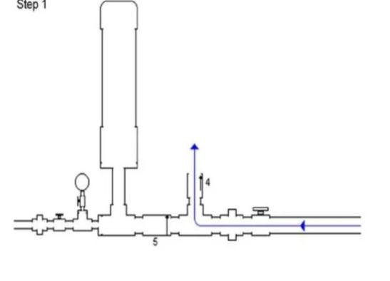

(2) At some point, water is moving so quickly through the brass swing check. "waste" valve (#4) that it grabs the swing check's flapper, pulling it up and slamming it shut. The water in the pipe is moving quickly and doesn't want to stop. All that water weight and momentum is stopped, though, by the valve slamming shut. That makes a high pressure spike (red arrows) at the closed valve. The high pressure spike forces some water (blue arrows) through the spring check valve (#5 on the diagram) and into the pressure chamber. This increases the pressure in that chamber slightly. The pressure "spike" the pipe has nowhere else to go, so it begins moving away from the waste valve and back up the pipe (red arrows). It actually generates a very small velocity backward in the pipe.

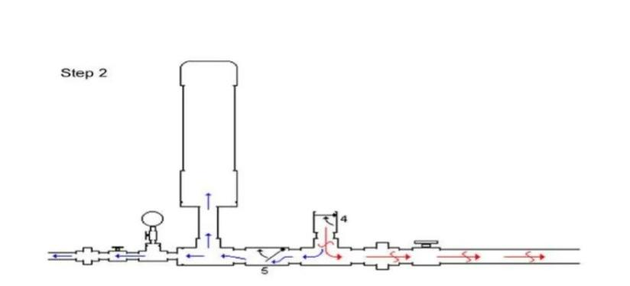

(3)As the pressure wave or spike (red arrows) moves back up the pipe, it creates a lower pressure situation (green arrows) at the waste valve. The spring-loaded check valve (#5) closes as the pressure drops, retaining the pressure in the pressure chamber.

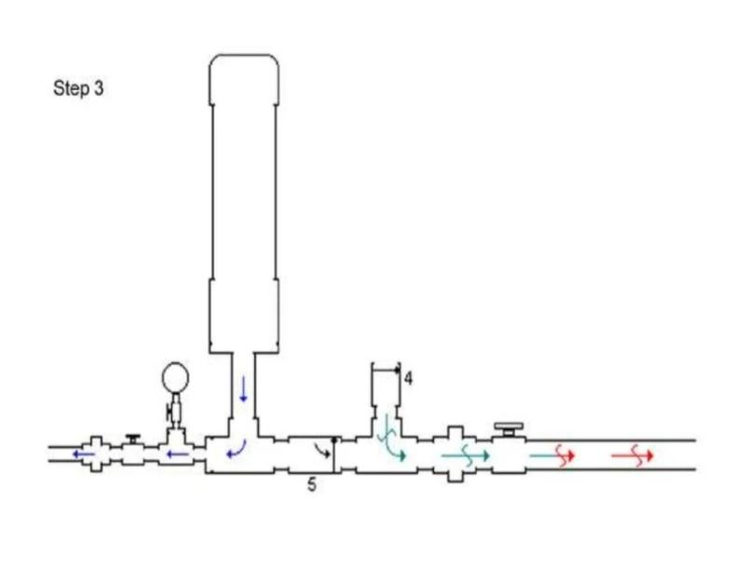

(4)At some point this pressure (green arrows) becomes low enough that the flapper in the waste valve (#4) falls back down, opening the waste valve again.

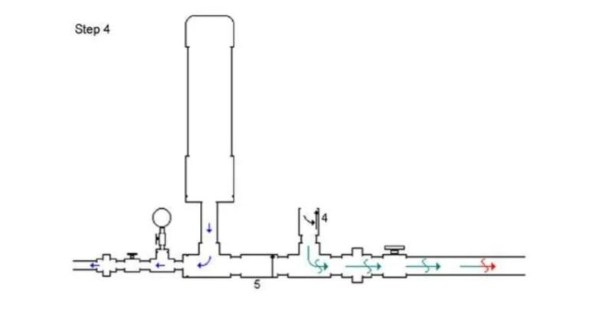

(5)Most of the water hammer high pressure shock wave (red arrows) release at the drive pipe inlet, which is open to the source water body. Some small portion may travel back down the drive pipe, but in any case after the shock wave has released, pressure begins to build again at the waste valve (#4) simply due to the elevation of the source water above the ram, and water begins to flow toward the hydraulic ram again.

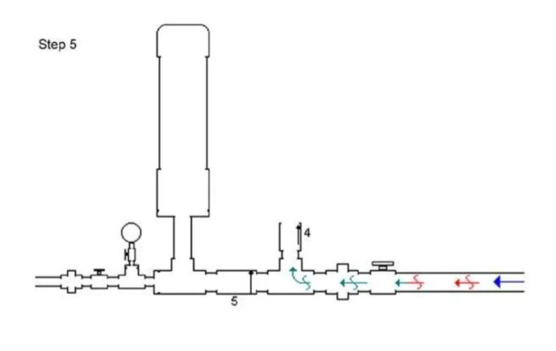(6) Water begins to flow out of the waste valve (#4), and the process starts over once again.

A hydram is a structurally simple unit consisting of two moving parts. These are the impulse valve (or waste valve) and the delivery (check) valve. The unit also includes an air chamber and an air valve. The operation of a hydram is intermittent due to the cyclic opening and closing of the waste and delivery values. The closure of the waste valve creates a high pressure rise in the drive pipe. An air chamber is required to transform the high intermittent pumped flows into a continuous stream of flow. The air valves allow air into the hydram to replace the air absorbed by the water due to the high pressure and mixing in the air chamber.

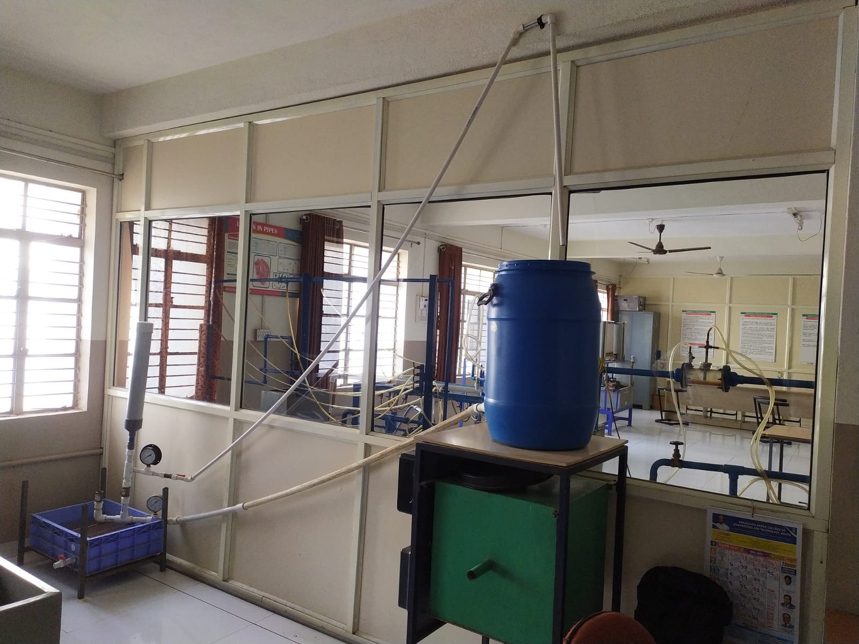

**Figure 2.1 : Hydraulic Ram Pump**

**2.1 Working**

**Working Principle**: A simplified hydraulic ram is shown in Figure .Initially, the waste valve is open, and the delivery valve is closed. The water in the inlet pipe starts to flow under the force of gravity and picks up speed and kinetic energy until the increasing drag force closes the waste valve. The momentum of the water flow in the inlet pipe against the now closed waste valve causes a water hammer that raises the pressure in the pump, opens the delivery valve, and forces some water to flow into the delivery pipe. Because this water is being forced uphill through the delivery pipe farther than it is falling downhill from the source, the flow slows; when the flow reverses, the delivery check valve closes. Meanwhile, the water hammer from the closing of the waste valve also produces a pressure pulse which propagates back up the inlet pipe to the source where it converts to a suction pulse that propagates back down the inlet pipe. This suction pulse, with the weight or spring on the valve, pulls the waste valve back open and allows the process to begin again. A pressure vessel containing air cushions the hydraulic pressure shock when the waste valve closes, and it also improves the pumping efficiency by allowing a more constant flow through the delivery pipe. Although the pump could in theory work without it, the efficiency would drop drastically, and the pump would be subject to extraordinary stresses that could shorten its life .One problem is that the pressurized air will gradually be dissolved into the water until none remains. One solution to this problem is to have the air separated from the water by an elastic diaphragm (similar to an expansion tank); however, this solution can be problematic in developing countries where replacements are difficult to procure. Another solution is to have a mechanism such as a shifting valve that automatically inserts a small bubble of air when the suction pulse mentioned above reaches the pump. Another solution is to put a certain inner tube of a car or bicycle tire into the pressure vessel with some air in it and the valve closed. This tube is in effect the same as the diaphragm, but it is implemented with more pulse mentioned above reaching the pump. Another solution is to put a certain inner tube of a car or bicycle tire into the pressure vessel with some air in it and the valve closed. This tube is in effect the same as the diaphragm, but it isimplemented with more widely available materials . The air in the cushion of the shock water tube is the same as the other configuration does .

**fig 2.1 modern design**Diagram

Description automatically generated

1. **Equations**

# SYMBOLS AND NOTATIONS

|  |  |
| --- | --- |
|  | h = level of water in the supply tank above the waste valve  H =level of water in the delivery tank above that in the  supply tank q = rate of discharge of water actually lifted by the ram  Q = rate of discharge of water flowing through past the |

**1) D’Aubuisson’s efficiency**

In this system the datum may be taken to be passing through the waste valve, and hence the energy input during one cycle is and the useful output during the same cycle is. The corresponding overall efficiency then becomes

**D’Aubuisson’s efficiency = q (H+h) / h (Q+q)**

Which is known as D’Aubuisson’s efficiency, and its value is always more than Rankine’s efficiency.

**2) Rankine’s efficiency:**

In the Rankine system the water surface in the supply reservoir is taken as datum and hence the energy input during one cycle is (wQh), and the useful output during the same cycle is (wqH) ,where w is the specific weight of water. Thus,

**Rankine’s efficiency = wqH /wQh**

h = level of water in the supply tank above the waste valve

H =level of water in the delivery tank above that in the supply tank  
q = rate of discharge of water actually lifted by the ram

Q = rate of discharge of water flowing through past the waste valve

Specifications of air vessel:

length = 62 cm Diameter = 8.5 cm

volume = 3518.19 cm3

Supply pipe

length= 259 cm Diameter = 0.5 inch

Delivery pipe

Length =335 cm Diameter = 1 inch

Discharge of water flowing

through Waste valve = volume/time = 1/10.9 *60

= 5.50 lit/min

Discharge of water actually

lifted by the ram (q) = 1/28.33*60 = 2.12 lit/min

Discharge of water flowing

through past the waste valve (Q) = 5.50 + 2.12 = 7.72 lit/min

1) D’Aubuisson’s efficiency= w*q*(H+h)/w*(Q+q)*h

= 2.12(94.48+137.16)

137.16(7.72)

= 0.46*100

= 46 %

2) Rankine’s efficiency = w*q*H/w*Q*h

= 2.12(94.48)

7.72(137.16)

= 0.19*100

= 19 %

**4. Online license transfer**

All authors are required to complete the Procedia exclusive license transfer agreement before the article can be published, which they can do online. This transfer agreement enables Elsevier to protect the copyrighted material for the authors, but does not relinquish the authors’ proprietary rights. The copyright transfer covers the exclusive rights to reproduce and distribute the article, including reprints, photographic reproductions, microfilm or any other reproductions of similar nature and translations. Authors are responsible for obtaining from the copyright holder, the permission to reproduce any figures for which copyright exists.

**Acknowledgements**

We would like to express our deep and sincere gratitude to our Guide **Mr. G.N. Rakate** Department of Mechanical Engineering, for guiding us to accomplish this Mini Project work. It was our privilege and pleasure to work under his able guidance. We are indeed grateful to him for providing helpful suggestions, from time to time. Due to his constant encouragement and inspiration we are able to present this mini project.

We express our deep gratitude to **Mr. M. M. Jadhav**, Head of Mechanical Engineering Department, for his valuable guidance and constant encouragement. We are very much thankful to **Dr. V. S. Patil** Director, Annasaheb Dange College of Engineering and technology, Ashta for providing all the necessary facilities to carry out project work.

1. Increasing Efficiency By Changing Diameter of Air Vessel which Effect Hydraulic Ram . With the help of Rankine’s efficiency .

References

R.K.Bansal " A Textbook Of Fluid Mechanics And Hydraulic Machines" Laxmi Publication (P) LTD , Ninth Edition , Page 1053 to 1055, Year 1989.

2) R.K. Rajput " A Textbook Of Fluid Mechanics And Hydraulic Machine" ,S. Chand & Company LTD , Fifth Edition , Year 1998

3) FatihhiSzaliJanuddi " Development and Testing of Hydraulic Ram Pump (Hydram): Experiments and Simulations" IOP Publication ,Year 2018

4) S. S. Mondol "Design, Manufacture and Test a Hydraulic Ram" research gate, Year May 2017

5) Matthias Inthachota, Suchard Saehaengb, Johannes F.J.Maxa, "Hydraulic ram pumps for irrigation in Northern Thailand ",ScienceDirect , Year 2015

6) Sheikh, S., Handa, C., Ninawe, A. Design Methodology for Hydraulic Ram Pump. IJMERR, 2 (4), 170–175.- Year 2013

7) Hussin, N. S. M., Gamil, S. A., Amin, N. A. M., Safar, M. J. A., Majid, M. S. A., Kazim, M. N. F. M., Nasir, N. F. M. (2017). Design and analysis of hydraulic ram water pumping system. Journal of Physics: Year 2017

8) Chatterjee S, Saha T, Banerjee S, Efficiency of a working Hydram pump system, -Year Dec 2020

9) Design and Fabrication of Hydraulic Ram Pump: Nairs, Pranav PS, Purushothaman D, Sivasankar V -Year April 2018

1.