**Parent Control and Preventing Touchy Information and Derivation Attack in Social System**

H. Umar Fareeth1, Mr. E.R. Ramesh2, Ms. Sarika Jain3, Dr. S. Geetha4

1M.Sc -CFIS, Department of Computer Science and Engineering, Dr. M.G.R Educational and Research Institute, Chennai 600 095, Tamilnadu, India

2,3Center of Excellence in Digital Forensics, Perungudi, Chennai 600 089, Tamilnadu, India

4Head of the Department, Department of Computer Science and Engineering, Dr. M.G.R Educational and Research Institute, Chennai 600 095, Tamilnadu, India

Abstract

Discharging interpersonal organization information could truly break client protection. Client profile and fellowship relations are intrinsically private Shockingly, it is conceivable to foresee touchy data conveyed in discharged information inactively by using information mining systems in this paper, we investigate how to dispatch a surmising assault misusing interpersonal. Organizations with a blend of non-delicate characteristics and social connections surmising assault misusing interpersonal organizations with a blend of non-delicate characteristics and social connections. We outline issue to an aggregate characterization issue and propose an aggregate induction display. In our model, an aggressor uses client profile and social connections in a system way to anticipate touchy data of related casualties in a discharged interpersonal organization dataset. To ensure against such assaults, we propose information cleansing strategy all things considered controlling client profile and fellowship relation

Keywords: Black listing, monitoring, graph view.

1. **Introduction**

In this digital network provide a virtual stage for users to reveal themselves to their own societies or to the public. For example, Facebook users publish information regarding favourite books, popular songs, interesting movies, political views, etc. A professional network for scientists and researchers, publish information regarding research experiences, publications, academic activities and so on. Besides users, third party users such as researchers, merchants, advertisers, and even adversaries may benefit from the huge amount of published data that can be easily and deliberately obtained from social networks for scientific/commercial purpose or malicious intention. Privacy concerns in social networks can be mainly categorized into two types: inherent-data privacy and latent- data privacy. Inherent-data privacy is related to sensitive data contained in the data profile submitted by users in order to receive data-related services. For example, age and gender are unavoidable data for health-related services yet unwilling to be released by most users. In this project, we focus on latent-data privacy. We assume third party users may collect anonymous user data from social third-party networks. Some users disclose their sensitive information, while others do not. However, users can carry out de-anonymization actions and further infer sensitive information of users. We first investigate how to infer sensitive information hidden in the released data. Then, we propose some effective data sanitization strategies to prevent information inference attacks. On the other hand, the sanitized data obtained by these strategies should not reduce the valuable benefit brought by the abundant data resources, so that non-sensitive information can still be inferred and utilized by third party users. To explore how to launch an inference attack by third party users, we employ a typical inference attack, called collective inference, as a case study. We present a novel implementation method for collective inference. Collective inference mainly relies on iteratively propagating current predicting results throughout a network to improve prediction accuracy thus we need to consider how to best predict sensitive information in each iteration. Previous works primarily utilize the Naive Bayes classifier to infer sensitive information in each iteration. Social networks data to investigate collective attacks in diverse large scale social network.

1. **Literature Survey**

(According to kui ren. (2021)) the enabling privacy preserving project contains the increasing popularity of images at social media sites is posing new opportunities for social discovery applications, i.e., suggesting new friends and discovering new social groups with similar interests via exploring images. To effectively handle the explosive growth of images involved in social discovery, one common trend for many emerging social media sites is to leverage the commercial public cloud as their robust backend data center.

(According to mukamala, A. Abid hussain (2020)) a Set Theoretical Approach to Big Data Analytics Current analytical approaches in computational social science can be characterized by four dominant paradigms: text analysis (information extraction and classification), social network analysis (graph theory), social complexity analysis (complex systems science), and social simulations (cellular automata and agent-based modeling). However, when it comes to organizational and societal units of analysis, there exists no approach to conceptualize, model, analyze, explain, and predict social media interactions as individuals' associations with ideas, values, identities, and so on

(Enabling Privacy-preserving Image-centric Social Discovery) The increasing popularity of images at social media sites is posing new opportunities for social discovery applications., suggesting new friends and discovering new social groups with similar interests via exploring images. To effectively handle the explosive growth of images involved in social discovery, one common trend for many emerging social media sites is to leverage the commercial public cloud as their robust backend data center. While extremely convenient, directly exposing content-rich images and the related social discovery results to the public cloud also raises new acute privacy concerns. In light of the observation, in this paper we propose a privacy-preserving social discovery service architecture based on encrypted images.

(Social Set Analysis: A Set Theoretical Approach to Big Data Analytics) Current analytical approaches in computational social science can be characterized by four dominant paradigms: text analysis (information extraction and classification), social network analysis (graph theory), social complexity analysis (complex systems science), and social simulations (cellular automata and agent-based modeling). However, when it comes to organizational and societal units of analysis, there exists no approach to conceptualize, model, analyze, explain, and predict social media interactions as individuals' associations with ideas, values, identities, and so on. To address this limitation, based on the sociology of associations and the mathematics of set theory, this paper presents a new approach to bigdata analytics called social set analysis. Social set analysis consists of a generative framework for the philosophies of computational social science, theory of social data, conceptual and formal models of social data, and an analytical framework for combining big social data sets with organizational and societal datasets. Three empirical studies of big social data are presented to illustrate and demonstrate social set analysis in terms of fuzzy set-theoretical sentiment analysis, crisp set-theoretical interaction analysis, and event studies-oriented set-theoretical visualizations. Implications for big data analytics, current limitations of the set-theoretical approach, and future directions are outlined.

(Exploiting Social Ties for Cooperative D2DCommunications: A Mobile Social Networking Case) Thanks to the convergence of pervasive mobile communications and fast-growing online social networking, mobile social networking is penetrating into our everyday life. Aiming to develop a systematic understanding of mobile social networks, in this paper we exploit social ties in human social networks to enhance cooperative device-to-device (D2D) communications. Specifically, as handheld devices are carried by human beings, we leverage two key social phenomena, namely social trust and social reciprocity, to promote efficient cooperation among devices. With this insight, we develop a coalitional game-theoretic framework to devise social-tie-based cooperation strategies for D2D communications. We also develop a network-assisted relay selection mechanism to implement the coalitional game solution, and show that the mechanism is immune to group deviations, individually rational, truthful, and computationally efficient. We evaluate the performance of the mechanism by using real social data traces. Simulation results corroborate that the proposed mechanism can achieve significant performance gain over the case without D2D cooperation.

1. **Existing System**

However, the rising privacy concerns restrain the data release scale. Facebook Beacon is an unsuccessful example that reminds people to release anonymous and incomplete user data. Therefore, the contradiction between the benefit rendered by data and privacy concerns drives third party users to mine sensitive information hidden in the released data in addition to non-sensitive information. Privacy concerns in social networks can be mainly categorized into two types: inherent-data privacy and latent data privacy. Inherent-data privacy is related to sensitive data contained in the data profile submitted by users in order to receive data-related services.

1. **Proposing System**

In this paper, we present a finer-grained utility definition. In this paper, we explore how to launch an inference attack exploiting social networks with a mixture of non-sensitive attributes and social relationships. We map this issue to a collective classification problem and propose a collective inference model. In our model, an attacker utilizes user profile and social relationships in a collective manner to predict sensitive information of related victims in a released social network dataset. The key novel idea lies that besides sanitizing friendship relations, the proposed method can take advantages of various data-manipulating methods. We show that we can easily reduce adversary’s prediction accuracy on sensitive information, while resulting in less accuracy decrease on non-sensitive information towards three social network datasets. To the best of our knowledge, this is the first work that employs collective methods involving various data-manipulating methods and social relationships to protect against inference attacks in social networks.

1. **Architecture Diagram**

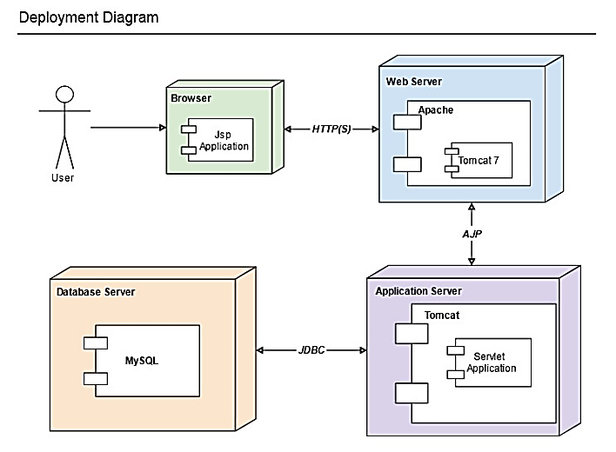

**Figure. 5.1 Architecture Diagram**

1. **List of phases**

There are 5 phases

* Detecting Spam in Trending Topic
* Fake User Identification
* Ham Learning Algorithm
* Fake Content Based Spammer Detection

## **Detecting Spam in Trending Topic**

* The collection of tweets with respect to trending topics on social media. After storing the tweets in a particular file format, the tweets are subsequently analyzed. Labeling of spam is performed to check through all datasets that are available to detect the malignant social media.
* Feature extraction separates the characteristics construct based on the language model that uses tweets as a tool and helps in determining whether the tweets are fake or not.
* The classification of data set is performed by shortlisting the set of tweets that is described by the set of features provided to the classifier to instruct the model and to acquire the knowledge for spam detection.
* The spam detection uses the classification technique to accept tweets as the input and classify the spam and non-spam examined the degree to which the trending affairs in Twitter are exploited by spammers.
* Although numerous methods to detect the spam have been proposed, the research on determining the effects of spam on Twitter trending topics has attained only limited attention of the researchers.

**Fake User Identification**

* A categorization method is proposed to detect spam accounts on social media. The dataset used in the study was collected manually.
* The classification is performed by analysing user-name, profile, number of friends and followers, content of tweets, description of account, and number of tweets.
* The dataset comprised 501 fake and 499 real accounts, where 16 features from the information that were obtained from the social website were identified. Two experiments were performed for classifying fake accounts.
* The first experiment uses the Naïve Bayes learning algorithm on the social website dataset including all aspects without discretization, whereas the second experiment uses the Naïve Bayes learning algorithm on the social website dataset after the discretization.
* Proposed a hybrid technique that utilizes user-based, content-based, and graph-based characteristics for spammer profiles detection. A model is proposed to differentiate between the non-spam and spam profiles using three characteristics.
* The proposed technique was analyzed using social website dataset with users and approximately tweets. The goal is to attain higher efficiency and preciseness by integrating all these characteristics. User-based features are established because of relationship and properties of user accounts.
* It is essential to append user-based features for the spam detection model. As these features are related to user accounts, all attributes, which were linked to user accounts, were identified.

**HAM Learning Algorithm**

* Ham is WordNet that is not Spam. In other words, non-spam or good positive words. It should be considered a shorter, snappier synonym for "non-spam. Its usage is particularly common among anti-spam software developers and not widely known elsewhere in general it is probably better to use the term non-spam, instead.
* Content attributes have the property of the wordings of tweets that are posted by the users which gather features that are relevant to the way users write tweets. On the other hand, user behavior attributes gather particular features of the behavior of users in the context of the posting frequency, interaction, and impact on social website. The following attributes are considered as user characteristics, which include the total number of followers and following, account age, number of tags, fraction of followers per followings, number of times users replied, number of tweets received, average, maximum, minimum, and median time among user tweets, and daily and weekly tweets

**Fake Content Based Spammer Detection**

* Performed an in-depth characterization of the components that are affected by the rapidly growing malicious content.
* It was observed that a large number of people with high social profiles were responsible for circulating fake news.
* To recognize the fake accounts, the authors selected the accounts that were built immediately after the Boston blast and were later banned by social media due to violation of terms and conditions.
* This dataset is known as the largest dataset of Boston blast. The authors performed the fake content categorization through temporal analysis where temporal distribution of tweets is calculated based on the number of tweets posted per hour ours.
* Fake tweet user accounts were analyzed by the activities performed by user accounts from where the spam tweets were generated. It was observed that most of the fake tweets were shared by people with followers.

1. **Screen Shots**

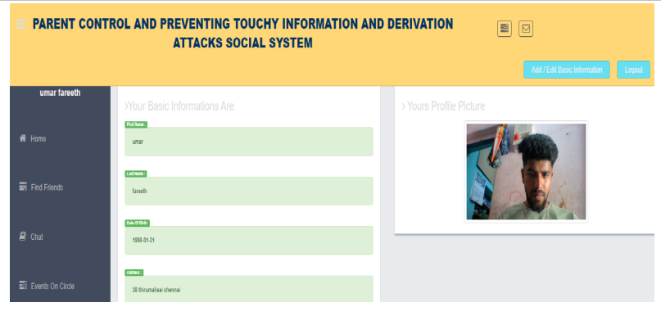

**Figure. 7.1 User page**

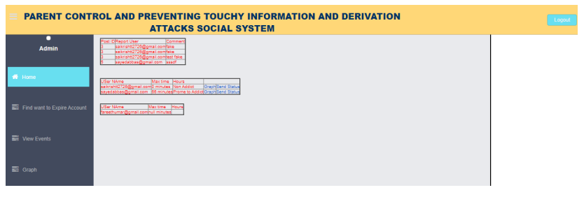

**Figure.7.2 Admin page**

1. **Conclusion****s**

We address two issues in this paper: (a) how precisely third-party clients dispatch a derivation assault to anticipate delicate data of clients, and (b) are there viable techniques to secure against such an assault to accomplish a coveted privacy utility trade off. For the primary issue, we demonstrate that all in all using both trait and connection data can fundamentally increment expectation exactness for touchy data. For the second issue, we investigate the reliance connections for utility/open characteristics, and security/open traits. In light of these outcomes, we propose a Collective Method that take points of interest of different information controlling strategies tenure disinfecting client information does not bring about a terrible effect on information utility. Utilizing Collective Method, we can successfully disinfect interpersonal organization information before discharge. The answers for the two tended to issues are ended up being successful towards three genuine social datasets.

**References**

1. https://www.researchgate.net/.
2. <http://www.imdb.com/>.
3. “Facebook beacon,” 2007
4. K. Heussner, “’gaydar’ on Facebook: Can your friends reveal sexual orientation?” ABC News.,2009
5. C. Johnson, “Gaydar,” The Boston Blobe., 2009.
6. http://www.pewinternet.org/2013/05/21/teens-social-mediaand-privacy/
7. S. Nilizadeh, A. Kapadia, and Y.-Y. Ahn, “Community-enhanced de-anonymization of online social networks,” in Proceedings of the 2014 ACM SIGSAC Conference on Computer and Communications Security, ser. CCS ’14. New York, NY, USA: ACM, 2014, pp. 537.
8. Narayanan A and V. Shmatikov, “De-anonymizing social net- works,” in Proceedings of the 2009 30th IEEE Symposium on Security Society, 2009, pp. 173–187. L. Backstrom, C. Dwork, and J. Kleinberg, “Wherefore art thour3579x? Anonymized social networks, hidden patterns, and structural steganography,” in Proceedings of the 16th International Conference on World Wide Web, ser. WWW ’07. New York, NY, USA:ACM, 2007, pp. 181–190.
9. [www.codeproject.com](http://www.codeproject.com)
10. [www.w3schools.com](http://www.w3schools.com)
11. www.google.com