Aadhar Card Based Wellbeing Records Observing Framework

Liviya Mary Wilson1, Ms. Sarika Jain2, Dr. S.Geetha3

1M.Sc – CFIS, Department of Computer Science and Engineering, Dr. M.G.R Educational and Research Institute, Chennai 600 095, Tamilnadu, India

2Center of Excellence in Digital Forensics, Perungudi, Chennai 600 089, Tamilnadu, India

3Head of the Department, Department of Computer Science and Engineering, Dr. M.G.R Educational and Research Institute, Chennai 600 095, Tamilnadu, India

**Abstract**

Distributed computing is arising as a promising worldview for registering and is drawing the consideration from both scholarly community and industry. The distributed computing model moves the processing framework to outsider specialist co-ops that deal with the equipment and programming assets with tremendous expense decreases. It is arising as another registering worldview in the clinical area other than other business spaces. Enormous quantities of wellbeing associations have begun moving the electronic wellbeing data to the cloud climate. Presenting the cloud administrations in the wellbeing area not just works with the trading of electronic clinical records among the emergency clinics and facilities, yet additionally empowers the cloud to go about as a clinical record stockpiling focus. In addition, moving to the cloud climate frees the medical care associations from the dreary errands of foundation the executives and furthermore limits advancement and upkeep costs. Putting away the clinical information in cloud makes the therapy proficient by recovering patient's clinical history from the data set prior to going for the treatment and get to realize about the medical problems of the patient.

1. **Introduction**

Cloud based wellbeing framework's principal center is the patient's information assortment, capacity, access, analysis, and show and so on. The ongoing patient information assortment strategies are time consuming, inefficient, difficult for the staffs. It is likewise clear that flows method is abusing the continuous information access for observing the patients.

1. **Objectives**

A framework which handles the clinical history of every person of the nation and gives admittance to all enlisted emergency clinics to peruse or refresh the information. The medical clinic which gets to the data set should be enrolled and probably got a permit. The permit number is utilized as a one of a kind code to get to the data set. The subtleties of the patients will be put away and an ID number will be created when their information are put away into the data set interestingly after the execution of the framework.

* Store vast amount of medical data
* Efficient treatment through the data reference
* Reduce the difficulties to keep the data safe.

1. **Existing System**

Cloud based wellbeing framework's primary center is the patient's information assortment, capacity, access, investigation, and show and so forth. The ongoing patient information assortment strategies are tedious, wasteful, difficult. It is likewise clear that flows method is disregarding the constant information access for observing the patients. In m-medical care interpersonal organizations, the individual wellbeing data is constantly divided between the patients situated in particular friendly networks experiencing a similar illness for shared help, and across conveyed medical care suppliers furnished with their own cloud servers for clinical specialist. Be that as it may, it likewise achieves a progression of difficulties, particularly how to guarantee the security and protection of the patients individual wellbeing data from different assaults in the remote correspondence channel, for example, listening in and altering.

1. **Proposed System**

Cloud based wellbeing framework arrangement depends on the idea of "Distributed computing" a disseminated processing framework where a pool of virtualized, progressively marketable, oversaw figuring power, capacity, stages, and administrations are conveyed. This framework gives a climate where patient's records are put away and it will be referred to by the specialists to work on the proficiency of the treatment. This handles the clinical history of every person of the nation and gives admittance to all enrolled medical clinics to peruse or refresh the information. The emergency clinic which gets to the information base should be enrolled and probably got a permit. The permit number is utilized as an extraordinary code to get to the information base. The subtleties of the patients will be put away and an ID number will be created when their information is put away into the data set interestingly after the execution of the framework. At the point when they go for a therapy, their clinical information will be put away into the data set utilizing their distinguishing proof number. For the sake of security, any individual who needs to see their information will be permitted exclusively to peruse the information. They won't be given admittance to refresh the data set. For medical clinics to refresh the data set they require the permit number alongside the ID number of the individual whose record must be put away.

1. **Literature Survey**

**M. Li et.al,** personal health record (PHR) is an emerging patient-centric model of health information exchange, which is often outsourced to be stored at a third party, such as cloud providers. In this paper, we propose a novel patient-centric framework and a suite of mechanisms for data access control to PHRs stored in semi trusted servers. To achieve fine-grained and scalable data access control for PHRs, we leverage attribute-based encryption (ABE) techniques to encrypt each patient’s PHR file. A high degree of patient privacy is guaranteed simultaneously by exploiting multiauthority ABE. Our scheme also enables dynamic modification of access policies or file attributes, supports efficient on-demand user/attribute revocation and break-glass access under emergency scenarios. Extensive analytical and experimental results are presented which show the security, scalability, and efficiency of our proposed scheme.

**H. Liang, et.al,** mobile cloud computing is a promising technique that shifts the data and computing service modules from individual devices to geographically distributed cloud service architecture. In this paper, we propose a service decision making system for inter domain service transfer to balance the computation loads among multiple cloud domains. To this end, we formulate the service request decision making process as a semi-Markov decision process. The optimal service transfer decisions are obtained by jointly considering the system incomes and expenses. Extensive simulation results show that the proposed decision making system can significantly improve the system rewards and decrease service disruptions compared with the greedy approach.

**Q. Shen et.al,** in this paper, we propose an e-health monitoring system with minimum service delay and privacy preservation by exploiting geo-distributed clouds. In the system, the resource allocation scheme enables the distributed cloud servers to cooperatively assign the servers to the requested users under the load balance condition. Through the numerical analysis, we show the efficiency of the proposed traffic-shaping algorithm in terms of service delay and privacy preservation. Furthermore, through the simulations, we demonstrate that the proposed resource allocation scheme significantly reduces the service delay compared to two other alternatives using jointly the short queue and distributed control law.

**Y. Yang et.al,** with the development of cloud computing, data sharing has a new effective method, i.e., outsourced to cloud platform. In this case, since the outsourced data may contain privacy, they only allow to be accessed by the authorized users. In this paper, we leverage the secure k-nearest neighbour to propose a secure dynamic searchable symmetric encryption scheme. Our scheme can achieve two important security features, i.e., forward privacy and backward privacy which are very challenging in Dynamic Searchable Symmetric Encryption (DSSE) area. In addition, we evaluate the performance of our proposed scheme compared with other DSSE schemes. The comparison results demonstrate the efficiency of our proposed scheme in terms of the storage, search and update complexity.

**C. Wang et.al,** in this paper, we investigate the problem of secure and efficient similarity search over outsourced cloud data. Similarity search is a fundamental and powerful tool widely used in plaintext information retrieval, but has not been quite explored in the encrypted data domain. We formally prove the privacy-preserving guarantee of the proposed mechanism under rigorous security treatment. To demonstrate the generality of our mechanism and further enrich the application spectrum, we also show our new construction naturally supports fuzzy search, a previously studied notion aiming only to tolerate typos and representation inconsistencies in the user searching input. The extensive experiments on Amazon cloud platform with real data set further demonstrate the validity and practicality of the proposed mechanism.

***5.1 Modules***

* Admin Modules
* Unique ID and Key verification
* Reports Upload
* Doctor Counselling
* User Entry Checking
* Database Report Search

*Admin Module*

In this module, a client must approve in our application and there is a supplier side should add the specialists and emergency clinics for the further guiding for patients or clients. Indeed, even specialist profile, specialists simply ready to known the secret word for their perspective on directing data.

*Unique ID and Key Verification*

In this module, when each supplier should have a remarkable medical clinic subtleties and specialist list. At the point when a client goes under in an application and acknowledges the supplier for additional procedure goes under in the booked supplier alone.

*Reports Upload*

In this module, when a client booked his supplier alongside accommodation works and specialist in an application. Once a client returns for additional cycle, they made a directing to specific specialist.

*Doctor Counselling*

We believe the server to be semi-trusted, that implies the server will attempt to find out however much restricted data in the put away PHR documents as could be expected, yet they will genuinely follow the convention overall. On the other hand, some clients will likewise attempt to get to the records past their honours. For example, a drug store might need to acquire the remedies of patients for showcasing and helping its benefits.

*User Entry Checking*

In this module, we had carried out principal objective of the venture it means security for review our own data to all jobs in an application. To forestall that we had proposed to utilize quality-based encryption calculation for the admittance to encode the chose subtleties to limit to see by others.

*Database Report Search*

In this module, administrator can ready to see generally speaking clients report, users individual records and client advising records. In such case, user had made encoded their data it will representation in figure message format and age show in the k-anatomy format.

*DFD Diagram*

*DFD Level 0*

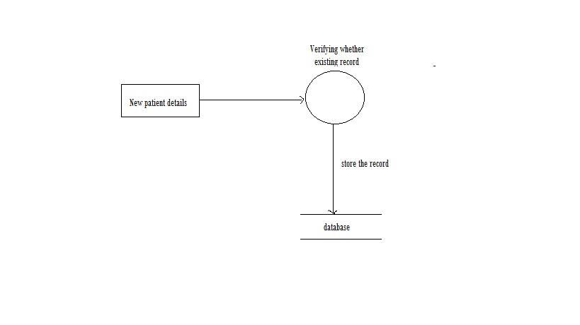

*DFD Level 1*

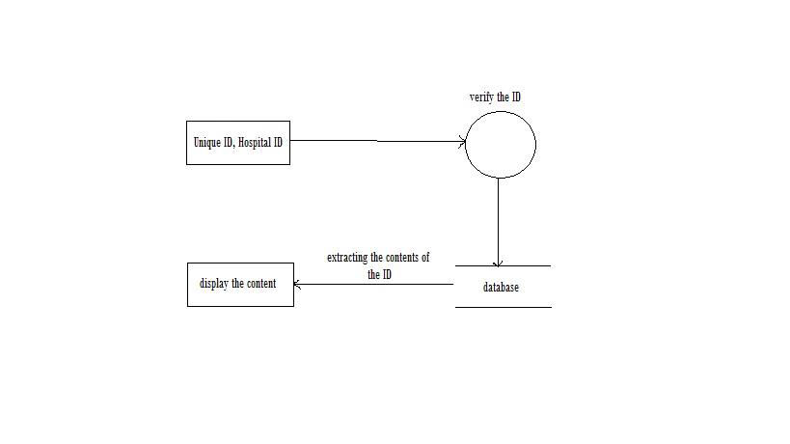

*DFD Level 2*

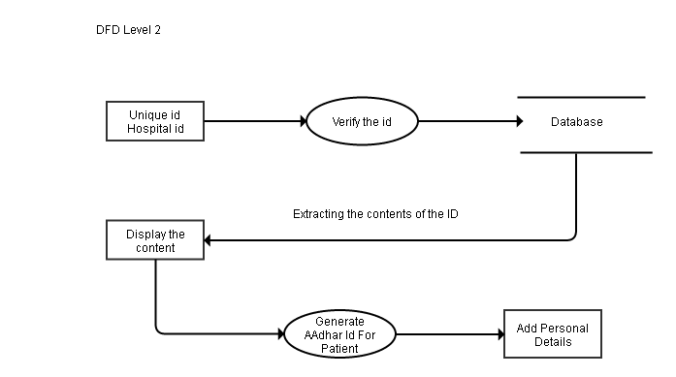

*DFD Level 3*

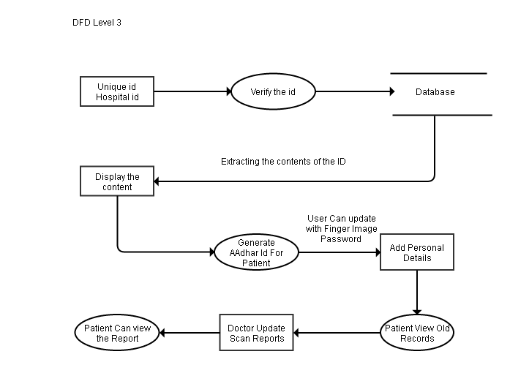

*Over All DFD*

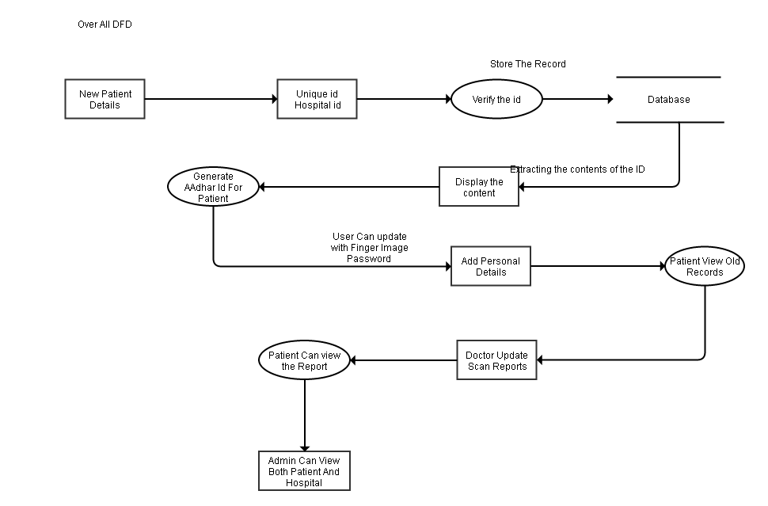

*Use Case Diagram*

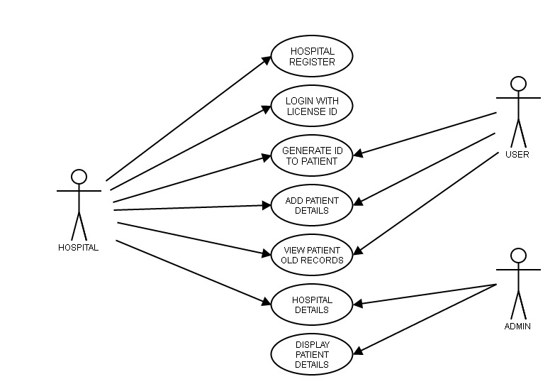

*Sequence Diagram*

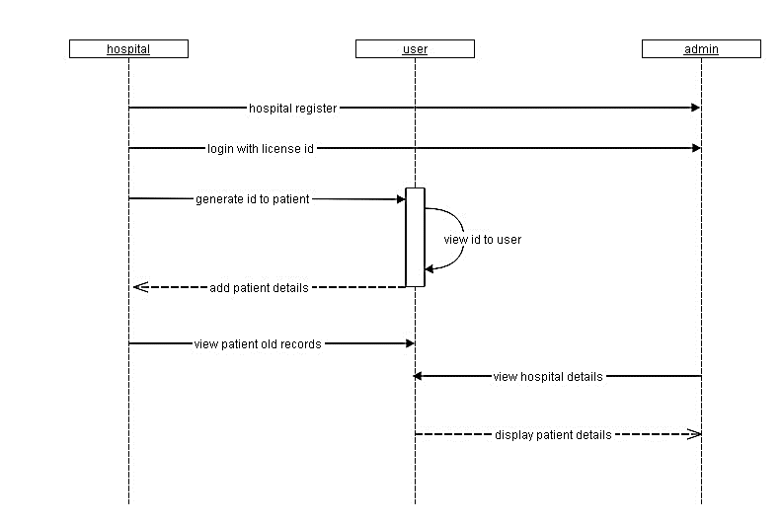

*E-R Diagram*

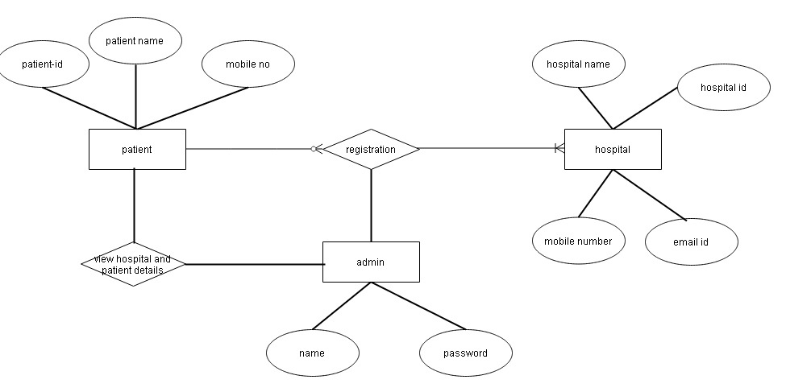

*Class Diagram*

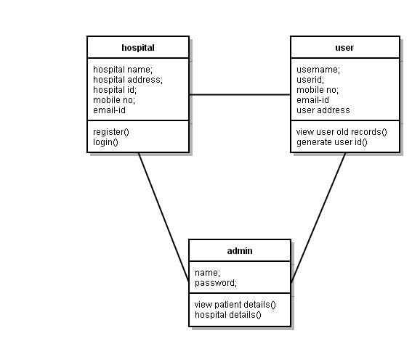

*Activity Diagram*

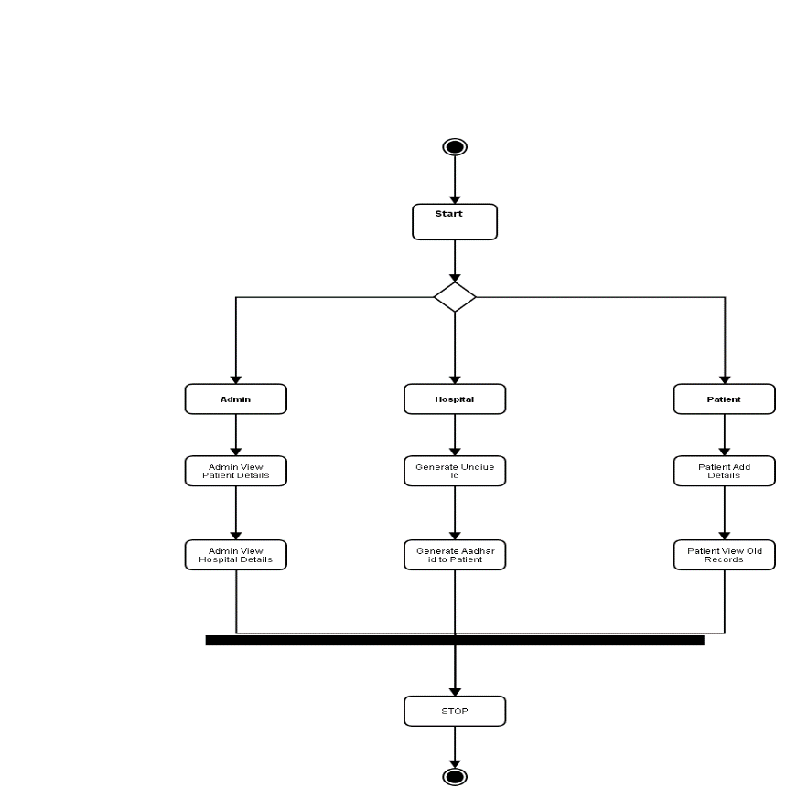

*Deployment Diagram*

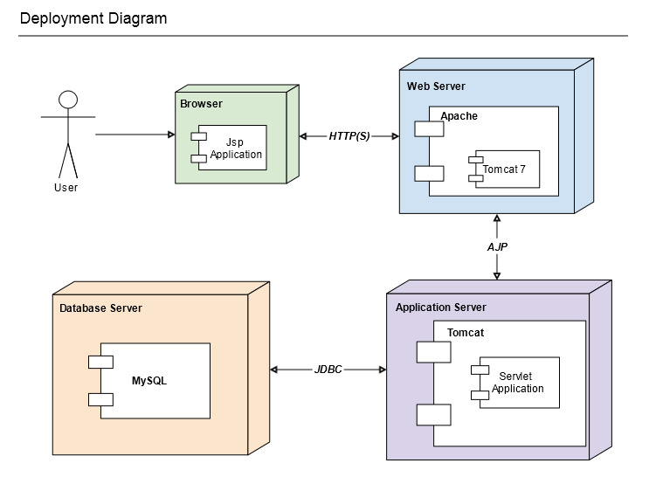

***Screen Shots***

*Home*

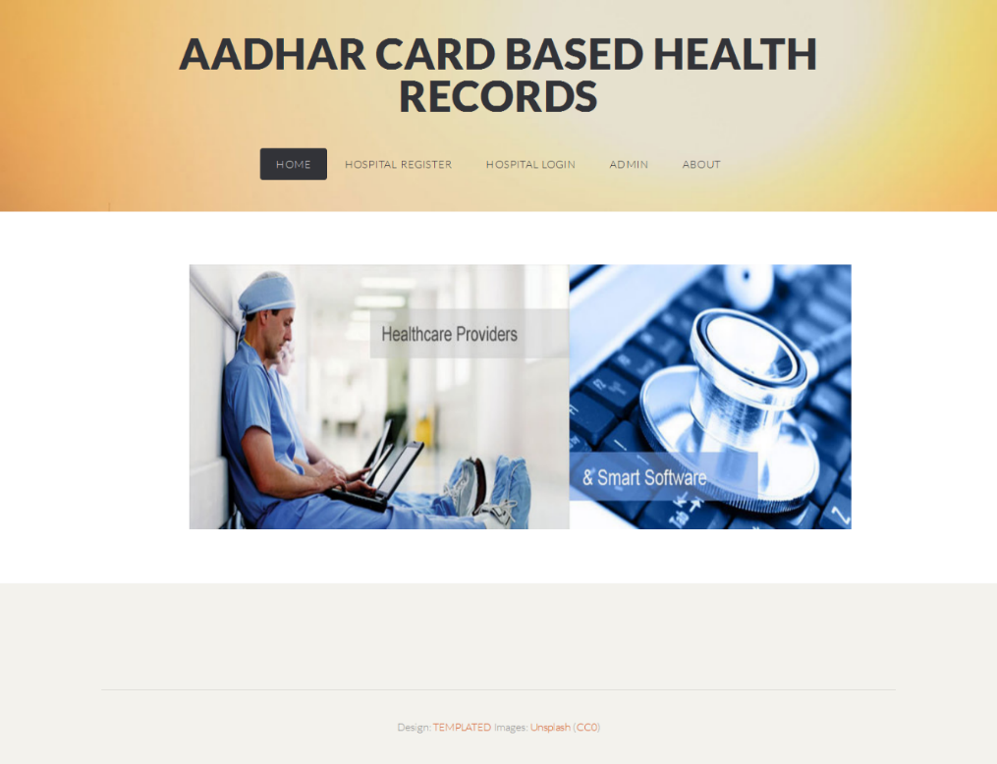

*Hospital Register*

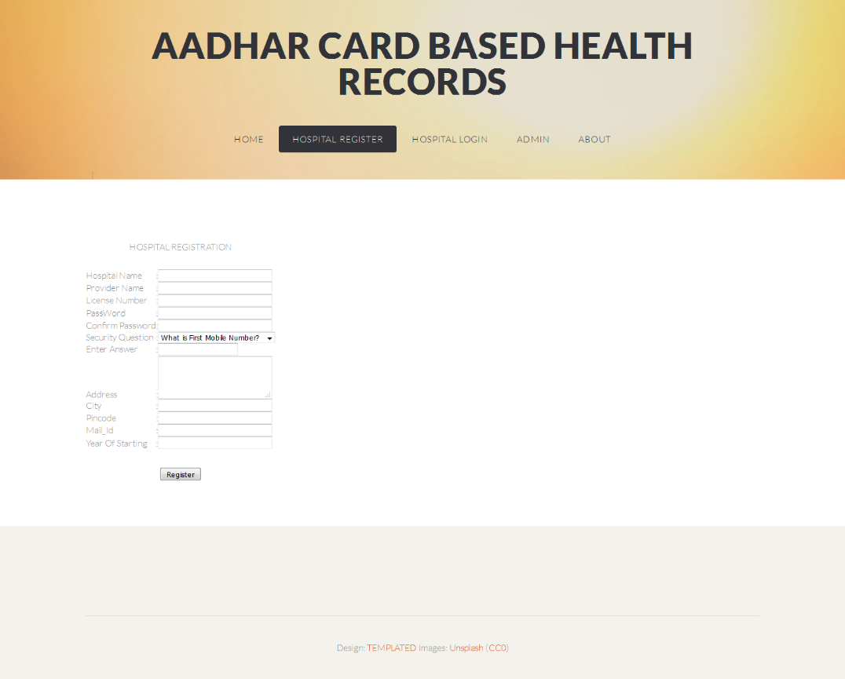

*Hospital Home*

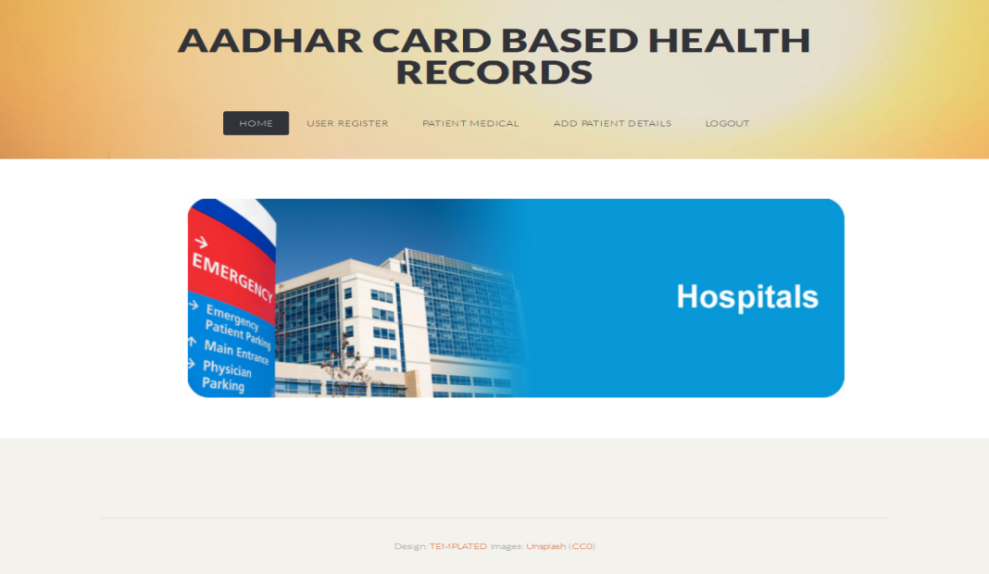

*User Register*

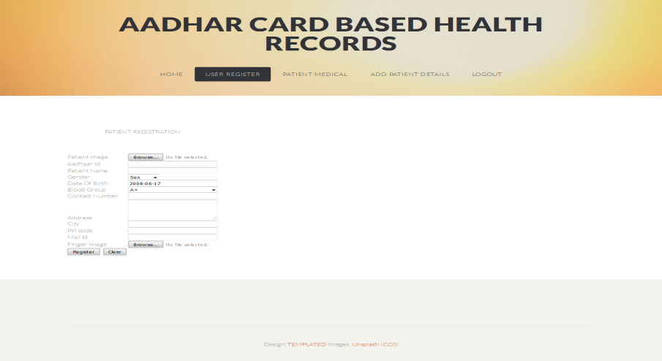

*Patient Login*

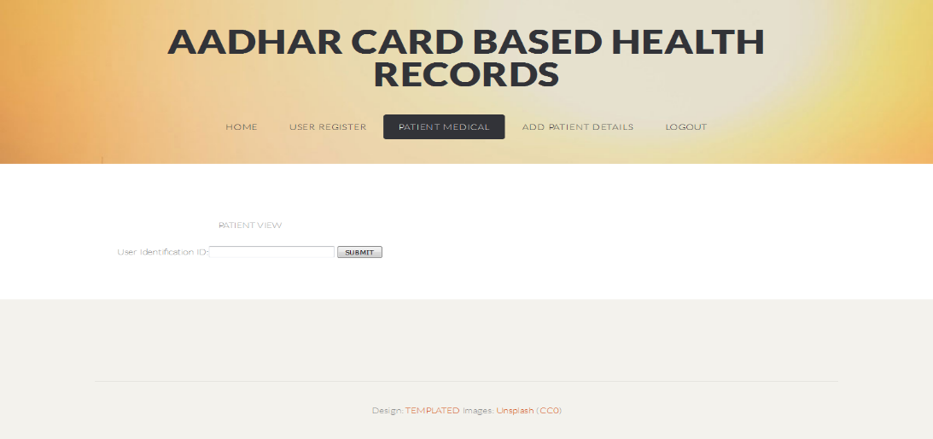

*Patient Home*

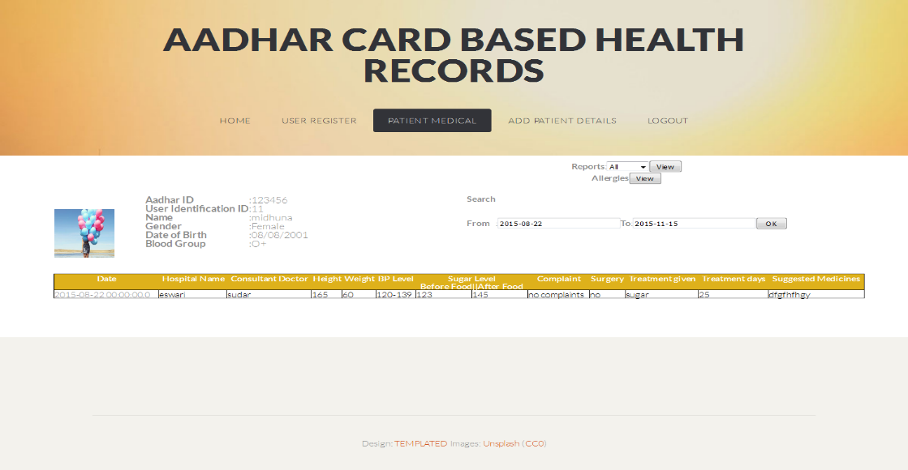

*Add Other Details*

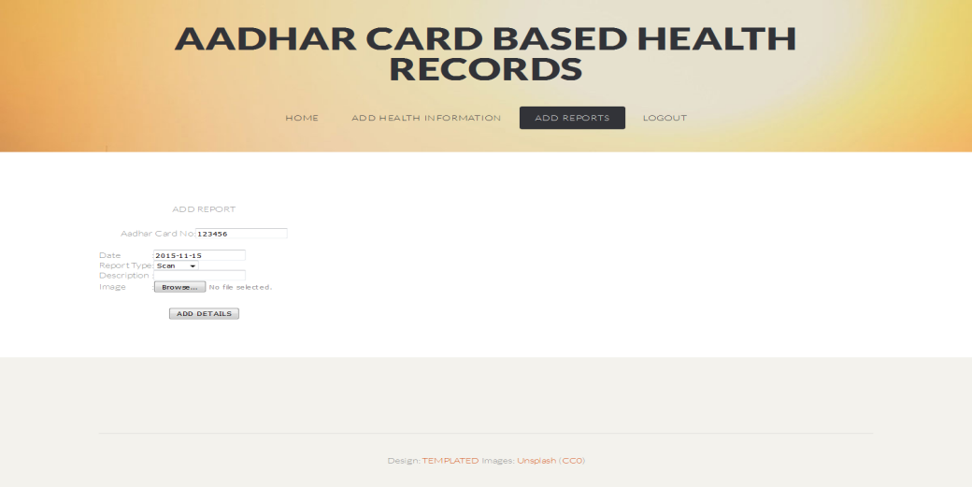

*Admin Page Patient Details*

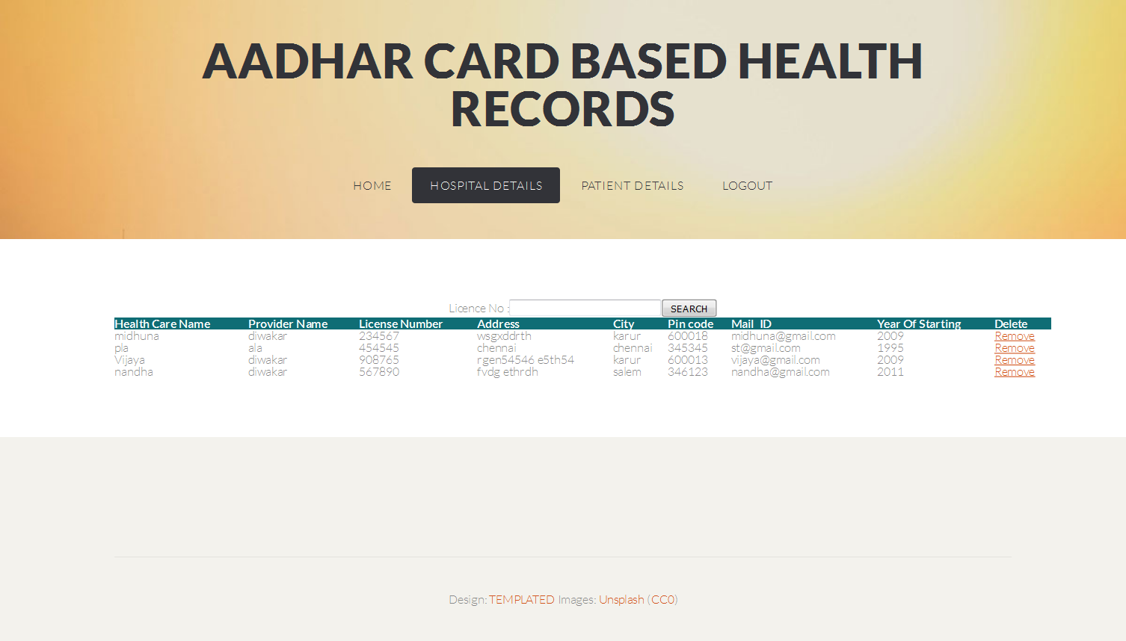

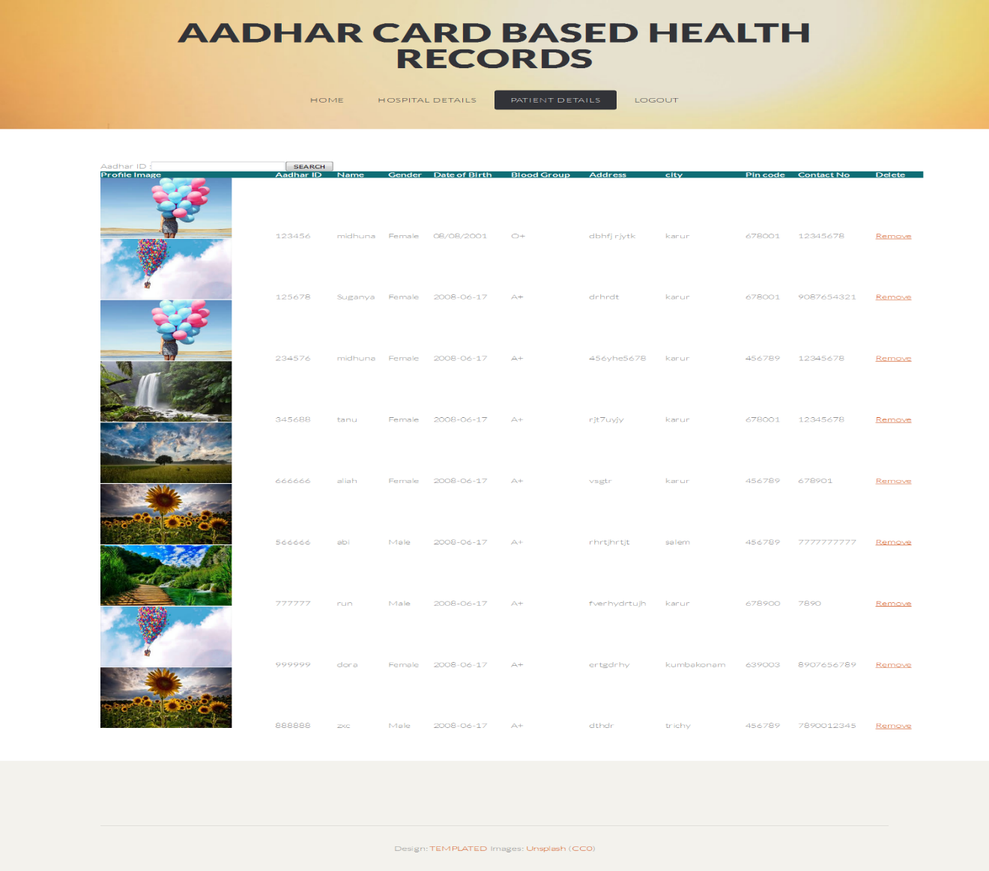

1. **Conclusion and Future Enhancement**

In this undertaking, proposed a framework which screens the medical services subtleties of every person of the country. It involves modules like producing the exceptional ID and store and recover information of an individual. The distributed computing is an arising figuring mode. It vows to build the speed with which applications are sent, increment advancement, and lower costs, all while expanding business deftness. The idea of distributed computing is valuable for developing the server farm. To the new age of cloud-based wellbeing framework, distributed computing is better methodology later on.

# References

1. M. Li, S. Yu, Y. Zheng, K. Ren, and W. Lou, “Scalable and secure sharing of personal health records in cloud computing using attribute-based encryption,” IEEE Transactions on Parallel and Distributed Systems, vol. 24, no. 1, pp. 131–143, 2013.
2. H. Liang, L. X. Cai, D. Huang, X. Shen, and D. Peng, “An smdpbased service model for interdomain resource allocation in mobile cloud networks,” IEEE Transactions on Vehicular Technology, vol. 61, no. 5, pp. 2222–2232, 2012.
3. Q. Shen, X. Liang, X. Shen, X. Lin, and H. Luo, “Exploiting geodistributed clouds for e-health monitoring system with minimum service delay and privacy preservation,” IEEE Journal of Biomedical and Health Informatics, vol. 18, no. 2, pp. 430–439, 2014.
4. Y. Yang, H. Li, L. Wenchao, H. Yang, and W. Mi, “Secure dynamic searchable symmetric encryption with constant document update cost,” in Proceedings of GLOBECOM. IEEE, 2014, pp. 775–780.
5. C. Wang, K. Ren, S. Yu, and K. M. R. Urs, “Achieving usable and privacy-assured similarity search over outsourced cloud data,” in Proceedings of IEEE INFOCOM, 2012, pp. 451–459.
6. D. Boneh, G. Di Crescenzo, R. Ostrovsky, and G. Persiano, “Public key encryption with keyword search,” in Advances in Cryptology–Eurocrypt. Springer, 2004, pp. 506–522.
7. R. Curtmola, J. Garay, S. Kamara, and R. Ostrovsky, “Searchable symmetric encryption: improved definitions and efficient constructions,” in Proceedings o ACM CCS, 2006, pp. 79—88.
8. K. Ren, C. Wang, and Q. Wang, “Security challenges for the public cloud,” IEEE Internet Computing, vol. 16, no. 1, pp. 69–73, Jan 2012.
9. D. X. Song, D. Wagner, and A. Perrig, “Practical techniques for searches on encrypted data,” in IEEE Symposium on Security and Privacy, 2000, pp. 44–55.
10. F. Hahn and F. Kerschbaum, “Searchable encryption with secure and efficient updates,” in Proceedings of CCS. ACM, 2014, pp. 310–320.