**IoT Based Child Monitoring System**

D.Dinesh1, Mr. D. Sathya Srinivas2, Ms. Sarika Jain3, Dr. S.Geetha4

1M.Sc-CFIS,Department of Computer Science and engineering, Dr. M.G.R Educational and Research Institute, Chennai 600 095, Tamilnadu, India

2,3Center of Excellence in Digital Forensics, Perungudi, Chennai 600 089, Tamilnadu, India

4Professor and Head,Department of Computer Science and engineering, Dr. M.G.R Educational and Research Institute, Chennai 600 095, Tamilnadu, India

**Abstract**

It is known that the technological advancements are increasing at a faster pace. But the utilization of technologies in various sectors is very low. We know that people of different age group face different difficulties. But the security for children’s is very low. There is lot of cases registered regarding child safety. Nowadays, the schools and the parents are very much worried about their school children for school transport and other places. So, the safety and monitoring the school children is very much difficult. In this project we are introducing the IOT based embedded system is used in this project. So, we propose a system to continuously monitor the parameters of the child and also their location for safety purpose. The system provides smart child tracking and monitoring system.

1. **Introduction**

For most of the year, children spend more time at school than anywhere else other than their own home. At school, children need a secure, positive, and comfortable environment to help them learn. Overall, schools are one of the safest places children can be. However, some schools have problems, such as bullying and theft, which make them less secure. These problems make students and educators feel less safe, and it makes it harder for students to learn and for teachers to do their jobs. But there are specific ways that parents can make going to school a safer and more valuable learning experience for their children. Kids need a safe and comfortable environment to learn to the best of their capabilities. This means they have to feel safe in their school and be able to positively interact with their teachers and classmates. By doing the following, parents and other adults can help make sure children have a positive school experience. Schools across the country have different guidelines and laws regarding safety measures. But we need to have one comprehensive legislation that can cover all the key areas regarding safety and security in schools. The onus on safety and security of children on[**school**](http://www.thehindu.com/tag/965-923/school/?utm=bodytag)campus should solely lie with the school authorities, the circular said adding that it was the fundamental right of children to study in an environment where they felt safe

1. **Objectives**

* To design and Implementation of IOT based child monitoring system
* We are providing wearable sensors for every child for continuous monitoring.

1. **Existing System**

The existing systems are not enough to prevent the crime against children since these systems give information about the children group and not about each child resulting in low assurance about their child safety to parents. There are few systems utilize sensors for monitoring the child parameters. But there is no communication had been used to alert the parents.

1. **Proposed System**

In our proposed system, we are continuously tracking the children by using Internet of Things. We are providing wearable sensors for every child for continuous monitoring and this system contains Microcontroller, temperature sensor, heartbeat sensor, respiratory sensor and IOT module. This framework continuously monitoring the value of sensors and the child location. Then this status will be automatically updated to the IOT web server.

1. **Literature Survey**

With the rising statistics of traffic accidents and child abduction, there is a need for a robust system that enables constant tracking for millions of children on their way commuting from and to schools. With emerging of Internet of Things (IoT) technology, in addition to Radio Frequency Identification (RFID), developing such system becomes feasible. This system provides complete visibility children tracking. In this paper, we propose a complete low cost design and implementation of an IoT-based system that allows schools, parents and authority to track the movement of the children during their presence in the school bus, which guarantees comfort for parents and safety for children. The system is based on, a low cost Nano RFID reader and a GPRS module both interfaced with Arduino microcontroller. The Nano RFID reader is used as an interface for providing the reader with a mean to access the internet over 3G/4G network. We build Mysql database and deploy it on Heroku's cloud platform, which makes building applications and deploying them fast, secure, easy and scalable. We also develop a Java GUI; with secure login grant admin access, for a complete visibility and control over the system users on internet. The system is tested successfully on field using one of King Fahd University of Petroleum and Minerals (KFUPM) school buses.

**M.S. Zaki et.al,** in present time, the security and safety aspect of a school going children is of main concern and paramount importance. In India, many children are found to be missing and yield to road accidents because of lack of preventive safety measures. Parents are always concerned about their children during commute. This project proposes an Arduino RFID based intelligent solution to assist parents in real time to track their children location. In order to track the location and find the identity of the child a GPS module and a RFID card is used in the proposed system. The system uses Arduino Mega 2560 as main microcontroller. The project also proposes safety systems such as drunk and drive prevention system by using an alcohol sensor (MQ-3), accident alert with location by using piezo vibration sensor, detecting objects in front of vehicle wheels by using ping sensors and detection of human movements on the footboard by using IR proximity sensors. The working prototype model of the developed system exhibits good accuracy with reduced computational time. By incorporating all those above features, we can assure the safety and security of every school child.

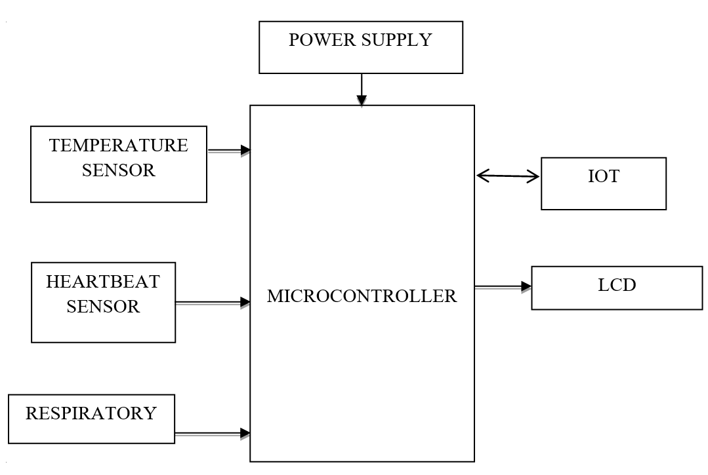

**Figure 1. Block Diagram**

1. **Hardware Requirements**

* Microcontroller
* Temperature Sensor
* Heartbeat Sensor
* IoT
* LCD
* Power Supply

1. **Software Requirements**

* Embedded C
* Arduino IDE

1. **Hardware Description**

**8.1 *Microcontroller: ESP32***

ESP32 is a series of low-cost, low-power system on a chip microcontroller with integrated Wi-Fi and dual-mode Bluetooth. The ESP32 series employs either a Tensilica Xtensa LX6 microprocessor in both dual-core and single-core variations, Xtensa LX7 dual-core microprocessor and a single-core RISC-V microprocessor and includes built-in antenna switches, RF balun, power amplifier, low-noise receive amplifier, filters, and power-management modules. ESP32 is created and developed by Espress if Systems, a Shanghai-based Chinese company, and is manufactured by TSMC using their 40 nm process.

***8.2 Power Supply***

The ac voltage, typically 220V rms, is connected to a transformer, which steps that ac voltage down to the level of the desired dc output. A diode rectifier then provides a full-wave rectified voltage that is initially filtered by a simple capacitor filter to produce a dc voltage. This resulting dc voltage usually has some ripple or ac voltage variation.

A regulator circuit removes the ripples and also remains the same dc value even if the input dc voltage varies, or the load connected to the output dc voltage changes. This voltage regulation is usually obtained using one of the popular voltage regulator IC units.

***8.3 16×2 LCD***

LCD stands for liquid crystal display. They come in many sizes 8x1, 8x2, 10x2, 16x1, 16x2, 16x4, 20x2, 20x4, 24x2, 30x2, 32x2, 40x2 etc. Many multinational companies like Philips Hitachi Panasonic make their own special kind of LCD'S to be used in their products. All the LCD'S performs the same functions (display characters numbers special characters ASCII characters etc). Their programming is also same and they all have same 14 pins (0-13) or 16 pins (0 to 15). Alphanumeric displays are used in a wide range of applications, including palmtop computers, word processors, photocopiers, point of sale terminals, medical instruments, cellular phones, etc.

***8.4 Temperature Sensor***

The LM35 series are precision integrated-circuit temperature devices with an output voltage linearly-proportional to the Centigrade temperature. The LM35 device has an advantage over linear temperature sensors calibrated in Kelvin, as the user is not required to subtract a large constant voltage from the output to obtain convenient Centigrade scaling. The LM35 device does not require any external calibration or trimming to provide typical accuracies of ±¼°C at room temperature and ±¾°C over a full −55°C to 150°C temperature range. The low-output impedance, linear output, and precise inherent calibration of the LM35 device makes interfacing to readout or control circuitry especially easy.

***8.5 Respiratory Sensor***

The Respiration Sensor is used to monitor abdominal or theoretical breathing, in biofeedback applications such as stress management and relaxation training. Besides measuring breathing frequency, this sensor also gives you an indication of the relative depth of breathing. The Respiration Sensor for Nexus can be worn over clothing, although for best results we advise that there only be 1 or 2 layers of clothing between the sensor and the skin. The Respiration Sensor is usually placed in the abdominal area, with the central part of the sensor just above the navel. The sensor should be placed tight enough to prevent loss of tension.

***8.6 Heart Beat Sensor***

HEART BEAT sensor is designed to give digital output of heat beat when a finger is placed on it. When the HEART BEAT detector is working, the beat LED flashes in unison with each heart beat. This digital output can be connected to microcontroller directly to measure the Beats Per Minute (BPM) rate. It works on the principle of light modulation by blood flow through finger at each pulse.

***8.7 IOT***

The Internet of things (IoT) is the network of everyday objects — physical things embedded with electronics, software, sensors, and connectivity enabling data exchange. Basically, a little networked computer is attached to a thing, allowing information exchange to and from that thing. Be it lightbulbs, toasters, refrigerators, flower pots, watches, fans, planes, trains, automobiles, or anything else around you, a little networked computer can be combined with it to accept input (especially object control) or to gather and generate informational output (typically object status or other sensory data). This means computers will be permeating everything around us — ubiquitous embedded computing devices, uniquely identifiable, interconnected across the Internet. Because of low-cost, networkable microcontroller modules, the Internet of things is really starting to take off.

***8.8 Web Server***

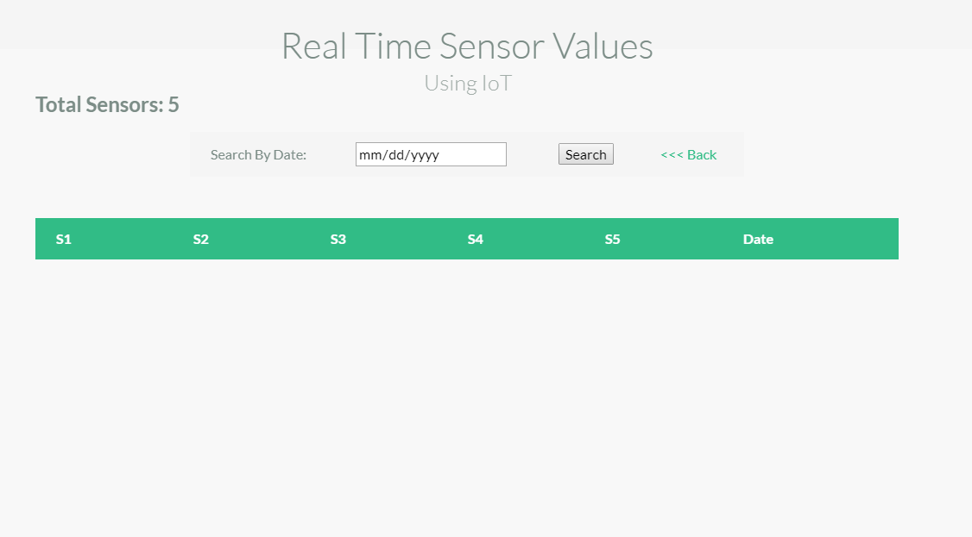

Espresso's ESP32EX delivers highly integrated Wi-Fi SoC solution to meet users’ continuous demands for efficient power usage, compact design and reliable performance in the Internet of Things industry. With the complete and self-contained Wi-Fi networking capabilities, ESP32EX can perform either as a standalone application or as the slave to a host MCU. When ESP32EX hosts the application, it promptly boots up from the flash. The integrated high-speed cache helps to increase the system performance and optimize the system memory. Also, ESP32EX can be applied to any microcontroller design as a Wi-Fi adaptor through SPI / SDIO or I2C / UART interfaces. ESP32EX integrates antenna switches, RF balun, power amplifier, low noise receives amplifier, filters and power management modules. The compact design minimizes the PCB size and requires minimal external circuitries. Besides the Wi-Fi functionalities, ESP32EX also integrates an enhanced version of Tensilica’s L106 Diamond series 32-bit processor and on-chip SRAM. It can be interfaced with external sensors and other devices through the GPIOs. Software Development Kit (SDK) provides sample codes for various applications. Espresso Systems’ Smart Connectivity Platform (ESCP) enables sophisticated features including fast switch between sleep and wakeup mode for energy-efficient purpose, adaptive radio biasing for low-power operation, advance signal processing, spur cancellation and radio co-existence mechanisms for common cellular, Bluetooth, DDR, LVDS, LCD interference mitigation.

1. **Software Description**

***9.1 Arduino Software (IDE)***

The Arduino Integrated Development Environment - or Arduino Software (IDE) - contains a text editor for writing code, a message area, a text console, a toolbar with buttons for common functions and a series of menus. It connects to the Arduino hardware to upload programs and communicate with them.

***9.2 Embedded C***

Embedded C is designed to bridge the performance mismatch between Standard C and the embedded hardware and application architecture. It extends the C language with the primitives that are needed by signal-processing applications and that are commonly provided by DSP processors. The design of the support for fixed-point data types and named address spaces in Embedded C is based on DSP-C. DSP-C [1] is an industry-designed extension of C with which experience was gained since 1998 by various DSP manufacturers in their compilers. For the development of DSP-C by ACE (the company three of us work for), cooperation was sought with embedded-application designers and DSP manufacturers. The Embedded C specification extends the C language to support freestanding embedded processors in exploiting the multiple address space functionality, user-defined named address spaces, and direct access to processor and I/O registers. These features are common for the small, embedded processors used in most consumer products. The features introduced by Embedded C are fixed-point and saturated arithmetic, segmented memory spaces, and hardware I/O addressing. The description we present here addresses the extensions from a language-design perspective, as opposed to the programmer or processor architecture perspective.

***Screenshots***

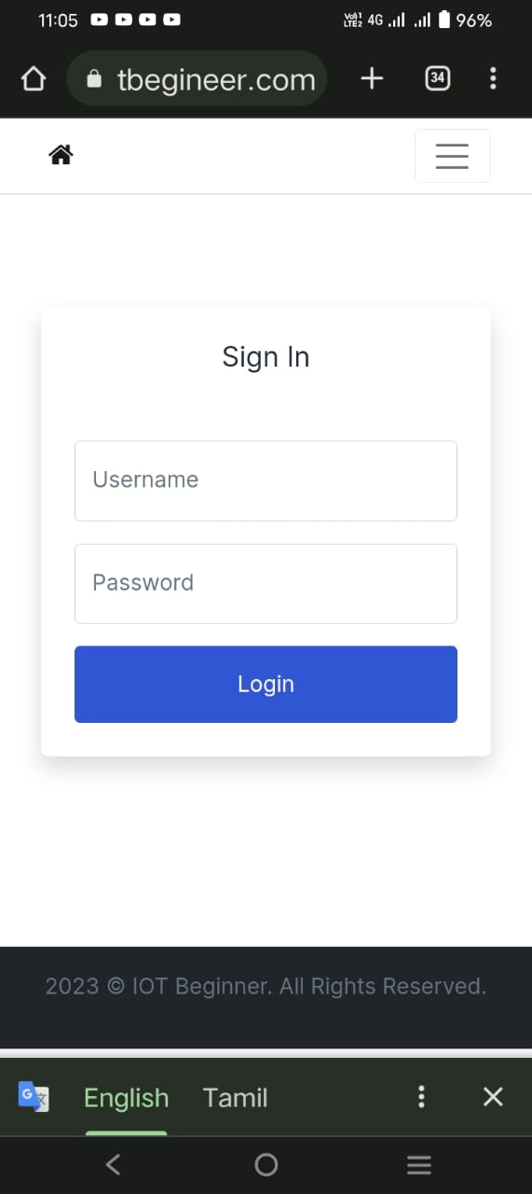

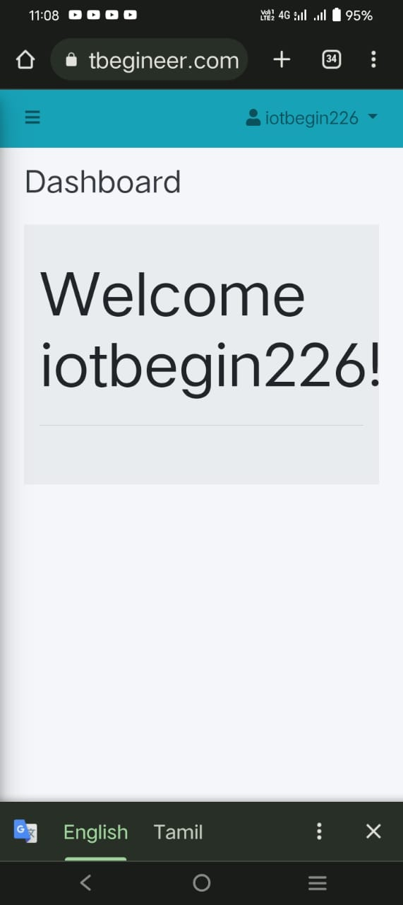

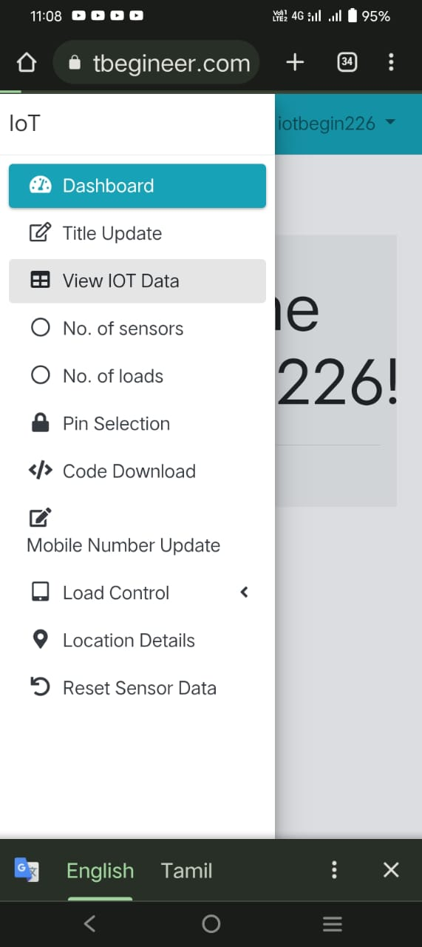

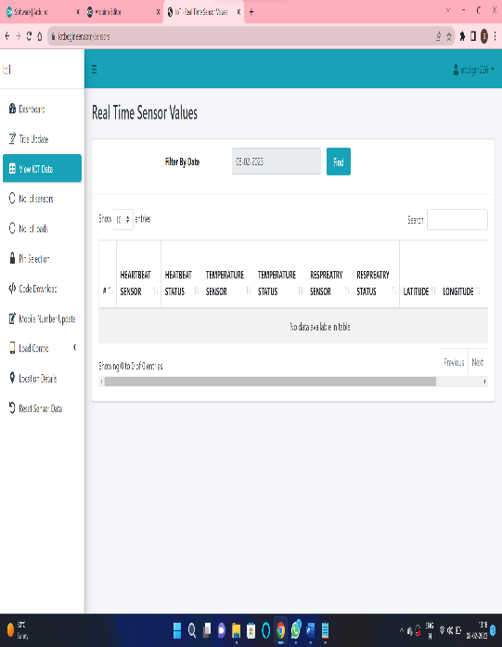

1. **Conclusions**

The proposed system makes use of hardware for the safety of children. we make use a hardware device so that the child is secured from the problem like kidnapping of child, child missing etc., And the child’s location will be updated for every five minutes to their parent’s smartphone. And also, health of child is to be continuously monitoring.

**References**

[1] J. Leis and D. Buttsworth, “A temperature compensation technique for near-infrared methane gas threshold detection,” IEEE Trans. Ind. Electron., vol. 63, DOI 10.1109/TIE.2015.2495292, no. 3, pp. 1813–1821, Mar. 2016.

[2] R. F. Wolffenbuttel, Silicon Sensors and Circuits: On-chip Compatibility. Springer Science & Business Media, 1996.

[3] F.-G. Banica, Chemical Sensors and Biosensors: Fundamentals and Applications. John Wiley & Sons, 2012.

[4] T. Seiyama, A. Kato, K. Fujiishi, and M. Nagatani, “A new detector for gaseous components using semiconductive thin films,” Anal. Chem., vol. 34, DOI 10.1021/ac60191a001, no. 11, pp. 1502–1503, Oct. 1962.

[5] G. F. Fine, L. M. Cavanagh, A. Afonja, and R. Binions, “Metal oxide semi-conductor gas sensors in environmental monitoring,” Sensors, vol. 10, DOI 10.3390/s100605469, no. 6, pp. 5469–5502, Jun. 2010.

[6] J. Janata, Principles of Chemical Sensors. Springer Science & Business Media, 2010.

[7] H. J. Lee, K. K. Park, Oralkan, M. Kupnik, and B. T. Khuri-Yakub, “A multichannel oscillator for a resonant chemical sensor system,” IEEE Trans. Ind. Electron., vol. 61, DOI 10.1109/TIE.2014.2300031, no. 10, pp. 5632–5640, Jan. 2014.

[8] H. Yu, P. Xu, X. Xia, D. W. Lee, and X. Li, “Micro-/nano combined gas sensors with functionalized mesoporous thin film self-assembled in batches onto resonant cantilevers,” IEEE Trans. Ind. Electron., vol. 59, DOI 10.1109/TIE.2011.2173094, no. 12, pp. 4881–4887, Dec. 2012.

[9] C. Yim et al., “Adsorption and desorption characteristics of alcohol vapors on a nanoporous ZIF-8 film investigated using silicon microcantilevers,” Chem. Commun., vol. 51, DOI 10.1039/C5CC01315A, no. 28, pp. 6168–6171, Mar. 2015.

[10] X. Liu, S. Cheng, H. Liu, S. Hu, D. Zhang, and H. Ning, “A survey on gas sensing technology,” Sensors, vol. 12, DOI 10.3390/s120709635.