**PLACEMENT MANAGEMENT SYSTEM**

**Punitha Nicholine J*1 ,Lakshmi Priya B*2, Ilakkiya S*3, Kartheeswari M*4, Kethrin Malar D*5**

*1Professor, Department of CSE, PSNA CET, Dindigul, TamilNadu, India

*2,3,4,5Students, Department of CSE, PSNA CET, Dindigul, TamilNadu, India

**ABSTRACT**

The Placement Management System consists of three modules which includes student, admin and company login. The system is not only beneficial for students, also for the various companies visiting the campus for recruitment and even the college placement officer. The system facilitates the students to register their account by giving their personal details. The admin has the control to edit/modify the student details and can also remove the accounts that are found to be faulty. The system also has company login by which various companies planning to visit the campus for the recruitment purpose can view the list of students applied for recruitment. The system allows the students in the college to view a list of companies who have posted for vacancy. The admin has the complete control over the system and can modify/delete anything that doesn’t meet the standards of the college management. The system maintains the database of the students as well as the company details efficiently and displays the data to the respective ends.

**Keywords:** Placement, Recruitment, Companies, Login, Portal

1. **INTRODUCTION**

The major goal of the students who joins the professional courses in the highly reputed institutions is to gain knowledge and the second most important thing is to get a well-paying secured job in a highly esteemed and reputed organizations. The Professional courses like Bachelor of Engineering and Bachelor of Technology provides technical education to students in various fields such as Computer Science and Engineering, Electrical and Electronical Engineering, Electronics and Communication Engineering, Civil Engineering, Mechanical Engineering etc. The degree is aimed at making students an experts in various technical fields, thus provides them various opportunities to stepping into their career. The organizations also faces a lot of difficulties in hiring students and with the recruitment process. The traditional system that exists, where we manually maintain all the records and process them makes the process slow and it will be difficult to have coordination between the students and the companies. It is a tedious process that involves a huge manpower to organize the activities of the student as well as the company details. It includes difficulties to face such as maintain the database manually and it’s almost impossible to find the root cause if any error occurs. the placement management system is a web application that is used to manage the student’s information regarding the placements [1,2]. It can also be used as a tool to analyze the placement details of the students. It will help students, teachers as well as the placement officers in an organization to provide the proper care towards the improvement of the individuals during the course period. The high placement rate is the key entity in building the reputation of the organization. It provides the pathway to everyone like students, placement officers, and recruiters can meet up and can collaboratively increase the reputation of the management. The system is designed in a such a way to manage and maintain the database efficiently in order to prevent potential human error by keeping data organized and accessible via permissions. Hence the system plays a major role towards the growth of the students as well as the organization

1. **PROBLEM STATEMENT**

The placement process is a time-consuming and complex task for both the recruiters and the candidates. Recruiters often receive a large number of resumes, making it difficult to filter and shortlist suitable candidates for job positions. Candidates, on the other hand, find it challenging to identify job openings that match their skills and preferences. This process can be made more efficient and effective by developing a placement management system that automates the entire process, from candidate registration to job placement.

1. **EXISTING SYSTEM**

The existing system for placement management system deals with the use of multiple databases for each and every drive when posted. The Placement Officer has to collect the list of eligible students for the drive through whatsapp or through visiting each class for every single drive and he has to filter the list manually which will be a very difficult process. In the existing system the student has to upload the CV’s by themselves [5] and does not have the option for generating the updated CV’s according to the eligibility criteria provided by the HR of the company. The Placement Officer has to wait for the acknowledgement of the student whether they have applied for the drives or not. There is no system for the updating the count of registered students. The framework of the placement system that is used nowadays has certain drawbacks which should be upgraded to a better version [2]. The website contains inaccurate data and it is complex, placement management system rely on accurate data and the date needs to be updated often. The cost can be expensive for the smaller organisation in order to maintain the support expenses and other software licensing fees. The problem of searching and sorting will exist during the verification of the excel sheets [2]. Students can directly enroll into the placement drive system without the approval or rejection by the admin [2] which is not encouraged.

1. **DRAWBACKS OF EXISTING SYSTEM**

* The existing systems mentioned above is not user friendly and implementing it can be costly, if the organization is small, it would difficult to cover the expenses such as licensing fees, hardware cost and other maintenance expenses.
* The placement and recruitment management system may have high level of complexity if the colleges or organizations are located in multiple locations or it has a complex recruiting process.
* If the designed system is biased, It can lead to unfair recruitment process and it causes harm to reputation of the college.

1. **PROPOSED SYSTEM**

A placement management system is a software solution designed to help companies and colleges to manage their recruitment and hiring process. The purpose of proposed system is to make the job of placement officer (TPO) easier. Placement coordinators and students can edit/modify and access the data in the system quickly. The system provides an efficient way to maintain students records and the company details in the database, ensures the correctness as well as the integrity of the data. The system also reduces the manual record maintenance time and provides an effective flow of information between different modules in the system. The placement management system web application is a software tool designed to assist organizations with managing their recruitment and placement process. It is typically used by companies, universities, and other institutions that need to manage large numbers of job applications and resumes. This system consists of different modules to interact with initiating with logging into system redirects to the home page which contains the navigations to pages like login, register, FAQ. The page also contains the information about the college and recruitment process. It also showcases the objectives of the placement portals, companies that are available for recruitment process. At the bottom of the page, the page displays the number of the total drives, job offers, CV/Resumes and Daily users.

1. **FEASIBILITY STUDY**

After doing the project Placement Management System, study and analyzing all the existing or required functionalities of the system, the next task is to do the feasibility study for the project. We have to consider the three key factors of the feasibility such as technical feasibility, which covers hardware and software requirements, integration with existing systems and data security. The economic feasibility covers the return on investment and cost benefit analysis. The Operational feasibility covers the aspects of user acceptance, Staffing and Training, Scalability of the system. The proposed solution should satisfy all the user requirements and should be flexible enough so that future changes can be easily done based on the future upcoming requirements.

1. **METHODOLOGY**

**7.1 Admin Module**

The Placement Officer (TPO) who is the administrator(admin) of the proposed system play a crucial role in the system. Admin can log into the system using his credentials such as username and password. They can maintain the placement records using this system. Admin is able to add details such as departments, batches and can also add /delete drives as well. Administrators have the access to complete activities of the company and the students. While students are registering the admin have the access to approve or reject the account. This option helps to secure the website from unauthorized users or duplicate accounts. Students who are interested can directly apply for the recruitment drives. Admin has the ability or controlling authority to analyze the student’s placement activities. Admin also have the control to approve the company’s details. Admin maintains the entire placement activities of the College or Institution. In Admin dashboard, the following information are present they are number of coordinators, registered students, total drive posted, pending coordinators, pending student’s confirmation and total drive applications. Admin can also post notice about any company or any important information that students need to know. Admin is the master of the website who can view total number of the placed students. This list can also be downloaded as the excel sheet.

**7.2 Placement Module**

Admin provides access to the company with a username and password. By using this company can access the system. If the company wants to post any job openings for the college the human resource or person who is recruiting from the company side can upload the details of the company and the roles and responsibilities of the position they want to recruit. The company conducts the drive for the applied students and the results of the drive will be updated by the Human Resource or admin. The process of publishing the shortlisted students for the drive and publishing the results for the drive will be done by the company people.

**7.3 Student Module**

The student can login and register for the company drives by registering themselves with valid information. He/she creates the profile by entering the details like first name, last name, date of birth, year of passing, stream, highest qualification and residential details and add their skills according to the need of the companies and finally upload his/her resume. Resume generator option can also be used by the student for creating resumes according to the requirements of the company. The students should wait until their profile gets approved or rejected by the admin. Once the profile gets approved by the admin, he/she can search for the active drives and apply for the job. The student can ask their doubt by using the chat bot available and can refer to the FAQ available.

1. **SYSTEM ARCHITECTURE**

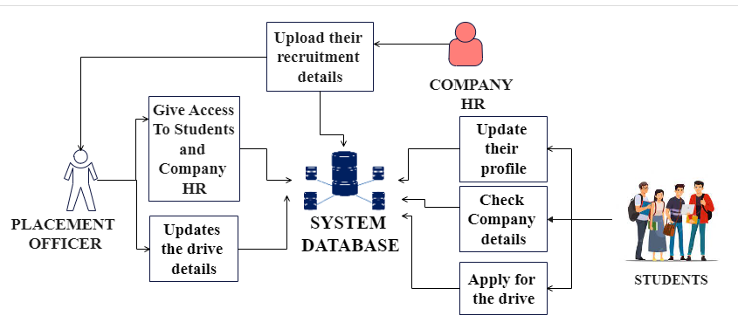

**Figure 1:** System architecture diagram

1. **RESULTS AND DISCUSSION**
   1. **Student registration**

Student can create their profile by filling the form with valid information, once registered admin need to accept or reject the candidate profile by checking whether it is authorized user.

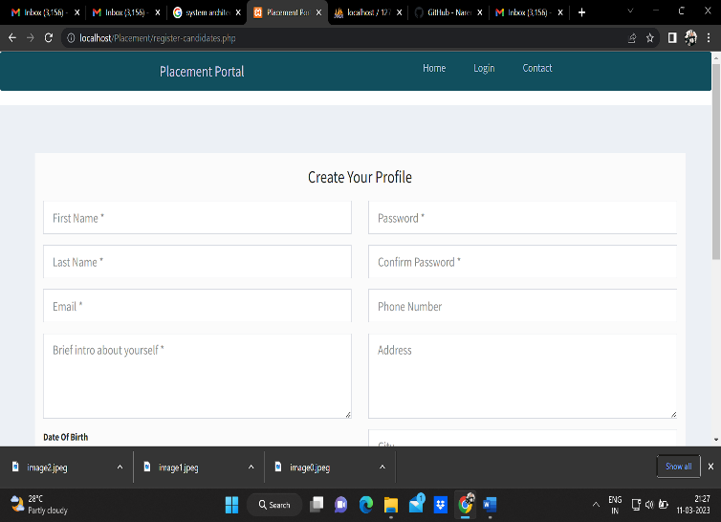

* 1. **Admin Dashboard**

The role of the admin would be to oversee and manage the system’s operations. The key responsibilities of an admin in a placement management system are data management, system configuration, user management, analytics and reporting, security and compliance etc.

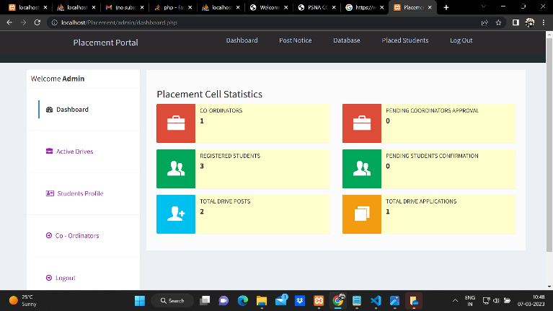

* 1. **Placement portal**

The Human Resource or person from the company side is responsible for job postings, candidate management, analytics and reporting, feedback and evaluation etc.

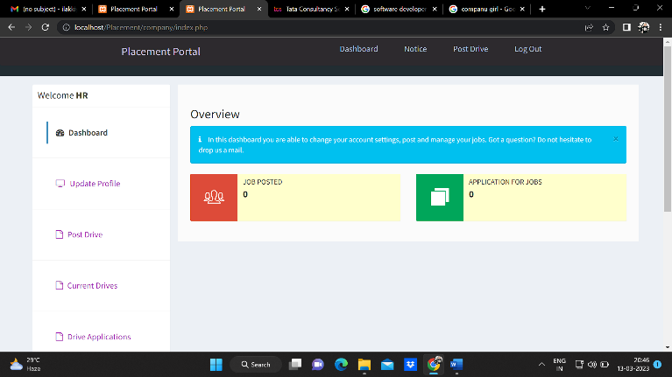

1. **CONCLUSION**

Only the authorized users can login to the system successfully using their valid credentials. In this system the admin who has the potentiality to modify anything in the system checks the list of students who are eligible to attend the specific drive as per the criteria’s mentioned by the company. The system consists of three modules which are completely secure and user-friendly. Storing and maintaining the large database with numerous data in a single place will always result in a pathetic situation. In order to overcome the issues mentioned in the existing systems can be overcome by the introduction of this system “Placement Management System”. The system has easy accessibility and functionality of the portal will help in the management of the allocation process during recruitment process. With the increasing demand of digitalization in every aspect of day-to-day activities we can anticipate the great demand for such portals soon and the comfort it will bring with it to the lives of all. The digitalization of the manual works into e-records can contribute a lot in protecting the mother earth and reduces the impacts of global warming. As a result of this we believe that you can all will get rid of the manual routine and enjoy the sophistication of the digitalization.

1. **REFERENCES**
2. Alfiya Banu, Dr. Manju Bargavi S. K.,2022 “A Research on Placement Management System” in International Journal for Research in Applied Science and Engineering Technology (IJRASET).
3. Ajeena Sunny, Aneena Felix, Angeli Saji, Christina Sebastian, Praseetha V.M "Placement Management System for Campus Recruitment" Volume 5, Issue 5, May – 2020 International Journal of Innovative Science and Research Technology
4. Nguyen Thai-Nghe, Tomas Horvath, Lars Schmidt-Thieme 2011, "Factorization models for forecasting student performance", Proceedings of the 4th International Conference on Educational Data Mining, Eindhoven, The Netherlands, July 6-8, 2011
5. Rajnish Tripathii, Raghvendra Singh, Ms. Jaweria Usmani,” Campus Recruitment and Placement System”, In International Conference on Recent Innovations in Science and Engineering (ICRISE-18), April, 2018.
6. Mythili M, Aishwarya R, Shenbagam P, Sandhiya C,” E Placement Management”, International Journal of Pure and Applied Mathematics (IJPAM), Volume 119 No. 10 2018,1823-1834.
7. Molina, M. M., Luna, J. M., Romero, C., & Ventura, S., 2012, "Meta-learning approach for automatic parameter tuning: A case study with educational datasets" In Proceedings of the 5th International Conference on Educational Data Mining, of EDM 2012, pages 180-183, Chania, Greece, 2012.