**THE STUDY OF IMAGE PROCESSING TECHNIQUE FOR BLOOD GROUP CLASSIFICATION**

**Abstract:-**

There is a worldwide demand for an affordable solution to blood grouping, which is a particularly urgent need in developing countries. Image processing, the most penetrated device in both resource-rich and resource-constrained regions, would be a suitable choice to build this solution. This project offers non-invasive blood grouping processes. Differences in data acquisition sites, bio signal processing techniques, theoretical foundations, photoplethysmography (PPG) signal and feature extraction process, image processing algorithms, and blood group detection models were also compared. This analysis was then used to suggest realistic approaches for imaging-based point of care to measure blood groups in a non-invasive manner.

Blood groups must be determined before blood transfusions in difficult situations. This is done before a blood transfusion in an emergency or when a person's blood type is being checked for a donation. Currently, laboratory workers perform the tests manually in the laboratory. This takes time and can lead to human errors in blood typing. The goal of the survey is to use image processing to reduce the physical work required to identify blood types. The blood group is determined by the presence or absence of an agglutination reaction of blood with an antigen.

**Introduction:-**

Blood is essential for life. It circulates throughout the human body, bringing oxygen and nutrients to all parts of the body so they can continue to function. It transports carbon dioxide and other waste products to the lungs, kidneys and digestive tract, where the waste products leave the body. Blood group is a classification of blood based on the presence or absence of antigenic substances in the blood cells. Austrian doctor Karl Landsteiner was the first to discover blood groups. In 1901, he discovered that there are substances in the blood, such as antigen and antibodies, which form the accumulation of red blood cells when one type of blood is added to another type of blood. Based on this, he distinguishes three types of blood groups A, B and C. He defined that group A agglutinates with group B, similarly group B agglutinates with group A, but group C blood is different because it agglutinates with both A and B. , he found two antigens and two antibodies. In 1910, Ludwik Hirszfeld and Emil Freiherr von Dungern coined the term O (zero) for the Landsteiner group, designated C, which has no antigens but anti-A and anti-B antibodies. A fourth rarer blood group, AB, discovered by Sturli and von Decastello, has both A and B antigens but no antibodies. The Rh blood group was discovered in 1940 by Karl Landsteiner and A. S. Weiner and they classify the blood group according to the presence or absence of the Rh antigen. The following are the blood groups of the human body. 1) Group A positive or negative: A antigens are present on the surface of blood cells. There are anti-B antibodies in the plasma. 2) Group B positive or B negative: B antigens are on the surface of blood cells. There are anti-A antibodies in the plasma. 2 Blood group identification system 3) AB group positive or AB negative: A and B antigens are present on the surface of blood cells. There are no antibodies in the plasma. People with AB-positive blood can usually receive from any group. 4) Group O positive or O negative: There are no antigens on the surface of blood cells. Both anti-B and anti-A antibodies in plasma. O is a frequent donor. People with blood type O can donate blood to any blood type. Blood group identification is very important to ensure the safety of blood transfusion. Blood typing is essential for many important medical procedures. Blood detection is the most important and indispensable activity in human life. Thalassemia patients require regular blood transfusions. Therefore, it is important to determine the correct blood group before blood transfusion, donation and other emergency situations that can directly affect the patient's survival and life. If a patient receives the wrong type of blood during a transfusion, an ABO incompatibility reaction can occur. If there is only an ABO incompatibility reaction, the antibodies already in the patient's blood will attack and destroy the donor's blood cells. It causes some dangerous effects on the immune system such as fever, chills, chest or back pain, bleeding, increased heart rate, shortness of breath, kidney damage and death of the person is also possible. The traditional blood group method in the laboratory can be replaced by a digital method that uses image processing technology. Image processing helps achieve their goals in many ways, especially in security and medicine. In the medical field, imaging is used for various tasks such as PET scanning, X-ray imaging, medical CT imaging, UV imaging, cancer cell imaging, etc. Today there are image processing techniques 3 Blood group identification system widely used to determine blood groups. Blood typing only takes a short time and there should be no mistakes. Image matching algorithms such as Scale Invariant Feature Transform (SIFT), Faster Robust Feature (SURF) and Oriented Fast and Rotated Short (ORB) algorithm are used to detect image similarities. SIFT is a computer vision feature detection algorithm. This algorithm helps to find local features of an image, often called image key points. It takes an image and turns it into a large collection of local features. This algorithm is distinctive because individual properties can be matched to large database objects. It offers many functions even for small objects. ORB is a powerful alternative to screening or browsing algorithms used for feature extraction, computational cost, and matching. This algorithm has the ability to reduce noise sensitivity. Different deep learning methods use the data to train neural network algorithms to perform different machine learning tasks, such as classifying different classes of objects. Convolutional neural network are deep learning algorithms that are very effective in image analysis. This blood identification system has many applications, as the correct blood type is required throughout the medical system. For example, before donating blood in a blood donation camp, the correct blood group of donors is required, in rural areas, laboratories are not available to identify the correct blood group, in such a case, people can use this system to identify the blood. a group

**Problem definition:-**

Application of a blood group detection system using a microscopic image of a blood sample. For this project, it is very important to quickly and accurately determine the blood type before transfusion in an emergency. Today, rapid blood grouping methods based on image recognition technology are widely used in automatic blood analyzers. This project proposes a fast, accurate and reliable blood group analysis method based on the ABO display function of the rapid blood group analyzer. Then, according to the gray-scale distribution of the image, the characteristic parameters of the ABO blood group are distinguished. Through the agglutination reaction between antigen and antibody, the system finally determines the blood group. Tests show that this method can quickly and accurately classify ABO blood groups.

**Purpose and Purpose**

The purpose of the proposed system is to develop a system that uses image processing technology to perform blood tests based on ABO and Rh blood groups. The objectives of the project are 1. Pre-processing of blood drop images. 2. Apply the model to identify the blood group A, B, AB or O (positive or negative) class. 3. Gives the result in the shortest possible time and saves the result for later use.

Sample input

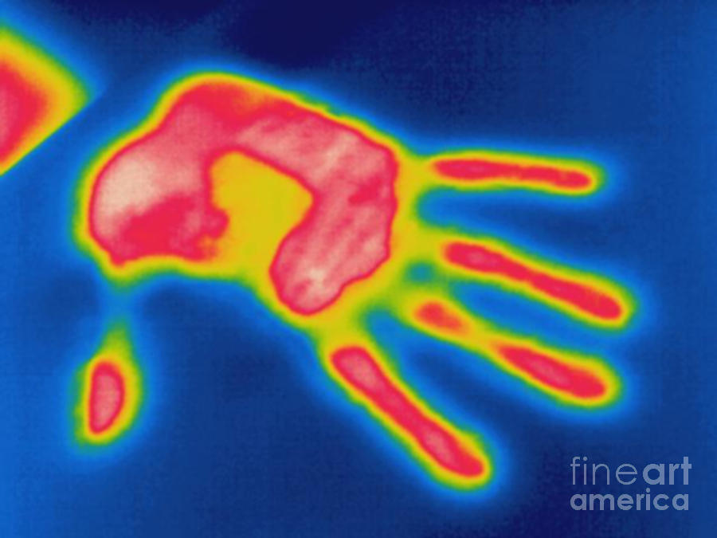

**Project scope and limitations**

The technique takes a single image of the blood sample. Then use an image matching method (SIFT or ORB) to locate the image agglutination. CNN is also used for image classification and training. The system requires antigen-mixed photos. It also cannot detect the Bombay blood type, which is a rare blood type.

**Efforts:** The effort is only a function of the number of lines of code and some constants evaluated according to the different software system.

**Efforts** = a (KLOC ) b

= 2.4 (1.970 )1.05

= 2.4 * 2.03

= 4.87

**Time:** The amount of time required for the completion of the job, which is, of course, proportional to the effort put in. It is measured in the units of time such as weeks,months.

### Time = c (Efforts)d

= 2.5 (4.87) 0.38

= 2.5 * 1.82

= 4.55

**Persons Required:** Persons required is nothing but effort divide by time.

**Persons Required** = Efforts / Time

= 4.87 / 4.55

= 1.07

**BACKGROUND STUDY & LITERATURE REVIEW**

Literature review medlinePlus.gov [1] The slide test is the traditional method for blood group identification. In this method, a drop of donor or recipient is mixed with anti-A, anti-B and anti-D separately. And agglutination or blood clotting is observed. The test is done in 5-10 minutes and is inexpensive. However, humans detect the formation of clusters, so this can lead to human error. Mehedi Talukdar, Md Rabiul slam and others. to [2] stated that blood type can be detected using image processing technology. The system takes a blood sample and calculates the standard deviation. If the standard deviation value is greater than 20, an agglutination reaction has occurred and the test is considered positive, otherwise it is considered negative. S. M. NaziaFathima [3] proposed a semi-automatic system for identifying recognizable blood groups using a microscopic stain image. First, it performs image preprocessing with histogram equalization, color correction, and then color space conversion to convert RBC to HIS. It recognizes the color and texture of the image using a cumulative histogram, and then can analyze the blood type of the corresponding person using SVM. This system requires more experienced people to manage the system and it is labor intensive. Enes Ayan, Erdem Kamil Yildirim [4] proposed a system for blood detection using the gel test method. Gel card with a special gel used in this method. Blood cells that do not agglutinate pass through this gel and collect at the bottom of the tube. Toz and colleagues developed software to read gel test cards using image processing technology. The gel test method requires three devices, which are a gel test centrifuge, a gel test incubator and a gel test reader. These devices are very expensive. Anurag Sadashiv phad, Tejas Sanjay Targhale, Bharat Bhalshankar, Sunita Kulkarni [5] proposed a system to detect blood using Raspberry Pi-3. In this system, reagents are mixed with three blood samples. after Blood group identification system sometimes agglutination may or may not occur. After the formation of agglutination, the slide is photographed with a Raspberry camera module and a Raspberry pi-3 module. Image processing such as morphology, thresholding, segmentation, quantization etc. is then done. Finally, the result will be displayed on the LCD screen. But the limitation of this system is that it requires more expensive cable. Mansi K, Hitashree M., Chandana Lakshman Hegdepaper [6], a blood grouping system using image processing technology is proposed which can be used by laboratory technicians and new users with no prior knowledge of blood grouping. All they have to do is draw blood and add three antigens to the blood and take a picture and transmit it to the system. The system can process the image and give the final output. The main steps in this application are image segmentation, thresholding, morphology, histogram and quantization.

**Description of the current project and related works:**

Nuha Odeh, Anas Toma, Falah Mohammed [7], An efficient system for automatic blood grouping based on image matching techniques, a fast and accurate system for automatic blood grouping based on image processing is proposed. Several blood samples were processed using different image matching techniques, including ORB and SIFT. These algorithms are used to look for an agglutination reaction in a blood sample. Convolution Neural Network is also used for image training and blood type prediction. The advantage of the proposed system is that this system does not require more expensive hardware.

**Collection of advertisements**

1. As a worker, log into the blood group software so that I can process the software.
2. As a lab employee, add the information of the new employee so that the new employee can also handle the software.
3. As a laboratory technician, I add new information about a patient so that I can use this information to identify patients' blood types.
4. As a worker, select the blood sample slide so that the software can process the additional steps on the image.
5. As a worker, the blood identification process is carried out.
6. As a laboratory worker, send an email to the patient about the patient's blood group report so that the patient can easily receive his blood group report.
7. As a worker, look at the list of donors in the list of patients for the benefit of donating blood.
8. As a worker, exit the blood typing software. So that I can close the software successfully.

User Stories

1. Laboratory can login to the blood group detection software with username and password.

2. Lab employee can add new employee using name, contact number, email address, gender, country and password.

3. Laboratory can add new patient with name, email address, contact number, gender, state, donor (yes or no) and blood sample.

4. The worker can select an image of a slide from the blood sample.

5. Blood identification can be done by a laboratory worker.

6. The report of the blood group of the patient can be sent by the worker by e-mail to the registered e-mail address and number.

7. The laboratory employee sees the list of donors with names and blood groups.

8. The worker can exit the software by clicking the Exit tab.

## **Requirement Specification:-**

|  |  |  |  |  |
| --- | --- | --- | --- | --- |
| **No** | **Requirement** | **Essentials/ Desirable** | **Description of Requirement** | **Remark** |
| RS1 | System should have a facility to login | Essential | After inserting valid login id and password and clicking on login button system should be login successfully into the software. | Username and password should valid |
| RS2 | The system should have a facility to add new employee | Essential | After clicking on employee button/tab form should ask required information of employee and should add into the database. |  |
| RS3 | The System should have a facility to add new patient | Essential | After clicking on patient button/tab form should ask for required information of patient and should add into the database. |  |
| RS4 | The System  should select  blood sample slide image | Essential | After clicking on select slide button system should select blood sample slide image. | File extension should be jpg, jpeg or png |
| RS5 | System should  Detect blood  group properly and store it into database | Essential | After clicking on image processing steps button system should apply all processes successfully and after clicking on store button system should store blood group information into database. |  |

|  |  |  |  |  |
| --- | --- | --- | --- | --- |
| RS6 | System should send email to patient | Essential | After clicking on store button system should redirect to email and msg sending form. |  |
| RS7 | System should display the donor list of patients | Essential | After clicking on donor tab button system should display donor list of patients. |  |
| RS8 | System should exit from software successfully. | Essential | After clinking on exit button/tab system should exit from application successfully. |  |

**Architectural diagram**

When an employee logs into the system, it sends a query to the database. The database validates that the username and password are correct or not. After that, the employee can successfully log into the system. After successful login, the employee can register a new employee. The employee can register a new patient and select a slide. Once the blood image is selected, it moves to image matching and classification techniques. Finally, the blood type is identified and stored in the database.

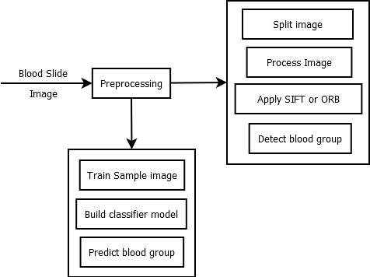

**System modelling**

Data flow diagram

A data flow diagram (DFD) maps the information flow of any process or system. The blood sample passes through the blood group detection system. Image matching techniques and a classification model are then applied and the final blood group is determined.

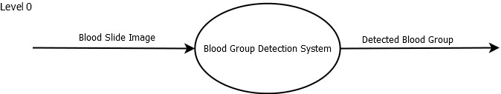

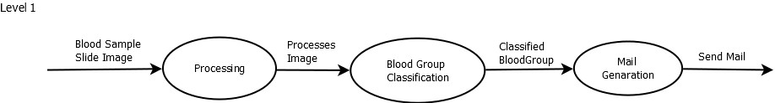

**Class diagram**

A class defines a method and a variable for an object that is a specific entity in your program or a unit of code that represents that entity. Each time a worker selects a blood slide, image processing techniques are used to identify the final blood type. In addition, the blood type of the database is stored in the database.

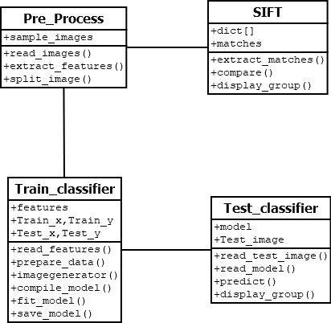

### 

### Sequence Diagram

A sequence diagram is a chronological arrangement of object interactions. The solid bar indicates the active time of the module. The dotted line shows the inactivity time of the model. The sequence diagram shows the flow of the project sequentially.

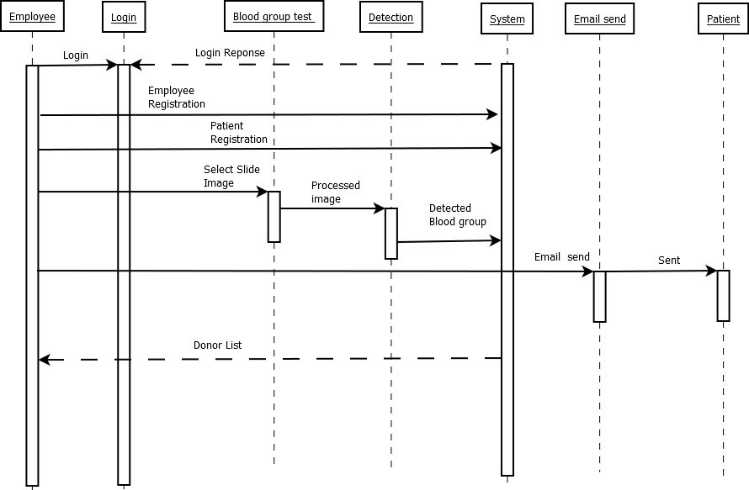

### Activity Diagram:

An activity diagram is basically a flow chart that shows the flow from one activity to another. Activities can be described as operating the system.

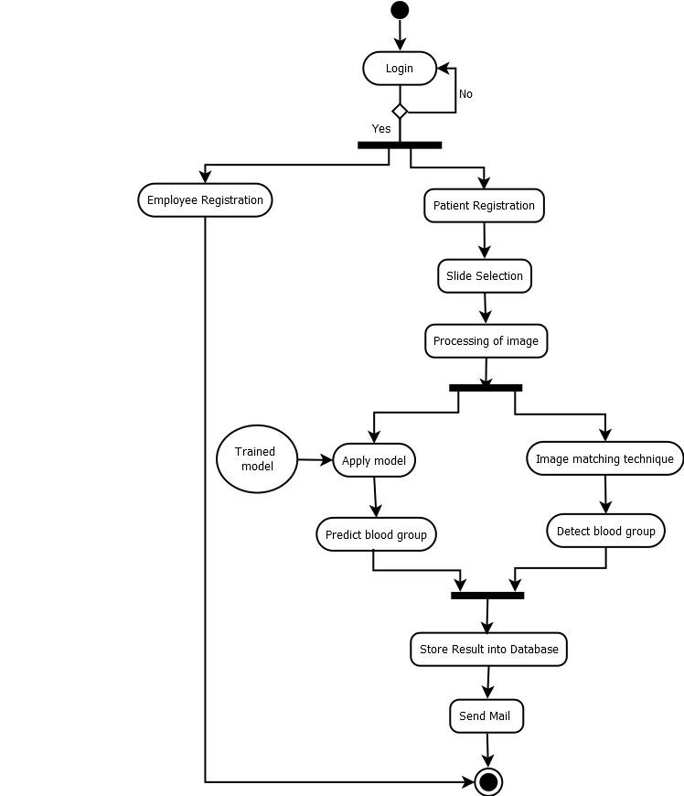

## Environmental settings for running the project

* + - To run this project database (SQLite) must be installed into the system.
    - To run this project python environment particularly Anaconda environment must be installed into the system.
    - To run this project following packages are required.

1. Pillow
2. TensorFlow
3. Keras
4. Matplotlib
5. OpenCV
6. Tkinter
7. Sqlite3
8. Sklearn

**Detailed Description of Methods**

Our system has different types of methods for handling all the operations. The different methods of our system are

1. Check_login(): This function checks the login credentials.
2. Insert_record(): This function enter all values of employee and patient into database.
3. Select_image() : This function is for selecting slide image.
4. Split_image(): This function is split the blood image into three separate image for further comparison.
5. Detection(): This function find out the matching distance between each split images and standard image and with help of matching distance it detect the blood group.
6. Prediction(): In this function train images model is loaded. Test the selected image with help of trained model predict the blood group.
7. Send_mail(): This function is for send mail to patient registered mail id.

## 

## **Description of Integration Modules**

|  |  |  |  |  |  |  |  |
| --- | --- | --- | --- | --- | --- | --- | --- |
| **Sr. No** | **Output Module** | | | **Input Module** | | | **Status** |
|  | **Module Name** | **Output** | **Type** | **Module Name** | **Input** | **Type** |  |
| 1. | Patient Registration | Patient information saved in database | String | Login | Username & password | String | Ok |
| 2. | Slide Selection | Blood slide Image | jpeg, jpg, png | Login | Patient information saved in database | String | Ok |
| 3. | Split Image | Split the image into three separate images | jpeg, jpg, png | Slide Selection | Blood slide Image | jpeg, jpg, png | Ok |
| 4. | Detection of blood group | Images with Matching distance and points, also pop up message for detected blood group | jpeg, jpg, png and String | Split Image | Split the image into three separate images | jpeg, jpg, png | Ok |
| 5. | Store | Pop up the message “Store” | String | Detection of blood group | Images with Matching distance and points, also pop up message for detected blood group | jpeg, jpg, png and String | Ok |

### Table 4: Integration Modules Table

**Testing**

|  |  |  |  |  |
| --- | --- | --- | --- | --- |
| **Sr. No** | **Test case Description** | **Expected Output** | **Actual Output** | **Status** |
| 1 | Log in | System needs to recognize valid username and password | System able to recognize valid username and password | Pass |
| 2 | Register new employee | System should be in position to register new employee | System able to register new employee | Pass |
| 3 | Register patient | System should be in position to register patient | System able to register new patients | Pass |
| 4 | Selection of Blood slide | System needs to select the blood slide image | System able to select the blood slide | Pass |
| 5 | Splitting of image into three sub images | System should split the image into three sub images. | System able to perform Split the image into three sub images | Pass |
| 6 | Detection | System must find out the matching points between splitted images with standard image and detect the blood group | System able to correctly find out the matching points between split images with standard image and detect the blood group | Pass |
| 7 | Prediction | System must test the selected image with help of trained model and predict the blood group. | System able to test the selected image with help of trained model and predict the blood group. | Pass |
| 8 | Mail send | After identifying the blood group system should send mail of detected blood group to the respective patient | After identifying blood group system able to send mail of detected blood group to patient | Pass |

**PERFORMANCE ANALYSIS**

This project is based on image processing based on the concept of neural network implemented using TensorFlow and Sphere. The model uses different layers such as cascade, dense, deletion. This algorithm generates the probability of image classification. All selected images have the logic of image matching techniques such as SIFT and ORB applied to identify the blood group. This blood group identification is important for donation purposes and for detailed study blood group classification.

**Future scope:-**

For future work, it is planned to develop an affordable portable device for automatic blood group determination. Using a handheld device, the employee takes a photo of the blood tube directly and identifies the blood group. The project is still being expanded to an Android application. In the Android app, employees take a blood sample directly on their mobile devices for blood type identification.

**APPLICATIONS**

The blood group system is based on the processing of the image obtained during the diatest. Software was developed for image processing to determine blood group in emergency situations without errors.

Improved export for use in many other applications:

Medical Technology: In the medical field, imaging is used for various tasks such as PET scanning, X-ray imaging, medical CT imaging, UV imaging, and imaging of cancer cells. The introduction of image processing in medical technology has greatly improved the diagnostic process.

Machine vision: One of the most useful applications of image processing is computer vision. Computer vision is used to make a computer aware of things, recognize things and process the entire environment as a whole. Self-driving cars, drones, etc. are important uses of Computer Vision.

Video editing: Video is basically a fast moving image. Image processing techniques are used in video processing. Some of the video editing techniques include noise reduction, image stabilization, frame rate conversion and detail enhancement.

REFERENCE:-

[1] MedlinePlus - Health Information from the National Library of medicine https://medlineplus.gov/ency/article/003345.html .

[2] Mehedi Talukdar, Md Rabiul Islam, Md. Mahfuz Reza, Mahbuba Begum, Md. Mahmudul Hasan, “Improvement of Accuracy of Human Blood Groups Determination using Image processing Techniques”, *International Journal of Advanced Research in Computer and Communication Engineering.* Vol. 4 Issue 10, October 2015.

[3] S. M. Nazia Fathima, “Classification of Blood Types by Microscopic Color Images”, *International Journal of Machine Learning and Computing.* Vol. 3, No 4, August 2013.

[4] Enes Ayan, Erdem Kamil Yildirim, “Real Time Blood Type Determination by Gel Test Method on an Embedded System”, *International Journal of Applied Mathematics, Electronic and Computers.* Vol 4, September 2016.

*[5]* Anurag Sadashiv Phad, Tejas Sanjay Targhale, Bharat Bhalshankar, Sunita Kulkurni, “Blood Group Detection by Using Raspberry Pi-3”, *International Journal of Advanced Research in Electronics and Communication Engineering (IJARECE).* Vol 7, Issue 4, April 2018.

**[6]** Mansi K, Hitashree M., Chandana Lakshman Hegdepaper, “Blood Group Determination through Medical Image Processing”, *International Journal for Research in Applied Science and Engineering Technology.* Vol 9, Issue v, May 2021.

***[7]*** Nuha Odeh, Anas Toma, Falah Mohammed, “An Efficient system for Automatic Blood Type Determination Based on image Matching Techniques”, *MDPI stays neutral with regard to jurisdictional claims in published maps and institutional affiliations.* Vol 11, June 2021.