**DESIGN AND DEVELOPMENT OF AGRICULTURAL LOAD CARRIER VEHICLE**

**Pankaj Jagtap1, Pratik Patil2, Pranav Salunkhe 3, Sumit Patil 4, Shreyash Rhayakar 5,  
 Prof. Ghanashyam Chendke 6**

**DEPARTMENT OF MECHANICAL ENGINEERING**

**ANNASAHEB DANGE COLLEGE OF ENGINEERING & TECHNOLOGY, ASHTA, DIST: SANGLI,**

**MAHARASHTRA, INDIA.**

**ABSTRACT**

After harvesting the fruits, farmers place it in bucket/basket. Once bucket/basket is filled, the farmers take it to safe place and then store it up to next process. After harvesting, the farmers weigh the harvested fruit. All this process is labor consuming and time consuming. To reduce the manual efforts, the agriculture load carrier vehicle is design and developed. In the design process, the chassis was designed considering the load, its forces, and moments. The static structural analysis was carried out in ANSYS Workbench. The Arduino program is developed for the desired task and tested. The ultrasonic sensor is used to detect the farmer’s motion and it will input to the Arduino. The Arduino program will signal it to the motor to run for the desired distance. High torque motors are used as vehicle driver motors, and weight sensors will display the bucket’s real-time weight on the display. The vehicle is developed and tested for 15kg. The developed load carrier vehicle can follow the man and showing instantaneous weight of added fruit with carrying weight of 15kg.

**Keywords:** Chassis, Agriculture, Multipurpose Components, Robotics, CATIA Design, Agricultural machine.

1. **INTRODUCTION**

The agriculture robot is used for farmers to automate slow, repetitive & dull tasks, so they can give more focus on improving overall production. The most of agriculture robot are used for harvesting, picking & weed control. The harvest is the operation of assemble or get together the useful part or parts of the plant. A harvesting robot is designed to pick fruits under certain environmental condition. A load carrier is an object with wheels for moving or transporting heavy items from one location to another the location.it is a useful mechanism to transfer of fruits and vegetable in agricultural market or factories and glories may more items. Traditional or manual handling of good a quite common and this has led to case of waist pain, backache, and more cases issues as well as wastages of time. Commonly large percentage of people in agricultural domain still make use of manual load carrier load system. Thus, there is need to design portable and multifunction load carrier Basically, harvesting the crop farmer takes collect the fruits and vegetables it in bucket, once the bucket is full, farmer must move bucket to the collection point and empty the bucket. He again returns to the same location and starts Harvesting. Due to this repetition, farmer gets fatigued. It will be better if an efficient system will be designing to reduce the task of farmer.

1. **METHODOLOGY**
2. Design and Analysis:

##### In this Design and Analysis,

* The concept drawing of the vehicle will be drawn.
* The major components of the vehicle will be listed, their weight will be noted from the specification sheet.
* The design of the vehicle will be done considering the weight to be carried i.e., 15kg, weight of crate self-weight of major components.
* The drawing of the model would be done in CATIA or suitable software.
* The suitable analytical and numerical method will be used while designing the system.

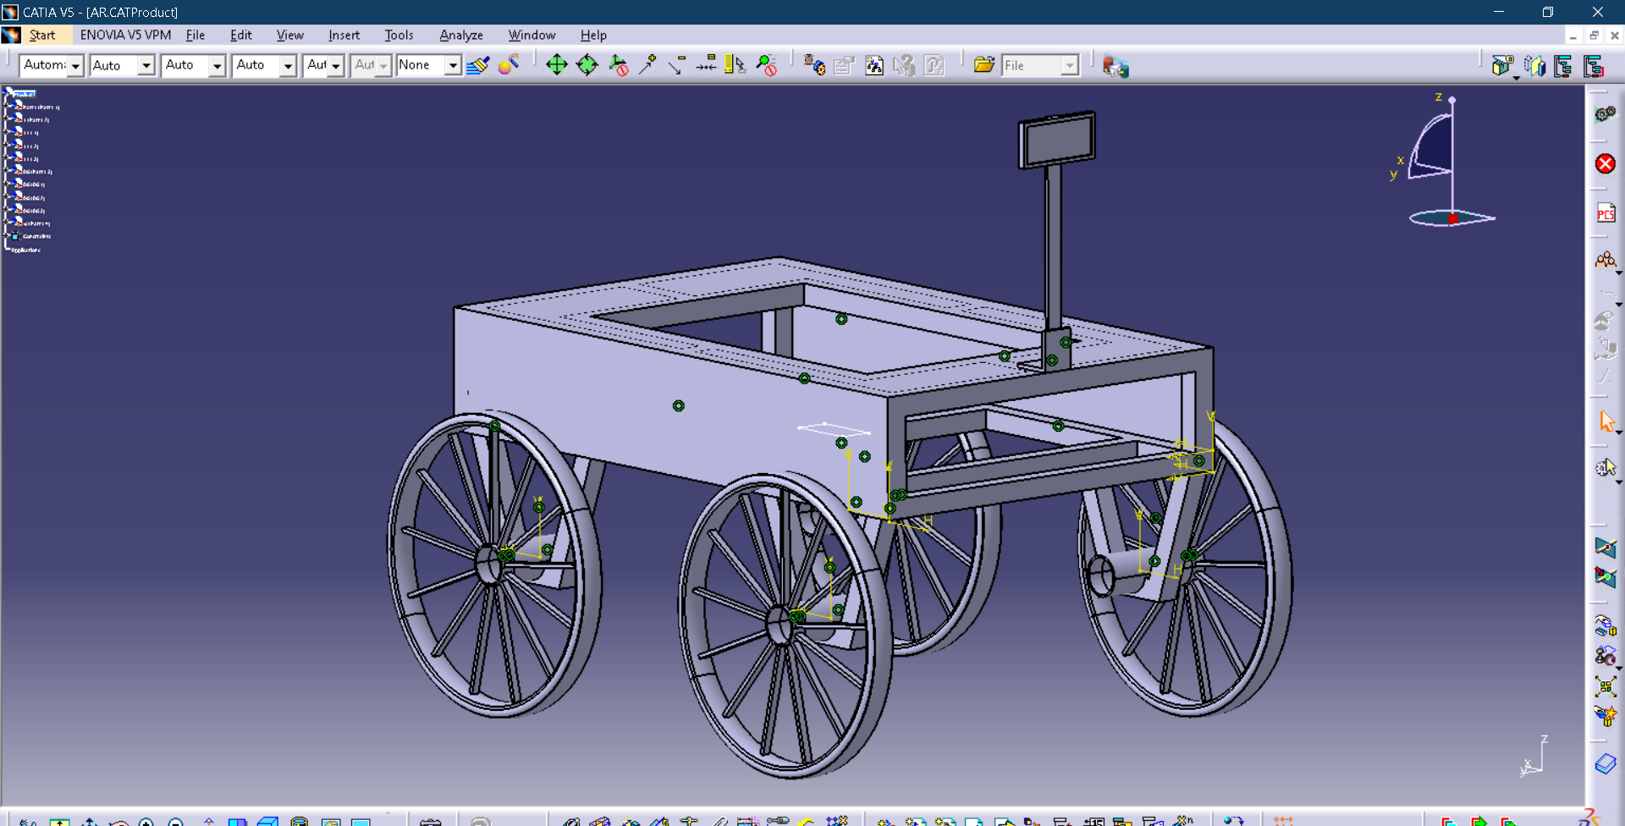

**Model Design in CATIA (proposed)**

1. Preparation of Manufacturing Drawing:

In this phase, the design will be finalized, and assembly and detailed drawing, bill of material will be done on suitable software. Automatic human following system will designed and dry run test will be carried out in laboratory in this phase.

1. Manufacturing of Component and Working Model:

The development of designed model will be done in institute workshop. Various manufacturing methods will be used for developing the system.

1. Performance Testing:

Performance testing of the model will be done in suitable agricultural land. The testing will be done by varying person, load carried etc. The testing will ensure completion of objectives mentioned.

1. **MODELING AND ANALYSIS**
2. Automatic control

After the fabrication**, we** done the assembly as well as we create the program code for Arduino and upload in Arduino. below is the working of vehicle.

**1-Forward direction-**

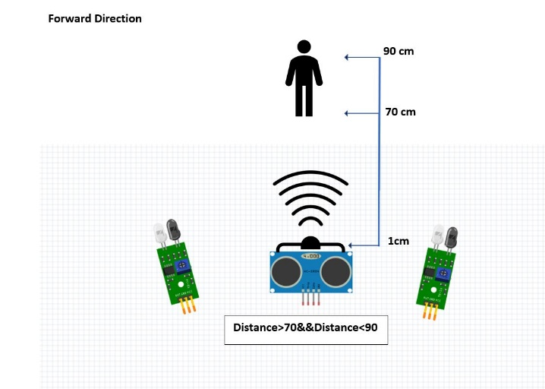

Forward direction

An ultrasonic sensor sense person or object at the angle of 30o in the range of 70 cm to 90 cm. When ultrasonic sensor, sense the person then it sends signal to the Arduino and Arduino send signal to the motor then vehicle go to the forward direction. At that time IR sensors are in a steady position. Figure 29 shows the working of ultrasonic sensor with their working range.

**2-Reverse direction**

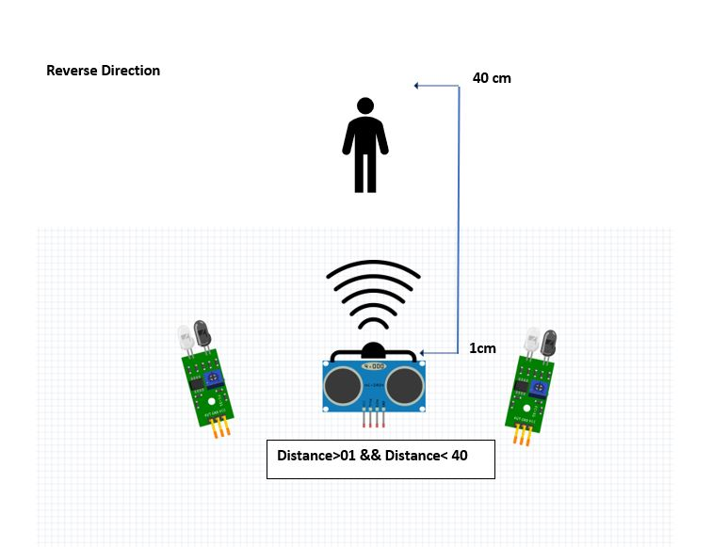

Reverse direction

An ultrasonic sensor, sense person or object at the angle of 30o in the range of 1 cm to 40 cm. When ultrasonic sensor sense person then it sends signal to the Arduino and Arduino send signal to the motor then vehicle go to the reverse direction. At that time, IR sensors are in a steady position. Figure 30 shows the working of ultrasonic sensor for reverse direction with their working range.

**3-Right turn**

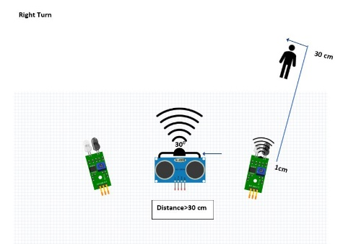

Right turn

An ultrasonic sensor sense person or object in the range of 70 cm to 90 cm and a person turn to the right side then the IR sensor senses the person or object then the two wheels of the vehicles on the left side move in the forward direction and right sides two wheels moves in the reverse direction. Then the vehicle get the right turn. Figure 31 shows the working of IR sensor for right turn with their working range.

**4-Left turn**

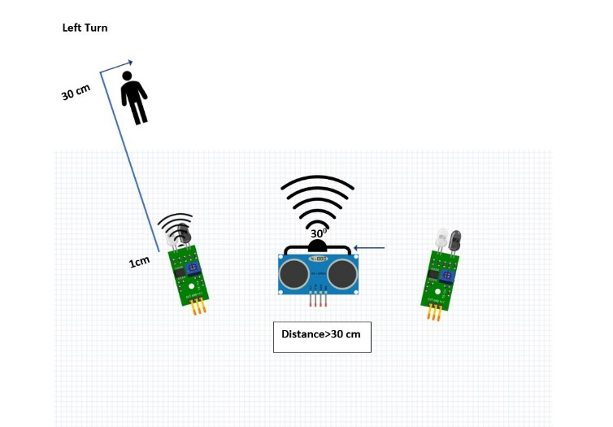

Left turn

An ultrasonic sensor sense person or object in the range of 70 cm to 90 cm and a person turn to the left side then the IR sensor senses the person or object then the two wheels of the vehicles on the right side move in the forward direction and left sides two wheels moves in the reverse direction. Then the vehicle gets the left turn. Figure 32 shows the working of IR sensor for left turn with their working range.

1. Manual control

For manually control, we use Bluetooth control module so we can control the vehicle from mobile device. So, it can be easy to control. In manual control, we use the Bluetooth module, so we download Arduino Bluetooth controller app from play store, and it is support only android 12 and there below version and install in smartphone.

**1-Start of vehicle**

After connecting the Mobile Device to the Arduino controller. For starting the vehicle, we need to press the start button on the mobile device. As shown in figure.

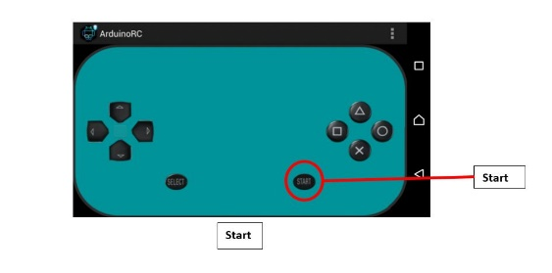

Start of vehicle

**2-Stop of vehicle**

To stop the vehicle, we need to press the select button (As shown in the figure 36) on the mobile device.

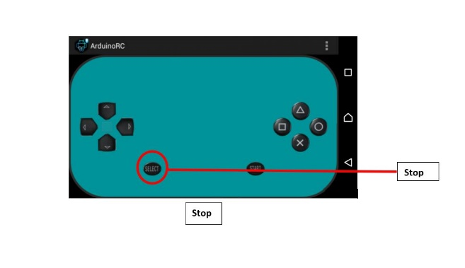

Stop of vehicle

**3-Forward direction**

To move vehicle in forward direction we need to press forward (triangle) button in mobile phone as shown in figure.

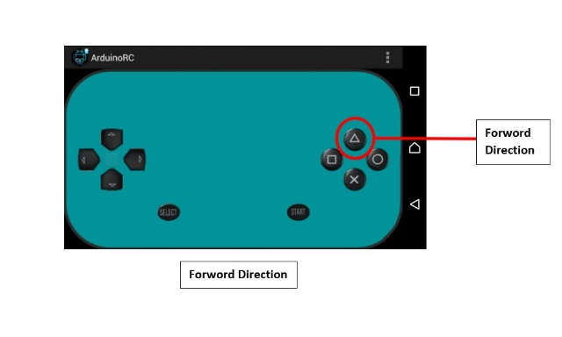

Forward direction

**4-Reverse direction**

To move vehicle in reverse direction we need to press Reverse (Cross) button in mobile phone.as shown in figure.

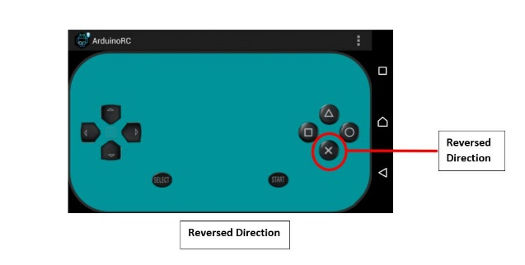

Reverse direction

**5-Right turn**

To move the vehicle in the right direction we need to press the rectangle button as shown in the figure. then the vehicle's left sides two wheels move in the forward direction and the right two wheels move in the reverse direction. Then the vehicle moves in the right direction.

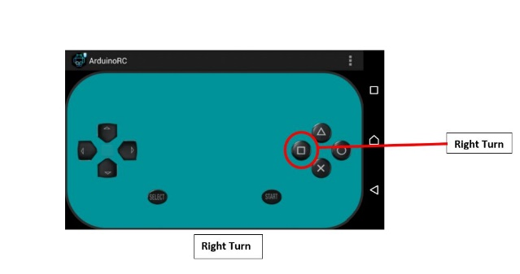

Right turn of Vehicle

**6-Left turn of vehicle**

To move the vehicle in the left direction we need to press the circle button as shown in the figure. then the vehicle's right sides two wheels move in the forward direction and the left two wheels move in the reverse direction. Then the vehicle moves in the left direction.

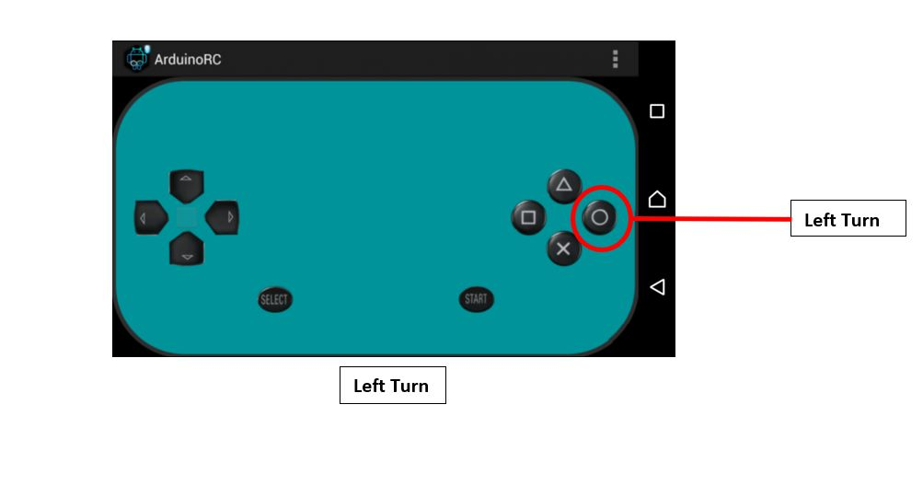

Left turn of vehicle

1. Testing

After the assembly and all the programming done. We take the test of Agriculture load carrier vehicle in the farm, in that we observed the working of our project. For the testing, we used standard weights to apply load on the vehicle. In the testing, we increased load on vehicle in that the vehicle is working. So, in that different weight the vehicle is automatically follow the person and work manually by Bluetooth module. In table 12 we show the testing reading on different weight.

Testing Table

|  |  |
| --- | --- |
| Weight (Kg) | Status |
| 2 | Yes |
| 4 | Yes |
| 6 | Yes |
| 8 | Yes |
| 10 | Yes |
| 12 | Yes |
| 14 | Yes |
| 16 | Yes |

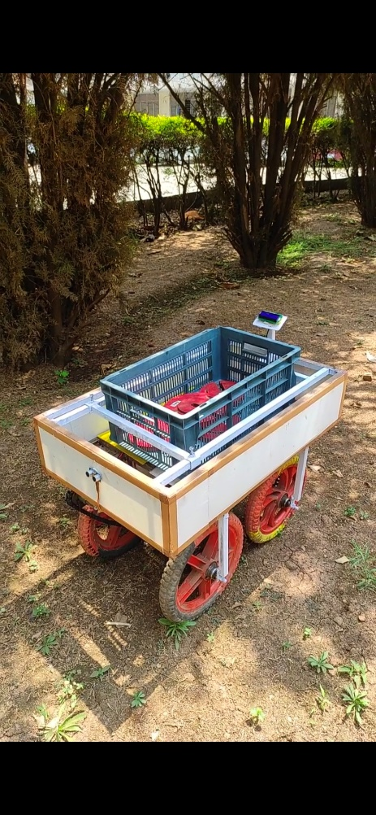 Photograph of Testing in farm Testing 6kg load (Bluetooth control) Testing 10Kg load (Automatic control)

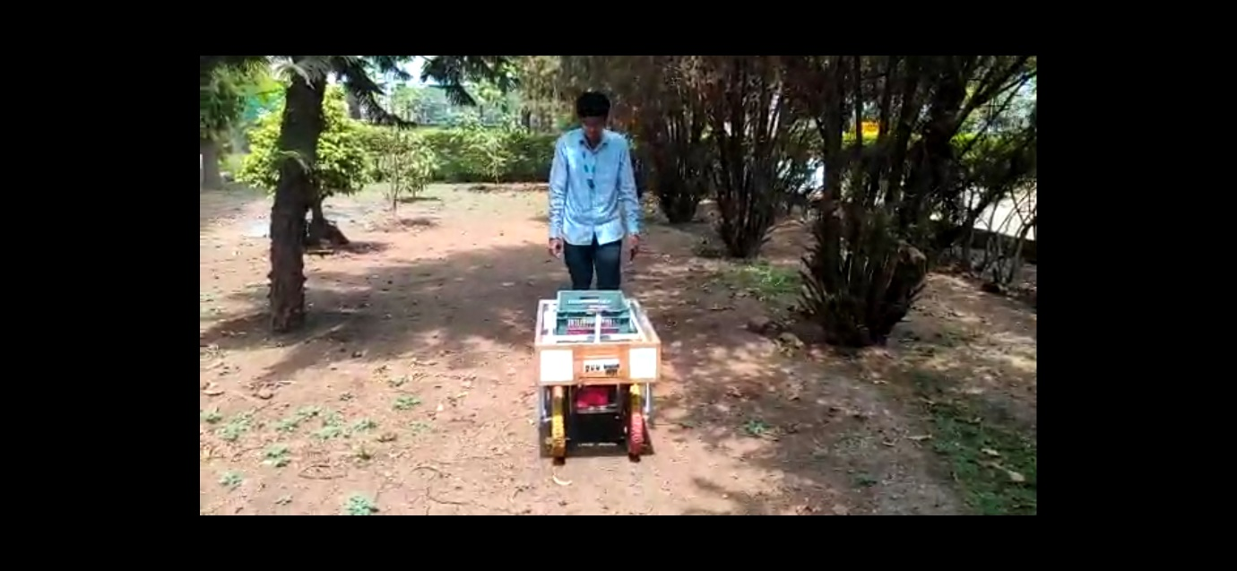

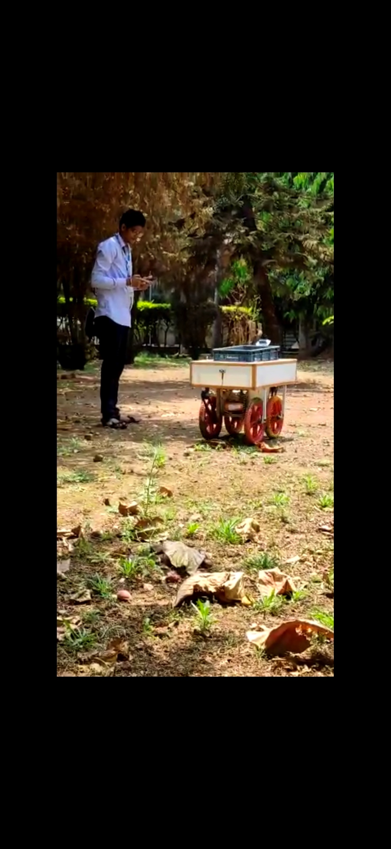

1. **RESULTS AND DISCUSSION**

As per the literature survey, the majority of vehicle have a direct program for certain root and end point. Most of the vehicles are fully automatic and cannot stop at any certain point. So, considering this gap, we decided to develop a vehicle that should follow the person by using sensors and motors. In this vehicle, weight measuring systems is added for displaying the real time weight of the fruit/crop. The design process was started with chassis design, being the crucial part of any vehicle. In the chassis design, we carried out theoretical calculation considering 17mm*17mm Mild steel square pipe. First, the moment of inertia of a 17mm*17mm square cross section was found out (3758.75 ${mm}^{4}) , then u$ sing bending equation, we find out bending stress in our chassis. For fining out bending stress, we first find out bending moment considering simply supported beam (Figure 2) so bending moment it 13238 70. Using this, the bending stress was found to be 59.87 N/ ${mm}^{2}$. This is much below the maximum applicable stress (150 N/ ${mm}^{2}) considerng the factor of safet 2$. So, the design of chassis is found to be safe as per the loading condition (150N force) Next, we find out total torque required to move the vehicle. Here, we considered friction force 87.5 N and then calculated the power required i.e 35.66 W. From the calculated power, the torque required for each motor is calculated (567 N-cm). With respect to this torque, the motor is selected. After that, the Finite element analysis- static structural analysis was carried considering tetrahedron and hexahedron element. The mesh sensitivity analysis was also carried out and the nest element size was decided. For boundary conditions, the force was applied at center of the chassis and bearing was considered as fixed. As per the FEM analysis, the design of chassis was safe. The further selection of electronic components is done and programmed needed was developed. The development of the vehicle was done in workshop and the electronic components were assembled. The testing of developed vehicle is carried out in farm. At first, we carried the test with 6kg weight placed on it, and then gradually the weight was added. The vehicle can sustain the weight of 16kg and follows the movement of person. The ultrasonic sensor woks and follows the person movement like forward and backward. For all the load conditions, the vehicle can be controlled using Bluetooth Control module. So, this developed vehicle can be controlled manually, automatically and by using Bluetooth Control module. The developed agricultural vehicle is working well in farm field and carried the load of 15kg.

1. **CONCLUSION**

The aim of the project is to design and develop the agriculture load carrier vehicle which will carry a load of 15kg, will show the weight kept and following the movement of person (forward/backward). Now, the vehicle is designed and developed in the workshop. The vehicle was tested in farm, and it completes all the desired task.

1. The agriculture load carrier vehicle is designed considering analytical and finite element method.
2. The designed vehicle is developed in the workshop.
3. The developed vehicle can carry a weight of 15kg with following a path of a person in front of it.
4. The developed vehicle is showing the weight of the collected fruit which will help the farmer for packaging of the fruits like grapes.

**5.1 Future scope:** The developed vehicle can be updated with Machine Learning - Artificial intelligence module so that vehicle will automatically sense the drop and pick point for the load kept and follow the person.

1. **REFERENCES**
   1. J. Wawer, And [Richard T. Vaughan](https://ieeexplore.ieee.org/author/37335176000), “A fast and frugal method for team task allocation in a multi-robot transportation system,” in Proceedings of the 2010 IEEE International Conference on Robotics and Automation (ICRA’10), Anchorage, AK, USA, May 2010, PP. 1432–1437.
   2. Keisuke TOMIO, Hiroya IGARASHI, And Akira HARADA,"Designing of a Carrier Robot “CARREY” at Office," 6th Asian Design Conference Vol.1 Japan, 2003.
   3. F. Tang and L. E. Parker, “ASyMTRe: Automated synthesis of multi-robot task solutions through software reconfiguration,” in Proceedings of the 2005 IEEE International Conference on Robotics and Automation (ICRA’05), Barcelona, Spain, April 2005, PP. 1501–1508.
   4. P. Kamal And Upputuri Hari Babu, “INTELLIGENT GOODS CARRIER ROBOT,” International Journal of Creative Research Thoughts (IJCRT), Volume 9, Issue 1, pp. 2925-2926, January 2021.
   5. R. Alami, “Multi-robot cooperation in the MARTHA project”, IEEE Robotics and Automation Magazine, vol. 5, no. 1, pp. 36–47, March 1998.
   6. Roldan J.J, Jaime del cerro, David Gerzon ramos and Mario garzon, “Robots in agriculture: State of art and practical experiences”, In Service Robots; Intech Open: London, UK, 2017.
   7. P.J. Grimstad, “Raspberry—Robotic and Autonomous Systems for Berry Production”. ASME Mech. Eng. 2018, 140, PP-14–18.