**“DESIGN AND FABRICATION OF ROAD CLEANING MACHINE”**

**Aniket Waghmare, Shubham Karande, Anil Kambale, Nikhil Mandhare , Abhijit Dhaygude,**

**Tejas Kumbhar, Dr. Laxman Waghmode**

DEPARTMENT OF MECHANICAL ENGINEERING

ANNASAHB DANGE COLLEGE OF ENGINEERING AND TECHNOLOGY, ASHTA , SANGLI , INDIA.

**ABSTRACT**

A new road cleaning equipment has been developed for Indian roadways, which utilizes updated technology that is suitable for Indian conditions. This streamlined equipment reduces the need for human labor to clean large areas over long distances, enabling the cleaning to be completed in a single drive. The technique has been used to clean highways and can effectively remove unwanted waste from roads, such as papers, covers, food, beverages, and fine dust.

The design satisfies all criteria for Indian roads and enables cleaning of broad roads and intersecting corners by adding extra accessories and mountings. Despite operating on the same principles as a vacuum cleaner, this system has a much larger cleaning area and particle sizes and is less expensive.

A prototype of a "Manually Operated Road Cleaning Machine" has been created, which utilizes local materials and is both economically and socially advantageous. This device operates using a straightforward rotational force and is effective at throwing dust particles from the road surface into the container with a cylindrical brush. It can be used on roads, college campuses, bus stands, and railway stations where dust accumulation is high.

1. **INTRODUCTION**

This machine is designed for planning and producing road cleaning equipment that combines the functions of a vacuum cleaner, a dryer, and a mop. While there are many types of floor cleaning machines available, they are often heavy and expensive, limiting their accessibility to many users. However, maintaining clean roads is crucial for a healthy environment and safe driving, as dust particles from passing cars can accumulate near road dividers, causing health and safety hazards. To support this cause, a study was conducted to develop a dust-cleaning device that can efficiently remove debris from roadsides. In our nation, hygiene is becoming increasingly important for national development, and a versatile and cost-effective road cleaning machine is needed that is easy to assemble and operate with minimal manual labor. Therefore, the machine should be designed with adaptable weight requirements, easy assembly, and operation, and a portable size that allows for easy transfer from one location to another. Creating such a machine will help maintain clean and safe roads while also promoting a healthy environment for all. Today, road cleaning machines play a crucial role in maintaining clean and safe roads for drivers and pedestrians. They are used in cities, towns, and other urban areas around the world to help control dust, prevent accidents, and promote a healthy environment. With ongoing advancements in technology and a growing focus on sustainability, the future of road cleaning machines looks bright

**METHODOLOGY**

• Design of the frame and different components of the machine.

• analysis of design and

• Study of mechanical drives for power transmission by using chain drives.

• Incorporating necessary

• To check the stress and force of various components of machines with the help of Ansys

• testing and evaluation of overall

**2.1 Design and Analysis:**

Understand previous work done on road cleaning methods by referring to IEEE research. The mechanism consists of main frame, chain drive, rotating brush, gears, shaft, and bearing. Draw a 3D model in CATIA. Analyses stress and force in ANSYS.

**2.2**  **Preparation of Manufacturing Drawing:**

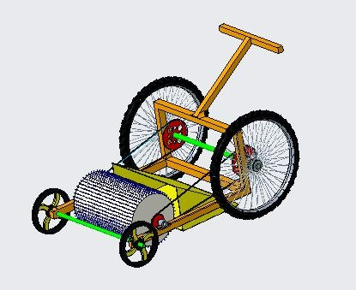

Fig.: 3D drawing of road cleaning machine

**2.3** **Manufacturing of component and experimentation:**

The fabrication process will include operations such as welding, grinding, drilling, and cutting. Firstly, the frame is the foundation. It will be connected to all components. When the frame is mounted on various components like a chain drive, brushes, wheels, and a waste collection box, The system is held together by a pair of wheels connected by a shaft. The shaft keeps the wheels connected to one another. The wheels are moved for a desired position with a help of manual force which can handle is provided to move. The handle can be adjusted for the required height, and there are three adjusting holes for it. A chain drive is connected to the wheels and gears on both sides. The chain is moved according to the wheel and gear. The brush moves in the opposite direction of the wheels movement, and the brush brooms the waste present on the road; it also dumps the waste into the waste collecting system .The waste collecting box is removed to dump the waste in desired places.

**2.4 Performance Testing:**

Machine will be tested on road in presence of cleaning staff worker.

**MODELING AND ANALYSIS**

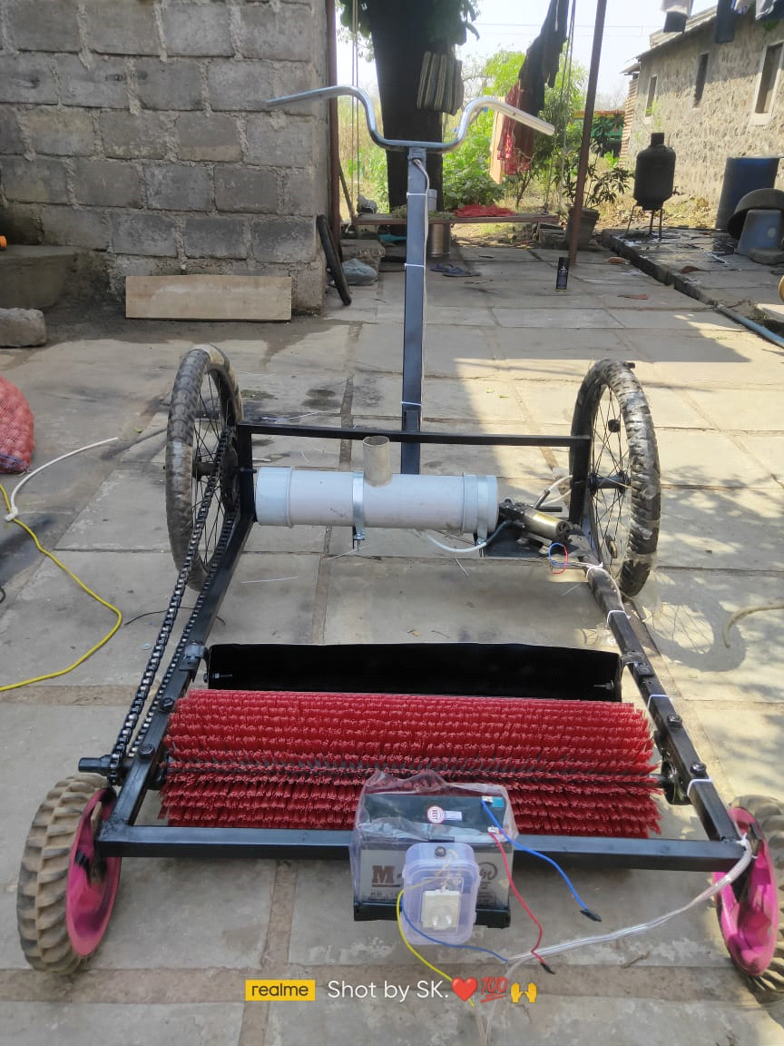

**Figure 1:** Actual Working Model.

1. **RESULTS AND DISCUSSION**

The results of using road cleaning machines are numerous and significant. Firstly, road cleaning machines improve the appearance of roads and public spaces. By removing litter, debris, and other unsightly materials, these machines help to create a more pleasant environment for pedestrians and motorists alike. This can have a positive impact on the perception of the area and increase its appeal for visitors and residents.

Secondly, road cleaning machines can improve the safety of roads and public spaces. Accumulated debris can cause slip and fall accidents, especially during wet or icy conditions. Road cleaning machines help to eliminate these hazards, reducing the risk of accidents and injuries. Additionally, these machines can improve visibility on the road, which is especially important for motorists and cyclists.

Thirdly, road cleaning machines can have a positive impact on the environment. By removing debris and other materials, these machines help to prevent pollution and protect local ecosystems. Additionally, some road cleaning machines use environmentally friendly methods, such as water recycling, which can reduce the environmental impact of their operation.

Overall, the use of road cleaning machines is essential for maintaining the cleanliness, safety, and attractiveness of roads and public spaces. By using these machines, communities can create a more welcoming environment for residents and visitors, while also promoting safety and protecting the environment.

**3.CONCLUSION**

Effectively created, examined, and manufactured. This project uses a manually powered, environmentally friendly road cleaner to clean the roads, saving money, time, and labor. During a power outage, it is the ideal replacement for an automatic road cleaning machine. It is discovered that the current road cleaning equipment runs on gasoline and diesel.

Because of machine vibration, it might also contribute to noise pollution. Physical cleaning, however, might be harmful because it exposes a person to dust up close.

This form of environmentally friendly road cleaning device can be used to clean any kind of remote spot. An automatic brush is necessary because the chain system can operate with much less power, which will save money and energy.

As a result of our hard effort, a manually driven road sweeper's design, fabrication, and testing were accomplished. However, we concluded that it is not acceptable to allow a spread in the numerical statistics of height, shape, and other factors. The design information needs to be correct and include a backup. Next, the manufacturing process developed into a much more complicated process than we had anticipated during the planning phase. The abundance of materials and the machine's ability to be manufactured were the main factors that had an impact on and compelled us to alter some of our design ideas. After that, testing was completed, and we discovered that this machine performs better than the manual, conventional sweeping technique. We also discovered that the cost-benefit ratio for this machine's high societal benefit is very favorable. However, our testing findings revealed some design inconsistencies. A small quantity of dust floated in the air and dispersed out. After overcoming all of these obstacles, we were able to finish the job and discover where the problems are most likely to arise during the planning and fabrication phases. Additionally, we learned how important it is to have access to the right tools, materials, and machines in order to create and build the machine and achieve the intended results.

Savings in electricity and money are possible since the chain mechanism uses a lot less power. Additionally, a brush with automated operation is required. Additionally, it offers a fresh addition to sanitizing the road.

The manually operated road cleaning machine may perform very successfully in terms of covering area, time, and cost of the road cleaning operation compared to current machinery. It is also cost-effective.

**4.REFERENCES**

1. International Journal for Research in Applied Science & Engineering Technology (IJRASET) SSN: 2321-9653; IC Value: 45.98; SJ Impact Factor: 6.887Volume 6 Issue V, May 2018- Available at [www.ijraset.com](http://www.ijraset.com).
2. Medak J. P. "Bicycle Drive Mechanism & it’s Adoption to the Development of a Manually Energised Process Machine" Invited Lecture, National Seminar on Human Engineering, Jan.'95 Organised by VIT, Pune & IIIE Chapter, Pune.
3. Medak J. P. “Design and Development of Manually Energised Process Machines having Relevance to Village/ Agriculture and other Productive Operations” HUMAN POWER, International.
4. Analysis about research paper design of road cleaning machine “international research journal of engineering and technology ISSN: 2395:0056
5. Pandey, J. K. (2000). Dust control practices in the Indian mining Industry.
6. . Sharma, M. (n.d.). Pollution in Kathmandu valley. The Kathmandu Post- Health.
7. Sanitation, M. o. (2008). Status of air pollution in Kathmandu valley.
8. Khurmi, R. (1980). Machine Design. S. Chand.